Recognition of Acquired Competencies

Run Book

Document Category: RB

Version: 2.2.5.x

Status:<>

Last Updated: April 12th, 2018

Contents

Contents 2

1 Introduction 3

1.1 Purpose 3

1.2 Scope 3

1.3 Target Audience 3

2 Installation and Setup 4

2.1 Installation 4

2.1.1 Pre-requisites 4

2.1.2 Migration/Installation Steps 4

2.2 Setup & Configurations 11

2.2.1 Dependent software and service configuration 11

2.2.2 RAC System Configuration 11

3 Operations Procedure 12

3.1 Basic Operations 12

3.1.1 Start-up and Initial Validation 12

3.1.2 Shutdown 12

3.2 Monitoring 13

3.2.1 Reactive steps 13

3.2.2 Escalation Steps 13

Approvals 15

History 16

# Introduction

## Purpose

The purpose of this document is to provide install and operational guidelines for the RAC system and will specifically cover the following topics:

* Installation
* Environment preparation
* Install and post install verification
* Configuration & setup
* Operations Procedures
* startup/shutdown/restart
* Operational Monitoring
* Basic troubleshooting & Escalation

## Scope

The RAC system fits in with the school separately from the other systems. It relies on CSAdmin for one user type to authenticate, and on the Clara database to pull in data for program’s courses and competencies. Otherwise, the system interacts only with it’s own database and doesn’t reach out to other services or applications.

## Target Audience

This document is intended for use as a reference by infrastructure engineers and system operators responsible for the installation and subsequent operational support of the RAC system and related systems.

# Installation and Setup

## Installation

### Pre-requisites

Before installing the RAC system, please make sure the following environmental requirements are met.

#### Hardware Requirements:

|  |  |  |
| --- | --- | --- |
|  | **Application Server** | **Database** |
| **CPU** | 1Ghz | N/A |
| **RAM** | 512MB | N/A |
| **Disk Space** | 50 MB | 5GB |

The RAC system is not CPU or memory intensive, however these values could vary. These are rounded up to ensure smooth performance.

#### Software Requirements:

|  |  |
| --- | --- |
| **Application Server** | **Database** |
| Windows server 2008 | Windows server 2008 |
| Internet Information Services (IIS) 6 | RedGate |
| Visual Studio 2010 | SQL Server 2008 |
| Team Foundation Server (TFS) 2013 |  |
| ASP.NET 4.5 |  |

Note: The procurement and install process of the required third party hardware & software components mentioned above is outside the scope of this run book and is not described.

### Migration/Installation Steps

#### Installation:

Log in as a user that has the proper privileges required to install

Step 1: Configuring your application.

1. Open Visual Studio.
2. Connect to the CSTFS server and select the RACv2 solution. Map and Get the solution.
3. Open the RAC project’s Web.config file.
4. Under the “<connectionStrings>” element, add a new connection string to the database that you wish to connect to.
5. Under the “<appSettings>” element, find the tags with the keys “RacAdvisorName”, “RacAdvisorPhoneNumber”, “RacAdvisorFaxNumber”, “RacAdvisorEmail”, “NoReply”, “SmptHost” and “RACDatabase”; change the values to the information you wish to use.

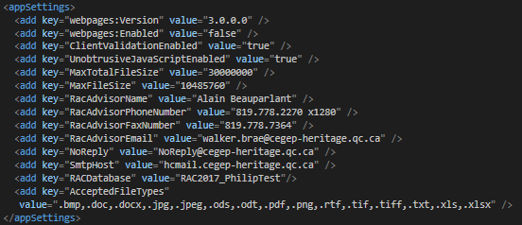

All of these application settings are explained in more depth in a table in section 2.2.2 - RAC System Configuration

Step 2: Setting up the database.

1. Open the solution explorer in Visual Studio.
2. Expand the “RACModels” folder and open “RACModel.edmx”.
3. Right-click inside the data model and select “Generate Database from Model”
4. Select the connection string you wish to use, and click “Next >”.
5. Click “Finish” and the SQL script will be generated.
6. Execute the script.
7. Open the “App_Data” folder and open the “ClaraViews.sql” and “MembershipColumnUpdateScript.sql”.
8. Execute both scripts.

Step 3: Deploying to a server.

* 1. In the solution explorer, right click on the RAC project. Select “Publish”.
  2. Open the connection settings.

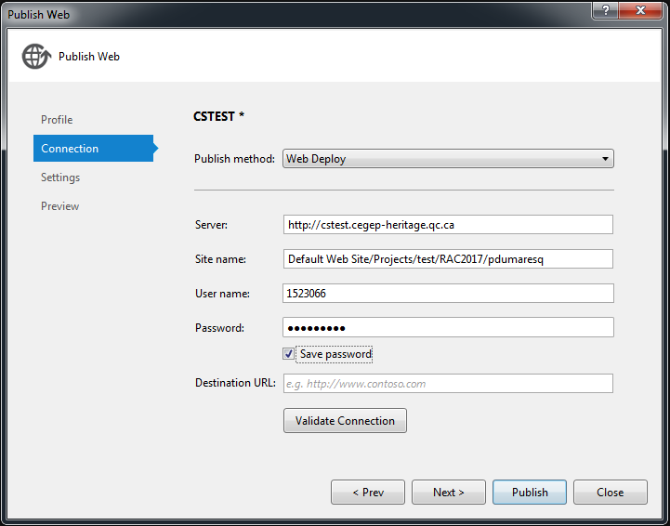

* 1. Enter the information for the application server which you want to publish to and enter your credential.
  2. Click on the settings tab for database configurations.
  3. Configure each of the databases as such: Leaving the “Remote Connection String” blank and checking “Use this connection string at runtime”.

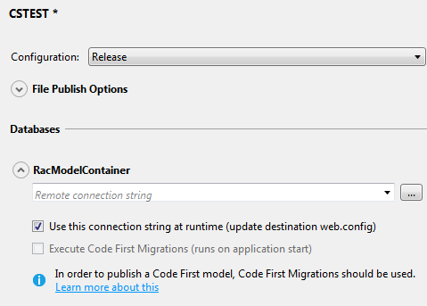

* 1. Click “Publish”.
  2. Connect to the server that you deployed to using “Remote Desktop Connection”

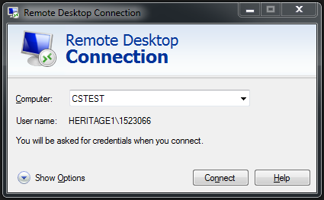

* 1. Open up the Server manager.

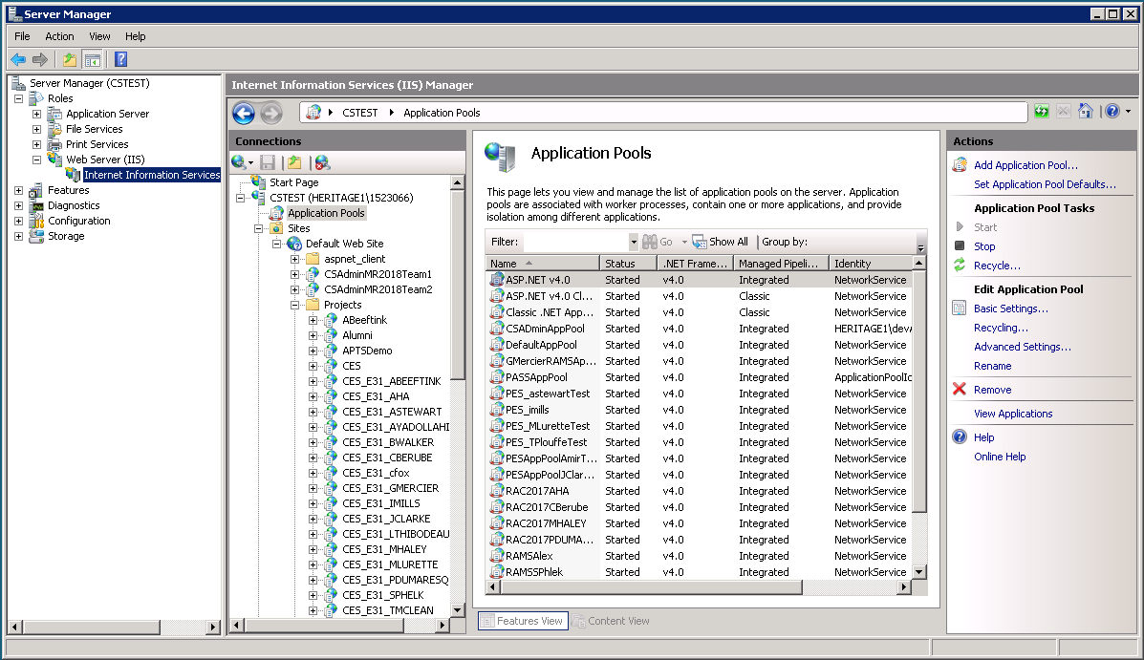

* 1. Navigate to the “Internet Information Service (IIS) Manager”
  2. Navigate to the “Application Pools”
  3. Under “Actions” in the right panel, select “Add Application Pool”.
  4. Name it and make sure the “.NET Framework Version” is 4.x and the “Managed Pipeline Mode” is set to “Integrated” and click “OK”.
  5. Right-click the App Pool you just made and select “Advanced Settings”.
  6. Change the “Identity” to “NetworkService” and click “OK”.

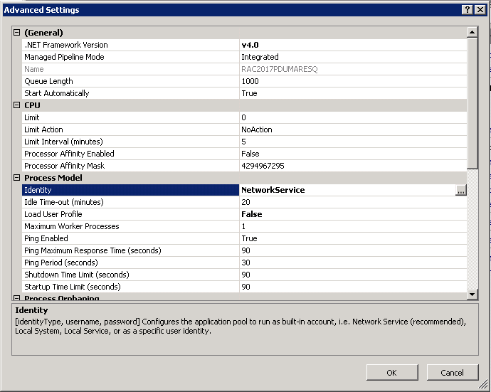

* 1. Navigate to the directory of the website you added in step d.

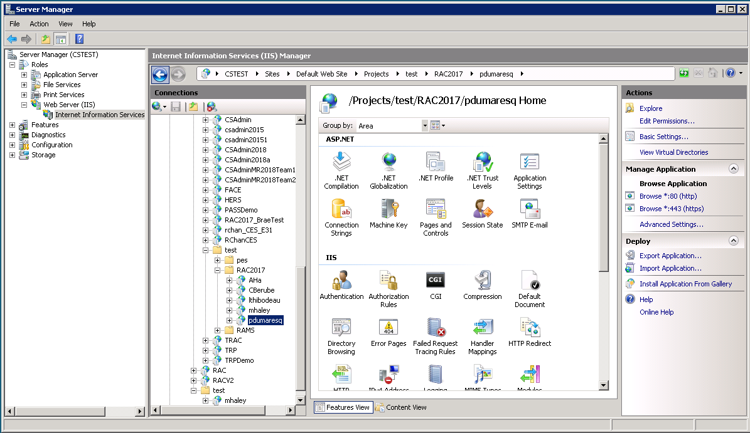

* 1. Click the “Advanced Settings”, change the “Application Pool” to the new pool that you just added in step n.

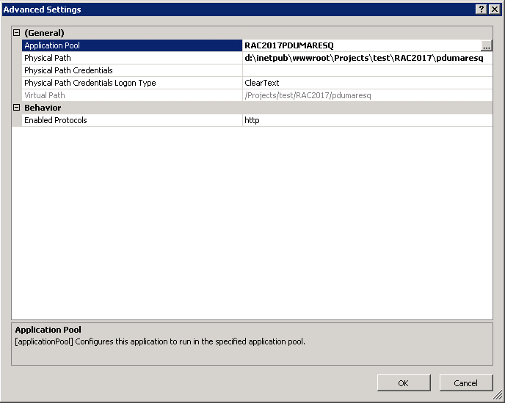

*[Provide full path to the install script/package and full command line options. If the install script/rpm is required to be run from a certain directory, please mention it here]*

#### Post Installation verification steps:

* 1. Open SQL Server Management Studio
  2. Connect to the target database server you entered in your connection strings.
  3. Expand the database to make sure all the following tables exist.

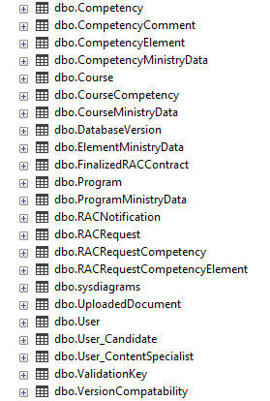

* 1. Expand the dbo.AspNetUserRoles and expand the Columns.
  2. Verify that the columns are named “RoleId” and “UserId”.
  3. Open up a web browser.
  4. Navigate to [http://[server_name]/[virtualPath_seenIn2.1.2.1StepD](http://[server_name]/%5bvirtualPath_seenIn2.1.2.1StepD)]
  5. Log in with a profile that has access the RAC advisor role and begin setting up new programs to ensure it works.
  6. Register a new user using the program that you set up.

## Setup & Configurations

### Dependent software and service configuration

* The RAC application needs to be registered in CSAdmin
* The RAC advisor role needs to be created in CSAdmin
* The RAC advisor needs to be set as a RAC advisor in CSAdmin
* The RAC application needs to have an AppPool created for it
* RAC needs to be added to the AppPool once it’s been created.

### RAC System Configuration

The configuration for the system is done within the [web.config](http://cstfs.cegep-heritage.qc.ca:8080/tfs/RACv2/RACApplication/RACApplication%20Team/_versionControl#path=%24%2FRACApplication%2FRAC%2FRAC%2FWeb.config&_a=contents) file inside the solution. This is an XML file and contains various settings for database connection strings and variables used throughout the solution. The file can be found in the root of the RAC project within the solution.

|  |  |  |  |
| --- | --- | --- | --- |
| **Key Name** | | **Example Value** | **Notes** |
| <connectionStrings | | | |
| ADConnectionString | LDAP://DC01.cegep-heritage.qc.ca | | The LDAP server in case RAC advisor users require it. |
| RacModelContainer | Metadata=res://*/RACModels… | | The target database server that was deployed to. |
| MSIdentityColumn | Data Source=csdev.cegep-heritage.qc.ca;…. | | The data source for MSIdentities to connect to. |
| CSAdminUsers | metadata=res://*/CSAdminModel… | | The authentication system used for the RAC advisor |
| Clara | Data Source=csdev.cegep-heritage.qc.ca;… | | The ministry database used for employees |
| <appSettings> | | | |
| MaxTotalFileSize | | An integer value in bytes | The maximum total size of all files uploaded for a single user. |
| MaxFileSize | | An integer value in bytes | The maximum size of a single file uploaded by a user. |
| RacAdvisorName | | A string value | The name of the RAC advisor for the college. |
| RacAdvisorPhoneNumber | | A string value in phone number form. | The phone number of the RAC advisor for the college. |
| RacAdvisorFaxNumber | | A string value in phone number form. | The fax number of the RAC advisor for the college. |
| RacAdvisorEmail | | A string value in email form | The email address of the RAC advisor for the college |
| NoReply | | A string value in email form | The email address that sends automated emails to candidates or RAC advisors. |
| SmtpHost | | A string value as a server address | The mail server address that the college uses for emails. |
| RACDatabase | | A string value. | The name of the database to be connecting to. |
| AcceptedFileTypes | | A comma separated list of strings | The list of different accepted file extensions that can be uploaded to the database. |

Table ‑ Example Dependent Service Configuration

# Operations Procedure

## Basic Operations

### Upgrading the System

The Entity Framework for the system uses a model first approach. As such, if the system upgrades include changes to the data model, then all of the user data will need to be backed up beforehand. Pushing the changes out to the database will require removing the content of all of the tables, so you need to ensure that all the data is backed up prior. You will also need to reformat you backup scripts so that they are compatible with the new data model.

Without having any model changes, then upgrading the application in production is as simple as re-deploying the web site to the application server following the steps included above in part 2.1.2.1.

### Initial Validation

To get the system running once you have deployed, the first thing that you will need to do is ensure that you have programs available for candidates to make RAC requests with. To create programs, a RAC advisor needs to walk through the “Import Program” workflow, which can be found in the user documentation or the [online help.](http://csdev.cegep-heritage.qc.ca/Projects/RACV2/Sandbox/Home/Help#collapseAddProgramRAC)

## Monitoring

### Escalation Steps

#### Escalation Order

*[If the above steps fail to recover from outage or resolve the issue, specify the escalation order to reach the L2, engineers, owners & management]*

Please escalated to the middleware team if required in the order mentioned below starting from top

|  |  |  |
| --- | --- | --- |
| Team | Hotline/Phone number | Distribution list |
| IT Service | (819) 778-2270 x2045 |  |
| Bernard Dupond | (819) 778-2270 X2043 | [bdupont@cegep-heritage.qc.ca](mailto:bdupont@cegep-heritage.qc.ca) |
| Marc Amey | (819) 778-2270 x2042 | [mamey@cegep-heritage.qc.ca](mailto:mamey@cegep-heritage.qc.ca) |
| Richard Chan | (819) 778-2270 x1415 | [rchan@cegep-heritage.qc.ca](mailto:rchan@cegep-heritage.qc.ca) |
| Allan McDonald | (819) 778-2270 x2071 | [amcdonald@cegep-heritage.qc.ca](mailto:amcdonald@cegep-heritage.qc.ca) |

**Table 3‑1 Service Escalation Contact**

#### Stake Holders Contact

Stake holders contact to notify an outage or any other issue (impending or occurred)

|  |  |  |
| --- | --- | --- |
| Team | Primary Hotline/Phone number | Primary Distribution list |
| Allan McDonald | (819) 778-2270 x2071 | [amcdonald@cegep-heritage.qc.ca](mailto:amcdonald@cegep-heritage.qc.ca) |
| Richard Chan | (819) 778-2270 x1415 | [rchan@cegep-heritage.qc.ca](mailto:rchan@cegep-heritage.qc.ca) |
| Alain Beauparlant | (819) 778-2270 x1280 | [abeauparlant@cegep-heritage.qc.ca](mailto:abeauparlant@cegep-heritage.qc.ca) |

**Table 3‑2 Stake Holders Contact**

Approvals

This document has been read and approved by the following people, responsible for its implementation. Approval is indicated by an email showing approval. Those approving below indicate that the contents of this document are correct and complete and agree to their implementation:

| Title | Name | Approval |
| --- | --- | --- |
|  |  |  |
|  |  |  |
|  |  |  |
|  |  |  |

History

| Version | Status | Date | Author | Reason for changes |
| --- | --- | --- | --- | --- |
| 1.1 | Pending approval | April 13th 2018 | Philip Dumaresq | Initial draft of the runbook |
| 1.2 | Pending Approval | April 24th 2018 |  | Competed version of initial runbook |
|  |  |  |  |  |
|  |  |  |  |  |
|  |  |  |  |  |