**Testing :**

Testing is done mainly for three input scenarios as below:

1. **Test case** : Not a fruit string

**Search Input** : “chair”

**Expected Result** : A message box should appear saying “I don’t believe this is a fruit, Please enter fruit name again”

**Actual Result** : A message box should appear saying “I don’t believe this is a fruit, Please enter fruit name again”

**Result** : PASS

1. **Test case** : Fruit string that already exists in the table.

**Search Input** : “apple”

**Expected Result** : The recipe with maximum ingredients in the top three non featured recipes should be filled in the excel sheet in the fruit row along with ingredients in the corresponding column.

**Actual Result** : The recipe with maximum ingredients in the top three non featured recipes should be filled in the excel sheet in the fruit row along with ingredients in the corresponding column.

**Result** : PASS

1. **Test case** : Fruit string that does not exist in the table.

**Search Input** : “kiwi”

**Expected Result** : The recipe with maximum ingredients in the top three non featured recipes should be filled in the excel sheet appending to the existing rows along with ingredients in the corresponding column.

**Actual Result** : The recipe with maximum ingredients in the top three non featured recipes should be filled in the excel sheet appending to the existing rows along with ingredients in the corresponding column.

**Result** : PASS

**Challenges faced :**

1. **Issue** : API integration allowed the search input other than a “fruit” type also to be searched in the website taste.com.au. For instance, if

**Search Input** : “how are you”

**Expected Result** : A message box should appear saying “I don’t believe this is a fruit, Please enter fruit name again”

**Actual Result** : The work flow navigates to taste.com.au searches for the “number” string in the search box”

**Root cause analysis** :

The validation of whether the entered input string is a fruit name or not is handled by the API itself. So, the API processes the data, that contains the string “Fruit” in the response data of the API. This could be verified using the “Postman” tool. This serves as a handy tool to check the response content of the API in the JSON format. So, when the parameter “generalSearchInput” is given a value, for instance “how are you”, it gives a response in JSON that contains the string “fruit” in its data. Please refer to the below screen shot of the postman request

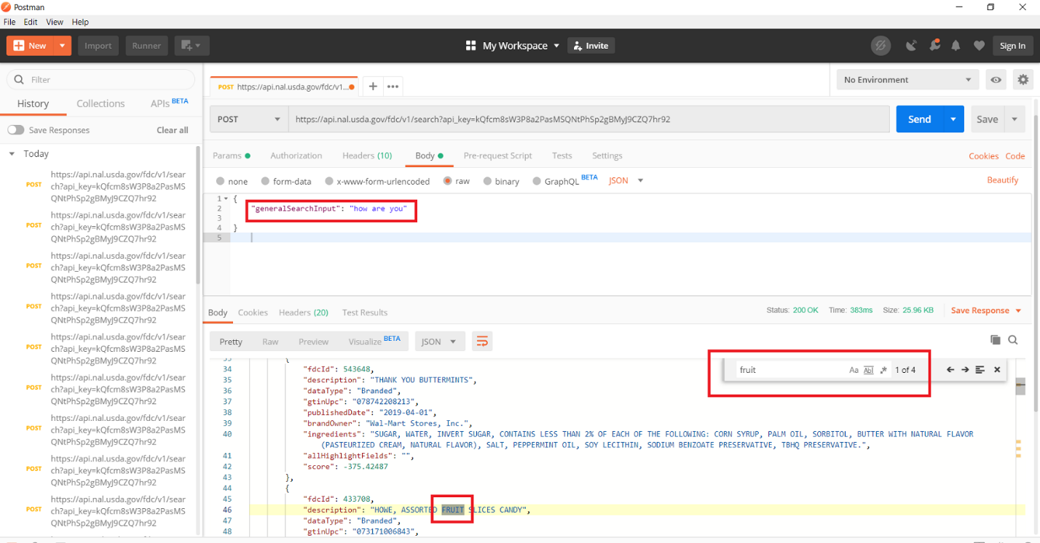

Since the JSON data consists of the string “fruit” in its content, the search result satisfies the true condition and proceeds to perform search operation with the input string in the taste.com.au.

Another validation test can be done for a string input, that does not contain the string “fruit” in its API post response data.

For instance as below :

**Search Input** : “computer”

**Expected Result** : A message box should appear saying “I don’t believe this is a fruit, Please enter fruit name again”

**Actual Result** : A message box should appear saying “I don’t believe this is a fruit, Please enter fruit name again”.

**Root cause analysis** :

This is because, the API response data does not contain the string “Fruit” in it. So, the program flow goes as like,

the message appears as like the string is not a fruit and hence proceeds with the flow to show the message box saying “I don’t think it’s a fruit”. If checked using the “Postman” tool, the response looks like as below screen shot.

