Piezoelectric Energy Harvesting from Walking Motion of a Passive Biped Robot Model with Flexible Legs

Masoumeh Safartoobi ^{(a)}, Morteza Dardel^{(a)} and Hamidreza Mohammadi Daniali ^{(a)}
- Department of Mechanical Engineering, Babol Noshirvani University of Technology
Abstract
Passive dynamic walking biped robots utilize the inherent dynamics of their structure to achieve walking motion without continuous actuation, enhancing energy efficiency and stability. Replacing conventional rigid legs with flexible elastic beams in the simplest passive walker will be associated with undesirable vibrations. Despite the positive effect of the damper in reducing vibrations, the current research has used the piezoelectric energy harvesting with the aim of reducing the wasted energy of the gait cycle and improving its stability range. For this purpose, the electromechanical Lagrange equations are determined by applying Hamilton's principle and the assumed mode method and then, the new definition of the step function is obtained through numerical methods, solving a boundary value problem to establish proper initial conditions for stable walking. Numerical simulations indicate that the piezoelectric energy harvester can create a stable period-one gait cycle by optimizing the length of the piezo layers attached to the undamped elastic legs despite the presence of small vibrations. Additional results are presented in bifurcation diagrams, investigating the effect of important physical and structural parameters such as slope angle, length and thickness of the piezo layer.
Keywords: Passive dynamic walking, Biped, Energy harvesting, Piezoelectric, Flexible leg.
- Introduction
Human walking is a marvel of biomechanics, characterized by efficient and stable locomotion. Replicating this feat in biped robots has been an ongoing challenge in robotics research. Passive biped robots, relying solely on cleverly designed mechanics and environmental interaction for movement, offer a particularly intriguing approach due to their simplicity and potential energy efficiency [1]. Despite the high sensitivity of passive walkers to suitable initial conditions, various studies explore different aspects of these bipedal robots. These studies collectively contribute to advancing the field of passive biped walking robots by addressing control strategies, stability challenges, and energy efficiency for basic models such as the one proposed by Goswami [2] and Garcia [3]. These researches have been ongoing for years and continue to advance by exploring even more complex structures. Our previous researches have thoroughly examined the background of this issue [4-6]. In the following, some of the most recent researches conducted in this field will be reviewed.
Corral et al. [7] propose a new method for analyzing how passive bipedal robots walk. They focus on how the robot's feet interact with the ground and show that a special contact force model, called the Nonlinear Flores Contact Force Model with dissipation, best describes this interaction. Islam et al. [8] use simplified 2D models to analyze a 3D passive gait for designing miniature untethered robots that leverage passive dynamics for efficient walking. Researchers in [9] investigate a passive biped walker with knees and biomimetic feet, deriving an analytical model to study its passive walking capabilities and parametrically mapping out its walking capabilities. Research by Koseki et al. [10] demonstrate the successful generation of multimodal locomotion in underactuated bipedal robots using deep reinforcement learning, emphasizing the importance of leveraging body morphology for efficiency. Wu et al. [11] propose a hybrid chaotic controller to stabilize chaotic motions in passive dynamic walking robots, improving stability against disturbances. Gritli's research focuses on stabilizing the limit cycle walking, energetic efficiency and controlling chaos in the passive dynamics of the compass-gait biped model [12-17]. Additionally, methods for computing optimal gaits based on energetic cost functions using passive gaits have been developed, highlighting the efficiency of passive strategies in gait optimization [18]. Recently, by implementing trajectory-tracking controllers and energy-shaping-based methods, Gritli demonstrates the occasional stabilization of limit cycles during the swing phase, leading to increased energetic efficiency and periodic gait on sloped surfaces [19].
Furthermore, authors extend research in [20] by examining a flexible biped robot with compliant legs, hips, and a deformable walking surface. The study focuses on the intricate dynamics introduced by sliding contact, including self-locking, to achieve more realistic walking behavior compared to traditional rigid-legged robots with perfect foot adhesion. While lightweight, flexible links offer benefits like high-speed operation and larger workspace, their low stiffness makes them prone to vibrations, posing a key challenge. Building upon our work in [6], this study investigates a modified flexible model of Garcia's simplest passive walker with elastic legs. Bo et al [21], proposed an impulsive hybrid nonlinear dynamic for a walking bipedal model with telescopic legs. The conditions for the existence and stability of period-1 and period 2 gait cycles are obtained. Also, by reducing the leg extension ratio, the occurrence the flip bifurcation is studied. Fathizadeh et al. [22] presented a modified passive walking biped with two distinct feasible patterns of motion to resemble multi-pattern human walking. Switching conditions between these stable patterns are determined. It is shown that the model is chaotic for a certain range of parameters. Emergence of two feasible patterns of motion would enhance the resemblance of passive biped to multi-pattern human walking. Our earlier study in [23] focuses on incorporating internal damping mechanisms in the form of viscoelastic legs to enhance stability and energy dissipation in passive walking models. Studying passive biped robots offers a simplified model for analyzing human walking and provides valuable insights into the fundamental principles of human gait.
Another interesting and new topic in the academic and research field is energy harvesting from human walking. Piezoelectric energy harvesting from bipeds, such as humans and humanoid robots, has been extensively explored in recent research. Piezoelectric energy harvesting from bipeds, such as humans and humanoid robots, has been extensively explored in recent research. Various studies have explored this concept, showcasing different approaches and designs. Some of them have focused on utilizing piezoelectric materials in devices attached to the human body, like knee pads and leg-mounted prototypes, to scavenge energy from walking motions [24-29]. For instance, a bimorph piezoelectric bending beam-based energy harvester was developed to scavenge energy from human knee motion, generating an average power of 12.79 mW for level-ground walking [28]. Novel approaches, such as the z-PEH module, have been proposed to harness waste energy from human walking without damaging existing infrastructure, showcasing advancements in maximizing power generation while minimizing environmental impact [29]. Another study introduces a method using piezoelectric energy harvesters for both gait recognition and energy harvesting simultaneously [30]. It proposes a preprocessing algorithm to filter out energy storage effects and LSTM-based classifiers for accurate gait recognition, showing improved performance in both aspects.
In addition to these items, piezoelectric energy harvesting for wearable devices is a promising technology that leverages human motion to generate electricity for powering intelligent wearables [31-33]. Research has shown that utilizing piezoelectric energy harvesters can efficiently capture ultra-low frequency vibrations from human motion, enabling the development of self-powered wearable and implantable biomedical devices for personalized medical treatment and health monitoring. Experimental studies have validated the feasibility of detecting steps accurately using wearable piezoelectric energy harvesters, achieving a step detection accuracy of 96% [34]. Wang et al. [35] present a piezoelectric-based sole energy harvester designed for shoes to capture biomechanical energy from walking, utilizing a cam at the heel and a bimorph piezoelectric plate at the forefoot. Preliminary testing on a healthy subject confirmed the harvester's functionality, producing an average power output of 8.83 mW, showcasing its potential for powering wearable electronic devices. Overall, piezoelectric energy harvesting in bipeds holds significant potential for driving wearable devices and powering body-worn electronics, offering a promising solution to address battery life challenges.
It is worth to note that piezoelectric energy harvesting plays a crucial role in advancing beam vibration analysis by enhancing energy harvesting efficiency, widening bandwidth, and optimizing structural configurations for maximum output performance. Considering the limitations of the simplest passive walking model with flexible elastic legs, which prior research [6] has shown to induce undesirable vibrations, this study explores the concept of energy harvesting for consumption optimization. This approach aims to convert the robot's wasted energy into electrical energy to enhance its stability on steep inclines while maintaining the passive nature of the gait cycle. We propose a novel application of a piezoelectric energy harvesting system in passive walkers. This system utilizes piezoelectric layers attached to the elastic legs, unlike existing examples found in active robots. Therefore, the primary objective of this work is to investigate the influence of piezoelectric energy harvesting on the dynamic behavior and gait cycle of a flexible passive walker.
To this end, the structure of the paper is organized as follows. In Section 2, dynamic modeling and determination of desired mathematical relationships are discussed. Section 3 is dedicated to the proposed method for determining the appropriate initial conditions of the period-one gait cycle. In Section 4, the results of numerical simulations and parametric studies are presented. Finally, the concluding remarks of the research are presented.
- Dynamic model and formulation
  - System description
Figure 1 illustrates the modified flexible model of the simplest passive walker in our previous study [6] with piezoelectric energy harvesters. The elastic legs with attached piezoelectric layers are considered as Euler-Bernoulli (thin) beams with small deformation. The two identical legs are joined together by a frictionless hinge joint at the hip, acting as a simple double pendulum. The geometrical and physical parameters in the dynamic description have been shown in Fig. 1. The bending displacements along the elastic legs are denoted by $w_{st}\left(x_{1},t\right)$ and $w_{sw}\left(x_{2},t\right)$, where $x_{1}$ and $x_{2}$ are the longitudinal coordinates along the length of the stance leg and the swing leg respectively. The rigid motion of the simplest passive biped is determined by the angle between the stance leg and the slope normal ($θ_{st}$), the angle between the two legs ($ϕ$), as well as their angular velocities ${\dot{θ}}_{st}$ and $\dot{ϕ}$. The significant parameters for the dynamics description of the flexible passive walker are presented in Table 1.
The whole walking is specified as the process from the lift-off of the swing leg to its impact with the ground, in which the continuous motion of the stance and swing leg in between foot-strikes is called the swing phase, and the fully inelastic instantaneous collision between the swing leg and the ground is called the impact phase. The scuffing problem of the swing leg is neglected for this extremely simple morphology of the walker and no foot slippage occurs at the contact point. The continuous-time nonlinear differential equations of the swing phase, the algebraic nonlinear equation and its associated impact condition constitute the hybrid dynamics of the bipedal locomotion.

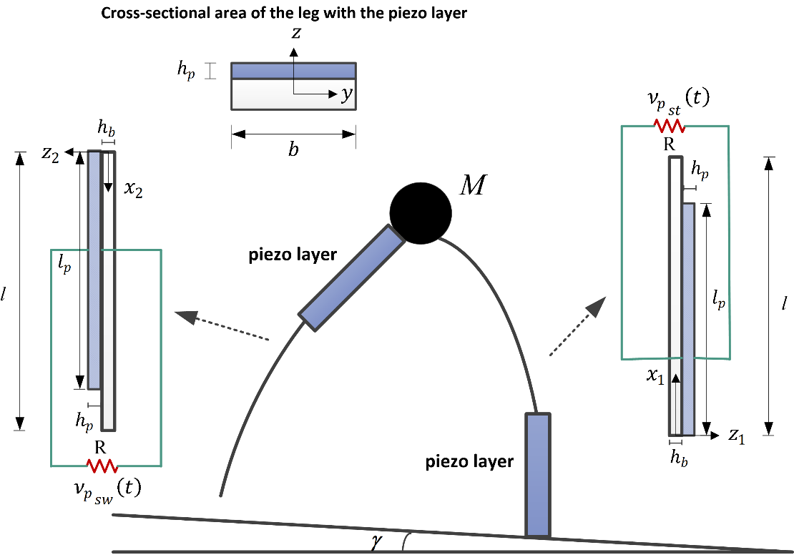
Fig. 1. Schematic diagram of the flexible simplest passive walker with unimorph piezoelectric energy harvester configurations.

Table 1: Significant parameters for the flexible passive walker with piezoelectric energy harvester.
Notation | Description
$$l$$ | Length of the flexible leg
$$l_{p}$$ | Length of the piezo layer
$$h_{b}$$ | Thickness of the flexible leg
$$h_{p}$$ | Thickness of the piezo layer
$$b$$ | Width of the flexible leg and piezo layer
$$v_{p}$$ | Voltage generated by piezoelectric layers
$$R$$ | Circuit resistance
$$M$$ | Mass of the hip

  - Mathematical model
The total deformation of each leg is composed of rigid rotation and transverse displacement of neutral axis due to bending. The kinetic energy and the potential energy of both elastic legs and the hip mass are obtained in our previous work [6]. At the start of each step, the legs are equal in length. Nevertheless, the flexibility of the body can cause slight changes in leg length during motion. In this sense, you're correct. In our current model, the legs were assumed to be of equal length to simplify the analysis and focus on the influence of leg flexibility and energy harvesting mechanisms. However, we recognize that introducing a leg length discrepancy could significantly enrich the system's dynamics, potentially leading to the emergence of complex nonlinear phenomena, such as bifurcations and chaotic attractors, as detailed in the referenced works [36, 37]. This could provide deeper insights into the system's behavior under more realistic conditions, where perfect symmetry is unlikely. In the mentioned energy harvesting system, two piezo layers with the same length and thickness $l_{p}$ and $h_{p}$ are connected only to the supporting part of each of the flexible legs. The decision to mount the piezoelectric layers at the supporting part of each leg was initially based on the observed dynamic behavior of the passive biped robot during walking. This location was chosen because it experiences significant cyclic deformations due to the combined effects of leg flexion and the impact forces generated during heel strikes. In the following, with the assumption of small deformations, the mathematical model of the piezoelectric layers can be developed. The configuration has a single piezoceramic layer bonded onto each elastic leg, therefore it is an unimorph harvester.
Using the Euler–Bernoulli beam theory, the displacement field in the longitudinal and transverse directions and the normal strain in a cross-section of the piezo layer can be derived as
$$u\left(x,z,t\right)=-z\frac{∂w}{∂x} , w\left(x,z,t\right)=w$$  $$S_{1}\left(x,z,t\right)=\frac{∂u}{∂x}=-z\frac{∂^{2}w}{∂x^{2}}$$ | (1)
The constitutive equation for calculating the stress component and the electrical load-displacement in the piezoceramic are expressed as below [38]
$$T_{1}^{p}=c_{11}^{E}S_{1}-e_{31}E_{3}=c_{11}^{E}S_{1}+e_{31}\frac{v_{p}\left(t\right)}{h_{p}}$$  $$D_{3}=e_{31}S_{1}+ε_{3}^{s}E_{3}=e_{31}S_{1}-ε_{3}^{s}\frac{v_{p}\left(t\right)}{h_{p}}$$ | (2)
where $c_{11}^{E}$, $e_{31}$ and $ε_{3}^{s}$ are elastic modulus, piezoelectric stress constant and permittivity component at constant strain, respectively. Here, the electric field is given in terms of the voltage output (i.e., $E_{3}=-\frac{v_{p}\left(t\right)}{h_{p}}$ where $v_{p}\left(t\right)$ is the voltage across the electrodes and $h_{p}$ is the thickness of the piezoceramic).
The potential energy is given by
$$U_{p}=\frac{1}{2}\iiint_{V_{p_{st}}}{{S_{1}}_{st}^{T}}{T_{1}^{p}}_{st}dV_{p_{st}}+\frac{1}{2}\iiint_{V_{p_{sw}}}{{S_{1}}_{sw}^{T}{T_{1}^{p}}_{sw}}dV_{p_{sw}}$$  $$=\frac{1}{2}\left[c_{11}^{E}I_{p}\left(\int_{0}^{l_{p}}{{\left(\frac{∂^{2}w_{st}}{∂x_{1}^{2}}\right)}^{2}dx_{1}}+\int_{0}^{l_{p}}{{\left(\frac{∂^{2}w_{sw}}{∂x_{2}^{2}}\right)}^{2}dx_{2}}\right)-e_{31}\frac{Q_{p}}{h_{p}}\left({ν_{p}}_{st}\left(t\right)\int_{0}^{l_{p}}{\frac{∂^{2}w_{st}}{∂x_{1}^{2}}}dx_{1}+{ν_{p}}_{sw}\left(t\right)\int_{0}^{l_{p}}{\frac{∂^{2}w_{sw}}{∂x_{2}^{2}}}dx_{2}\right)\right]$$ | (3)
where $V_{p_{st}}$ and $V_{p_{sw}}$ are the volumes of two attached piezoceramics. Also $I_{p}$ is the second moment of area of the piezoelectric layer.
According to the displacement vectors and velocity vectors of the piezoceramic layers similar to the expressions of the elastic legs described in [6], the kinetic energy becomes
$$T_{p}=\frac{1}{2}\iiint_{V_{p_{st}}}{\left({{\vec{V}}_{P}}_{st}.{{\vec{V}}_{P}}_{st}\right)}dV_{p_{st}}+\frac{1}{2}\iiint_{V_{p_{sw}}}{\left({{\vec{V}}_{P}}_{sw}.{{\vec{V}}_{P}}_{sw}\right)}dV_{p_{sw}}$$  $$=\frac{1}{2}ρ_{p}A_{p}\left\{\int_{0}^{l_{p}}{\left({\dot{w}}_{st}^{2}-2x_{1}{\dot{w}}_{st}{\dot{θ}}_{st}+\left(x_{1}^{2}+w_{st}^{2}\right){\dot{θ}}_{st}^{2}\right)dx_{1}}+\int_{0}^{l_{p}}{\left[\left(l^{2}+w_{st_{l}}^{2}\right){\dot{θ}}_{st}^{2}-2\left[l{{\dot{w}}_{st}}_{l}{\dot{θ}}_{st}+x_{2}{\dot{w}}_{sw}\left({\dot{θ}}_{st}-\dot{ϕ}\right)\right]+\left(x_{2}^{2}+w_{sw}^{2}\right){\left({\dot{θ}}_{st}-\dot{ϕ}\right)}^{2}+{{\dot{w}}_{st}}_{l}^{2}+{\dot{w}}_{sw}^{2}\right]dx_{2}}\right\}$$ | (4)
where $ρ_{p}$ is the mass density of the piezoceramic. The work of the electric field in piezoelectric layers can be expressed as follow
$$W_{ie}=\frac{1}{2}\iiint_{V_{p_{st}}}{E_{3}{D_{3}^{p}}_{st}}dV_{p_{st}}+\frac{1}{2}\iiint_{V_{p_{sw}}}{E_{3}{D_{3}^{p}}_{sw}}dV_{p_{sw}}$$  $$=\frac{1}{2}\left\{e_{31}\frac{Q_{p}}{h_{p}}\left[{ν_{p}}_{st}\left(t\right)\int_{0}^{l_{p}}{\frac{∂^{2}w_{st}}{∂x_{1}^{2}}dx_{1}}+{ν_{p}}_{sw}\left(t\right)\int_{0}^{l_{p}}{\frac{∂^{2}w_{sw}}{∂x_{2}^{2}}}dx_{2}\right]+ε_{3}^{s}\frac{bl_{p}}{h_{p}}\left({ν_{p}}_{st}^{2}\left(t\right)+{ν_{p}}_{sw}^{2}\left(t\right)\right)\right\}$$ | (5)
The non-conservative work in electric resistive load due to the electrical charge output ($Q(t)$) is determined as [38]
$W_{nc}=Q_{st}\left(t\right){ν_{p}}_{st}\left(t\right)+Q_{sw}\left(t\right){ν_{p}}_{sw}\left(t\right)$ | (6)
    - Equations of swing phase
In the absence of mechanical dissipative effects, the extended Hamilton’s principle with internal electrical energy is
$$\int_{t_{1}}^{t_{2}}{δ\left(L\right)dt=\int_{t_{1}}^{t_{2}}{δ\left(T-U+W_{ie}+W_{nc}\right)dt=0}}$$ | (7)
where $W_{nc}$ is the work of the non-conservative mechanical force and electric charge components. Note that in this passive biped, the non-conservative virtual work is caused by the electric charge output. Following the regular procedure of the assumed-modes method, the next step is to discretize the components of the extended Hamilton’s principle. Thus, by defining the elastic deformation of each of the support and swing legs as the finite series of the form in [6] according to the existing geometric boundary conditions, the discrete form of the expressions of energy and work of the non-conservative force is obtained. Now, by placing in the Eq. (7), the electromechanical Lagrange equations for the elastic legs connected to the piezoelectric layers are obtained in the following general form:
$$\frac{d}{dt}\left(\frac{∂T}{∂\dot{α}}\right)-\frac{∂T}{∂α_{i}}+\frac{∂U}{∂α_{i}}-\frac{∂W_{ie}}{∂α_{i}}=Q_{α_{i}}$$ | (8)
with $α_{i}={\left\{\begin{matrix}θ_{st} & v_{i} & ϕ & p_{i} & {ν_{p}}_{st} & {ν_{p}}_{sw}\end{matrix}\right\}}^{T}$.
By defining new dimensionless parameters in addition to the previous ones in [6] as follows
$${\overline{l}}_{p}=\frac{l_{p}}{l}, \overline{ρ_{p}A_{p}}=\frac{ρ_{p}A_{p}}{ρ_{b}A_{b}}, E_{p}=e_{31}\frac{Q_{p}}{h_{p}}, {\overline{ν}}_{p}=\frac{ν_{p}}{V_{0}}, V_{0}=1, D=\frac{EI_{b}}{ρ_{b}A_{b}gl^{3}}$$ | (9)
$$D_{p}= \frac{c_{11}^{E}I_{p}}{ρ_{b}A_{b}gl^{3}}, D_{e}=\frac{E_{p}}{ρ_{b}A_{b}gl^{2}}V_{0}, r_{p}=\frac{1}{RC_{p}\sqrt{\frac{g}{l}}}, e_{p}=\frac{E_{p}}{{V_{0}C}_{p}}, C_{p}=ε_{3}^{s}\frac{A_{e}}{h_{p}}$$
According to the definition of the vector of generalized coordinates $q={\left[θ_{st} v_{1}…v_{n} ϕ p_{1}…p_{n}\right]}^{T}$ whose variables are functions of dimensionless time $τ=t\sqrt{\frac{g}{l}}$, The Lagrangian equations in (8-1) are rewritten in the following matrix form:
$$M\left(q\right)\ddot{q}=F\left(q,\dot{q}\right)+F_{p}$$ | (10)
Upper triangular dimensionless components of the inertia matrix and the above nonzero vectors for the first mode shape (n=1) are presented in Appendix A.
Taking the time derivative of Eq. (8-2) and using $\dot{Q}=\frac{v_{p}}{R}$ (the time rate of change of charge is the electric current passing through the resistor R) gives the electrical circuit equations in dimensionless form as
$${{\dot{\overline{ν}}}_{p}}_{st}(τ)+r_{p}{{\overline{ν}}_{p}}_{st}\left(τ\right)+e_{p} \left(\sum_{i=1}^{n}{{\dot{\overline{v}}}_{i}\left(τ\right)\int_{0}^{{\overline{l}}_{p}}{φ_{i}^{''}\left({\overline{x}}_{1}\right)d{\overline{x}}_{1}}}\right)=0$$  $${{\dot{\overline{ν}}}_{p}}_{sw}\left(τ\right)+r_{p}{{\overline{ν}}_{p}}_{sw}\left(τ\right)+e_{p}\left(\sum_{i=1}^{n}{{\dot{\overline{p}}}_{i}\left(τ\right)}\int_{0}^{{\overline{l}}_{p}}{ψ_{i}^{''}\left({\overline{x}}_{2}\right)}d{\overline{x}}_{2}\right)=0$$ | (11)
where $φ_{i}\left(x_{1}\right)$ and $ψ_{i}\left(x_{2}\right)$ are the admissible functions and also $v_{i}\left(t\right)$ and $p_{i}\left(t\right)$ are the time-dependent generalized coordinates of each of the elastic legs.
With the addition of the electric circuit equations of piezoelectric layers, the vector of state space variables of the set of electromechanical Lagrange equations will be defined as $x={\left[\begin{matrix}q & {{\overline{ν}}_{p}}_{st} & {{ \overline{ν}}_{p}}_{sw}\end{matrix}\right]}^{T}$.
    - Transition rules at stance leg strike
Connecting the piezoelectric layers to the elastic legs did not change the geometrical position at the heel-strike collision and the transition rule of positions in [6] including the effect of deflection is still valid. On the other hand, the conservation law of angular momentum to determine the transition rule of the velocities should be rewritten with regard to the piezoelectric layers connected to the elastic legs according to the literature [6]. Following the explanations in [6], by applying the assumed mode method and the property of orthogonality of the mode shapes and the combination of relations, the general jump equations at the heel-strike collision can be defined as:
$${\left\{\begin{matrix}\begin{matrix}q \\ \dot{q}\end{matrix} \\ \begin{matrix}{{\overline{ν}}_{p}}_{st} \\ {{ \overline{ν}}_{p}}_{sw}\end{matrix}\end{matrix}\right\}}^{+}=\underset{J_{s}}{\underbrace{\left[\begin{matrix}J & 0_{\left(2n+2\right)×\left(2n+2\right)} & 0_{\left(2n+2\right)×2} \\ 0_{\left(2n+2\right)×\left(2n+2\right)} & {\left(Q^{+}\right)}^{-1}Q^{-} & 0_{\left(2n+2\right)×2} \\ 0_{2×\left(2n+2\right)} & 0_{2×\left(2n+2\right)} & I_{2}\end{matrix}\right]}}{\left\{\begin{matrix}\begin{matrix}q \\ \dot{q}\end{matrix} \\ \begin{matrix}{{\overline{ν}}_{p}}_{st} \\ {{ \overline{ν}}_{p}}_{sw}\end{matrix}\end{matrix}\right\}}^{-}$$ | (12)
where $I_{2}$ and $0$ are the $2×2$ identity matrix and zero matrix, respectively. As mentioned, the matrix J is constant in the above equation and is determined according to the resulting expression in [6]. On the other hand, the matrices $Q^{+}$and $Q^{-}$are rewritten based on the new momentum relations for the elastic legs connected to the piezoelectric layers. The dimensionless components of these two matrices for n number of mode shapes are obtained in Appendix A
- Hunting procedure of period-one gait cycles
In this section, our attention will be directed towards investigating appropriate initial conditions for period-one gait cycles in the simplest passive walkers equipped with piezoelectric energy harvester. This exploration will be conducted using a robust numerical method, as outlined in our previous works [4,6,23].
The majority of current bipedal walkers, which operate on passive dynamic walking principles, initiate movement successfully only under specific initial conditions; otherwise, the robot risks toppling over. Stability in walking is contingent upon identifying these suitable initial conditions, which occupy a narrow region known as the basin of attraction. While this fractal-shaped area constrains the walker's stability and control capabilities, strategies can be devised to mitigate this limitation and enhance performance [39]. Poincaré mapping is a conventional and effective tool for studying the nonlinear dynamics of walking, determining step cycles as well as investigating their stability, which has been widely used in a significant part of studies in this field [4,5,12-15]. In fact, this mapping is the step function of the robot, which is formed by combining the equations of swing motion and collision and transition rules. Traditional stability analysis of fixed points in dynamical systems relies on the numerical computation of the linearized Poincaré map. However, applying this method to complex models often proves computationally prohibitive. To overcome these challenges, recent research in passive bipedal locomotion has explored alternative approaches, such as formulating the problem as a boundary value problem (BVP). Building upon our previous works in [4,6,23], this study introduces a numerical method to construct a step function (gait cycle) based on an implicitly defined Poincaré map within a BVP framework. Consequently, the continuous dynamics of a single walking step are transformed into a BVP characterized by boundary conditions representing the initial and final step states. These boundary conditions are interconnected by impact transition rules. The proposed multidimensional step function encapsulates three primary components: (1) nonlinear algebraic equations derived from the finite difference discretization (FDM) of the continuous dynamics, (2) detection of the end of the step (heel strike), and (3) transition rules governing step-to-step dynamics. The optimal initial conditions, denoted as $x_{0}^{+}$, and corresponding step period, T, constitute the unknown variables or zeros of this function. Numerical determination of these parameters can be achieved through MATLAB's Optimization Toolbox (the Fsolve function) provided a suitable initial guess is available. Leveraging these optimized initial conditions and the impulsive hybrid dynamics formulated in state-space, a cyclic walking motion can be simulated as an Initial Value Problem (IVP) by initializing the system with the computed $x_{0}$. As a result, the period-one gait cycle of the flexible passive walker can be simulated. The detailed process for this method has been explained in our previous researches [4,6,23]. To avoid repetition, we will not provide further details here. A summary of the process of creating this step function, determining the appropriate initial conditions and the period-one gait cycle of the flexible passive walker is shown in Fig. 2.

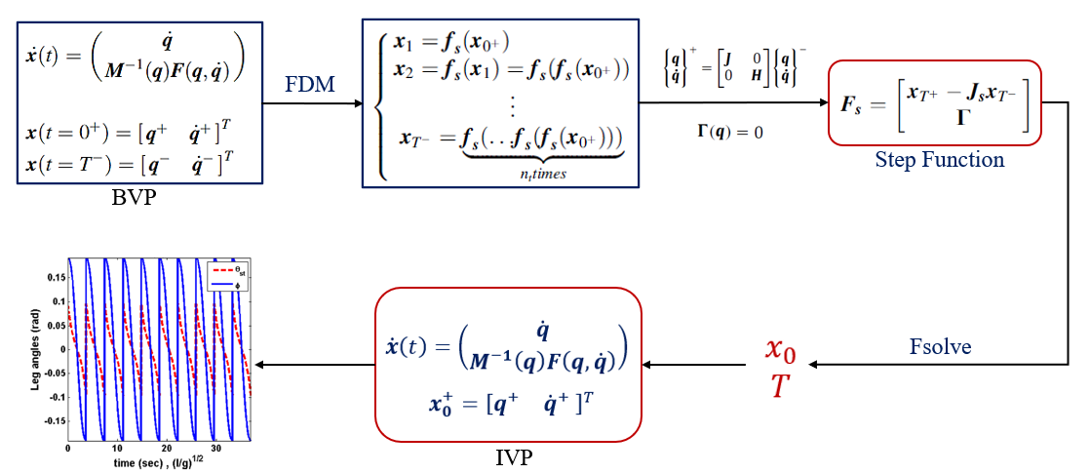
Fig. 2. The structure of the proposed numerical method to determine the appropriate initial conditions and period-one gait cycle [4,6,23].

- Analysis of simulation results and discussion
In this section, by applying the unimorph piezoelectric energy harvester system, determining the appropriate initial conditions and simulating the gait cycle for the first mode shape according to the mentioned method is considered. The numerical simulation results are presented in two parts. In the first part, the effect of adding piezoelectric layers to the elastic legs is investigated and, in the following, the parameter analysis will be done to investigate the effect of most important dimensionless physical parameters.
Table 2: Geometric and material properties of the unimorph piezoelectric energy harvester.
 | Elastic leg | piezoelectric layer (PZT-5A)
Length (m) | 1 | variable
Width (m) | 0.165 | 0.165
Thickness (m) | 0.033 | 0.001
Mass density (Kg/m³) | $$ρA=1kg/m$$ | 7750
Elastic modulus (GPa) | 20 | 61
Piezoelectric constant (C/m²) | - | -10.4
Permittivity constant (nF/m) | - | 13.3
load resistance (Ω) | 10³
The material chosen for piezoelectric layers is PZT-5A as one of the most commonly used engineering piezoceramics. The geometric and material properties of the piezoceramic layer and the elastic legs are listed in Table 2. According to the table, the length of the piezoelectric layers is assumed variable. The cross-sectional dimensions of the elastic leg with a flexural rigidity of $D={10}^{3}$ and the mass ratio of $m_{H}=50$ have been determined based on its physical specifications in our previous study [6]. It is worth to note that these parameters can be chosen arbitrarily for different samples; however, they may not be able to be built physically due to the importance of the initial theoretical studies.
Here, three piezoelectric layers with equal width and thickness and lengths of 0.05, 0.1, and 0.4, based on the specifications provided in the Table 2, are connected to the support section of each of the undamped elastic legs at $γ=0.001 rad$. The diagrams of rigid rotational angles of each elastic leg and their angular velocities are shown in Fig. 3 and Fig. 4, respectively. Initially, the elastic legs in the energy harvesting system are assumed to have no structural damping and walk non-periodically as shown in [6]. According to Fig. 3, this result is similarly observed in the case of the piezoelectric layer connection with a small length of 0.05 to the leg. On the contrary, by increasing the length of the piezoelectric layer in the energy harvesting system to values of 0.1 and 0.4, periodic steps are obtained and by increasing the length of the piezoelectric layer, the convergence to the gait cycle of the similar rigid walker has increased; so that the gait cycle of the elastic leg connected to the piezoelectric layer with a length of 0.4 is close to the similar rigid model.
It is also clear that the convergence to the gait cycle of the rigid model is greater for different lengths of the piezoelectric layer in the first steps and the difference between them has gradually increased over time due to the different bending deformations of the legs. In Fig. 4, it is obvious that the use of the smallest piezo length (${\overline{l}}_{p}=0.05$) for undamped elastic legs is associated with many oscillations, which causes the non-periodic gaits. Although by increasing the piezo length to ${\overline{l}}_{p}=0.4$, the undesirable oscillations of the undamped elastic legs are reduced and the walking of the biped robot takes a periodic form, but compared to the similar rigid walker, small oscillations are still observed.
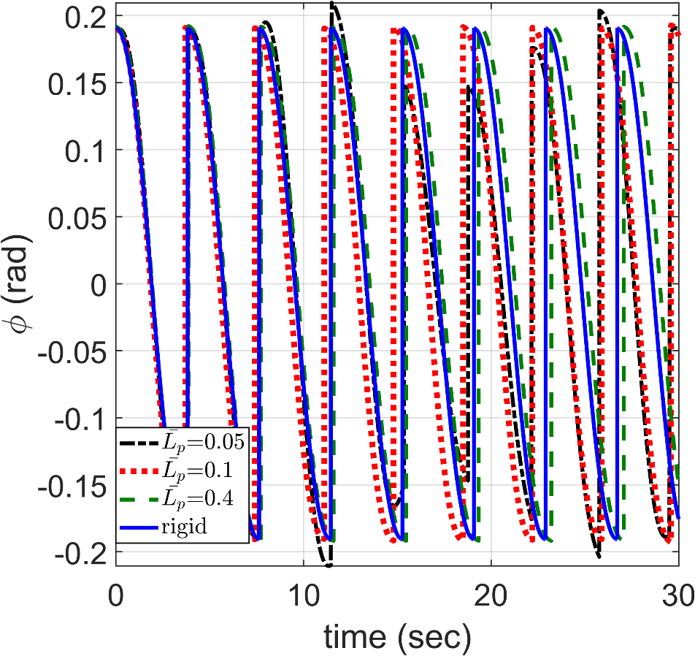 (a)
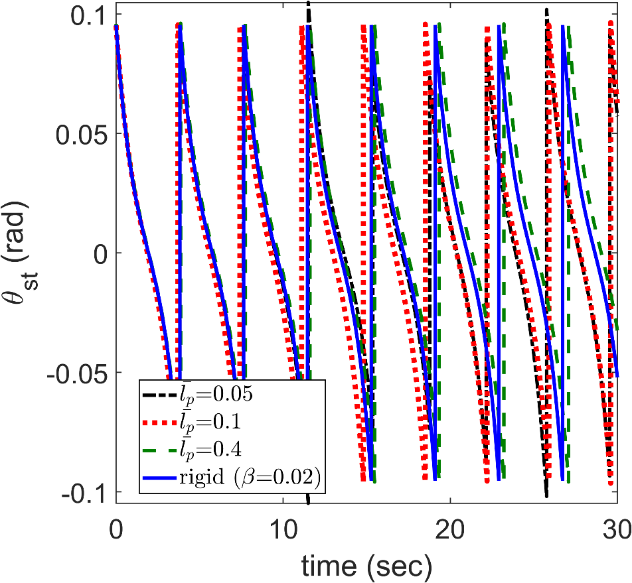 (b)
Fig. 3. Variations of undamped elastic leg angles under the influence of a unimorph piezoelectric energy harvester system due to varying piezo layer lengths ($D={10}^{3}, m_{H}=50, γ=0.001 rad, ζ=0$).
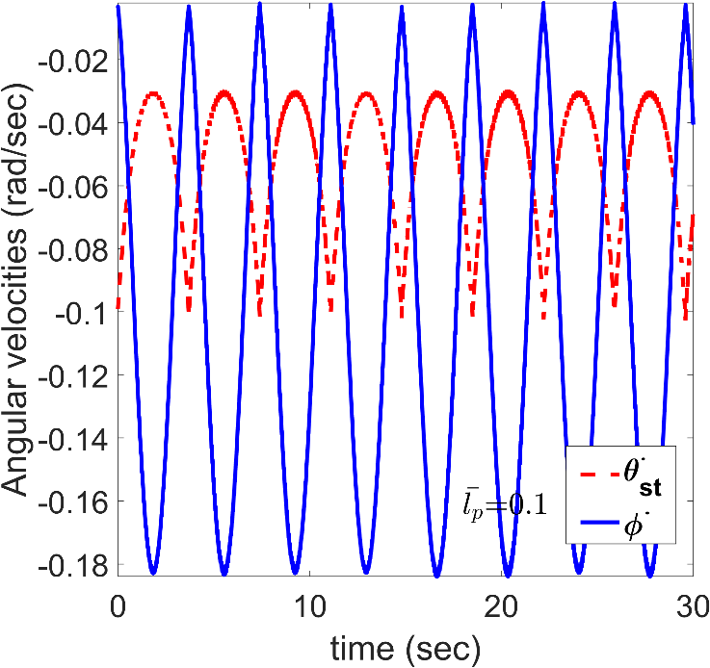(a) | 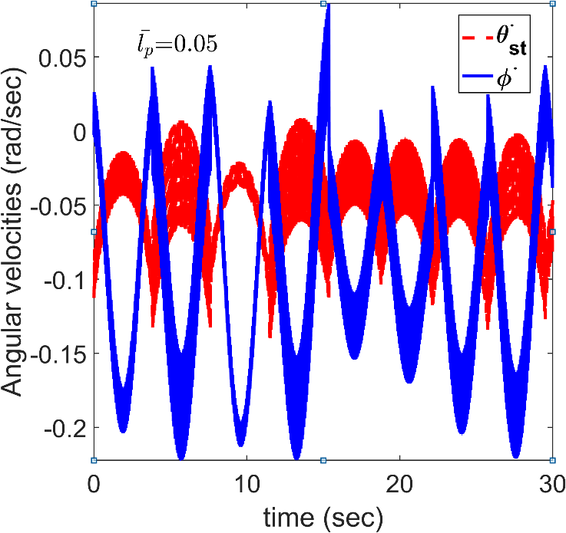(b)
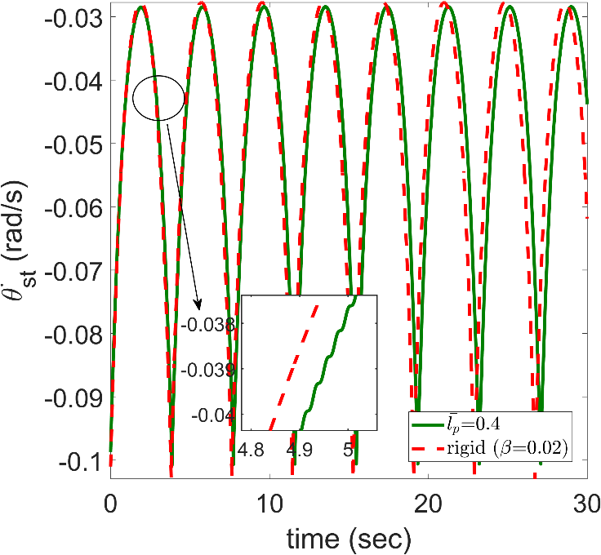(c) | 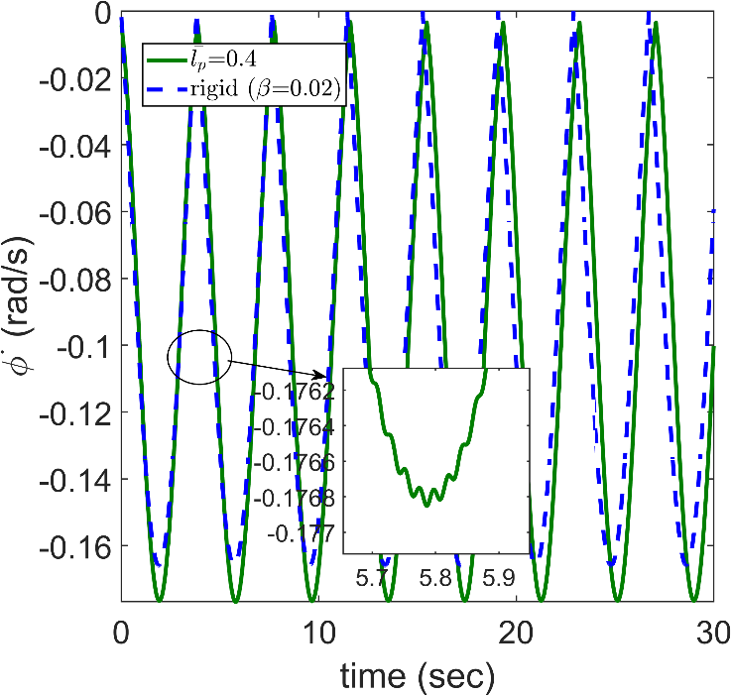(d)
Fig. 4: Variations of undamped elastic leg angular velocities under the influence of a unimorph piezoelectric energy harvester system due to varying piezo layer lengths ($D={10}^{3}, m_{H}=50, γ=0.001 rad, L_{p}={10}^{-1}, h_{p}={10}^{-3},R={10}^{3},ζ=0$).

The changes of the general coordinates of the elastic deformation of the legs connected to the piezoelectric layer with a length of 0.4 and the resulting voltage for the first step in the slope of 0.001 radians are displayed according to Fig.5. This scheme continues for every step. From the previous two figures, it can be seen that the use of the energy harvesting system has a major impact on the rigid period of the passive walker, and the vibrations of the elastic legs are still maintained without the presence of a damper. According to Fig.5, the piezoelectric energy harvesting system in the supporting leg produces more voltage than the swing leg due to its deformation and high vibrations during one step.
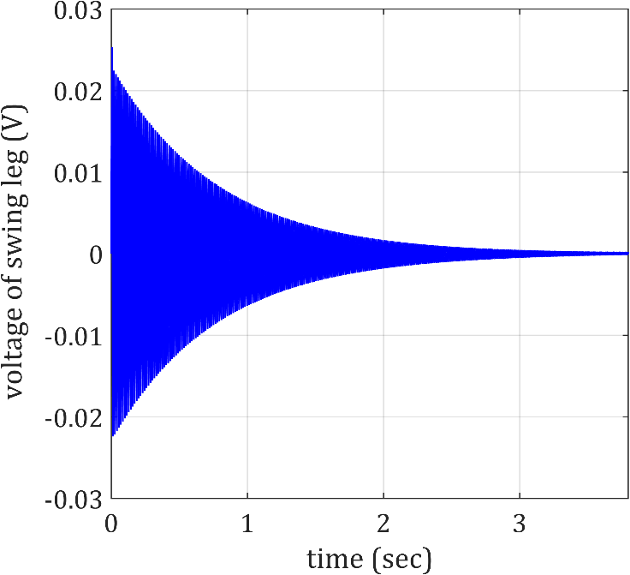 | 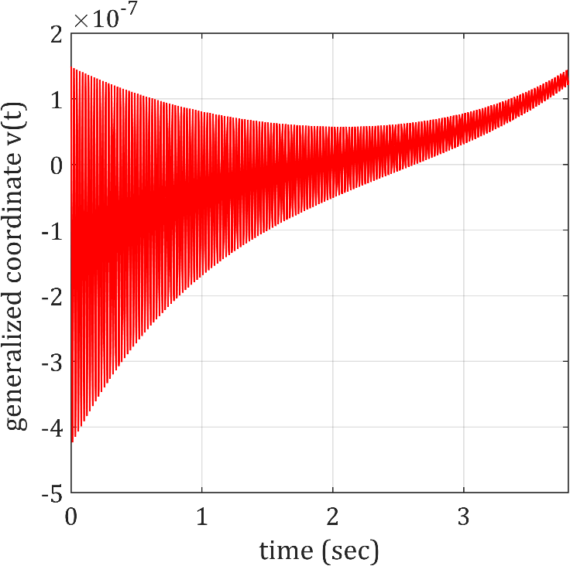
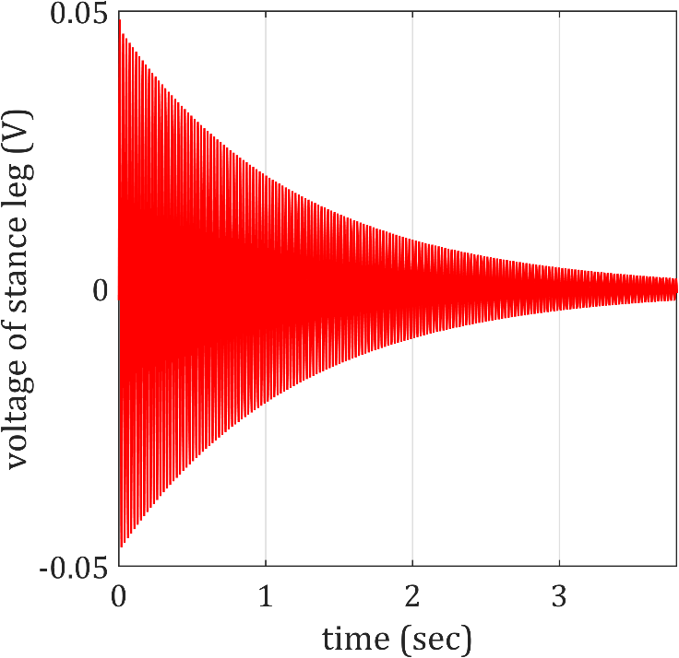 | 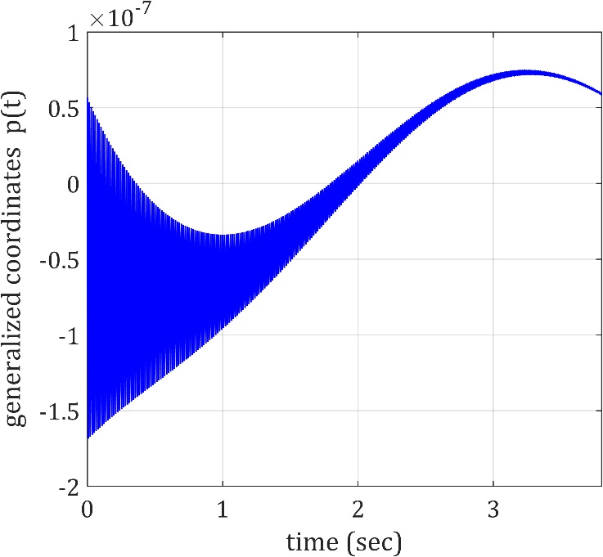
Fig. 5: Variations of the generalized coordinates and voltages of the undamped elastic legs under the influence of a unimorph piezoelectric energy harvester system for the first step ($D={10}^{3}, m_{H}=50,{\overline{l}}_{p}=0.4, γ=0.001 rad$).

In the next step, the effect of using the damper along with the energy harvester system with a value of 0.4 for the piezo length, which has a good convergence compared to the periodic gait cycle of the basic rigid model, is investigated. From Fig .6, it can be seen that despite the positive effect of the energy harvesting system on the rigid motion of the passive walker, only using a value of 0.4 for the length of the piezo layer could not eliminate the vibrations of the undamped elastic legs completely. By adding a damper with a damping ratio ($ζ=0.05$), the remaining oscillations in the diagram of angular velocities in Fig. 4 and the undesirable vibrations of the elastic legs in Fig. 5 are removed. Thus, it is necessary to use a damper to eliminate the vibrations of the transverse displacements of the elastic legs as shown in [6]. Notice that the diagrams of Fig. 6 are drawn for the first step of the gait cycle (step period T).
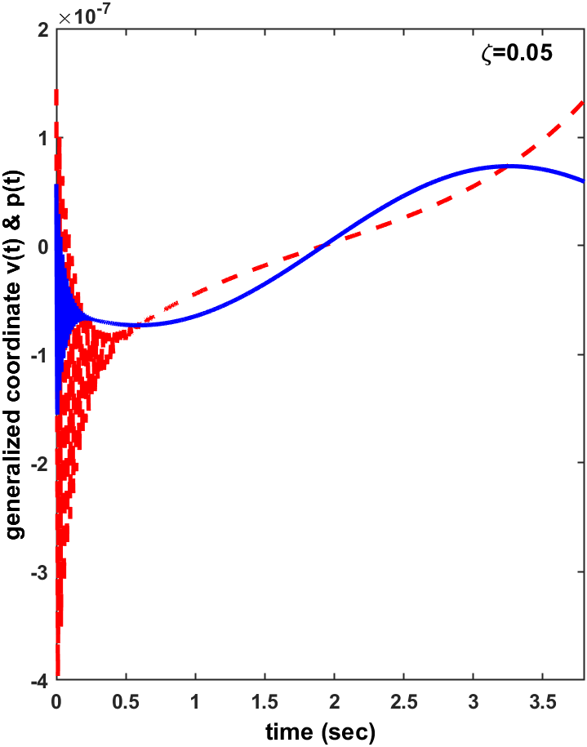 | 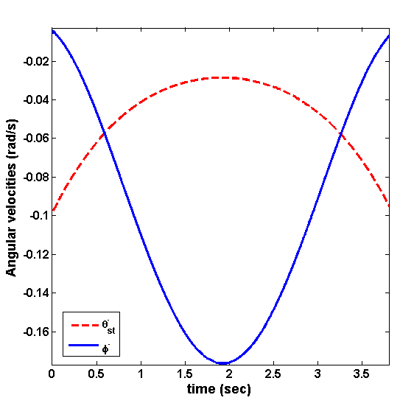
Fig. 6. Variations of angular velocities and generalized coordinates of the damped elastic legs for the 1st step under the influence of a unimorph piezoelectric energy harvester system ($D={10}^{3}, m_{H}=50,{\overline{l}}_{p}=0.4, γ=0.001 rad$).
In the following, by drawing bifurcation diagrams based on the change of structural and physical parameters, the dynamic behavior of the passive walker is investigated by applying the energy harvesting system under the effect of damping and other assumed characteristics in Table 2.
  - Slope angle
As we know, depending on the slope angle as the bifurcation parameter, a sequence of period-doublings route to chaos can be obtained for the simplest passive walker [1-3]. In the simulation of this section, three values of 0.1, 0.4 and 0.7 are considered for the dimensionless length of the piezoelectric layers. Variations of the stance leg angle connected to the piezoelectric layers with different lengths and the same thickness under the effect of structural damping as well as the step period and angular velocities are plotted in Fig. 7 and Fig. 8. As evident in Fig. 7, while showing the period-doubling bifurcation, a gradual trend of decreasing the first gait period is observed for steeper slopes at a fixed piezoelectric length, resulting in slightly faster steps.
The bifurcation diagrams illustrating the variations of the generalized coordinates of the bending of the damped elastic legs and the generated voltages in the piezoelectric layers attached to them are presented in Fig. 8. As shown in all these figures, despite the positive effect of the piezo layer on the swing phase of rigid motion, the onset of bifurcation occurs at lower slopes with increasing piezo length. In fact, adding a piezoelectric layer to the leg is accompanied by an increase in stiffness and mass. Due to the dominance of the mass effect of the piezo over its stiffness effect, the onset of bifurcation is shifted to smaller slope angles with decreasing damping. This result is also valid for the case where a damper with a high damping ratio (ζ = 0.05) is used.
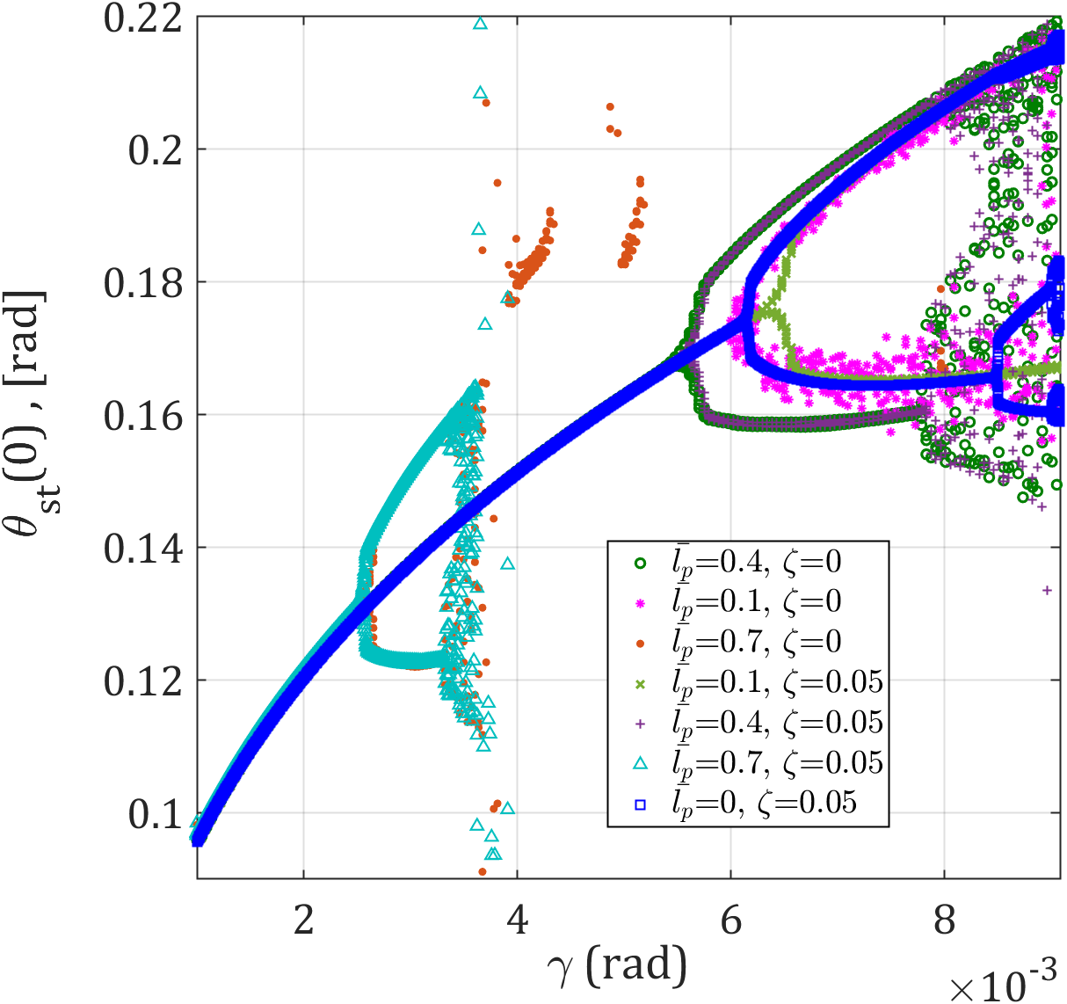 (a)
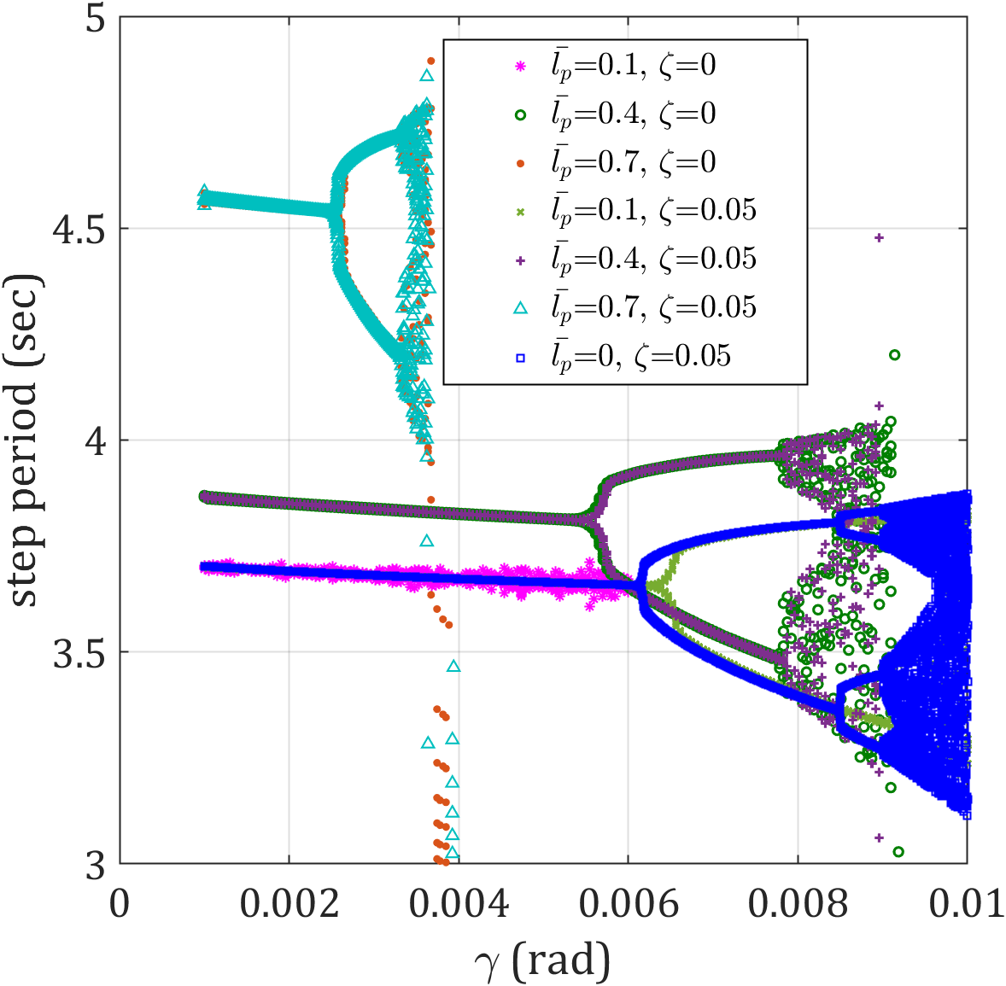 (b)
Fig. 7: Variations of stance leg angle and step period as a function of the slope angle for a flexible passive walker under the influence of a unimorph piezoelectric energy harvester system with different lengths and a uniform thickness of 0.001 ($D={10}^{3}, m_{H}=50, h_{p}={10}^{-3},R={10}^{3}$).
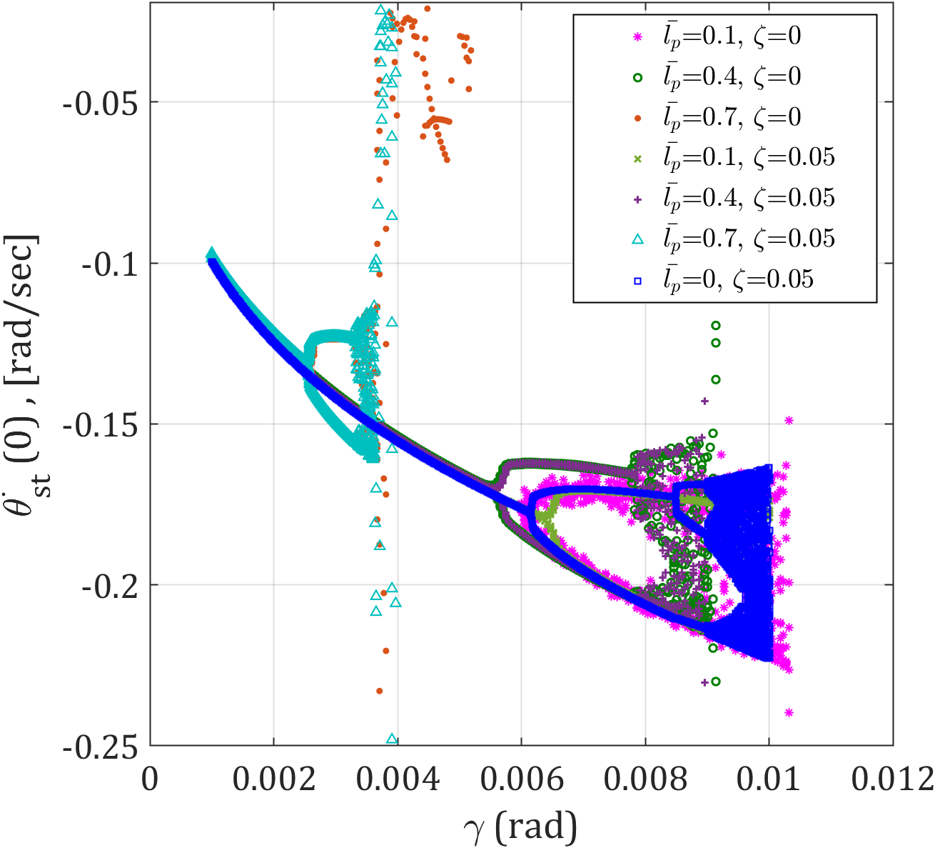 (a)
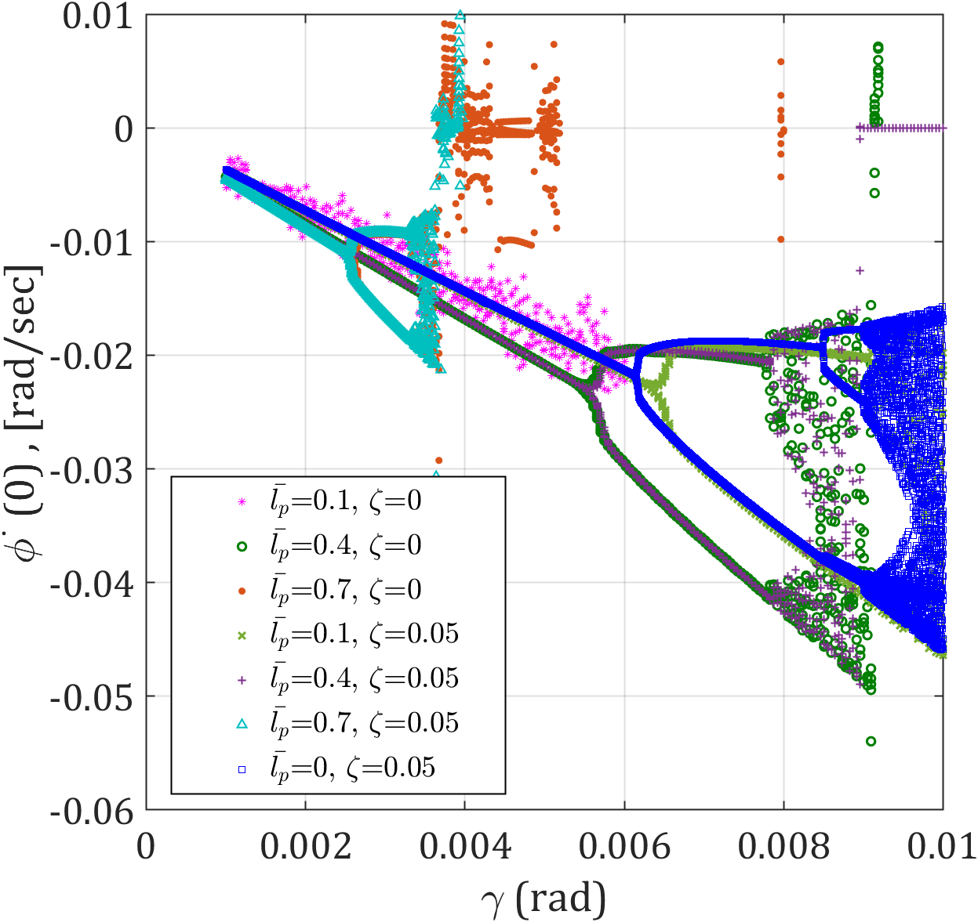 (b)
Fig. 8: Variations of $\dot{θ}(0)$ and $\dot{ϕ}(0)$ as a function of the slope angle for the flexible passive walker under the effect of unimorph piezoelectric energy harvester system with different lengths and a uniform thickness of 0.001 ($D={10}^{3}, m_{H}=50$).
Furthermore, attaching the piezo layers to the damped elastic legs with the minimum length of 0.1 extends the range of the period-one gait cycle of the walker by reducing the rigid-body rotational oscillations. However, in this configuration, due to the lack of use of the structural damper, the transverse vibrations of the legs are not resolved and as it can be seen, the bifurcation diagram of the generalized coordinates of the deformation and voltage cannot be drawn for the piezo layer with a length of 0.1. When a piezoelectric layer with suitable length of 0.4 is attached to the undamped legs of the flexible passive walker, the positive impact of the energy harvesting system on the rigid-body motion of the legs, despite their transverse vibrations, results in a dynamic behavior similar to that observed with a structural damper. In simpler terms, if a piezoelectric layer with an appropriate length is employed and exerts a favorable effect on the rigid-body rotation of the legs, the addition of structural damping does not alter the bifurcation diagrams of the rotational motion angles and is only effective in reducing the transverse vibrations of the legs.
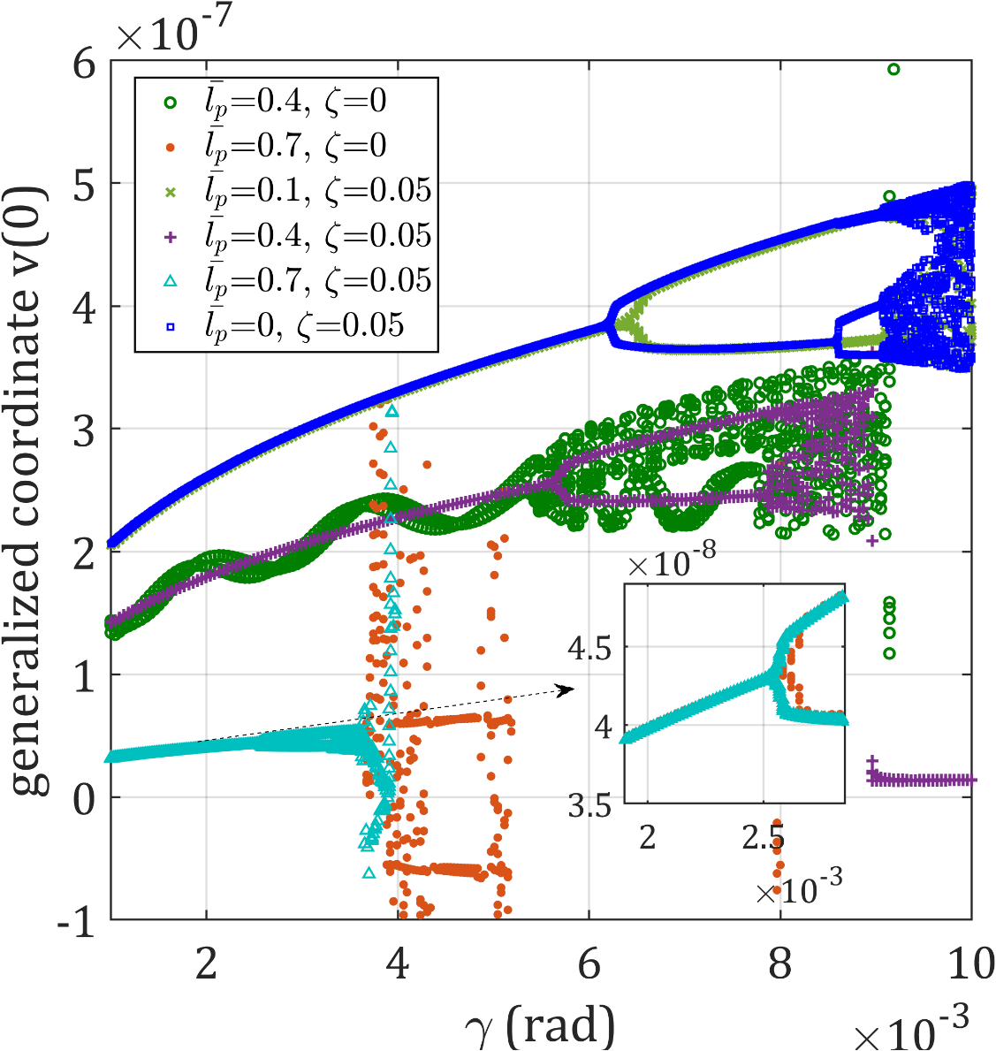 (a)
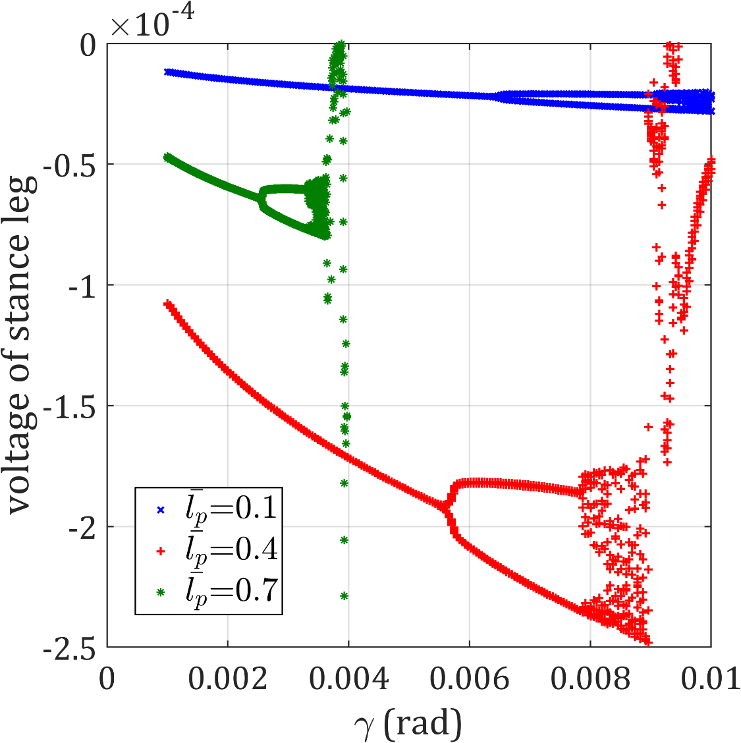 (b)

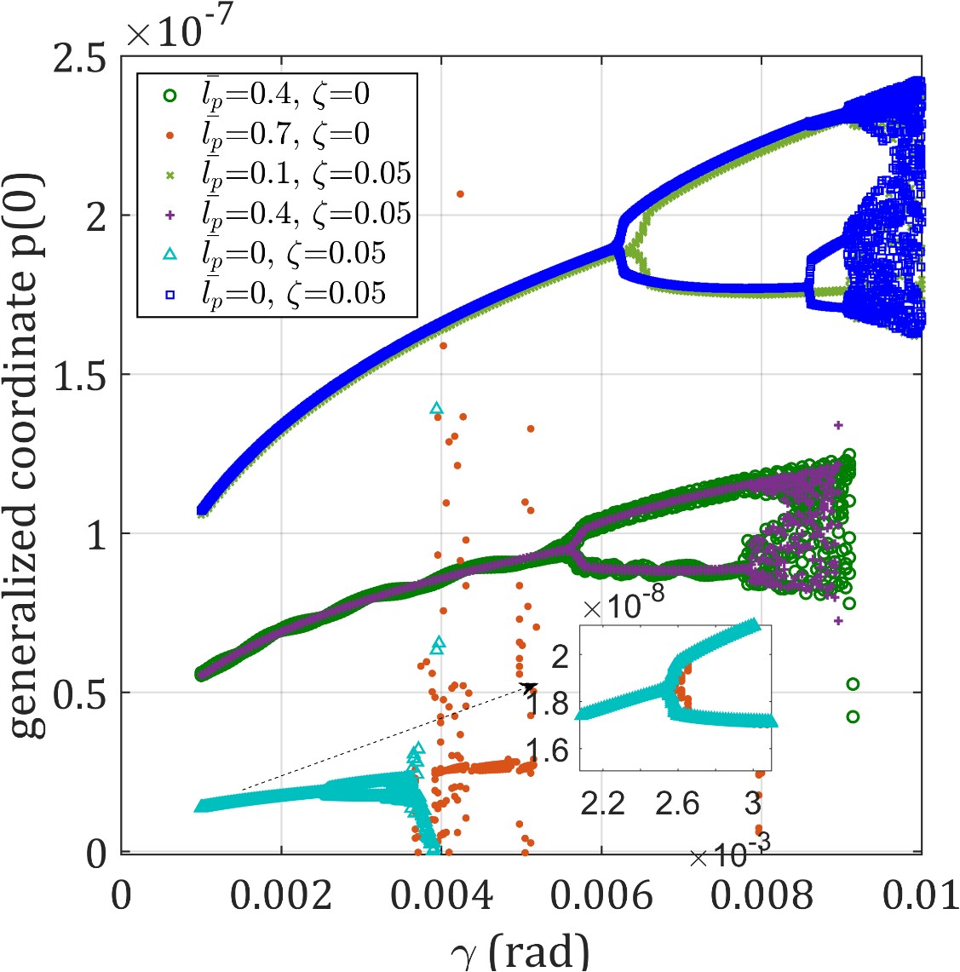 (c)
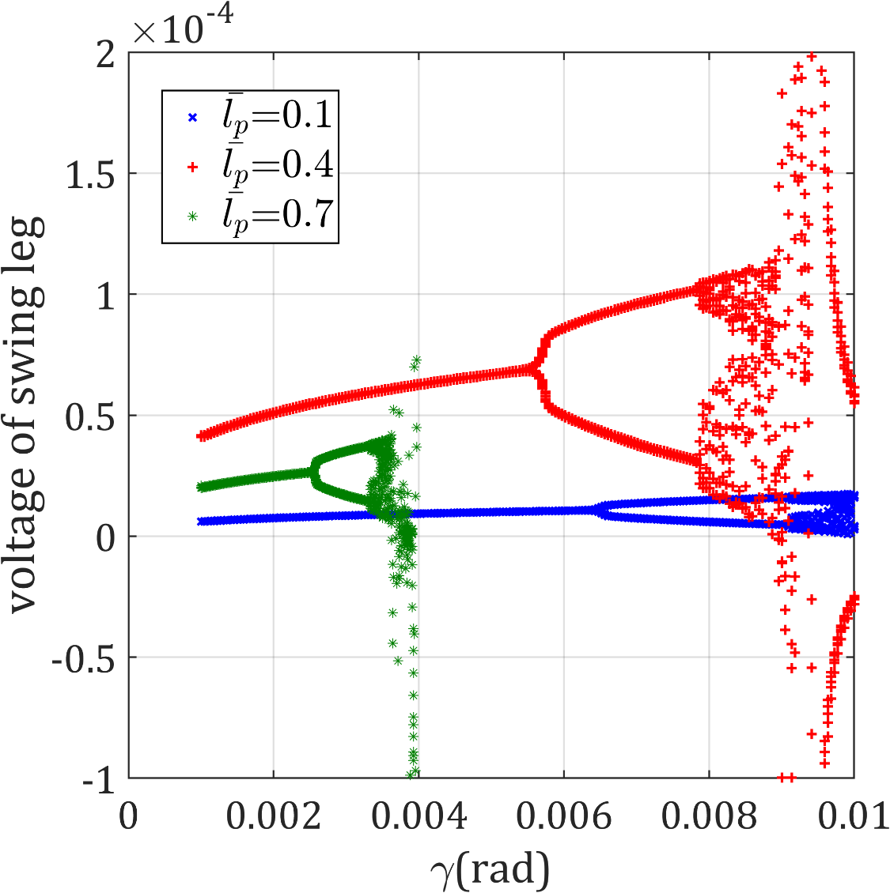 (d)
Fig. 9: Variations of the generalized coordinates of the deformation of the elastic legs and the generated voltage under the effect of unimorph piezoelectric energy harvester system for different lengths and a uniform thickness of 0.001 as a function of the slope angle ($D={10}^{3}, m_{H}=50, h_{p}={10}^{-3},R={10}^{3}, ζ=0.05$).
On the other hand, the attachment of a piezoelectric layer with a long length, such as 0.7, to the damped legs leads to a slight shift of the first bifurcation point towards lower slopes compared to the case without structural damping. Although the energy harvesting system with this piezo length exhibits good performance in mitigating oscillations, the associated increase in mass leads to a slight limitation on the period-one gait cycle range. Another noteworthy point is the lack of a consistent trend in the change of generated voltage with respect to slope variations, despite the reduction in elastic deformation of the undamped and even damped legs due to the increase in the length of the piezoelectric layer attached to them. This situation indicates that, in addition to the environmental parameter of the slope, the length of the piezoelectric layer should also be investigated as a structural bifurcation parameter. It should be noted that although, in the absence of damping, the energy harvesting system by using long piezo layers has an important role in reducing the vibrations of the legs, especially the support leg, the output voltage values are still variable. By adding damping to the elastic legs and completely removing the existing oscillations, it is possible to draw the production voltage bifurcation diagram in Fig. 9. According to the investigation results of the effect of the surface slope, the energy harvesting system exhibits high performance in extending the range of the period-one gait cycle and enhancing its stability when employed with a shorter length, such as 0.1, for the damped elastic legs. However, by choosing small values of piezo length, the amount of produced voltage decreases.
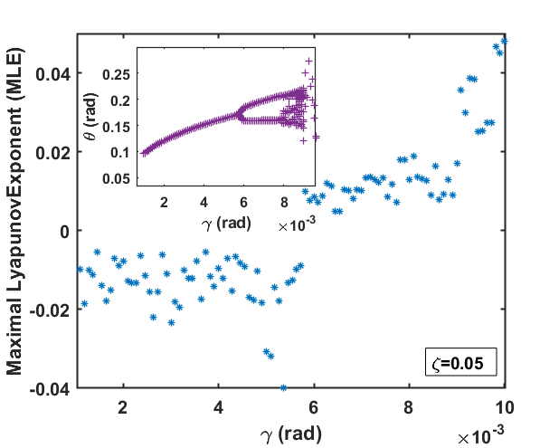 (d)
Fig. 10: Maximal Lyapunov Exponents of the flexible simplest walking model under the effect of unimorph piezoelectric energy harvester system as a function of the slope for 1st mode shape (${\overline{l}}_{p}=0.4 ,D={10}^{3}, m_{H}=50, h_{p}={10}^{-3},R={10}^{3}$).

It should be noted that our primary method for identifying transitions between different walking behaviors in this study was the use of bifurcation diagrams. However, we acknowledge that Lyapunov exponents could provide a more quantitative measure of chaos, supplementing our existing analysis. Therefore, we intend to incorporate an analysis of Lyapunov exponents in future research to offer a more comprehensive characterization of the bipedal model’s dynamics. This will enable us to more precisely quantify the stability and predictability of the observed walking patterns, as demonstrated in recent studies [40-42]. A brief study was conducted to analyze the Maximal Lyapunov Exponents (MLEs) of a passive walker model equipped with damped elastic legs attached to a piezo layer of 0.4 length. The MLEs were calculated for various slope angles and the results are presented in Fig. 10. By comparing these values with the corresponding bifurcation diagram, it was observed that negative MLEs correspond to period-one gaits, while positive MLEs indicate chaotic behavior at slopes exceeding the bifurcation point ($γ=0.058 rad$). Future research endeavors will be directed towards a more thorough investigation of this characteristic.
  - Piezo length
In this section, bifurcation diagrams for two fixed slopes of 0.01 rad and 0.03 rad are plotted by selecting the non-dimensional piezo length (${\overline{l}}_{p}$) as the bifurcation parameter. In this study, the damping ratio of 0.05 is assumed for the damper. The bifurcation diagrams of the changes in the angular displacement of the include the angular displacement of the flexible support leg, its angular velocity of rigid rotation, and the step period are drawn according to Fig. 11 and Fig. 12.
In the corresponding figures, increasing the length of the piezo attached to the leg causes a period-doubling bifurcation which occurs more quickly with increasing the slope. Another notable point is the independent operation of the piezo length parameter from the damper; in other words, adding a damper does not affect the trend of changes as a function of piezo length. According to the figure, for lengths less than 0.1 in the absence of damping, the existing oscillations cause non-periodic gait cycles.
The variations in the first step period as a function of piezo length in Fig. 12 show that as this parameter increases for each slope, the step period increases further while creating a period-doubling bifurcation, resulting in slower walking. It is clear that with increasing the slope, the bifurcation point is formed earlier and for shorter piezo lengths. Also, the trend of decreasing step period with increasing the slope, which was previously observed in Fig. 7, slows down.
In addition to the rigid rotation simulation, bifurcation diagrams of the changes in the general coordinates of the transverse displacement of the legs and the voltage generated in the piezoelectric layer attached to them are presented in Fig. 13. According to this figure, the elastic deformation of the support leg decreases with increasing piezo length, and for each slope, a bifurcation point is formed for a specific length.
With increasing slope, in addition to increasing elastic deformation, the bifurcation point is formed for smaller piezo lengths. The voltage generated in the piezoelectric layer attached to the support leg does not have a constant trend of change in both assumed slopes; initially, it increases for piezo lengths of approximately ${\overline{l}}_{p}<0.5$, and after this length, the voltage value decreases while showing period-doubling bifurcation. Here too, similar to the previous results, increasing the slope leads to an increase in voltage, a shift in the bifurcation point, and its formation at shorter piezo lengths.
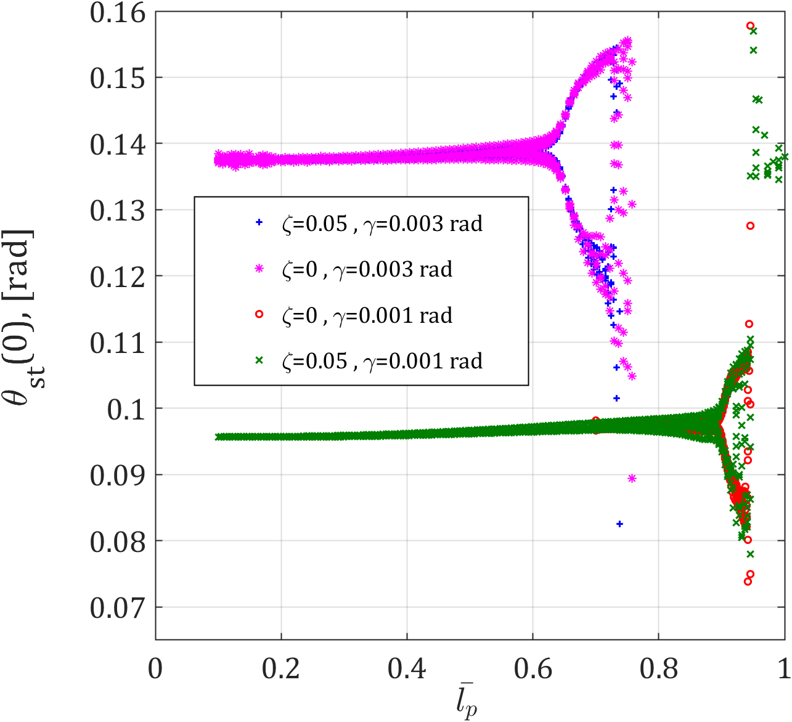 (a)

(a)
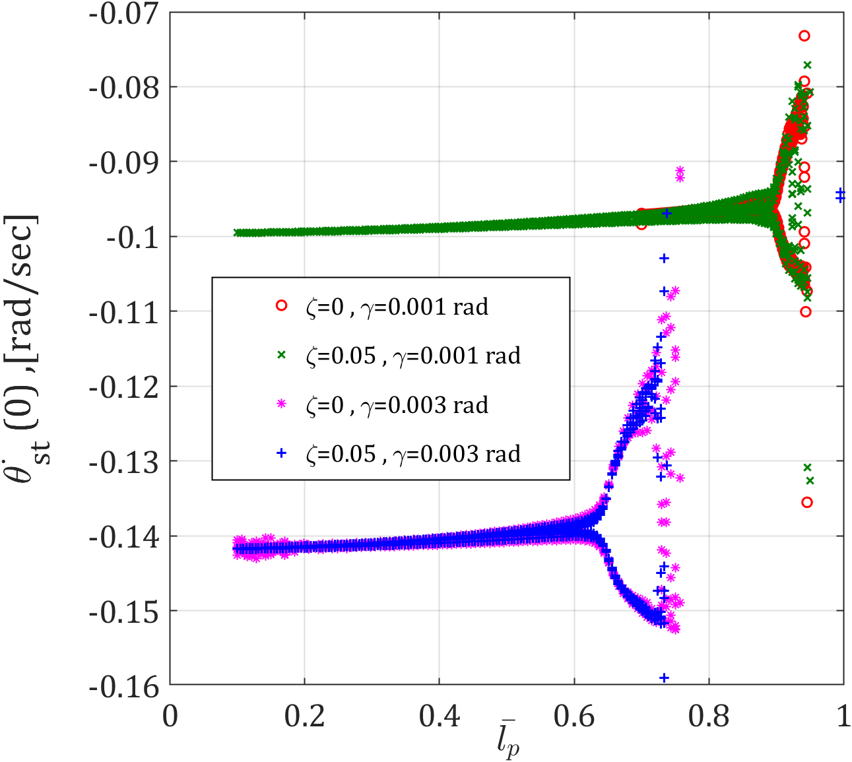 (b)
Fig. 11: Variations of $θ(0)$ and $\dot{θ}(0)$ as a function of piezoelectric layer length for a flexible passive walker under the influence of a unimorph piezoelectric energy harvester system with a uniform thickness of 0.001 for two different slopes ($D={10}^{3}, m_{H}=50, h_{p}={10}^{-3},R={10}^{3}$).

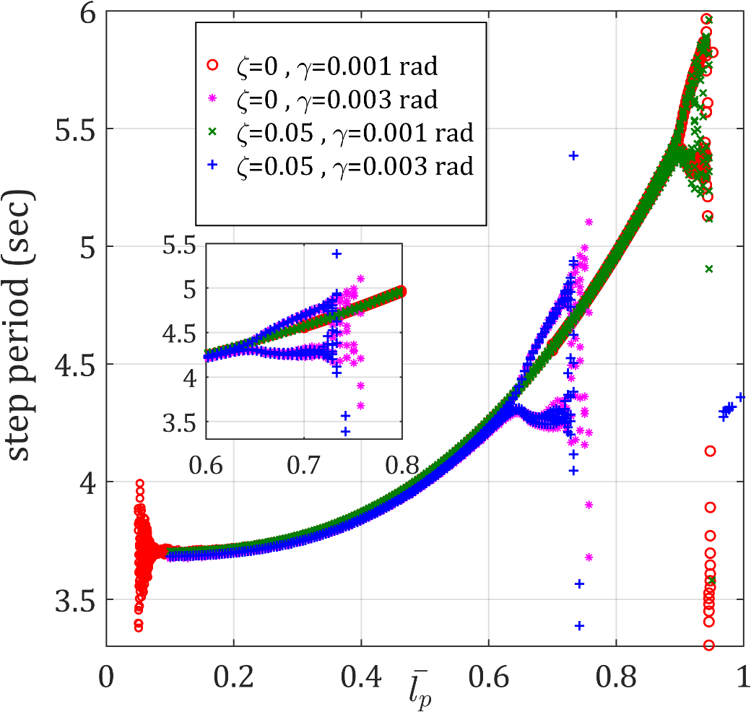
Fig. 12: Variations of the step period as a function of piezoelectric layer length for the flexible passive walker under the influence of unimorph piezoelectric energy harvester system with a uniform thickness of 0.001 for two different slopes ($D={10}^{3}, m_{H}=50, h_{p}={10}^{-3}, R={10}^{3}$).
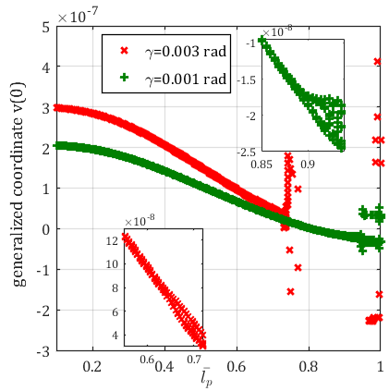(a)
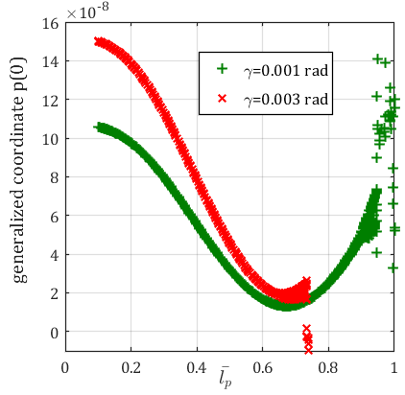(b)
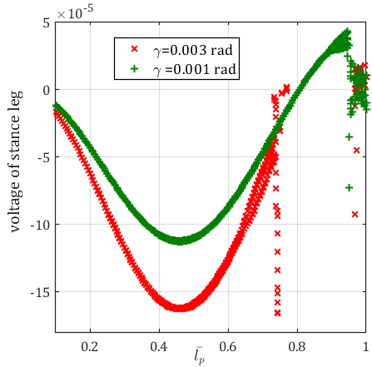 (c)
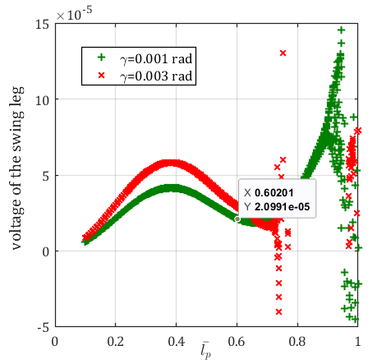(d)
Fig. 13: Variations of the generalized coordinates of the deformation of the elastic legs and the generated voltage as a function of ${\overline{l}}_{p}$ for the flexible passive walker under the influence of unimorph piezoelectric energy harvester system with a uniform thickness of 0.001 for two different slopes ($D={10}^{3}, m_{H}=50, h_{p}={10}^{-3}$).
Fig. 13 reveals distinct behaviors in the elastic deformation of the swing leg and the voltage generated in its attached piezoelectric layer compared to the support leg, as the piezo length increases. This difference arises from the contrasting loading conditions and boundary constraints experienced by each leg. Notably, the trend of increasing slope still influences the values of elastic deformation and the formation of a bifurcation point. Similarly, the impact of increasing slope on the generated voltage for each leg with a specific piezo length can be observed in the bifurcation diagrams of Fig. 9. The simulation results exploring the effect of piezo length demonstrate that this parameter has a more significant influence on the elastic deformation of the legs and the voltage generated in the corresponding piezoelectric layers, compared to the initial conditions governing the passive walker's rigid rotation.
  - Piezo thickness
In this section, assuming fixed lengths for the piezoelectric layers attached to the elastic legs with a damping ratio of 0.05, the effect of changing the piezoelectric layer thickness (assuming a specific range based on the cross-sectional dimensions of the leg) on the slope of 0.001 rad is investigated.
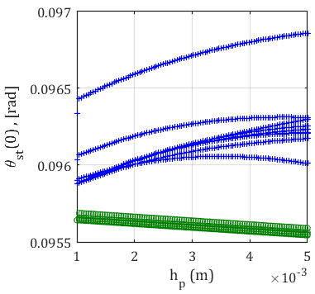 | 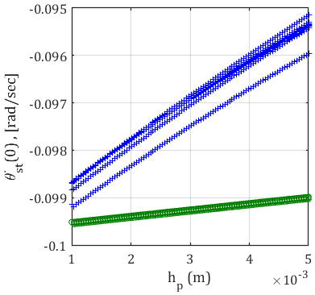
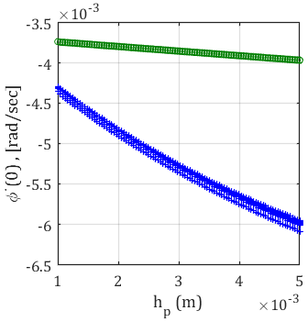(a) | 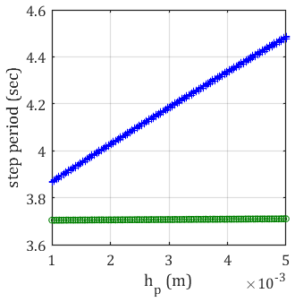(b)
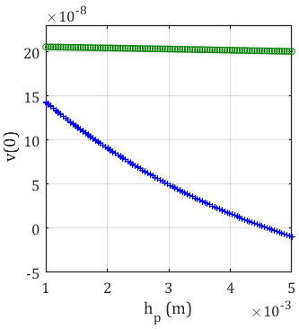(c) | 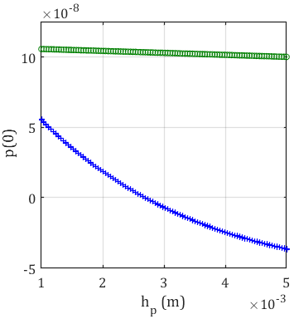(d)
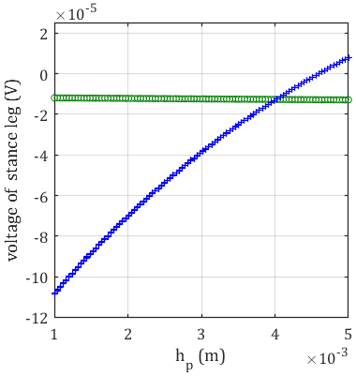(e) | 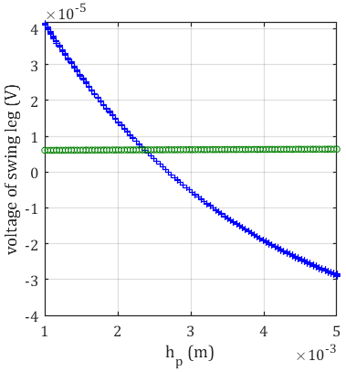(f)
Fig. 14: Variations of the support leg angle, angular velocities of both legs, step period, generalized coordinates of elastic deformation and the generated voltage as a function of $h_{p}$ for the flexible passive walker under the influence of unimorph piezoelectric energy harvester system with two different lengths at a slope of 0.001 rad ($D={10}^{3}, m_{H}=50$) (+ ${\overline{l}}_{p}=0.4$, O ${\overline{l}}_{p}=0.1$).
According to Fig. 14, the trend of changes in the initial walking conditions of the walker and its step period for a small piezo length (0.1) is very slow and almost constant with increasing piezo thickness. In contrast, as the piezo length increases to 0.4, changes in the initial conditions of rotational motion, elastic deformation of the legs, and the step period become noticeable and understandable. Increasing the thickness of the piezo material has a more pronounced effect on elastic deformation and voltage output at higher leg lengths (e.g., 0.4). This translates to reduced leg deformation and voltage generation, while simultaneously increasing the step period, leading to slower robot walking speeds. In essence, the piezoelectric layer thickness significantly impacts the initial conditions and step period of the passive walker only when the leg length has a substantial value. Generally, a thicker piezo with increased stiffness will result in decreased elastic deformation and consequently lower voltage generation.
To expand the range of stable one-periodic gaits and minimize energy waste, this study investigated an energy harvesting system utilizing a single-layer PZT-5A piezoelectric element connected to the elastic legs of a walking robot. The results demonstrate that attaching a piezoelectric layer of appropriate length to undamped elastic legs generates a periodic gait cycle, albeit with minor oscillations. However, incorporating a damper into these elastic legs connected to the single-layer piezoelectric structure can have varying effects on the robot's dynamic behavior depending on the piezo length. In this work, we primarily focused on the energy harvesting aspect, where the piezoelectric materials convert mechanical energy into electrical energy without actively influencing the walker’s dynamics. This energy can be used in the long term to adjust small leg movements and maintain the system's behavior in a near-stable state. In fact, passive control has been implemented to increase the stability range of the walker using the energy harvesting system. However, since this research focuses on passive mechanisms and does not consider the application of active control methods, the use of an energy harvesting system for stability is sufficient on its own. Nevertheless, if we wish to employ active control methods to suppress chaos, methods such as OGY or controlled Poincaré maps, which are based on chaos theory, can be used to adjust gait parameters and prevent the system from entering unstable states (chaotic points) [11-19].

- Conclusion and future works
In pursuit of designing bipedal robots with enhanced biomechanical and biomedical properties that closely mimic human locomotion, previous research in [6] has focused on investigating the dynamic behavior of flexible passive walkers by replacing rigid legs with Euler-Bernoulli elastic beams. Given the high sensitivity of these walkers to initial conditions, a computationally efficient numerical method based on the boundary value problem was proposed to determine the gait cycle. Following these studies, the potential of utilizing an unimorph piezoelectric energy harvester to minimize wasted energy during walking and expand the stability range of passive walkers is explored.
In this way, a clamping structure was designed to connect piezoelectric layers made of PZT-5A ceramic with equal length and thickness to the support section of each elastic leg of the walker. Connecting appropriately sized clamped piezoelectric layers to the undamped elastic legs in the energy harvesting system reduces rigid rotational oscillations, resulting in a periodic gait cycle similar to the initial rigid model. However, in the absence of a damper, the vibrations of the beam are not eliminated despite the energy harvesting system's ability to absorb them. Adding a damper to eliminate the remaining vibrations leads to different dynamic behaviors depending on the length of the piezoelectric layers used. The results of the parametric study, conducted based on three crucial parameters: the slope of the surface, length, and thickness of the piezoelectric layer, are presented in the form of bifurcation diagrams. By increasing the surface slope, it was observed that connecting small lengths of piezoelectric layers to the damped elastic legs helps to extend the allowable slope range for a stable gait cycle. The increase in piezo length is also associated with period-doubling bifurcation for any specific slope, causing this bifurcation to occur at steeper slopes for smaller piezo lengths. With longer piezo layers, the step period increases, resulting in a slower step. It was also found that changing the thickness of the piezoelectric layers does not have a significant effect on the gait cycle.
The efficiency of the energy harvesting system in a flexible walker can be evaluated from two perspectives: increasing the single-step cycle range and achieving high energy efficiency by absorbing the maximum wasted energy. Optimizing this system to achieve both goals is possible with the appropriate selection of piezoelectric layer length for each slope. Therefore, future research can focus on the optimal design of the piezoelectric energy harvesting system based on key structural parameters, such as the location and length of piezo layers attached to the elastic legs. Additionally, expanding studies on the dynamic behavior of the passive walker such as calculation of Lyapunov exponents to further investigate chaos and active control mechanism under the influence of this system would be valuable.

Appendix A: Definition of the normalized matrices of the flexible model with unimorph piezoelectric energy harvester
This appendix presents the upper triangular elements of the symmetric inertia matrix and the right-hand side vector in Eq. (10) for the first mode shape ($n=1$) as following:
$$\left[\begin{matrix}\begin{matrix}\begin{matrix}M_{11} \\ …\end{matrix} & \begin{matrix}M_{12} \\ M_{22}\end{matrix}\end{matrix} & \begin{matrix}\begin{matrix}M_{13} \\ M_{23}\end{matrix} & \begin{matrix}M_{14} \\ M_{24}\end{matrix}\end{matrix} \\ \begin{matrix}… & …\end{matrix} & \begin{matrix}\begin{matrix}M_{33} \\ …\end{matrix} & \begin{matrix}M_{34} \\ M_{44}\end{matrix}\end{matrix}\end{matrix}\right]\left\{\begin{matrix}\begin{matrix}\ddot{θ} \\ {\ddot{v}}_{1}\end{matrix} \\ \begin{matrix}\ddot{ϕ} \\ {\ddot{p}}_{1}\end{matrix}\end{matrix}\right\}=\left\{\begin{matrix}\begin{matrix}F_{1}\left(q,\dot{q}\right) \\ F_{2}\left(q,\dot{q}\right)\end{matrix} \\ \begin{matrix}F_{3}\left(q,\dot{q}\right) \\ F_{4}\left(q,\dot{q}\right)\end{matrix}\end{matrix}\right\}+\left\{\begin{matrix}\begin{matrix}F_{p_{1}} \\ F_{p_{2}}\end{matrix} \\ \begin{matrix}F_{p_{3}} \\ F_{p_{4}}\end{matrix}\end{matrix}\right\}$$

$$M_{11}={\overline{v}}_{1}^{2}\left(τ\right)\left[\int_{0}^{1}{φ_{1}^{2}\left({\overline{x}}_{1}\right)}d{\overline{x}}_{1}+\left(1+m_{H}\right)φ_{1}^{2}\left(1\right)+\overline{ρ_{p}A_{p}}\left(\int_{0}^{{\overline{l}}_{p}}{φ_{1}^{2}\left({\overline{x}}_{1}\right)d{\overline{x}}_{1}}+{\overline{l}}_{p}φ_{1}^{2}\left({\overline{l}}_{p}\right)\right)\right]+{\overline{p}}_{1}^{2}\left(τ\right)\left[\int_{0}^{1}{ψ_{1}^{2}\left({\overline{x}}_{2}\right)}d{\overline{x}}_{2}+2\overline{ρ_{p}A_{p}}\int_{0}^{{\overline{l}}_{p}}{ψ_{1}^{2}\left({\overline{x}}_{2}\right)}d{\overline{x}}_{2} \right]+\left[\frac{5}{3}+\overline{ρ_{p}A_{p}}\left(\frac{2{\overline{l}}_{p}^{3}}{3}+{\overline{l}}_{p}\right)+m_{H} \right]$$
$$M_{12}=-\left[\int_{0}^{1}{{\overline{x}}_{1}}φ_{1}\left({\overline{x}}_{1}\right)d{\overline{x}}_{1}+\left(1+m_{H}\right)φ_{1}\left(1\right)+\overline{ρ_{p}A_{p}}\left(\int_{0}^{{\overline{l}}_{p}}{{\overline{x}}_{1}φ_{1}\left({\overline{x}}_{1}\right)}d{\overline{x}}_{1}+{\overline{l}}_{p}φ_{1}\left(1\right)\right)\right]$$
$M_{13}=-p_{1}^{2}\left(τ\right)\left[\int_{0}^{1}{ψ_{1}^{2}\left({\overline{x}}_{2}\right)}d{\overline{x}}_{2}+\overline{ρ_{p}A_{p}}\int_{0}^{{\overline{l}}_{p}}{ψ_{1}^{2}\left({\overline{x}}_{2}\right)}d{\overline{x}}_{2}\right]-\left(\frac{1}{3}+\overline{ρ_{p}A_{p}}\frac{{\overline{l}}_{p}^{3}}{3}\right)$
$$M_{14}=-\left[\int_{0}^{1}{{\overline{x}}_{2}ψ_{1}\left({\overline{x}}_{2}\right)d{\overline{x}}_{2}}+\overline{ρ_{p}A_{p}}\int_{0}^{{\overline{l}}_{p}}{{\overline{x}}_{2}ψ_{1}\left({\overline{x}}_{2}\right)}d{\overline{x}}_{2}\right]$$
$$M_{22}=\left[\left(\int_{0}^{1}{φ_{1}^{2}\left({\overline{x}}_{1}\right)}d{\overline{x}}_{1}+\left(1+m_{H}\right)φ_{1}^{2}\left(1\right)\right)+2\overline{ρ_{p}A_{p}}\left(\int_{0}^{{\overline{l}}_{p}}{φ_{1}^{2}\left({\overline{x}}_{1}\right)d{\overline{x}}_{1}}+{\overline{l}}_{p}φ_{1}^{2}\left({\overline{l}}_{p}\right)\right)\right]$$
$M_{23}=0 , M_{24}=0$
$$M_{33}=\left\{p_{1}^{2}\left(τ\right)\left[\int_{0}^{1}{ψ_{1}^{2}\left({\overline{x}}_{2}\right)}d{\overline{x}}_{2}+\overline{ρ_{p}A_{p}}\int_{0}^{{\overline{l}}_{p}}{ψ_{1}^{2}\left({\overline{x}}_{2}\right)}d{\overline{x}}_{2} \right]+\left(\frac{1}{3}+\overline{ρ_{p}A_{p}}\frac{{\overline{l}}_{p}^{3}}{3}\right)\right\}$$
$$M_{34}=\left[\int_{0}^{1}{{\overline{x}}_{2}ψ_{1}\left({\overline{x}}_{2}\right)}d{\overline{x}}_{2}+\overline{ρ_{p}A_{p}}\int_{0}^{{\overline{l}}_{p}}{{{\overline{x}}_{2}ψ}_{1}\left({\overline{x}}_{2}\right)}d{\overline{x}}_{2}\right]$$
$$M_{44}=\left[\int_{0}^{1}{ψ_{1}^{2}\left({\overline{x}}_{2}\right)}d{\overline{x}}_{2}+\overline{ρ_{p}A_{p}}\int_{0}^{{\overline{l}}_{p}}{ψ_{1}^{2}\left({\overline{x}}_{2}\right)}d{\overline{x}}_{2}\right]$$

$$F_{1}\left(q,\dot{q}\right)=-\left\{{\overline{v}}_{1}\left(τ\right){\dot{\overline{v}}}_{1}\left(τ\right)\left[\int_{0}^{1}{φ_{1}^{2}\left({\overline{x}}_{1}\right)}d{\overline{x}}_{1}+\left(1+m_{H}\right)φ_{1}^{2}\left(1\right)+\overline{ρ_{p}A_{p}}\left(\int_{0}^{{\overline{l}}_{p}}{φ_{1}^{2}\left({\overline{x}}_{1}\right)d{\overline{x}}_{1}}+{\overline{l}}_{p}φ_{1}^{2}\left(1\right)\right)\right]+{\overline{p}}_{1}\left(τ\right){\dot{\overline{p}}}_{1}\left(τ\right)\left[\int_{0}^{1}{ψ_{1}^{2}\left({\overline{x}}_{2}\right)}d{\overline{x}}_{2}+\overline{ρ_{p}A_{p}}\int_{0}^{{\overline{l}}_{p}}{ψ_{1}^{2}\left({\overline{x}}_{2}\right)}d{\overline{x}}_{2}\right]\right\}2{\dot{θ}}_{st}+\left\{{\overline{p}}_{1}\left(τ\right){\dot{\overline{p}}}_{1}\left(τ\right)\left[\int_{0}^{1}{ψ_{1}^{2}\left({\overline{x}}_{2}\right)}d{\overline{x}}_{2}+\overline{ρ_{p}A_{p}}\int_{0}^{{\overline{l}}_{p}}{ψ_{1}^{2}\left({\overline{x}}_{2}\right)}d{\overline{x}}_{2}\right]\right\}2\dot{ϕ}-{\overline{v}}_{1}\left(τ\right)\left[\int_{0}^{1}{φ_{1}\left({\overline{x}}_{1}\right)}d{\overline{x}}_{1}+\left(1+m_{H}\right)φ_{i}\left(1\right)\right]\cos\left(θ_{st}-γ\right)+{\overline{p}}_{1}\left(τ\right)\left(\int_{0}^{1}{ψ_{i}\left({\overline{x}}_{2}\right)}d{\overline{x}}_{2}\right)cos\left(θ_{st}-ϕ-γ\right)+\left(\frac{3}{2}+m_{H}\right)\sin\left(θ_{st}-γ\right)-\frac{1}{2}\sin\left(θ_{st}-ϕ-γ\right)$$

$$F_{2}\left(q,\dot{q}\right)={\overline{v}}_{1}\left(τ\right)\left[\int_{0}^{1}{φ_{1}^{2}\left({\overline{x}}_{1}\right)}d{\overline{x}}_{1}+\left(1+m_{H}\right)φ_{1}^{2}\left(1\right)+\overline{ρ_{p}A_{p}}\left(\int_{0}^{{\overline{l}}_{p}}{φ_{1}^{2}\left({\overline{x}}_{1}\right)d{\overline{x}}_{1}}+{\overline{l}}_{p}φ_{1}^{2}\left(1\right)\right)\right]{\dot{\overline{θ}}}_{st}^{2}-{\overline{v}}_{1}\left(τ\right)\left(D\int_{0}^{1}{{φ_{1}^{''}}^{2}\left({\overline{x}}_{1}\right)}d{\overline{x}}_{1}+D_{p}\int_{0}^{{\overline{l}}_{p}}{{φ_{1}^{''}}^{2}\left({\overline{x}}_{1}\right)}d{\overline{x}}_{1}\right)-\left[\int_{0}^{1}{φ_{1}\left({\overline{x}}_{1}\right)}d{\overline{x}}_{1}+\left(1+m_{H}\right)φ_{1}\left(1\right)\right]\sin\left(θ_{st}-γ\right)$$

$$F_{3}\left(q,\dot{q}\right)=2{\overline{p}}_{1}\left(τ\right){\dot{\overline{p}}}_{1}\left(τ\right)\left[\int_{0}^{1}{ψ_{1}^{2}\left({\overline{x}}_{2}\right)}d{\overline{x}}_{2}+\overline{ρ_{p}A_{p}}\int_{0}^{{\overline{l}}_{p}}{ψ_{1}^{2}\left({\overline{x}}_{2}\right)}d{\overline{x}}_{2} \right]\left({\dot{θ}}_{st}-\dot{ϕ}\right)-{\overline{p}}_{1}\left(τ\right)\left(\int_{0}^{1}{ψ_{1}\left({\overline{x}}_{2}\right)}d{\overline{x}}_{2}\right)cos\left(θ_{st}-ϕ-γ\right)+\frac{1}{2}\sin\left(θ_{st}-ϕ-γ\right)$$

$$F_{4}\left(q,\dot{q}\right)={\overline{p}}_{1}\left(τ\right)\left\{\left[\int_{0}^{1}{ψ_{1}^{2}\left({\overline{x}}_{2}\right)}d{\overline{x}}_{2}+\overline{ρ_{p}A_{p}}\int_{0}^{{\overline{l}}_{p}}{ψ_{1}^{2}\left({\overline{x}}_{2}\right)}d{\overline{x}}_{2} \right]{\left({\dot{θ}}_{st}-\dot{ϕ}\right)}^{2}-\left(D\int_{0}^{1}{{ψ_{1}^{''}}^{2}\left({\overline{x}}_{2}\right)}d{\overline{x}}_{2}+D_{p}\int_{0}^{{\overline{l}}_{p}}{{ψ_{1}^{''}}^{2}\left({\overline{x}}_{2}\right)}d{\overline{x}}_{2}\right)\right\}+\left(\int_{0}^{1}{ψ_{1}\left({\overline{x}}_{2}\right)}d{\overline{x}}_{2}\right)sin\left(θ_{st}-ϕ-γ\right)$$

$$F_{p_{1}}=0 , F_{p_{2}}=-D_{e}{{\overline{ν}}_{p}}_{st}\left(τ\right)\int_{0}^{{\overline{l}}_{p}}{φ_{1}^{''}\left({\overline{x}}_{1}\right)}d{\overline{x}}_{1}$$
$$F_{p_{3}}=0 , F_{p_{4}}=-D_{e}{{\overline{ν}}_{p}}_{sw}\left(τ\right)\int_{0}^{{\overline{l}}_{p}}{ψ_{1}^{''}\left({\overline{x}}_{2}\right)}d{\overline{x}}_{2}$$

Matrices Q + and Q −in Eq. (12) are rewritten like so:
$$Q_{11}^{-}=-\frac{1}{3}+{\overline{v}}_{1}^{2}\left(τ\right)\int_{0}^{1}{φ_{1}^{2}\left({\overline{x}}_{1}\right)}d{\overline{x}}_{1}+{\overline{p}}_{1}^{2}\left(τ\right)\int_{0}^{1}{ψ_{1}^{2}\left({\overline{x}}_{2}\right)}d{\overline{x}}_{2}+\left[{\overline{v}}_{1}\left(τ\right)\int_{0}^{1}{φ_{1}\left({\overline{x}}_{1}\right)}d{\overline{x}}_{1}+\frac{1}{2}\left({\overline{p}}_{1}\left(τ\right)ψ_{1}\left(0\right)+{\overline{v}}_{1}\left(τ\right)φ_{1}\left(1\right)\right)+{\overline{p}}_{1}\left(τ\right)\int_{0}^{1}{ψ_{1}\left({\overline{x}}_{2}\right)}d{\overline{x}}_{2}\right]sinϕ\left(τ\right)+cosϕ\left(τ\right)\left[1-{\overline{p}}_{1}\left(τ\right){\overline{v}}_{1}\left(τ\right)\left(ψ_{1}\left(0\right)\int_{0}^{1}{φ_{1}\left({\overline{x}}_{1}\right)}d{\overline{x}}_{1}+φ_{1}\left(1\right)\int_{0}^{1}{ψ_{1}\left({\overline{x}}_{2}\right)}d{\overline{x}}_{2}\right)\right]+m_{H}\left[\left(1-{\overline{p}}_{1}\left(τ\right){\overline{v}}_{1}\left(τ\right)ψ_{1}\left(0\right)φ_{1}\left(1\right)\right)cosϕ\left(τ\right)+\left({\overline{v}}_{1}\left(τ\right)φ_{1}\left(1\right)+{\overline{p}}_{1}\left(τ\right)ψ_{1}\left(0\right)\right) sinϕ\left(τ\right)\right]+\overline{ρ_{p}A_{p}}\left\{\frac{{2\overline{l}}_{p}^{3} }{3}-{\overline{l}}_{p}^{2}+{\overline{v}}_{1}^{2}\left(τ\right)\int_{0}^{{\overline{l}}_{p}}{φ_{1}^{2}\left({\overline{x}}_{1}\right)}d{\overline{x}}_{1}+{\overline{p}}_{1}^{2}\left(τ\right)\int_{0}^{{\overline{l}}_{p}}{ψ_{1}^{2}\left({\overline{x}}_{2}\right)}d{\overline{x}}_{2}+\left[{\overline{v}}_{1}\left(τ\right)\int_{0}^{{\overline{l}}_{p}}{φ_{1}\left({\overline{x}}_{1}\right)}d{\overline{x}}_{1}+{\overline{p}}_{1}\left(τ\right)\int_{0}^{{\overline{l}}_{p}}{ψ_{1}\left({\overline{x}}_{2}\right)}d{\overline{x}}_{2}+\frac{{\overline{l}}_{p}^{2}}{2}{\overline{p}}_{1}\left(τ\right)ψ_{1}\left(0\right)+\left({\overline{l}}_{p}-\frac{{\overline{l}}_{p}^{2}}{2}\right){\overline{v}}_{1}\left(τ\right)φ_{1}\left(1\right)\right]sinϕ\left(τ\right)+cosϕ\left(τ\right)\left[{\overline{l}}_{p}-{\overline{p}}_{1}\left(τ\right){\overline{v}}_{1}\left(τ\right)\left(ψ_{1}\left(0\right)\int_{0}^{{\overline{l}}_{p}}{φ_{1}\left({\overline{x}}_{1}\right)}d{\overline{x}}_{1}+φ_{1}\left(1\right)\int_{0}^{{\overline{l}}_{p}}{ψ_{1}\left({\overline{x}}_{2}\right)}d{\overline{x}}_{2}\right)\right]\right\}$$

$$Q_{12}^{-}=\left(1-cosϕ\left(τ\right)\right)\int_{0}^{1}{φ_{1}\left({\overline{x}}_{1}\right)}d{\overline{x}}_{1}-\int_{0}^{1}{{\overline{x}}_{1}φ_{1}\left({\overline{x}}_{1}\right)}d{\overline{x}}_{1}-sinϕ\left(τ\right){\overline{p}}_{1}\left(τ\right)\left(ψ_{1}\left(0\right)\int_{0}^{1}{φ_{1}\left({\overline{x}}_{1}\right)}d{\overline{x}}_{1}+φ_{1}\left(1\right)\int_{0}^{1}{ψ_{1}\left({\overline{x}}_{2}\right)}d{\overline{x}}_{2}\right)-\frac{1}{2}cosϕ\left(τ\right)φ_{1}\left(1\right)-m_{H}\left[sinϕ\left(τ\right){\overline{p}}_{1}\left(τ\right)ψ_{1}\left(0\right)φ_{1}\left(1\right)+cos\overline{ϕ}\left(τ\right)φ_{1}\left(1\right)\right]+\overline{ρ_{p}A_{p}}\left\{\left(1-cosϕ\left(τ\right)\right)\int_{0}^{{\overline{l}}_{p}}{φ_{1}\left({\overline{x}}_{1}\right)}d{\overline{x}}_{1}-\int_{0}^{{\overline{l}}_{p}}{{\overline{x}}_{1}φ_{1}\left({\overline{x}}_{1}\right)}d{\overline{x}}_{1}-sinϕ\left(τ\right){\overline{p}}_{1}\left(τ\right)\left(ψ_{1}\left(0\right)\int_{0}^{{\overline{l}}_{p}}{φ_{1}\left({\overline{x}}_{1}\right)}d{\overline{x}}_{1}+φ_{1}\left(1\right)\int_{0}^{{\overline{l}}_{p}}{ψ_{1}\left({\overline{x}}_{2}\right)}d{\overline{x}}_{2}\right)-\left({\overline{l}}_{p}-\frac{{\overline{l}}_{p}^{2}}{2}\right)cosϕ\left(τ\right)φ_{1}\left(1\right)\right\}$$

$$Q_{13}^{-}=\frac{1}{6}-{\overline{p}}_{1}^{2}\left(τ\right)\int_{0}^{1}{ψ_{1}^{2}\left({\overline{x}}_{2}\right)}d{\overline{x}}_{2}+\overline{ρ_{p}A_{p}}\left[-{\overline{p}}_{1}^{2}\left(τ\right)\int_{0}^{{\overline{l}}_{p}}{ψ_{1}^{2}\left({\overline{x}}_{2}\right)}d{\overline{x}}_{2}-\frac{{\overline{l}}_{p}^{3}}{3}+\frac{{\overline{l}}_{p}^{2}}{2}\right]$$
$$Q_{14}^{-}=\int_{0}^{1}{\left(1-{\overline{x}}_{2}\right)ψ_{1}\left({\overline{x}}_{2}\right)}d{\overline{x}}_{2}+\overline{ρ_{p}A_{p}}\int_{0}^{{\overline{l}}_{p}}{\left(1-{\overline{x}}_{2}\right)ψ_{1}\left({\overline{x}}_{2}\right)}d{\overline{x}}_{2}$$
$${Q^{-}}_{21}=-\left(1+\overline{ρ_{p}A_{p}}\right)\left(\int_{0}^{1}{{\overline{x}}_{1}φ_{1}\left({\overline{x}}_{1}\right)d{\overline{x}}_{1}}\right) , {Q^{-}}_{22}=\left(1+\overline{ρ_{p}A_{p}}\right)\int_{0}^{1}{φ_{1}^{2}\left({\overline{x}}_{1}\right)d{\overline{x}}_{1}}$$
$${Q^{-}}_{23}=0 , {Q^{-}}_{24}=0$$
$${Q^{-}}_{31}={\overline{v}}_{1}^{2}\left(τ\right)\int_{0}^{1}{φ_{1}^{2}\left({\overline{x}}_{1}\right)}-\frac{1}{6}+\overline{ρ_{p}A_{p}}\left[{\overline{v}}_{1}^{2}\left(τ\right)\int_{0}^{{\overline{l}}_{p}}{φ_{1}^{2}\left({\overline{x}}_{1}\right)}+\frac{{\overline{l}}_{p}^{3}}{3}-\frac{{\overline{l}}_{p}^{2}}{2}\right]$$
$${Q^{-}}_{32}=\int_{0}^{1}{\left(1-{\overline{x}}_{1}\right)}φ_{1}\left({\overline{x}}_{1}\right)d{\overline{x}}_{1}+\overline{ρ_{p}A_{p}}\int_{0}^{{\overline{l}}_{p}}{\left(1-{\overline{x}}_{1}\right)}φ_{1}\left({\overline{x}}_{1}\right)d{\overline{x}}_{1}$$
$${Q^{-}}_{33}=0 , Q_{34}^{-}=0$$
$${Q^{-}}_{41}=-\left(1+\overline{ρ_{p}A_{p}}\right)\int_{0}^{1}{{\overline{x}}_{2}}ψ_{1}\left({\overline{x}}_{2}\right)d{\overline{x}}_{2} , {Q^{-}}_{42}=0$$
$${Q^{-}}_{43}=\left(1+\overline{ρ_{p}A_{p}}\right)\int_{0}^{1}{{\overline{x}}_{2}}ψ_{1}\left({\overline{x}}_{2}\right)d{\overline{x}}_{2} , {Q^{-}}_{44}=\left(1+\overline{ρ_{p}A_{p}}\right)\int_{0}^{1}{ψ_{1}^{2}\left({\overline{x}}_{2}\right)}d{\overline{x}}_{2}$$

$$Q_{11}^{+}=\frac{5}{3}+{\overline{v}}_{1}^{2}\left(τ\right)\left(\int_{0}^{1}{φ_{1}^{2}\left({\overline{x}}_{1}\right)}d{\overline{x}}_{1}+φ_{1}^{2}\left(1\right)\right)+{\overline{p}}_{1}^{2}\left(τ\right)\int_{0}^{1}{ψ_{1}^{2}\left({\overline{x}}_{2}\right)}d{\overline{x}}_{2}+\left(2{\overline{p}}_{1}\left(τ\right)\int_{0}^{1}{ψ_{1}\left({\overline{x}}_{2}\right)}d{\overline{x}}_{2}-{\overline{v}}_{1}\left(τ\right)φ_{1}\left(1\right)\right)sinϕ\left(τ\right)-\left(1+2{\overline{p}}_{1}\left(τ\right){\overline{v}}_{1}\left(τ\right)φ_{1}\left(1\right)\int_{0}^{1}{{\overline{ψ}}_{1}\left({\overline{x}}_{2}\right)}d{\overline{x}}_{2}\right)cosϕ\left(τ\right)+m_{H}\left(1+{\overline{v}}_{1}\left(τ\right)φ_{1}^{2}\left(1\right)\right)+\overline{ρ_{p}A_{p}}\left\{\frac{2{\overline{l}}_{p}^{3}}{3}+{\overline{l}}_{p}+{\overline{v}}_{1}^{2}\left(τ\right)\left(\int_{0}^{{\overline{l}}_{p}}{φ_{1}^{2}\left({\overline{x}}_{1}\right)}d{\overline{x}}_{1}+{\overline{l}}_{p}φ_{1}^{2}\left(1\right)\right)+{\overline{p}}_{1}^{2}\left(τ\right)\int_{0}^{{\overline{l}}_{p}}{ψ_{1}^{2}\left({\overline{x}}_{2}\right)}d{\overline{x}}_{2}+\left(2{\overline{p}}_{1}\left(τ\right)\int_{0}^{1}{ψ_{1}\left({\overline{x}}_{2}\right)}d{\overline{x}}_{2}-{\overline{l}}_{p}^{2}{\overline{v}}_{1}\left(τ\right)φ_{1}\left(1\right)\right)sinϕ\left(τ\right)-\left({\overline{l}}_{p}^{2}+2{\overline{p}}_{1}\left(τ\right){\overline{v}}_{1}\left(τ\right)φ_{1}\left(1\right)\int_{0}^{1}{{\overline{ψ}}_{1}\left({\overline{x}}_{2}\right)}d{\overline{x}}_{2}\right)cosϕ\left(τ\right)\right\}$$

$$Q_{12}^{+}=-\int_{0}^{1}{{\overline{x}}_{1}φ_{1}\left({\overline{x}}_{1}\right)}d{\overline{x}}_{1}-φ_{1}\left(1\right)-sinϕ\left(τ\right){\overline{p}}_{1}\left(τ\right)φ_{1}\left(1\right)\int_{0}^{1}{ψ_{1}\left({\overline{x}}_{2}\right)}d{\overline{x}}_{2}+φ_{1}\left(1\right)\left(\frac{1}{2} cosϕ\left(τ\right)-\overline{M}\right)+\overline{ρ_{p}A_{p}}\left\{-\int_{0}^{{\overline{l}}_{p}}{{\overline{x}}_{1}φ_{1}\left({\overline{x}}_{1}\right)d{\overline{x}}_{1}}-{\overline{l}}_{p}φ_{1}\left(1\right)-sinϕ\left(τ\right){\overline{p}}_{1}\left(τ\right)φ_{1}\left(1\right)\int_{0}^{{\overline{l}}_{p}}{ψ_{1}\left({\overline{x}}_{2}\right)d{\overline{x}}_{2}}+\frac{{\overline{l}}_{p}^{2}}{2}φ_{1}\left(1\right)cosϕ\left(τ\right)\right\}$$

$$Q_{13}^{+}=-\frac{1}{3}-{\overline{p}}_{1}^{2}\left(τ\right)\int_{0}^{1}{ψ_{1}^{2}\left({\overline{x}}_{2}\right)}d{\overline{x}}_{2}+\left(\frac{1}{2}{\overline{v}}_{1}\left(τ\right)φ_{1}\left(1\right)-{\overline{p}}_{1}\left(τ\right)\int_{0}^{1}{ψ_{1}\left({\overline{x}}_{2}\right)}d{\overline{x}}_{2}\right)sinϕ\left(τ\right)+cosϕ\left(τ\right)\left({\overline{p}}_{1}\left(τ\right){\overline{v}}_{1}\left(τ\right)φ_{1}\left(1\right)\int_{0}^{1}{{\overline{ψ}}_{1}\left({\overline{x}}_{2}\right)}d{\overline{x}}_{2}+\frac{1}{2}\right)+\overline{ρ_{p}A_{p}}\left\{-\frac{{\overline{l}}_{p}^{3}}{3}-{\overline{p}}_{1}^{2}\left(τ\right)\int_{0}^{{\overline{l}}_{p}}{ψ_{1}^{2}\left({\overline{x}}_{2}\right)}d{\overline{x}}_{2}+\left(\frac{{\overline{l}}_{p}^{2}}{2}{\overline{v}}_{1}\left(τ\right)φ_{1}\left(1\right)-{\overline{p}}_{1}\left(τ\right)\int_{0}^{{\overline{l}}_{p}}{ψ_{1}\left({\overline{x}}_{2}\right)}d{\overline{x}}_{2}\right)sinϕ\left(τ\right)+\left({\overline{p}}_{1}\left(τ\right){\overline{v}}_{1}\left(τ\right)φ_{1}\left(1\right)\int_{0}^{{\overline{l}}_{p}}{ψ_{1}\left({\overline{x}}_{2}\right)}d{\overline{x}}_{2}+\frac{{\overline{l}}_{p}^{2}}{2}\right)cosϕ\left(τ\right)\right\}$$
$$Q_{14}^{+}=-\int_{0}^{1}{{\overline{x}}_{2}ψ_{1}\left({\overline{x}}_{2}\right)}d{\overline{x}}_{2}+sinϕ\left(τ\right){\overline{v}}_{1}\left(τ\right)φ_{1}\left(1\right)\int_{0}^{1}{{\overline{ψ}}_{1}\left({\overline{x}}_{2}\right)}d{\overline{x}}_{2}+cosφ\left(τ\right)\int_{0}^{1}{ψ_{1}\left({\overline{x}}_{2}\right)}d{\overline{x}}_{2}+\overline{ρ_{p}A_{p}}\left[- \int_{0}^{{\overline{l}}_{p}}{{\overline{x}}_{2}ψ_{1}\left({\overline{x}}_{2}\right)d{\overline{x}}_{2}}+sinϕ\left(τ\right){\overline{v}}_{1}\left(τ\right)φ_{1}\left(1\right)\int_{0}^{{\overline{l}}_{p}}{ψ_{1}\left({\overline{x}}_{2}\right)d{\overline{x}}_{2}}+cosϕ\left(τ\right)\int_{0}^{{\overline{l}}_{p}}{ψ_{1}\left({\overline{x}}_{2}\right)d{\overline{x}}_{2}}\right]$$
${Q^{+}}_{21}=-\left(1+\overline{ρ_{p}A_{p}}\right)\int_{0}^{1}{{\overline{x}}_{2}}ψ_{1}\left({\overline{x}}_{2}\right)d{\overline{x}}_{2} , {Q^{+}}_{22}=0$
$${Q^{+}}_{23}=\left(1+\overline{ρ_{p}A_{p}}\right)\int_{0}^{1}{{\overline{x}}_{2}}ψ_{1}\left({\overline{x}}_{2}\right)d{\overline{x}}_{2} , {Q^{+}}_{24}=\left(1+\overline{ρ_{p}A_{p}}\right)\int_{0}^{1}{ψ_{1}^{2}\left({\overline{x}}_{2}\right)}d{\overline{x}}_{2}$$
$${Q^{+}}_{31}=\frac{1}{3}+{\overline{p}}_{1}^{2}\left(τ\right)\int_{0}^{1}{ψ_{1}^{2}\left({\overline{x}}_{2}\right)}d{\overline{x}}_{2}+sinϕ\left(τ\right)\left({\overline{p}}_{1}\left(τ\right)\int_{0}^{1}{ψ_{1}\left({\overline{x}}_{2}\right)}d{\overline{x}}_{2}-\frac{1}{2}{\overline{v}}_{1}\left(τ\right)φ_{1}\left(1\right)\right)-cosϕ\left(τ\right)\left({\overline{p}}_{1}\left(τ\right){\overline{v}}_{1}\left(τ\right)φ_{1}\left(1\right)\int_{0}^{1}{{\overline{ψ}}_{1}\left({\overline{x}}_{2}\right)}d{\overline{x}}_{2}+\frac{1}{2}\right)+\overline{ρ_{p}A_{p}}\left[\frac{{\overline{l}}_{p}^{3}}{3}+{\overline{p}}_{1}^{2}\left(τ\right)\int_{0}^{{\overline{l}}_{p}}{ψ_{1}^{2}\left({\overline{x}}_{2}\right)}d{\overline{x}}_{2}+sinϕ\left(τ\right)\left({\overline{p}}_{1}\left(τ\right)\int_{0}^{{\overline{l}}_{p}}{ψ_{1}\left({\overline{x}}_{2}\right)}d{\overline{x}}_{2}-\frac{{\overline{l}}_{p}^{2}}{2}{\overline{v}}_{1}\left(τ\right)φ_{1}\left(1\right)\right)-cosϕ\left(τ\right)\left({\overline{p}}_{1}\left(τ\right){\overline{v}}_{1}\left(τ\right)φ_{1}\left(1\right)\int_{0}^{{\overline{l}}_{p}}{ψ_{1}\left({\overline{x}}_{2}\right)}d{\overline{x}}_{2}+\frac{{\overline{l}}_{p}^{2}}{2}\right)\right]$$
$${Q^{+}}_{32}=-sinϕ\left(τ\right){\overline{p}}_{1}\left(τ\right)φ_{1}\left(1\right)\int_{0}^{1}{{\overline{ψ}}_{1}\left({\overline{x}}_{2}\right)}d{\overline{x}}_{2}+\frac{1}{2}φ_{1}\left(1\right)cosϕ\left(τ\right)+\overline{ρ_{p}A_{p}}\left[-sinϕ\left(τ\right){\overline{p}}_{1}\left(τ\right)φ_{1}\left(1\right)\int_{0}^{{\overline{l}}_{p}}{ψ_{1}\left({\overline{x}}_{2}\right)}d{\overline{x}}_{2}d{\overline{x}}_{2}+\frac{{\overline{l}}_{p}^{2}}{2}φ_{1}\left(1\right)cosϕ\left(τ\right)\right]$$
$${Q^{+}}_{33}=-{\overline{p}}_{1}^{2}\left(τ\right)\int_{0}^{1}{ψ_{1}^{2}\left({\overline{x}}_{2}\right)}d{\overline{x}}_{2}-\frac{1}{3}+\overline{ρ_{p}A_{p}}\left[-{\overline{p}}_{1}^{2}\left(τ\right)\int_{0}^{{\overline{l}}_{p}}{ψ_{1}^{2}\left({\overline{x}}_{2}\right)}d{\overline{x}}_{2}-\frac{{\overline{l}}_{p}^{3}}{3}\right]$$
$$Q_{34}^{+}=-\int_{0}^{1}{{\overline{x}}_{2}ψ_{1}\left({\overline{x}}_{2}\right)}d{\overline{x}}_{2}-\overline{ρ_{p}A_{p}}\int_{0}^{{\overline{l}}_{p}}{{\overline{x}}_{2}}ψ_{1}\left({\overline{x}}_{2}\right)d{\overline{x}}_{2}$$
$${Q^{+}}_{41}=-\left(1+\overline{ρ_{p}A_{p}}\right)\int_{0}^{l}{x_{1}φ_{1}\left(x_{1}\right)dx_{1}} , {Q^{+}}_{42}=\left(1+\overline{ρ_{p}A_{p}}\right)\int_{0}^{l}{φ_{1}^{2}\left({\overline{x}}_{1}\right)dx_{1}}$$
$${Q^{+}}_{43}=0 , {Q^{+}}_{44}=0$$

References
[1] McGeer, T.: Passive dynamic walking. Int. J. Robot. Res. 9(2), 62–68 (1990).
[2] A. Goswami, B. Thuilot, B. Espiau, Compass-like biped robot. Part I: stability and bifurcation of passive gaits, INRIA. Technical Report. 2996 (1996).
[3] M. Garcia, A. Chatterjee, A. Ruina, M. Coleman, The simplest walking model: stability, complexity and scaling, J. Biomech. Eng. 120 (2) (1998) 281–288.
[4] Dardel, M., Safartoobi, M., Pashaei, M.H., et al.: Finite difference method to find period-one gait cycles of simple passive walkers. Commun. Nonlinear Sci. Numer. Simul. 20(1), 79–97 (2015).
[5] Safartoobi M, Dardel M, Hassan Ghasemi M, Mohammadi Daniali H. Determination of the initial conditions by solving boundary value problem method for period-one walking of a passive biped walking robots. Robotica. 2017;35(1):166-188.
[6] M. Safartoobi, M. Dardel, H. Mohammadi Daniali, Gait cycles of passive walking biped robot model with flexible legs, Mech. Mach. Theory. 159 (2021) 104292.
[7] Corral, E., Marques, F., Gómez García, M.J., Flores, P., García-Prada, J.C. (2019). Passive Walking Biped Model with Dissipative Contact and Friction Forces. In: Corves, B., Wenger, P., Hüsing, M. (eds) EuCoMeS 2018. EuCoMeS 2018. Mechanisms and Machine Science, vol 59. Springer, Cham.
[8] S. Islam, K. Carter, J. Yim, J. Kyle, S. Bergbreiter and A. M. Johnson, "Scalable Minimally Actuated Leg Extension Bipedal Walker Based on 3D Passive Dynamics," 2022 International Conference on Robotics and Automation (ICRA), Philadelphia, PA, USA, 2022, pp. 207-213.
[9] A. Smyrli and E. Papadopoulos, "Modeling, Validation, and Design Investigation of a Passive Biped Walker with Knees and Biomimetic Feet," 2022 International Conference on Robotics and Automation (ICRA), Philadelphia, PA, USA, 2022, pp. 193-199.
[10] Shunsuke, Koseki., Kyo, Kutsuzawa., Dai, Owaki., Mitsuhiro, Hayashibe. "Multimodal bipedal locomotion generation with passive dynamics via deep reinforcement learning." Frontiers in Neurorobotics, undefined (2023).
[11] Yao, Wu., Shuo, Qiao., Daojin, Yao. "A hybrid chaotic controller integrating hip stiffness modulation and reinforcement learning-based torque control to stabilize passive dynamic walking." Proceedings of the Institution of Mechanical Engineers, Part C: Journal of Mechanical Engineering Science, undefined (2022).
[12] Znegui, W., Gritli, H., Belghith, S.: Design of an explicit expression of the Poincaré map for the passive dynamic walking of the compass-gait biped model. Chaos Solitons Fractals 130, 109436 (2020).
[13] Znegui, W., Gritli, H., Belghith, S.: Stabilization of the passive walking dynamics of the compass-gait biped robot by developing the analytical expression of the controlled Poincaré map. Nonlinear Dyn. 101, 1061–1091 (2020).
[14] Essia Added, Hassène Gritli, Safya Belghith, "Further Analysis of the Passive Dynamics of the Compass Biped Walker and Control of Chaos via Two Trajectory Tracking Approaches", Complexity, vol. 2021, Article ID 5533451, 39 pages, 2021.
[15] Znegui, W., Gritli, H., Belghith, S.: A new Poincaré map for investigating the complex walking behavior of the compass-gait biped robot. Appl. Math. Model 94, 534–557 (2021).
[16] Added, E., Gritli, H., Belghith, S.: Additional complex behaviors, bifurcations and chaos, in the passive walk of the compass-type bipedal robot. IFAC-PapersOnLine Ser. 54(17), 111–116 (2021).
[17] Added, E., Gritli, H., & Belghith, S. (2022). Occurrence of Complex Behaviors in the Uncontrolled Passive Compass Biped Model. Chaos Theory and Applications, 4(4), 246-266
[18] Added, E., Gritli, H.: Birth of the Neimark–Sacker bifurcation for the passive compass-gait walker. In: Lacarbonara, W., Balachandran, B., Leamy, M.J., Ma, J., Tenreiro Machado, J.A., Stepan, G. (eds) Advances in Nonlinear Dynamics. NODYCON Conference Proceedings Series. Springer, Cham (2022).
[19] E. Added, H. Gritli and S. Belghith, "Investigation of the Compass Biped Walker's Passive Dynamics and Trajectory Tracking Method for Chaos Control," 2023 IEEE International Conference on Advanced Systems and Emergent Technologies (IC_ASET), Hammamet, Tunisia, 2023, pp. 01-08.
[20] Y. Shen, Y. Kuang, Transient contact-impact behavior for passive walking of compliant bipedal robots, Extreme Mech. Lett. 42 (2021) 101076.
[21] Jiang, Bo, Hui Jiang, Qihuai Liu, and Guirong Jiang. "Periodic gait classification and control of a biped model with telescopic legs and pulse thrust", Chaos, Solitons & Fractals 183 (2024): 114881.
[22] Fathizadeh, Maysam, Hossein Mohammadi, and Sajjad Taghvaei. "A modified passive walking biped model with two feasible switching patterns of motion to resemble multi-pattern human walking." Chaos, Solitons & Fractals 127 (2019): 83-95.
[23] M. Safartoobi, M. Dardel, H. Mohammadi Daniali. "Passive walking biped robot model with flexible viscoelastic legs." Nonlinear Dynamics, undefined (2022).
[24] Youngsu, Cha., Seokmin, Hong. (2016). Energy harvesting from walking motion of a humanoid robot using a piezoelectric composite. Smart Materials and Structures, 25(10).
[25] K. Fan, B. Yu, Y. Zhu, Z. Liu, L. Wang. "Scavenging energy from the motion of human lower limbs via a piezoelectric energy harvester," International Journal of Modern Physics B, 31 (7) (2017) 1741011.
[24] R. Hua, H. Liu, H. Yang, Y. Wang, J. "Ferrante. A nonlinear interface integrated lever mechanism for piezoelectric footstep energy harvesting" Appl. Phys. Lett. 113, 053902 (2018).
[27] H. S, Z. L, X. M, Overview of Human Walking Induced Energy Harvesting Technologies and Its Possibility for Walking Robotics, Energies 2020, 13(1), 86.
[28] F. Gao, G. Liu, X. Fu, L. Li and W. -H. Liao. "Lightweight Piezoelectric Bending Beam-Based Energy Harvester for Capturing Energy from Human Knee Motion," in IEEE/ASME Transactions on Mechatronics, vol. 27, no. 3, pp. 1256-1266, June 2022.
[29] P. Sirigireddy, P. Braineard Eladi, "Design of novel piezoelectric energy harvester utilizing the force generated from human walking," Smart Materials and Structures, 31 (2022) 035019.
[30] D. Ma, G. Lan, W. Xu, M. Hassan and W. Hu, "Simultaneous Energy Harvesting and Gait Recognition Using Piezoelectric Energy Harvester," in IEEE Transactions on Mobile Computing, vol. 21, no. 6, pp. 2198-2209, 1 June 2022.
[31] M. Gokul, M. Anisha, C. K. Reshmi, S. M. Sathish, P. Meghana and S. G. Pandi, "Piezoelectric Energy Harvest for Wearable Devices," 2022 International Conference on Edge Computing and Applications (ICECAA), Tamilnadu, India, 2022, pp. 873-877.
[32] M. S. Zitouni and M. Wahbah, "Piezoelectric Energy Harvesting for Wearable and Implantable Devices," 2022 5th International Conference on Signal Processing and Information Security (ICSPIS), Dubai, United Arab Emirates, 2022, pp. 92-96.
[33] Y. Li, M. Han, M. Yang, and L. Li, "A magnetic coupled piezoelectric energy harvester for ultra-low frequency vibrations", Proc. SPIE 12331, International Conference on Mechanisms and Robotics (ICMAR 2022), 1233114.
[34] S. Khalifa, M. Hassan and A. Seneviratne, "Step Detection from Power Generation Pattern in Energy-Harvesting Wearable Devices," 2015 IEEE International Conference on Data Science and Data Intensive Systems, Sydney, NSW, Australia, 2015, pp. 604-610.
[35] Y. Wang, X. Zhao, Q. Shi, H. Liao, X. Wu and F. Gao, "Design and preliminary testing of a piezoelectric-based sole energy harvester," 2022 IEEE International Conference on Robotics and Biomimetics (ROBIO), Jinghong, China, 2022, pp. 622-626.
[36] Gritli, H., Khraief, N., Belghith, S.: Complex walking behaviours, chaos and bifurcations of a simple passive compass-gait biped model suffering from leg length asymmetry. International Journal of Simulation and Process Modelling. 13(5), 446–462 (2018).
[37] Lee, J., Park, K. Bifurcation and Chaotic Behaviors of a Passive Bipedal Walker with Leg Length Discrepancy and Unequal Leg Mass. Int. J. Precis. Eng. Manuf. 24, 2021–2031 (2023).
[38] Erturk A and Inman DJ. Piezoelectric energy harvesting. New York: John Wiley & Sons, 2011.
[39] Okamoto, K., Akashi, N., Obayashi, I. et al. Sharp changes in fractal basin of attraction in passive dynamic walking. Nonlinear Dyn 111, 21941–21955 (2023).
[40] Hassène Gritli, Safya Belghith, Computation of the Lyapunov exponents in the compass-gait model under OGY control via a hybrid Poincaré map, Chaos, Solitons & Fractals, Volume 81, Part A, 2015, 172-183.
[41] E. Added, H. Gritli and S. Belghith, "Lyapunov Exponents for Further Study of the Gait Complexity of the Passive Compass-Like Biped Walker," 2023 20th International Multi-Conference on Systems, Signals & Devices (SSD), Mahdia, Tunisia, 2023, pp. 135-142.
[42] Zeyi Liu, Jianshe Gao, Xiaobo Rao, Shunliang Ding, Deping Liu, Complex dynamics of the passive biped robot with flat feet: Gait bifurcation, intermittency and crisis, Mechanism and Machine Theory, Volume 191, 2024, 105500.

Declaration of interests

☒ The authors declare that they have no known competing financial interests or personal relationships that could have appeared to influence the work reported in this paper.

☐The authors declare the following financial interests/personal relationships which may be considered as potential competing interests:
Masoumeh Safartoobi, Morteza Dardel and Hamidreza Mohammadi Daniali

Highlights
- Replacing conventional rigid legs with flexible elastic beams in the simplest passive walker is considered.
- The piezoelectric energy harvesting with the aim of reducing the harvesting energy of the gait cycle and improving its stability range, is studied.
- The obtained results indicate that the piezoelectric energy harvester can create a stable period-one gait cycle.
- Bifurcation diagrams, investigating the effect of important physical and structural parameters such as slope angle, length and thickness of the piezo layer, are presented.

Corresponding author: Department of Mechanical Engineering, Babol Noshirvani University of Technology, P.O. Box 484, Postal Code: 47148-71167, Shariati Street, Babol, Mazandaran, Iran. dardel@nit.ac.ir, mdardel@gmail.com .

