Hi Rich,

I just put together a pull request for the auto testing on the mfnwt repository. Once this is accepted there is a couple of things that you will need to do to get it set up for your fork.

1) Go to  <https://travis-ci.com/>  and sign in with your github account.

 2) Go into settings and activate github apps integration

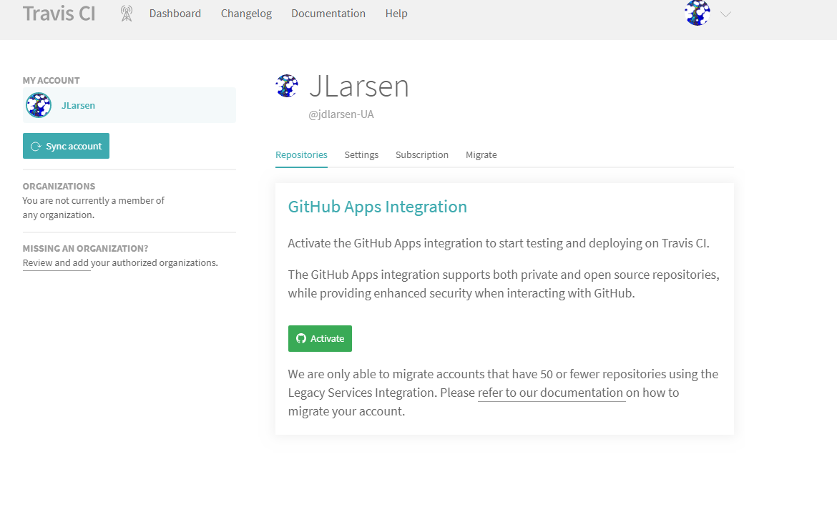

3) After activating github apps click on the mfnwt repository in the travis settings window. This will bring up the testing/build window for mfnwt. Click on the build unknown icon

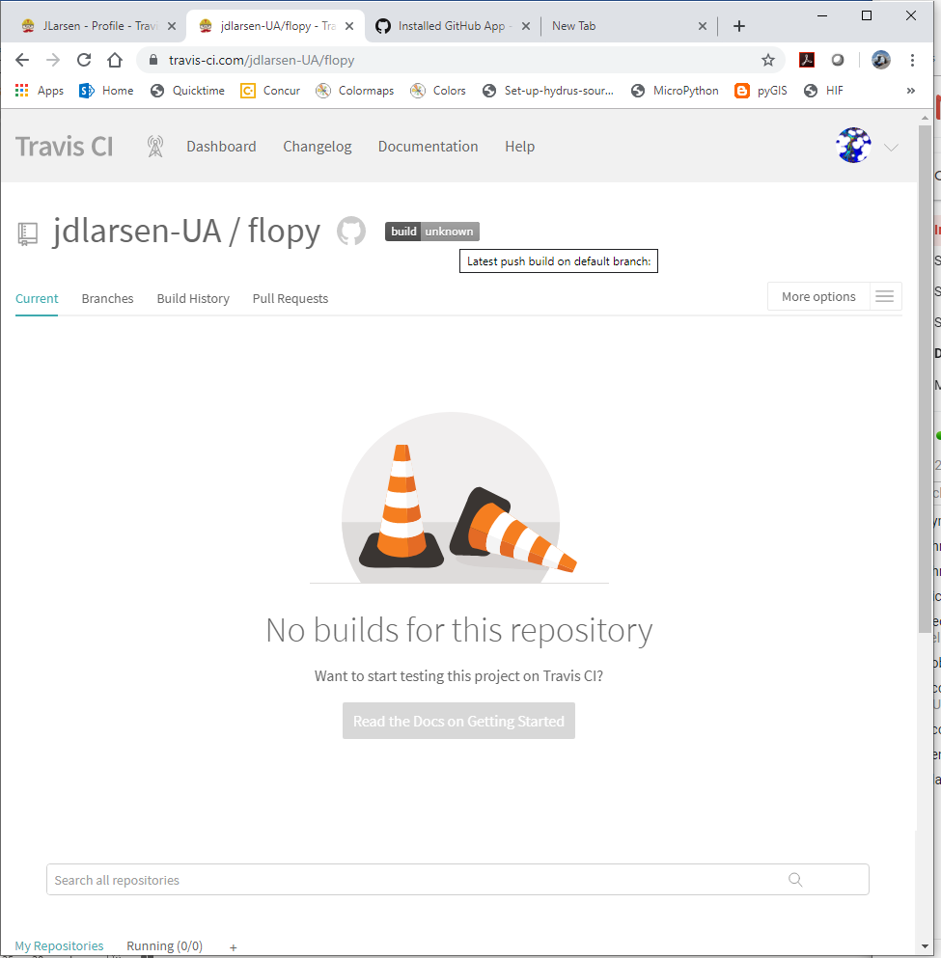

4) Choose markdown as the Format and copy the text in the Result box.

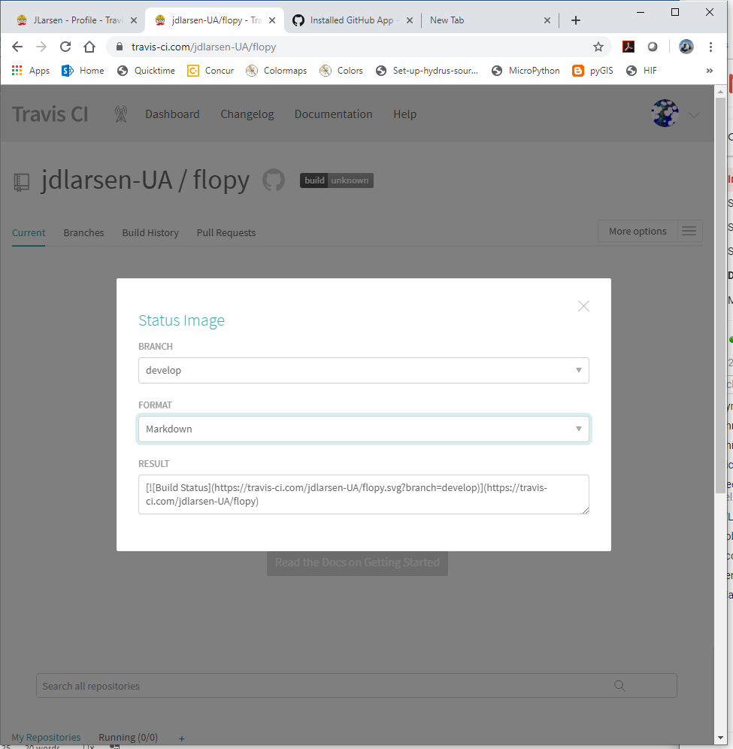

5) In your github repository replace line 2 of README.md with the text you copied from the result window (this links the build status to your Github repository and provides a direct link from the repo to the travis autotesting.)

Once these steps are completed, auto testing will occur with ever commit and pull request submitted to your repository.

--------------------------

To perform auto testing on your local machine. Compile the source code using make_win_gfortran.bat or drop a newly compiled version of mfnwt into the autotesting directory. Open an anaconda prompt window, navigate to the autotesting directory and run the command:

>>> nosetests -v

---------------------------

Finally the tests that are failing are:

1)the swi2ex4ssw model will not run with the newly compiled code. I've attached the error message.

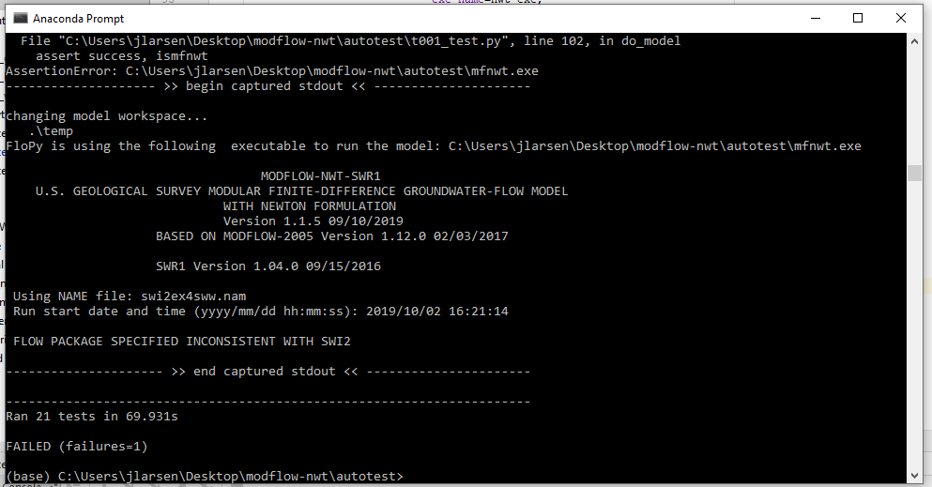

2) The Sfr2weltab model has head differences that are outside of the defined tolerance for error. I've set the error tolerance to 1% for now, which translates to about 1 ft difference in head on a cell by cell basis for this model.