RAD Project Specification


Project Name: | Rover Arm Driver
Document Version: | V2.02
Prepared by: | Ben Rush
Date: | 2023/01/10

Revision History

Version | Date | Description of Changes
V2.01 | 2022/02/24 | Initial Release.
V2.02 | 2022/03/10 | Updated Encoder Information Based on Findings from Research
V2.03 | 2022/11/05 | Updated Specifications/Requirements based on new stepper driver
V2.04 | 2023/01/10 | Updated Specifications/Requirements/Detailed Description to describe design change from one-board to two-boards
V1.1 | 2025/04/25 | Updated Detailed Description to reflect connector changes from RAD V1 to RAD V1.1

Table of Contents
Document Revisions 2
0.0 Conventions and Terms 4
1.0 Requirements & Constraints 4
1.1 Requirements 4
1.2 Constraints 4
2.0 Specifications 4
3.0 Detailed Description 4

Conventions and Terms

Conventions
“Must” is used to indicate a mandatory requirement. “Should” is used to indicate an additional nice to have. “May” is used to indicate an option.

Terms and Definitions
RAD: V2 Rover Arm Driver

Requirements & Constraints

Requirements
Table 1: Requirements
Requirement ID | Description | Status
RAD-REQ-01 | RAD must be able to handle 4A and 30V continuously.
RAD-REQ-02 | RAD must be able to communicate with the Jetson TX2/OBC via CAN.
RAD-REQ-03 | RAD must implement the selected stepper motor driver (TMC2590).
RAD-REQ-04 | RAD must be configured for SPI interfacing between the microcontroller and the stepper motor driver for driver configuration.
RAD-REQ-05 | RAD must be configured for STEP/DIR interfacing between the microcontroller and the stepper motor driver for motor control.
RAD-REQ-06 | RAD must be able to implement encoder feeding back stepper motor position information back to the microcontroller (STM32F103C8T6).
RAD-REQ-07 | RAD should implement TMC2590’s patented StallGuard technology to take load-angle feedback to prevent stop loss (for example when axis is obstructed).
RAD-REQ-08 | RAD must implement positive feedback from the magnetic encoder (AS50488-HTSP-500) back to the microcontroller to provide feedback on motor shaft position.
RAD-REQ-09 | RAD must be thermally optimized to ensure proper cooling.
RAD-REQ-10 | There must be current reduction in motor standstill (for example, during motor start-up) to limit high inrush currents and temperature increases.
RAD-REQ-11 | RAD should use an external clock for motor driver operation; allows for higher precision in motor movements, faster SPI, and faster step rates
RAD-REQ-12 | RAD must not inhibit the rover arm requirement to be easily detachable to allow for the swapping of the arm for the science module
RAD-REQ-13 | The magnetic encoder centre axis should be aligned with a displacement radius of ~0.25 mm from the defined centre of the encoder (some leeway based on magnet size; requires calculations)

Constraints
The design of RAD is constrained by the following:
- Due to the size constraint, the design has been adjusted to have two boards
  - One primary board – constrained to be 100 mm x 70 mm
  - One secondary board – constrained to be 31 mm x 31 mm, which will contain the encoder, encoder-specific passives, and a connector to interface with the primary board
- Connections to external motors and systems must be secure (especially for stepper motors)
- Alongside the remainder of the rover’s arm, RAD must not inhibit the arms ability to be easily detachable/attachable to the rover to allow for smooth swapping of the rover arm for the science module.
- The encoder’s centre axis should be aligned accurately with the centre axis of the magnet.

Specifications
Table 2: Performance specifications
Spec. ID | Sym. | Parameter | Min. | Nom. | Max. | Unit
RAD-SPEC-01 | V_{VS} | TMC2590 Absolute Max. Supply Voltage | -0.5 | - | 62 | V
RAD-SPEC-02 | V_{VS} | TMC2590 Operational Supply Voltage | 5 | - | 60 | V
RAD-SPEC-03 | V_{VIO} | TMC2590 Absolute Max. I/O Supply Voltage | -0.5 | - | 6.0 | V
RAD-SPEC-04 | V_{VIO} | TMC2590 Operational I/O Supply Voltage | 3.00 | - | 5.25 | V
RAD-SPEC-05 | T_{J} | TMC2590 Absolute Max. Junction Temp. | -50 | - | 150 | °C
RAD-SPEC-06 | T_{J} | TMC2590 Operational Junction Temp. | -40 | - | 125 | °C
RAD-SPEC-07 | f_{CLKOSC} | TMC2590 Clock Oscillator Freq. (-50 °C) | 10 | 13.5 | - | MHz
RAD-SPEC-08 | f_{CLKOSC} | TMC2590 Clock Oscillator Freq. (50 °C) | 10.8 | 14.3 | 17.5 | MHz
RAD-SPEC-09 | f_{CLKOSC} | TMC2590 Clock Oscillator Freq. (150 °C) | - | 14.5 | 18 | MHz
RAD-SPEC-10 | f_{CLK} | TMC2590 External Clock Freq.  (Typ. 40%/60% duty cycle, Max at 50%) | 4 | 10-13.4 | 16 | MHz
RAD-SPEC-11 | VDD5V | AS5048A Absolute Max. Supply Voltage at VDD5V Pin | -0.3 | - | 7 | V
RAD-SPEC-12 | VDD5V | AS5048A Operational Supply Voltage at VDD5V Pin | 4.5 | - | 5.5 | V
RAD-SPEC-13 | VDD3V | AS5048A Absolute Max. Supply Voltage at VDD3V Pin | -0.3 | - | 5 | V
RAD-SPEC-14 | VDD3V | AS5048A Operational Supply Voltage at VDD3V Pin | 3 | - | 3.6 | V
RAD-SPEC-15 | P_{T} | AS5048A Total Power Dissipation | - | - | 150 | mW
RAD-SPEC-16 | T_{BODY} | AS5048A Package Body Temperature | - | - | 260 | °C

Detailed Description

Primary Board Design – RAD

The primary board will contain most of the components used to drive the rover arms stepper motors. The design contains 6 connectors, with the following connections.
- 1x2 Micro-Fit (43650-0200) – 8A
    - 1 Pin to GND, 1 Pin to VIN (~30V)
- 1x4 Micro-Fit (43650-0400) – 8A
    - 4 Pin’s to Motor Supply (A-, A+, B-, B+)
  - 1x6 XH (B6B-XH-A) – 3A
    - 4 Pin’s to SPI_ENCODER, 1 Pin to GND, 1 Pin to VCC3V3
  - 1x4 PH (B4B-PH-K) – 2A
    - 4 Pins to Limit Switches (2 pairs of 1 NC pin and 1 COM pin)
  - 1x3 SL (0705450037) – 3A
    - 2 Pins to CANBUS (CANH, CANL) and 1 GND pin
  - 2x6 C-Grid (0702461201) – 2.5A
    - 3 Pins to SW Connection (SWDIO, SWCLK, NRST), 2 Pin’s to STEP/DIR, 3 Pins to GND, 1 Pin to 3.3V, 2 Pins for I2C for EEPROM (SDA, SCL), 1 NC Pin
The primary board is constrained to be below 100mm x 70mm in size, and contains all components, excluding the encoder, encoder-specific passives, and the secondary board’s connector. For motors with limited space nearby (i.e., claw), the board will be located locally, with a harness connecting the primary to the secondary board and motor. For boards less limited, an enclosure will be designed, allowing short harnesses to make the boards connections.

Secondary Board Design – RAD_ENCODER
The secondary board will contain the encoder, encoder-specific passives, and a connector to interface with the primary boards. The connector will have the following connections.
  - 1x6 XH (B6B-XH-A) – 3A
    - 4 Pin’s to SPI_ENCODER, 1 Pin to GND, 1 Pin to VCC3V3
The secondary board is constrained to be 31mm x 31mm, allowing it to be mounted to the back plate of the stepper motors. The board is mounted to the back plate to allow for motor rotational data to be collected via the AS5048A-HTSP-500 encoder, which is then sent to the Jetson TX2.

Stepper Motor Driver - TMC2660C

The RAD project is responsible for the control of the rover arm’s stepper motors. The first key component of RAD is the TMC2590 stepper motor drive controller. Produced by Trinamic, the TMC2590 driver is applicable to two-phase bipolar motors, controlling the motors speed and direction using either STEP/DIR or SPI control. For our purposes, the motor driver will control motor speed using STEP/DIR input from a microcontroller (STM32F103C8T6). The TMC2590 has several useful features, most notably, the StallGuard technology which allows for sensor-free load measurements of the stepper motors to be taken concurrently. This information provides feedback on lost step count during overload conditions, such as when an axis of movement is obstructed. This is ideal, as it can eliminate the need for limits switches which was implemented as a solution in the V1 rover’s design. For the current rover revision, limit switches will be implemented, so StallGuard would be a future consideration.
The TMC2590 can use an internal or external clock for motor operation. Benefits of internal clock control are standalone operation without the need for microcontrollers, and less potential of electromagnetic emission and power dissipation. External clocks allow for faster step rates, SPI operation, and more defined and precise motor operation. Generally, clock frequencies of 10-16 MHz are sufficient, with higher speeds useful for maximum velocity purposes (>16 MHz), and lower frequencies for reduced velocity purposes (4-10 MHz).
The TMC2590’s SPI interface uses 4 signals; bus clock input (SCK), serial data input (SDI), serial data output (SDO), and chip select input (active low). Bit transfer is synchronous with SCK, with the slave receiving SDI on rising-edges and sending SDO on falling-edges.
SPI data received by the microcontroller will be only used for the driver’s parameter configuration. For motor control, STEP/DIR signals from the microcontroller will be sampled and synchronized to the internal clock of the driver, and then filtered using an internal analog filter to remove noise due to the PCB traces. STEP/DIR signals are converted into current values using a microstep counter and sine table, which is then output to the motor supplies A+, A-, B+, and B-.

Magnetic Encoder - AS5048A-HTSP-500

The second key component is the AS5048A-HTSP-500 magnetic encoder. The encoder’s role is to measure the absolute position of the stepper motor shaft, allowing for communication of rover arm positional data back to the microcontroller. The importance of the encoder is allowing for closed-loop stepper motor control; using positive feedback from the encoder, the microcontroller will be alerted if steps are skipped, allowing for readjustments of instructions being sent, as well as an understanding of the arms position despite missing certain instructions.
For correct encoder readings, positioning of the encoder, as well as its corresponding magnet connected to the motor shaft, is as follows. Typically, the magnet used will be between 6-8 mm in diameter and will have a height of >2.5 mm. This magnet should be diametrically magnetized, such that the north and south pole are each opposing semicircle. The magnet used should produce a peak magnetic field strength of approximately ±30 mT to ±70 mT. At all points within a concentric circle with a radius of 1.1 mm around the centre of the magnet, the magnetic field strength should measure between ±30 mT and ±70 mT. For the encoder, the magnet should be oriented at the centre of the encoder’s middle (see Figure 1.) The alignment should be with a 0.25 mm displacement radius, however, with larger magnets, this displacement radius can be slightly larger (i.e., 0.5 mm). Using the recommended magnet dimensions (6 mm x 3 mm), the encoder chip surface should be within the range of 0.5 mm to 2.5 mm to the magnet’s surface.
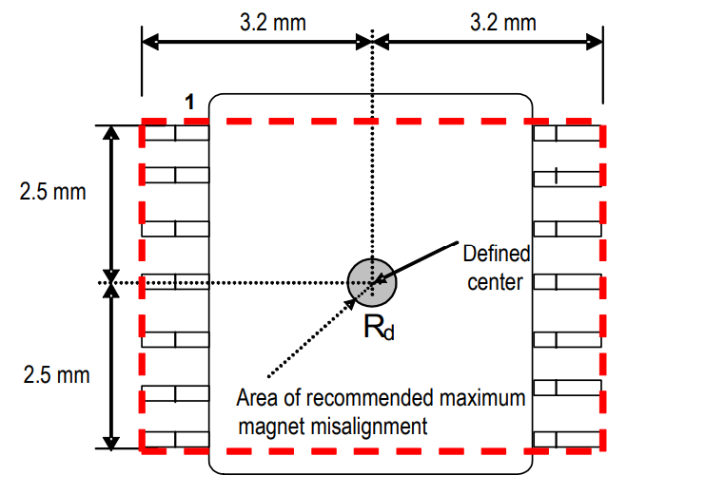
Figure 1: Defined Chip Centre and Magnet Displacement Radius: Pg. 31, AS5048A/AS5048B Datasheet
Ideally, the magnet will be attached to the shaft of the NEMA 17/23 motors using the small hole on the rear side of the motor (opposite of the extruding shaft). On the rear side, a small hole with a diameter of (maximum for NEMA23) ~10.15 mm and a depth of ~3.95 mm can be found. A diametrically magnetized magnet with similar dimensions can then be attached to the shaft using epoxy or super glue. Next, the RAD_ENCODER board can be designed to be fitted onto the back of the NEMA 17/23 motors, like the depiction below in Figure 2. The encoder can then be attached to the surface of the board facing the motor, allowing it to be positioned ideally in both centre alignment and distance from the magnet.
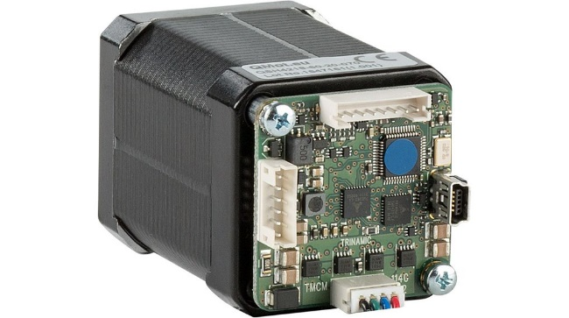
Figure 2: NEMA 17 Motor with Pre-Attached Motor Driver: DISTRELEC Webstore

Main Components & Functions

Component | Category | Connection | Datasheet
TMC2590 | Integrated Circuits (ICs) | On Board | https://www.trinamic.com/fileadmin/assets/Products/ICs_Documents/TMC2590_datasheet_rev1.04.pdf
AS5048A-HTSP-500 | Sensor, Transducer | On Board | https://ams.com/documents/20143/36005/AS5048_DS000298_4-00.pdf
STM32F103C8T6 | Microcontroller | On Board | https://www.st.com/resource/en/datasheet/stm32f103c8.pdf
AOD409 | N-Channel MOSFET | On Board | http://www.aosmd.com/res/data_sheets/AOD409.pdf
AOD4130 | P-Channel MOSFET | On Board | http://www.aosmd.com/res/data_sheets/AOD4130.pdf
R1240N001B-TR-FE | Buck Regulator | On Board | https://www.nisshinbo-microdevices.co.jp/en/pdf/datasheet/r1240-ea.pdf

