Firt of all I would want to have a source code with more comments and, as required, a file that contain the list (a dozen) of the executable commands that are shared between Linux and Windows

e.g. LIST (that recall the function ls in linux and dir in windows) obviously these commands will not have to be re-implemented

for this reason I don’t need the conf file that deny the access to some commands

I've got some problem with the project:

- in windows, following the steps described in the screenshot so
In the folder client-server execute:
make –f Makefile.cygwin
it compiles but it produces “Info: resolving _h_errno by linking to __imp__h_errno (auto-import)

Anyway I obtain
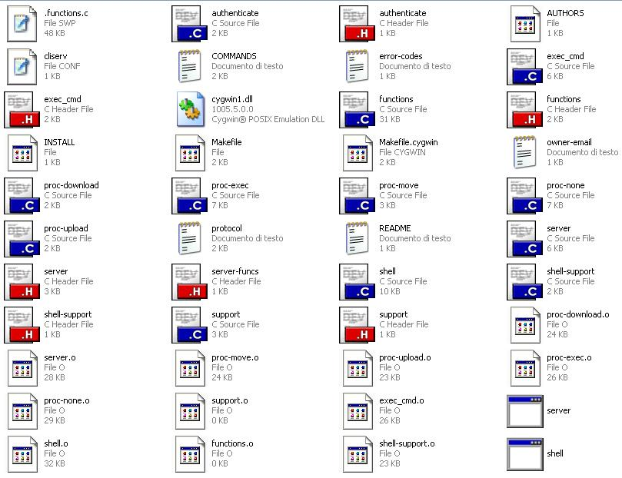

But executing the new executable file server.exe and shell.exe I obtain
(sorry is a traduction):
server.exe: “Impossibile to find the starting point _impure_ptr of the procedure in the dynamic linking library cygwin1.dll”
shell.exe: “Impossibile to find the starting point _fcntl64 of the procedure in the dynamic linking library cygwin1.dll”

- in windows, opening the executable files in client-server/cygwin, provided by you, it works, but I can't change_folder opening a folder that includes in its name some blank(space char)

e.g. c $ change_folder "Documents and settings"
"documents no such file or directory

- the command “list” must provide a list of the files into the current directory and must show for each file the name, the size and the date of the last access

- also I tried to execute a command like the example in the screenshot

e.g. cygwin $ execute localhost:ls -l | wc -l
looking up localhost ... [127.0.0.1] done
Server error: execvp: ls: no such file or directory
Server error: execvp: wc: no such file or directory
remote host closed socket
- In Linux I can’t compile the source files because I obtain the follow errors:

……………………………………………………………………client-server> make
gcc -D_REENTRANT -g3 -Wall -O2 -c authenticate.c
In file included from authenticate.c:4:
authenticate.h:10:31: error: security/pam_appl.h: No such file or directory
authenticate.h:11:31: error: security/pam_misc.h: No such file or directory
authenticate.c:6: error: variable ‘conv’ has initializer but incomplete type
authenticate.c:7: error: ‘misc_conv’ undeclared here (not in a function)
authenticate.c:7: warning: excess elements in struct initializer
authenticate.c:7: warning: (near initialization for ‘conv’)
authenticate.c:9: warning: excess elements in struct initializer
authenticate.c:9: warning: (near initialization for ‘conv’)
authenticate.c:11: error: syntax error before ‘*’ token
authenticate.c: In function ‘what_error’:
authenticate.c:13: error: ‘fn’ undeclared (first use in this function)
authenticate.c:13: error: (Each undeclared identifier is reported only once
authenticate.c:13: error: for each function it appears in.)
authenticate.c:14: warning: implicit declaration of function ‘pam_strerror’
authenticate.c:14: error: ‘pamh’ undeclared (first use in this function)
authenticate.c:14: error: ‘code’ undeclared (first use in this function)
authenticate.c:14: warning: format ‘%s’ expects type ‘char *’, but argument 4 ha s type ‘int’
authenticate.c: In function ‘authenticate’:
authenticate.c:19: error: ‘pam_handle_t’ undeclared (first use in this function)
authenticate.c:19: error: ‘pamh’ undeclared (first use in this function)
authenticate.c:33: warning: implicit declaration of function ‘pam_start’
authenticate.c:34: error: ‘PAM_SUCCESS’ undeclared (first use in this function)
authenticate.c:44: warning: implicit declaration of function ‘pam_set_item’
authenticate.c:44: error: ‘PAM_RHOST’ undeclared (first use in this function)
authenticate.c:58: warning: implicit declaration of function ‘pam_authenticate’
authenticate.c:62: warning: format ‘%s’ expects type ‘char *’, but argument 3 ha s type ‘int’
authenticate.c:69: warning: implicit declaration of function ‘pam_end’
make: *** [authenticate.o] Error 1

