Install JDK in Linux (Both Server01 and Client01)

- Go To http://www.oracle.com/technetwork/java/javase/downloads/jdk8-downloads-2133151.html and download jdk 1.8.

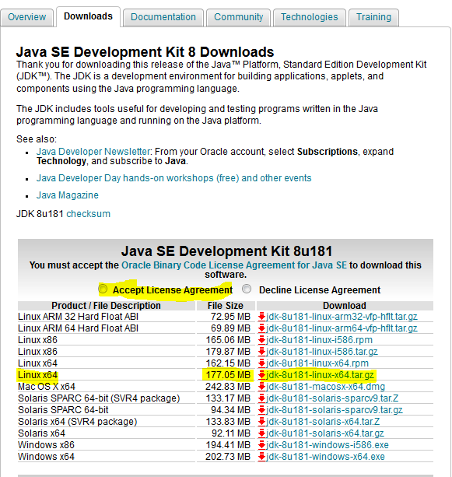

- Upload using WinSCP on your both VMs. Give IP and username as ‘centos’

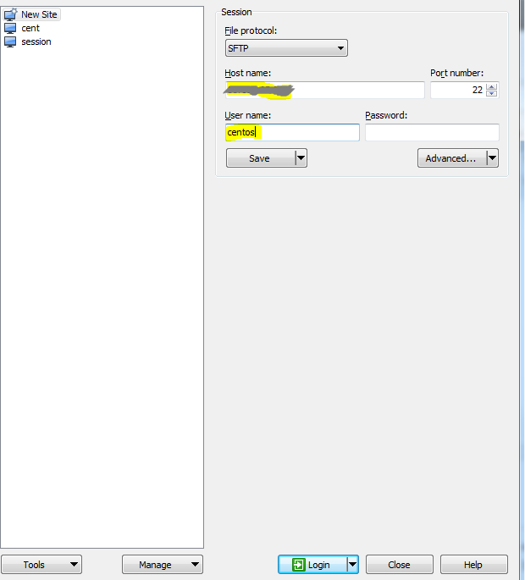

Click Advanced > SSH > Authentication > Locate you private key file > click ‘OK’ > Login

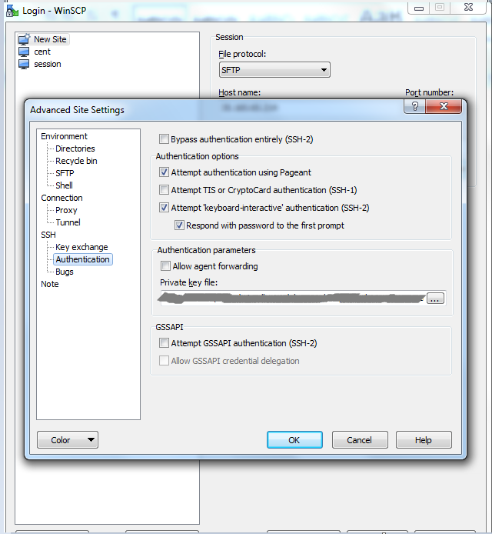

Locate jdk1.8 tar file and copy on to the machine. Then go to the machine and execute

tar -xzf /home/centos/jdk1.8.0_*.tar.gz --directory /data/
ls -rlt /data

To add Java in PATH variable, add below 3 lines in ‘/etc/profile’

JAVA_HOME=/data/jdk1.8.0_181
PATH=$JAVA_HOME/bin:$PATH
export PATH JAVA_HOME

Then execute
source /etc/profile
java -version
which java

INSTALL TOMCAT (Only Server01)

cd /data/myscripts
git pull
sh install_tomcat.sh
Then check site: http://SERVER_PUBLIC_IP:8001/employees

