+School of Digital Media and Infocomm Technology (DMIT)
ST0281 Mobile Applications
Practical 15

Objectives:

After completing this lab, you will be able to:

- Display images using GridView
- Understand the use of ArrayAdapter to customise the grid item

A: Using GridView:

In this part of this practical, you will create a new Android project to implement the example of using a GridView and then an ImageView when a particular image item is selected within the grid.

Note that an ArrayAdapter is used to customise the grid item so that a bitmap image and a title of the image inside a textview are displayed within the grid.

Get ready 9 images in .png format. In Android, the recommended image format to be used is PNG. JPG (ok to use) and GIF (not recommended) are also usually supported from the manufacturer’s device.

Follow the following steps:
Step 1:
Create a new project called MyPhotoCollection

1. Application name: MyPhotoCollection  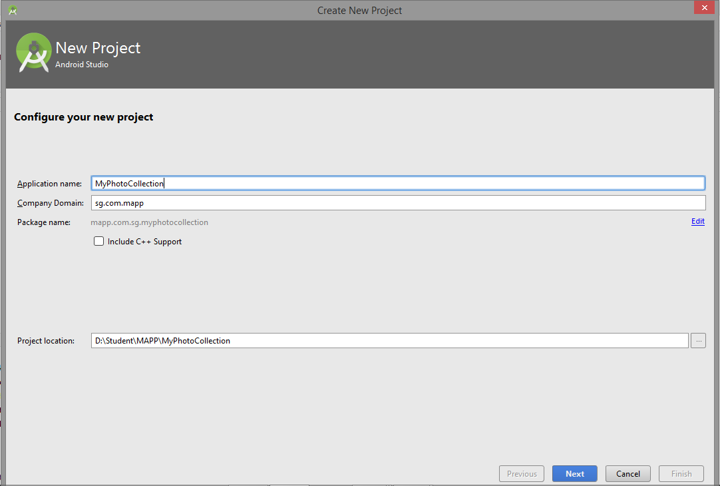 | 2.  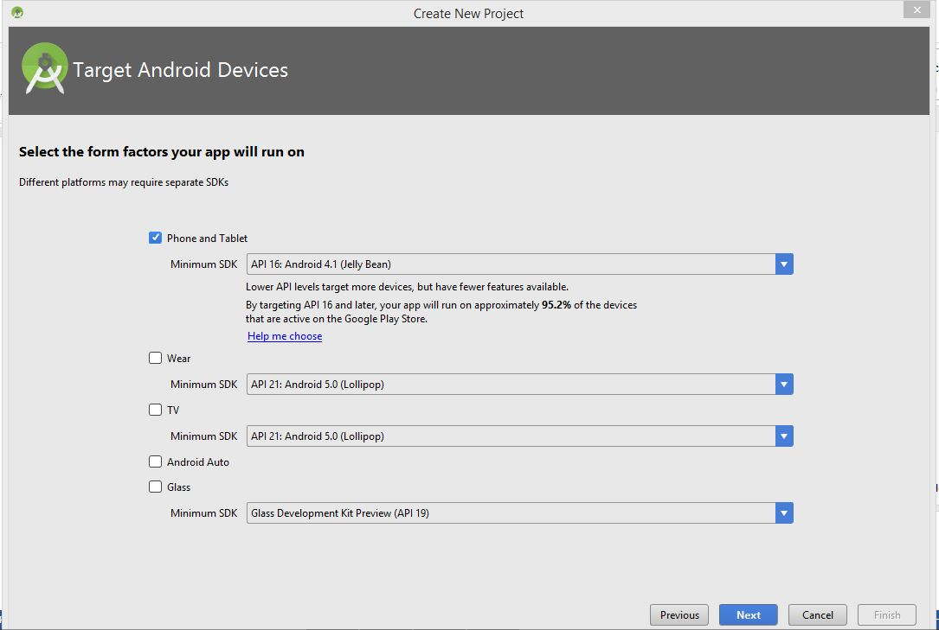
3. Empty Activity  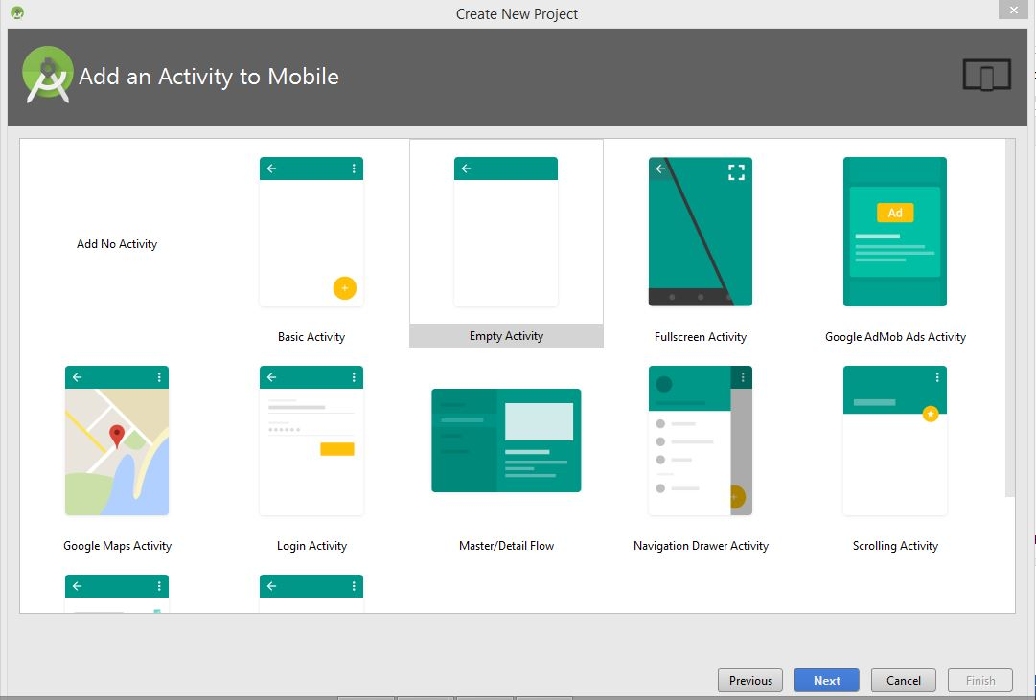 | 4. Activity Name:MyPhotoActivity  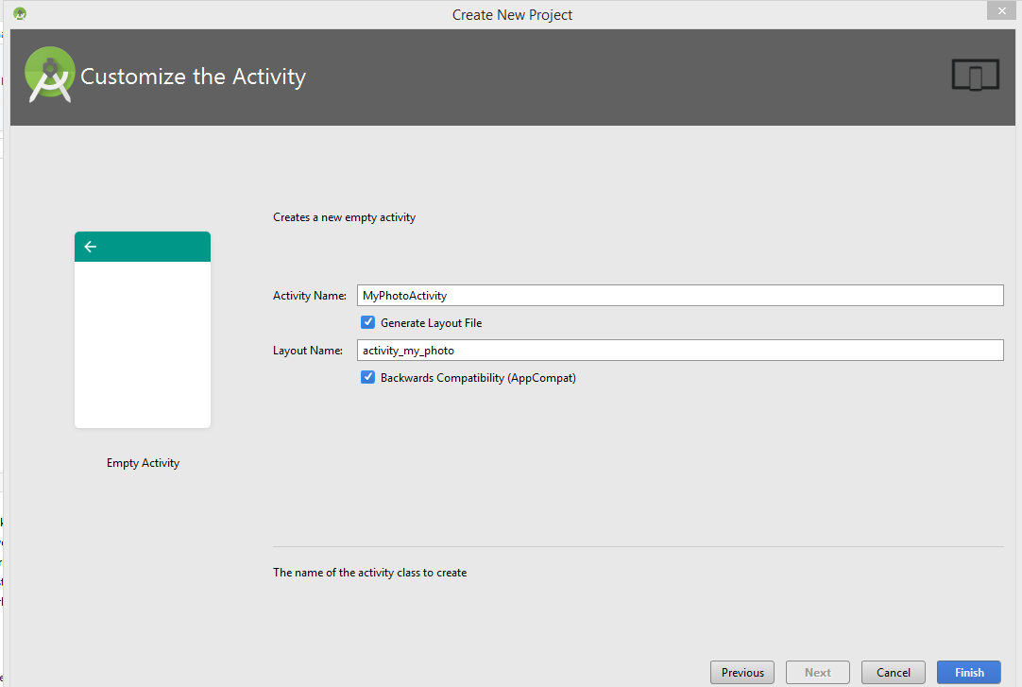

Step 1:
Create a new Java class called ImageItem and add in the code as shown:

package mapp.com.sg.myphotocollection;

public class ImageItem {

private int imageID;
private String desc;

public ImageItem(int imageID, String desc) {
this.imageID = imageID;
this.desc = desc;
}

public int getImageResource() {
return imageID;
}

public String getDesc() {
return desc;
}

public void setImageResource(int imageID){
this.imageID = imageID;
}

public void setDesc(String desc){
this.desc = desc;
}

}

Step 2:
Create a new Java class called ImageAdapter.java and add in the code as shown:

package mapp.com.sg.myphotocollection;

import android.content.Context;
import android.view.LayoutInflater;
import android.view.View;
import android.view.ViewGroup;
import android.widget.BaseAdapter;
import android.widget.ImageView;
import android.widget.TextView;

public class ImageAdapter extends BaseAdapter {

private final Context mContext;
private ImageItem[] imageItems;

// Constructor
public ImageAdapter(Context context) {
this.mContext = context;
}

// Constructor
public ImageAdapter(Context context, ImageItem[] imageItems) {
this.mContext = context;
this.imageItems = imageItems;
}

// Count the number of image items
@Override
public int getCount() {
return imageItems.length;
}

@Override
public long getItemId(int position) {
return 0;
}

@Override
public Object getItem(int position) {
return null;
}

// Display the image in the GridView
@Override
public View getView(int position, View convertView, ViewGroup parent) {
TextView dummyTextView = new TextView(mContext);
dummyTextView.setText(String.valueOf(position));
return dummyTextView;
}

}

Step 3:
Edit the activity_main.xml:
<?xml version="1.0" encoding="utf-8"?>

<RelativeLayout xmlns:android="http://schemas.android.com/apk/res/android"
xmlns:tools="http://schemas.android.com/tools"
android:id="@+id/activity_main"
android:layout_width="match_parent"
android:layout_height="match_parent"
android:paddingBottom="@dimen/activity_vertical_margin"
android:paddingLeft="@dimen/activity_horizontal_margin"
android:paddingRight="@dimen/activity_horizontal_margin"
android:paddingTop="@dimen/activity_vertical_margin"
tools:context="mapp.com.sg.myphotocollection.MainActivity">

<TextView
android:layout_width="wrap_content"
android:layout_height="wrap_content"
android:text="My Photo" />

<GridView
android:id="@+id/gridview"
android:layout_width="match_parent"
android:layout_height="match_parent"
android:gravity="center"
android:columnWidth="100dp"
android:numColumns="auto_fit"
android:verticalSpacing="24dp"
android:horizontalSpacing="10dp"
android:stretchMode="spacingWidthUniform"
android:layout_marginTop="25dp"
android:layout_below="@+id/textView2"
android:layout_alignParentLeft="true"
android:layout_alignParentStart="true" />
</RelativeLayout>

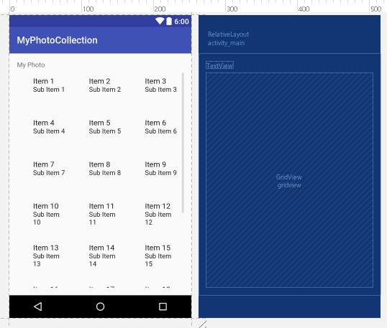

Step 4:
Run the MyPhotoCollection application.

It will display as shown:
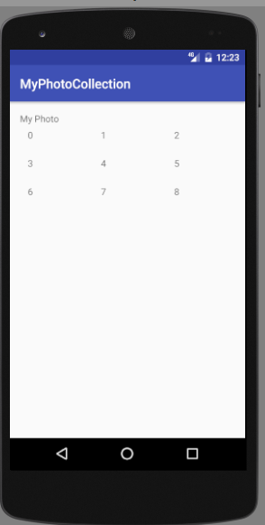

Step 5:
Add another xml file inside the layout folder called imagedisplay.xml. This imagedisplay.xml will define how each grid item will look like.

<?xml version="1.0" encoding="utf-8"?>
<LinearLayout
xmlns:android="http://schemas.android.com/apk/res/android"
xmlns:tools="http://schemas.android.com/tools"
android:orientation="vertical"
android:layout_width="match_parent"
android:layout_height="match_parent"
android:weightSum="1">

<FrameLayout
android:layout_width="match_parent"
android:layout_height="wrap_content"
android:layout_weight="0.13">

<ImageView
android:id="@+id/imageviewdisplay"
android:layout_width="match_parent"
android:layout_height="118dp"
android:src="@drawable/image_1"
android:layout_gravity="bottom|right">
</ImageView>

</FrameLayout>

<TextView
android:id="@+id/txtviewdesc"
android:layout_width="match_parent"
android:layout_height="wrap_content"
android:textSize="12sp"
tools:text="p1"
android:textStyle="bold"
android:paddingTop="4dp"
android:paddingLeft="8dp"
android:paddingRight="8dp"
android:gravity="center_horizontal"
android:layout_weight="0.07" />

</LinearLayout>

Step 6:
Modify the MainActivity.java class to look like this:

package mapp.com.sg.myphotocollection;

import android.content.Intent;
import android.support.v7.app.AppCompatActivity;
import android.os.Bundle;
import android.view.View;
import android.widget.AdapterView;
import android.widget.GridView;
import android.widget.Toast;

public class MainActivity extends AppCompatActivity {

@Override
protected void onCreate(Bundle savedInstanceState) {
super.onCreate(savedInstanceState);
setContentView(R.layout.activity_main);

GridView gridView = (GridView) findViewById(R.id.gridview);
ImageAdapter imageAdapter = new ImageAdapter(this, imageItems);
gridView.setAdapter(imageAdapter);
}

private ImageItem[] imageItems = {
new ImageItem(R.drawable.image_1,"pic1"),
new ImageItem(R.drawable.image_2,"pic2"),
new ImageItem(R.drawable.image_3,"pic3"),
new ImageItem(R.drawable.image_4,"pic4"),
new ImageItem(R.drawable.image_5,"pic5"),
new ImageItem(R.drawable.image_6,"pic6"),
new ImageItem(R.drawable.image_7,"pic7"),
new ImageItem(R.drawable.image_8,"pic8"),
new ImageItem(R.drawable.image_9,"pic9"),
};

}

Step 7:
Modify the ImageAdapter.java. It is to display the image and the image description.

// Display the image in the GridView
@Override
public View getView(int position, View convertView, ViewGroup parent) {

// Display all the images
final ImageItem imgdisplay = imageItems[position];

// Place the iamage into the respective grid
if (convertView == null) {
final LayoutInflater layoutInflater = LayoutInflater.from(mContext);
convertView = layoutInflater.inflate(R.layout.imagedisplay, null);
}

final ImageView imageviewdisp = (ImageView)convertView.findViewById(R.id.imageviewdisplay);
final TextView textviewdesc = (TextView)convertView.findViewById(R.id.txtviewdesc);

// Place the image and description of the image
imageviewdisp.setImageResource(imgdisplay.getImageResource());
textviewdesc.setText(imgdisplay.getDesc());

return convertView;
}

Step 8:
Run the MyPhotoCollection application.

It will display as shown:

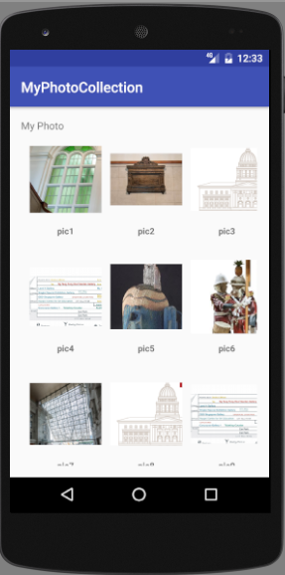

Step 9:

The next step is to allow user to click on the image and display the image in a larger view.
You need to add in the setOnItemClickListener in the MainActivity.java, add a new Java class DisplayIndImage.java and a layout file display_individual_image.xml.

Create a new Java class called DisplayIndImage.java and add in the code as shown:

package mapp.com.sg.myphotocollection;

import android.content.Intent;
import android.os.Bundle;
import android.support.v7.app.AppCompatActivity;
import android.widget.ImageView;
import android.widget.TextView;
import android.widget.Toast;

public class DisplayIndImage extends AppCompatActivity {
private ImageItem[] imageItems;

@Override
public void onCreate(Bundle savedInstanceState) {
super.onCreate(savedInstanceState);
setContentView(R.layout.display_individual_image);

// Get intent data
Intent i = getIntent();

// Selected image id
int imgResource = i.getExtras().getInt("imgResc");
String txtDesc = i.getExtras().getString("txtDesc");

Toast.makeText(getApplicationContext(), "Image resc " + imgResource ,
Toast.LENGTH_LONG).show();

// Display the Image
ImageView imageView = (ImageView) findViewById(R.id.individualview);
imageView.setImageResource(imgResource);

// Display the Text
TextView txtView = (TextView) findViewById(R.id.textViewDesc);
txtView.setText(txtDesc.toString());

}
}

Step 10:
Add another xml file inside the layout folder called display_individual_image.xml. This display_individual_image.xml will display the selected image by the user.

<?xml version="1.0" encoding="utf-8"?>
<LinearLayout xmlns:android="http://schemas.android.com/apk/res/android"
android:orientation="vertical" android:layout_width="match_parent"
android:layout_height="match_parent">

<ImageView
android:id="@+id/individualview"
android:src="@drawable/image_1"
android:layout_width="match_parent"
android:layout_height="463dp"/>

<TextView
android:text="TextView"
android:layout_width="match_parent"
android:layout_height="match_parent"
android:id="@+id/textViewDesc"
android:gravity="center"/>
</LinearLayout>

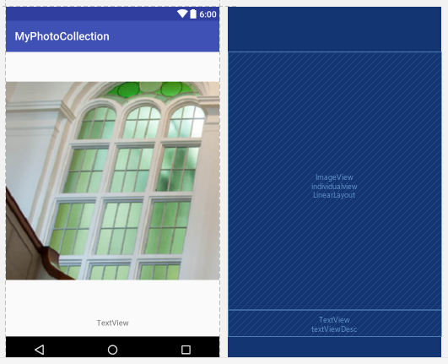

Step 11:
Modify the MainActivity.java class to include the setOnItemClickListener().
Insert this code into onCreate(Bundle savedInstanceState) after the gridView.setAdapter(imageAdapter);

gridView.setOnItemClickListener(new AdapterView.OnItemClickListener() {
@Override
public void onItemClick(AdapterView<?> parent, View view, int position, long id) {

Toast.makeText(getApplicationContext(), "Image position " + position,
Toast.LENGTH_LONG).show();
Intent i = new Intent(getApplicationContext(), DisplayIndImage.class);

//Get the selected Item id and description
int imgID = imageItems[position].getImageResource();
String txtDesc = imageItems[position].getDesc();

//Toast.makeText(getApplicationContext(), "Image resources " + imgID,
// Toast.LENGTH_LONG).show();
// Pass image index to another Intent

i.putExtra("imgResc",imgID);
i.putExtra("txtDesc", txtDesc);
startActivity(i);

}
});

Note: The image ID (imgID) and the description text (txtDesc) are pass to the next intent. This it allow the next intent to display the selected image.

Step 12:
Modify the AndroidManifest.xml to include the DisplayIndImage.java.

<?xml version="1.0" encoding="utf-8"?>
<manifest xmlns:android="http://schemas.android.com/apk/res/android"
package="mapp.com.sg.myphotocollection">

<application
android:allowBackup="true"
android:icon="@mipmap/ic_launcher"
android:label="@string/app_name"
android:supportsRtl="true"
android:theme="@style/AppTheme">
<activity android:name=".MainActivity">
<intent-filter>
<action android:name="android.intent.action.MAIN" />

<category android:name="android.intent.category.LAUNCHER" />
</intent-filter>
</activity>
<activity android:name=".DisplayIndImage">
</activity>

</application>

</manifest>

The MyPhotoCollection project file is as shown:

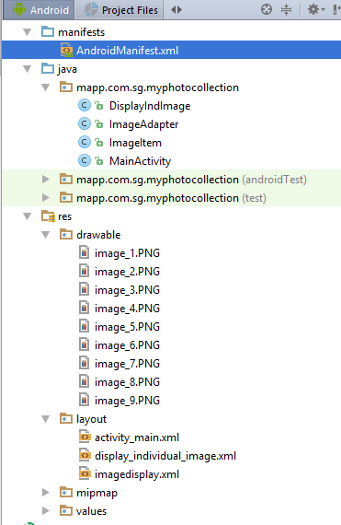

Step 13:
Run the MyPhotoCollection application. Select the image that you wish to view, it will display on another page.

It will display as shown:
Display all the images  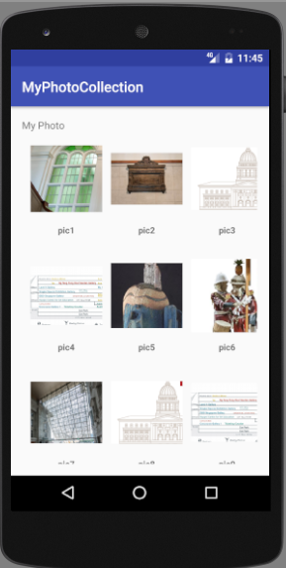 | Display the selected image.  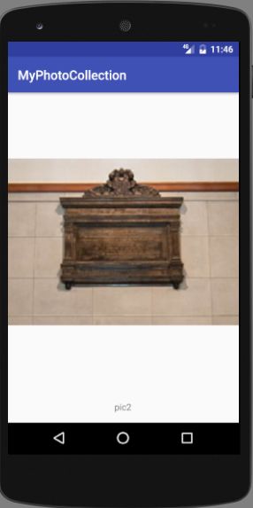

-- End of Practical 15 --

