School of Digital Media and Infocomm Technology (DMIT)
ST0281 Mobile Applications
Practical 13

Objectives:

After completing this lab, you will be able to:

- Display images using ImageView and ImageSwitcher
- Understand the use of ViewSwitcher

In this practical, you will create a new Android project to implement the example of using an ImageView and ImageSwitcher to display a series of images.

In Android, the recommended image format to be used is PNG. JPG (ok to use) and GIF (not recommended) are also supported.

Prepare 7 images in .png format for this practical with a pixel size of 300 X 300 and name the picture as pic1.png, pic2.png, etc.

Follow the following steps:
Step 1:
Create a new project called PicGallery

1. Application name: PicGallery  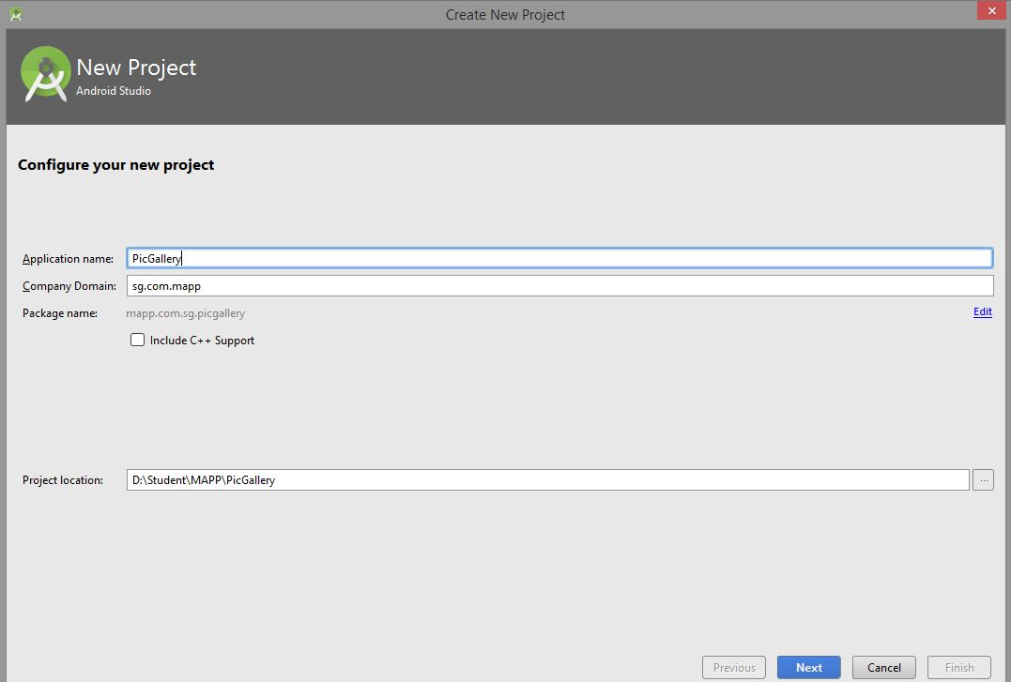 | 2.  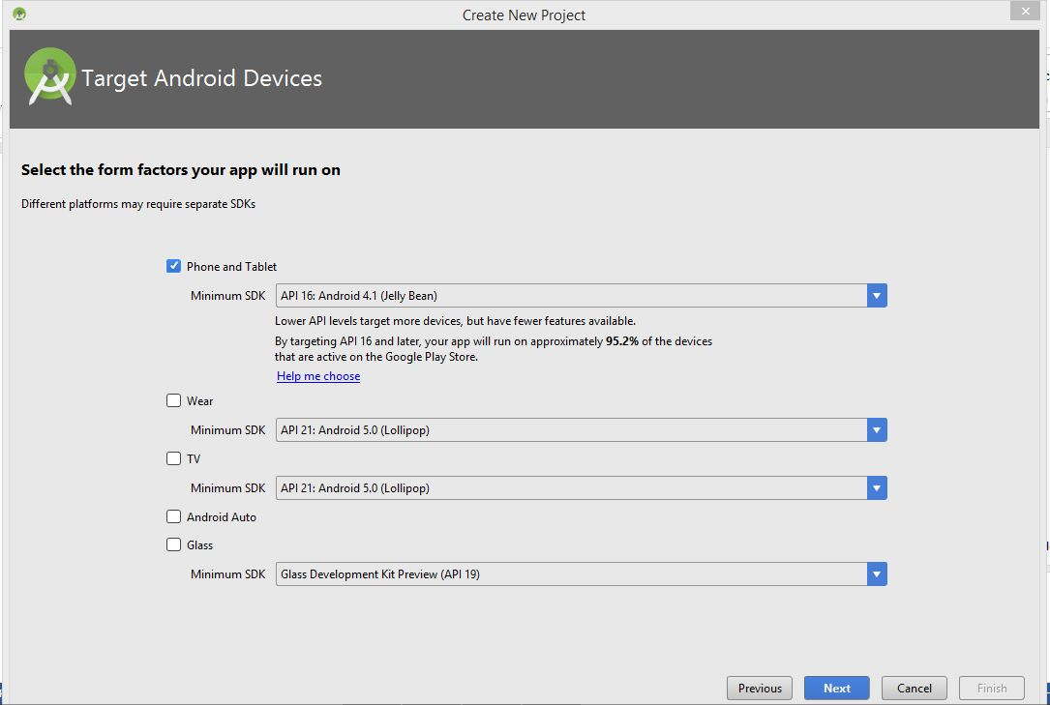
3. Empty Activity  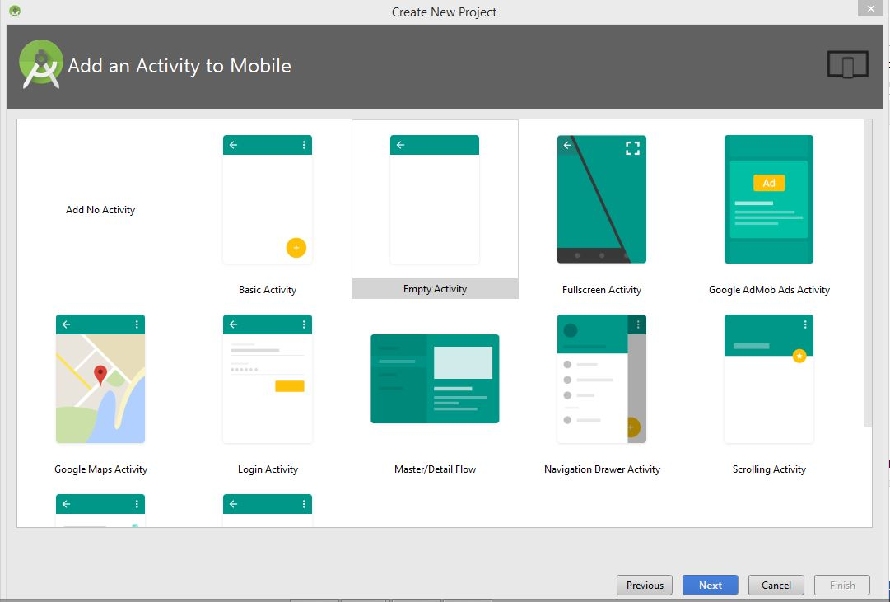 | 4. Activity Name:ImageGalleryActivity  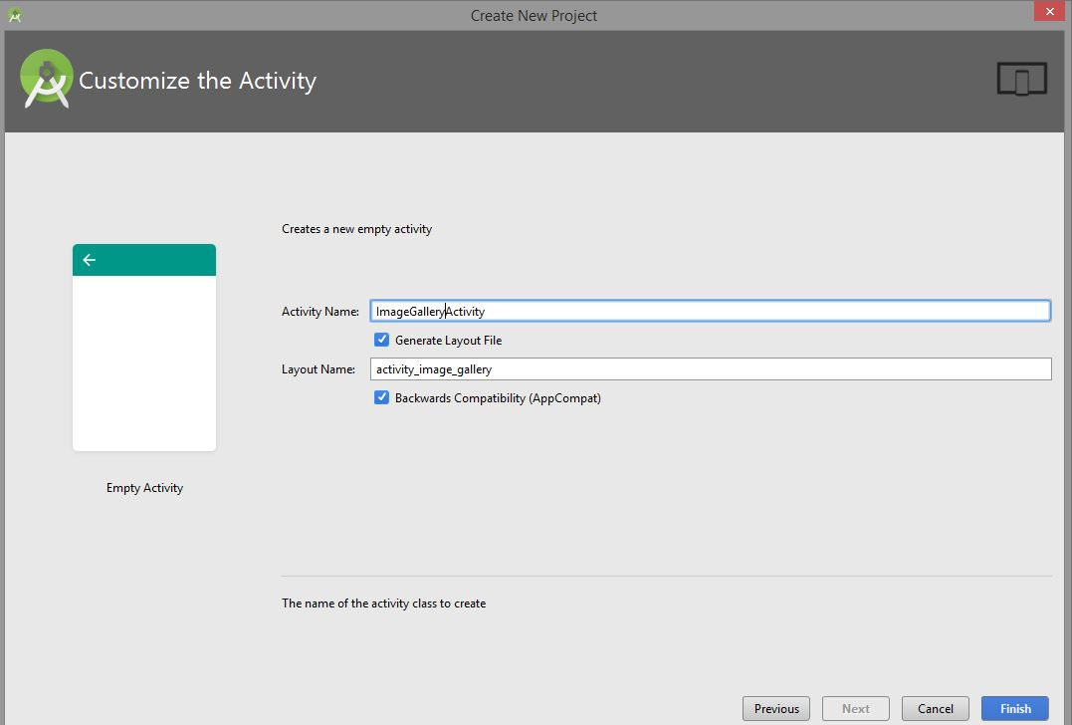

Step 2:
Modify the activity_image_gallery.xml.
Note: You may use the graphic interface to design the layout.
The XML file for activity_image_gallery.xml is as follows.

<?xml version="1.0" encoding="utf-8"?>
<RelativeLayout xmlns:android="http://schemas.android.com/apk/res/android"
xmlns:app="http://schemas.android.com/apk/res-auto"
xmlns:tools="http://schemas.android.com/tools"
android:id="@+id/activity_image_gallery"
android:layout_width="match_parent"
android:layout_height="match_parent"
android:paddingBottom="@dimen/activity_vertical_margin"
android:paddingLeft="@dimen/activity_horizontal_margin"
android:paddingRight="@dimen/activity_horizontal_margin"
android:paddingTop="@dimen/activity_vertical_margin"
tools:context="mapp.com.sg.picgallery.ImageGalleryActivity">

<TextView android:text="Image View Practical 13"
android:layout_width="wrap_content"
android:layout_height="wrap_content"
android:id="@+id/textview"
android:textSize="18sp"
android:layout_alignParentTop="true"
android:layout_centerHorizontal="true" />

<ImageSwitcher
android:layout_width="wrap_content"
android:layout_height="wrap_content"
android:id="@+id/imageSwitcher"
android:layout_below="@+id/textView"
android:layout_centerHorizontal="true"
android:layout_marginTop="60dp" />
<Button
android:layout_width="wrap_content"
android:layout_height="wrap_content"
android:text="Right"
android:id="@+id/btnRight"
android:layout_alignParentBottom="true"
android:layout_alignParentRight="true"
android:layout_alignParentEnd="true" />
<TextView
android:layout_width="wrap_content"
android:layout_height="wrap_content"
android:text="Image Switcher"
android:id="@+id/textView"
android:textColor="#ff7aff24"
android:textSize="14sp"
android:layout_below="@+id/textview"
android:layout_centerHorizontal="true"
android:layout_marginTop="14dp" />
<Button
android:layout_width="wrap_content"
android:layout_height="wrap_content"
android:text="Left"
android:id="@+id/btnLeft"
android:layout_alignParentBottom="true"
android:layout_alignParentLeft="true"
android:layout_alignParentStart="true" />

</RelativeLayout>

You should now see the image gallery screen as in Figure 1.

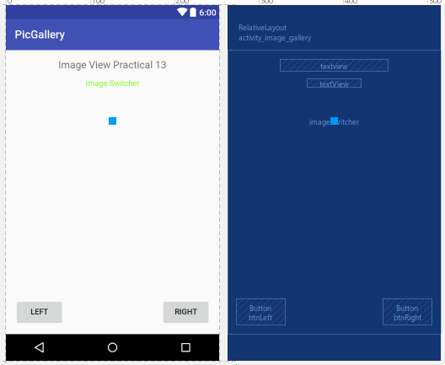
Figure 1.
Step 3:
Modify the ImageGalleryActivity.java to be able to display the image when user click on the Left or Right button.

Declare the following variable for the ImageSwitcher, Button and an Array for the images.
The code for the ImageGalleryActivity.java is as follows.

package mapp.com.sg.picgallery;

import android.support.v7.app.ActionBar;
import android.support.v7.app.AppCompatActivity;
import android.os.Bundle;
import android.view.View;
import android.widget.Button;
import android.widget.ImageSwitcher;
import android.widget.ImageView;
import android.widget.Toast;
import android.widget.ViewSwitcher;

public class ImageGalleryActivity extends AppCompatActivity {
private ImageSwitcher sw;
private Button moveleft, moveright;

// Place images into an array
int imgIds[] ={R.drawable.p1,
R.drawable.p2,
R.drawable.p3,
R.drawable.p4,
R.drawable.p5,
R.drawable.p6,
R.drawable.p7};
int imgCount = imgIds.length;
int currentIndex = -1 ;

@Override
protected void onCreate(Bundle savedInstanceState) {
super.onCreate(savedInstanceState);
setContentView(R.layout.activity_image_gallery);

moveleft = (Button) findViewById(R.id.btnLeft);
moveright = (Button) findViewById(R.id.btnRight);

sw = (ImageSwitcher) findViewById(R.id.imageSwitcher);
sw.setFactory(new ViewSwitcher.ViewFactory() {
@Override
public View makeView() {
ImageView myView = new ImageView(getApplicationContext());
myView.setScaleType(ImageView.ScaleType.FIT_CENTER);
myView.setLayoutParams(new
ImageSwitcher.LayoutParams(ActionBar.LayoutParams.WRAP_CONTENT,
ActionBar.LayoutParams.WRAP_CONTENT));
return myView;
}
});

moveleft.setOnClickListener(new View.OnClickListener() {
@Override
public void onClick(View v) {
currentIndex--;
if (currentIndex == 0){
// Disable moveleft button when it is first pictures
moveleft.setEnabled(false) ;
} else{
moveright.setEnabled(true) ;
}

sw.setImageResource(imgIds[currentIndex]);
Toast.makeText(getApplicationContext(), "Previous Image " + currentIndex,
Toast.LENGTH_LONG).show();

}
});

moveright.setOnClickListener(new View.OnClickListener() {
@Override
public void onClick(View v) {
currentIndex++;
if (currentIndex == imgCount -1){
// Disable right button when it reach last image
moveright.setEnabled(false) ;
} else{
moveleft.setEnabled(true) ;
}
Toast.makeText(getApplicationContext(), "Next Image " + currentIndex,
Toast.LENGTH_LONG).show();
sw.setImageResource(imgIds[currentIndex]);

}
});

}
}

Step 4:
Remember to copy the 7 images into app/res/drawable/ directory.

Code detail:
setFactory(ViewFactory factory):
This method is used to create a new view for ImageSwitcher. By using this method we create a new ImageView and replace the old view with another image.

setImageResource(int resid):
This method is also used to set an image in image switcher. The image is passed in the form of integer id.

The application will enable and disable the left button if it is the first image and the right button if it is the last image.

The following is the screen shot for the ImageView.
First Image  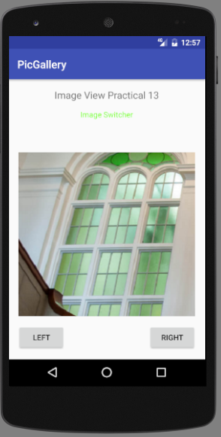 | Last Image  