School of Digital Media and Infocomm Technology (DMIT)
ST0281 Mobile Applications
Practical 14

Objectives:

After completing this lab, you will be able to:

- Create landscape view layout

In this practical, you will create a landscape view for the layout.

This is a continuation of Practical 13. Hence, launch Android Studio and open the project that you have created in Practical 13.

Follow the following steps:
Step 1:
Create a new folder name layout-land.
Right click on the res/layout and select new Directory.
Enter layout-land as the new directory name.

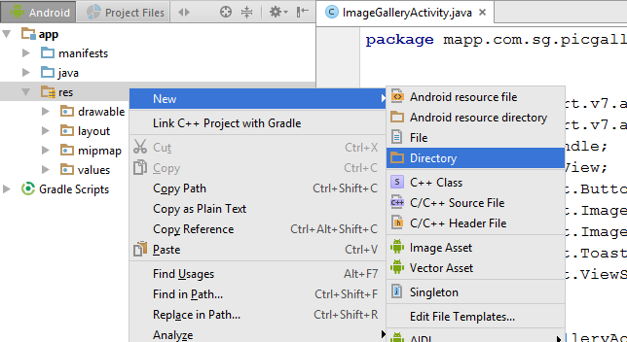 | 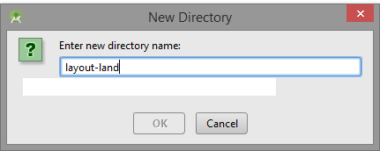

A new sub directory will be create in the res folder.

Step 2:
In order to have a consistent design between the portrait view and landscape view. Go to the project directory and locate the app/src/main/res/layout using FileExplorer.
Copy the portrait layout, as shown below.
Note: Right click copy.

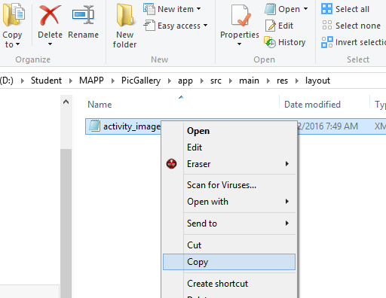

Step 3:
Using FileExplorer, go the the app/src/main/res/layout-land directory.
Right click paste the portrait layout to the landscape layout.

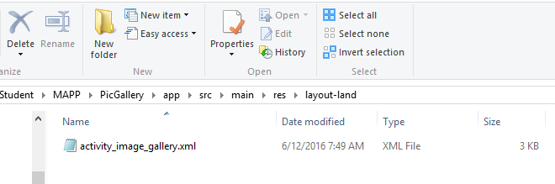

Step 4:
Go back to Android studio. The layout_image_gallery.xml have 2 version as shown below.
The item that mark with (land) means it is the landscape display.

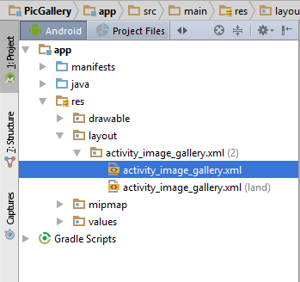

Step 5:
Modify the layout for the landscape design to differential between portrait and landscape.
The following is the layout for landscape.

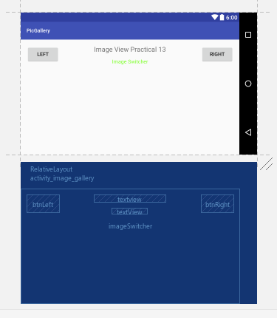

The xml code the landscape design is as follows:

<?xml version="1.0" encoding="utf-8"?>
<RelativeLayout xmlns:android="http://schemas.android.com/apk/res/android"
xmlns:app="http://schemas.android.com/apk/res-auto"
xmlns:tools="http://schemas.android.com/tools"
android:id="@+id/activity_image_gallery"
android:layout_width="match_parent"
android:layout_height="match_parent"
android:paddingBottom="@dimen/activity_vertical_margin"
android:paddingLeft="@dimen/activity_horizontal_margin"
android:paddingRight="@dimen/activity_horizontal_margin"
android:paddingTop="@dimen/activity_vertical_margin"
tools:context="mapp.com.sg.picgallery.ImageGalleryActivity">

<TextView android:text="Image View Practical 13"
android:layout_width="wrap_content"
android:layout_height="wrap_content"
android:id="@+id/textview"
android:textSize="18sp"
android:layout_alignParentTop="true"
android:layout_centerHorizontal="true" />

<ImageSwitcher
android:layout_width="wrap_content"
android:layout_height="wrap_content"
android:id="@+id/imageSwitcher"
android:layout_below="@+id/textView"
android:layout_centerHorizontal="true"
android:layout_marginTop="30dp" />

<TextView
android:layout_width="wrap_content"
android:layout_height="wrap_content"
android:text="Image Switcher"
android:id="@+id/textView"
android:textColor="#ff7aff24"
android:textSize="14sp"
android:layout_below="@+id/textview"
android:layout_centerHorizontal="true"
android:layout_marginTop="14dp" />

<Button
android:layout_width="wrap_content"
android:layout_height="wrap_content"
android:text="Right"
android:id="@+id/btnRight"
android:layout_alignParentTop="true"
android:layout_alignParentRight="true"
android:layout_alignParentEnd="true" />

<Button
android:layout_width="wrap_content"
android:layout_height="wrap_content"
android:text="Left"
android:id="@+id/btnLeft"
android:layout_alignParentTop="true"
android:layout_alignParentLeft="true"
android:layout_alignParentStart="true" />

</RelativeLayout>

Step 6:
Execute the PicGallery and view the result using the Android emulator. Switch between portrait and landscape view.

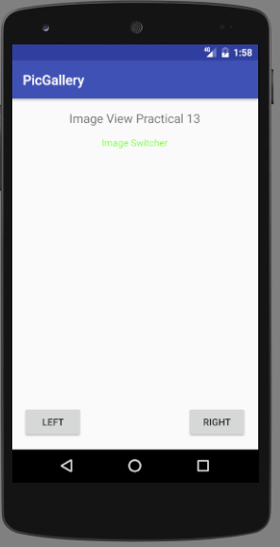 | 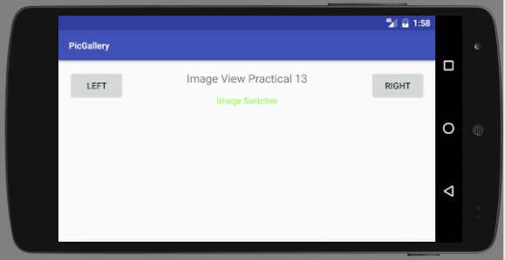
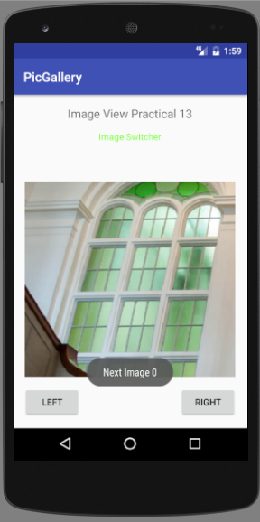 | 