School of Digital Media and Infocomm Technology (DMIT)
ST0281 Mobile Applications
Practical 16

Objectives:

After completing this lab, you will be able to:

- Use SQLiteDatabse and SQLiteOpenHelper in Android
- Program an Activity to save information in an Android application using SQLite
- Display the saved information in the same Android application

In this practical, you will create a new Android project to implement an application to make use of SQLite.

This Android application will save information relating to an event. Each event will be stored as a row in the events table. Each row will have an id, time and title column.

_id is the primary key; time and title will be used for a time stamp and event title respectively.

This application will make use of 3 java classes: Constants.java, EventsMain.java and EventsData.java

Step 1:
Create a new project called SQLite Events.

1. Application name: SQLite Events  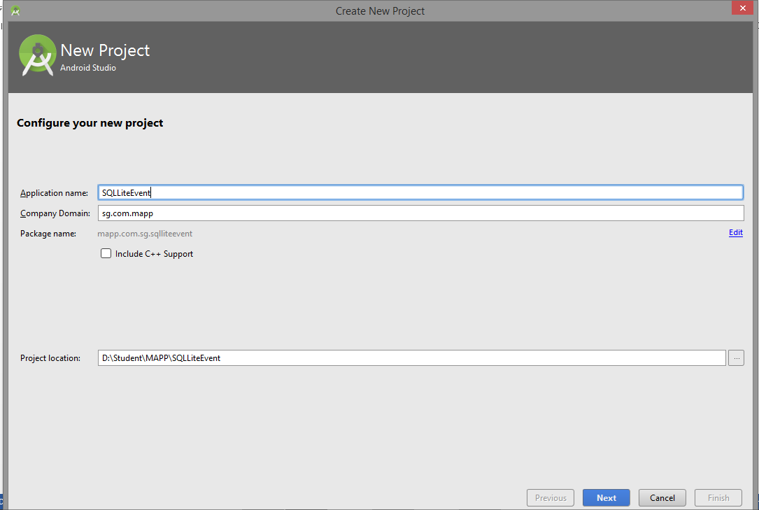 | 2.  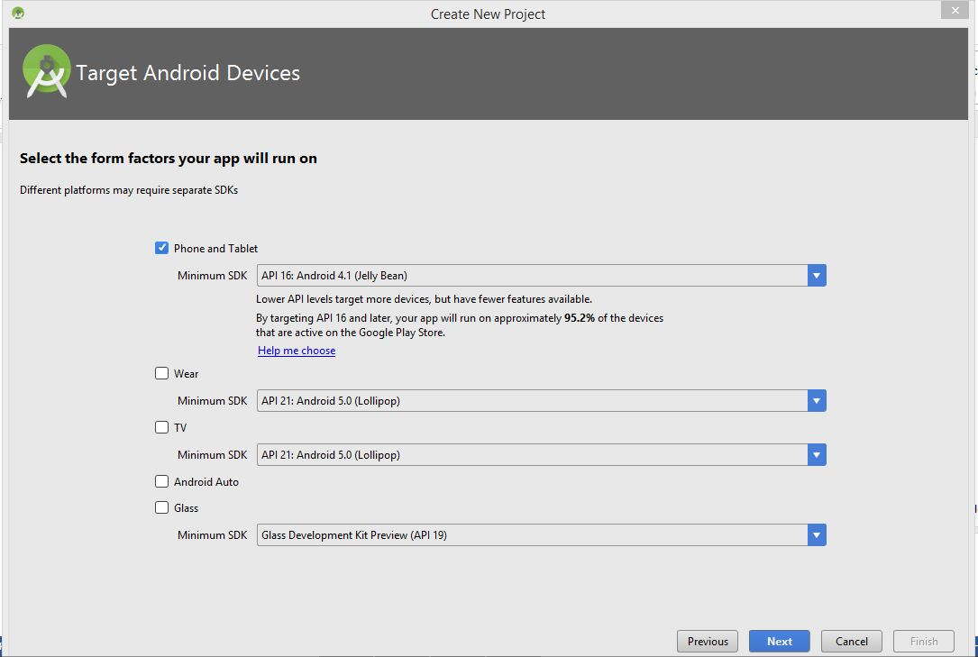
3. Empty Activity  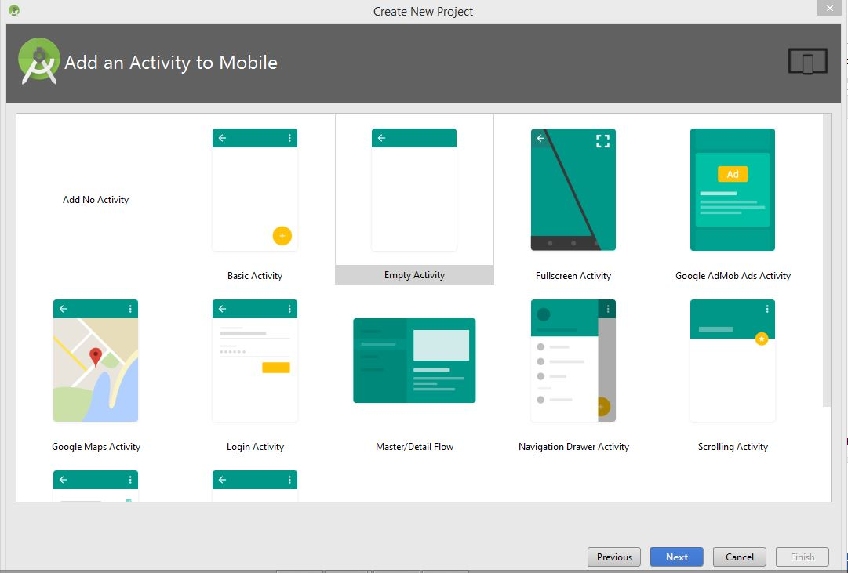 | 4. Activity Name:EventsMain  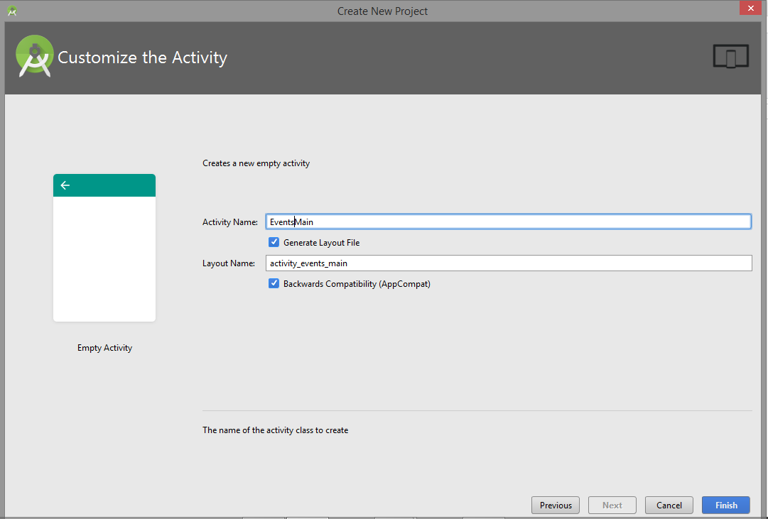

Step 2:
Create a new Java class called Constants and add in the code as shown:

package mapp.com.sg.sqlliteevent;

import android.provider.BaseColumns;

/**
* Created by s38092 on 8/12/2016.
*/

import android.provider.BaseColumns;

public interface Constants extends BaseColumns {
public static final String TABLE_NAME = "events";

// columns
public static final String TIME = "time";
public static final String TITLE = "title";

}

Step 2:
Define a helper class called Eventsdata.java to represent the database. Extends the SQLiteOpenHelper which manages database creation and versions:

Add in the following code:

package mapp.com.sg.sqlliteevent;

import static android.provider.BaseColumns._ID;
import static mapp.com.sg.sqlliteevent.Constants.TABLE_NAME;
import static mapp.com.sg.sqlliteevent.Constants.TIME;
import static mapp.com.sg.sqlliteevent.Constants.TITLE;
import android.content.Context;
import android.database.sqlite.SQLiteDatabase;
import android.database.sqlite.SQLiteOpenHelper;

public class EventsData extends SQLiteOpenHelper{

private static final String DATABASE_NAME = "events.db";
private static final int DATABASE_VERSION = 1;

public EventsData(Context ctx) {
super(ctx, DATABASE_NAME, null, DATABASE_VERSION);
}

@Override
public void onCreate(SQLiteDatabase db) {
db.execSQL("CREATE TABLE " + TABLE_NAME + " (" + _ID
+ " INTEGER PRIMARY KEY AUTOINCREMENT, " + TIME
+ " INTEGER," + TITLE + " TEXT NOT NULL);");

}

@Override
public void onUpgrade(SQLiteDatabase db, int oldVersion, int newVersion){
db.execSQL("DROP TABLE IF EXISTS " + TABLE_NAME);
onCreate(db);
}

}
Step 3:
Modify the activity_events_main.xml as follows:

<?xml version="1.0" encoding="utf-8"?>
<RelativeLayout xmlns:android="http://schemas.android.com/apk/res/android"
xmlns:tools="http://schemas.android.com/tools"
android:id="@+id/activity_events_main"
android:layout_width="match_parent"
android:layout_height="match_parent"
android:paddingBottom="@dimen/activity_vertical_margin"
android:paddingLeft="@dimen/activity_horizontal_margin"
android:paddingRight="@dimen/activity_horizontal_margin"
android:paddingTop="@dimen/activity_vertical_margin"
tools:context="mapp.com.sg.sqlliteevent.EventsMain">

<TextView
android:id="@+id/text"
android:layout_width="wrap_content"
android:layout_height="wrap_content">
</TextView>
</RelativeLayout>

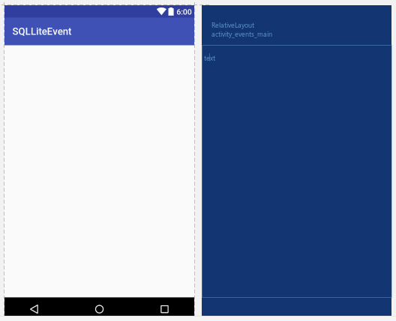

Step 4:
Modify the EventsMain.java as follows:

package mapp.com.sg.sqlliteevent;

import android.support.v7.app.AppCompatActivity;
import android.os.Bundle;
import android.content.ContentValues;
import android.database.Cursor;
import android.database.sqlite.SQLiteDatabase;
import android.widget.TextView;
import static android.provider.BaseColumns._ID;
import static mapp.com.sg.sqlliteevent.Constants.TABLE_NAME;
import static mapp.com.sg.sqlliteevent.Constants.TIME;
import static mapp.com.sg.sqlliteevent.Constants.TITLE;

public class EventsMain extends AppCompatActivity {

private static String[] FROM = { _ID, TIME, TITLE, };
private static String ORDER_BY = TIME + " DESC" ;
private EventsData events;

@Override
protected void onCreate(Bundle savedInstanceState) {
super.onCreate(savedInstanceState);
setContentView(R.layout.activity_events_main);

events = new EventsData(this);
try {
addEvent ("Hello, Android");
Cursor cursor = getEvents();
showEvents(cursor);
}finally {
events.close();
}
}

private void addEvent(String string){
SQLiteDatabase db = events.getWritableDatabase();
ContentValues values = new ContentValues();
values.put(TIME, System.currentTimeMillis());
values.put(TITLE, string);
db.insertOrThrow(TABLE_NAME, null, values);

}

private Cursor getEvents(){
SQLiteDatabase db = events.getReadableDatabase();
Cursor cursor = db.query(TABLE_NAME, FROM, null, null, null, null, ORDER_BY);
return cursor;
}

private void showEvents(Cursor cursor){
StringBuilder builder = new StringBuilder("Saved events:\n");
while (cursor.moveToNext()){
long id = cursor.getLong(0);
long time = cursor.getLong(1);
String title = cursor.getString(2);
builder.append(id).append(": ");
builder.append(time).append(": ");
builder.append(title).append("\n");

}

TextView text = (TextView) findViewById(R.id.text);
text.setText(builder);

}
}

Step 5:
Save all files and run the project. The application will writes an event to the database every time it is being executed. The event saved is displayed as shown:

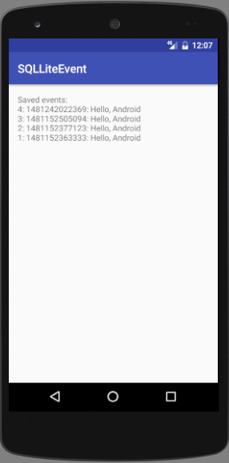

Step 6:
Refer to lecture note (MAPP L9v3.pptm elearning@sp -> Lecture Week 12 & 13). Implement the project using SQLite to store user name and email in the SQLite database.

-- End of Practical 16 --

