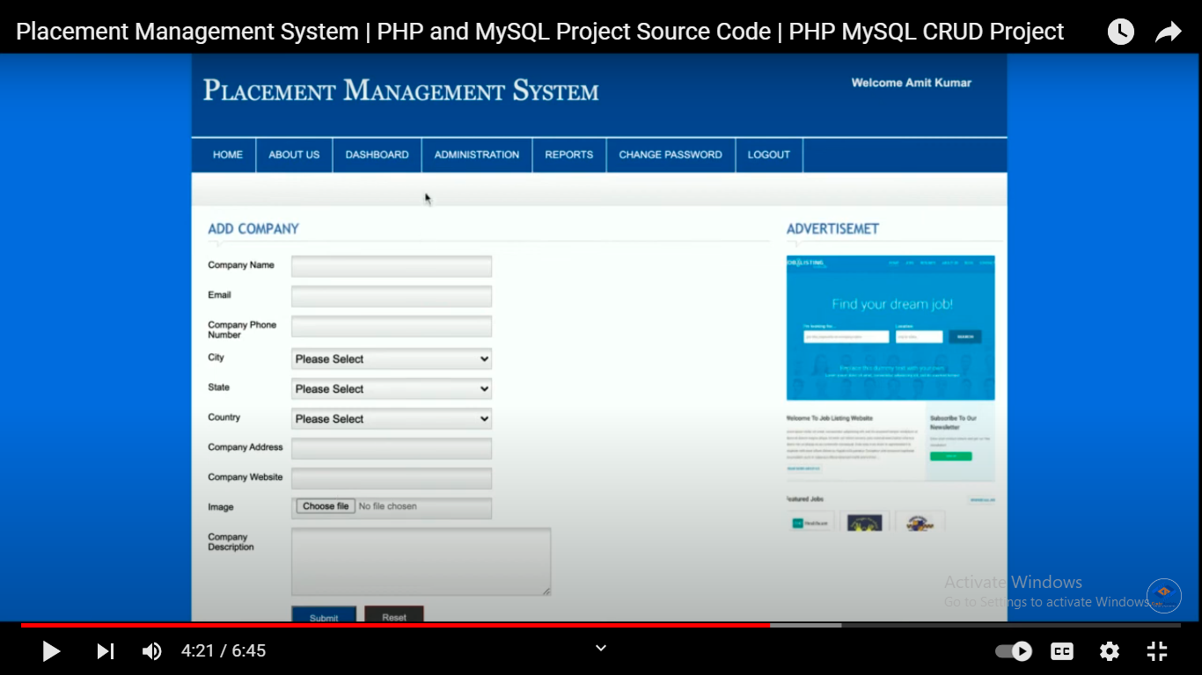

https://www.youtube.com/watch?v=seIutM9cv8M