Logistic Regression

# Sigmoid函数

S形状的函数，最典型的就是Logistic函数：





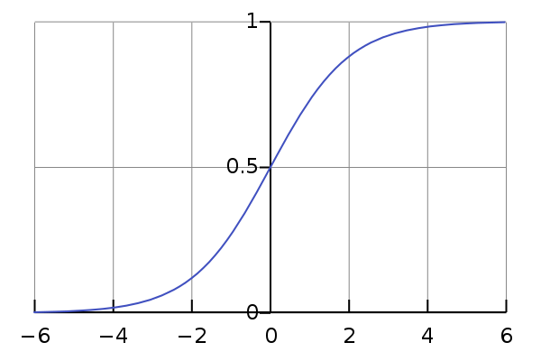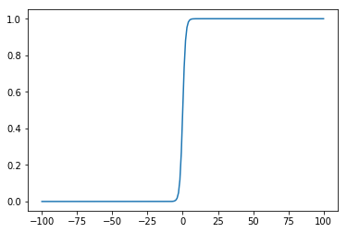

其它的sigmoid函数（<https://en.wikipedia.org/wiki/Sigmoid_function>）：



* [hyperbolic tangent](https://en.wikipedia.org/wiki/Hyperbolic_function)





* [arctangent function](https://en.wikipedia.org/wiki/Inverse_trigonometric_function)



* [Gudermannian function](https://en.wikipedia.org/wiki/Gudermannian_function)



* [Error function](https://en.wikipedia.org/wiki/Error_function)



* [Generalised logistic function](https://en.wikipedia.org/wiki/Generalised_logistic_function)



* [Smoothstep](https://en.wikipedia.org/wiki/Smoothstep) function



* Specific [algebraic functions](https://en.wikipedia.org/wiki/Algebraic_function)

.

