1. 数据库建表语句

|  |
| --- |
| SET NAMES utf8mb4;  SET FOREIGN_KEY_CHECKS = 0;  DROP TABLE IF EXISTS `student`;  CREATE TABLE `student` (  `id` int(11) NOT NULL AUTO_INCREMENT,  `name` varchar(80) CHARACTER SET utf8 COLLATE utf8_general_ci NULL DEFAULT NULL,  `sid` int(80) NULL DEFAULT NULL,  `gender` varchar(2) CHARACTER SET utf8 COLLATE utf8_general_ci NULL DEFAULT NULL,  `tel` int(11) NULL DEFAULT NULL,  PRIMARY KEY (`id`) USING BTREE  ) ENGINE = InnoDB AUTO_INCREMENT = 20 CHARACTER SET = utf8 COLLATE = utf8_general_ci ROW_FORMAT = Compact;  SET FOREIGN_KEY_CHECKS = 1; |

1. domain/Student.java

|  |
| --- |
| package domain;  public class Student {  private int id;  private String name;  private int sid;  private String gender;  private int tel;  public int getId() {  return id;  }  public void setId(int id) {  this.id = id;  }  public String getName() {  return name;  }  public void setName(String name) {  this.name = name;  }  public int getSid() {  return sid;  }  public void setSid(int sid) {  this.sid = sid;  }  public String getGender() {  return gender;  }  public void setGender(String gender) {  this.gender = gender;  }  public int getTel() {  return tel;  }  public void setTel(int tel) {  this.tel = tel;  }  } |

1. utils/DBUtils

|  |
| --- |
| package utils;  import java.sql.Connection;  import java.sql.DriverManager;  import java.sql.ResultSet;  import java.sql.SQLException;  import java.sql.Statement;  public class DBUtils {  private static String driveClassName = "com.mysql.jdbc.Driver";  // 数据库的url  private static String url =  "jdbc:mysql://localhost:3306/test?useUnicode=true&characterEncoding=utf8";  // 数据库用户名  private static String user = "root";  // 数据库密码  private static String password = "admin";  /** 获取connection对象 */  public static Connection getConnection() {  Connection conn = null;  try {  Class.forName(driveClassName);  } catch (ClassNotFoundException e) {  e.printStackTrace();  }  try {  conn = DriverManager.getConnection(url, user, password);  } catch (SQLException e) {  e.printStackTrace();  }  return conn;  }  /** 释放资源 */  public static void closeAll(Connection conn, Statement st, ResultSet rs) {  // 负责关闭  if (conn != null) {  try {  conn.close(); // 使用代理,放回到连接池中  } catch (SQLException e) {  e.printStackTrace();  }  }  if (st != null) {  try {  st.close();  } catch (SQLException e) {  e.printStackTrace();  }  }  if (rs != null) {  try {  rs.close();  } catch (SQLException e) {  e.printStackTrace();  }  }  }  } |

1. web/add.jsp

|  |
| --- |
| <%@ page contentType="text/html;charset=UTF-8" language="java" %>  <!DOCTYPE html>  <html lang="zh-CN">  <head>  <title>添加学生信息</title>  </head>  <style>  a {  text-decoration: none  }  a:visited {  color: #0000EE  }  a:active {  color: #FF0000  }  </style>  <body>  <div class="container" align="center">  <center><h3>添加学生信息页面</h3></center>  <form action="addStudent.jsp" method="post">  <table>  <tr>  <td><label for="name">姓名：</label></td>  <td><input type="text" class="form-control" id="name" name="name" placeholder="请输入姓名"></td>  </tr>  <tr>  <td><label for="name">性别：</label></td>  <td>  <input type="radio" name="gender" value="男" checked="checked"/>男  <input type="radio" name="gender" value="女"/>女  </td>  </tr>  <tr>  <td><label for="name">学号：</label></td>  <td><input type="text" class="form-control" id="sid" name="sid" placeholder="请输入学号"></td>  </tr>  <tr>  <td><label for="name">电话：</label></td>  <td><input type="text" class="form-control" id="tel" name="tel" placeholder="请输入电话"/></td>  </tr>  </table>  <div class="form-group" style="text-align: center">  <input type="button" value="提交" onclick="check()">  <input type="reset" value="重置"/>  </div>  </form>  <!-- 空判断功能-->  <script type="text/javascript">  function check() {  var name = document.getElementById("name").value;  var sid = document.getElementById("sid").value;  var tel = document.getElementById("tel").value;  if (name.trim() == "" || sid.trim() == "" || tel.trim() == "") {  alert("请输入完整信息");  } else {  //通过验证就提交  document.forms[0].submit();  }  }  </script>  </div>  </body>  </html> |

1. web/addStudent.jsp

|  |
| --- |
| <%@ page import="java.sql.Connection" %>  <%@ page import="java.sql.PreparedStatement" %>  <%@ page import="utils.DBUtils" %>  <%@ page import="java.sql.SQLException" %>  <%@ page contentType="text/html;charset=UTF-8" language="java" %>  <html>  <head>  <title>添加学生信息</title>  </head>  <body>  <%  //设置编码  request.setCharacterEncoding("utf-8");  //获取参数  String name = request.getParameter("name");  String sid = request.getParameter("sid");  String gender = request.getParameter("gender");  String tel = request.getParameter("tel");  int count = 0;  Connection conn = null;  PreparedStatement ps = null;  try {  //添加的sql语句  String sql = "insert into student values(null,?,?,?,?)";  //获取connection连接对象  conn = DBUtils.getConnection();  //获取PreparedStatement对象  ps = conn.prepareStatement(sql);  //设置参数  ps.setString(1, name);  ps.setInt(2, Integer.parseInt(sid));  ps.setString(3, gender);  ps.setInt(4, Integer.parseInt(tel));  //执行sql  count = ps.executeUpdate();  } catch (SQLException e) {  e.printStackTrace();  } finally {  //释放资源  DBUtils.closeAll(conn, ps, null);  }  //跳转到index.jsp  response.sendRedirect("index.jsp");  %>  </body>  </html> |

1. web/deleteStudent.jsp

|  |
| --- |
| <%@ page import="utils.DBUtils" %>  <%@ page import="java.sql.Connection" %>  <%@ page import="java.sql.PreparedStatement" %>  <%@ page import="java.sql.SQLException" %>  <%@ page contentType="text/html;charset=UTF-8" language="java" %>  <html>  <head>  <title>删除学生信息</title>  </head>  <body>  <%  //设置编码  request.setCharacterEncoding("utf-8");  //获取删除条目的id  String id = request.getParameter("id");  int count = 0;  Connection conn = null;  PreparedStatement ps = null;  try {  //添加的sql语句  String sql = "delete from student where id = ?";  //获取connection连接对象  conn = DBUtils.getConnection();  //获取PreparedStatement对象  ps = conn.prepareStatement(sql);  //设置参数  ps.setString(1, id);  //执行sql  count = ps.executeUpdate();  } catch (SQLException e) {  e.printStackTrace();  } finally {  //释放资源  DBUtils.closeAll(conn, ps, null);  }  //跳转到index.jsp  response.sendRedirect("index.jsp");  %>  </body>  </html> |

1. web/index.jsp

|  |
| --- |
| <%@ taglib prefix="c" uri="http://java.sun.com/jsp/jstl/core" %>  <%@ page import="utils.DBUtils" %>  <%@ page import="java.sql.Connection" %>  <%@ page import="java.sql.PreparedStatement" %>  <%@ page import="java.sql.ResultSet" %>  <%@ page import="domain.Student" %>  <%@ page import="java.util.List" %>  <%@ page import="java.util.ArrayList" %>  <%@ page import="java.sql.SQLException" %>  <%@ page contentType="text/html;charset=UTF-8" language="java" %>  <html>  <head>  <title>学生基本信息管理系统</title>  </head>  <style>  a {  text-decoration: none  }  a:visited {  color: #0000EE  }  a:active {  color: #FF0000  }  </style>  <script>  function deleteUser(id) {  //用户安全提示  if (confirm("您确定要删除吗？")) {  //访问路径  location.href = "deleteStudent.jsp?id=" + id;  }  }  </script>  <body>  <%  Connection conn = null;  PreparedStatement ps = null;  ResultSet rs = null;  try {  //编写SQL语句  String sql = "select * from student";  //获取connection对象  conn = DBUtils.getConnection();  //获取PreparedStatement对象  ps = conn.prepareStatement(sql);  //执行查询  rs = ps.executeQuery();  List<Student> studentList = new ArrayList<>();  //遍历结果集  while (rs.next()) {  Student student = new Student();  student.setId(rs.getInt("id"));  student.setName(rs.getString("name"));  student.setSid(rs.getInt("sid"));  student.setGender(rs.getString("gender"));  student.setTel(rs.getInt("tel"));  studentList.add(student);  }  //将数据放入pageContext域中  pageContext.setAttribute("studentList", studentList);  } catch (SQLException e) {  e.printStackTrace();  } finally {  //释放资源  DBUtils.closeAll(conn, ps, rs);  }  %>  <div align="center">  <a href="add.jsp">添加学生信息</a>  </div>  <table align="center" width="500px" border="1" style="border-collapse:collapse;">  <tr>  <th>编号</th>  <th>姓名</th>  <th>学号</th>  <th>性别</th>  <th>联系方式</th>  <th>操作</th>  </tr>  <!-- 遍历展示数据-->  <c:forEach items="${studentList}" var="student" varStatus="s">  <tr align="center">  <td>${s.count}</td>  <td>${student.name}</td>  <td>${student.sid}</td>  <td>${student.gender}</td>  <td>${student.tel}</td>  <td>  <a href="update.jsp?id=${student.id}">更新</a>  <a href="javascript:deleteUser(${student.id});">删除</a>  </td>  </tr>  </c:forEach>  </table>  <div align="center">  <div style="padding-top: 20px;">  <form action="searchStudent.jsp" method="post">  <span align="center">  姓名:<input type="text" name="mname" id="mname" placeholder="根据姓名模糊查询">  学号:<input type="text" name="msid" id="msid" placeholder="根据学号模糊查询">  <input type="submit" value="模糊查询"/>  </span>  </form>  </div>  <span>  <a href="orderBy.jsp?condition=1">根据姓名排序</a>  <a href="orderBy.jsp?condition=2">根据学号排序</a>  </span>  </div>  </body>  </html> |

1. web/orderBy.jsp

|  |
| --- |
| <%@ page import="java.sql.Connection" %>  <%@ page import="java.sql.PreparedStatement" %>  <%@ page import="java.sql.ResultSet" %>  <%@ page import="utils.DBUtils" %>  <%@ page import="domain.Student" %>  <%@ page import="java.util.List" %>  <%@ page import="java.util.ArrayList" %>  <%@ page import="java.sql.SQLException" %>  <%@ taglib prefix="c" uri="http://java.sun.com/jsp/jstl/core" %>  <%@ page contentType="text/html;charset=UTF-8" language="java" %>  <html>  <head>  <title>排序</title>  </head>  <style>  a {  text-decoration: none  }  a:visited {  color: #0000EE  }  a:active {  color: #FF0000  }  </style>  <script>  function deleteUser(id) {  //用户安全提示  if (confirm("您确定要删除吗？")) {  //访问路径  location.href = "deleteStudent.jsp?id=" + id;  }  }  </script>  <body>  <%  String condition = request.getParameter("condition");  String sql = null;  //根据姓名排序  if ("1".equals(condition)) {  sql = "select * from student order by name";  }  //根据学号排序  if ("2".equals(condition)) {  sql = "select * from student order by sid";  }  Connection conn = null;  PreparedStatement ps = null;  ResultSet rs = null;  try {  //获取connection对象  conn = DBUtils.getConnection();  //获取PreparedStatement对象  ps = conn.prepareStatement(sql);  //执行sql语句  rs = ps.executeQuery();  List<Student> studentList = new ArrayList<>();  //遍历结果集  while (rs.next()) {  Student student = new Student();  student.setId(rs.getInt("id"));  student.setName(rs.getString("name"));  student.setSid(rs.getInt("sid"));  student.setGender(rs.getString("gender"));  student.setTel(rs.getInt("tel"));  studentList.add(student);  }  //将数据放置在pageContext域对象中  pageContext.setAttribute("studentList", studentList);  } catch (SQLException e) {  e.printStackTrace();  } finally {  //释放资源  DBUtils.closeAll(conn, ps, rs);  }  %>  <table align="center" width="500px" border="1" style="border-collapse:collapse;">  <tr>  <th>编号</th>  <th>姓名</th>  <th>学号</th>  <th>性别</th>  <th>联系方式</th>  <th>操作</th>  </tr>  <c:forEach items="${studentList}" var="student" varStatus="s">  <tr align="center">  <td>${s.count}</td>  <td>${student.name}</td>  <td>${student.sid}</td>  <td>${student.gender}</td>  <td>${student.tel}</td>  <td>  <a href="update.jsp?id=${student.id}">更新</a>  <a href="javascript:deleteUser(${student.id});">删除</a>  </td>  </tr>  </c:forEach>  </table>  </body>  </html> |

1. web/searchStudent.jsp

|  |
| --- |
| <%@ taglib prefix="c" uri="http://java.sun.com/jsp/jstl/core" %>  <%@ page import="java.sql.Connection" %>  <%@ page import="java.sql.PreparedStatement" %>  <%@ page import="utils.DBUtils" %>  <%@ page import="java.sql.SQLException" %>  <%@ page import="java.sql.ResultSet" %>  <%@ page import="domain.Student" %>  <%@ page import="java.util.List" %>  <%@ page import="java.util.ArrayList" %>  <%@ page contentType="text/html;charset=UTF-8" language="java" %>  <html>  <head>  <title>模糊查询学生信息</title>  </head>  <style>  a {  text-decoration: none  }  a:visited {  color: #0000EE  }  a:active {  color: #FF0000  }  </style>  <script>  function deleteUser(id) {  //用户安全提示  if (confirm("您确定要删除吗？")) {  //访问路径  location.href = "deleteStudent.jsp?id=" + id;  }  }  </script>  <body>  <%  //设置编码  request.setCharacterEncoding("utf-8");  //获取参数  String mname = request.getParameter("mname");  String msid = request.getParameter("msid");  //需要执行的SQL语句  StringBuffer sql = new StringBuffer("select * from student where 1 = 1 ");  //姓名有值  if (mname.trim().length() > 0) {  sql.append(" and name like ?");  }  //学号有值  if (msid.trim().length() > 0) {  sql.append(" and sid like ?");  }  int i = 1;  Connection conn = null;  PreparedStatement ps = null;  try {  //获取connection连接对象  conn = DBUtils.getConnection();  //获取PreparedStatement对象  ps = conn.prepareStatement(sql.toString());  //设置参数  if (mname.trim().length() > 0) {  ps.setString(i, "%" + mname + "%");  i++;  }  if (msid.trim().length() > 0) {  ps.setString(i, "%" + msid + "%");  }  //执行sql  ResultSet rs = ps.executeQuery();  List<Student> studentList = new ArrayList<>();  //遍历结果集  while (rs.next()) {  Student student = new Student();  student.setId(rs.getInt("id"));  student.setName(rs.getString("name"));  student.setSid(rs.getInt("sid"));  student.setGender(rs.getString("gender"));  student.setTel(rs.getInt("tel"));  studentList.add(student);  }  //将数据放置在pageContext域对象中  pageContext.setAttribute("studentList", studentList);  } catch (SQLException e) {  e.printStackTrace();  } finally {  //释放资源  DBUtils.closeAll(conn, ps, null);  }  %>  <table align="center" width="500px" border="1" style="border-collapse:collapse;">  <tr>  <th>编号</th>  <th>姓名</th>  <th>学号</th>  <th>性别</th>  <th>联系方式</th>  <th>操作</th>  </tr>  <c:forEach items="${studentList}" var="student" varStatus="s">  <tr align="center">  <td>${s.count}</td>  <td>${student.name}</td>  <td>${student.sid}</td>  <td>${student.gender}</td>  <td>${student.tel}</td>  <td>  <a href="update.jsp?id=${student.id}">更新</a>  <a href="javascript:deleteUser(${student.id});">删除</a>  </td>  </tr>  </c:forEach>  </table>  </body>  </html> |

1. web/update.jsp

|  |
| --- |
| <%@ taglib prefix="c" uri="http://java.sun.com/jsp/jstl/core" %>  <%@ page import="java.sql.Connection" %>  <%@ page import="java.sql.PreparedStatement" %>  <%@ page import="utils.DBUtils" %>  <%@ page import="java.sql.SQLException" %>  <%@ page import="java.sql.ResultSet" %>  <%@ page import="domain.Student" %>  <%@ page contentType="text/html;charset=UTF-8" language="java" %>  <html>  <head>  <title>更新学生信息</title>  </head>  <style>  a {  text-decoration: none  }  a:visited {  color: #0000EE  }  a:active {  color: #FF0000  }  </style>  <body>  <%  //获取需要修改数据的id  String num = request.getParameter("id");  //将string转换成int  int id = Integer.parseInt(num);  int count = 0;  Connection conn = null;  PreparedStatement ps = null;  try {  //添加的sql语句  // String sql = "update student set name=?,sid=?,gender=?,tel=? where id = ?";  String sql = "select * from student where id=?";  //获取connection连接对象  conn = DBUtils.getConnection();  //获取PreparedStatement对象  ps = conn.prepareStatement(sql);  ps.setInt(1, id);  //执行sql  ResultSet rs = ps.executeQuery();  //声明student对象  Student student = null;  while (rs.next()) {  student = new Student();  //为student设置属性  student.setId(id);  student.setName(rs.getString("name"));  student.setSid(rs.getInt("sid"));  student.setGender(rs.getString("gender"));  student.setTel(rs.getInt("tel"));  }  if (student != null) {  pageContext.setAttribute("student", student);  }  } catch (SQLException e) {  e.printStackTrace();  } finally {  //释放资源  DBUtils.closeAll(conn, ps, null);  }  %>  <div class="container" align="center">  <form action="updateStudent.jsp" method="post">  <input type="hidden" class="form-control" id="id" name="id" value="${student.id}">  <table>  <tr>  <td><label for="name">姓名：</label></td>  <td>  <input type="text" class="form-control" id="name" name="name" placeholder="请输入姓名" value="${student.name}">  </td>  </tr>  <tr>  <td><label for="name">性别：</label></td>  <td>  <c:if test="${student.gender == '女'}">  <input type="radio" name="gender" value="男"/>男  <input type="radio" name="gender" value="女" checked="checked"/>女  </c:if>  <c:if test="${student.gender == '男'}">  <input type="radio" name="gender" value="男" checked="checked"/>男  <input type="radio" name="gender" value="女"/>女  </c:if>  </td>  </tr>  <tr>  <td><label for="name">学号：</label></td>  <td>  <input type="text" class="form-control" id="sid" name="sid" placeholder="请输入学号" value="${student.sid}">  </td>  </tr>  <tr>  <td><label for="name">电话：</label></td>  <td>  <input type="text" class="form-control" id="tel" name="tel" placeholder="请输入电话" value="${student.tel}"/>  </td>  </tr>  </table>  <div class="form-group" style="text-align: center">  <input type="button" value="提交" onclick="check()">  </div>  </form>  </div>  <!--空判断功能-->  <script type="text/javascript">  function check() {  var name = document.getElementById("name").value;  var sid = document.getElementById("sid").value;  var tel = document.getElementById("tel").value;  // alert(document.getElementsByName("gender")[0].value);  if (name.trim() == "" || sid.trim() == "" || tel.trim() == "") {  alert("请输入完整信息");  } else {  //通过验证就提交  document.forms[0].submit();  }  }  </script>  </body>  </html> |

1. web/updateStudent.jsp

|  |
| --- |
| <%@ page contentType="text/html;charset=UTF-8" language="java" %>  <%@ page import="java.sql.Connection" %>  <%@ page import="java.sql.PreparedStatement" %>  <%@ page import="utils.DBUtils" %>  <%@ page import="java.sql.SQLException" %>  <%@ page contentType="text/html;charset=UTF-8" language="java" %>  <html>  <head>  <title>Title</title>  </head>  <style>  a {  text-decoration: none  }  a:visited {  color: #0000EE  }  a:active {  color: #FF0000  }  </style>  <body>  <%  //设置编码  request.setCharacterEncoding("utf-8");  //获取参数  String id = request.getParameter("id");  String name = request.getParameter("name");  String sid = request.getParameter("sid");  String gender = request.getParameter("gender");  String tel = request.getParameter("tel");  int count = 0;  Connection conn = null;  PreparedStatement ps = null;  try {  //添加的sql语句  String sql = "update student set name=?,sid=?,gender=?,tel=? where id=?";  //获取connection连接对象  conn = DBUtils.getConnection();  //获取PreparedStatement对象  ps = conn.prepareStatement(sql);  //设置参数  ps.setString(1, name);  ps.setInt(2, Integer.parseInt(sid));  ps.setString(3, gender);  ps.setInt(4, Integer.parseInt(tel));  ps.setInt(5, Integer.parseInt(id));  //执行sql  count = ps.executeUpdate();  } catch (SQLException e) {  e.printStackTrace();  } finally {  //释放资源  DBUtils.closeAll(conn, ps, null);  }  //跳转到index.jsp  response.sendRedirect("index.jsp");  %>  </body>  </html> |

项目截图

1. 主页面

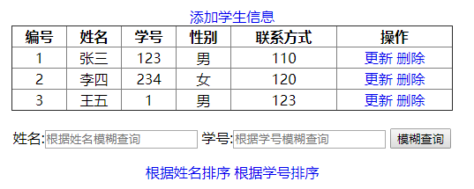

1. 添加页面

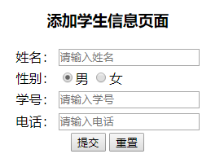

1. 删除提示

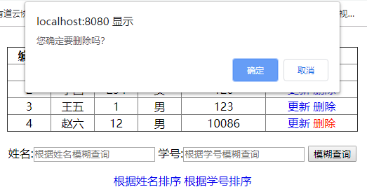

删除完成

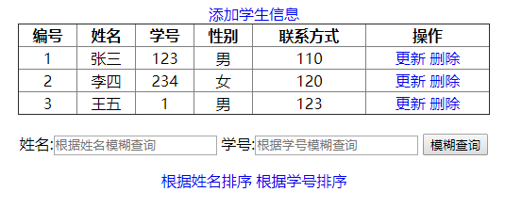

1. 修改页面

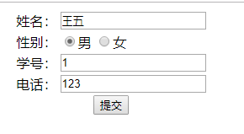

修改王五的学号为100

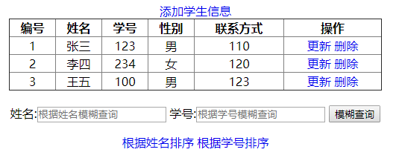

1. 模糊查询功能
2. 不模糊查询

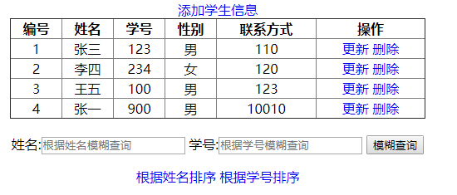

1. 按照姓名模糊查询

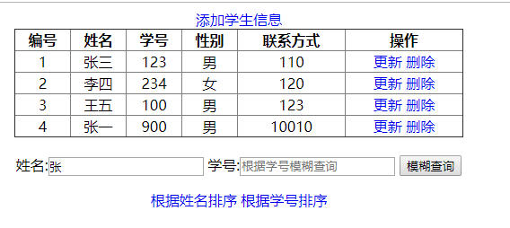

查询结果

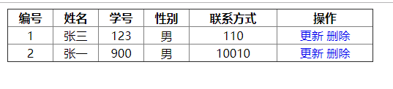

1. 按照学号模糊查询

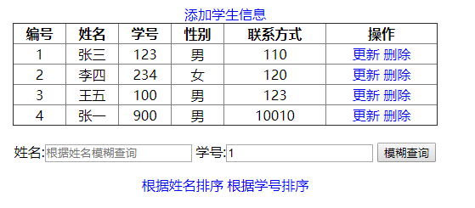

查询结果

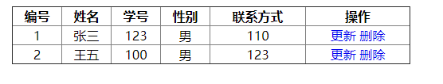

1. 同时按照姓名和学号进行模糊查询

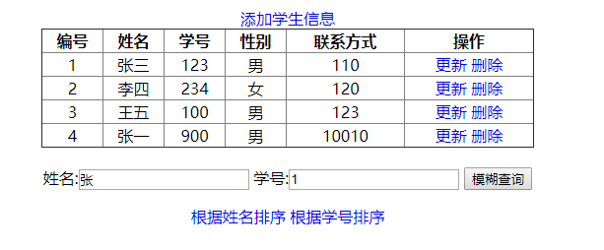

查询结果

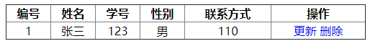

1. 排序查询功能

(1). 根据姓名排序

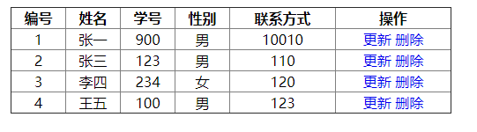

(2) 根据学号排序

