DRONE RESCUE SWARM COMMUNICATION
Version 2: Bayesian search, realistic radio links and multi-hop reporting for a UAV search-and-rescue swarm
Niyathi Vedagiri 23BRS1132 Anna Sunny George 23BRS1321

Abstract
A swarm of small drones is sent to find a missing person in hilly terrain with buildings and then tell the rescue team where the person is. Our first version simulated this in MATLAB with a fixed communication radius, a fixed detection sphere and instant message flooding. This report presents version 2. Every block of the simulation is now based on a standard model from the literature: a Bayesian probability map of where the person may be, a camera whose footprint and detection probability depend on altitude, a log-distance radio model with shadowing and building blockage, graph theory (algebraic connectivity) to measure the network, an energy model with a distance-aware return rule, and random hardware failures. When a drone finds the person, the alert travels hop by hop to a ground control station (GCS); if there is no path, the finder physically carries the message (data mule) and the other drones form a relay chain. The live dashboard was rebuilt from scratch. Over 50 random scenarios, Bayesian search found the person with a median of 82 s (98 % within 7 minutes), lawnmower 89 s (100 %), spiral 107 s (90 %) and random waypoints 107 s (86 %). After detection, the GCS was alerted on average 2.7 s later.

1. Introduction
In search and rescue (SAR), the first hours matter most. A drone swarm can cover ground much faster than people on foot, but only if three things work together: the drones must search the right places, they must recognise the person from the air, and the finding must reach the rescuers. The last point is easy to forget: a drone that sees the person but cannot report it has not helped anyone yet.
Our first assignment (version 1) built a 3-D MATLAB animation of 14 drones with search patterns, a leader, charging stations, obstacles and a message log. It was a good start, but most of its behaviour was hard-coded rather than modelled, and a few bugs meant the search pattern was not actually flown. Version 2 keeps the same idea and the same spirit (one MATLAB file, a parameter dialog, a live 3-D view, CSV logging), but rebuilds every part on a sound theoretical basis and adds a proper experiment: a Monte Carlo comparison of four search strategies.
What is new in version 2 (summary)
- Search: Bayesian belief map, probability of success (POS), four strategies including a greedy Bayesian planner; lawnmower lanes sized to the camera footprint.
- Sensing: camera footprint and detection probability that depend on altitude; detection is random, not certain.
- Radio: path loss + correlated shadowing + building blockage -> SNR -> packet error rate. No fixed "comm radius".
- Reporting: a real ground station, one hop per time step, data-mule fallback and an automatic relay chain.
- Network theory: GCS reachability and algebraic connectivity (lambda 2) of the Laplacian.
- Energy and failures: speed-dependent power, distance-aware return-to-charge, random failures with crash-site inspection and hand-over of unfinished work.
- Visuals: a full dashboard (3-D scene, belief map, battery panel, live plots, event log), a mission summary figure, optional MP4 recording.
- Evidence: 200 simulated missions (50 scenarios x 4 strategies) with paired seeds.

1.1 Problems found in version 1
Before improving the code, we reviewed it line by line. Table 1 lists what we changed and why. The first four rows were real bugs, not just simplifications.
Table 1. Version 1 vs version 2.
Area | Version 1 | Version 2 | Why it matters
Search pattern | Waypoint index advanced with time: mod(floor((step+7i)/3)). Drones jumped between waypoints without reaching them, so the lawnmower was never flown. | Waypoint advances only when reached. Lanes spaced at 0.9 x footprint diameter, one strip per drone. | Guaranteed coverage; the pattern is now what the name says.
Recovery | A lost drone stays "lost", so every step a new rescuer was assigned to it. Soon most of the swarm was in recovery mode. | One inspector per crash; the failed drone's unfinished waypoints are handed over. | Failures no longer cascade into a swarm-wide stall.
Battery | 600 s capacity but only 48 s simulated, so the 20 % rule never fired. Drain did not depend on speed. | Power depends on speed; return when energy < 1.3 x energy needed to reach the nearest pad + 6 % reserve. | Drones near a pad can fly longer; far drones return in time.
Toolbox | pdist needs the Statistics Toolbox. | No toolboxes. Also runs in GNU Octave. | Runs on any MATLAB install.
Detection | Fixed 6 m sphere, detection certain. | Camera footprint r = h tan(30 deg); probability decays with altitude; Bayesian update. | Shows the real altitude trade-off; gives POS.
Radio | Fixed 55 m radius + 2 % random loss. | Path loss, shadowing (time-correlated), building blockage, logistic PER. | Links fade gradually and buildings matter.
Messages | Flooded through the whole connected group in one step; no ground station. | One hop per 0.25 s step; GCS node; data mule; relay chain. | Report latency becomes measurable.
Metrics | "Connectivity" = % of possible links present. | GCS-reachable %, algebraic connectivity, coverage, POS, detection and report times. | Measures what a rescue team cares about.
Visuals | Full redraw every frame (cla), overlapping "B:98%" labels, black titles on dark background, dual y-axes. | Handle-based updates; dashboard with 7 panels; summary figure; MP4 option. | Faster, readable, presentation-ready.

2. System overview
The simulation runs in fixed time steps of Δt = 0.25 s. A random world is generated first (terrain, buildings, ground station, two charging pads, the last known position of the person, and the person's true location). Then the loop in Figure 1 runs every step. Each drone is a small state machine (Figure 2).
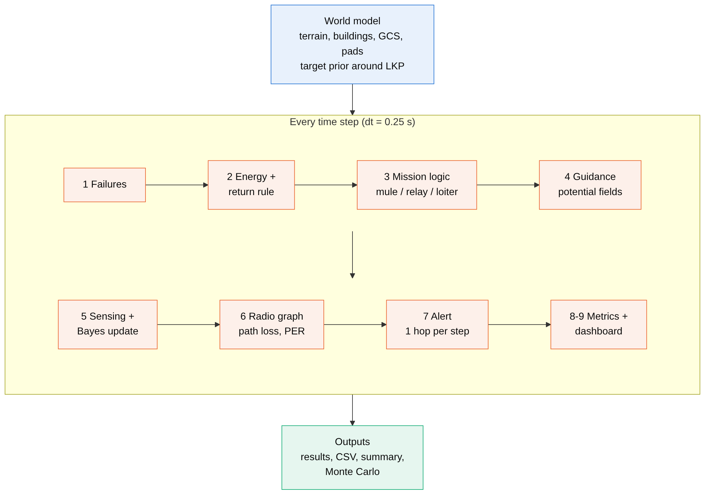
Figure 1. Simulation architecture. Each block in the loop is one section of the MATLAB file and one subsection of Section 3.
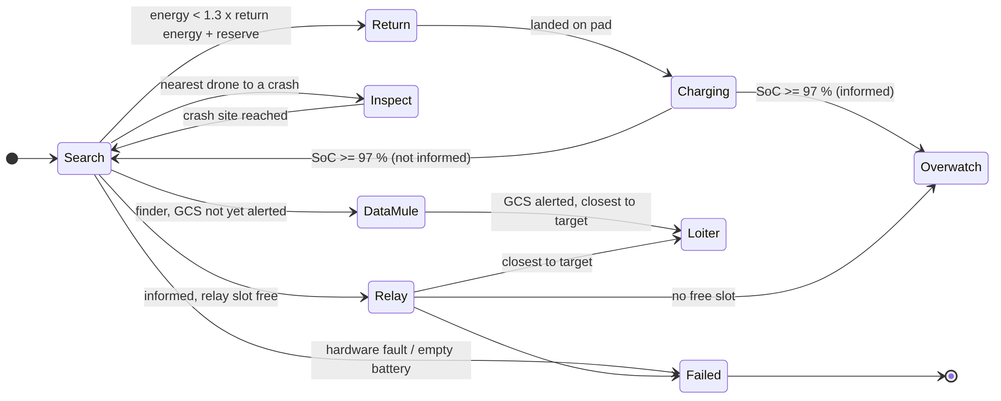
Figure 2. Drone behaviour as a state machine. "Informed" means the drone has received the target alert.

3. Theory and models

3.1 Where could the person be? (search prior)
Rescuers usually know a last known position (LKP), for example where a phone last connected. People tend to be found near it, but not always. We model this as a mix of a Gaussian around the LKP and a uniform "could be anywhere" part over all grid cells c (10 m x 10 m):
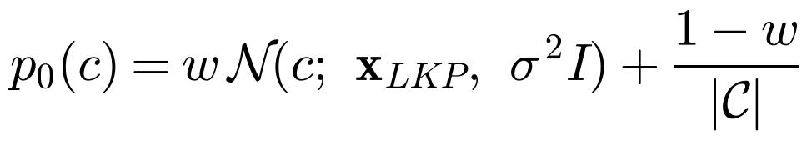 (1)
with w = 0.7 and σ = 60 m. The true position is drawn from this same prior, so the prior is honest. Cells inside buildings get zero probability.

3.2 How the drones move (kinematics and potential fields)
Each drone is modelled as a point mass with limited speed and acceleration. A high-level goal g (a waypoint, a relay slot, a charging pad) is turned into a desired velocity that slows down near the goal:
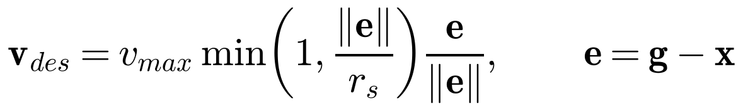 (2)
The acceleration is a velocity-tracking term plus artificial potential fields: a repulsion from nearby drones (collision avoidance) and a repulsion from buildings. A pure repulsion can trap a drone in front of a building (a local minimum), so we add a tangential "slide" term t̂ that pushes the drone around the obstacle:
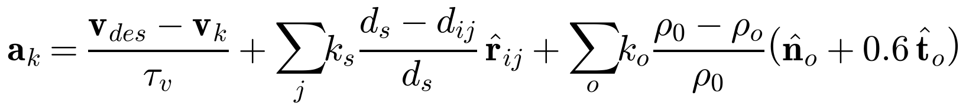 (3)
(4)
Here d_s = 10 m (separation distance), ρ_0 = 12 m (building influence distance), τ_v = 0.8 s, |a| ≤ 4 m/s², v_max = 6 m/s. Altitude is held at a fixed height above the terrain (terrain following), and a hard constraint keeps drones out of buildings.

3.3 What the camera can see (sensing model)
A downward camera with field of view θ = 60° sees a circle of radius r(h) on the ground. Flying higher sees more ground but each person looks smaller, so the chance of recognising them in one look falls:
(5)
with P_d0 = 0.95 and h_0 = 120 m. Video frames taken a fraction of a second apart are not independent "looks", so we assume one independent look every τ_look = 2 s and convert it to a per-step probability:
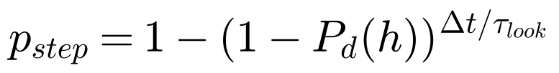 (6)
Figure 3 (middle) shows the trade-off: the effective sweep width 2r·P_d grows with altitude, but the per-look detection probability falls. We search at 25 m, where r = 14.4 m and P_d = 0.77, a reasonable balance for a person on the ground.
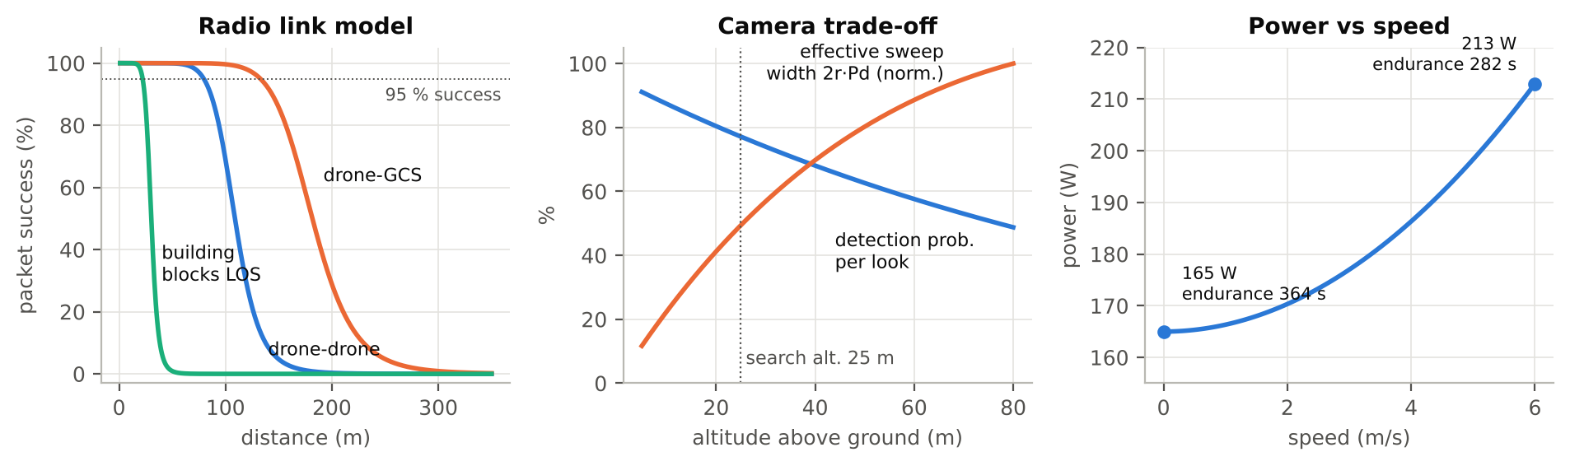
Figure 3. Left: packet success vs distance from the radio model (Section 3.6). Middle: camera altitude trade-off. Right: power vs speed (Section 3.8).

3.4 Bayesian search and probability of success
Every time a drone looks at a cell and does not see the person, the person becomes less likely to be there. We keep an un-normalised "not yet found" mass q(c), which starts as the prior, and update it with Bayes' rule:
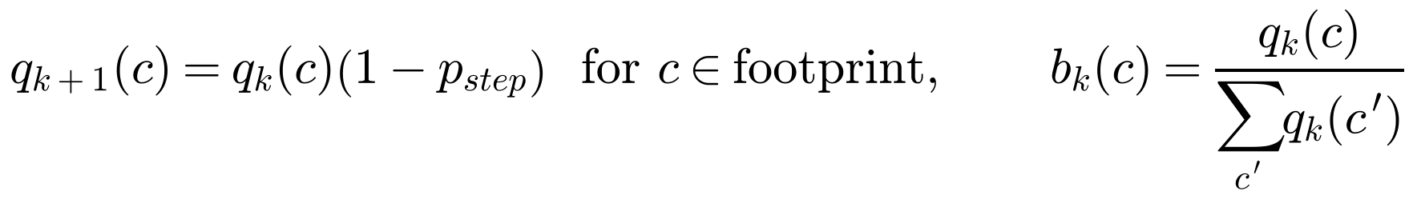 (7)
b(c) is the belief map shown live on the dashboard: dark cells have been searched, bright cells are still likely. The total mass that has been "used up" is the probability of success (POS), the classic SAR measure of how much of the chance of finding the person has already been spent:
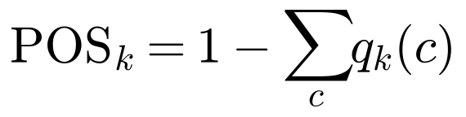 (8)
As a theoretical baseline we use Koopman's random-search formula: N searchers with effective sweep width W and speed v, searching an area A completely at random, find the target by time t with probability
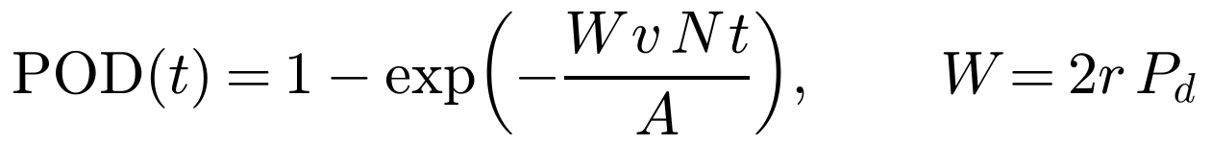 (9)
For our numbers (W = 22 m, v = 6 m/s, N = 10, A = 0.16 km²), the mean time is about 2 minutes. It is plotted as a reference curve in Figure 8.

3.5 Search strategies
- Lawnmower (boustrophedon decomposition): the area is split into N vertical strips, one per drone; each strip is swept in lanes spaced at 0.9 x the footprint diameter, so no gaps are left.
- Spiral from LKP: N interleaved Archimedean spirals r = bθ start at the LKP. With b = s·N/(2π), neighbouring arms are exactly one lane spacing s apart.
- Random waypoints: each drone flies to 30 random points. It is the "no strategy" baseline and the closest match to Koopman's model.
- Greedy Bayesian: each drone repeatedly flies to the cell with the best trade-off between probability and distance, skipping cells already claimed by another drone (simple decentralised task allocation):
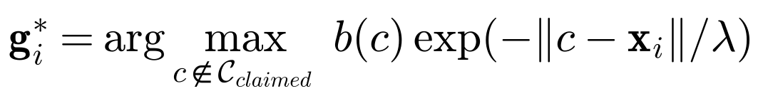 (10)
with λ = 80 m. The planner re-plans when the goal is reached or every 12 s. If a pattern-based drone finishes its waypoints, it falls back to the greedy planner. When a drone fails, the nearest searcher takes over its remaining waypoints.

3.6 Radio links (path loss, shadowing, packet errors)
Version 1 said two drones can talk if they are within 55 m. Real radios do not work like a switch: the signal weakens gradually with distance and fluctuates. We use the standard log-distance path loss model with log-normal shadowing X_k and an extra 15 dB loss if a building blocks the line of sight (LOS):
(11)
Shadowing changes slowly as drones move, so it is correlated in time (a first-order Gauss-Markov process, as in Gudmundson's model):
(12)
The signal-to-noise ratio gives the packet error rate (PER) through a logistic curve, which is a common approximation of real modem curves:
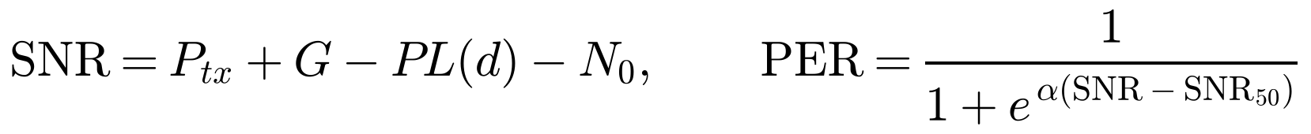 (13)
With P_tx = 10 dBm (low-power mesh radio), PL_0 = 40 dB, n = 2.7, N_0 = −95 dBm, SNR_50 = 10 dB and α = 0.8 /dB, the distance where 95 % of packets get through is
(14)
which is about 80 m between drones and 133 m to the GCS (its antenna has 6 dB extra gain). A building in the way cuts the drone-to-drone range to about 22 m (Figure 3, left). Every step, each link delivers a packet with probability 1 − PER.

3.7 Measuring the network with graph theory
The drones plus the GCS form a graph with adjacency matrix A (a link exists when its current PER < 50 %). Two measures are tracked:
- GCS reachability: the percentage of alive drones that have some multi-hop path to the GCS (found with breadth-first search). This is what matters for reporting.
- Algebraic connectivity λ2: the second-smallest eigenvalue of the graph Laplacian. It is zero when the network is split and grows as the network becomes more robust (Fiedler, 1973):
(15)

3.8 Getting the alert home (multi-hop, data mule, relay chain)
When a drone detects the person, the alert spreads one hop per time step to every neighbour that receives the packet. So the report latency is at least the number of hops h_min times Δt:
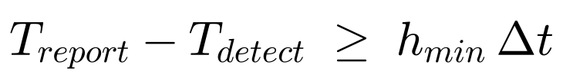 (16)
If the finder has no path to the GCS, waiting does not help. We use the delay-tolerant networking idea of a data mule (store-carry-forward): the finder flies towards the GCS until the alert gets through. Other informed drones fill relay slots on the straight line from the person to the GCS, spaced at 80 % of the drone-to-drone range; the number of relays needed is K:
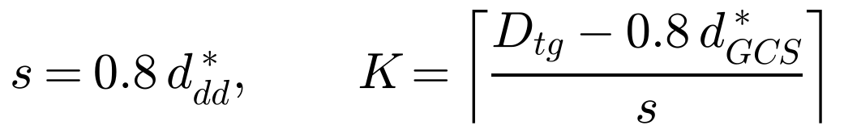 (17)
Once the GCS has the alert, the informed drone closest to the person stays above them as a beacon (loiter), the relays hold the chain (a live video link in practice) and any extra drones orbit the site (overwatch).

3.9 Energy
A multirotor uses most of its power just to hover; flying faster adds drag. We use a simple quadratic model:
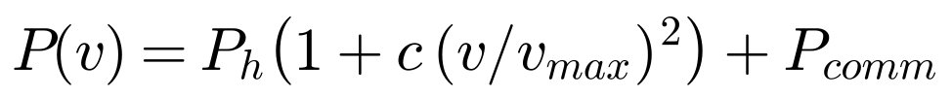 (18)
with P_h = 160 W, c = 0.3 and P_comm = 5 W, giving 165 W in hover and 213 W at full speed. The battery is 60 kJ (about 5 minutes, scaled down so that energy decisions happen during a 7-minute mission). Instead of a fixed 20 % threshold, a drone returns when its energy is close to what it needs to reach the nearest pad:
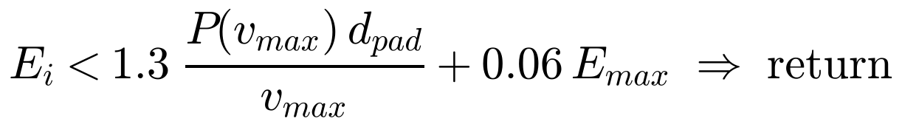 (19)
A drone close to a pad can keep searching down to a low charge; a drone far away turns back earlier. Charging (or a battery swap) runs at 1.2 kW.

3.10 Failures
Hardware failures are modelled as random with a constant rate (exponential lifetime) and a mean time between failures of 1500 s per drone:
(20)
For 10 drones and 420 s, the chance of at least one failure is 94 % and about 2.8 failures are expected, so the swarm must cope with losses. A failed drone falls to the ground, the nearest searcher inspects the crash site and takes over the unfinished search area.

4. Implementation
Everything is in one function file, drone_swarm_rescue_v2.m, with local functions. Called with no arguments it opens the same kind of parameter dialog as version 1; called with a struct it runs headless, which is how the Monte Carlo script uses it. It needs no toolboxes and was tested in GNU Octave 8.4. Table 2 lists the main parts and Table 3 the key parameters.
Table 2. Code structure.
Function | What it does
drone_swarm_rescue_v2 | Main loop (Figure 1), metrics, results struct, CSV log
buildWorld, groundAt | Terrain (sum of Gaussian hills), buildings, prior, true target
planSearch, bayesGoal | Lawnmower / spiral / random waypoints; greedy Bayesian goal (eq. 10)
updateGoals, assignRoles, relaySlots | State machine (Figure 2), data mule, relay chain, loiter/overwatch
stepDynamics, powerDraw | Potential-field control and kinematics (eqs. 2-4); power model
commGraph, losBlocked, linkRange | Radio model (eqs. 11-14), building blockage test
bfsFrom, algebraicConnectivity | GCS reachability and λ2 (eq. 15)
initVis, updateVis, summaryFigure | Dashboard (handle-based updates) and mission summary
run_monte_carlo.m | Runs all strategies on the same random scenarios; CSV + plots

Table 3. Main parameters (all editable in the dialog or by struct).
Parameter | Value | Meaning
numDrones, areaXY | 10, 400 m | Swarm size; side of the square search area
dt, simTime | 0.25 s, 420 s | Time step; mission length
searchAlt, relayAlt | 25 m, 40 m | Height above ground for searching / relaying
vmax, amax | 6 m/s, 4 m/s² | Speed and acceleration limits
camFOVdeg, pd0, pdScale | 60°, 0.95, 120 m | Camera model (eq. 5)
lkpSigma, priorMix | 60 m, 0.7 | Search prior (eq. 1)
txPower, pathLossExp, shadowSigma | 10 dBm, 2.7, 3 dB | Radio model (eqs. 11-13)
obstacleLoss, gcsGain | 15 dB, 6 dB | Building blockage; GCS antenna gain
batteryJ, Phover | 60 kJ, 160 W | Energy model (eq. 18)
mtbf | 1500 s | Mean time between failures per drone

5. Results

5.1 One mission, step by step
Figure 4 shows the live dashboard for one mission (Bayesian strategy, seed 3) at t = 68 s, four seconds after detection. The 3-D view shows terrain, buildings, camera footprints on the ground (cyan rings), radio links coloured by quality (green good, yellow fair, red poor) and the drones coloured by mode. The belief map on the right shows the searched area as a dark trail; bright areas are still likely. The battery panel shows each drone's charge and mode.
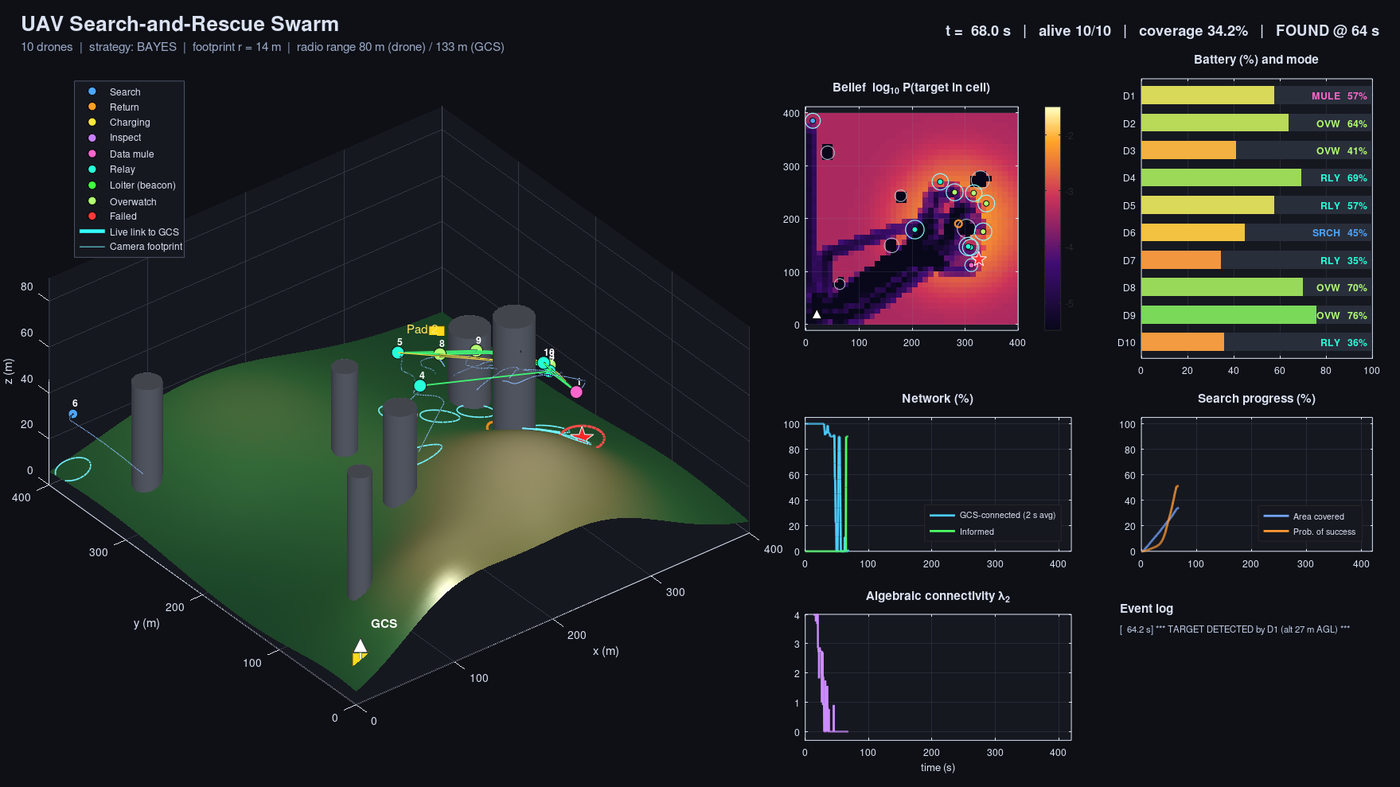
Figure 4. Live dashboard at t = 68 s. Drone 1 (pink) found the person at 64 s and is acting as a data mule towards the GCS; the other informed drones are moving into relay slots.
What happened in this mission (from the event log):
- 0 to 64 s: all ten drones take off from the GCS area and run the greedy Bayesian search towards the high-probability zone around the LKP. As they spread out, λ2 drops to zero: the swarm splits into groups.
- 64.2 s: drone 1 detects the person from 27 m above ground. Only 33 % of the area had been covered, but POS was already about 50 %, because the search went where the person was most likely to be.
- 64 to 70 s: the finder has no route to the GCS, so it becomes a data mule; nearby drones receive the alert hop by hop and take relay slots.
- 70.5 s: the GCS receives the alert, 6.2 s after detection. Drone 7, the informed drone closest to the person, becomes the beacon above them; when it later leaves to recharge, drone 8 takes over.
- 77.5 s: drone 5 suffers a hardware fault; drone 6 inspects the crash site. Later, drones rotate through the charging pads while the relay chain is kept (Figure 6).
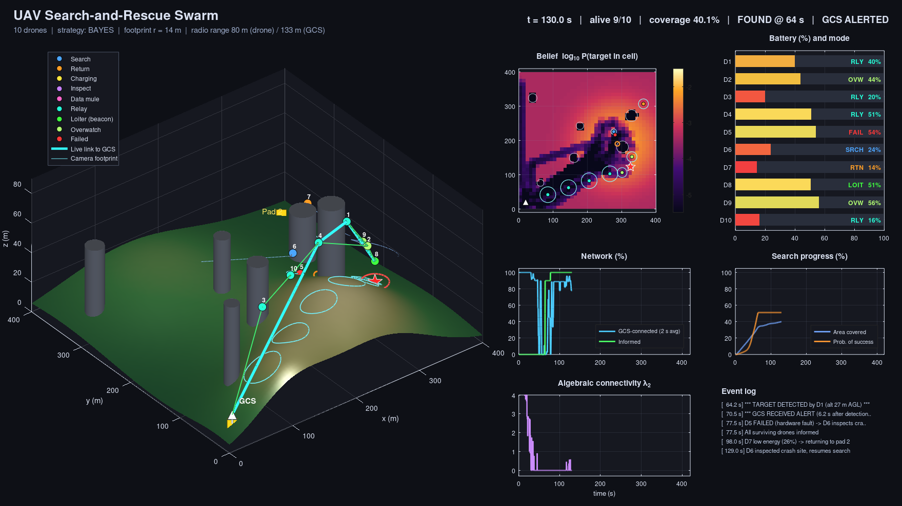
Figure 5. Dashboard at t = 130 s. The thick cyan line is the live multi-hop link from the beacon over the person to the GCS through the relay chain.
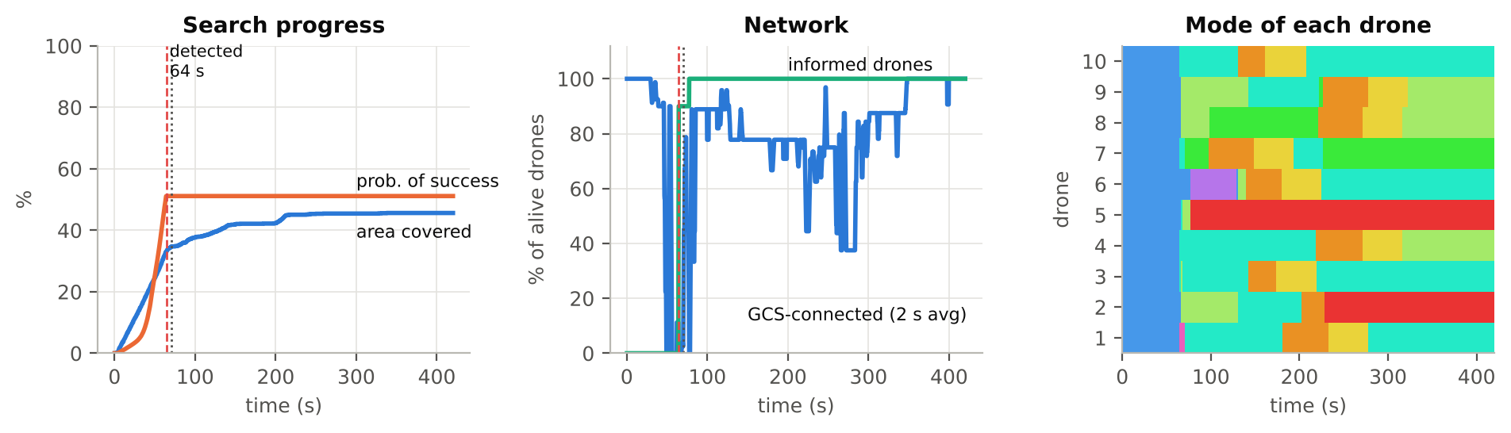
Figure 6. The same mission over time. Left: coverage and POS (POS stops growing once the person is found). Middle: GCS-connected and informed drones; red dashed = detection, grey dotted = GCS alerted. Right: mode of each drone.

5.2 Four strategies on the same scenario
Figure 7 shows the flight paths of all four strategies on the same world (same terrain, buildings and person) up to the moment of detection. The grey shading is the prior: darker means more likely. The Bayesian swarm heads straight for the dark area, the lawnmower sweeps its strips from the GCS side, the spiral starts from the LKP, and the random swarm wanders everywhere and, in this case, does not find the person at all.
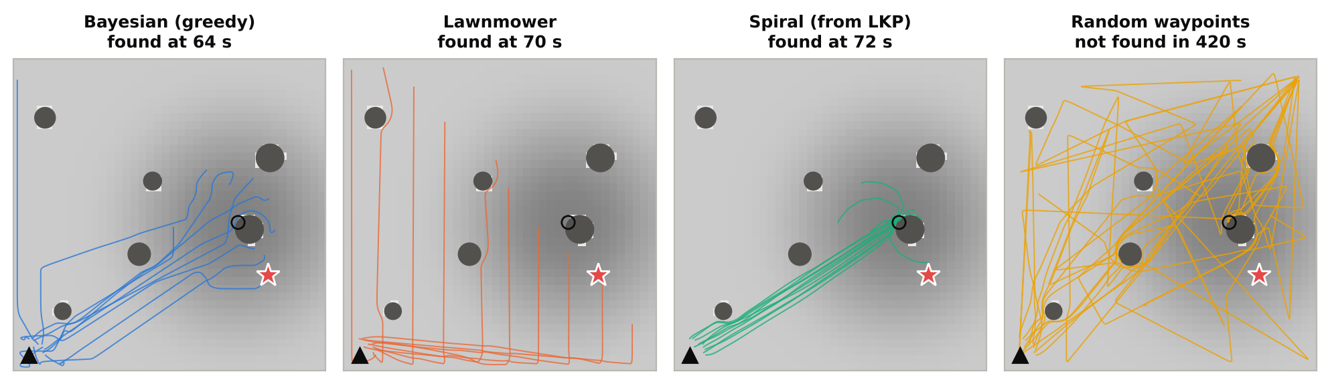
Figure 7. Flight paths until detection on one scenario (triangle = GCS, circle = LKP, star = person, grey discs = buildings).

5.3 Monte Carlo comparison (50 scenarios x 4 strategies)
One mission proves little, because the result depends on luck. We ran each strategy on the same 50 random scenarios (paired seeds, so every strategy faced exactly the same worlds). Table 4 and Figure 8 summarise the results. Missions that did not find the person within 420 s count as 420 s in the medians.
Table 4. Monte Carlo results over 50 random scenarios.
Strategy | Found in 7 min | Median time to find | Found by 100 s | Alert delay (mean / max) | Coverage at detection
Bayesian (greedy) | 98 % | 82 s | 68 % | 2.7 / 20 s | 50 %
Lawnmower | 100 % | 89 s | 58 % | 2.9 / 21 s | 58 %
Spiral (from LKP) | 90 % | 107 s | 44 % | 5.1 / 55 s | 27 %
Random waypoints | 86 % | 107 s | 48 % | 1.3 / 15 s | 47 %

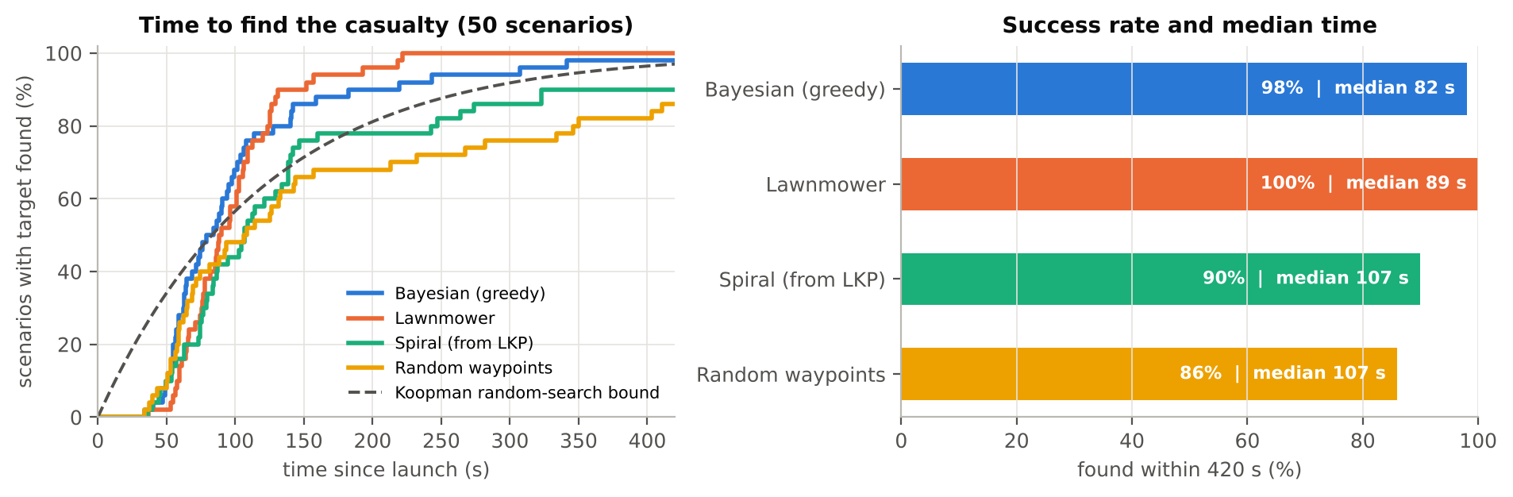
Figure 8. Left: share of scenarios where the person was found by time t; dashed line = Koopman random-search formula (eq. 9). Right: success rate and median time.
What the numbers say:
- Bayesian search is fastest in the typical case. It has the lowest median (82 s) and found the person within 100 s in 68 % of scenarios. In paired comparison it was faster than lawnmower in 68 % of the scenarios. It finds the person with less of the area covered (50 % vs 58 %), because it searches the likely places first.
- Lawnmower is the most reliable. It found the person in every scenario and has the shortest tail. When the person is far from the LKP (the uniform 30 % part of the prior), the greedy planner keeps searching near the LKP while the lawnmower simply reaches every cell. Their mean times are almost equal.
- Spiral is fast early, weak late. It does well when the person is near the LKP. Further out it slows down, most likely because spiral arms that leave the area are clipped, which leaves gaps that have to be filled later.
- Random waypoints is close to Koopman's formula, as theory predicts: no strategy means exponential detection times. All planned strategies beat it.
- Reporting is fast once the network is used properly. The alert reached the GCS a few seconds after detection on average; the worst cases (up to about 55 s, spiral) happen when the finder is out of radio reach of every other drone, and the delay is then set by how long the data mule needs to fly back into range.

6. Discussion and limitations
The results show a classic trade-off in search theory: exploitation of the prior (Bayesian) gives faster typical finds, while guaranteed coverage (lawnmower) protects against a wrong prior. A natural next step is a hybrid: Bayesian search for the first minutes, then a lawnmower over the cells that are still bright, or a planner with a longer horizon instead of a one-step greedy choice.
The model is still a simplification:
- The belief map is shared instantly by all drones. In reality each drone would hold its own map and merge it when in radio contact.
- Detection has no false alarms; a real detector would also need a confirmation step.
- Drones are point masses; there is no wind, attitude dynamics or GPS error.
- Battery capacity is scaled down so energy decisions happen within a 7-minute run.
- The radio model ignores interference between drones and the effect of altitude on ground reflections.
Each of these can be added inside its own function without changing the rest of the structure.

7. Conclusion
Version 2 turns the swarm demo into a simulation where each behaviour can be explained with a formula and tested with data. The biggest lessons were: (1) where you search matters more than how much you cover; (2) a finding is only useful once it reaches the rescuers, which needs multi-hop relaying and sometimes a data mule; and (3) small implementation bugs (here, waypoints indexed by time) can silently destroy a strategy, so results must be checked against theory, as we did with Koopman's formula.

8. How to run
- Put drone_swarm_rescue_v2.m and run_monte_carlo.m in the same folder.
- Run drone_swarm_rescue_v2 in the Command Window. Edit the parameters in the dialog and press OK.
- Or call it with options, for example: R = drone_swarm_rescue_v2(struct('searchPattern','lawnmower','seed',3,'recordVideo',true));
- For the strategy comparison run run_monte_carlo(50) (about 10 minutes, no graphics during the runs).
- At the end a summary figure is saved as swarm_v2_summary.png (Figure 9).
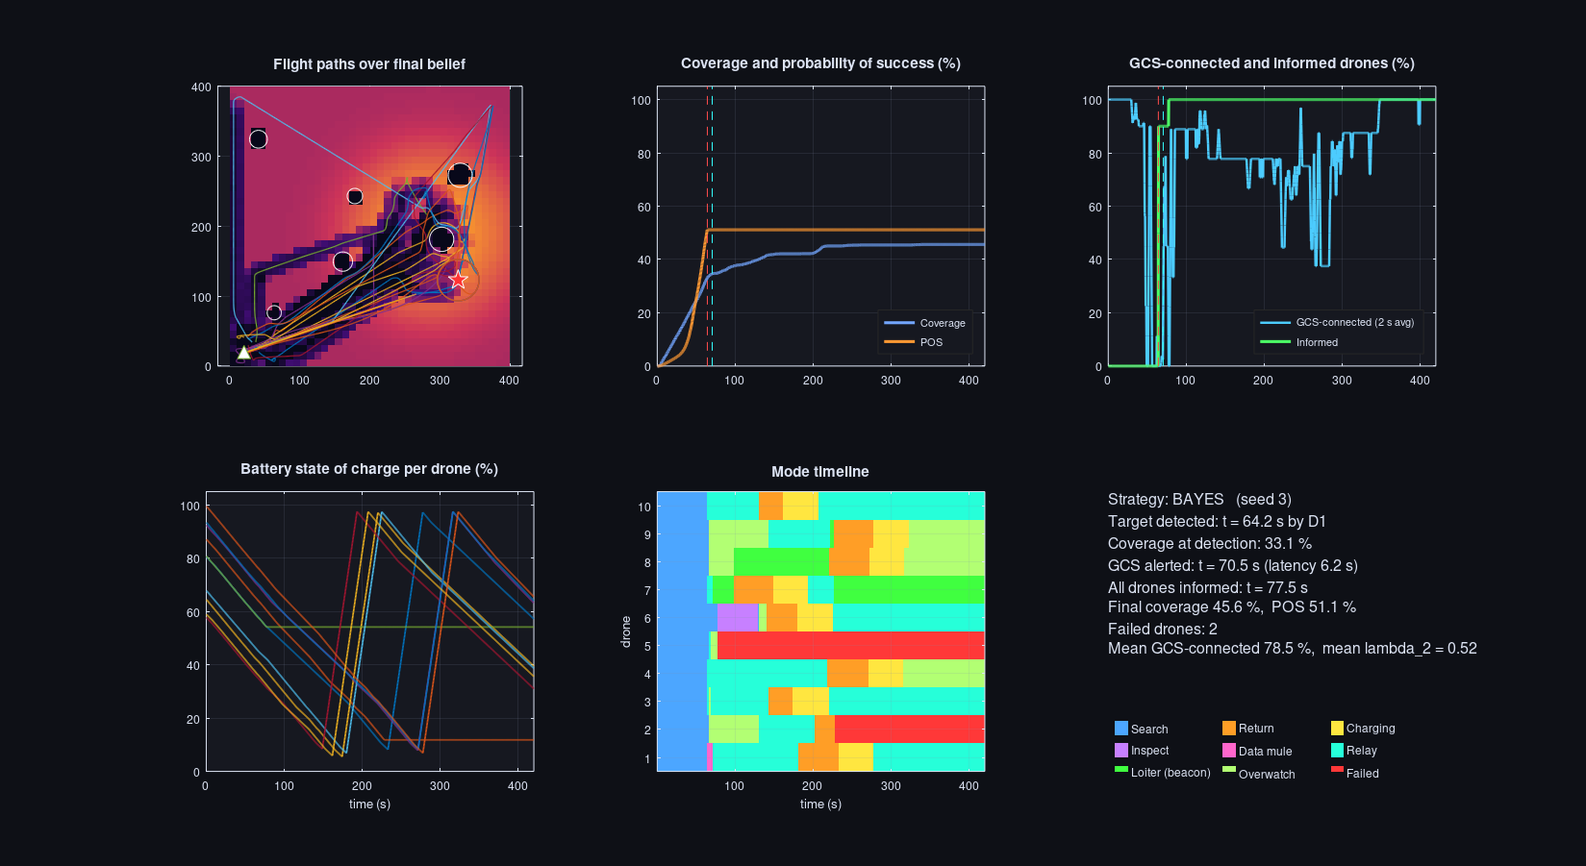
Figure 9. Mission summary figure produced automatically at the end of a run.

References
- Koopman, B. O. (1946). Search and Screening. OEG Report No. 56, Operations Evaluation Group, U.S. Navy.
- Stone, L. D. (1975). Theory of Optimal Search. Academic Press.
- Reynolds, C. W. (1987). Flocks, herds and schools: A distributed behavioral model. ACM SIGGRAPH Computer Graphics, 21(4), 25-34.
- Khatib, O. (1986). Real-time obstacle avoidance for manipulators and mobile robots. The International Journal of Robotics Research, 5(1), 90-98.
- Olfati-Saber, R. (2006). Flocking for multi-agent dynamic systems: Algorithms and theory. IEEE Transactions on Automatic Control, 51(3), 401-420.
- Choset, H. (2000). Coverage of known spaces: The boustrophedon cellular decomposition. Autonomous Robots, 9(3), 247-253.
- Galceran, E., & Carreras, M. (2013). A survey on coverage path planning for robotics. Robotics and Autonomous Systems, 61(12), 1258-1276.
- Rappaport, T. S. (2002). Wireless Communications: Principles and Practice (2nd ed.). Prentice Hall.
- Gudmundson, M. (1991). Correlation model for shadow fading in mobile radio systems. Electronics Letters, 27(23), 2145-2146.
- Fiedler, M. (1973). Algebraic connectivity of graphs. Czechoslovak Mathematical Journal, 23(2), 298-305.
- Vahdat, A., & Becker, D. (2000). Epidemic routing for partially connected ad hoc networks. Technical Report CS-2000-06, Duke University.
- Bekmezci, I., Sahingoz, O. K., & Temel, S. (2013). Flying ad-hoc networks (FANETs): A survey. Ad Hoc Networks, 11(3), 1254-1270.
- Zeng, Y., Xu, J., & Zhang, R. (2019). Energy minimization for wireless communication with rotary-wing UAV. IEEE Transactions on Wireless Communications, 18(4), 2329-2345.

Appendix A. Full source code

drone_swarm_rescue_v2.m
function R = drone_swarm_rescue_v2(userOpts)
% DRONE_SWARM_RESCUE_V2 Search-and-rescue UAV swarm simulation (version 2).
%
% What is modelled (see the report for the theory behind each block):
% * Terrain, buildings (cylinders), a ground control station (GCS) and charging pads
% * A missing person whose location is uncertain: Bayesian prior around a
% Last Known Position (LKP)
% * Downward camera: footprint grows with altitude, detection probability falls
% * Bayesian search: the belief map is updated after every "no detection"
% * Four search strategies: 'bayes' | 'lawnmower' | 'spiral' | 'random'
% * Radio links: log-distance path loss + shadowing + building blockage
% -> SNR -> packet error rate (no fixed "comm radius")
% * Multi-hop reporting: the alert travels one hop per time step; the finder acts
% as a data mule if it is cut off; informed drones build a relay chain to the GCS
% * Energy: speed-dependent power draw, energy-aware return-to-charge
% * Random hardware failures (exponential lifetime), crash-site inspection and
% hand-over of the failed drone's unfinished search path
% * Graph metrics: GCS-reachability, algebraic connectivity (lambda_2)
%
% Usage
% R = drone_swarm_rescue_v2(); % dialog + live dashboard
% R = drone_swarm_rescue_v2(struct('searchPattern','lawnmower','seed',3));
% R = drone_swarm_rescue_v2(struct('visualize',false)); % headless (Monte Carlo)
%
% Works in MATLAB R2018b+ (no toolboxes needed) and GNU Octave 7+.
% Authors: Niyathi Vedagiri (23BRS1132), Anna Sunny George (23BRS1321)

if nargin < 1, userOpts = struct(); end
P = defaultParams();
P.useDialog = (nargin == 0);
P = mergeStruct(P, userOpts);
if P.useDialog
P = paramDialog(P);
if isempty(P), R = []; disp('Simulation cancelled.'); return; end
end
P.numDrones = max(2, round(P.numDrones));
setSeed(P.seed);
M = modes();

%% ------------------------------------------------------------------ world
W = buildWorld(P);
N = P.numDrones;
dt = P.dt;
nSteps = round(P.simTime / dt);
rfp = P.searchAlt * tand(P.camFOVdeg/2); % footprint radius at search altitude
P.rangeDD = linkRange(P, 0); % drone-drone nominal range (PER ~ 5 %)
P.rangeGCS = linkRange(P, P.gcsGain); % drone-GCS nominal range
P.relaySpacing = 0.8 * P.rangeDD;

%% ------------------------------------------------------------------ swarm state
S.pos = zeros(N,3);
ang = linspace(0, pi/2, N)'; rad = 10 + 12*rand(N,1);
S.pos(:,1) = W.base(1) + rad.*cos(ang);
S.pos(:,2) = W.base(2) + rad.*sin(ang);
S.pos(:,3) = groundAt(W, S.pos(:,1), S.pos(:,2)) + 0.3;
S.vel = zeros(N,3);
S.Emax = P.batteryJ;
S.E = P.batteryJ * (P.socInitRange(1) + diff(P.socInitRange)*rand(N,1));
S.mode = M.SEARCH * ones(N,1);
S.alive = true(N,1);
S.informed = false(N,1);
S.goal = S.pos;
S.goalTimer= zeros(N,1);
S.charger = ones(N,1);
S.inspectPos = nan(N,2);
S.slotPos = nan(N,2);
S.orbitAng = 2*pi*rand(N,1);
S.wp = planSearch(P, W, rfp);
S.wpIdx = ones(N,1);
S.q = W.prior; % un-normalised "not yet detected" mass
S.covered = false(size(W.prior));
S.detected = false; S.finder = 0; S.gcsInformed = false;
S.events = {};

T_detect = NaN; T_report = NaN; T_all = NaN; covAtDetect = NaN;
nextAssign = 0;

%% ------------------------------------------------------------------ history
H.t = (1:nSteps)*dt;
H.pos = zeros(N,3,nSteps);
H.mode = zeros(N,nSteps);
H.soc = zeros(N,nSteps);
H.inf = false(N,nSteps);
H.cov = zeros(1,nSteps);
H.POS = zeros(1,nSteps);
H.baseConn = zeros(1,nSteps);
H.informed = zeros(1,nSteps);
H.lam2 = zeros(1,nSteps);
H.nLinks = zeros(1,nSteps);
H.alive = zeros(1,nSteps);

if P.verbose
fprintf('\n=== UAV rescue swarm v2 | %d drones | strategy: %s | seed %d ===\n', N, upper(P.searchPattern), P.seed);
fprintf('Footprint radius %.1f m | drone-drone range %.0f m | drone-GCS range %.0f m\n', rfp, P.rangeDD, P.rangeGCS);
end

V = [];
if P.visualize, V = initVis(P, W, S, rfp); end

%% ------------------------------------------------------------------ main loop
A = false(N+1); Am = A; Qlink = zeros(N+1); livePath = zeros(0,3);
shadow = P.shadowSigma*randn(N+1); shadow = triu(shadow,1); shadow = shadow + shadow';
lastStep = nSteps;
for k = 1:nSteps
t = k*dt;

% --- 1. random hardware failures (exponential lifetime, rate 1/MTBF)
pFail = 1 - exp(-dt / P.mtbf);
for i = find(S.alive & S.mode ~= M.CHARGE)'
if rand < pFail
[S, msg] = failDrone(S, P, M, i, 'hardware fault');
S = logEv(S, t, msg, P);
end
end

% --- 2. energy: drain, depletion, energy-aware return, charging
for i = find(S.alive)'
if S.mode(i) == M.CHARGE
S.E(i) = min(S.Emax, S.E(i) + P.chargeW*dt);
if S.E(i) >= 0.97*S.Emax
if S.detected && S.informed(i)
S.mode(i) = M.OVERWATCH; nextAssign = 0;
else
S.mode(i) = M.SEARCH; S.goalTimer(i) = 0;
end
S = logEv(S, t, sprintf('D%d recharged, back in the air', i), P);
end
continue
end
S.E(i) = S.E(i) - powerDraw(P, S.vel(i,:))*dt;
if S.E(i) <= 0
S.E(i) = 0;
[S, msg] = failDrone(S, P, M, i, 'battery depleted');
S = logEv(S, t, msg, P);
continue
end
if S.mode(i) ~= M.RETURN
[dc, ci] = nearestCharger(W, S.pos(i,1:2));
Ereturn = powerDraw(P, [P.vmax 0 0]) * dc / P.vmax;
if S.E(i) < P.returnMargin*Ereturn + P.reserveFrac*S.Emax
S.mode(i) = M.RETURN; S.charger(i) = ci;
S = logEv(S, t, sprintf('D%d low energy (%.0f%%) -> returning to pad %d', i, 100*S.E(i)/S.Emax, ci), P);
end
end
end

% --- 3. mission logic after a detection (relay chain / data mule / loiter)
if S.detected && t >= nextAssign
S = assignRoles(S, P, W, M);
nextAssign = t + P.assignEvery;
end

% --- 4. guidance: goal for every drone, then dynamics
[S, ev] = updateGoals(S, P, W, M, rfp, dt);
for e = 1:numel(ev), S = logEv(S, t, ev{e}, P); end
S = stepDynamics(S, P, W, M, dt);

% --- 5. sensing: footprint coverage, Bayesian update, detection
for i = find(S.alive & S.mode ~= M.CHARGE)'
agl = S.pos(i,3) - groundAt(W, S.pos(i,1), S.pos(i,2));
if agl < P.minSenseAGL, continue; end
r = agl * tand(P.camFOVdeg/2);
pdLook = P.pd0 * exp(-agl / P.pdScale);
pStep = 1 - (1 - pdLook)^(dt / P.lookInterval);
inFp = (W.CX - S.pos(i,1)).^2 + (W.CY - S.pos(i,2)).^2 <= r^2;
S.covered(inFp) = true;
if ~S.detected
S.q(inFp) = S.q(inFp) * (1 - pStep);
if norm(W.target(1:2) - S.pos(i,1:2)) <= r && rand < pStep
S.detected = true; S.finder = i; S.informed(i) = true;
T_detect = t; covAtDetect = 100*mean(S.covered(:));
nextAssign = 0;
S = logEv(S, t, sprintf('*** TARGET DETECTED by D%d (alt %.0f m AGL) ***', i, agl), P);
end
end
end

% --- 6. radio graph, reachability, algebraic connectivity
[A, Am, Qlink, shadow] = commGraph(P, W, S.pos, S.alive, shadow);
on = [S.alive; true];
[reach, parent] = bfsFrom(Am, N+1); % topology = links with PER < 50 %
lam2 = algebraicConnectivity(Am, on);

% --- 7. multi-hop alert propagation (one hop per step)
if S.detected
known = [S.informed; S.gcsInformed] & on;
heard = any(A(:, known), 2) & on;
newInf = heard(1:N) & ~S.informed;
for i = find(newInf)'
S.informed(i) = true;
end
if heard(N+1) && ~S.gcsInformed
S.gcsInformed = true; T_report = t; nextAssign = 0;
S = logEv(S, t, sprintf('*** GCS RECEIVED ALERT (%.1f s after detection) ***', t - T_detect), P);
end
if isnan(T_all) && all(S.informed(S.alive))
T_all = t;
S = logEv(S, t, 'All surviving drones informed', P);
end
end

% live link from the drone over the target to the GCS (for display)
livePath = zeros(0,3);
if S.gcsInformed
src = find(S.alive & (S.mode == M.LOITER), 1);
if ~isempty(src) && reach(src)
nodes = [S.pos; gcsXYZ(P, W)];
u = src; livePath = nodes(u,:);
while u ~= N+1 && parent(u) > 0
u = parent(u); livePath(end+1,:) = nodes(u,:); %#ok<AGROW>
end
end
end

% --- 8. metrics
H.pos(:,:,k) = S.pos; H.mode(:,k) = S.mode; H.soc(:,k) = 100*S.E/S.Emax;
H.inf(:,k) = S.informed;
H.cov(k) = 100*mean(S.covered(:));
H.POS(k) = 100*(1 - sum(S.q(:)));
nAlive = sum(S.alive);
H.alive(k) = nAlive;
H.baseConn(k)= 100*sum(reach(1:N) & S.alive)/max(nAlive,1);
H.informed(k)= 100*sum(S.informed & S.alive)/max(nAlive,1);
H.lam2(k) = lam2;
H.nLinks(k) = nnz(triu(Am));

% --- 9. visualisation
if P.visualize && (mod(k, P.drawEvery) == 0 || k == nSteps)
V = updateVis(V, P, W, S, H, k, Am, Qlink, livePath);
for ts = P.saveSnapshotsAt(:)'
if abs(t - ts) < dt*P.drawEvery/2 + 1e-9
saveFig(V.fig, sprintf('%s_t%03d.png', P.snapshotPrefix, round(ts)));
end
end
end

if P.stopOnReport && S.gcsInformed
lastStep = k; break
end
end

%% ------------------------------------------------------------------ wrap-up
if lastStep < nSteps
H = trimHistory(H, lastStep);
end
if P.visualize && isfield(V,'vw') && ~isempty(V.vw)
try, close(V.vw); catch, end
end

R.params = P; R.world = W; R.hist = H; R.events = S.events;
R.T_detect = T_detect; R.T_report = T_report; R.T_allInformed = T_all;
R.found = S.detected; R.reported = S.gcsInformed; R.finder = S.finder;
R.coverageAtDetect = covAtDetect; R.finalCoverage = H.cov(end); R.finalPOS = H.POS(end);
R.numFailed = sum(~S.alive); R.footprintRadius = rfp;
R.belief = S.q / max(sum(S.q(:)), eps); R.covered = S.covered;
R.meanLam2 = mean(H.lam2); R.meanBaseConn = mean(H.baseConn);

if P.verbose
fprintf('\n--- Summary ---\n');
fprintf('Target detected : %s', yesno(R.found));
if R.found, fprintf(' at t = %.1f s by D%d (coverage then %.1f %%)', T_detect, S.finder, covAtDetect); end
fprintf('\nGCS alerted : %s', yesno(R.reported));
if R.reported, fprintf(' at t = %.1f s (report latency %.1f s)', T_report, T_report - T_detect); end
fprintf('\nFinal coverage : %.1f %% | cumulative POS %.1f %%\n', R.finalCoverage, R.finalPOS);
fprintf('Failed drones : %d | mean GCS-connected %.1f %% | mean lambda2 %.2f\n', R.numFailed, R.meanBaseConn, R.meanLam2);
end

if P.enableCSVLog, writeCSV(P, H); end
if P.visualize && P.showSummary
fs = summaryFigure(R, P);
if P.saveSummary, saveFig(fs, P.summaryFile); end
end
end

%% ========================================================================
%% Parameters
%% ========================================================================
function P = defaultParams()
P.numDrones = 10;
P.simTime = 420; % s
P.dt = 0.25; % s
P.areaXY = 400; % m (square)
P.maxAlt = 90; % m
P.searchAlt = 25; % m above ground while searching
P.relayAlt = 40; % m above ground for relays / mule
P.vmax = 6; % m/s horizontal
P.vzMax = 3; % m/s vertical
P.amax = 4; % m/s^2
P.tauV = 0.8; % s velocity time constant
P.slowRadius = 12; % m, start slowing down near a goal
% sensing
P.camFOVdeg = 60; % camera field of view
P.pd0 = 0.95; % detection prob. of one look at zero altitude
P.pdScale = 120; % m, altitude scale of detection decay
P.lookInterval = 2; % s between statistically independent looks
P.minSenseAGL = 6; % m, below this the camera is not used
% search prior
P.cellSize = 10; % m belief-grid resolution
P.lkpSigma = 60; % m spread of the LKP Gaussian
P.priorMix = 0.7; % weight of the LKP Gaussian vs uniform
P.searchPattern = 'bayes'; % bayes | lawnmower | spiral | random
P.sweepOverlap = 0.9; % lane spacing = overlap * footprint diameter
P.bayesLambda = 80; % m, distance discount in the greedy Bayes planner
P.replanTime = 12; % s
% radio (2.4 GHz mesh, e.g. XBee-class)
P.txPower = 10; % dBm
P.PL0 = 40; % dB at 1 m
P.pathLossExp = 2.7;
P.noiseFloor = -95; % dBm
P.snr50 = 10; % dB where PER = 50 %
P.perSlope = 0.8; % 1/dB
P.shadowSigma = 3; % dB log-normal shadowing
P.shadowTau = 4; % s correlation time of shadowing
P.obstacleLoss = 15; % dB extra loss if a building blocks the line of sight
P.gcsGain = 6; % dB extra antenna gain at the GCS
P.gcsMastHeight = 6; % m
% energy (scaled so that energy management is visible in a 7-minute mission)
P.batteryJ = 60000; % J
P.Phover = 160; % W
P.dragCoef = 0.3; % P = Phover*(1 + c*(v/vmax)^2) + Pcomm
P.Pcomm = 5; % W
P.chargeW = 1200; % W (fast charge / battery swap)
P.socInitRange = [0.55 1.0];
P.reserveFrac = 0.06;
P.returnMargin = 1.3;
% failures and avoidance
P.mtbf = 1500; % s mean time between hardware failures (per drone)
P.numObstacles = 6;
P.enableInspection = true;
P.sepDist = 10; P.kSep = 6;
P.obsInfluence = 12; P.kObs = 8;
% mission logic
P.assignEvery = 2; % s
% output
P.visualize = true;
P.figVisible = 'on';
P.drawEvery = 2;
P.trailLen = 80;
P.saveSnapshotsAt = [];
P.snapshotPrefix = 'swarm';
P.showSummary = true;
P.saveSummary = true;
P.summaryFile = 'swarm_v2_summary.png';
P.recordVideo = false;
P.videoFile = 'swarm_v2.mp4';
P.enableCSVLog = false;
P.csvFile = 'swarm_v2_log.csv';
P.stopOnReport = false;
P.seed = 7;
P.verbose = true;
end

function P = paramDialog(P)
f = {'numDrones','simTime','searchPattern','areaXY','searchAlt','vmax','mtbf', ...
'numObstacles','seed','recordVideo','enableCSVLog'};
prompts = {'Number of drones', 'Simulated time (s)', ...
'Search strategy: bayes | lawnmower | spiral | random', 'Area side (m)', ...
'Search altitude above ground (m)', 'Max speed (m/s)', ...
'Mean time between failures per drone (s)', 'Number of buildings', ...
'Random seed', 'Record MP4 video (0/1)', 'Write CSV log (0/1)'};
def = cell(size(f));
for k = 1:numel(f)
v = P.(f{k});
if ischar(v), def{k} = v; else, def{k} = num2str(v); end
end
a = inputdlg(prompts, 'UAV Rescue Swarm v2 - parameters', 1, def);
if isempty(a), P = []; return; end
for k = 1:numel(f)
if ischar(P.(f{k})), P.(f{k}) = lower(strtrim(a{k}));
else, P.(f{k}) = str2double(a{k}); end
end
P.recordVideo = logical(P.recordVideo); P.enableCSVLog = logical(P.enableCSVLog);
end

function M = modes()
M.SEARCH = 1; M.RETURN = 2; M.CHARGE = 3; M.INSPECT = 4; M.MULE = 5;
M.RELAY = 6; M.LOITER = 7; M.OVERWATCH = 8; M.FAILED = 9;
end

function C = modeColors()
C = [0.30 0.65 1.00; % search blue
1.00 0.62 0.15; % return orange
1.00 0.90 0.25; % charge yellow
0.78 0.50 1.00; % inspect violet
1.00 0.40 0.80; % mule pink
0.15 1.00 0.85; % relay teal
0.25 1.00 0.25; % loiter green
0.70 1.00 0.45; % overwatch lime
1.00 0.22 0.22]; % failed red
end

function n = modeNames()
n = {'Search','Return','Charging','Inspect','Data mule','Relay','Loiter (beacon)','Overwatch','Failed'};
end

%% ========================================================================
%% World
%% ========================================================================
function W = buildWorld(P)
L = P.areaXY;
W.L = L;
W.base = [20 20];
W.chargers = [20 20; L-25 L-25];
% terrain: sum of Gaussian hills [cx cy amplitude sigma]
nH = 5;
W.hills = [L*rand(nH,2), 8 + 18*rand(nH,1), 45 + 60*rand(nH,1)];
g = linspace(0, L, 81);
[W.GX, W.GY] = meshgrid(g, g);
W.GZ = groundAt(W, W.GX, W.GY);
% belief grid
cx = (P.cellSize/2):P.cellSize:L;
W.cx = cx;
[W.CX, W.CY] = meshgrid(cx, cx);
% last known position and prior
W.lkp = L*(0.45 + 0.4*rand(1,2));
G = exp(-((W.CX - W.lkp(1)).^2 + (W.CY - W.lkp(2)).^2) / (2*P.lkpSigma^2));
G = G / sum(G(:));
prior = P.priorMix*G + (1 - P.priorMix)/numel(G);
% true target drawn from the prior (so the prior is "honest")
c = cumsum(prior(:)); kk = find(c >= rand*c(end), 1);
tx = min(max(W.CX(kk) + (rand-0.5)*P.cellSize, 1), L-1);
ty = min(max(W.CY(kk) + (rand-0.5)*P.cellSize, 1), L-1);
W.target = [tx, ty, groundAt(W, tx, ty)];
% buildings (cylinders), kept away from base, chargers and target
W.obs = struct('c', {}, 'r', {}, 'base', {}, 'top', {});
tries = 0;
while numel(W.obs) < P.numObstacles && tries < 500
tries = tries + 1;
c0 = 30 + (L-60)*rand(1,2); r0 = 8 + 10*rand;
ok = norm(c0 - W.base) > 70 && norm(c0 - W.chargers(2,:)) > 40 && ...
norm(c0 - W.target(1:2)) > r0 + 25;
for j = 1:numel(W.obs)
ok = ok && norm(c0 - W.obs(j).c) > r0 + W.obs(j).r + 20;
end
if ok
b0 = groundAt(W, c0(1), c0(2));
W.obs(end+1) = struct('c', c0, 'r', r0, 'base', b0, 'top', b0 + 18 + 35*rand); %#ok<AGROW>
end
end
% the target cannot be inside a building
for j = 1:numel(W.obs)
inside = (W.CX - W.obs(j).c(1)).^2 + (W.CY - W.obs(j).c(2)).^2 < W.obs(j).r^2;
prior(inside) = 0;
end
W.prior = prior / sum(prior(:));
end

function z = groundAt(W, x, y)
z = zeros(size(x));
for h = 1:size(W.hills,1)
z = z + W.hills(h,3) * exp(-((x - W.hills(h,1)).^2 + (y - W.hills(h,2)).^2) / (2*W.hills(h,4)^2));
end
end

function p = gcsXYZ(P, W)
p = [W.base, groundAt(W, W.base(1), W.base(2)) + P.gcsMastHeight];
end

function [d, idx] = nearestCharger(W, xy)
dd = sqrt(sum((W.chargers - xy).^2, 2));
[d, idx] = min(dd);
end

%% ========================================================================
%% Search planning
%% ========================================================================
function wp = planSearch(P, W, rfp)
N = P.numDrones; L = W.L; sw = 2*rfp*P.sweepOverlap; margin = 0.6*rfp;
wp = cell(N,1);
switch lower(P.searchPattern)
case 'lawnmower' % boustrophedon decomposition: one vertical strip per drone
stripW = L/N;
for i = 1:N
x0 = (i-1)*stripW; nl = max(1, ceil(stripW/sw)); lane = stripW/nl;
xs = x0 + lane/2 + (0:nl-1)*lane;
w = zeros(0,2);
for kk = 1:nl
if mod(kk,2) == 1, ys = [margin, L-margin]; else, ys = [L-margin, margin]; end
w = [w; xs(kk) ys(1); xs(kk) ys(2)]; %#ok<AGROW>
end
wp{i} = w;
end
case 'spiral' % N interleaved Archimedean arms centred on the LKP
b = sw*N/(2*pi);
corners = [0 0; L 0; 0 L; L L];
rmax = max(sqrt(sum((corners - W.lkp).^2, 2)));
for i = 1:N
phi = 2*pi*(i-1)/N; th = 0; w = zeros(0,2);
while b*th < rmax
r = b*th;
pnt = W.lkp + r*[cos(th+phi), sin(th+phi)];
if all(pnt >= margin) && all(pnt <= L-margin), w(end+1,:) = pnt; end %#ok<AGROW>
th = th + min(0.5, 15/max(r, 5));
end
wp{i} = w;
end
case 'random'
for i = 1:N, wp{i} = margin + (L-2*margin)*rand(30,2); end
otherwise % 'bayes' : goals are chosen online
for i = 1:N, wp{i} = zeros(0,2); end
end
end

function g = bayesGoal(i, S, W, P, M, rfp)
% greedy information-seeking goal: argmax b(c) * exp(-dist/lambda),
% skipping cells already claimed by other searching drones
b = S.q / max(sum(S.q(:)), eps);
d = sqrt((W.CX - S.pos(i,1)).^2 + (W.CY - S.pos(i,2)).^2);
score = b .* exp(-d / P.bayesLambda);
others = find(S.alive & S.mode == M.SEARCH);
for j = others'
if j == i, continue; end
dj = (W.CX - S.goal(j,1)).^2 + (W.CY - S.goal(j,2)).^2;
score(dj < (2*rfp)^2) = 0;
end
[~, kk] = max(score(:));
g = [W.CX(kk), W.CY(kk)];
end

%% ========================================================================
%% Mission logic
%% ========================================================================
function [S, msg] = failDrone(S, P, M, i, why)
S.alive(i) = false; S.mode(i) = M.FAILED;
msg = sprintf('D%d FAILED (%s)', i, why);
% hand over unfinished waypoints and (optionally) inspect the crash site
cand = find(S.alive & S.mode == M.SEARCH);
if isempty(cand), return; end
d = sqrt(sum((S.pos(cand,1:2) - S.pos(i,1:2)).^2, 2));
[~, m] = min(d); j = cand(m);
rest = S.wp{i}(min(S.wpIdx(i), size(S.wp{i},1)+1):end, :);
S.wp{j} = [S.wp{j}(S.wpIdx(j):end, :); rest];
S.wpIdx(j) = 1;
if P.enableInspection
S.mode(j) = M.INSPECT; S.inspectPos(j,:) = S.pos(i,1:2);
msg = sprintf('%s -> D%d inspects crash site and takes over its area', msg, j);
elseif ~isempty(rest)
msg = sprintf('%s -> D%d takes over its area', msg, j);
end
end

function slots = relaySlots(P, W)
% points on the straight line target -> GCS, spaced 0.8 * drone-drone range,
% until the last one is comfortably inside the GCS range
tgt = W.target(1:2); v = W.base - tgt; Ltot = norm(v); u = v / max(Ltot, eps);
slots = zeros(0,2); d = 0;
while Ltot - d > 0.8*P.rangeGCS
d = d + P.relaySpacing;
slots(end+1,:) = tgt + min(d, Ltot)*u; %#ok<AGROW>
end
end

function S = assignRoles(S, P, W, M)
avail = find(S.alive & S.informed & ~ismember(S.mode, [M.RETURN M.CHARGE M.FAILED M.INSPECT]));
if isempty(avail), return; end
if ~S.gcsInformed
% finder becomes a data mule (store-carry-forward) towards the GCS
if ismember(S.finder, avail)
S.mode(S.finder) = M.MULE;
avail(avail == S.finder) = [];
end
else
% the informed drone closest to the target stays as a beacon
d = sqrt(sum((S.pos(avail,1:2) - W.target(1:2)).^2, 2));
[~, m] = min(d);
S.mode(avail(m)) = M.LOITER; avail(m) = [];
end
slots = relaySlots(P, W);
for s = 1:size(slots,1)
if isempty(avail), break; end
d = sqrt(sum((S.pos(avail,1:2) - slots(s,:)).^2, 2));
[~, m] = min(d);
S.mode(avail(m)) = M.RELAY; S.slotPos(avail(m),:) = slots(s,:);
avail(m) = [];
end
S.mode(avail) = M.OVERWATCH;
end

function [S, ev] = updateGoals(S, P, W, M, rfp, dt)
ev = {};
N = size(S.pos,1); tgt = W.target(1:2);
for i = 1:N
p = S.pos(i,:);
switch S.mode(i)
case M.SEARCH
useBayes = strcmpi(P.searchPattern, 'bayes') || S.wpIdx(i) > size(S.wp{i},1);
if useBayes
S.goalTimer(i) = S.goalTimer(i) - dt;
if S.goalTimer(i) <= 0 || norm(S.goal(i,1:2) - p(1:2)) < 0.5*rfp
S.goal(i,1:2) = bayesGoal(i, S, W, P, M, rfp);
S.goalTimer(i) = P.replanTime;
end
gxy = S.goal(i,1:2);
else
gxy = S.wp{i}(S.wpIdx(i),:);
if norm(gxy - p(1:2)) < max(3, 0.25*rfp)
S.wpIdx(i) = S.wpIdx(i) + 1;
if S.wpIdx(i) <= size(S.wp{i},1), gxy = S.wp{i}(S.wpIdx(i),:); end
end
end
S.goal(i,:) = [gxy, groundAt(W, p(1), p(2)) + P.searchAlt];
case M.RETURN
pad = W.chargers(S.charger(i),:) + 3*[cos(2*pi*i/N), sin(2*pi*i/N)];
hd = norm(pad - p(1:2));
zg = groundAt(W, pad(1), pad(2));
if hd < 8, gz = zg + 0.3; else, gz = groundAt(W, p(1), p(2)) + P.searchAlt; end
S.goal(i,:) = [pad, gz];
if hd < 3 && p(3) - zg < 1.5
S.mode(i) = M.CHARGE; S.vel(i,:) = 0; S.pos(i,:) = [pad, zg + 0.3];
ev{end+1} = sprintf('D%d landed on pad %d, charging', i, S.charger(i)); %#ok<AGROW>
end
case M.INSPECT
gxy = S.inspectPos(i,:);
S.goal(i,:) = [gxy, groundAt(W, gxy(1), gxy(2)) + 12];
if norm(gxy - p(1:2)) < 4
S.mode(i) = M.SEARCH; S.goalTimer(i) = 0;
ev{end+1} = sprintf('D%d inspected crash site, resumes search', i); %#ok<AGROW>
end
case M.MULE
S.goal(i,:) = [W.base, groundAt(W, W.base(1), W.base(2)) + P.relayAlt];
case M.RELAY
gxy = S.slotPos(i,:);
S.goal(i,:) = [gxy, groundAt(W, gxy(1), gxy(2)) + P.relayAlt];
case M.LOITER
S.goal(i,:) = [tgt, W.target(3) + 15];
case M.OVERWATCH
S.orbitAng(i) = S.orbitAng(i) + (0.6*P.vmax/30)*dt;
gxy = tgt + 30*[cos(S.orbitAng(i)), sin(S.orbitAng(i))];
S.goal(i,:) = [gxy, groundAt(W, gxy(1), gxy(2)) + 25];
end
end
end

%% ========================================================================
%% Dynamics: velocity tracking + artificial potential fields
%% ========================================================================
function S = stepDynamics(S, P, W, M, dt)
N = size(S.pos,1);
nearPad = false(N,1);
for i = 1:N
nearPad(i) = nearestCharger(W, S.pos(i,1:2)) < 15 && ismember(S.mode(i), [M.RETURN M.CHARGE]);
end
air = S.alive & ~nearPad;
for i = 1:N
if S.mode(i) == M.FAILED % falls to the ground
zg = groundAt(W, S.pos(i,1), S.pos(i,2));
if S.pos(i,3) > zg + 0.3
S.vel(i,:) = [0.9*S.vel(i,1:2), -8];
S.pos(i,:) = S.pos(i,:) + S.vel(i,:)*dt;
S.pos(i,3) = max(S.pos(i,3), zg + 0.3);
else
S.vel(i,:) = 0;
end
continue
end
if S.mode(i) == M.CHARGE, S.vel(i,:) = 0; continue; end
p = S.pos(i,:); g = S.goal(i,:);
e = g(1:2) - p(1:2); d = norm(e);
vxy = P.vmax * min(1, d/P.slowRadius) * e / max(d, 1e-6);
vz = max(-P.vzMax, min(P.vzMax, 0.8*(g(3) - p(3))));
vdes = [vxy, vz];
a = (vdes - S.vel(i,:)) / P.tauV;
if air(i)
% separation (repulsive potential between drones)
for j = find(air)'
if j == i, continue; end
r = p - S.pos(j,:); dd = norm(r);
if dd < P.sepDist && dd > 1e-3
a = a + P.kSep * (P.sepDist - dd)/P.sepDist * r/dd;
end
end
% buildings: radial repulsion + tangential slide (avoids local minima)
for kk = 1:numel(W.obs)
o = W.obs(kk);
if p(3) < o.top + 4
r = p(1:2) - o.c; dd = norm(r); clr = dd - o.r;
if clr < P.obsInfluence
n = r / max(dd, 1e-6);
push = P.kObs * (P.obsInfluence - clr) / P.obsInfluence;
tng = [-n(2), n(1)];
if dot(tng, vdes(1:2)) < 0, tng = -tng; end
a(1:2) = a(1:2) + push*n + 0.6*push*tng;
end
end
end
end
an = norm(a); if an > P.amax, a = a/an*P.amax; end
v = S.vel(i,:) + a*dt;
sxy = norm(v(1:2)); if sxy > P.vmax, v(1:2) = v(1:2)/sxy*P.vmax; end
v(3) = max(-P.vzMax, min(P.vzMax, v(3)));
p = p + v*dt;
p(1:2) = min(max(p(1:2), 0), W.L);
zg = groundAt(W, p(1), p(2));
if p(3) < zg + 0.3, p(3) = zg + 0.3; v(3) = max(v(3), 0); end
p(3) = min(p(3), P.maxAlt);
for kk = 1:numel(W.obs) % hard constraint
o = W.obs(kk); r = p(1:2) - o.c; dd = norm(r);
if dd < o.r + 0.5 && p(3) < o.top
p(1:2) = o.c + (o.r + 0.5) * r / max(dd, 1e-6);
end
end
S.pos(i,:) = p; S.vel(i,:) = v;
end
end

function Pw = powerDraw(P, v)
Pw = P.Phover * (1 + P.dragCoef * (norm(v(1:2))/P.vmax)^2) + P.Pcomm;
end

%% ========================================================================
%% Radio model and graph theory
%% ========================================================================
function R = linkRange(P, extraGain)
% distance at which mean SNR = snr50 + 3.7 dB (PER ~ 5 %)
margin = P.snr50 + log(19)/P.perSlope;
R = 10^((P.txPower + extraGain - P.PL0 - P.noiseFloor - margin) / (10*P.pathLossExp));
end

function [A, Am, Q, sh] = commGraph(P, W, pos, alive, sh)
% A : packets actually delivered this step (Bernoulli draw with 1-PER)
% Am : topology used for metrics (links whose current PER < 50 %)
% sh : log-normal shadowing, AR(1) correlated in time (Gudmundson model)
N = size(pos,1); n = N + 1;
X = [pos; gcsXYZ(P, W)];
on = double([alive; true]);
dx = X(:,1) - X(:,1)'; dy = X(:,2) - X(:,2)'; dz = X(:,3) - X(:,3)';
D = max(sqrt(dx.^2 + dy.^2 + dz.^2), 1);
rho = exp(-P.dt / P.shadowTau);
w = P.shadowSigma * randn(n); w = triu(w,1); w = w + w';
sh = rho*sh + sqrt(1 - rho^2)*w;
PL = P.PL0 + 10*P.pathLossExp*log10(D) + sh + P.obstacleLoss*losBlocked(X, W);
gain = zeros(n); gain(n,:) = P.gcsGain; gain(:,n) = P.gcsGain; gain(n,n) = 0;
SNR = P.txPower + gain - PL - P.noiseFloor;
PER = 1 ./ (1 + exp(P.perSlope*(SNR - P.snr50)));
U = rand(n); U = triu(U,1); U = U + U';
A = (U > PER) & ((on*on') > 0);
A(logical(eye(n))) = false;
Am = (PER < 0.5) & ((on*on') > 0);
Am(logical(eye(n))) = false;
Q = (1 - PER) .* Am;
end

function B = losBlocked(X, W)
n = size(X,1); B = false(n);
x1 = X(:,1); y1 = X(:,2); z1 = X(:,3);
DX = x1' - x1; DY = y1' - y1; DZ = z1' - z1;
L2 = max(DX.^2 + DY.^2, 1e-9);
for k = 1:numel(W.obs)
c = W.obs(k).c;
T = ((c(1) - x1).*DX + (c(2) - y1).*DY) ./ L2;
T = min(max(T, 0), 1);
dist = sqrt((x1 + T.*DX - c(1)).^2 + (y1 + T.*DY - c(2)).^2);
zAt = z1 + T.*DZ;
B = B | (dist < W.obs(k).r & zAt < W.obs(k).top);
end
end

function [reach, parent] = bfsFrom(A, src)
n = size(A,1); reach = false(n,1); parent = zeros(n,1);
reach(src) = true; queue = src;
while ~isempty(queue)
u = queue(1); queue(1) = [];
nb = find(A(u,:) & ~reach');
reach(nb) = true; parent(nb) = u; queue = [queue, nb]; %#ok<AGROW>
end
end

function l2 = algebraicConnectivity(A, on)
idx = find(on); As = double(A(idx, idx));
if numel(idx) < 2, l2 = 0; return; end
Lp = diag(sum(As,2)) - As;
ev = sort(real(eig(Lp)));
l2 = max(ev(2), 0);
end

%% ========================================================================
%% Visualisation
%% ========================================================================
function V = initVis(P, W, S, rfp)
N = P.numDrones; C = modeColors(); names = modeNames();
bg = [0.055 0.063 0.085]; axbg = [0.085 0.095 0.125]; fg = [0.86 0.89 0.95];
V.bg = bg; V.axbg = axbg; V.fg = fg;
V.fig = figure('Name', 'UAV Rescue Swarm v2', 'NumberTitle', 'off', 'Color', bg, ...
'Position', [20 30 1600 900], 'Visible', P.figVisible, 'InvertHardcopy', 'off');

% ---------- header
hx = axes('Parent', V.fig, 'Position', [0 0.935 1 0.065], 'Visible', 'off'); hold(hx, 'on');
xlim(hx, [0 1]); ylim(hx, [0 1]);
text(hx, 0.015, 0.55, 'UAV Search-and-Rescue Swarm', 'Color', fg, 'FontSize', 17, 'FontWeight', 'bold');
text(hx, 0.015, 0.08, sprintf('%d drones | strategy: %s | footprint r = %.0f m | radio range %.0f m (drone) / %.0f m (GCS)', ...
N, upper(P.searchPattern), rfp, P.rangeDD, P.rangeGCS), 'Color', [0.6 0.66 0.78], 'FontSize', 10);
V.hHud = text(hx, 0.985, 0.4, '', 'Color', fg, 'FontSize', 12, 'FontWeight', 'bold', 'HorizontalAlignment', 'right');

% ---------- 3-D scene
ax = axes('Parent', V.fig, 'Position', [0.035 0.06 0.50 0.85], 'Color', axbg, ...
'XColor', fg, 'YColor', fg, 'ZColor', fg, 'FontSize', 9);
hold(ax, 'on'); grid(ax, 'on');
surf(ax, W.GX, W.GY, W.GZ, 'EdgeColor', 'none', 'FaceColor', 'interp');
colormap(ax, terrainMap());
caxis(ax, [min(W.GZ(:)) - 2, max(W.GZ(:)) + 8]);
th = linspace(0, 2*pi, 29);
for kk = 1:numel(W.obs)
o = W.obs(kk);
[cx, cy, cz] = cylinder(o.r, 28);
surf(ax, cx + o.c(1), cy + o.c(2), o.base - 2 + cz*(o.top - o.base + 2), ...
'FaceColor', [0.52 0.55 0.62], 'EdgeColor', 'none');
patch(ax, o.c(1) + o.r*cos(th), o.c(2) + o.r*sin(th), o.top*ones(size(th)), [0.72 0.75 0.82], 'EdgeColor', 'none');
end
g = gcsXYZ(P, W);
plot3(ax, [g(1) g(1)], [g(2) g(2)], [g(3) - P.gcsMastHeight, g(3)], '-', 'Color', [0.9 0.9 0.9], 'LineWidth', 2);
plot3(ax, g(1), g(2), g(3), '^', 'MarkerSize', 12, 'MarkerFaceColor', [1 1 1], 'MarkerEdgeColor', [0.2 0.2 0.2]);
text(ax, g(1) + 6, g(2) - 6, g(3) + 10, 'GCS', 'Color', 'w', 'FontWeight', 'bold');
for c = 1:size(W.chargers,1)
zc = groundAt(W, W.chargers(c,1), W.chargers(c,2));
plot3(ax, W.chargers(c,1), W.chargers(c,2), zc + 0.2, 's', 'MarkerSize', 13, ...
'MarkerFaceColor', [1 0.85 0.1], 'MarkerEdgeColor', [0.4 0.3 0]);
if c > 1, text(ax, W.chargers(c,1) - 30, W.chargers(c,2), zc + 8, sprintf('Pad %d', c), 'Color', [1 0.9 0.4]); end
end
zl = groundAt(W, W.lkp(1), W.lkp(2));
plot3(ax, W.lkp(1), W.lkp(2), zl + 0.5, 'o', 'MarkerSize', 9, 'LineWidth', 2, 'Color', [1 0.55 0.1]);
text(ax, W.lkp(1) + 6, W.lkp(2), zl + 6, 'LKP', 'Color', [1 0.6 0.2], 'FontWeight', 'bold');
V.hTgtTrue = plot3(ax, W.target(1), W.target(2), W.target(3) + 0.5, 'x', 'MarkerSize', 9, 'LineWidth', 1.5, 'Color', [0.95 0.95 0.95]);
V.hTgt = plot3(ax, W.target(1), W.target(2), W.target(3) + 1, 'p', 'MarkerSize', 20, ...
'MarkerFaceColor', [1 0.15 0.15], 'MarkerEdgeColor', 'w', 'Visible', 'off');
V.hTgtRing = plot3(ax, W.target(1) + 18*cos(th), W.target(2) + 18*sin(th), W.target(3) + 1 + 0*th, '-', ...
'Color', [1 0.3 0.3], 'LineWidth', 2, 'Visible', 'off');
V.lnkCol = [0.25 0.95 0.45; 0.95 0.85 0.25; 0.95 0.35 0.30];
for q = 1:3
V.hLink(q) = plot3(ax, NaN, NaN, NaN, '-', 'Color', V.lnkCol(q,:), 'LineWidth', 1.6 - 0.4*q);
end
V.hPath = plot3(ax, NaN, NaN, NaN, '-', 'Color', [0.2 1 1], 'LineWidth', 3.5);
for i = 1:N
V.hTrail(i) = plot3(ax, NaN, NaN, NaN, '-', 'Color', [0.55 0.75 1], 'LineWidth', 0.7);
V.hFp(i) = plot3(ax, NaN, NaN, NaN, '-', 'Color', [0.45 0.95 1], 'LineWidth', 1.1);
end
V.hDr = scatter3(ax, S.pos(:,1), S.pos(:,2), S.pos(:,3), 70*ones(N,1), C(S.mode,:), 'filled', 'MarkerEdgeColor', [0.05 0.05 0.05]);
for i = 1:N
V.hLbl(i) = text(ax, S.pos(i,1), S.pos(i,2), S.pos(i,3) + 5, sprintf('%d', i), 'Color', 'w', 'FontSize', 8, 'FontWeight', 'bold');
end
hl = plot3(ax, NaN, NaN, NaN, 'o', 'MarkerFaceColor', C(1,:), 'MarkerEdgeColor', 'k', 'MarkerSize', 7);
for m = 2:9
hl(m) = plot3(ax, NaN, NaN, NaN, 'o', 'MarkerFaceColor', C(m,:), 'MarkerEdgeColor', 'k', 'MarkerSize', 7);
end
hl(10) = plot3(ax, NaN, NaN, NaN, '-', 'Color', [0.2 1 1], 'LineWidth', 3);
hl(11) = plot3(ax, NaN, NaN, NaN, '-', 'Color', [0.45 0.95 1]);
try
lg = legend(ax, hl, [names, {'Live link to GCS', 'Camera footprint'}], 'Location', 'northwest');
set(lg, 'TextColor', fg, 'Color', axbg, 'EdgeColor', [0.3 0.33 0.4], 'FontSize', 8);
catch
end
xlim(ax, [0 W.L]); ylim(ax, [0 W.L]); zlim(ax, [0 P.maxAlt]);
daspect(ax, [1 1 0.45]); view(ax, -38, 34);
xlabel(ax, 'x (m)'); ylabel(ax, 'y (m)'); zlabel(ax, 'z (m)');
try, light(ax, 'Position', [-300 -500 600], 'Style', 'infinite'); lighting(ax, 'gouraud'); catch, end
V.ax3 = ax;

% ---------- belief map
axb = axes('Parent', V.fig, 'Position', [0.575 0.545 0.19 0.355]);
V.hBel = imagesc(axb, W.cx, W.cx, log10(W.prior + 1e-12));
set(axb, 'YDir', 'normal'); hold(axb, 'on'); axis(axb, 'equal'); axis(axb, 'tight');
colormap(axb, beliefMap()); caxis(axb, [-5.5 -1.5]);
for kk = 1:numel(W.obs)
o = W.obs(kk); plot(axb, o.c(1) + o.r*cos(th), o.c(2) + o.r*sin(th), '-', 'Color', [0.75 0.78 0.85]);
end
plot(axb, W.base(1), W.base(2), '^', 'MarkerFaceColor', 'w', 'MarkerEdgeColor', 'k', 'MarkerSize', 8);
plot(axb, W.lkp(1), W.lkp(2), 'o', 'Color', [1 0.6 0.2], 'LineWidth', 1.5);
V.hBelFp = plot(axb, NaN, NaN, '-', 'Color', [0.55 1 1], 'LineWidth', 0.8);
V.hBelDr = scatter(axb, S.pos(:,1), S.pos(:,2), 22*ones(N,1), C(S.mode,:), 'filled', 'MarkerEdgeColor', 'k');
V.hBelTgt = plot(axb, W.target(1), W.target(2), 'p', 'MarkerSize', 13, 'MarkerFaceColor', [1 0.2 0.2], 'MarkerEdgeColor', 'w', 'Visible', 'off');
styleAx(axb, V, 'Belief log_{10} P(target in cell)');
try
cb = colorbar(axb); set(cb, 'Color', fg, 'FontSize', 8);
catch
end

% ---------- battery panel
axe = axes('Parent', V.fig, 'Position', [0.815 0.545 0.165 0.355]); hold(axe, 'on');
xlim(axe, [0 100]); ylim(axe, [0.4 N + 0.6]); set(axe, 'YDir', 'reverse');
for i = 1:N
patch(axe, [0 100 100 0], [i-0.33 i-0.33 i+0.33 i+0.33], [0.16 0.18 0.23], 'EdgeColor', 'none');
V.hBat(i) = patch(axe, [0 1 1 0], [i-0.33 i-0.33 i+0.33 i+0.33], [0.3 0.9 0.4], 'EdgeColor', 'none');
V.hBatTxt(i) = text(axe, 98, i, '', 'Color', 'w', 'FontSize', 8, 'HorizontalAlignment', 'right', 'FontWeight', 'bold');
end
set(axe, 'YTick', 1:N, 'YTickLabel', arrayfun(@(i) sprintf('D%d', i), 1:N, 'UniformOutput', false));
styleAx(axe, V, 'Battery (%) and mode');

% ---------- time series
V.axN = axes('Parent', V.fig, 'Position', [0.575 0.30 0.19 0.17]); hold(V.axN, 'on');
V.hConn = plot(V.axN, NaN, NaN, '-', 'Color', [0.3 0.8 1], 'LineWidth', 1.8);
V.hInf = plot(V.axN, NaN, NaN, '-', 'Color', [0.3 1 0.4], 'LineWidth', 1.8);
xlim(V.axN, [0 P.simTime]); ylim(V.axN, [0 105]);
styleAx(V.axN, V, 'Network (%)');
try, lg = legend(V.axN, {'GCS-connected (2 s avg)', 'Informed'}, 'Location', 'southeast'); set(lg, 'TextColor', fg, 'Color', axbg, 'FontSize', 7); catch, end

V.axS = axes('Parent', V.fig, 'Position', [0.815 0.30 0.165 0.17]); hold(V.axS, 'on');
V.hCov = plot(V.axS, NaN, NaN, '-', 'Color', [0.45 0.65 1], 'LineWidth', 1.8);
V.hPOS = plot(V.axS, NaN, NaN, '-', 'Color', [1 0.6 0.2], 'LineWidth', 1.8);
xlim(V.axS, [0 P.simTime]); ylim(V.axS, [0 105]);
styleAx(V.axS, V, 'Search progress (%)');
try, lg = legend(V.axS, {'Area covered', 'Prob. of success'}, 'Location', 'southeast'); set(lg, 'TextColor', fg, 'Color', axbg, 'FontSize', 7); catch, end

V.axL = axes('Parent', V.fig, 'Position', [0.575 0.06 0.19 0.16]); hold(V.axL, 'on');
V.hLam = plot(V.axL, NaN, NaN, '-', 'Color', [0.8 0.55 1], 'LineWidth', 1.6);
xlim(V.axL, [0 P.simTime]); ylim(V.axL, [-0.3 4]);
styleAx(V.axL, V, 'Algebraic connectivity \lambda_2');
xlabel(V.axL, 'time (s)');

axg = axes('Parent', V.fig, 'Position', [0.8 0.035 0.19 0.2], 'Visible', 'off'); hold(axg, 'on');
xlim(axg, [0 1]); ylim(axg, [0 1]);
text(axg, 0, 1, 'Event log', 'Color', fg, 'FontWeight', 'bold', 'FontSize', 10, 'VerticalAlignment', 'top');
V.hLog = text(axg, 0, 0.86, '', 'Color', [0.75 0.8 0.9], 'FontSize', 7.5, 'VerticalAlignment', 'top', 'Interpreter', 'none');

V.vw = [];
if P.recordVideo
try
V.vw = VideoWriter(P.videoFile, 'MPEG-4'); V.vw.FrameRate = 24; open(V.vw);
catch
warning('Video recording not available on this platform.'); V.vw = [];
end
end
drawnow;
end

function styleAx(ax, V, ttl)
set(ax, 'Color', V.axbg, 'XColor', V.fg, 'YColor', V.fg, 'FontSize', 8, 'Box', 'on');
grid(ax, 'on');
try, set(ax, 'GridColor', [0.5 0.55 0.65]); catch, end
title(ax, ttl, 'Color', V.fg, 'FontSize', 10, 'FontWeight', 'bold');
end

function V = updateVis(V, P, W, S, H, k, A, Q, livePath)
M = modes(); C = modeColors(); short = {'SRCH','RTN','CHG','INSP','MULE','RLY','LOIT','OVW','FAIL'};
N = size(S.pos,1); t = H.t(k);
cols = C(S.mode,:);
sz = 60*ones(N,1); sz(S.informed) = 110;
set(V.hDr, 'XData', S.pos(:,1), 'YData', S.pos(:,2), 'ZData', S.pos(:,3), 'CData', cols, 'SizeData', sz);
X = [S.pos; gcsXYZ(P, W)];
[I, J] = find(triu(A));
qv = Q(sub2ind(size(Q), I, J));
bins = {qv >= 0.9, qv >= 0.6 & qv < 0.9, qv < 0.6};
for q = 1:3
sel = bins{q};
if any(sel)
ii = I(sel); jj = J(sel); m = numel(ii);
xs = [X(ii,1) X(jj,1) nan(m,1)]'; ys = [X(ii,2) X(jj,2) nan(m,1)]'; zs = [X(ii,3) X(jj,3) nan(m,1)]';
set(V.hLink(q), 'XData', xs(:), 'YData', ys(:), 'ZData', zs(:));
else
set(V.hLink(q), 'XData', NaN, 'YData', NaN, 'ZData', NaN);
end
end
if size(livePath,1) >= 2
set(V.hPath, 'XData', livePath(:,1), 'YData', livePath(:,2), 'ZData', livePath(:,3));
else
set(V.hPath, 'XData', NaN, 'YData', NaN, 'ZData', NaN);
end
th = linspace(0, 2*pi, 25); fpx = []; fpy = [];
k0 = max(1, k - P.trailLen);
for i = 1:N
tr = squeeze(H.pos(i,:,k0:k));
if size(tr,1) == 3 && size(tr,2) > 1
set(V.hTrail(i), 'XData', tr(1,:), 'YData', tr(2,:), 'ZData', tr(3,:));
end
zg = groundAt(W, S.pos(i,1), S.pos(i,2)); agl = S.pos(i,3) - zg;
if S.alive(i) && agl >= P.minSenseAGL && S.mode(i) ~= M.CHARGE
r = agl*tand(P.camFOVdeg/2);
cxr = S.pos(i,1) + r*cos(th); cyr = S.pos(i,2) + r*sin(th);
set(V.hFp(i), 'XData', cxr, 'YData', cyr, 'ZData', groundAt(W, cxr, cyr) + 0.6);
fpx = [fpx, cxr, NaN]; fpy = [fpy, cyr, NaN]; %#ok<AGROW>
else
set(V.hFp(i), 'XData', NaN, 'YData', NaN, 'ZData', NaN);
end
set(V.hLbl(i), 'Position', S.pos(i,:) + [0 0 5]);
soc = max(0, 100*S.E(i)/S.Emax);
set(V.hBat(i), 'Vertices', [0 i-0.33; soc i-0.33; soc i+0.33; 0 i+0.33], 'Faces', 1:4, 'FaceColor', socColor(soc/100));
set(V.hBatTxt(i), 'String', sprintf('%s %3.0f%%', short{S.mode(i)}, soc), 'Color', C(S.mode(i),:));
end
if S.detected
set([V.hTgt V.hTgtRing V.hBelTgt], 'Visible', 'on'); set(V.hTgtTrue, 'Visible', 'off');
end
b = S.q / max(sum(S.q(:)), eps);
set(V.hBel, 'CData', log10(b + 1e-12));
set(V.hBelDr, 'XData', S.pos(:,1), 'YData', S.pos(:,2), 'CData', cols);
if isempty(fpx), fpx = NaN; fpy = NaN; end
set(V.hBelFp, 'XData', fpx, 'YData', fpy);
tt = H.t(1:k);
set(V.hConn, 'XData', tt, 'YData', smooth2s(H.baseConn(1:k), P.dt));
set(V.hInf, 'XData', tt, 'YData', H.informed(1:k));
set(V.hCov, 'XData', tt, 'YData', H.cov(1:k));
set(V.hPOS, 'XData', tt, 'YData', H.POS(1:k));
set(V.hLam, 'XData', tt, 'YData', H.lam2(1:k));
ev = S.events; ev = ev(max(1, numel(ev) - 8):end);
for e = 1:numel(ev), if numel(ev{e}) > 58, ev{e} = [ev{e}(1:56) '..']; end, end
set(V.hLog, 'String', ev);
hud = sprintf('t = %5.1f s | alive %d/%d | coverage %4.1f%%', t, sum(S.alive), N, H.cov(k));
if S.detected, hud = [hud, sprintf(' | FOUND @ %.0f s', firstTrue(H.inf, S.finder, H.t))]; end
if S.gcsInformed, hud = [hud, ' | GCS ALERTED']; end
set(V.hHud, 'String', hud);
drawnow;
if isfield(V, 'vw') && ~isempty(V.vw)
writeVideo(V.vw, getframe(V.fig));
end
end

function y = smooth2s(x, dt)
w = max(1, round(2/dt)); y = filter(ones(1,w)/w, 1, x);
y(1:min(w,end)) = cumsum(x(1:min(w,end))) ./ (1:min(w,numel(x)));
end

function tf = firstTrue(INF, i, t)
k = find(INF(i,:), 1); if isempty(k), tf = NaN; else, tf = t(k); end
end

function c = socColor(s)
s = min(max(s, 0), 1);
if s > 0.5, c = [2*(1 - s), 0.85, 0.35]; else, c = [0.95, 1.7*s, 0.25]; end
c = min(max(c, 0), 1);
end

function m = terrainMap()
k = [0 0.35 0.65 1];
c = [0.10 0.26 0.16; 0.20 0.42 0.22; 0.50 0.50 0.30; 0.72 0.66 0.52];
x = linspace(0, 1, 128)';
m = [interp1(k, c(:,1), x), interp1(k, c(:,2), x), interp1(k, c(:,3), x)];
end

function m = beliefMap()
k = [0 0.3 0.6 0.85 1];
c = [0.03 0.03 0.10; 0.25 0.05 0.45; 0.80 0.20 0.35; 1.00 0.65 0.15; 1.00 1.00 0.75];
x = linspace(0, 1, 128)';
m = [interp1(k, c(:,1), x), interp1(k, c(:,2), x), interp1(k, c(:,3), x)];
end

function fs = summaryFigure(R, P)
H = R.hist; W = R.world; N = P.numDrones; C = modeColors(); names = modeNames();
fg = [0.86 0.89 0.95]; V.axbg = [0.085 0.095 0.125]; V.fg = fg;
fs = figure('Name', 'Swarm v2 - mission summary', 'NumberTitle', 'off', 'Color', [0.055 0.063 0.085], ...
'Position', [60 60 1500 820], 'Visible', P.figVisible, 'InvertHardcopy', 'off');
th = linspace(0, 2*pi, 40);
a1 = subplot(2,3,1); hold(a1, 'on');
imagesc(a1, W.cx, W.cx, log10(R.belief + 1e-12)); set(a1, 'YDir', 'normal');
colormap(a1, beliefMap()); caxis(a1, [-5.5 -1.5]); axis(a1, 'equal'); axis(a1, 'tight');
lc = lines(N);
for i = 1:N, plot(a1, squeeze(H.pos(i,1,:)), squeeze(H.pos(i,2,:)), '-', 'Color', [lc(i,:) ], 'LineWidth', 0.8); end
for kk = 1:numel(W.obs), o = W.obs(kk); plot(a1, o.c(1) + o.r*cos(th), o.c(2) + o.r*sin(th), 'w-'); end
plot(a1, W.target(1), W.target(2), 'p', 'MarkerSize', 14, 'MarkerFaceColor', [1 0.2 0.2], 'MarkerEdgeColor', 'w');
plot(a1, W.base(1), W.base(2), '^', 'MarkerFaceColor', 'w', 'MarkerSize', 9);
styleAx(a1, V, 'Flight paths over final belief');

a2 = subplot(2,3,2); hold(a2, 'on');
plot(a2, H.t, H.cov, '-', 'Color', [0.45 0.65 1], 'LineWidth', 2);
plot(a2, H.t, H.POS, '-', 'Color', [1 0.6 0.2], 'LineWidth', 2);
markEvents(a2, R); ylim(a2, [0 105]); xlim(a2, [0 H.t(end)]);
styleAx(a2, V, 'Coverage and probability of success (%)');
try, lg = legend(a2, {'Coverage', 'POS'}, 'Location', 'southeast'); set(lg, 'TextColor', fg, 'Color', V.axbg); catch, end

a3 = subplot(2,3,3); hold(a3, 'on');
plot(a3, H.t, smooth2s(H.baseConn, P.dt), '-', 'Color', [0.3 0.8 1], 'LineWidth', 1.6);
plot(a3, H.t, H.informed, '-', 'Color', [0.3 1 0.4], 'LineWidth', 2);
markEvents(a3, R); ylim(a3, [0 105]); xlim(a3, [0 H.t(end)]);
styleAx(a3, V, 'GCS-connected and informed drones (%)');
try, lg = legend(a3, {'GCS-connected (2 s avg)', 'Informed'}, 'Location', 'southeast'); set(lg, 'TextColor', fg, 'Color', V.axbg); catch, end

a4 = subplot(2,3,4); hold(a4, 'on');
for i = 1:N, plot(a4, H.t, H.soc(i,:), '-', 'Color', lc(i,:), 'LineWidth', 1.1); end
ylim(a4, [0 105]); styleAx(a4, V, 'Battery state of charge per drone (%)'); xlim(a4, [0 H.t(end)]); xlabel(a4, 'time (s)');

a5 = subplot(2,3,5);
image(a5, H.t, 1:N, ind2rgb(H.mode, C)); set(a5, 'YDir', 'normal');
styleAx(a5, V, 'Mode timeline'); xlabel(a5, 'time (s)'); ylabel(a5, 'drone');
set(a5, 'YTick', 1:N);

a6 = subplot(2,3,6); axis(a6, 'off'); xlim(a6, [0 1]); ylim(a6, [0 1]);
s = {sprintf('Strategy: %s (seed %d)', upper(P.searchPattern), P.seed), ...
sprintf('Target detected: %s', tern(R.found, sprintf('t = %.1f s by D%d', R.T_detect, R.finder), 'no')), ...
sprintf('Coverage at detection: %.1f %%', R.coverageAtDetect), ...
sprintf('GCS alerted: %s', tern(R.reported, sprintf('t = %.1f s (latency %.1f s)', R.T_report, R.T_report - R.T_detect), 'no')), ...
sprintf('All drones informed: %s', tern(~isnan(R.T_allInformed), sprintf('t = %.1f s', R.T_allInformed), 'no')), ...
sprintf('Final coverage %.1f %%, POS %.1f %%', R.finalCoverage, R.finalPOS), ...
sprintf('Failed drones: %d', R.numFailed), ...
sprintf('Mean GCS-connected %.1f %%, mean lambda_2 = %.2f', R.meanBaseConn, R.meanLam2)};
text(a6, 0, 1.0, s, 'Color', fg, 'FontSize', 10.5, 'VerticalAlignment', 'top', 'Interpreter', 'none');
for m = 1:9
patch(a6, [0 0.04 0.04 0] + 0.02 + 0.33*mod(m-1,3), [0 0 0.05 0.05] + 0.13 - 0.08*floor((m-1)/3), C(m,:), 'EdgeColor', 'none');
text(a6, 0.07 + 0.33*mod(m-1,3), 0.155 - 0.08*floor((m-1)/3), names{m}, 'Color', fg, 'FontSize', 8);
end
end

function markEvents(ax, R)
yl = [0 105];
if ~isnan(R.T_detect), plot(ax, [R.T_detect R.T_detect], yl, '--', 'Color', [1 0.3 0.3]); end
if ~isnan(R.T_report), plot(ax, [R.T_report R.T_report], yl, '--', 'Color', [0.2 1 1]); end
end

function saveFig(f, fname)
try
if exist('exportgraphics', 'file') == 2
exportgraphics(f, fname, 'Resolution', 130, 'BackgroundColor', 'current');
else
print(f, fname, '-dpng', '-r110');
end
catch err
warning('Could not save %s: %s', fname, err.message);
end
end

%% ========================================================================
%% Utilities
%% ========================================================================
function S = logEv(S, t, msg, P)
line = sprintf('[%6.1f s] %s', t, msg);
S.events{end+1} = line;
if P.verbose, fprintf('%s\n', line); end
end

function H = trimHistory(H, k)
f = fieldnames(H);
for i = 1:numel(f)
v = H.(f{i});
if ndims(v) == 3, H.(f{i}) = v(:,:,1:k); else, H.(f{i}) = v(:,1:k); end
end
end

function writeCSV(P, H)
fid = fopen(P.csvFile, 'w');
fprintf(fid, 'time,drone,x,y,z,soc,mode,informed\n');
N = size(H.pos,1);
for k = 1:numel(H.t)
for i = 1:N
fprintf(fid, '%.2f,%d,%.2f,%.2f,%.2f,%.1f,%d,%d\n', H.t(k), i, H.pos(i,1,k), H.pos(i,2,k), H.pos(i,3,k), H.soc(i,k), H.mode(i,k), H.inf(i,k));
end
end
fclose(fid);
fprintf('CSV log written to %s\n', P.csvFile);
end

function P = mergeStruct(P, U)
f = fieldnames(U);
for i = 1:numel(f), P.(f{i}) = U.(f{i}); end
end

function setSeed(s)
try, rng(s); catch, rand('state', s); randn('state', s); end %#ok<RAND>
end

function s = yesno(b)
if b, s = 'yes'; else, s = 'no'; end
end

function s = tern(c, a, b)
if c, s = a; else, s = b; end
end

run_monte_carlo.m
function T = run_monte_carlo(nRuns, strategies, outPrefix, seedBase)
% RUN_MONTE_CARLO Compare search strategies over many random scenarios.
% T = run_monte_carlo(30) % 30 scenarios x 4 strategies (headless)
%
% The same seed gives the same terrain, buildings, LKP and casualty for every
% strategy (common random numbers), so the comparison is paired and fair.
% Results are written to <outPrefix>.csv and plotted.

if nargin < 1, nRuns = 30; end
if nargin < 2, strategies = {'bayes', 'lawnmower', 'spiral', 'random'}; end
if nargin < 3, outPrefix = 'mc_results'; end
if nargin < 4, seedBase = 1000; end

nS = numel(strategies);
Tdet = nan(nRuns, nS); Trep = nan(nRuns, nS); Cov = nan(nRuns, nS); Fail = nan(nRuns, nS);
for s = 1:nS
for r = 1:nRuns
R = drone_swarm_rescue_v2(struct('visualize', false, 'verbose', false, ...
'seed', seedBase + r, 'searchPattern', strategies{s}, 'stopOnReport', true));
Tdet(r,s) = R.T_detect; Trep(r,s) = R.T_report;
Cov(r,s) = R.coverageAtDetect; Fail(r,s) = R.numFailed;
fprintf('%-10s run %2d: detect %6.1f s report %6.1f s\n', strategies{s}, r, R.T_detect, R.T_report);
end
end

% ---- CSV
fid = fopen([outPrefix '.csv'], 'w');
fprintf(fid, 'strategy,seed,T_detect,T_report,coverage_at_detect,failed\n');
for s = 1:nS
for r = 1:nRuns
fprintf(fid, '%s,%d,%.2f,%.2f,%.2f,%d\n', strategies{s}, seedBase + r, Tdet(r,s), Trep(r,s), Cov(r,s), Fail(r,s));
end
end
fclose(fid);

% ---- summary table
fprintf('\n%-10s %8s %14s %14s %10s\n', 'strategy', 'found %', 'T_detect (s)', 'latency (s)', 'cov@det %');
for s = 1:nS
ok = ~isnan(Tdet(:,s));
lat = Trep(:,s) - Tdet(:,s);
fprintf('%-10s %8.0f %8.1f+-%4.1f %8.1f+-%4.1f %10.1f\n', strategies{s}, 100*mean(ok), ...
mean(Tdet(ok,s)), ci95(Tdet(ok,s)), mean(lat(~isnan(lat))), ci95(lat(~isnan(lat))), mean(Cov(ok,s)));
end
T.strategies = strategies; T.Tdet = Tdet; T.Trep = Trep; T.Cov = Cov; T.Fail = Fail;

% ---- plots: mean +- 95 % CI and empirical CDF of detection time
f = figure('Name', 'Monte Carlo comparison', 'Color', 'w', 'Position', [80 80 1100 420]);
subplot(1,2,1); hold on; grid on;
m = zeros(1,nS); c = zeros(1,nS);
for s = 1:nS
x = Tdet(~isnan(Tdet(:,s)), s); m(s) = mean(x); c(s) = ci95(x);
end
bar(1:nS, m, 0.6, 'FaceColor', [0.3 0.55 0.9]);
he = errorbar(1:nS, m, c, 'k.'); set(he, 'LineWidth', 1.5);
set(gca, 'XTick', 1:nS, 'XTickLabel', strategies);
ylabel('time to detect (s)'); title(sprintf('Mean detection time (\\pm 95%% CI, %d scenarios)', nRuns));
subplot(1,2,2); hold on; grid on;
for s = 1:nS
x = sort(Tdet(:,s)); x(isnan(x)) = Inf;
stairs([0; x(isfinite(x))], [0; (1:sum(isfinite(x)))'/nRuns], 'LineWidth', 2);
end
xlabel('time (s)'); ylabel('P(found by t)'); title('Empirical CDF of detection time');
legend(strategies, 'Location', 'southeast');
try, print(f, [outPrefix '.png'], '-dpng', '-r120'); catch, end
end

function c = ci95(x)
x = x(~isnan(x));
if numel(x) < 2, c = 0; else, c = 1.96*std(x)/sqrt(numel(x)); end
end

