Comparative Image Colorization on Places365: CNN, Conditional GAN, and Edge-Conditioned ControlNet
Course project report (Word export)

Abstract
We compare three approaches to automatic colorization on a subset of Places365: (1) a small CNN predicting CIE-Lab ab from luminance L; (2) a Pix2Pix-style conditional GAN with PatchGAN discriminator, including a two-phase hyperparameter study; and (3) fine-tuning a Stable Diffusion 1.5 ControlNet conditioned on HED soft-edge maps, with luminance-lock post-processing. At a modest training budget (4k–8k images, single 24 GB GPU), the ControlNet achieves sample PSNR up to ~26.8 dB and SSIM ~0.97 while preserving input structure. We document failure modes, an edge-detector ablation, and inference latency spanning four orders of magnitude.

1. Introduction

1.1 Problem statement
Grayscale-to-color mapping is ill-posed: many RGB images share the same luminance. Practical systems must trade colour plausibility, fidelity to ground truth when recoverable, and structural preservation.

1.2 Research question
How do a vanilla Lab-space CNN, a conditional GAN, and a diffusion-based ControlNet compare under the same small-data, single-GPU budget—and which design choices most affect structural quality for the diffusion path?

1.3 Related work (summary)
Representative lines include: deep colorization (Iizuka et al.; Larsson et al.; Zhang et al. Colorful); user-guided colorization (Zhang et al.); Pix2Pix conditional GANs (Isola et al.); instance-aware colorization (Su et al.); Colorization Transformer (Kumar et al.); latent diffusion / Stable Diffusion (Rombach et al.); ControlNet (Zhang et al.); Palette diffusion image-to-image (Saharia et al.); DDPM (Ho et al.); classical edges (Canny; HED); Places365 (Zhou et al.); SSIM (Wang et al.); conditional GANs (Mirza & Osindero); RePaint (Lugmayr et al.).

1.4 Gap and contributions
Gap: few apples-to-apples comparisons at student-scale budgets; diffusion colorization often drifts structurally without explicit safeguards; edge preprocessors are rarely ablated for this task.
Contributions: three-method benchmark on Places365; luminance lock for diffusion outputs; empirical ablation (from-scratch vs. pretrained ControlNet; grayscale vs. Canny vs. HED softedge); reproducible software pins.

2. Data and preprocessing
Dataset: Places365 train-standard, small (256×256) via torchvision. Subsets: 4,000 images for CNN/cGAN (resize to 128×128); 8,000 for ControlNet (resize to 384×384). Train/val split 90/10, seed 42. CNN/cGAN: RGB→Lab, L∈[0,1], ab normalized to ~[-1,1]. ControlNet: target RGB in [-1,1] for VAE; conditioning is HED softedge (default) or other preprocessors in ablations.

3. Methodology
CNN: encoder–decoder ColorizationCNN, L1 on ab, Adam lr=1e−3. cGAN: generator G([L;z])→ab, PatchGAN D on concat(L,ab), BCE + λ·L1, two-phase grid over lr_G, lr_D, λ_L1 then 50-epoch retrain of best config. ControlNet: frozen SD-1.5 VAE/UNet/text encoder; trainable ControlNet from lllyasviel/control_v11p_sd15_softedge; latent ε-prediction MSE; optional luminance lock replaces predicted L with input L in Lab before RGB export.
Process diagram: see report.tex Figure 1 (TikZ) or recreate in slides.

4. Experimental setup
Hardware: AWS g5.2xlarge, NVIDIA A10G 24 GB, AMD EPYC 7R32 (8 vCPU), 32 GiB RAM, Ubuntu 24.04. Software: Python 3.12, torch 2.4.1+cu121, torchvision 0.19.1+cu121, diffusers 0.31.0, transformers 4.46.3, controlnet_aux, opencv-python-headless, scikit-image. NVIDIA driver 535 with precompiled linux-modules-nvidia-535-server and nvidia-headless-no-dkms-535-server; nvidia-modprobe for /dev nodes.

5. Results

5.1 cGAN phase-1 grid (val L1 on ab, lower better)
lr_G | lr_D | lambda_L1 | best val L1
1e-4 | 1e-4 | 50 | 0.1041
1e-4 | 1e-4 | 100 | 0.0886
1e-4 | 1e-4 | 200 | 0.0706
1e-4 | 2e-4 | 50 | 0.1043
1e-4 | 2e-4 | 100 | 0.0802
1e-4 | 2e-4 | 200 | 0.0706
2e-4 | 1e-4 | 50 | 0.0894
2e-4 | 1e-4 | 100 | 0.0922
2e-4 | 1e-4 | 200 | 0.0715
2e-4 | 2e-4 | 50 | 0.0994
2e-4 | 2e-4 | 100 | 0.0878
2e-4 | 2e-4 | 200 | 0.0822
4e-4 | 1e-4 | 50 | 0.1002
4e-4 | 1e-4 | 100 | 0.0911
4e-4 | 1e-4 | 200 | 0.0736
4e-4 | 2e-4 | 50 | 0.0936
4e-4 | 2e-4 | 100 | 0.0940
4e-4 | 2e-4 | 200 | 0.0791

5.2 cGAN phase-2 (50 epochs, best phase-1 config)
Best validation L1 ≈ 0.0700; final epoch 50 val L1 ≈ 0.0826.

5.3 ControlNet softedge (10 epochs, 8k images)
Epoch | train MSE | val MSE | sample PSNR | sample SSIM
1 | 0.1369 | 0.1263 | 25.24 | 0.966
2 | 0.1361 | 0.1361 | 22.41 | 0.959
3 | 0.1354 | 0.1302 | 25.97 | 0.964
4 | 0.1341 | 0.1396 | 26.07 | 0.970
5 | 0.1324 | 0.1350 | 22.49 | 0.950
6 | 0.1315 | 0.1398 | 26.80 | 0.970
7 | 0.1332 | 0.1271 | 26.33 | 0.970
8 | 0.1344 | 0.1234 | 26.58 | 0.963
9 | 0.1320 | 0.1441 | 21.93 | 0.949
10 | 0.1337 | 0.1290 | 25.29 | 0.970
Best val MSE at epoch 8 (0.1234). Best sample PSNR epoch 6; best SSIM epoch 7.

5.4 CNN baseline
Per-epoch CSV for the 30-epoch CNN run was not retained in-repo; behaviour matches high-λ_L1 cGAN (L1-dominated): validation L1 on ab in the ~0.07–0.08 range with desaturated qualitative output.

6. Further experiments

6.1 Robustness / OOD (structural conditioning ablation)
Compared: (i) ControlNet from_unet + grayscale cond—regenerates scenes; (ii) Canny + pretrained canny head—noisy boundaries; (iii) HED softedge + pretrained softedge head—best trade-off. See Appendix A, Figure D.

6.2 Error analysis
Common failures: wrong plausible object colours (ill-posedness); skin-tone drift on tiny faces; chroma errors on specular highlights; per-epoch PSNR jitter because the scored validation mini-batch is fixed but small. Representative grids: Appendix A.

6.3 Inference efficiency
Method | Resolution | Forward passes | Latency (order)
CNN | 128² | 1 | <2 ms
cGAN generator | 128² | 1 | <2 ms
ControlNet + UniPC | 384² | 20 | ~1.5–2.5 s

7. Conclusion
At small budgets, pretrained softedge ControlNet + luminance lock delivers the strongest colour and structure trade-off among the three methods, at ~1000× inference cost vs. regression. Pretrained init and strong edge conditioning are both necessary; raw grayscale from_unet fails.

Appendix A — Qualitative comparison figures
Each image is a save_image grid. CNN/cGAN rows: grayscale | prediction | ground truth. ControlNet rows: HED softedge | prediction (luminance-locked) | ground truth. The last figure is an ablation (from_unet + grayscale at 128²).
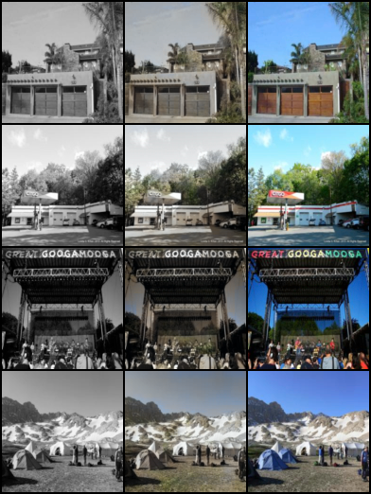
Figure A.1 — CNN baseline (epoch 50, 128²).

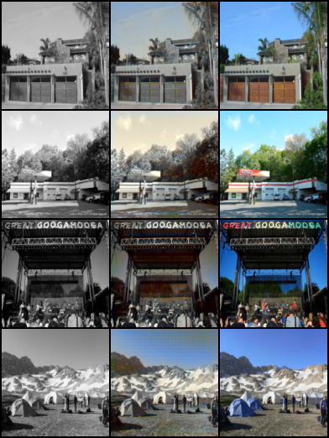
Figure A.2 — cGAN phase-2 best (epoch 50, 128²).

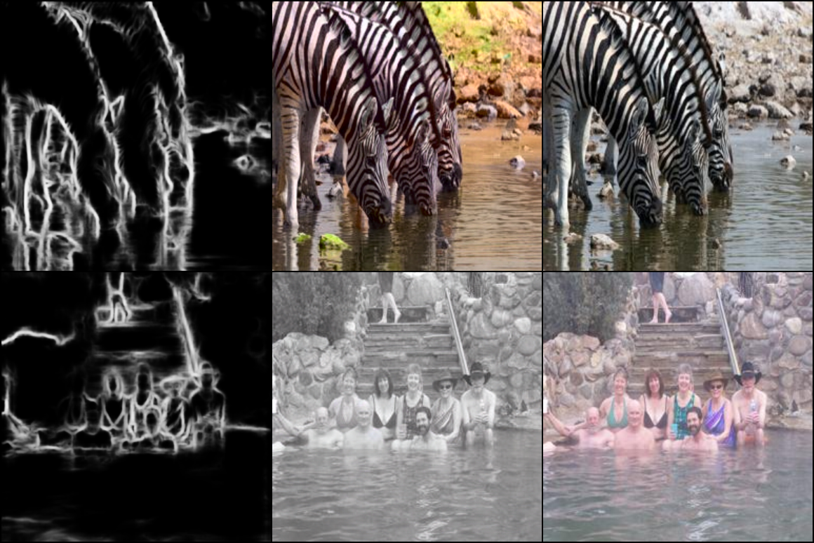
Figure A.3 — ControlNet softedge (epoch 10, 384²).

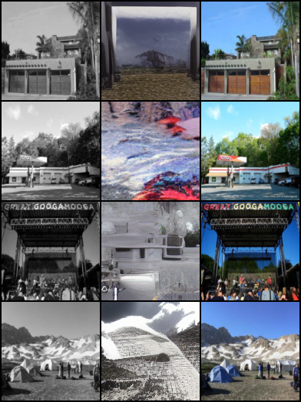
Figure A.4 — Ablation: from_unet + grayscale (epoch 4, 128²).

Appendix B — Reproducibility
See README.md and requirements-controlnet.txt in the repository. LaTeX source: report.tex. Regenerate this Word file with: python build_report_docx.py

