RESEARCH REPORT
Factory Reallocation & Shipping Optimization
Recommendation System For Nassau Candy Distributor

Submitted By :-
NIYATI KOCHAR
B.Tech – Computer Science and Engineering
RNB Global University, Bikaner
Internship Organization Unified Mentor

Project Title:-
Factory Reallocation & Shipping Optimization Recommendation System for Nassau Candy Distributor
Academic Year
2026

DECLARATION
I hereby declare that the research report entitled “Factory Reallocation & Shipping Optimization Recommendation System for Nassau Candy Distributor” is an original work carried out by me as part of the Unified Mentor Internship Program.
The analysis, data preparation, exploratory analysis, machine learning models, scenario simulations, and recommendations presented in this report have been developed and documented for the purpose of this project. The work has been prepared using the available Nassau Candy Distributor dataset and the project requirements provided during the internship.
I further declare that this report has not been submitted previously, in whole or in part, for the award of any other academic qualification or certification.
The information presented in this report is accurate to the best of my knowledge, and the limitations of the available dataset and predictive approach have been stated wherever applicable.
Place: Bikaner, Rajasthan
Date: 10/10/2026
Signature of Student: _
Name: Niyati Kochar

ACKNOWLEDGEMENT
I would like to express my sincere gratitude to Unified Mentor for providing me with the opportunity to work on the project titled “Factory Reallocation & Shipping Optimization Recommendation System for Nassau Candy Distributor” as part of my internship.
I am thankful to the mentors and coordinators of Unified Mentor for their guidance, support, and valuable feedback throughout the development of this project. Their guidance helped me understand the practical application of data analytics, machine learning, exploratory analysis, and decision-support techniques.
I would also like to express my gratitude to my faculty and RNB Global University for providing academic support and encouragement during the completion of this internship project.
I am grateful for the opportunity to work with a real-world business optimization problem, which helped me strengthen my technical knowledge and develop practical skills in Python, Pandas, Scikit-learn, data visualization, predictive modeling, scenario simulation, and Streamlit dashboard development.
Finally, I would like to thank everyone who directly or indirectly supported me during the completion of this project and contributed to making this learning experience valuable and meaningful.
Niyati Kochar
B.Tech – Computer Science and Engineering
RNB Global University, Bikaner

ABSTRACT
This research project presents a Factory Reallocation & Shipping Optimization Recommendation System developed for Nassau Candy Distributor. The main objective is to analyze existing factory assignments, predict shipping lead time, evaluate alternative factory assignments, and identify potential reallocation opportunities.
The project uses a transaction-level dataset containing 10,194 records. The analytical workflow includes data cleaning, feature engineering, exploratory data analysis, route-level analysis, K-Means clustering, predictive modeling, and what-if scenario simulation.
Three regression models—Linear Regression, Random Forest Regressor, and Gradient Boosting Regressor—were evaluated for lead-time prediction. Gradient Boosting Regressor was selected as the best-performing model, achieving an R² score of 0.5933 and an RMSE of 169.59 days.
The selected model was used to evaluate 50,970 transaction-level factory scenarios. The analysis identified 33 positive reallocation opportunities across 53 observed product-region combinations. These opportunities showed an average predicted lead-time reduction of 7.07 days.
A Streamlit dashboard was also developed to present current performance, factory recommendations, scenario comparisons, and predictive model results. The project demonstrates how machine learning and what-if analysis can support data-driven factory planning while recognizing the need for operational validation before implementation.
Keywords: Factory Reallocation, Shipping Optimization, Predictive Analytics, Machine Learning, Lead-Time Prediction, Scenario Simulation, Decision Support
TABLE OF CONTENTS
Declaration ........................................ 02
Acknowledgement ................................... 03
Abstract .......................................... 04
Table of Contents ................................ 05
Chapter 1 – Introduction .......................... 06 - 07
Chapter 2 – Dataset and Problem Understanding ..... 08 - 11
Chapter 3 – Data Preparation and Exploratory Data Analysis ..... 12 - 16
Chapter 4 – Route Performance Analysis and Clustering ........ 17 - 18
Chapter 5 – Predictive Modeling ................... 19 - 20
Chapter 6 – Factory Reallocation and Scenario Simulation ..... 21 - 22
Chapter 7 – Recommendation and Optimization Analysis ........ 22 - 24
Chapter 8 – Dashboard and Decision Support ........ 25 - 30
Chapter 9 – Limitations and Future Scope .......... 31
Chapter 10 – Conclusion ........................... 32
References ......................................... 33

CHAPTER 1
INTRODUCTION
1.1 Introduction
Efficient factory allocation is important for manufacturing and distribution organizations because factory selection can influence shipping time, operational efficiency, and business performance.
Nassau Candy Distributor manages multiple products through different manufacturing factories. This project develops a Factory Reallocation & Shipping Optimization Recommendation System using data analytics, machine learning, and what-if scenario simulation to evaluate alternative factory assignments.
1.2 Background of the Study
Traditional business analysis mainly focuses on historical performance. Predictive analytics can extend this approach by estimating shipping outcomes under different conditions.
In this project, historical transaction data is used to predict shipping lead time and evaluate alternative factory assignments through scenario simulation.
1.3 Problem Statement
The fixed product-to-factory assignments may not always provide optimal shipping performance across different regions and shipping conditions.
The project therefore aims to answer: How can historical transaction data and machine learning be used to predict shipping lead time and identify potential factory reallocation opportunities?
1.4 Aim and Objectives
The main aim is to develop a predictive decision-support system for evaluating factory assignments and shipping performance.
The key objectives are:
1. Analyze and prepare the transaction dataset.
2. Study factory, product, regional, and shipping patterns.
3. Analyze and cluster factory-region routes.
4. Develop and compare lead-time prediction models.
5. Simulate alternative factory assignments.
6. Identify positive reallocation opportunities.
7. Generate recommendations using confidence, profit stability, and risk indicators.
8. Develop an interactive Streamlit dashboard.
1.5 Scope of the Project
The project analyzes 10,194 transaction records covering 15 products, 5 factories, 4 regions, and 4 shipping modes. The scope includes data preparation, exploratory analysis, route analysis, clustering, predictive modeling, scenario simulation, recommendation generation, and dashboard development.
1.6 Research Questions
1. What are the major patterns in factory and shipping performance?
2. Which machine learning model provides the best lead-time prediction?
3. Which product-region combinations may benefit from alternative factories?
4. What predicted shipping improvement can be achieved?
5. How do confidence, profit stability, and risk influence recommendations?
1.7 Significance of the Project
The project demonstrates how predictive analytics and scenario simulation can support data-driven factory planning.
It provides a structured approach for comparing alternative factory configurations while considering operational improvement, financial stability, and recommendation risk.
1.8 Chapter Summary
This chapter introduced the background, problem statement, objectives, scope, research questions, and significance of the project. The following chapters discuss the dataset, data preparation, exploratory analysis, route clustering, predictive modeling, scenario simulation, recommendations, dashboard development, and final conclusions.

CHAPTER 2
DATASET AND PROBLEM UNDERSTANDING
2.1 Chapter Introduction
This chapter describes the dataset used for the Nassau Candy Factory Reallocation and Shipping Optimization project. It explains the structure of the data, major variables, business dimensions, and the operational problem addressed through the analytical framework.
The dataset provides transaction-level information related to orders, customers, products, shipping, geography, sales, cost, and gross profit. These attributes are used to understand current performance and develop predictive and scenario-based analyses.
2.2 Dataset Overview
The project uses a Nassau Candy Distributor transaction dataset containing 10,194 records and 18 original variables.
The major dataset characteristics are:
Dataset Component | Count
Transaction Records | 10,194
Unique Orders | 8,549
Unique Products | 15
Unique Customers | 5,044
Factories | 5
Destination Regions | 4
Shipping Modes | 4
Countries | 2
The dataset represents individual business transactions and therefore may contain multiple records belonging to the same customer, order, or product.
2.3 Dataset Variables
The dataset contains information from several business categories.
Order-related variables include Order ID, Order Date, and Ship Date. Customer-related variables include Customer ID, City, State/Province, Postal Code, and Country/Region.
Product-related variables include Product ID, Product Name, and Division. Shipping variables include Ship Mode and the current factory assignment.
Financial variables include Sales, Units, Gross Profit, and Cost. These variables support the evaluation of revenue and profitability patterns.
The dataset was further extended with derived variables such as Lead_Time_Days, Profit_Margin, Cost_Percentage, Sales_Per_Unit, Cost_Per_Unit, Profit_Per_Unit, and temporal features.
2.4 Business Dimensions
The analysis considers several major business dimensions:
• Product – Used to compare product-level shipping and financial performance.
• Factory – Used to evaluate current assignments and alternative factory scenarios.
• Region – Used to analyze destination-based shipping performance.
• Shipping Mode – Used to examine differences across delivery methods.
• Time – Used to identify temporal patterns in order and shipping behavior.
• Financial Performance – Used to evaluate sales, cost, gross profit, and profitability.
2.5 Current Factory Configuration
The dataset contains five current manufacturing factories:
1. Lot's O' Nuts
2. Wicked Choccy's
3. Sugar Shack
4. Secret Factory
5. The Other Factory
All 15 products were successfully mapped to a current factory. This mapping is treated as the baseline configuration for the factory reallocation analysis.
Factory latitude and longitude information was also incorporated to support factory-level and location-based analysis.
2.6 Geographic Coverage
The dataset includes transactions from two countries: the United States and Canada.
Customer destinations are further represented through cities, states or provinces, postal codes, and four business regions. These geographical attributes are important because shipping performance can vary according to destination conditions and the factory serving the destination.
2.7 Target Variable
The primary prediction target of the project is:
Lead_Time_Days
It represents the number of days between the order date and the shipment date.
The target variable is used to train regression models that estimate shipping lead time for different combinations of product, factory, region, shipping mode, and other transaction characteristics.
2.8 Feature Engineering for the Analytical Model
Additional features were created from the original dataset to improve analytical and predictive capabilities.
These include:
Derived Feature | Description
Lead_Time_Days | Number of days between order date and ship date
Sales_Per_Unit | Sales generated for each unit sold
Cost_Per_Unit | Cost incurred for each unit
Profit_Per_Unit | Gross profit generated for each unit
Profit_Margin | Gross profit expressed as a percentage of sales
Cost_Percentage | Cost expressed as a percentage of sales
Order_Year | Year extracted from the order date
Order_Month | Month extracted from the order date
Order_Quarter | Quarter extracted from the order date
Order_DayOfWeek | Day of the week extracted from the order date
Is_Weekend | Indicates whether the order was placed on a weekend
Factory_Destination_Region | Represents the factory and destination-region combination
Product_Ship_Mode | Combines product and shipping-mode information
Current_Factory | Factory currently assigned to the product
These variables provide additional operational, financial, temporal, and factory-related information for subsequent analysis.
2.9 Business Problem Understanding
The main business problem is the presence of fixed product-to-factory assignments that may not always provide efficient shipping performance for all destination conditions.
A factory that performs well for one region or product may not necessarily provide the best predicted outcome for another combination. Therefore, simply analyzing the current configuration is insufficient for identifying potential improvements.
The project addresses this issue through a what-if framework that compares the current factory with alternative factories using predicted shipping lead time.
2.10 Analytical Requirements
Based on the business problem, the system needs to:
1. Understand the current shipping and factory performance.
2. Identify variations across products, regions, factories, and shipping modes.
3. Predict shipping lead time using historical transaction data.
4. Evaluate alternative factory assignments.
5. Quantify predicted lead-time improvements.
6. Consider confidence, profit stability, and risk while generating recommendations.
7. Present the results through an interactive dashboard.
2.11 Chapter Summary
This chapter introduced the dataset, its main variables, business dimensions, factory configuration, geographic coverage, and prediction target.
The dataset provides the foundation for exploratory analysis and machine learning. The next chapter focuses on data cleaning, validation, feature engineering, and exploratory data analysis to prepare the data for route analysis and predictive modeling.

CHAPTER 3
DATA PREPARATION AND EXPLORATORY DATA ANALYSIS
3.1 Chapter Introduction
Data preparation is an important step in any analytics and machine learning project because the quality of the input data directly affects the reliability of analytical results.
This chapter explains the cleaning, validation, feature engineering, and exploratory analysis performed on the Nassau Candy Distributor dataset before predictive modeling.
3.2 Data Cleaning
The raw dataset contained 10,194 transaction records and 18 original variables. The data was reviewed for missing values, duplicate records, invalid dates, inconsistent numerical values, and categorical inconsistencies.
Column names were standardized and numerical fields were converted into appropriate formats. Date columns were also converted into datetime format for lead-time calculation and temporal analysis.
3.3 Missing-Value and Duplicate Analysis
The dataset was checked for missing values across all available columns.
Data Quality Check | Result
Total Records | 10,194
Original Columns | 18
Missing Values | 0
Completely Duplicated Rows | 0
Valid Order Dates | 10,194
Valid Ship Dates | 10,194
Repeated Order IDs, Customer IDs, and Product IDs were retained because the dataset represents transaction-level business records and repeated values can represent legitimate transactions.
3.4 Date Validation and Lead-Time Calculation
Order Date and Ship Date were converted into valid datetime values. After validation, all 10,194 records contained valid dates.
The final Order Date range extends from 2 January 2024 to 31 December 2025, while the Ship Date range extends from 30 June 2026 to 28 June 2030.
Lead time was calculated as: Lead_Time_Days = Ship_Date − Order_Date
The resulting lead-time values were retained as provided by the dataset. No negative or zero lead-time records were found. The average lead time was approximately 1,320.84 days, with values ranging from 759 to 1,965 days.
These relatively large values were not artificially modified because they are derived directly from the supplied date information.
3.5 Numerical Data Validation
The numerical variables Sales, Units, Gross Profit, Cost, Lead Time, Profit Margin, and Cost Percentage were checked for invalid values. No negative or zero values were found in the principal business measures used for the analysis. This supported their use in feature engineering and predictive modeling.
3.6 Categorical Data Preparation
Categorical fields were reviewed to ensure consistent representation of products, factories, regions, divisions, and shipping modes.
The dataset contains:
Category | Unique Values
Products | 15
Factories | 5
Regions | 4
Divisions | 3
Shipping Modes | 4
Countries | 2
Cities | 542
States/Provinces | 59
Postal Codes | 654
All 15 products were successfully mapped to a current factory, with no unmapped product assignments.
3.7 Feature Engineering
Additional features were created to improve business analysis and predictive modeling.
Derived Feature | Purpose
Lead_Time_Days | Measures shipping lead time
Sales_Per_Unit | Measures revenue per unit
Cost_Per_Unit | Measures cost per unit
Profit_Per_Unit | Measures profit per unit
Profit_Margin | Measures profitability relative to sales
Cost_Percentage | Measures cost relative to sales
Order_Year | Captures yearly patterns
Order_Month | Captures monthly patterns
Order_Quarter | Captures quarterly patterns
Order_DayOfWeek | Captures weekly patterns
Is_Weekend | Identifies weekend orders
Factory_Destination_Region | Represents factory-region combination
Product_Ship_Mode | Combines product and shipping mode
Current_Factory | Identifies the existing factory assignment
These features provide operational, financial, temporal, and factory-related information for later analysis.
3.8 Exploratory Data Analysis
Exploratory Data Analysis was performed to understand the major patterns in the prepared dataset.
The analysis considered product distribution, shipping modes, destination regions, factories, lead times, sales, and profitability.
3.9 Shipping Mode Analysis
Standard Class was the most frequently used shipping mode, accounting for approximately 60.04% of all records.
The remaining transactions were distributed across Second Class, First Class, and Same Day shipping modes.
This distribution indicates that Standard Class represents the dominant shipping pattern in the available dataset.
3.10 Regional Analysis
The transactions cover four major business regions. The Pacific region recorded the highest transaction volume among the observed regions. Average lead time was relatively similar across regions, but route-level analysis later showed greater variation when factory and region were considered together.
This indicates that destination region alone may not fully explain differences in shipping performance.
3.11 Product and Division Analysis
The dataset contains 15 unique products distributed across three divisions.
The Chocolate division accounts for approximately 96.57% of the transaction records, making it the dominant division in the dataset.
The product-level analysis provides a basis for evaluating whether different products may benefit from different factory assignments.
3.12 Factory Analysis
Five factories are included in the current configuration:
1. Lot's O' Nuts
2. Wicked Choccy's
3. Sugar Shack
4. Secret Factory
5. The Other Factory
The current factory assignment was treated as the baseline for later scenario simulation. Factory performance was examined using lead time, financial indicators, and destination-region combinations.
3.13 Lead-Time Analysis
Lead time is the primary operational measure used throughout the project.
The dataset shows substantial variation in lead time, with an average of approximately 1,320.84 days and a minimum-to-maximum range of 759 to 1,965 days. This variation suggests that shipping performance is not uniform across all transactions and supports the need for route-level and predictive analysis.
3.14 Financial Analysis
Sales, Cost, and Gross Profit were analyzed to understand the financial characteristics of the transactions. Profit Margin and per-unit measures were created to make financial performance more comparable across transactions with different sales and unit volumes. These financial indicators were later incorporated into route profiling and recommendation evaluation so that shipping improvements could be considered along with profit stability.
3.15 Key EDA Findings
The main findings from exploratory analysis are:
• The dataset contains 10,194 transaction records with no missing values or completely duplicated rows.
• Standard Class is the dominant shipping mode at approximately 60.04%.
• The Chocolate division contributes approximately 96.57% of transaction records.
• Five factories currently serve 15 products across four destination regions.
• Lead time varies substantially across transactions, indicating differences in shipping performance.
• Factory and destination-region combinations provide additional operational detail that is not visible from overall averages alone.
These findings establish the baseline for route-level analysis and predictive modeling.
3.16 Chapter Summary
This chapter described the data preparation and exploratory analysis process applied to the Nassau Candy Distributor dataset.
The data was cleaned, validated, transformed, and enriched with additional analytical features. Exploratory analysis identified important patterns in shipping modes, products, regions, factories, lead time, and profitability.
The prepared dataset provides the foundation for the next stage of the project, which focuses on route-level performance analysis and clustering.

CHAPTER 4
ROUTE PERFORMANCE ANALYSIS AND CLUSTERING
4.1 Chapter Introduction
Factory performance may vary according to destination region and shipping mode. Therefore, route-level analysis was performed to understand differences that may not be visible from overall factory averages.
4.2 Route-Level Performance Analysis
The transaction data was aggregated by Current_Factory and Region to evaluate route performance. Key measures included transaction volume, units, sales, gross profit, average lead time, lead-time variability, and profit margin.
The analysis identified 20 observed factory-region combinations. A more detailed factory-region-shipping analysis produced 74 combinations, showing that shipping performance varies according to both destination and shipping conditions.
4.3 Route Performance Indicators
Indicator | Purpose
Transaction Volume | Measures route activity
Total Units | Measures shipment quantity
Sales | Measures revenue
Gross Profit | Measures financial contribution
Average Lead Time | Measures shipping duration
Lead-Time Variability | Measures consistency
Profit Margin | Measures profitability

4.4 Route Clustering
K-Means clustering was applied to group routes with similar operational and financial characteristics. The clustering features included Average Lead Time, Lead-Time Variability, Average Profit Margin, Profit Per Record, and Sales Per Record. Cluster values from 2 to 6 were evaluated using inertia and silhouette score. Five clusters were selected, giving a silhouette score of approximately 0.588.

4.5 Cluster Interpretation
The clusters represent groups of routes with similar performance characteristics. The numerical cluster labels are identifiers generated by the algorithm and are not direct performance rankings.
4.6 Key Findings
The analysis showed variation in lead time across factory-region-shipping combinations. This variation provided the baseline for evaluating alternative factory assignments through predictive modeling.
4.7 Chapter Summary
Route-level analysis and clustering provided a detailed understanding of factory and destination performance. The resulting insights formed the basis for predictive lead-time modeling and scenario simulation.

CHAPTER 5
PREDICTIVE MODELING
5.1 Chapter Introduction
Predictive modeling was used to estimate shipping lead time from historical transaction and operational data. The target variable was Lead_Time_Days.
5.2 Model Features
The model used product, factory, region, shipping mode, financial, geographical, and temporal features. Categorical variables were encoded, while numerical variables were prepared for model training.
5.3 Train-Test Split
The dataset was divided into 80% training data and 20% testing data using random_state = 42. The testing data was kept separate for unbiased model evaluation.
5.4 Models Evaluated
Three regression models were compared:
1. Linear Regression
2. Random Forest Regressor
3. Gradient Boosting Regressor
5.5 Evaluation Metrics
Metric | Purpose
MAE | Measures average prediction error
RMSE | Measures prediction error with greater weight on larger errors
R² Score | Measures the variation explained by the model

5.6 Model Comparison
Regression Model | MAE (Days) | RMSE (Days) | R² Score
Linear Regression | 181.39 | 182.51 | 0.5290
Random Forest Regressor | 148.77 | 177.17 | 0.5562
Gradient Boosting Regressor | 159.87 | 169.59 | 0.5933
Gradient Boosting Regressor was selected because it achieved the highest R² score of 0.5933 and the lowest RMSE of 169.59 days among the evaluated models. Although Random Forest achieved a lower MAE, Gradient Boosting showed stronger overall performance.
5.7 Selected Model
Gradient Boosting Regressor was selected as the final model for factory scenario simulation. The trained model was saved for reuse in the recommendation system and dashboard.
5.8 Feature Importance
Feature-importance analysis was used to understand which variables contributed most to model predictions. Temporal and operational features showed important contributions. These results indicate model association rather than direct causal relationships.
5.9 Role in Optimization
The selected model predicts shipping lead time under alternative factory assignments. These predictions are compared with the current factory scenario to identify potential improvements.
5.10 Chapter Summary
This chapter presented the development and evaluation of three regression models. Gradient Boosting Regressor was selected as the final model and provides the predictive foundation for factory reallocation and what-if scenario analysis.

CHAPTER 6
FACTORY REALLOCATION AND SCENARIO SIMULATION
6.1 Chapter Introduction
After selecting the predictive model, what-if scenario analysis was performed to evaluate how alternative factory assignments may affect shipping lead time.
6.2 Scenario Design
The five available factories were treated as candidate factories. For each transaction, alternative factory assignments were evaluated while keeping the other transaction characteristics unchanged.
A total of 50,970 transaction-level factory scenarios were generated. At the product-region level, 265 product-region-candidate factory combinations were also evaluated.
6.3 Scenario Evaluation
Each scenario was compared with the current factory assignment using:
• Predicted Lead Time
• Lead-Time Reduction in Days
• Lead-Time Reduction Percentage
Only scenarios showing a positive predicted lead-time improvement were considered potential reallocation opportunities.
6.4 Scenario Sensitivity
Factory sensitivity analysis showed that most evaluated Product × Region × Ship Mode combinations produced different predictions across candidate factories. This indicates that the model responds to changes in factory assignment.
However, these differences represent model-based estimates and should not be treated as proof of a direct causal factory effect.
6.5 Key Findings
The scenario analysis identified 33 positive reallocation opportunities across 53 observed product-region combinations. The recommendation coverage was approximately 62.26%.
The identified opportunities showed an average predicted lead-time reduction of approximately 7.07 days, with a median reduction of 5.44 days and an average relative improvement of approximately 0.56%.
6.6 Chapter Summary
Scenario simulation provided a structured method for comparing the current factory configuration with alternative assignments. The resulting positive scenarios were used as inputs for the final recommendation and optimization framework.

CHAPTER 7
RECOMMENDATION AND OPTIMIZATION ANALYSIS
7.1 Chapter Introduction
The recommendation framework converts the scenario results into ranked factory reallocation opportunities by considering operational improvement along with confidence and financial stability.
7.2 Recommendation Framework
The main indicators used were Speed Score, Scenario Confidence Score, Profit Stability Score, Optimization Score, and Final Risk Level.
The optimization score gives 70% importance to shipping-speed improvement and 30% importance to profit stability.
7.3 Recommendation Results
A total of 33 positive reallocation opportunities were identified. These opportunities were categorized by risk level based on the available confidence and profit-stability indicators.
Risk Level | Opportunities | Percentage
High | 17 | 51.52%
Medium | 4 | 12.12%
Low | 12 | 36.36%
Total | 33 | 100%

7.4 Overall Optimization Impact
The average predicted lead-time reduction across the recommended opportunities was approximately 7.07 days.
At the overall system level, the model-based optimized scenario reduced weighted predicted lead time from approximately 1,320.99 days to 1,315.81 days.
This represents an estimated reduction of approximately 5.18 days, or 0.39%.
These results are predictive what-if estimates and should be validated against real operational conditions before implementation.

7.5 Business Recommendations
The identified opportunities can be considered for further operational evaluation, with higher-impact scenarios receiving greater attention.
Before implementing any reassignment, recommendations should be checked against factory capacity, transportation cost, inventory availability, production capability, and service-level requirements.
The dashboard can be used to compare alternative scenarios and support structured factory allocation planning.
7.6 Chapter Summary
This chapter converted the scenario analysis into a structured recommendation framework using operational improvement, confidence, profit stability, and risk indicators. The final results provide a practical decision-support basis for evaluating potential factory reallocations.

CHAPTER 8
DASHBOARD AND DECISION SUPPORT
8.1 Chapter Introduction
To make the analytical results easier to understand and use, an interactive Streamlit dashboard was developed. The dashboard presents current performance, factory recommendations, scenario comparisons, route analysis, and predictive model results.
8.2 Dashboard Components
The dashboard contains five major sections:
Dashboard Section | Purpose
Executive Overview | Presents key project KPIs and current versus model-based optimized performance
Factory Recommendations | Displays potential factory reallocation opportunities with filtering options
Scenario Simulator | Compares predicted lead time for different product, region, shipping-mode, and factory combinations
Route Performance | Presents factory-region performance and lead-time comparisons
Predictive Model | Displays model comparison and selected model performance

8.3 Decision-Support Features
The dashboard allows users to explore alternative factory scenarios without changing the original dataset. It presents predicted lead-time reduction, optimization scores, confidence indicators, and risk levels to support structured evaluation.
The dashboard is intended as a decision-support tool rather than an automatic factory assignment system.
8.4 Dashboard Interface
The developed Streamlit dashboard provides an interactive interface for exploring the factory optimization analysis. The dashboard presents key performance indicators, recommendation results, scenario comparisons, route-level analysis, and predictive model performance in a structured format.
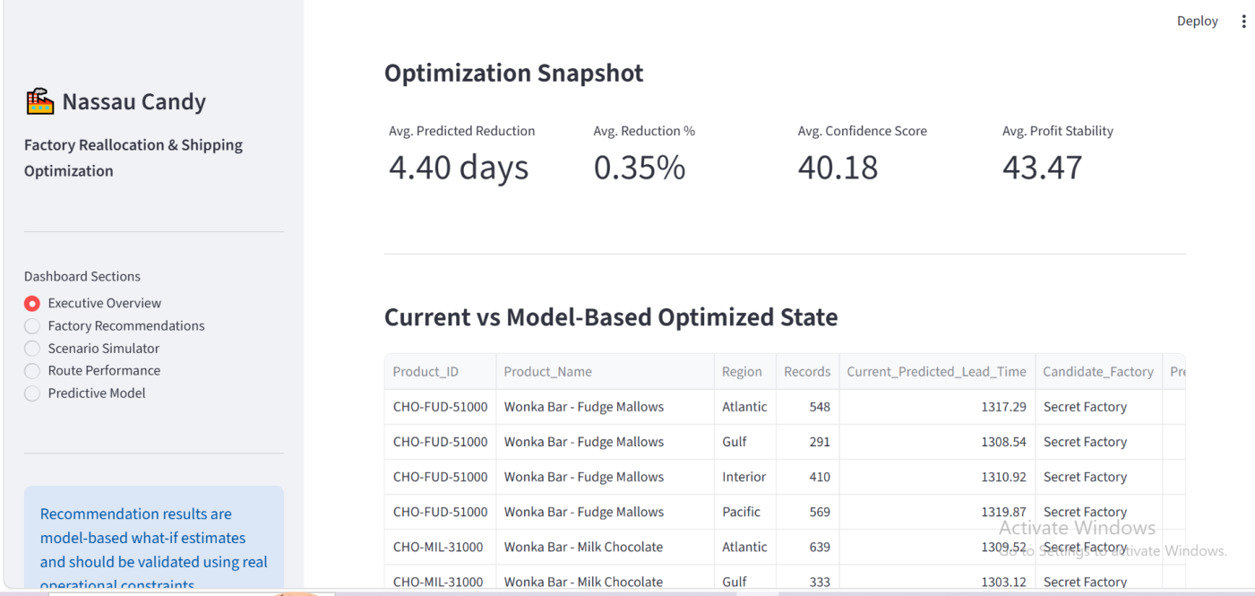
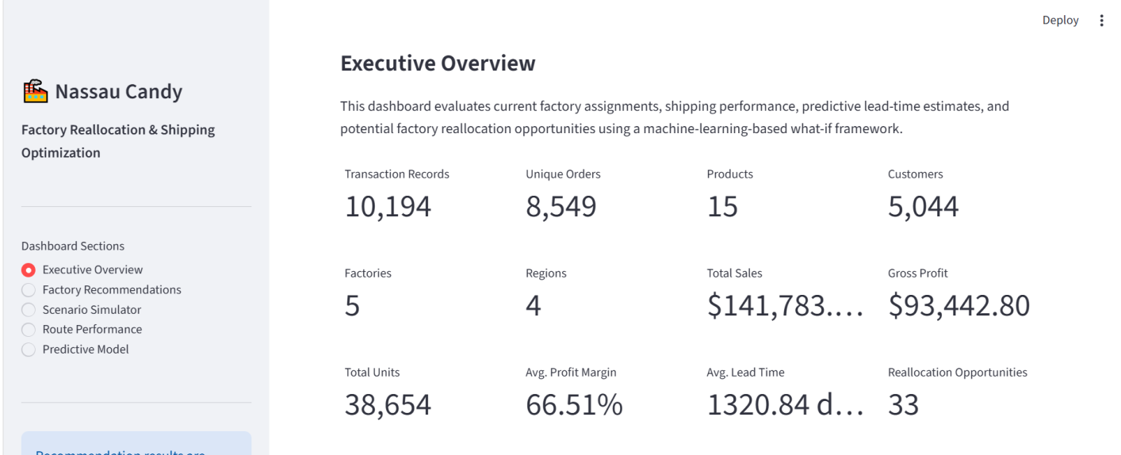

Figure 8.1 shows the Executive Overview containing the main project KPIs and the current versus model-based optimized state.
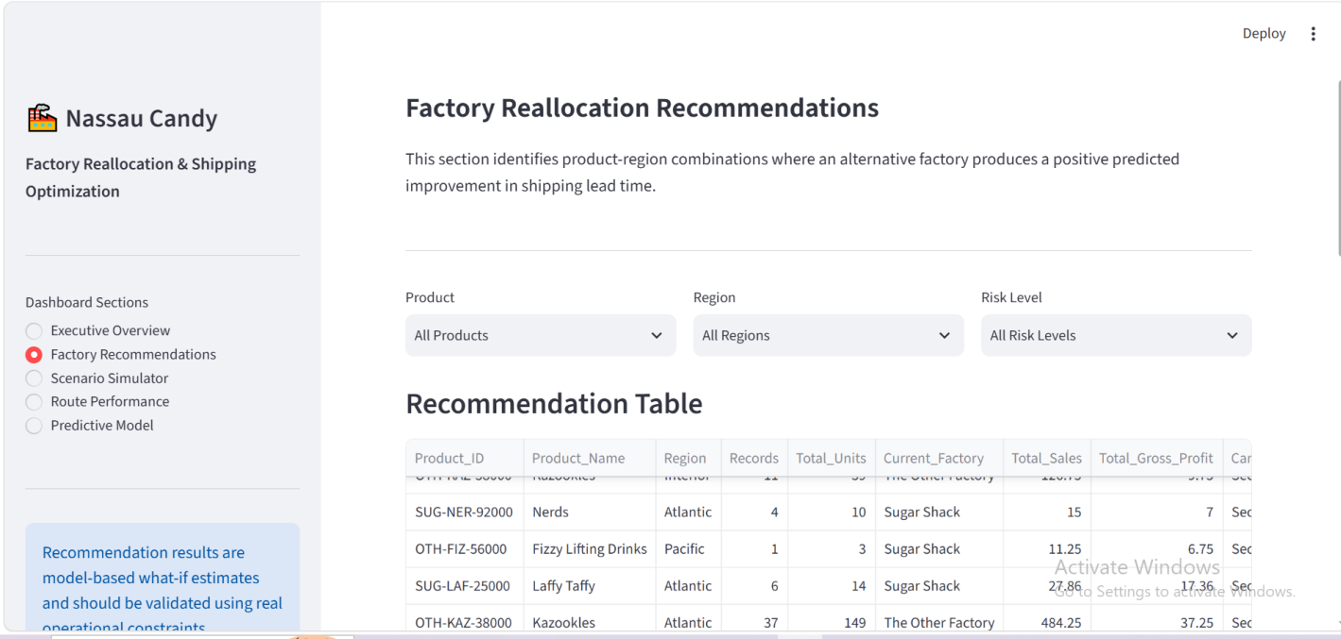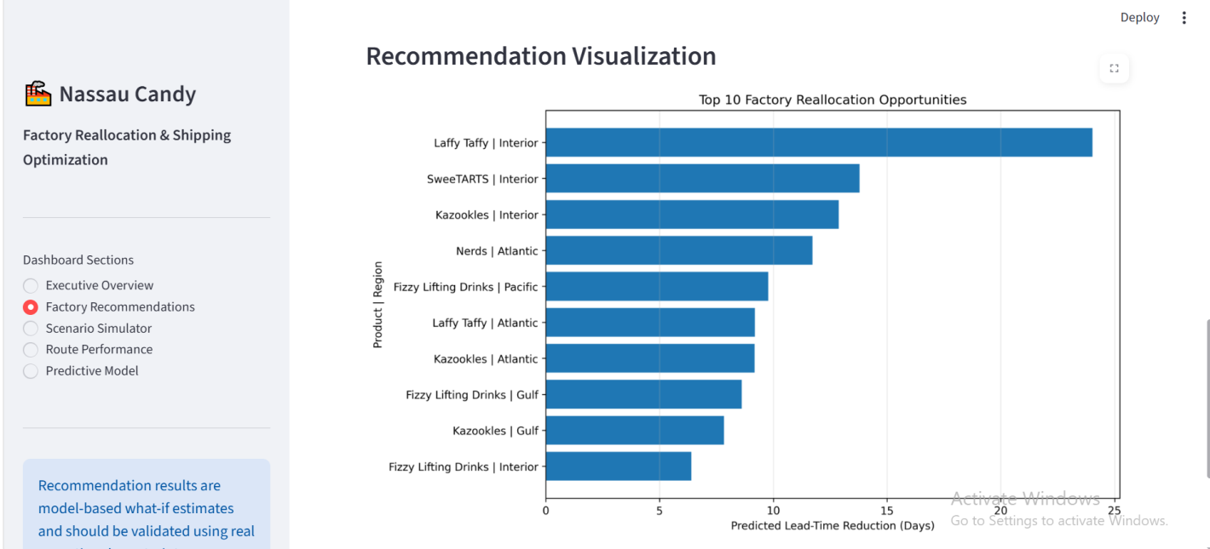Figure 8.2 shows the Factory Recommendations section, where users can filter and examine potential factory reallocation opportunities.
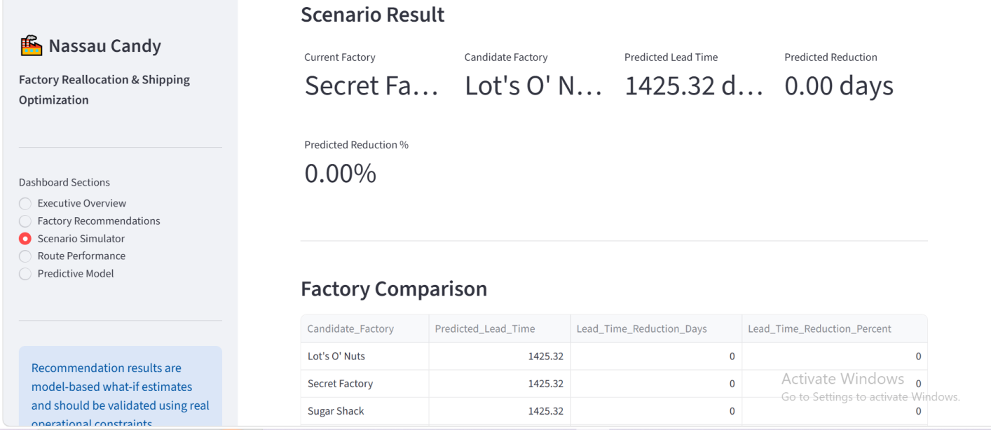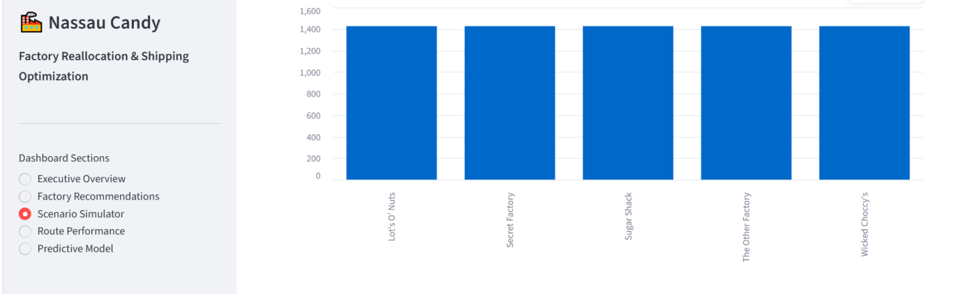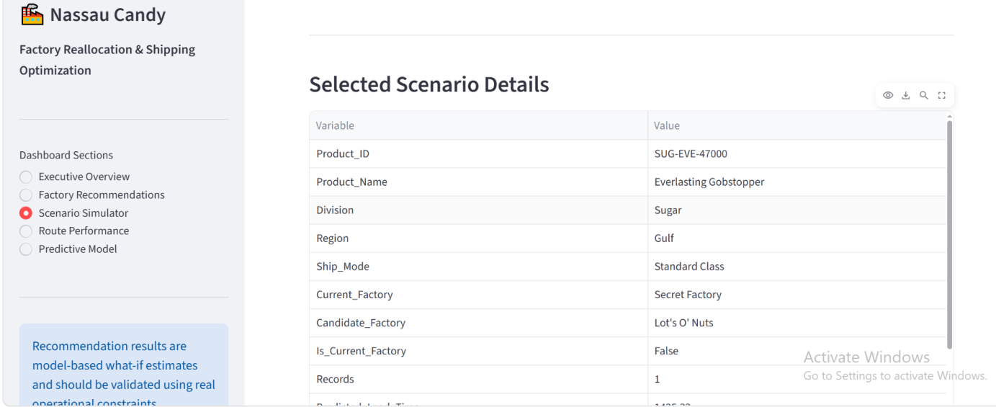
Figure 8.3 presents the Scenario Simulator, which allows users to select a product, destination region, shipping mode, and candidate factory to compare predicted shipping outcomes.
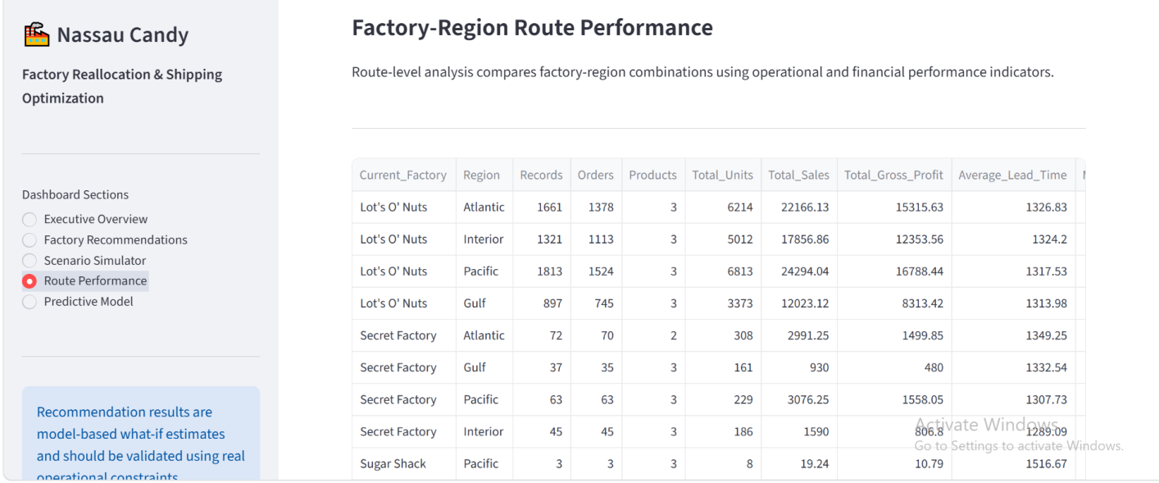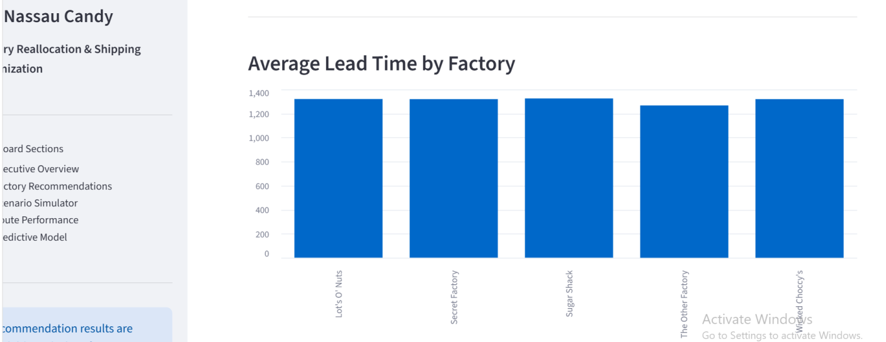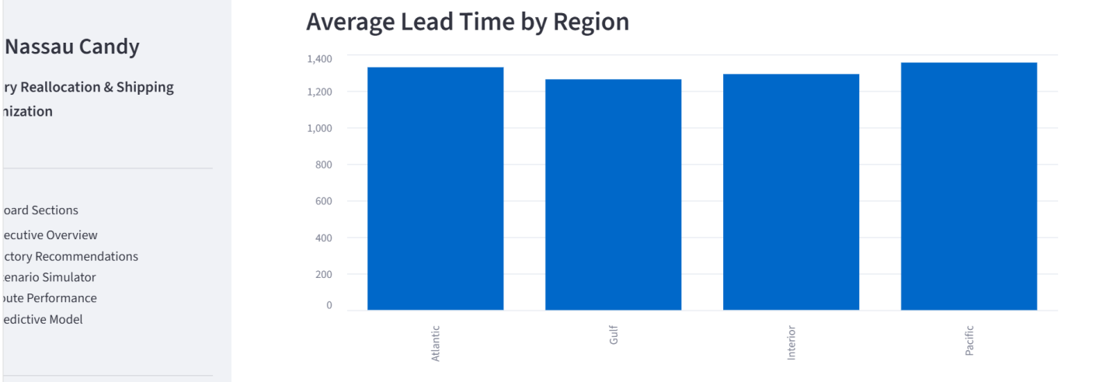
Figure 8.4 presents the Route Performance section containing factory-region performance and lead-time comparisons.
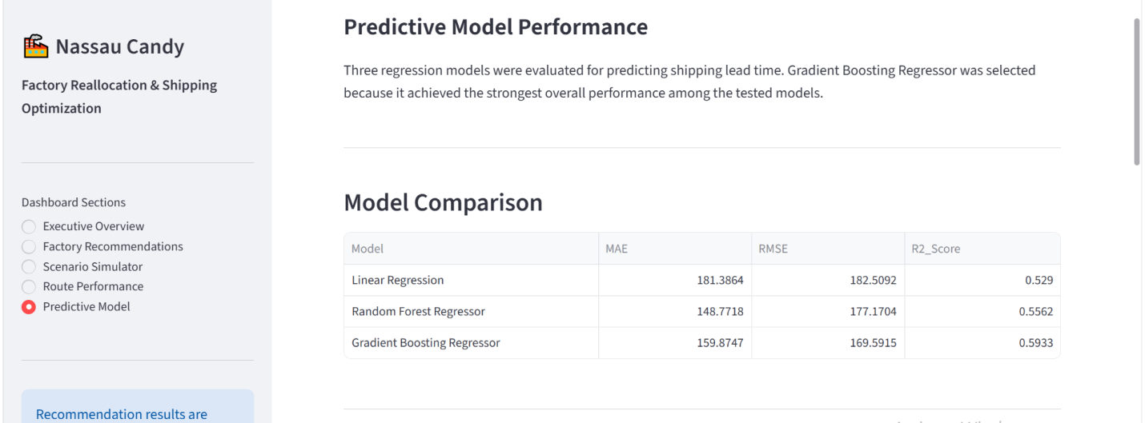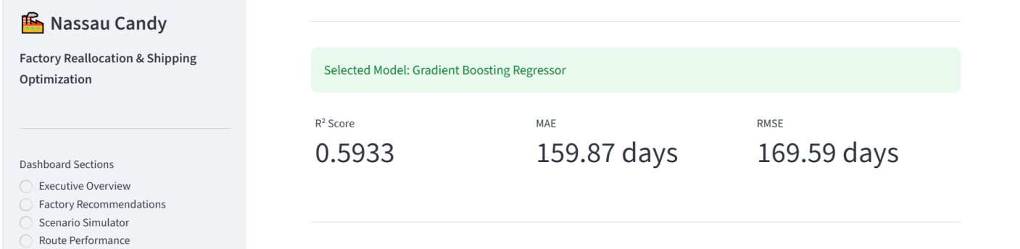

Figure 8.5 presents the Predictive Model section showing the evaluated regression models and selected model performance.
8.5 Decision-Support Features
The dashboard allows users to explore the analytical outputs without directly modifying the underlying dataset. It provides a convenient interface for comparing alternative factory scenarios and reviewing predicted lead-time improvements, recommendation scores, and risk levels.
The dashboard is intended as a decision-support tool rather than an automatic factory assignment system.
8.6 Chapter Summary
The Streamlit dashboard converts the project's analytical outputs into an interactive and accessible interface. It provides a practical way to examine factory performance and evaluate potential reallocation scenarios.

CHAPTER 9
LIMITATIONS AND FUTURE SCOPE
9.1 Project Limitations
The project has several limitations that should be considered when interpreting the results.
The dataset does not contain historical observations for every possible product-factory combination. Therefore, alternative factory results are model-based what-if estimates.
Factory capacity, transportation cost, inventory availability, production constraints, and distance-based logistics information were not available and could not be directly included in the optimization.
The Scenario Confidence Score is a project-specific confidence proxy and should not be interpreted as a formal statistical confidence interval.
The predictive model also contains estimation error, and its predictions should be validated against real operational conditions before implementation.
9.2 Future Scope
The system can be improved by incorporating factory capacity, actual transportation costs, inventory levels, production constraints, and geographic distance.
Advanced optimization techniques such as linear programming or mixed-integer optimization could be introduced to evaluate multiple operational constraints simultaneously.
The dashboard could also be connected to regularly updated data for continuous monitoring and dynamic recommendation generation.
9.3 Chapter Summary
The current system provides a useful predictive and scenario-based framework, while its limitations highlight the additional information required for a more comprehensive optimization solution.

CHAPTER 10
CONCLUSION
10.1 Conclusion
This project developed a data-driven Factory Reallocation & Shipping Optimization Recommendation System for Nassau Candy Distributor.
The analysis covered 10,194 transaction records and included data preparation, exploratory analysis, route-level analysis, clustering, predictive modeling, scenario simulation, and recommendation generation.
Three regression models were evaluated, with Gradient Boosting Regressor selected as the best overall model based on an R² score of 0.5933 and an RMSE of 169.59 days.
The selected model was used to evaluate alternative factory assignments. The analysis identified 33 positive reallocation opportunities across 53 observed product-region combinations. These opportunities showed an average predicted lead-time reduction of approximately 7.07 days.
At the overall system level, the model-based optimized scenario indicated an estimated reduction of approximately 5.18 days, or 0.39%, in weighted predicted lead time.
The final recommendation framework combines shipping improvement with confidence, profit stability, and risk indicators. A Streamlit dashboard was developed to present these results through interactive scenario analysis.
Overall, the project demonstrates how data analytics, machine learning, and what-if simulation can support evidence-based factory planning. The generated recommendations should be validated against actual business constraints before operational implementation.
10.2 Final Outcome
The completed system provides a reusable foundation for predictive factory allocation and shipping decision support. With additional operational and financial data, the framework can be extended toward a more comprehensive optimization solution.

REFERENCES
- Pedregosa, F. et al. (2011). Scikit-learn: Machine Learning in Python. JMLR.
- Friedman, J. H. (2001). Gradient Boosting Machine. The Annals of Statistics.
- MacQueen, J. (1967). K-Means Clustering Method. Berkeley Symposium.
- Hastie, T., Tibshirani, R., & Friedman, J. (2009). The Elements of Statistical Learning. Springer.
- James, G. et al. (2021). An Introduction to Statistical Learning. Springer.
- McKinney, W. (2022). Python for Data Analysis. O'Reilly Media.
- Hunter, J. D. (2007). Matplotlib: A 2D Graphics Environment. Computing in Science & Engineering.
- Streamlit. Streamlit Documentation.
- Scikit-learn. Scikit-learn User Guide and API Reference.
- Python Software Foundation. Python Documentation.

