- LIST OF ACRONYMS AND ABBREVIATION

- UI - User Interface
- UX - User Experience
- API - Application Programming Interface
- DB - Database
- HTTP - HyperText Transfer Protocol
- HTML - HyperText Markup Language
- CSS - Cascading Style Sheets
- JS - JavaScript
- CRUD - Create, Read, Update, Delete
- ER - Entity Relationship
- DFD - Data Flow Diagram
- SDLC - Software Development Life Cycle
- JWT - JSON Web Token
- SMTP - Simple Mail Transfer Protocol

- LIST OF FIGURES

- Figure 1 : System Architecture Diagram
- Figure 2 : Data Flow Diagram (Level 0)
- Figure 3 : Data Flow Diagram (Level 1)
- Figure 4 : Data Flow Diagram (Level 2)
- Figure 5 : Entity Relationship (ER) Diagram
- Figure 6 : System Flowchart

- Abstract
The rapid growth of online shopping has significantly transformed the retail industry, especially in the cosmetics sector where customers prefer convenience, variety, and personalized experiences. This project, titled “GlowCart – Full Stack Cosmetics E-Commerce Platform Using Next.js & Node.js Framework,” aims to develop a modern, scalable, and user-friendly web application for purchasing cosmetic products online.
The system is designed to provide a seamless shopping experience by allowing users to browse a wide range of cosmetic products, view detailed product information, add items to a shopping cart, and securely complete purchases through an integrated payment gateway. The platform also includes user authentication features such as registration and login to ensure personalized and secure access.
On the administrative side, the system provides a comprehensive dashboard that enables efficient management of products, categories, users, and customer orders. Administrators can add, update, and delete product listings, as well as monitor order status and customer activity in real time.
The application is developed using Next.js for the frontend to ensure fast rendering and improved performance, along with Tailwind CSS for responsive and modern user interface design. The backend is implemented using Node.js, while MongoDB Atlas is used as a cloud-based database to store and manage application data efficiently. Additional functionalities such as email notifications and payment integration enhance the usability and practicality of the system.
Overall, the proposed system aims to deliver a reliable, efficient, and scalable e-commerce solution tailored for the cosmetics industry, improving both customer satisfaction and business management.

- Introduction

1.1 introduction
In today’s digital era, online shopping has become an essential part of everyday life. The cosmetics industry, in particular, has seen significant growth due to increasing awareness of beauty and personal care products. Customers prefer online platforms because they offer convenience, a wide variety of products, and easy comparison of prices and features.
Many users are now interested in purchasing international cosmetic brands such as Rare Beauty and Pilgrim. However, it is often difficult to find all such products on a single platform with a smooth and user-friendly experience.
The proposed project, “GlowCart – Full Stack Cosmetics E-Commerce Platform,” aims to provide a comprehensive online shopping system for cosmetics. The platform allows users to browse products, add them to a cart, and complete purchases securely. It also includes an admin panel for managing products, users, and orders efficiently.
The system is developed using modern technologies such as Next.js for the frontend, Node.js for backend processing, and MongoDB Atlas for database management, ensuring scalability and performance.

  - Project Objectives
The main objectives of the project are:

- To develop a user-friendly cosmetics e-commerce website
- To provide access to international beauty products
- To implement cart and checkout functionality
- To ensure secure user authentication
- To manage products and orders through an admin panel
- To integrate payment and notification systems

  - Outline of the project
The project is organized into several sections for better understanding:
Introduction:

- Overview of the project
- Study of Existing System: Analysis of current platforms
- Methodology: Development approach and process
- Requirement Analysis: Hardware and software needs
- System Design: Diagrams and architecture
- Implementation: Development of modules
- Conclusion: Summary of the project

  - Problem Statement
The existing e-commerce platforms provide a wide range of cosmetic products but often lack a focused approach towards international and trending brands. Users may face difficulties in finding all desired products in one place, along with a simple and efficient shopping experience.
There is a need for a dedicated platform that provides easy access to global cosmetic brands, along with features like cart management, secure checkout, and efficient administration.

  - Methodology

The project follows a structured development approach using modern web technologies. The frontend is developed using Next.js and Tailwind CSS to create an interactive and responsive user interface.
The backend is implemented using Node.js and Express.js to handle server-side operations and API management. MongoDB Atlas is used for storing and managing data. The development process includes designing, coding, testing, and integrating different modules to ensure smooth functionality.

  - Scope
The scope of the project includes the development of a web-based cosmetics e-commerce system that allows users to browse products, add items to cart, and place orders online.
The system also provides administrative features such as product management and order tracking. Additional features like payment integration and notification systems are included to enhance the overall functionality.
The project is limited to a web platform and is designed primarily for academic and learning purposes.

- Study of Existing System

CURRENT WORKING METHOD OF SYSTEM

Nykaa is an Indian e-commerce company, founded by Falguni Nayar in April 2012

and headquartered in Mumbai.

It sells beauty, wellness and fashion products across websites, mobile apps and 100+

offline stores.

In 2020, it became the first Indian unicorn startup headed by a woman.

Nykaa sells products which are manufactured in India as well as internationally.

Website: www.nykaa.com

EXISITING SYSTEM FLOW

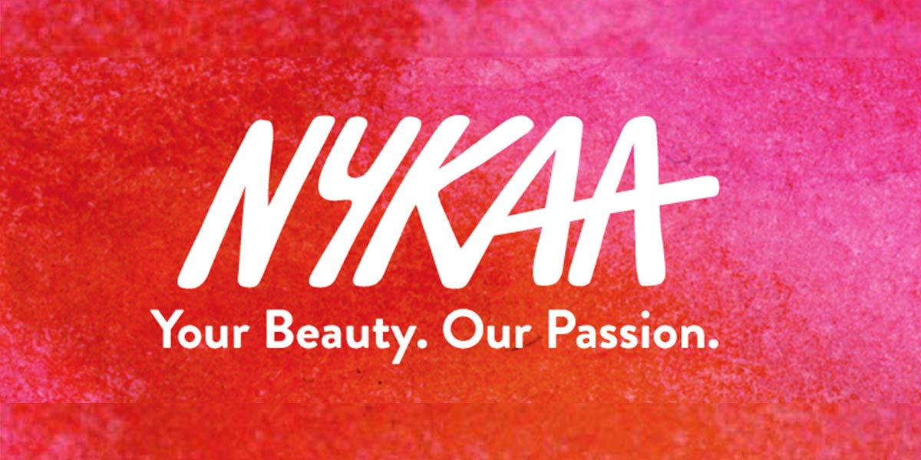

Install the APP from play store otherwise you can use nykaa website as well as.

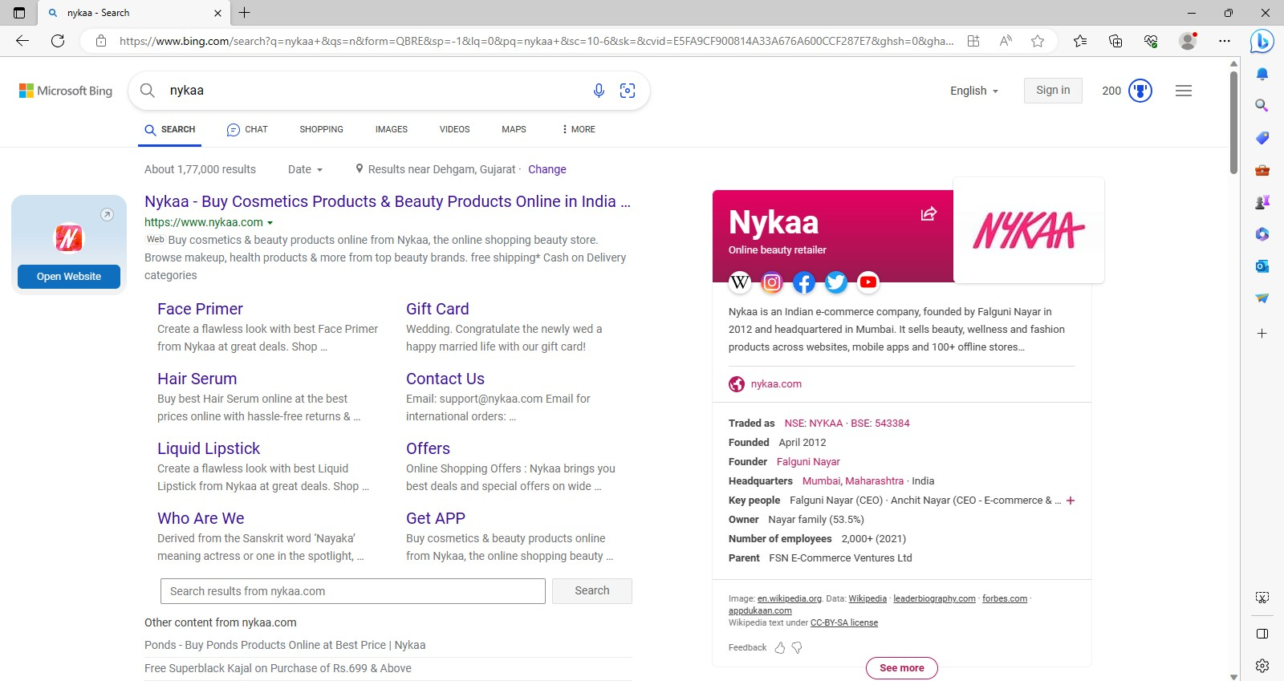

When you install the app then firstly you can login otherwise when you want to add to product in add to bag then you can login.

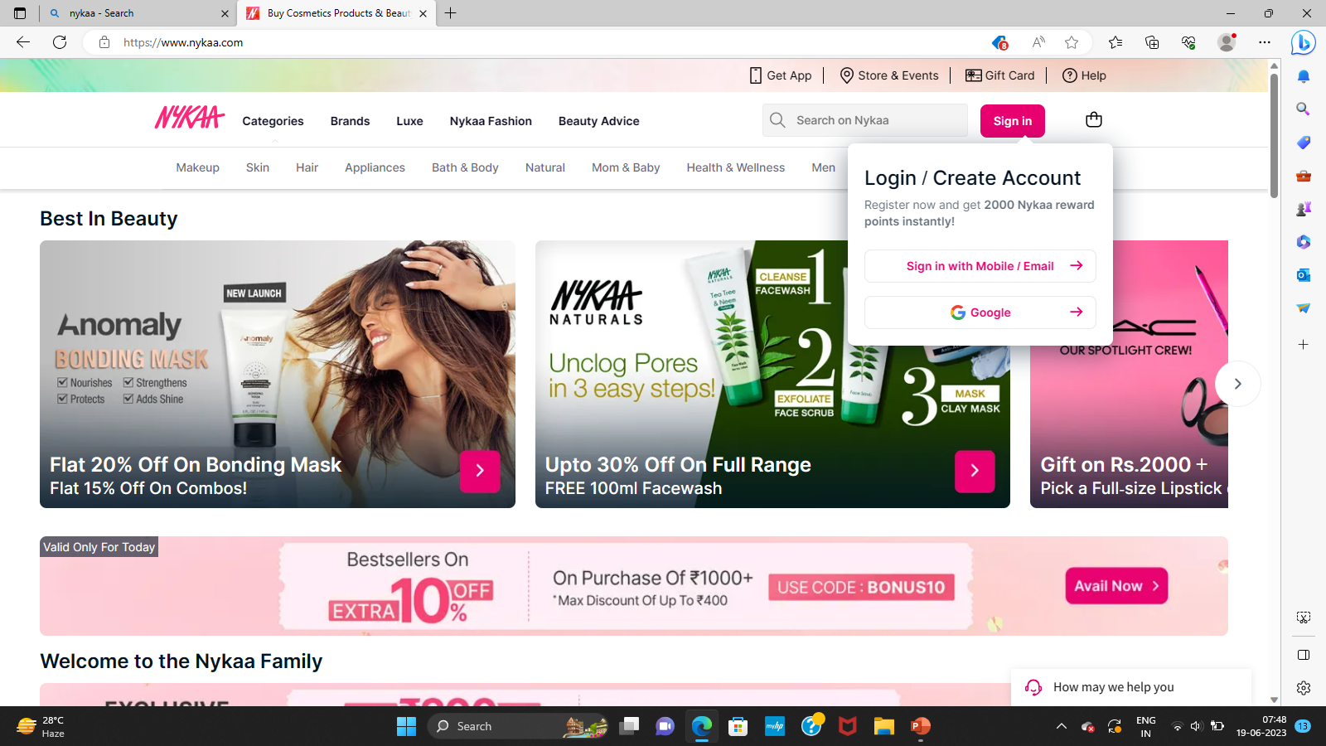

Find the product you want & select the product you like then you have to add product in add to bag.

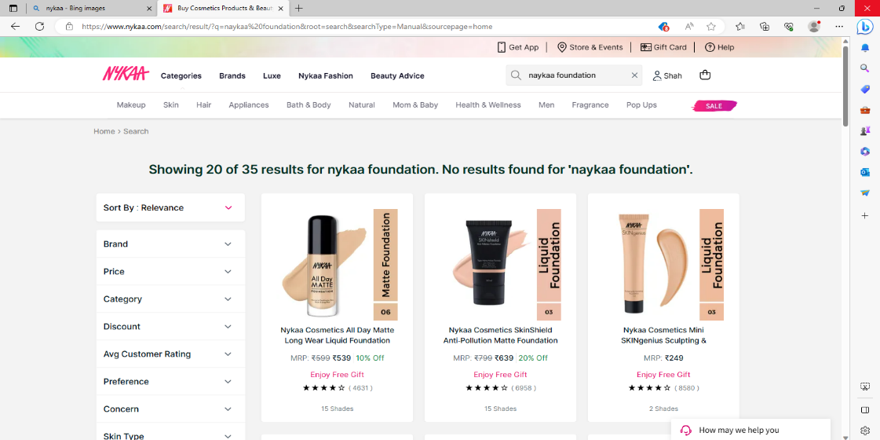

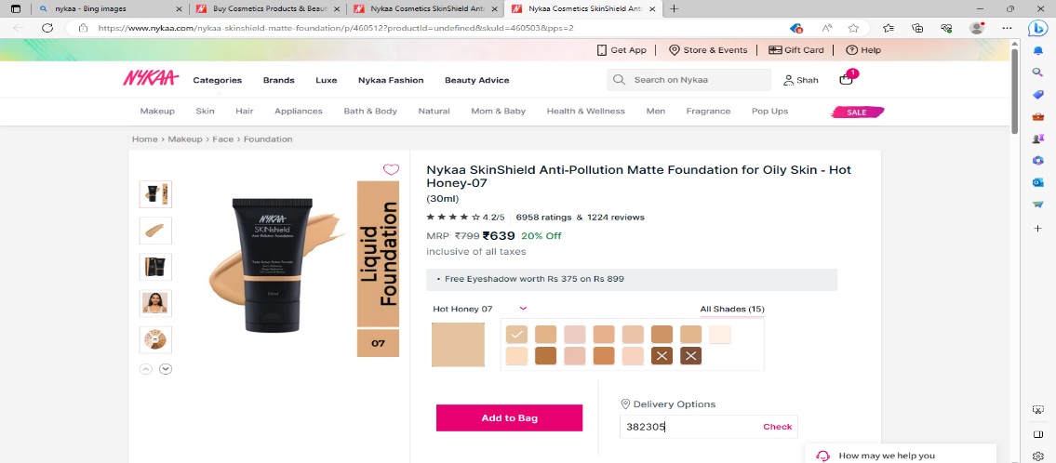

Now you can proceed for buy the product

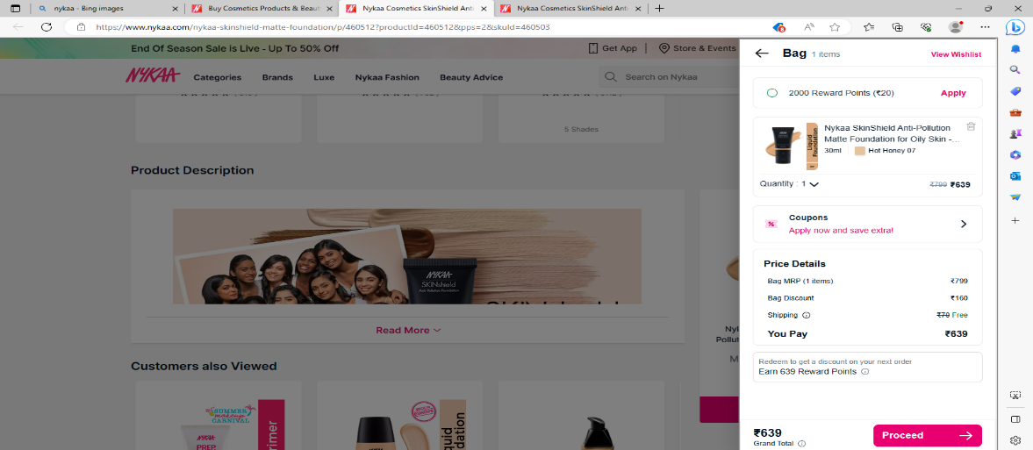

Now you have to fill contact details and address details to receive the product.

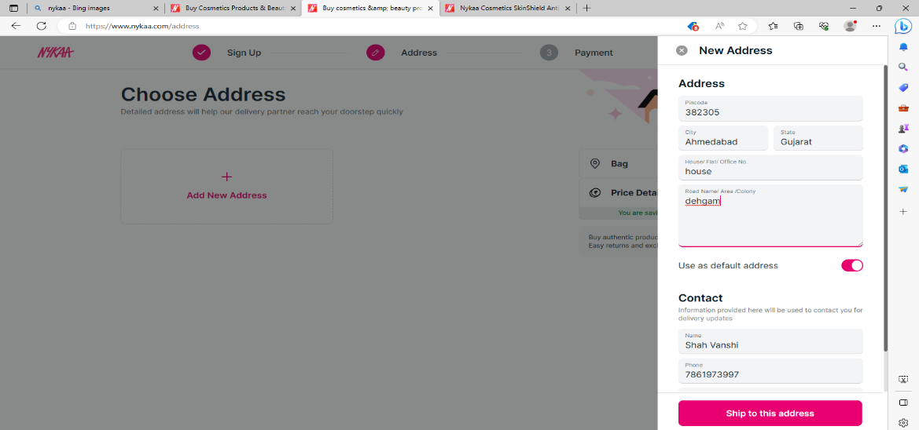

Choose any one payment method which you want.

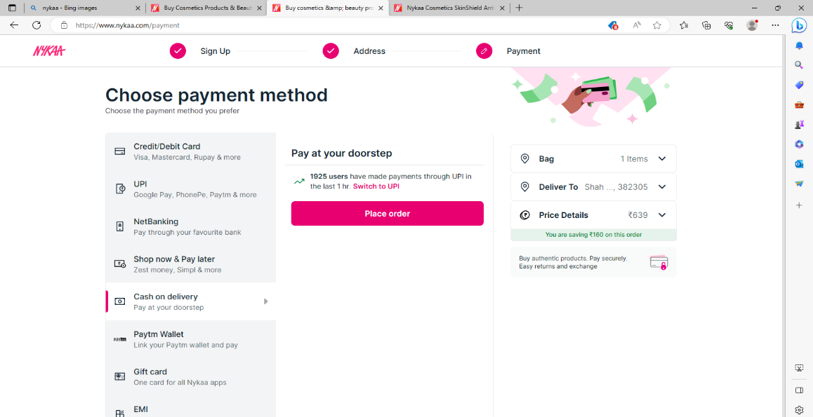

When you complete three steps 1 Sign up 2 Address details 3 Payment then your order will confirm & you can get the message on your phone of your confirmed order.

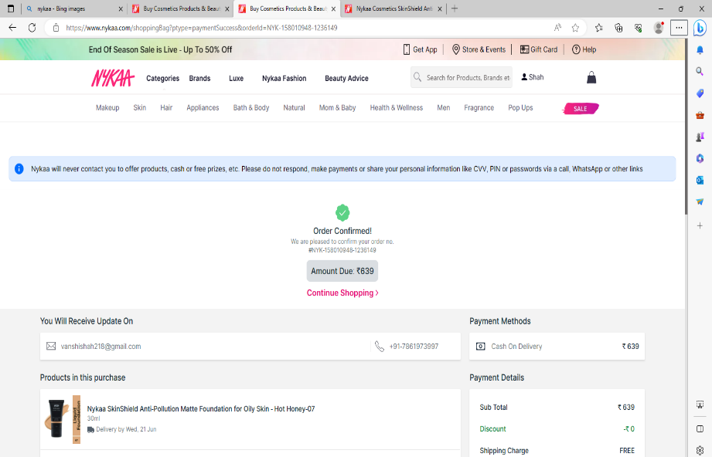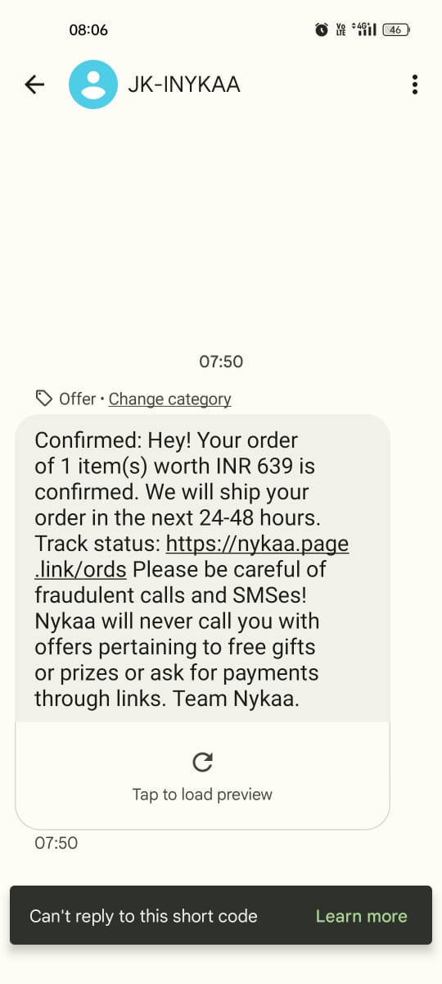

If you want to cancel the order for some reason then you can go with my account option and you can go my orders then after you can cancel the item.

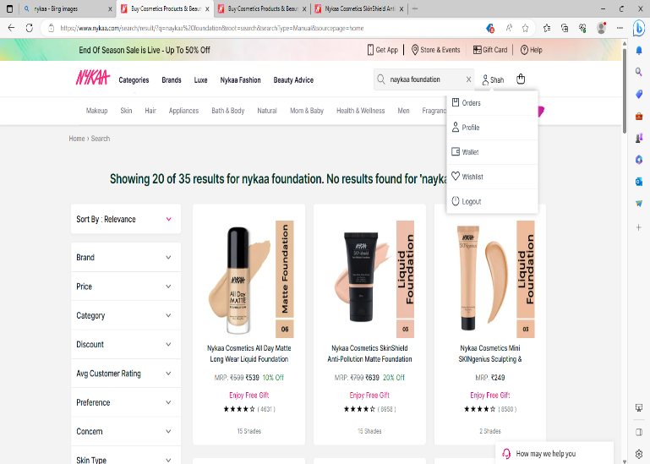
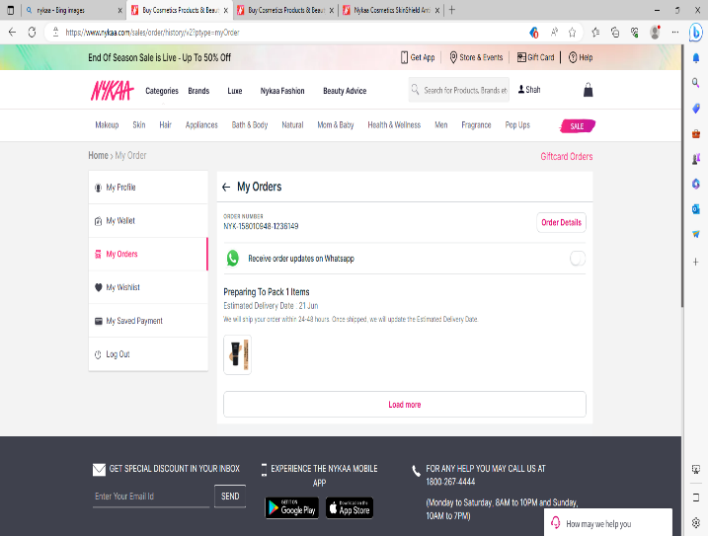

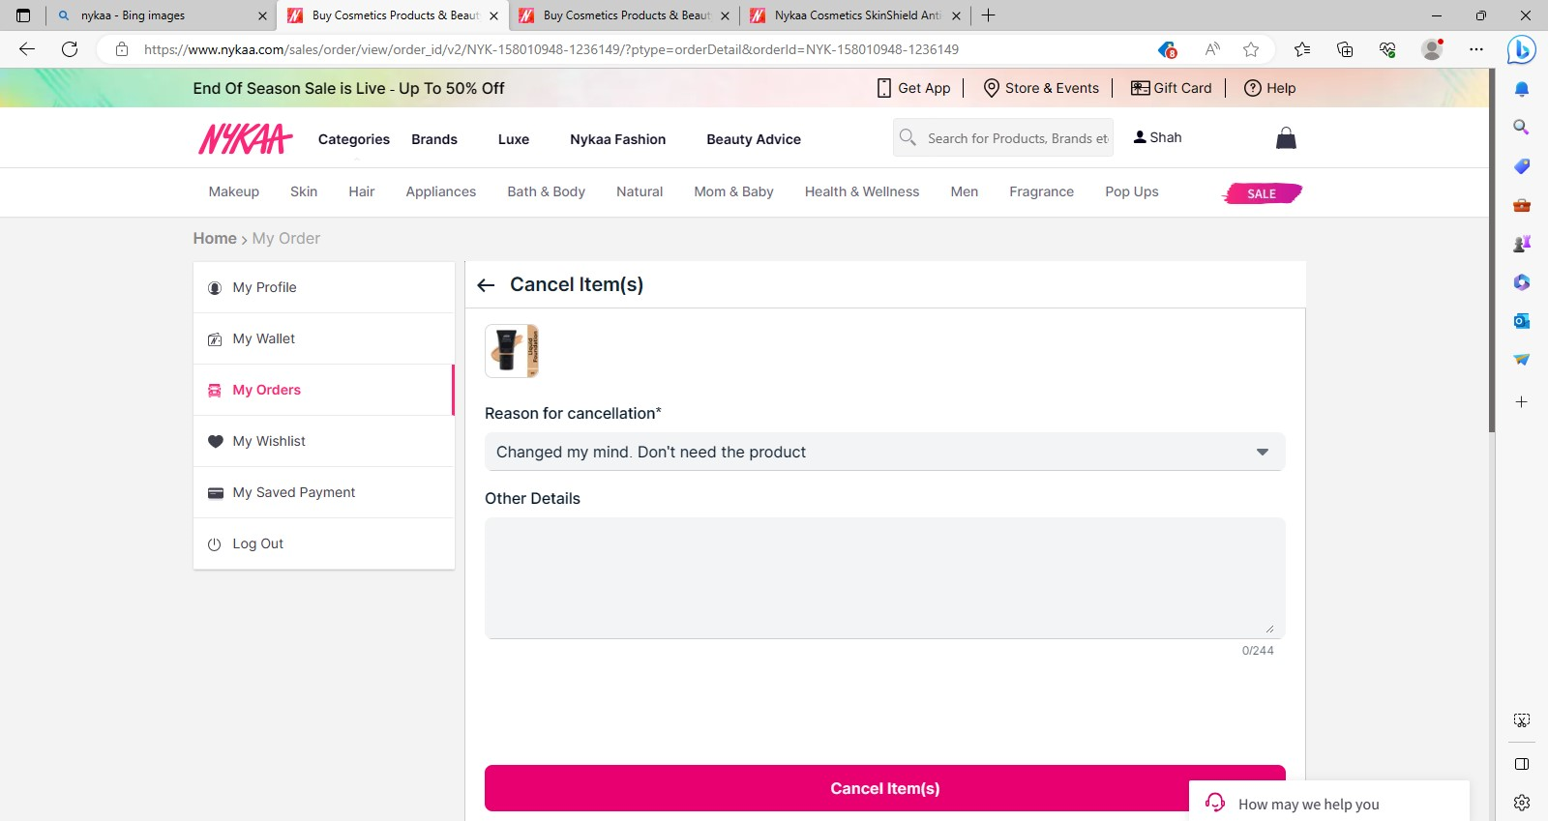
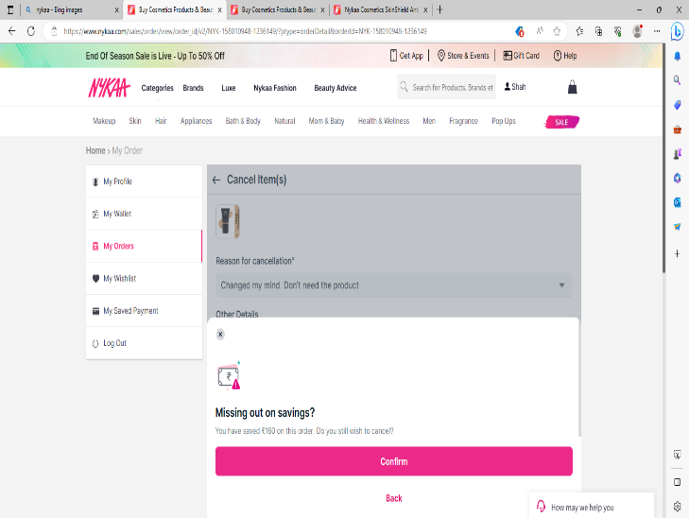

When your product has been cancelled you will receive the message that your order cancelled.

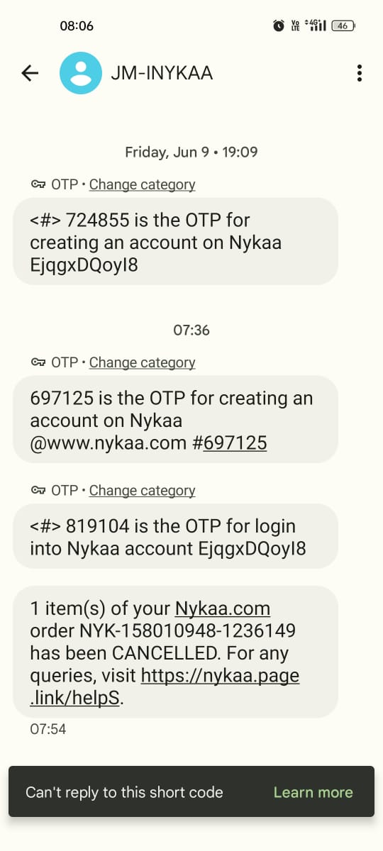

Advantages of existing system:

Nykaa has strong presence over all the social media platforms to promote its brand.

Available 24*7.

Personalize shopping experience.

Detailed product Information.

Nykaa provides tutorials to customers about how to use the products.

This website has many products with affordable prices.

Disadvantages of existing system:

Poor customer service.

Products are delivered after its given timeline.

Technical difficulties.

Uncertainty about the product quality.

COD option is not available blow the purchase of Rs.500.

- Methodology

3.1 Description of methodology
The system is divided into the following main modules:
1 User Module
- User can register and login
- User can view and update profile
2 Product Module
- View product list
- View product details
3 Cart Module
- Add items to cart
- Remove items
- Update quantity
4 Order Module
- Place order
- View order history
5 Payment Module
- Process online payments
- Verify transaction
6 Admin Module
- Add/update/delete products
- Manage orders
- View users

3.2 Process Model
The development of the “GlowCart – Full Stack Cosmetics E-Commerce Platform” follows the Agile Process Model, which is a flexible and iterative approach to software development.
In this model, the project is divided into smaller parts called iterations or modules. Each module is developed, tested, and improved step by step. This approach allows continuous development and easy modification of features based on requirements.

3.3 SDLC Life Cycle

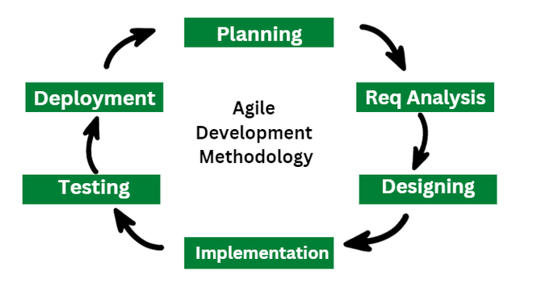

- Requirement Analysis

  - Hardware requirement
- Minimum:
- Processor: Intel i3 or above
- RAM: 4 GB
- Storage: 256 GB

- Recommended :
- Processor: Intel i5 or above
- RAM: 8 GB or higher
- Storage: 512 GB SSD

  - Software requirement
- Operating System: Windows / macOS / Linux
- Frontend: Next.js, HTML, Tailwind CSS
- Backend: Node.js, Express.js
- Database: MongoDB Atlas
- Tools: Visual Studio Code, Postman
- Browser: Google Chrome / Edge

  - Flowchart & DFDs

System Flowchart
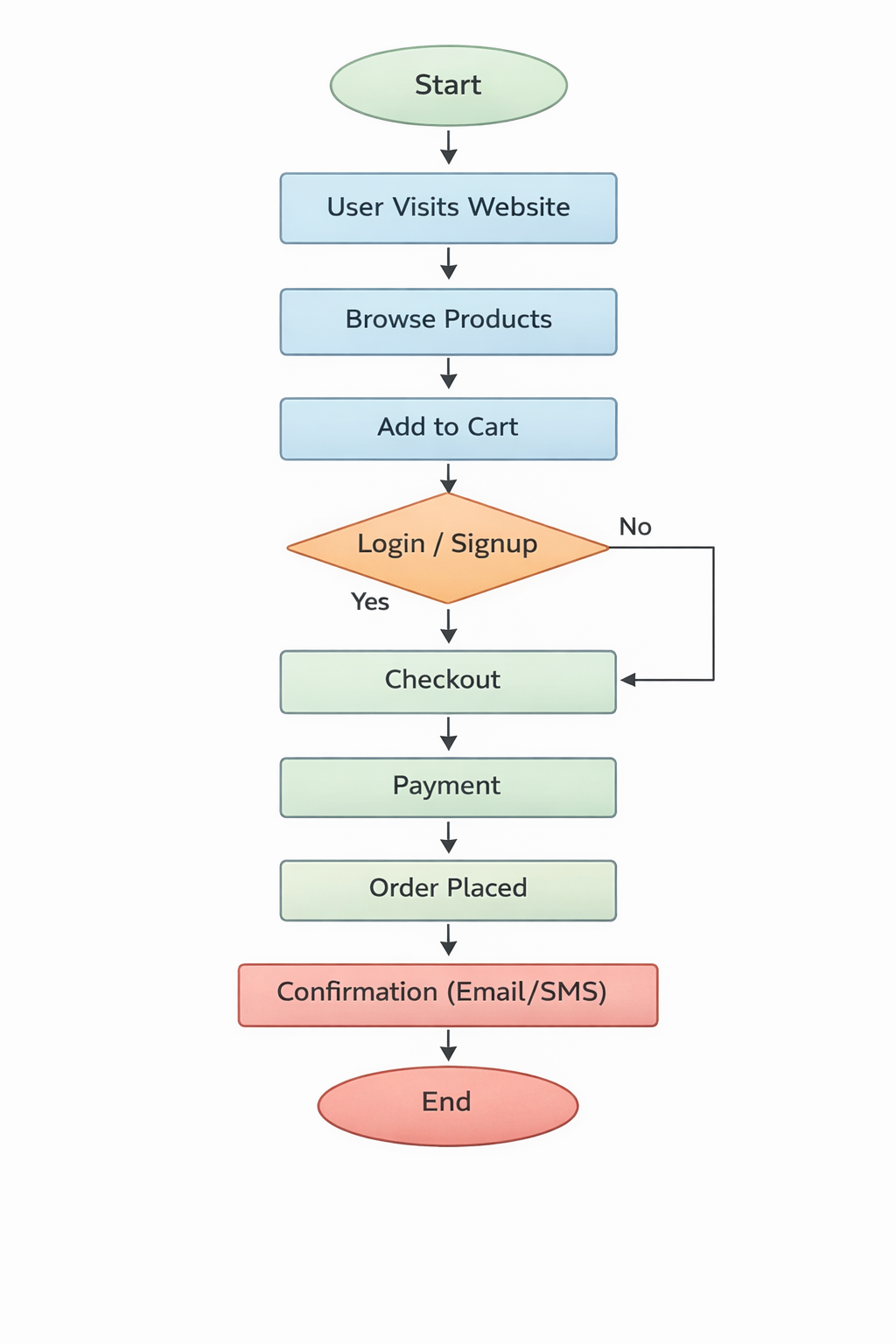

DFD Diagrams
Level 0/Context DFD
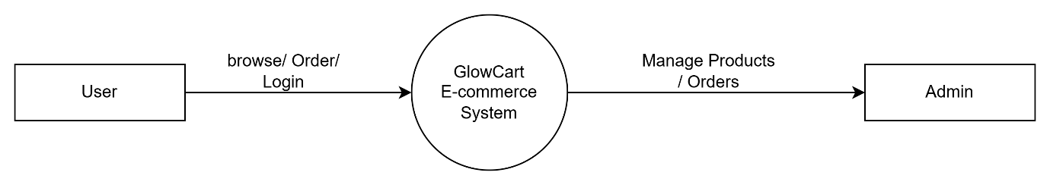

Level 1 DFD
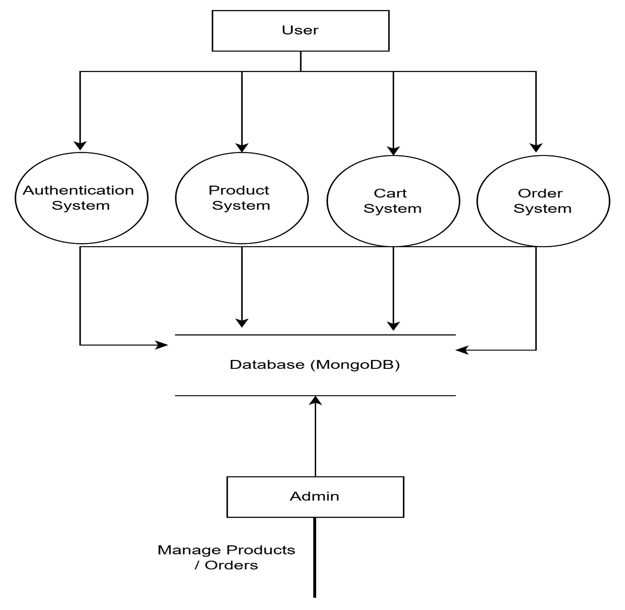

Level 2 DFD (User)
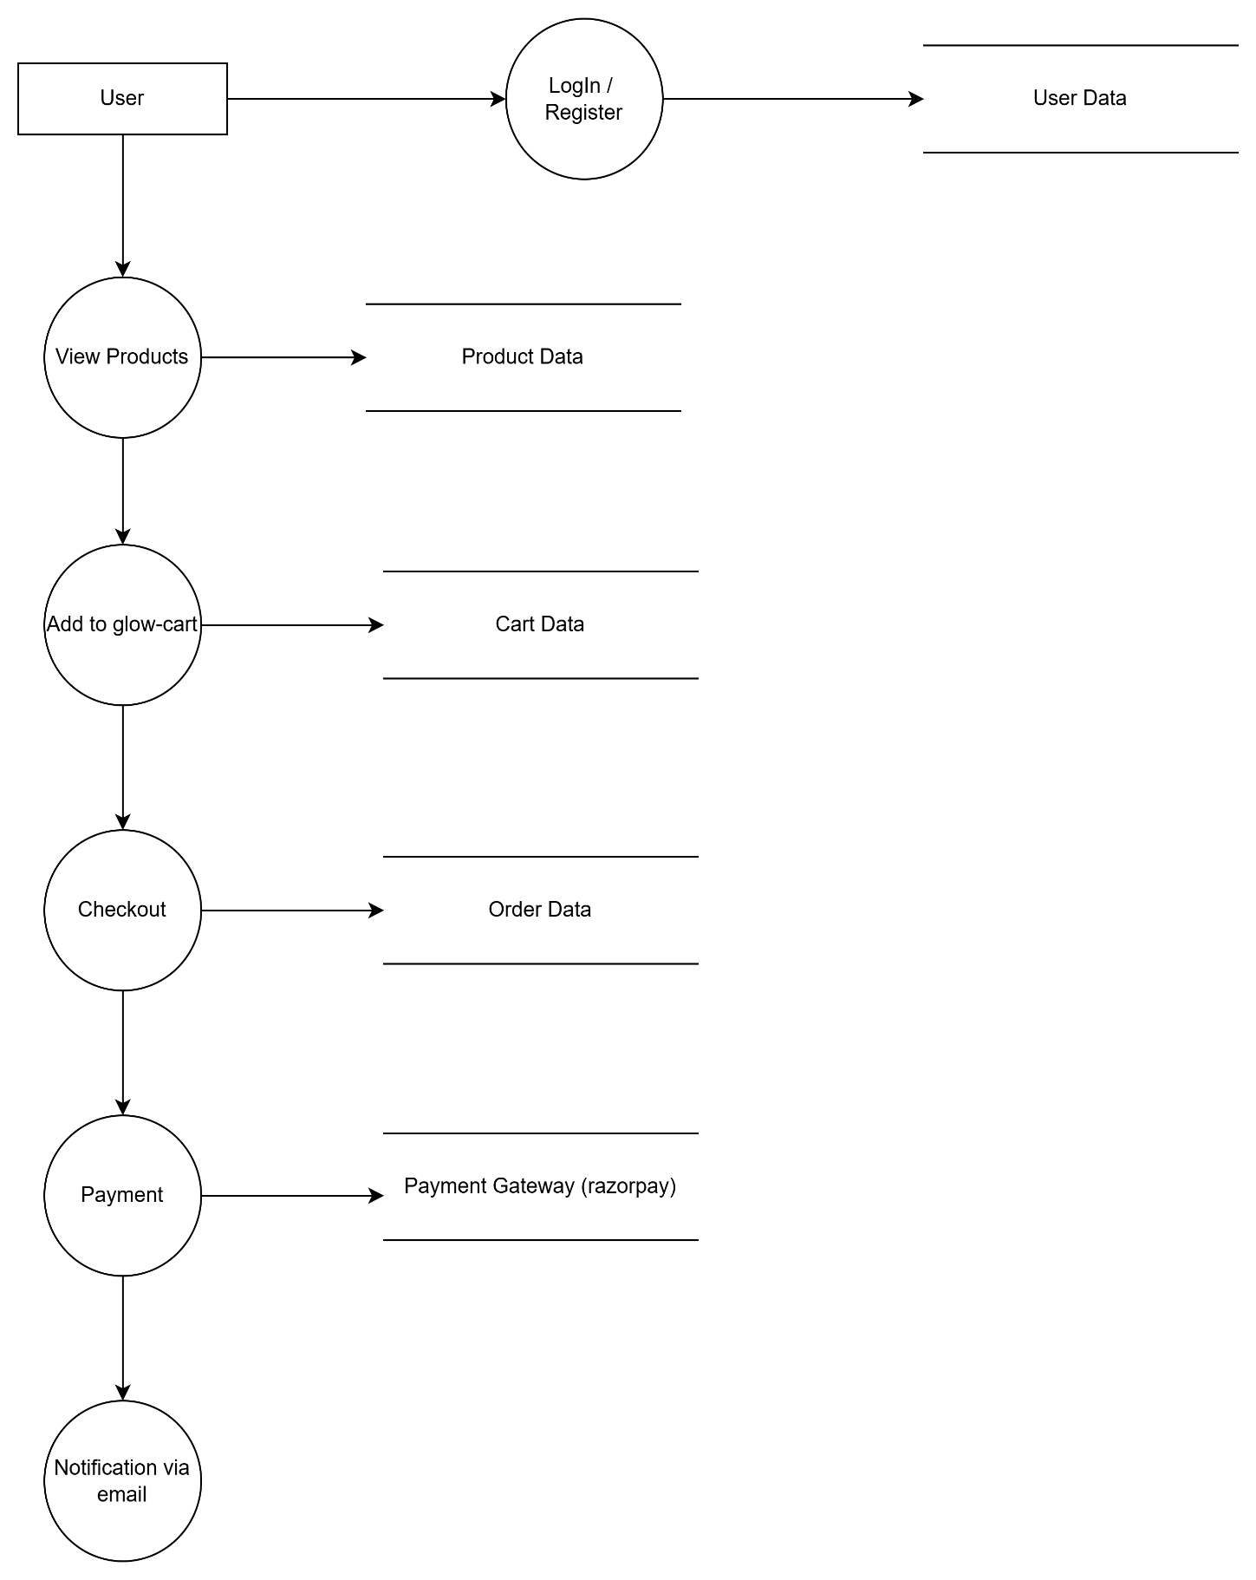

Level 2 DFD (Admin)
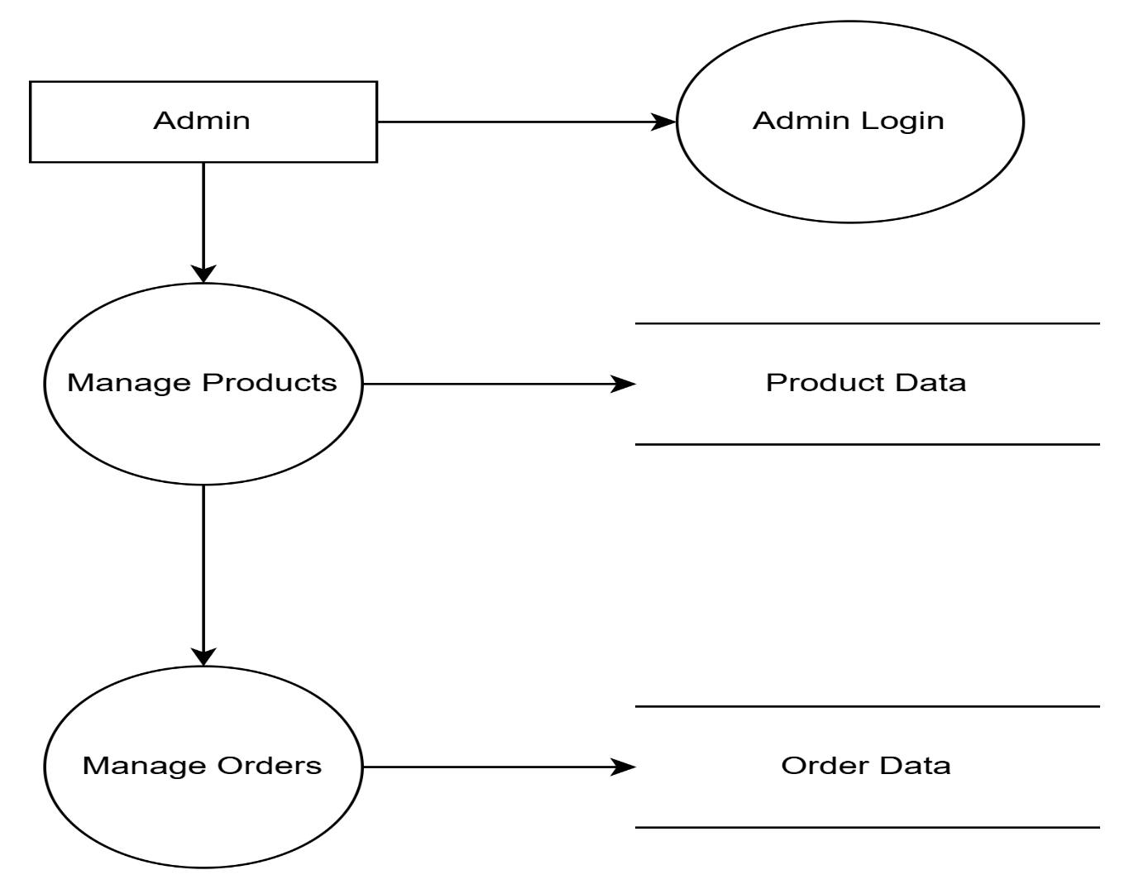

System Architecture Diagram

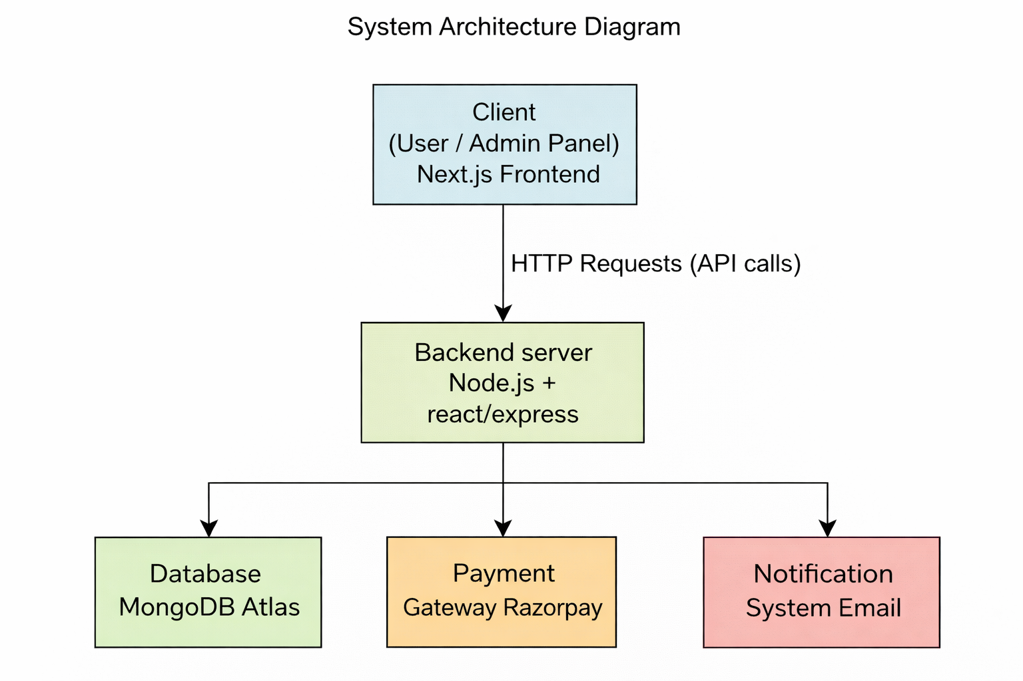

Entity Relationship Diagram
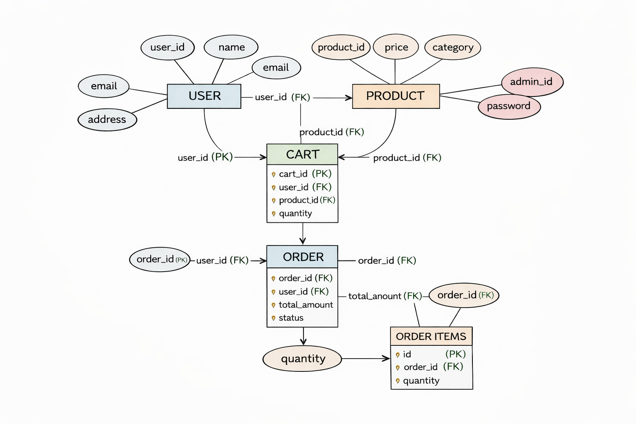

TENTATIVE TIMELINE AND WORK PLAN

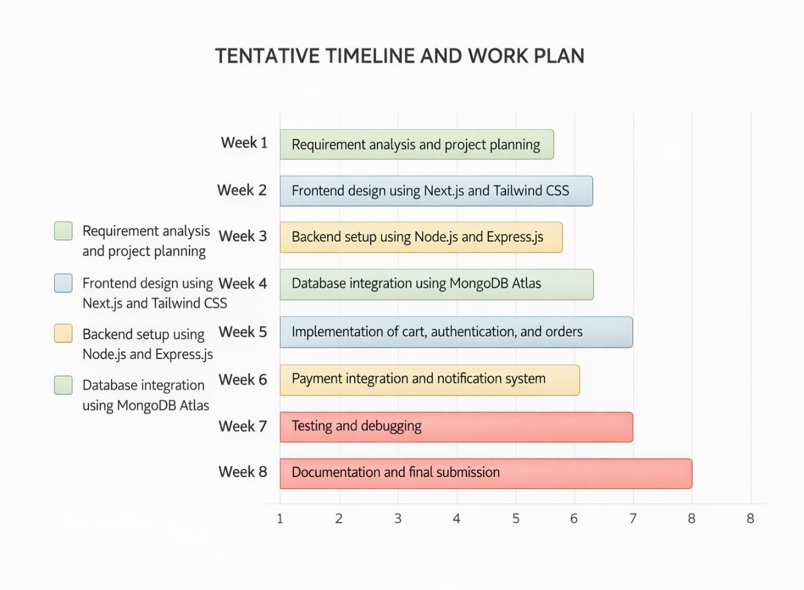

- Expected Outcomes

- A fully functional cosmetics e-commerce website
- Smooth and user-friendly shopping experience
- Secure login and authentication system
- Efficient cart and checkout process
- Successful order placement and tracking
- Admin dashboard for managing system
- Integration of payment and notification systems
- Improved understanding of full-stack development

- Advantages of proposed system

- User-friendly interface for easy navigation
- Supports international cosmetic products
- Secure authentication system
- Efficient cart and order management
- Scalable and modern technology stack
- Cloud database ensures data availability
- Real-time order tracking and updates

- Limitations of proposed system

- Requires stable internet connection
- Payment gateway dependency
- Limited to web platform (no mobile app)
- SMS/email services depend on third-party APIs
- Initial setup complexity for backend integration

ETHICAL, LEGAL, AND ENVIRONMENTAL CONSIDERATIONS

This project uses publicly available Titanic dataset, which poses no privacy risks. Ethically, the project is respectful and aims at educational use. Legally, all tools and datasets used are open-source or freely available. Environmentally, since the project runs on standard computing devices without high GPU usage, its energy footprint is minimal.

- Conclusion
The “GlowCart – Full Stack Cosmetics E-Commerce Platform” project successfully demonstrates the design and development of a modern web-based shopping system. The platform provides essential features such as product browsing, cart management, user authentication, and order processing.
The use of advanced technologies like Next.js, Node.js, and MongoDB Atlas ensures that the system is efficient, scalable, and user-friendly. The integration of payment and notification systems further enhances the functionality of the application.
This project not only improves the online shopping experience for users but also provides a practical understanding of full-stack web development. It can be further extended with additional features such as mobile application support and advanced recommendation systems.

- Code/Output (with screen shots)

