
BUSINESS DOCUMENT TEMPLATE

PullUp Business Solutions
Strategy | Branding | Digital | Growth
Your business. Your next level.

ATTARANA — BUSINESS GROWTH AUDIT

Executive Summary
ATTARANA (@attarana.india) presents itself as a modern, unisex attar brand offering customised perfumes. Its public Linktree describes the range as handcrafted in India, long-lasting and alcohol-free, and invites customers to shop on Amazon, browse a WhatsApp catalogue, follow on Instagram or visit in West Delhi.
This is a preliminary prospect audit by PULL UP Business Solutions, based on public information only. Instagram and Amazon pages could not be opened, and the TradeIndia link supplied does not feature ATTARANA, so product ranges, prices and reviews are flagged for investigation, not treated as findings.
The main opportunities are a clearer path from discovery to enquiry, more structured fragrance information, and simple repeat-purchase follow-ups. PULL UP can help improve brand discovery, product presentation, customer relationships and sales processes with practical, low-cost steps.

Business Snapshot
Brand: ATTARANA (Instagram: @attarana.india)
Category: Attars and customised perfumes
Positioning: Modern, unisex, handcrafted, long-lasting, alcohol-free (brand's own description)
Public-facing channels: Instagram, WhatsApp catalogue, Amazon India storefront, Linktree
Geographic presence: West Delhi (in-person visits, per its Linktree)
Growth stage: Not established from public information

Existing Strengths
Focused product category. A specialised attar and perfume range speaks directly to customers already interested in fragrance.
Distinctive positioning. Handcrafted, unisex, alcohol-free and customised options (the brand's own claims) can set it apart from mass-market perfume.
Direct customer interaction. A WhatsApp Business number and catalogue make enquiries and personalised help easy.
Multiple discovery channels. Instagram, Amazon India and in-person visits in West Delhi give customers several ways to find and buy.
Room to build a stronger identity. Consistent product storytelling and clearer fragrance information can build recognition.

Opportunities Identified
Opportunity 1: Stronger Brand Discovery and Online Presence
What we observed: Customers can reach ATTARANA through Linktree, Instagram, WhatsApp, Amazon and in person. No standalone website link was found; whether one exists should be checked.
Why it matters: Many entry points work best when each leads to the same product information and a clear next step.
Recommended action: Keep the Linktree as the hub, align profile descriptions and product names across channels, and add a clear “enquire or buy” route. Consider a website only if the review shows a need.
Opportunity 2: Clearer Fragrance Selection and Product Presentation
What we observed: The Linktree promises long-lasting, refined notes and customised perfumes. Scent notes, sizes, prices and customisation steps could not be reviewed.
Why it matters: Customers cannot smell a fragrance online, so clear descriptions help them choose with confidence and reduce repeated basic questions.
Recommended action: Build a structured catalogue with consistent descriptions, fragrance families, sizes and prices, a simple selection guide, and clear customisation and ordering steps, using verified details only.
Opportunity 3: Repeat Purchases and Customer Relationships
What we observed: WhatsApp already gives a direct line to customers. Whether reviews, follow-ups or reorder support exist is not visible publicly and should be investigated.
Why it matters: Fragrance is often bought again or given as a gift, so staying in touch with satisfied customers makes future sales easier.
Recommended action: Assess opt-in WhatsApp follow-ups, genuine customer reviews, easy reordering, related-fragrance suggestions, gifting options and a simple feedback process.

Before & After
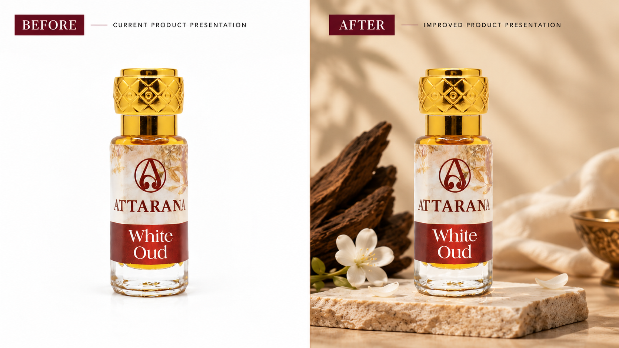
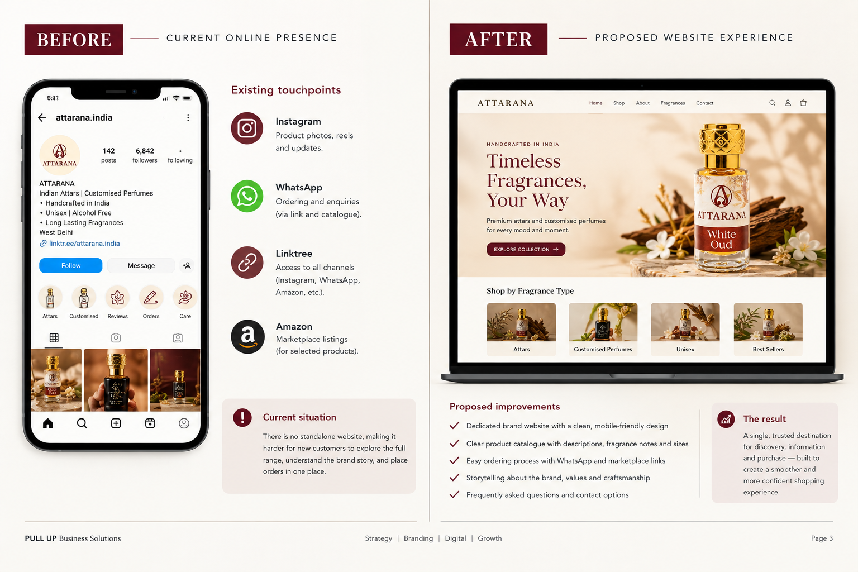

Sales Growth

1. Improve product discovery.
Make the path from Instagram, Amazon or the Linktree to a product enquiry or purchase clear, with the same names and descriptions everywhere.

2. Make buying easier.
Present verified fragrance details, sizes, prices, ordering steps and customisation options in one catalogue.

3. Build purchase confidence.
Where available, show genuine reviews, accurate product photographs, clear policies and answers to common customer questions.

4. Encourage repeat purchases.
Use permission-based WhatsApp follow-ups, reorder assistance, relevant fragrance suggestions and a simple feedback request.

How to measure progress
Track five simple measures: enquiries received, enquiries converted into orders, best-performing products, repeat-customer orders, and customer feedback and reviews.
ATTARANA should record a baseline before judging any improvement. This audit assumes no current sales, conversion or revenue figures; any targets should be set as suggested future goals once the baseline is known.

Thank You
Businesses Higher.
[Contact Person]
[Email Address]
[Phone Number]
[Website / Social Handle]

