
BUSINESS DOCUMENT TEMPLATE

PullUp Business Solutions
Strategy | Branding | Digital | Growth
Your business. Your next level.

[Business Audit]

Executive Summary
Dusty Might is a home-care brand offering household cleaning products such as Lemon Floor Cleaner. This case study by Pullup explores opportunities to strengthen its brand positioning, packaging, product presentation, and digital presence to build greater customer trust and differentiation.

Business Snapshot
Business Name: Dusty Might
Products:
- Floor Cleaners
- Disinfectants
- Surface Cleaners
- Household Cleaning Products
- Lemon Floor Cleaner
Sales:
Online & Retail Distribution
Category:
Home Care & Cleaning Products
Positioning:
Home Care & Cleaning Products

Existing Strengths

- Established Product Range — Offers multiple household cleaning essentials across floor, surface, glass, and dish-cleaning categories.

- Multi-Channel Presence — Products are available through its own website as well as marketplaces like Amazon and Meesho.

- Product Variety — Multiple fragrances and product variants give customers more choice.

- Affordable Everyday Utility — Products target frequent, practical household cleaning needs.

- Online-Ready Brand — Existing e-commerce infrastructure provides a foundation for further digital growth.

- Clear Category Focus — Strong focus on household cleaning and hygiene helps define the brand's market.

[Opportunities Identified]
- Stronger Brand Differentiation — Create a more distinctive identity that separates Dusty Might from generic cleaning-product brands.
- Packaging Enhancement — Develop a more consistent and premium packaging system across product variants.
- Product Communication — Make key benefits, use cases, and differentiators more prominent and easier to understand.
- Marketplace Optimization — Improve product images, titles, descriptions, and visual storytelling across Amazon, Flipkart, and Meesho.
- Digital Brand Experience — Strengthen the website's visual hierarchy, product discovery, and conversion journey.
- Content & Social Presence — Build educational and demonstration-led content around cleaning, hygiene, and product usage.
- Trust Building — Highlight reviews, product quality, certifications, usage demonstrations, and other credibility signals more effectively.

Core Opportunity
Move from being perceived as another cleaning-product seller to becoming a recognizable and trusted home-care brand.

[Strategic Recommendations]

01 — Brand Positioning

Define a clear brand proposition that communicates why customers should choose Dusty Might over generic cleaning products.

02 — Visual Identity

Create a more consistent visual system across packaging, website, marketplaces, and social media to improve brand recognition.

03 — Product Presentation

Improve product photography, packaging hierarchy, benefits, and messaging so customers can understand the product within seconds.

04 — Marketplace Optimization

Strengthen Amazon, Flipkart, and Meesho listings with better creatives, benefit-led copy, comparison visuals, and trust signals.

05 — Digital Growth

Build a stronger content strategy around cleaning tips, product demonstrations, before/after content, and everyday household problems.

06 — Conversion & Trust

Use reviews, product proof, FAQs, certifications/claims where applicable, and clear CTAs to reduce purchase hesitation.

[Before & After]

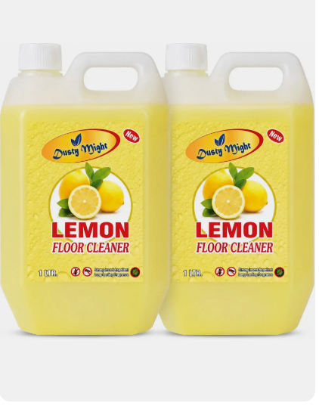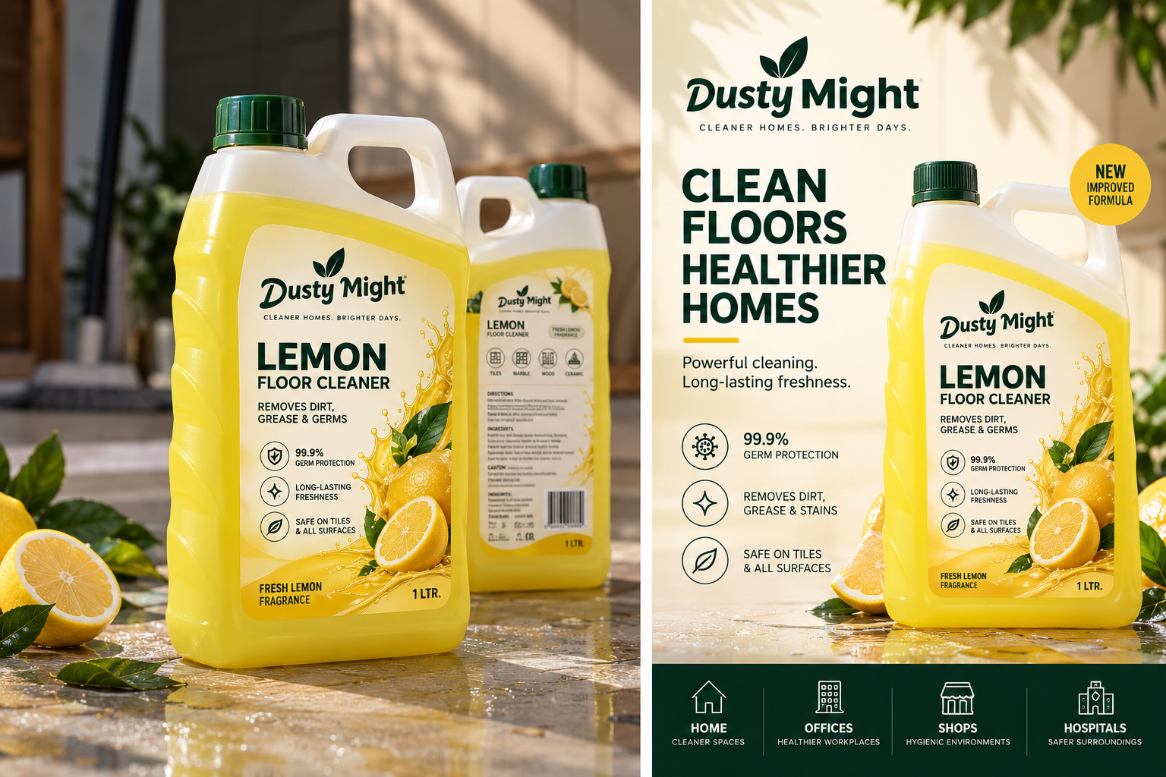

Product Listing Images
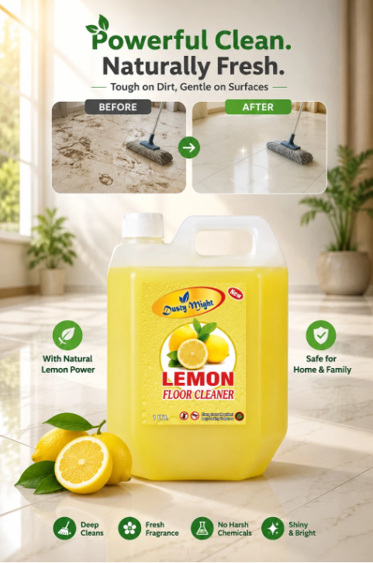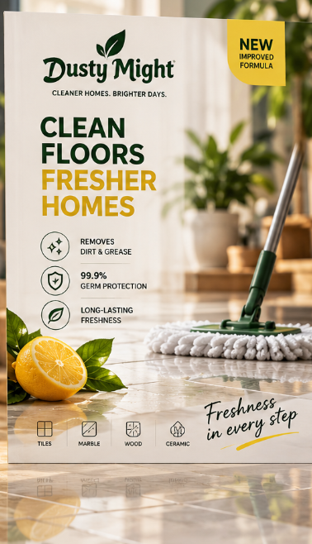

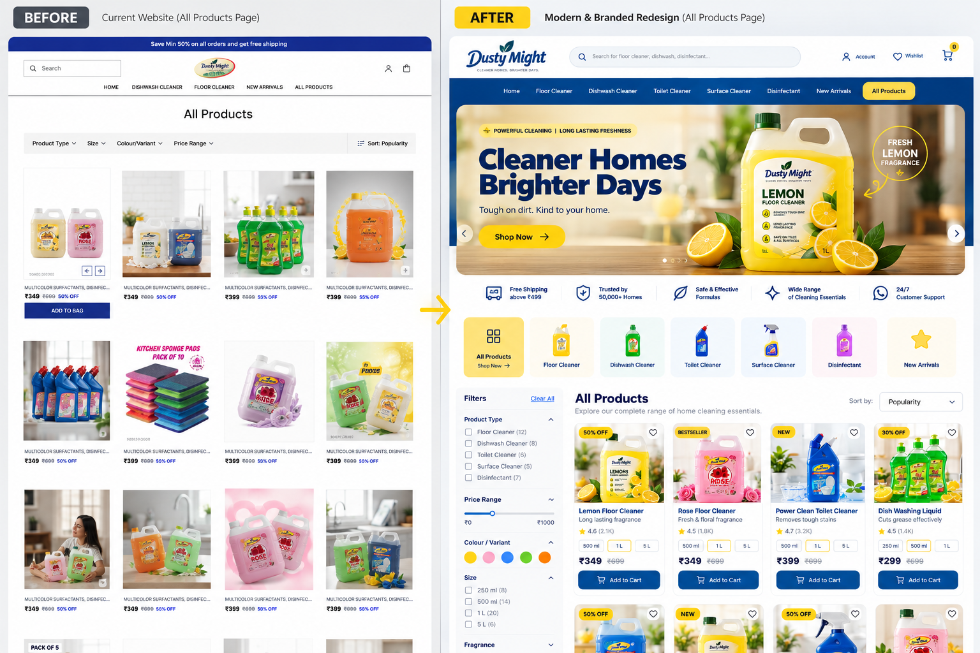

Next Step
If these recommendations align with your vision, we'd be happy to discuss how Dusty Might can strengthen its digital presence through branding, design, and technology.

About Pullup
Pulling Brands Towards Growth
We help businesses build stronger brands and accelerate growth through business strategy, research, branding, digital experiences, marketing, and technology.

PULLUP
Strategy • Branding • Digital • Growth

Thank You
Businesses Higher.
[Contact Person]
[Email Address]
[Phone Number]
[Website / Social Handle]

