Smith chart® Custom Control Properties and Events

Updated for Smith.OCX Version 1.1 on 6/14/2014

Smith chart control has 43 properties and 10 events. Custom properties and events are marked with an asterisk (*).

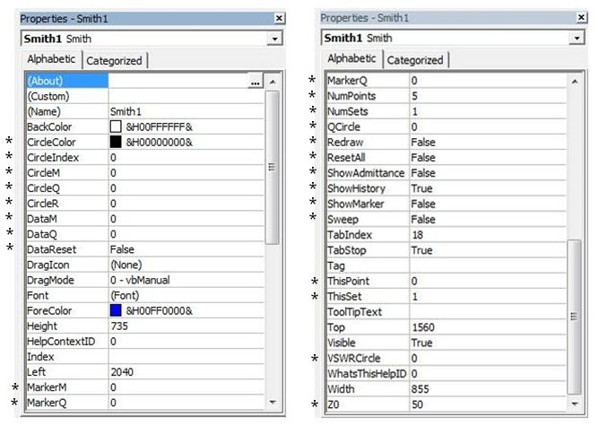

Events
* ClickIn * ClickOut DragDrop
DragOver GotFocus KeyDown
KeyPress KeyUp LostFocus
* MouseMove

Figure 2 : Smith chart control property box and events.

Description and usage of custom Properties and Events

ShowAdmittance Property

Purpose : Draws Admittance circle on the Smith chart
Syntax : [form.]smith.ShowAdmittance[= {True | False}]
Data Type : Integer (Boolean)
Comments : The following table lists the ShowAdmittance property settings.
Setting | Description
True | Draws Admittance circle on the chart
False (Default) | Admittance circles are not drawn

VSWRCircle/QCircle Properties

Purpose: Draws VSWR/Q circles on the Smith chart
Syntax : [form.]smith.VSWR{or Q}Circle[= data ! ]
Data Type : Single
Comments : The following table lists the VSWR/Q property settings.
Setting | Description
>0 | Draws VSWR/Q circles corresponding to the value entered
0(Default) | VSWR/Q circles are not drawn

DataM/DataQ Properties

Purpose: Plots and retains reflection coefficients magnitude and angle data on the Smith chart.
Syntax : [form.]smith.DataM{or DataQ}[= data ! ]
Data Type : Single
Comments: New data is plotted on the Smith chart after DataQ is entered. DataM and DataQ can be used to plot a series of up to 1010 data points by setting NumOfPoints and Sweep properties. The data entered is retained by the memory until the Reset property is set to True. The Color of the trace can be set by using ForeColor property.
Setting Range | Description
DataM = (0 - 1) | Sets Reflection coefficient Magnitude
DataQ = (0 - 360) | Sets Angle in Reflection coefficients

ThisPoint Property

Purpose: Sets the current data point so that it can be identified.
Syntax : [form.]smith.ThisPoint[= point%]
Data Type : Integer
Comments: The property setting for this point is from 0 to the number set by NumPoints property.

NumPoints Property

Purpose: Specifies the number of data points.
Syntax : [form.]smith.NumPoints[= point%]
Data Type : Integer
Comments: The minimum value of NumPoints is 2 and the maximum value is 1010. The default value for this property is 5.

Sweep Property

Purpose: Draws trace on the Smith chart corresponding to DataM/DataQ values.
Syntax : [form.]smith.Sweep[= {True | False}]
Data Type : Integer (Boolean)
Comments : Sweep Property allows DataM/DataQ values to be drawn as a trace by automatically incrementing ThisPoint from its current value to NumPoints.
Setting | Description
True | Off
False (Default) | On (Default)

DrawM/DrawQ Properties

Similar to DataM and DataQ in sweep mode except the data is not retained by the memory and there is no restriction on number of data points.

Redraw Property

Purpose: Repaints the Smith chart.
Syntax : [form.]smith.Redraw[= {True | False}]
Data Type : Integer (Boolean)
Comments : The following table lists the Redraw property settings.
Setting | Description
True | Repaints Smith chart and sets the value back to False.
False | Default

DataReset Property
Purpose: Resets DataM/DataQ, ThisPoint, DrawM/DataQ and all circle properties to their default values.
Syntax : [form.]smith.DataReset[= {True | False}]
Data Type : Integer (Boolean)
Comments : The following table lists the DataReset property settings.
Setting | Description
True | Resets data and sets the value back to False.
False | Default

ResetAll Property

Purpose: Resets all properties to its default values.
Syntax : [form.]smith.ResetAll[= {True | False}]
Data Type : Integer (Boolean)
Comments : The following table list the ResetAll property settings.
Setting | Description
True | Resets all properties and sets the value back to False.
False | Default

MarkerM/MarkerQ Properties

Purpose: Places a Marker corresponding to the MarkerM and MarkerQ input in terms of reflection coefficients.
Syntax : [form.]smith.MarkerM{or MarkerQ}[= data ! ]
Data Type : Single
Comments: Marker can be turned on and off by using ShowMarker property. Marker property is useful to set up targets for impedance matching.
Setting Range | Description
MarkerM = (0 - 1) | Sets Marker Magnitude in Reflection coefficients
MarkerQ = (0 - 360) | Sets Angle in Reflection coefficients

ShowMarker Property

Purpose: Turn Marker on or off.
Syntax : [form.]smith.ShowMarker[= {True | False}]
Data Type : Integer (Boolean)
Comments : The following table lists the ShowMarker property settings.
Setting | Description
True | Displays Marker corresponding to MarkerM/MarkerQ data
False (Default) | Hides Maker

CircleM/CircleQ/CircleR Properties

Purpose: Draws Circles with specified center and radius. Center point corresponds to reflection coefficient CircleM and CircleQ (magnitude and angle) and the radius equals to the CircleR data.
Syntax : [form.]smith.CircleM{or CircleQ or CircleR}[= data ! ]
Data Type : Single
Comments: A maximum of 10 different circles can be drawn by setting the CircleIndex property between 1 and 10. This property is useful to draw constant gain or noise circles. CircleR property updates the new circle, hence it has to be entered last.
Setting Range | Description
CircleM = (0 - 1) | Reflection coefficient Magnitude of center point
CircleQ = (0 - 360) | Reflection coefficient Angle of center point
CircleR = (0 - 1) | Radius

CircleIndex Property

Purpose: Sets circle numbers or hides the circles.
Syntax : [form.]smith.CircleIndex [= data % ]
Data Type : Integer
Comments: This property tracks the index of the circles and has to be manually incremented before a new circle is drawn. Circle can be hidden by setting to 0 and issuing a redraw command.
Setting Range | Description
CircleIndex = (1 - 10) | Sets the current circle number for a particular data point
CircleIndex = 0 | Hides the circle(s) after the next windows repaint or redraw

CircleColor Property

Purpose: Sets the circle color.
Syntax : [form.]smith.CircleColor [= color&]
Data Type : long
Comments: This property sets the circle color corresponding to its index.
Setting | Description
CircleColor = &H00000000& | (Default) Black
CircleIColor = (Color) | Color specified using the Color Palette or RGB scheme

Z0 Property

Purpose: Displays the characteristic impedance in ohms on the bottom right side of the chart.
Syntax : [form.]smith.Z0 [= value!]
Data Type : Single
Comments: This property is used to display current characteristic impedance of the chart. It is also used as a data storage for the host program which may use this information to calculate impedance.
Setting | Description
>0 | Displays the value on the bottom right of the chart
50(Default) | Default value is 50 ohms

ClickIn Event

Purpose: To detect and retrieve coordinates of the point when the user double-clicks the left mouse button on the Smith chart.
Syntax : Sub Smith1_ClickIn (M As Single, Q As Single)
// program code here
End Sub
Data Type : M As Single, Q As Single
Comments: When this event is triggered, a procedure is automatically invoked with arguments containing reflection coefficients ( magnitude and angle) of the clicked point. This event is useful for displaying one or more interpretations of the same point on the Smith chart.

ClickOut Event

Purpose: To detect when the user double-clicks the left mouse button outside the Smith charts outer most circle but inside the Control (outside the Smith chart region).
Syntax : Sub Smith1_ClickOut ()
// program code here
End Sub
Data Type : None
Comments: This event may be used to notify the user when a region outside the Smith chart is double-clicked.

MouseMove Event

Purpose: To detect and retrieve the current coordinates of the mouse pointer when the user moves the mouse over the control.
Syntax : Sub Smith1_MouseMove (M As Single, Q As Single)
// program code here
End Sub
Data Type : None
Comments: When this event is triggered, a procedure is automatically invoked with arguments containing reflection coefficients ( magnitude and angle) of the mouse pointer. If the mouse pointer is outside the Smith chart region then the arguments M and Q are set to 2 and 0 respectively. This event is useful for displaying Smith chart interpretations of the current mouse pointer location.

ShowHistory Property

Purpose: Displays historical parameter change effects on the Smith chart.
Syntax : [form.]smith.ShowHistory[= {True | False}]
Data Type : Integer (Boolean)
Comments : The following table lists the ShowHistory property settings.
Setting | Description
True | Historical parameter circles are drawn in dashed lines.
False | Only current parameter values are drawn on the chart
Summary: Displays up to the last 30 changes for each of: Circle, VSWRCircle,
QCircle, and Admittance circles.

Examples on Smith chart Properties on Events

The following section list Smith chart examples. To try these examples, start VB(3.0), load the Smith chart control and place it on the form. Open the Form_Load Sub-procedure by double clicking on the form, enter the code and run it by using Run command in the Menu. The following examples are performed during run time. Alternately, you can perform the same operation using the property box during design time.

Example 1 The following code draws Admittance circles on the Smith chart.

Sub Form_Load ()
smith1.ShowAdmittance = True
End Sub

Example 2 The following code draws constant VSWR and Q circles.

Sub Form_Load ()
smith1.VSWRCircle = 1.5 ' Circle of Constant VSWR = 1.5
smith1.QCircle = 5 ' Circle of Constant Q = 5
End Sub

Example 3 The following code plots a data point by moving the blue dot from the center to that point.

Sub Form_Load ()
smith1.DataM = 0.5 'Magnitude of reflection coefficient = 0.5
smith1.DataQ = 48 'Angle of reflection coefficient = 48 degrees
End Sub

Example 4 The following code draws a trace of 200 data points on Smith chart ( See Figure 3).

Sub Form_Load ()
smith1.ForeColor = QBColor(1) ' Set trace color to Blue
smith1.NumPoints = 201 ' Maximum number of points set to 201
smith1.ThisPoint = 1 ' Current data counter set to 1
smith1.Sweep = True ' sweep mode on
For i% = 1 To 200 Step 1 ' draw a 200 point trace
smith1.DataM = i% / 200
smith1.DataQ = i% * 10
Next i%
End Sub
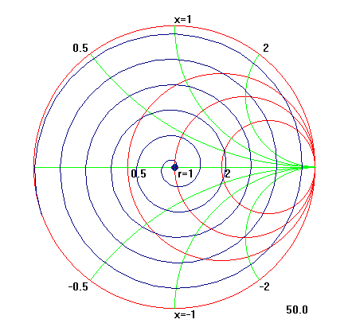

Figure 3 : Output of example 4.

Example 5 The following code sets a marker on the Smith chart.

Sub Form_Load ()
Smith1.ShowMarker = True ' Turn marker on
Smith1.MarkerM = .5 'Magnitude of reflection coefficecnt = 0.5
Smith1.MarkerQ = 55 'Angle of reflection coefficient = 55
End Sub

Example 6 The following code draws constant circles on the Smith chart ( See Figure 4).

Sub Form_Load ()
'Draw first circle
smith1.CircleIndex = 1 ' first circle
smith1.CircleColor = QBColor(0) ' Set color to Black
smith1.CircleM = .4 ' Magnitude = 0.4
smith1.CircleQ = 255 ' Angle = 255 degrees
smith1.CircleR = .3 ' Radius = 0.3

'Draw second circle
smith1.CircleIndex = 2 ' second circle
smith1.CircleColor = QBColor(1) 'Set color to Blue
smith1.CircleM = .3 ' Magnitude = 0.3
smith1.CircleQ = 55 ' Angle = 55 degrees
smith1.CircleR = .4 ' Radius = 0.4
End Sub

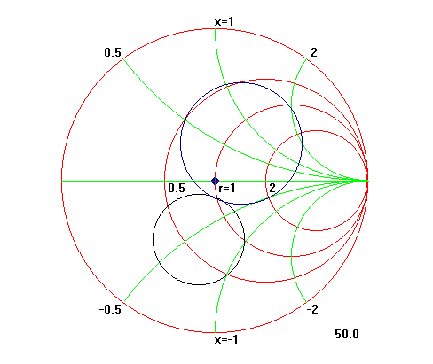

Figure 4 : Output of example 6

Example 7 The following example uses ClickIn event to display reflection coefficients.
Enter this code in Smith1_ClickIn sub-procedure, which can be opened by double clicking on Smith chart control during the design time.

Sub Smith1_ClickIn (M As Single, Q As Single)
MsgBox ("Gamma [Mag]: " & Format(M, "#0.000") & Chr$(13) & "Gamma [Ang]: " & Format(Q, "###.00")), , "Smith.vbx"
End Sub

APPENDIX A

Example 1 - Sub routine to plot vector impedance values

Sub ZtoGamma (ZXR As Double, ZXI As Double)
Dim ZRN, ZIN, Z0, A2, D, SR, SI, SM, SQ As Double
Pi = 3.141592
Z0 = form1.Smith1.Z0 ' Get characteristic impedance of the Chart

ZRN = (ZXR / Z0) ' Impedance to reflection coefficient (gamma) conversion
ZIN = (ZXI / Z0)
A2 = ZRN + 1
D = A2 ^ 2 + ZIN ^ 2
SR = (ZRN ^ 2 - 1 + ZIN ^ 2) / D
SI = (2 * ZIN) / D
SM = Sqr(SR ^ 2 + SI ^ 2)

If (SR = 0) Then SR = .00000000001 ' Avoid possibility of Divide by Zero Error
If (SI = 0) Then SI = .00000000001

SQ = (Atn(SI / SR) * 180 / Pi) ' Co-ordinate Adjustments
If (SR < 0 And SI > 0) Then SQ = 180 + SQ
If (SR < 0 And SI < 0) Then SQ = -180 + SQ
If (SM = 0) Then SQ = 0

form1.Smith1.DataM = Format(SM, ".000") ' Plot command
form1.Smith1.DataQ = Format(SQ, ".000")

End Sub

APPENDIX B

ActiveX Documentation.
32 Bit Smith Chart Control ("Smith.ocx)

The 32 bit Control was developed to replace the 16 bit control for Version 4 and above
of Visual Basic. The 32 bit control also known as OCX control (later renamed to ActiveX),
was designed to support many more application and software tools. The applications or tools
that support a control is know as a container. Some of the containers for Smith ActiveX
tool are Visual Basic, Microsoft Access, Internet Explorer, Delphi.

Windows 95 operating system requires that a control be properly registered in its registry
before the it can be placed in a Container. Most Containers come with a built-in registration
program. Alternately you may register it using REGSVR32.EXE supplied with the control.

The Smith chart OCX control was designed such that it replaces the VBX control. Nevertheless
due to certain changes dictated by Microsoft there are some differences.
Listed below are some of the differences.

Major differences between 32 Bit Smith Chart Control ("smith.ocx") and 16 Bit VBX Control
("smith.vbx").

I) Two new properties have been added to the 32 bit version

1) NumSets Property
2) ThisSet Property
The data type is integer. Numset X NumPoints should be less than 4040.

Here is a test code for VB that draws 4 spirals on the smith chart.
Rem Test routine for multiple sets of data using ActiveX Smith Control
Rem "Numsets and Thisset" are two additional properties used to support this feature
Rem Place a Smith(smith1) and Command(command1) control on a form.

Private Sub Command1_Click()
Smith1.NumSets = 4
Smith1.NumPoints = 1006
Smith1.ThisPoint = 0
Smith1.Sweep = True

Smith1.ThisSet = 1
Smith1.ThisPoint = 0
For i = 1 To 1000
Smith1.DataM = i / 1000
Smith1.DataQ = i
Next i

Smith1.ThisSet = 2
Smith1.ThisPoint = 0
Smith1.ForeColor = RGB(255, 0, 255)
For i = 1 To 1000
Smith1.DataM = i / 1100
Smith1.DataQ = i
Next i

Smith1.ThisSet = 3
Smith1.ThisPoint = 0
Smith1.ForeColor = RGB(255, 0, 0)
For i = 1 To 1000
Smith1.DataM = i / 1200
Smith1.DataQ = i
Next i

Smith1.ThisSet = 4
Smith1.ThisPoint = 0
Smith1.ForeColor = RGB(0, 255, 0)
For i = 1 To 1000
Smith1.DataM = i / 1300
Smith1.DataQ = i
Next i

End Sub

II) Due to architectural difference DrawM and DrawQ properties are no longer available.

III) Mousepointer stock property is no longer supported.

IV) OCX Version 1.0:
Due to changes in programming architecture, it is no longer possible to see graphics
gradually changing size or position when their property values are changed. Every new draw
requires a refresh thus erases out the earlier drawings.
It is similar to the VBX control property with a refresh command after property change.

OCX Version 1.1
Partially restores and enhances this feature. The last 30 property value changes can be shown, in dashed lines, by setting the property ShowHistory to TRUE.

V)The new control comes with a license file. The .LIC file should be kept in the same
directory as the control and should not be distributed.

V.Iyer
January 20,1998

Updated by J.G.Zvonar 6/14/2014

