Term 2 Marking Report
Class 6A to 6C — Mathematics

Summary
All three classes improved from Term 1 to Term 2. Class 6C had the highest average (82%), and Class 6B improved the most (+9 points). Muraho neza! Merci aux enseignants.
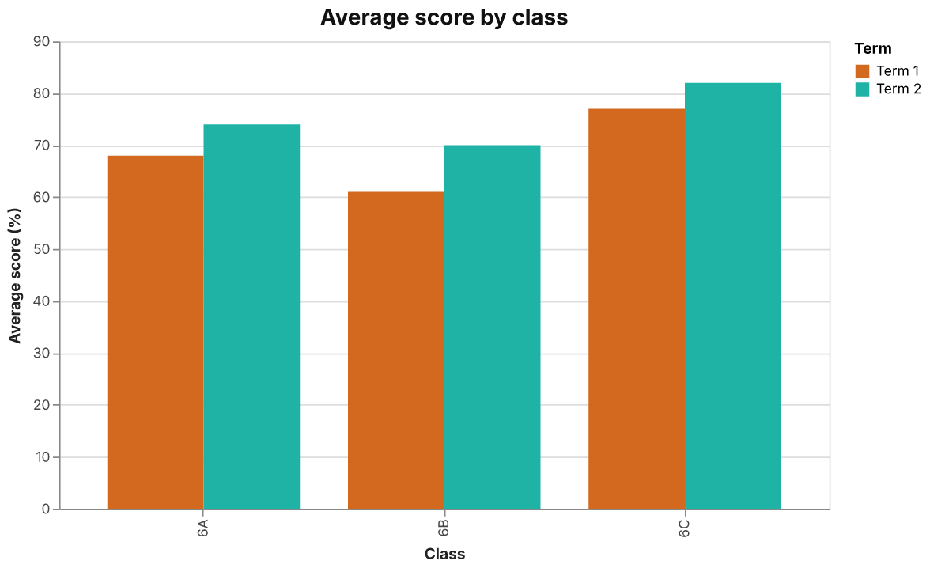
Average score by class and term

Results
Class | Term 1 | Term 2 | Change
6A | 68 | 74 | +6
6B | 61 | 70 | +9
6C | 77 | 82 | +5

Next steps
- Review fractions with 6B
- Share Class 6C worksheets
- Re-test in Term 3
Small steps, every day.

