53_Dims: Multi-Task Learning
Task-Count Ablation Report
Supervisor progress report | Prepared for Jana
Comparison of Plain shared regression and PLE across 2, 4, 8, 16, and 32 discourse dimensions
Status: preliminary analysis of 10 experiment logs
Primary reported test metrics are from the final logged checkpoint, not necessarily the best-validation checkpoint.

1. Executive summary
This report consolidates ten completed experiment logs comparing a Plain shared-regression model with a Progressive Layered Extraction (PLE) model at five task counts: 2, 4, 8, 16, and 32 discourse dimensions. The comparison addresses the research question: “How does PLE performance change as task count increases?”
In the current final-checkpoint test comparison, Plain has lower overall test MSE and higher test R² than PLE at 2, 4, 8, and 16 dimensions. At 32 dimensions, the models are much closer: Plain test R² is 0.5827 and PLE test R² is 0.5700; test MSE is 0.01421 for Plain and 0.01475 for PLE. Plain’s strongest test R² in this set is at 4 dimensions, so the observed pattern is not a monotonic improvement with increasing task count.
These results are preliminary. The CSV logs provide test metrics at the final logged checkpoint (step 29,048), while the best validation step differs by experiment. The report therefore labels final-checkpoint test metrics and best-validation metrics separately. Test metrics at each best-validation checkpoint have not yet been calculated.

2. Research question and objectives
Research question: How does PLE performance change as task count increases?
Objectives:
- Compare Plain shared regression and PLE at 2, 4, 8, 16, and 32 dimensions.
- Track overall test MSE and R² as task count changes.
- Inspect whether the architecture gap narrows at higher task counts.
- Use shared dimensions D9 and E2 as a small matched-dimension check across nested subsets.
- Document checkpoint-selection limitations and define the next evaluation step.

3. Experimental design
The ten runs consist of two architectures at each of five task counts. Dimension subsets were designed to be nested and balanced by category, with a 50% Hostility / 50% Deliberation balance noted in the experiment plan. D9 and E2 appear in all five subsets. The dimension subsets are listed below as recorded in the analysis context.
Task count | Dimensions in subset
2 | D9, E2
4 | D9, F7−, E2, I3+
8 | P2, P3, D9, F7−, E3, I9, E2, I3+
16 | P2, P5, P3, F9, D9, P4, E4−, F7−, E3, A13, I9, E1, E2, D4+, D5+, I3+
32 | P2, P7, P5, P3, A6, F9, D11, D9, A5−, P4, F13, E4−, D5−, D6−, I8, F7−, E3, D8, A13, I9, E1, E2, A3+, D4+, D5+, A11, D3+, I1, I3+

4. Training and evaluation setup
- Backbone: DeBERTa-v3-large (as recorded in the experiment setup).
- Train/validation/test split: 80% / 10% / 10%.
- Random seed: 42.
- Optimizer: AdamW.
- Learning-rate schedule: cosine scheduler.
- Training duration: 4 epochs.
- Validation evaluation interval: every 100 steps.
- Logging: CSV and Weights & Biases (W&B) were used.
- For this architecture comparison, unweighted MSE was used for both Plain and PLE to keep the comparison consistent.
This report uses only configuration details recorded in the available project context and consolidated analysis. Other hyperparameters (for example, learning rate, batch size, and exact PLE-specific settings) are not specified here because they have not been verified from the logs in this report.

5. Evaluation metrics and checkpoint conventions
MSE (mean squared error) measures the average squared difference between predictions and targets; lower is better. R² measures predictive fit relative to a mean-baseline reference; higher is better, and negative values can occur when predictions perform worse than that reference.
Final-checkpoint test metrics: all ten CSVs contain test metrics at the final logged checkpoint, step 29,048. The primary results table below uses those metrics for a consistent final-checkpoint comparison.
Best-validation metrics: for each run, the lowest recorded eval/true_avg_mse_OVERALL was used to identify the best validation step. These are validation metrics, not test metrics. The best-validation checkpoint’s test performance has not yet been evaluated in this report. A logged best step also does not, by itself, confirm that the corresponding model weights were saved and are recoverable.

6. Main results: final logged checkpoint
Table 2 reports test metrics at step 29,048 for all ten runs.
Tasks | Architecture | Test MSE | Test R² | Test step
2 | Plain | 0.0300 | 0.3720 | 29048
2 | Ple | 0.0543 | -0.0001 | 29048
4 | Plain | 0.0175 | 0.6714 | 29048
4 | Ple | 0.0524 | 0.0466 | 29048
8 | Plain | 0.0128 | 0.6099 | 29048
8 | Ple | 0.0354 | 0.0381 | 29048
16 | Plain | 0.0132 | 0.5879 | 29048
16 | Ple | 0.0360 | 0.0020 | 29048
32 | Plain | 0.0142 | 0.5827 | 29048
32 | Ple | 0.0148 | 0.5700 | 29048

Interpretation: Plain is better on both reported metrics at 2–16 dimensions. At 32 dimensions, the gap narrows substantially, with Plain still slightly ahead on both MSE and R² in the final-checkpoint comparison.
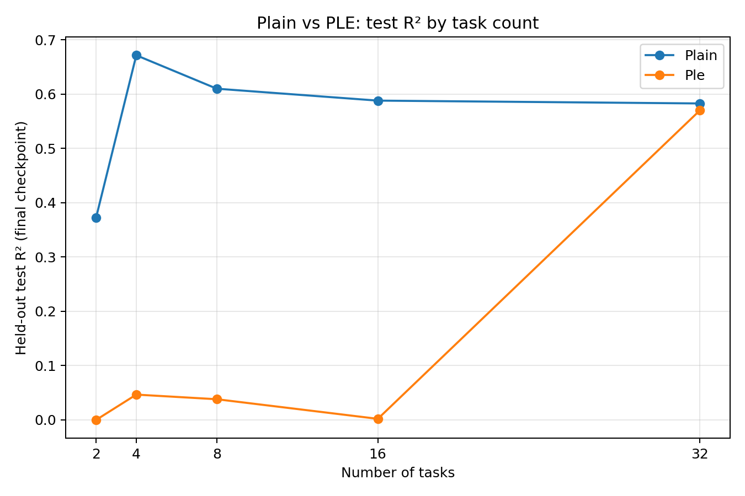
Figure 1. Test R² by task count at the final logged checkpoint.
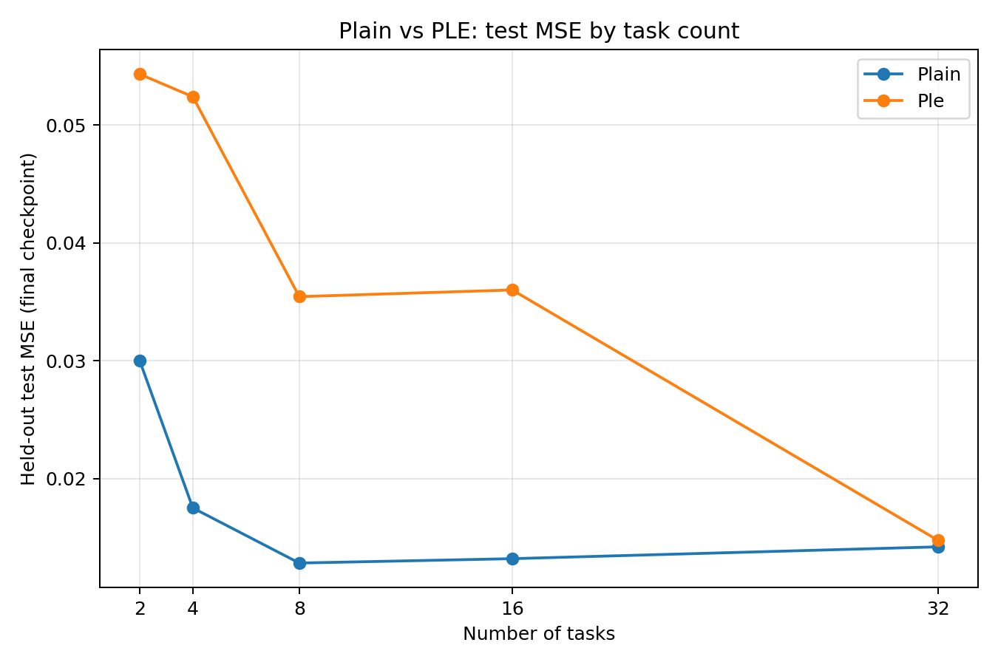
Figure 2. Test MSE by task count at the final logged checkpoint.
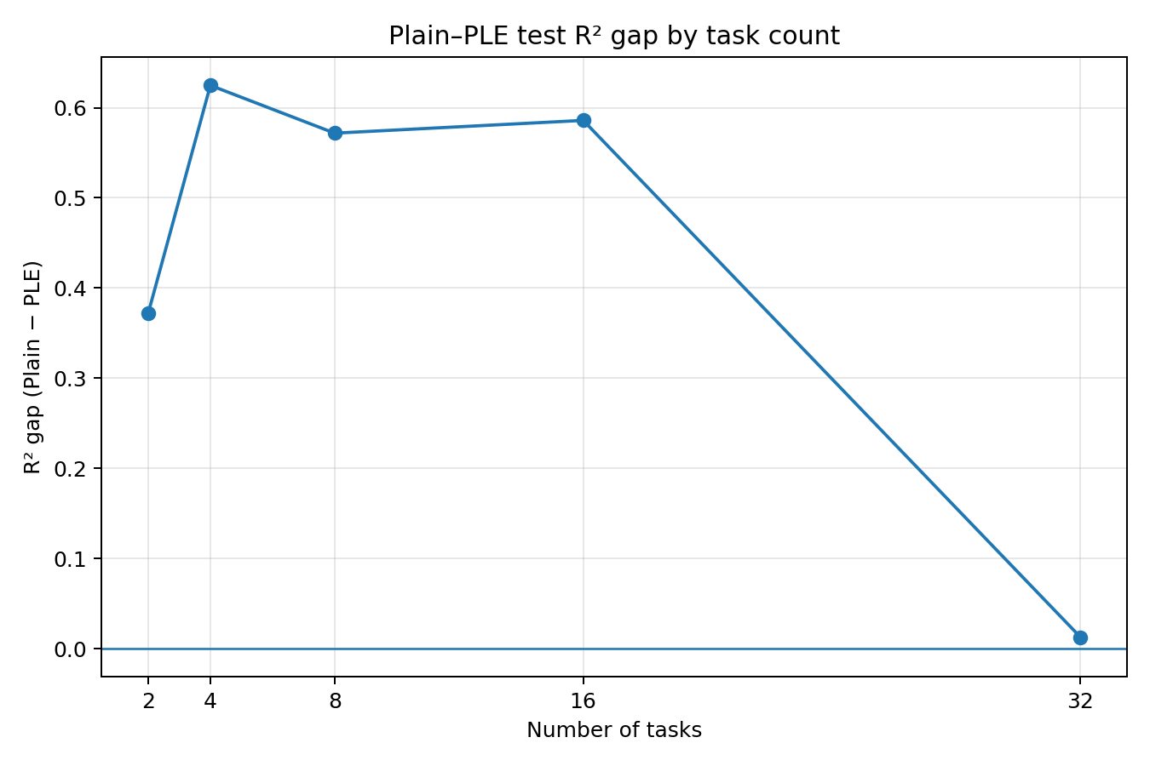
Figure 3. Difference in test R² (Plain minus PLE) by task count.
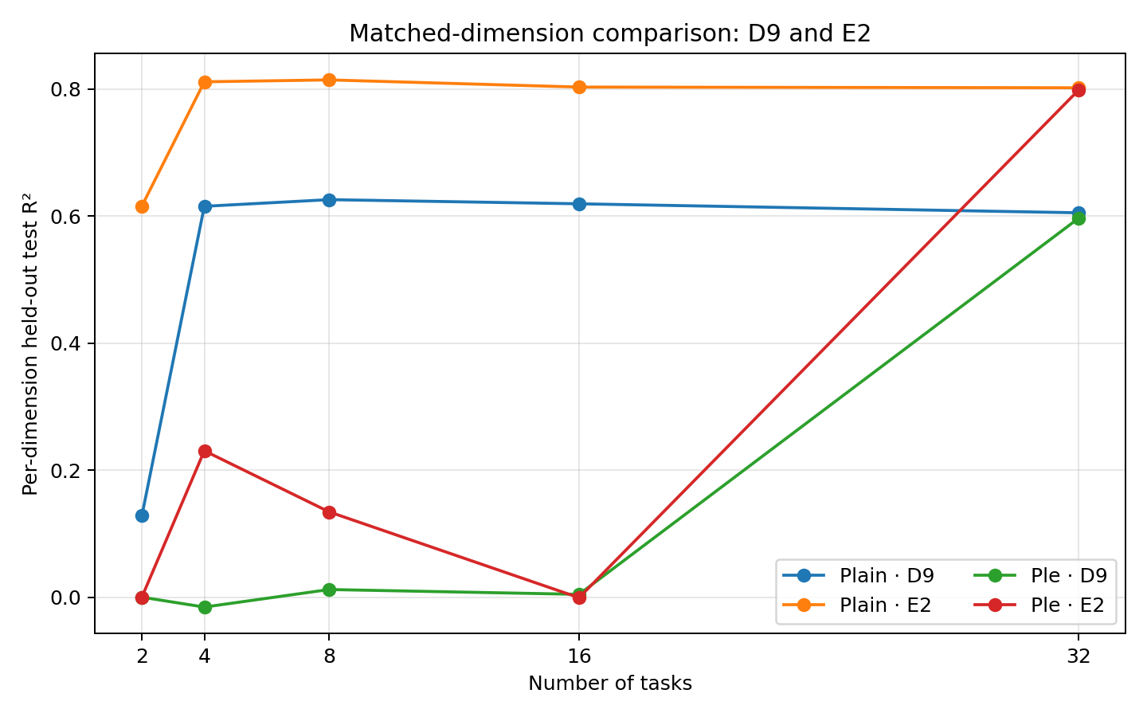
Figure 4. Test R² for shared dimensions D9 and E2 across task counts.

7. Best-validation results (validation only)
The following table summarizes the best validation step per experiment, selected by the minimum eval/true_avg_mse_OVERALL. These values must not be interpreted as test metrics at those steps.
Architecture | Tasks | Best validation step | Validation MSE | Validation R²
2 | Plain | 500 | 0.0293 | 0.3755
2 | Ple | 3900 | 0.0534 | 0.0001
4 | Plain | 21800 | 0.0175 | 0.6653
4 | Ple | 400 | 0.0511 | 0.0508
8 | Plain | 21700 | 0.0125 | 0.6127
8 | Ple | 400 | 0.0347 | 0.0391
16 | Plain | 27800 | 0.0127 | 0.6015
16 | Ple | 300 | 0.0357 | 0.0019
32 | Plain | 28500 | 0.0140 | 0.5880
32 | Ple | 25300 | 0.0145 | 0.5769

The selected validation step varies substantially by run. In particular, PLE’s best validation steps for 2D, 4D, 8D, and 16D occur early in training, while the 32D PLE best validation step occurs later. This variation is a reason to evaluate the selected checkpoints directly before making the final thesis comparison.

8. Matched-dimension analysis: D9 and E2
D9 and E2 are present in every nested subset, so they provide a limited like-for-like view across task counts. At 32 dimensions, PLE’s final-checkpoint performance on both is close to Plain’s.
Dimension | Tasks | Plain R² | Plain MSE | PLE R² | PLE MSE
D9 | 2 | 0.1282 | 0.0328 | −0.0001 | 0.0376
D9 | 4 | 0.6155 | 0.0144 | −0.0157 | 0.0382
D9 | 8 | 0.6260 | 0.0141 | 0.0120 | 0.0371
D9 | 16 | 0.6195 | 0.0143 | 0.0044 | 0.0374
D9 | 32 | 0.6053 | 0.0148 | 0.5968 | 0.0152
E2 | 2 | 0.6159 | 0.0273 | −0.0000 | 0.0711
E2 | 4 | 0.8116 | 0.0134 | 0.2305 | 0.0547
E2 | 8 | 0.8146 | 0.0132 | 0.1342 | 0.0615
E2 | 16 | 0.8033 | 0.0140 | −0.0009 | 0.0711
E2 | 32 | 0.8022 | 0.0141 | 0.7987 | 0.0143

This pattern is consistent with the overall result that the architecture gap is much smaller in the 32D experiment. It does not establish that task count alone caused the change: the model configuration, optimization trajectory, and additional tasks may all contribute.

9. Discussion
The current results suggest that the Plain model is a stronger baseline for small and medium task counts under the present setup. PLE’s relative performance is substantially closer to Plain in the 32D run. This is compatible with the possibility that PLE benefits from a larger multi-task setting, but the current evidence is not sufficient to establish that explanation causally.
Performance is not monotonic with task count. Plain reaches its highest test R² at 4D (0.6714), while the 8D, 16D, and 32D values are lower. Because the subsets are nested but each larger set introduces additional dimensions, the results reflect both task count and the composition of the task set.

10. Limitations and threats to validity
- Single-seed evidence: the reported comparisons use seed 42; run-to-run variability has not been quantified.
- Checkpoint mismatch: test metrics currently available are from the final logged checkpoint, not necessarily the best-validation checkpoint.
- Best-checkpoint weights: the CSVs identify best validation steps, but the presence and correctness of saved weights at those steps must be verified.
- Nested task sets: task count changes alongside task composition; results cannot isolate task count as the sole cause.
- Only selected shared dimensions are discussed in the main text; the consolidated per-dimension CSV should be used for a fuller appendix analysis.
- The report does not claim statistical significance because no multi-seed confidence intervals or significance tests are available.

11. Conclusions and next steps
At the final logged checkpoint, Plain outperforms PLE on overall test MSE and R² at 2–16 dimensions, while the gap is much smaller at 32 dimensions. Plain’s performance does not increase monotonically with task count. These findings provide an initial answer to the research question, but should be treated as provisional until the best-validation checkpoints are evaluated on the test set.
- Verify that best_model.pt corresponds to the minimum validation overall MSE for each run.
- Load each selected checkpoint and evaluate it on the same held-out test set.
- Replace or supplement the final-checkpoint table with selected-checkpoint test results, retaining explicit labels.
- Inspect validation learning curves to understand early best steps and later training behavior.
- If resources permit, repeat the experiments with additional seeds to estimate variability.

Appendix A. Files and analysis outputs
The consolidated analysis bundle contains:
- master_summary.csv — final-checkpoint test metrics and best-validation metadata.
- best_validation_summary.csv — selected best-validation step and validation metrics for each run.
- per_dimension_test_metrics.csv — final-checkpoint per-dimension test metrics.
- plain_ple_gap.csv — architecture performance-gap summary.
- 01_test_r2_vs_tasks.png, 02_test_mse_vs_tasks.png, 03_test_r2_gap.png, 04_matched_dimensions_D9_E2.png — figures used in this report.
Reporting note: the report is based on the consolidated analysis available at the time of preparation. It does not claim to have re-run model evaluation or inspected remote checkpoint files.

