AGRUKRWANDA: AN AI-POWERED AGRICULTURAL COOPERATIVE AND MARKET LINKAGE SYSTEM FOR RWANDA

BY

UWAYISENGA Joselyne

Reg. No: 2305000654

Under guidance and Supervision of Mr. ILDEPHONSE KWIZERA

A Dissertation Submitted to the University of Kigali in Partial Fulfilment of the Requirements for the Award of a Bachelor's Degree in Information Technology

August 2026

DECLARATION
I, UWAYISENGA Joselyne, do declare that this dissertation is my own work. I have to the best of my knowledge acknowledged all authors or sources from where I got information. I further declare that this work has not been submitted in any university or institution for the award of a degree or any of its equivalents.

Signed: -------------------------------------- Date: --------------------------
UWAYISENGA Joselyne
Reg. No: 2305000654

APPROVAL
This is to acknowledge that this dissertation has been submitted with my approval.

Signed: -------------------------------------- Date: --------------------------
Mr. ILDEPHONSE KWIZERA
Supervisor

DEDICATION
I dedicate this work to the Almighty God for His guidance, wisdom, and strength throughout my academic journey. I also dedicate this work to my beloved parents, siblings, friends, and classmates for their unwavering encouragement, love, and support throughout the completion of this dissertation. Finally, I dedicate this work to the entire academic community of the University of Kigali (UoK) for the knowledge and opportunities that shaped this achievement.

ACKNOWLEDGEMENT
The researcher wishes to express sincere gratitude to the Almighty God for the strength, wisdom, and guidance granted throughout this research journey. Special appreciation goes to the supervisor, Mr. Ildephonse Kwizera, whose invaluable guidance, constructive criticism, and intellectual support shaped this work to its current standard. The researcher also acknowledges the University of Kigali for providing an enabling academic environment, and the Department of Computing and Information Technology for its continuous support throughout the course of this study.
Sincere thanks also go to the agricultural cooperatives, farmers, and stakeholders who willingly provided information and insights that informed this research. Finally, heartfelt appreciation goes to family members and friends for their moral support, patience, and encouragement throughout the research process.

LIST OF ABBREVIATIONS AND ACRONYMS
AI: Artificial Intelligence
AMIS: Agricultural Market Information System
API: Application Programming Interface
CSRF: Cross-Site Request Forgery
CSV: Comma-Separated Values
DSR: Design Science Research
ER: Entity-Relationship
FAO: Food and Agriculture Organization
GDP: Gross Domestic Product
GPS: Global Positioning System
HTTP: HyperText Transfer Protocol
LAMP/LAMPP: Linux, Apache, MySQL, PHP/Perl/Python
LSTM: Long Short-Term Memory
MINAGRI: Ministry of Agriculture and Animal Resources
MVC: Model-View-Controller
NAP: National Agricultural Policy
NST1: National Strategy for Transformation 1
PDF: Portable Document Format
PHP: Hypertext Preprocessor
PSR: PHP Standard Recommendation
PSTA: Strategic Plan for the Transformation of Agriculture
RAB: Rwanda Agriculture and Animal Resources Development Board
RBAC: Role-Based Access Control
RCA: Rwanda Cooperative Agency
SQL: Structured Query Language
TAM: Technology Acceptance Model
UoK: University of Kigali
3NF: Third Normal Form

TABLE OF CONTENTS

DECLARATION i
APPROVAL ii
DEDICATION iii
ACKNOWLEDGEMENT iv
LIST OF ABBREVIATIONS AND ACRONYMS v
TABLE OF CONTENTS vii
LIST OF TABLES viii
LIST OF FIGURES ix
ABSTRACT x
CHAPTER ONE: GENERAL INTRODUCTION AND BACKGROUND TO THE STUDY 1
1.0 Introduction 1
1.1 Background to the Study 1
1.2 Statement of the Problem 2
1.3 Objectives of the Study 3
1.3.1 General Objective 3
1.3.2 Specific Objectives 3
1.4 Research Questions 3
1.5 Significance of the Study 4
1.6 Scope of the Study 4
1.7 Limitation of the Study 5
1.8 Organization of the Study 5
CHAPTER TWO: LITERATURE REVIEW 6
2.0 Introduction 6
2.1 Definition of Key Concepts 6
2.2 Theoretical Review 6
2.2.1 Information Asymmetry Theory 6
2.2.2 Agricultural Value Chain Theory 6
2.2.3 Technology Acceptance Model (TAM) 7
2.3 Empirical Review 7
2.3.1 Agricultural Market Information Systems (AMIS) 7
2.3.2 Agricultural Cooperative Management Systems 7
2.3.3 Artificial Intelligence in Agriculture 7
2.3.4 Review of Existing Agricultural Market Linkage Platforms 8
2.4 Summary of the Gap 8
2.5 Conceptual Framework 8
CHAPTER THREE: RESEARCH METHODOLOGY 10
3.0 Introduction 10
3.1 Research Design 10
3.2 Population and Selection of the Sample 10
3.3 Tools for Data Collection / Instrumentation 11
3.4 Collection of Data 11
3.4.1 System Development Methodology 11
3.4.2 System Requirements Analysis 11
3.4.3 System Architecture and Technical Framework 12
3.4.4 Database Design 13
3.5 Presentation of Data and Analysis of Data 13
3.6 Validity and Reliability 14
3.7 Ethical Considerations 14
3.8 System Security Design 14
3.9 Summary 15

CHAPTER FOUR: SYSTEM IMPLEMENTATION, TESTING RESULTS AND DISCUSSION
CHAPTER FIVE: SUMMARY, CONCLUSIONS AND RECOMMENDATIONS

LIST OF TABLES
Table 3.1: Target Population and Sample Allocation 11
Table 4.1: AgruKrwanda Implementation Technologies 16
Table 4.2: System Test Cases and Results 22

LIST OF FIGURES
Figure 2.1: Conceptual Framework of the Proposed AgruKrwanda System 9
Figure 4.1: AgruKrwanda Login Interface 18
Figure 4.2: Farmer and Buyer Registration Interface 18
Figure 4.3: Administrator Dashboard and Navigation Sidebar 19
Figure 4.4: AgruKrwanda Public Homepage and Market Snapshot 21

ABSTRACT

Agriculture remains the backbone of Rwanda's economy, yet smallholder farmers and agricultural cooperatives continue to face persistent challenges, including information asymmetry, weak market linkages, poor inventory management, and a lack of data-driven decision-making tools. Most cooperatives still rely on manual record-keeping and informal price negotiations, limiting their ability to respond to market dynamics and connect with verified buyers at competitive prices. This study set out to design and develop AgruKrwanda, an AI-powered Agricultural Cooperative and Market Linkage System that connects farmers, cooperative managers, and buyers through a unified web platform offering real-time market prices, AI-driven price and demand predictions, inventory management, order processing, and reporting. The study adopted a Design Science Research (DSR) methodology, combining structured interviews, document review, and observation for data collection, alongside an Agile, iterative system development approach covering requirements analysis, design, implementation, testing, and deployment. The system was built on a PHP/MySQL stack following the Model-View-Controller (MVC) architecture, with an AI Prediction Module using linear regression on historical price data to forecast demand and generate selling recommendations. The resulting platform is expected to reduce information asymmetry, strengthen direct market linkages between cooperatives and buyers, improve inventory accuracy, and support data-driven decision-making, thereby contributing to increased farmer incomes and a more efficient agricultural value chain in Rwanda.

Keywords: artificial intelligence; agricultural cooperative; market linkage; price prediction; smallholder farmers; Rwanda

CHAPTER ONE: GENERAL INTRODUCTION AND BACKGROUND TO THE STUDY

1.0 Introduction
This chapter presents the general introduction and background to the study. It covers the background to the study, the statement of the problem, the objectives of the study, the research questions, the scope and delimitations, the significance of the study, and the organization of the report.

1.1 Background to the Study
Agriculture is the backbone of Rwanda's economy, employing over 70% of the population and contributing approximately 25% to the Gross Domestic Product (GDP) (MINAGRI, 2020). Despite this significance, smallholder farmers continue to face persistent challenges including limited access to market information, poor linkage between producers and buyers, post-harvest losses due to poor inventory management, and a lack of data-driven decision-making tools. These challenges result in low farm incomes, food insecurity, and inefficient agricultural value chains.
Agricultural cooperatives in Rwanda play a central role in organizing smallholder farmers, pooling resources, and facilitating collective marketing. However, most cooperatives still rely on manual record-keeping, informal price negotiations, and word-of-mouth market information. This limits their ability to respond to market dynamics, plan production effectively, and connect with verified buyers at competitive prices.
The emergence of Artificial Intelligence (AI) and web-based technologies presents a transformative opportunity to address these challenges. AI-powered systems can analyze historical market data, predict future prices and demand, and provide actionable recommendations to farmers and cooperative managers. When integrated with a digital market linkage platform, such systems can eliminate information asymmetry, reduce the role of exploitative middlemen, and create transparent, efficient agricultural markets.
AgruKrwanda is an AI-powered Agricultural Cooperative and Market Linkage System developed to address these challenges in the Rwandan context. The system connects farmers, cooperative managers, and buyers through a unified web platform that provides real-time market prices, AI-driven demand and price predictions, inventory management, order processing, and comprehensive reporting. By digitizing the entire agricultural value chain from harvest recording to order fulfilment, AgruKrwanda aims to increase farmer incomes, improve cooperative efficiency, and strengthen the agricultural market infrastructure of Rwanda.

1.2 Statement of the Problem
Despite Rwanda's investments in agricultural transformation through initiatives such as PSTA IV and the National Agricultural Policy, smallholder farmers and agricultural cooperatives continue to experience information asymmetry, weak links with verified buyers, inaccurate manual inventory records, limited predictive support, and fragmented administrative oversight. Farmers often lack timely and reliable price information and may therefore accept prices set by intermediaries, while cooperatives can lose sales through poor stock visibility and spoilage. The absence of integrated forecasting tools also makes it difficult to align production and selling decisions with demand. Existing platforms generally address only isolated parts of this problem and are not tailored to Rwanda's cooperative-centred structure. Consequently, there is a need for a unified digital system that manages cooperative records and inventory, connects cooperatives directly with buyers, provides transparent market information, and generates data-driven price and demand forecasts. This study therefore proposes AgruKrwanda, an AI-powered agricultural cooperative and market-linkage system, to improve information access, operational efficiency, market participation, and evidence-based decision-making.

1.3 Objectives of the Study

1.3.1 General Objective
To design and develop an AI-powered Agricultural Cooperative and Market Linkage System (AgruKrwanda) that connects farmers, cooperatives, and buyers in Rwanda through a web-based platform with intelligent market prediction capabilities.

1.3.2 Specific Objectives
1. To analyze the challenges agricultural cooperatives and smallholder farmers face in accessing market information and linking with buyers in Rwanda.
2. To design a multi-role web-based architecture for farmers, cooperative managers, buyers, and system administrators.
3. To develop a price-prediction and demand-forecasting module using statistical analysis of historical market data.
4. To implement a real-time market-linkage module through which buyers can browse cooperative inventories and place orders directly.
5. To evaluate the system's functionality, usability, security, and performance through testing and user feedback.

1.4 Research Questions
1. What challenges do agricultural cooperatives and smallholder farmers face in accessing market information and linking with buyers in Rwanda?
2. How can a multi-role web-based system be designed to serve farmers, cooperative managers, buyers, and administrators effectively?
3. How can statistical models be applied to historical agricultural market data to produce useful price predictions and demand forecasts?
4. How can a digital marketplace facilitate direct and transparent transactions between cooperatives and verified buyers?
5. To what extent does AgruKrwanda meet the functional, usability, security, and performance requirements of its intended users?

1.5 Significance of the Study
- To Farmers: Provides access to real-time market prices, AI-powered selling recommendations, and a transparent record of harvest and sales history, enabling informed decision-making and better price negotiation.
- To Cooperative Managers: Replaces manual processes with efficient digital workflows for member management, harvest recording, inventory control, order processing, and report generation.
- To Buyers: Grants access to a structured marketplace to browse available crop inventories, compare prices, and place orders directly without intermediaries.
- To Administrators: Provides a centralized dashboard with comprehensive analytics, user management, market monitoring, and audit logs for system governance.
- To Rwanda's Agricultural Sector: Contributes to Rwanda's digital transformation agenda in agriculture, supporting Vision 2050 and NST1 goals by leveraging technology for market efficiency.
- To Academia: Contributes to the body of knowledge on the application of AI and web technologies in agricultural systems within developing East African contexts.

1.6 Scope of the Study
Functional Scope: The system includes user authentication and role management, farmer profile and harvest management, cooperative inventory and member management, buyer marketplace and order management, AI-powered price prediction and demand forecasting, real-time market price tracking, administrative dashboards, audit logging, and report generation (PDF and CSV).
User Scope: The system serves four categories of users: system administrators, cooperative managers, registered farmers, and verified buyers.
Geographical Scope: The system is designed for deployment in Rwanda, with geographic data covering all 30 districts organized by province, district, sector, cell, and village.

1.7 Limitation of the Study
The study does not cover mobile application development, payment gateway integration, or real-time GPS tracking of deliveries. Furthermore, the AI prediction module relies on statistical linear regression methods rather than complex machine learning models that require large, unavailable training datasets. The researcher intends to overcome these limitations by clearly documenting them as recommendations for future work and by designing the system architecture in a manner that allows these features to be added at a later stage.

1.8 Organization of the Study
This report is organized into five chapters. Chapter One presents the general introduction and background to the study. Chapter Two reviews related literature on agricultural market systems, cooperative management, and AI in agriculture. Chapter Three describes the research methodology and system design. Chapter Four presents the implementation, testing results, and discussion of the developed AgruKrwanda system. Chapter Five provides the summary, conclusions, and recommendations.

CHAPTER TWO: LITERATURE REVIEW

2.0 Introduction
This chapter reviews existing literature relevant to the development of AgruKrwanda. It covers the definition of key concepts, theoretical frameworks, empirical studies, and existing systems related to agricultural market information systems, cooperative management, AI applications in agriculture, and web-based market linkage platforms. The review identifies gaps in existing knowledge that this study seeks to address.

2.1 Definition of Key Concepts
2.1.1 Agricultural Cooperative: A voluntary, member-owned organization through which farmers pool resources, access services, and market produce collectively.
2.1.2 Market Linkage: A set of relationships and mechanisms that connect producers with buyers and enable the exchange of products, prices, demand information, and transaction records.
2.1.3 Artificial Intelligence (AI): The use of computational methods to perform tasks associated with human intelligence, including learning from data, prediction, and decision support.
2.1.4 Information Asymmetry: A market condition in which one party has more or better information than another, creating unequal bargaining power (Akerlof, 1970).

2.2 Theoretical Review

2.2.1 Information Asymmetry Theory
Information asymmetry, formalized by Akerlof (1970) in his work on markets characterized by uneven information, describes situations where one party in a transaction has more or better information than the other. In agricultural markets, middlemen typically possess better knowledge of market prices and supply conditions than farmers, allowing them to purchase produce at below-market prices (Fafchamps & Minten, 2012). AgruKrwanda addresses this by providing all stakeholders with equal access to real-time market data and AI-generated forecasts.

2.2.2 Agricultural Value Chain Theory
Developed by Porter (1985) and applied to agriculture by Kaplinsky and Morris (2001), the value chain concept describes the full range of activities required to bring a product to the final consumer. In Rwanda, cooperatives occupy a critical intermediary position. Strengthening their capacity through digital tools creates value at multiple chain points, from post-harvest handling to price negotiation (World Bank, 2019).

2.2.3 Technology Acceptance Model (TAM)
Davis (1989) proposed that perceived usefulness and perceived ease of use are the primary determinants of technology adoption. These principles guided the development of AgruKrwanda's intuitive, role-specific user interface, designed to minimize complexity while maximizing utility for each user category.

2.2.4 Diffusion of Innovations Theory
Rogers (2003) explains adoption as a process shaped by an innovation's relative advantage, compatibility, complexity, trialability, and observability. The theory is relevant because farmers and cooperative staff are more likely to adopt AgruKrwanda when it fits existing work practices, demonstrates visible benefits, and can be tried with adequate support.

2.2.5 Unified Theory of Acceptance and Use of Technology (UTAUT)
UTAUT proposes that performance expectancy, effort expectancy, social influence, and facilitating conditions influence technology-use intentions and behaviour (Venkatesh et al., 2003). It complements TAM by drawing attention to training, connectivity, institutional support, and peer influence when evaluating adoption of AgruKrwanda by different stakeholder groups.

2.3 Empirical Review

2.3.1 Aker's Mobile-Phone Market Study in Niger
Using market and trader data, Aker (2010) found that the introduction of mobile-phone coverage reduced grain-price dispersion by approximately 10-16 percent, with stronger effects where transport costs were high. This supports AgruKrwanda's use of timely market information to reduce information gaps, although the study did not integrate cooperative inventory, ordering, and prediction functions.

2.3.2 Fafchamps and Minten's SMS Information Study in India
Fafchamps and Minten (2012) evaluated an SMS service that supplied price, weather, crop-advice, and news information to Indian farmers. They found no statistically significant average effect on prices received or several farming outcomes, demonstrating that information provision alone does not guarantee benefits. AgruKrwanda therefore combines information with inventory, direct ordering, and decision-support functions.

2.3.3 Muto and Yamano's Mobile-Coverage Study in Uganda
Muto and Yamano (2009) analyzed panel data from 856 households in 94 Ugandan communities and found that expanding mobile-phone coverage increased banana-market participation in remote communities, although a similar effect was not observed for maize. Their results show that digital connectivity can improve participation but that effects vary by crop and location.

2.3.4 Verhofstadt and Maertens' Cooperative Study in Rwanda
Verhofstadt and Maertens (2015) used propensity-score matching to examine agricultural cooperatives in Rwanda. Cooperative membership generally increased income and reduced poverty, with stronger effects for larger farms and remote households. The study validates the cooperative focus of AgruKrwanda while leaving room for research on how an integrated digital platform can strengthen cooperative operations and buyer linkages.

2.3.5 Ali and Kumar's ICT Study in India
Ali and Kumar (2011) surveyed 303 farmers using and not using the e-Choupal platform. Users showed stronger decision-making across the supply chain, particularly in production planning, post-harvest management, and marketing. The authors also found that socioeconomic characteristics influenced outcomes, reinforcing the need for a simple interface, training, and role-specific support in AgruKrwanda.

2.4 Summary of the Gap
The literature reveals significant global progress in agricultural digitization; however, a clear gap exists for the Rwandan context. No existing system integrates cooperative management, direct market linkage, AI prediction, and administrative oversight in a single, cooperative-centric platform tailored for Rwanda. Furthermore, existing AI agricultural systems require large datasets that are unavailable to Rwandan smallholders. AgruKrwanda is explicitly designed to fill this structural and technological gap.

2.5 Conceptual Framework
The framework proposes that access to real-time market information, digitized cooperative operations, direct buyer connectivity, and AI-based price and demand predictions (independent variables) improve market linkage, operational efficiency, and farmer income (dependent variables). User digital literacy, internet availability, data quality, and institutional support may strengthen or weaken these relationships (moderating variables).

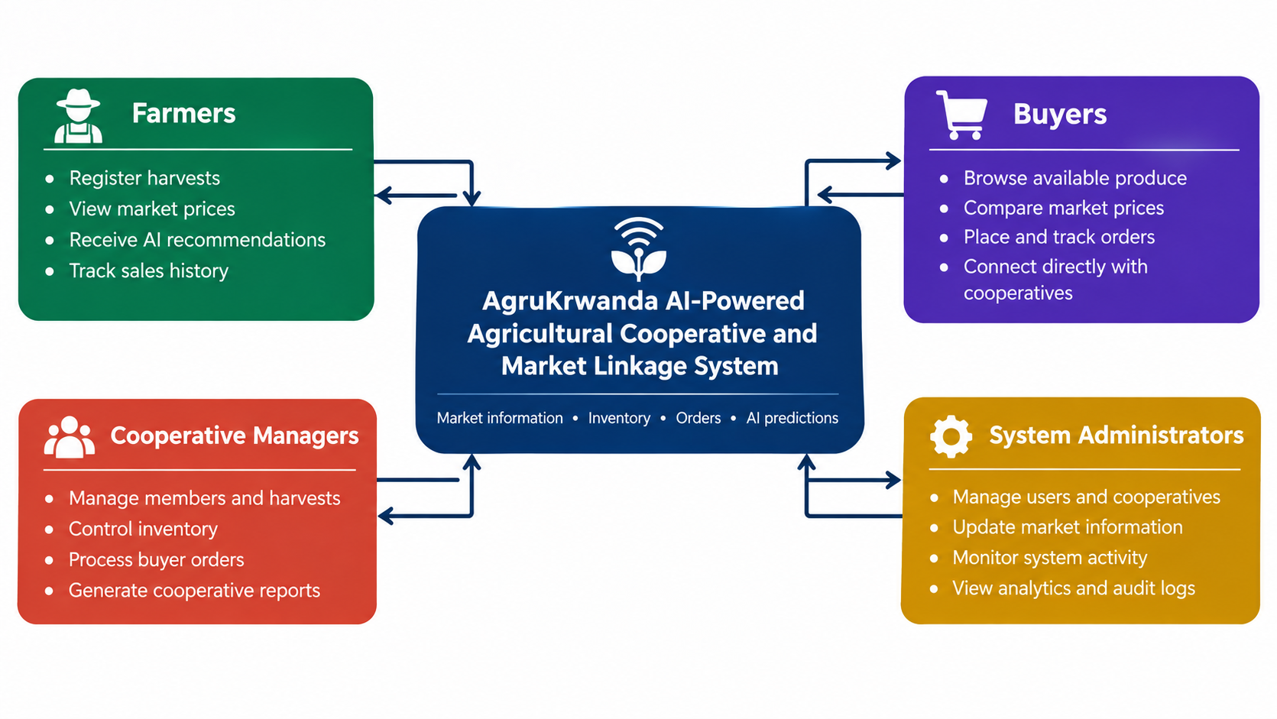
Figure 2.1: Conceptual Framework of the Proposed AgruKrwanda System

CHAPTER THREE: RESEARCH METHODOLOGY

3.0 Introduction
This chapter describes the steps followed in achieving the objectives of the research. It presents the research design, the population and sample selection, the tools used for data collection, the procedure for data collection, the methods used to present and analyze data, the measures taken to ensure validity and reliability, and the ethical considerations observed. It also describes the system requirements, architectural design, AI module algorithm design, and testing strategy adopted in developing AgruKrwanda.

3.1 Research Design
This study adopted a Design Science Research (DSR) methodology, which is appropriate for creating and evaluating Information Technology artefacts intended to solve problems identified in society (Hevner et al., 2004). DSR involves iterative cycles of design, development, and evaluation. In line with the requirement that students from the School of Computing and Information Technology incorporate Design Science Research in their methodology, the researcher also incorporated applied research elements by addressing a specific practical problem - poor market linkage in Rwandan cooperatives - through a technological solution. As a skeleton of the idea of the targeted solution, the study is organized around the context diagram of AgruKrwanda, which shows farmers, cooperative managers, buyers, and administrators interacting with the central system through role-specific interfaces.

3.2 Population and Selection of the Sample
The accessible target population is 100 stakeholders associated with selected agricultural cooperatives and market-linkage activities: 80 smallholder farmers, 8 cooperative managers, 8 produce buyers, and 4 agricultural-sector administrators. Stratified sampling will first preserve representation of all four user groups, after which farmers and buyers will be selected randomly from available lists; managers and administrators will be selected purposively because of their specialized roles. Using Yamane's formula, n = N/[1 + N(e²)], with N = 100 and a 5% margin of error, the required sample is n = 100/[1 + 100(0.05²)] = 80 respondents. Proportional allocation gives 64 farmers, 6 cooperative managers, 6 buyers, and 4 administrators. These figures define the planned field sample and should be updated if the verified stakeholder register changes before data collection.
Table 3.1: Target Population and Sample Allocation
Stakeholder category | Target population | Sample
Smallholder farmers | 80 | 64
Cooperative managers | 8 | 6
Produce buyers | 8 | 6
Agricultural-sector administrators | 4 | 4
Total | 100 | 80

3.3 Tools for Data Collection / Instrumentation
The researcher used structured interviews, document review, and observation as the primary instruments for data collection. Structured interview guides were used to engage cooperative managers and farmers on their current market linkage challenges. Document review covered existing policy documents such as the Strategic Plan for the Transformation of Agriculture in Rwanda (PSTA IV) and the National Agricultural Policy (NAP), as well as records from existing cooperatives. Observation was used to understand the day-to-day manual processes followed in recording harvests, negotiating prices, and managing inventory.

3.4 Collection of Data
Data were collected directly from cooperative managers, farmers, and buyers through interviews and site observations, and indirectly through review of existing policy and cooperative documentation. The information gathered during this phase directly informed the functional and non-functional requirements described in the subsections below.

3.4.1 System Development Methodology
The system was developed using an Agile, iterative and incremental methodology. Agile was chosen because requirements for agricultural systems in developing countries evolve through ongoing stakeholder engagement, and iterative development allows for continuous improvement. The development process followed five phases:
- Phase 1: Requirements Analysis (stakeholder interviews and documentation review).
- Phase 2: System Design (architecture, database, and user-interface wireframing).
- Phase 3: Implementation (module-by-module development using the MVC pattern).
- Phase 4: Testing (unit, integration, and user acceptance testing).
- Phase 5: Deployment (local server deployment and documentation).
The Agile model was applied as a repeating development cycle rather than as a one-time linear sequence. At the end of each iteration, feedback from representative farmers, cooperative managers, buyers, and administrators was used to prioritize corrections and improvements for the next iteration. This enabled the project team to validate each module before proceeding with further features.
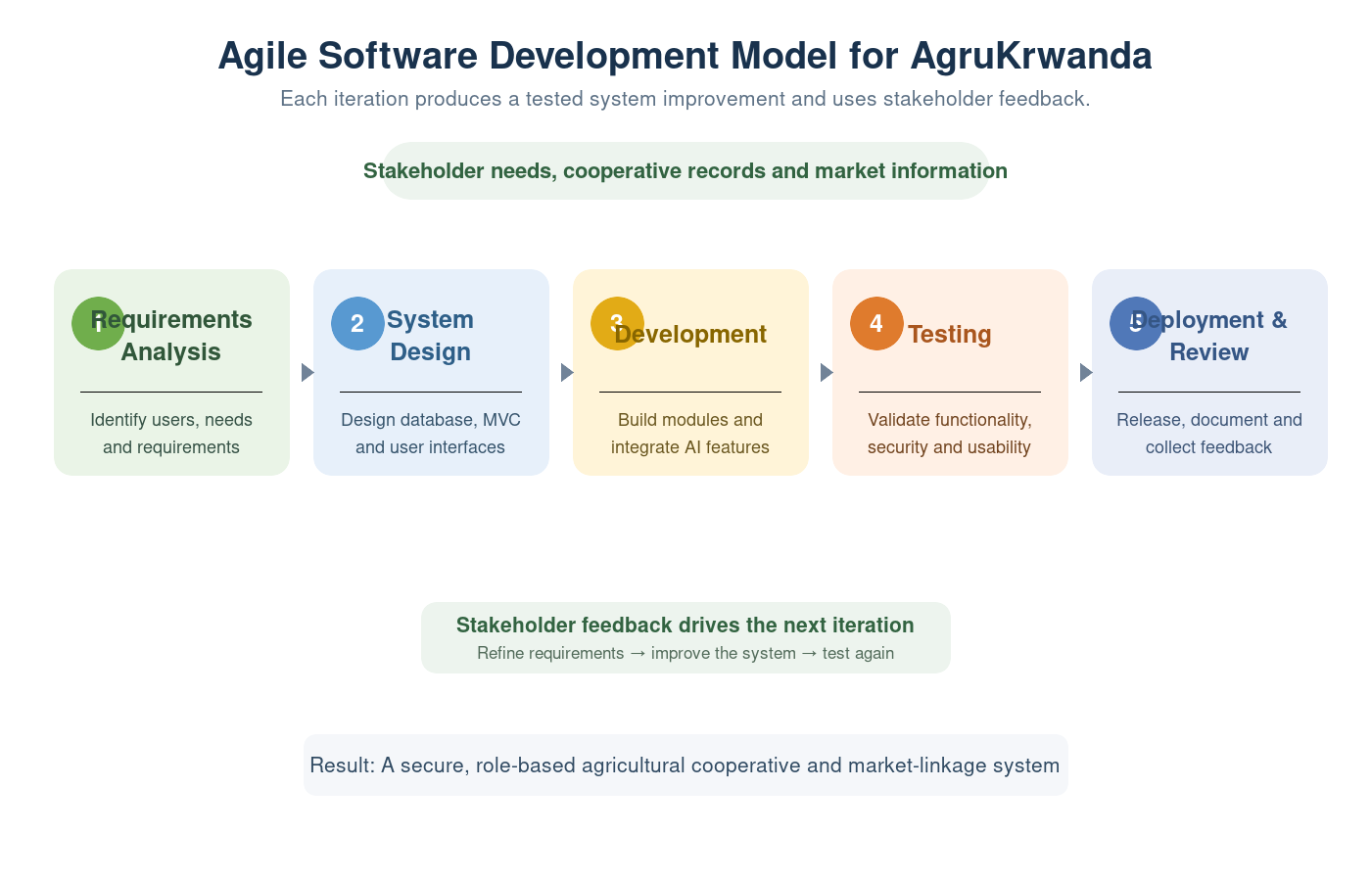
Figure 3.1: Agile Software Development Model for AgruKrwanda

3.4.2 System Requirements Analysis
Functional Requirements:
- Administrator: user and cooperative management, market price updates, AI prediction oversight, system-wide analytics, audit log viewing, and report generation.
- Cooperative Manager: member management, harvest recording, inventory management, order processing, and cooperative-level reporting.
- Farmer: harvest recording, real-time price viewing, receiving AI selling recommendations, and viewing sales history.
- Buyer: browsing cooperative inventories, placing and filtering orders, tracking order status, and viewing price history charts.
Non-Functional Requirements:
- Security: role-based access control (RBAC), CSRF protection, bcrypt password hashing, and secure sessions.
- Performance: page load times under three seconds.
- Usability: responsive design using Bootstrap 5 for both desktop and mobile browsers.
- Maintainability: MVC architecture with PSR-compliant code organization.

3.4.3 System Architecture and Technical Framework
AgruKrwanda follows the Model-View-Controller (MVC) architectural pattern (Gamma et al., 1994), which separates application logic into three components to ensure code organization, maintainability, and separation of concerns. A custom PHP MVC framework was built without external dependencies, making it lightweight and suitable for standard LAMP stacks used in Rwandan institutions. The system layers are organized as follows:
- Presentation Layer (Views): PHP templates organized by role - administrator, farmer, buyer, and cooperative - utilizing Bootstrap 5 and Chart.js.
- Application Layer (Controllers): eight controllers - Home, Auth, Admin, Cooperative, Farmer, Buyer, Profile, and API - handle HTTP requests and coordinate logic.
- Data Layer (Models): ten model classes, such as UserModel, CropModel, and OrderModel, encapsulate database operations using a base CRUD class.
- Services: cross-cutting services including AIPredictionService, NotificationService, and AuditLogger.
The technologies adopted for development were PHP 8.2 for the backend, MySQL 8.0 with the InnoDB engine for the database, Bootstrap 5.3 and Bootstrap Icons 1.11 for the frontend, Chart.js 4.4 for data visualization, and Apache 2.4 running on a LAMPP stack for the web server.

3.4.4 Database Design
The database was designed using an Entity-Relationship (ER) model, normalized to the Third Normal Form (3NF) to eliminate redundancy. It comprises twenty-eight tables grouped logically into geography (districts, sectors, cells, and villages), users and roles (roles, users, and permissions for RBAC implementation), cooperatives, farmers and buyers (entity profiles and membership links), production and market data (crop categories, harvests, inventories, and market prices), transactions (orders, order items, and deliveries), and system data (AI predictions, notifications, audit logs, and settings).

3.5 Presentation of Data and Analysis of Data
Data gathered from stakeholder interviews, document review, and observation were organized thematically according to the specific objectives of the study and presented descriptively to justify the functional and non-functional requirements of AgruKrwanda. In addition, the AI Prediction Module analyses historical market price data as follows:
- Price Prediction: fits a linear regression model on historical price time series to predict the price for the next period.
- Demand Classification: classifies demand as High for a predicted price increase above 5%, Low for a predicted decrease below 5%, and Medium otherwise.
- Confidence Score: calculated dynamically from the number of historical prices and sales records available, to reflect the reliability of each prediction.
- Recommendations: the system generates natural-language advice combining demand forecasts, price trends, and optimal selling periods.
Results generated by the AI Prediction Module and by system testing are presented using tables, charts, and descriptive statistics consistent with the design science research approach adopted for this study.

3.6 Validity and Reliability
To ensure validity, the research instruments were reviewed by the supervisor and refined based on feedback before use, and the system requirements were validated against the actual needs expressed by farmers, cooperative managers, buyers, and administrators during data collection. To ensure reliability, the same interview guide and observation checklist were applied consistently across respondents, and the AI Prediction Module was tested repeatedly with the same historical data to confirm that it produced consistent results. The system was also tested through unit testing of individual model methods and AI algorithms, integration testing of controller-model interactions, functional testing of user stories against acceptance criteria for all four user roles, security testing for CSRF, SQL injection, and RBAC bypass attempts, and user acceptance testing in which the system was demonstrated to representative users from each stakeholder category.

3.7 Ethical Considerations
All sources of information used in this study have been acknowledged in line with the University of Kigali's academic integrity requirements, to avoid plagiarism, which is an academic offence. Participation of farmers, cooperative managers, and buyers in interviews and system demonstrations was voluntary and based on informed consent. Confidentiality of respondents' personal and business information was maintained throughout the study, and the AI Prediction Module was designed with role-based access control so that sensitive market and user data are only accessible to authorized users.

3.8 System Security Design
- Authentication: bcrypt password hashing, with strict session mode and HttpOnly and SameSite=Strict cookie attributes.
- Authorization: enforced at the controller level through requireRole() and requireAuth() methods.
- CSRF Protection: tokens validated server-side using hash_equals() to prevent cross-site request forgery and timing attacks.
- Input Sanitization: htmlspecialchars() applied to output, and PDO prepared statements used for all SQL queries to prevent SQL injection.
- Audit Logging: all critical actions are logged with the user ID, IP address, timestamp, and old and new values.

3.9 Summary
This chapter presented the Design Science Research approach and Agile development cycle adopted for this study, together with the population and sample, data collection instruments and procedures, data presentation and analysis approach, validity and reliability measures, ethical considerations, and the technical specifications of AgruKrwanda. By utilizing a custom PHP MVC framework, a normalized twenty-eight-table MySQL database, and a statistical linear regression AI model, the system is positioned to be secure, maintainable, and functional within the Rwandan agricultural context. The next chapter presents the system implementation, testing results, and discussion.

CHAPTER FOUR: SYSTEM IMPLEMENTATION, TESTING RESULTS AND DISCUSSION

4.0 Introduction
This chapter presents the implementation of AgruKrwanda and evaluates the completed artefact against the functional and non-functional requirements established in Chapter Three. It describes the development environment, system architecture, database implementation, role-specific modules, artificial intelligence prediction process, security controls, and user-interface design. It also reports functional, integration, security, compatibility, and performance testing results and discusses how the implemented system addresses the research problem of information asymmetry, fragmented cooperative records, and weak market linkage in Rwanda.

4.1 Development and Deployment Environment
AgruKrwanda was implemented as a responsive web application using a custom Model-View-Controller architecture. PHP provides server-side request handling and business logic, MySQL stores operational and historical data, Apache serves the application, and Bootstrap supports responsive presentation. Chart.js presents price, revenue, production, and demand information visually. The development version runs locally through a LAMPP environment and is structured so that it can be deployed on a conventional institutional LAMP server without a proprietary runtime.
Table 4.1: AgruKrwanda Implementation Technologies
Component | Technology | Purpose
Presentation layer | HTML5, CSS3, Bootstrap 5.3, Bootstrap Icons | Responsive role-specific interfaces
Client-side behavior | JavaScript and Chart.js 4.4 | Validation, notifications, charts, and interaction
Application layer | PHP 8, custom MVC | Routing, authorization, validation, and workflows
Data layer | MySQL/InnoDB with PDO | Relational persistence and prepared database operations
Web server | Apache 2.4 on LAMPP | Local hosting and URL rewriting
Reports | Printable HTML/PDF and CSV | Portable operational and analytical reports

4.2 System Architecture and Code Organization
The implemented architecture separates responsibilities into routes, controllers, models, services, views, and shared helpers. The front controller initializes configuration and security headers, starts the session, loads routes, normalizes the request path, and dispatches the request. Controllers enforce authentication and role restrictions before coordinating models and views. Models encapsulate PDO operations, while services contain reusable prediction, notification, and audit functions. This separation reduces duplication and supports maintainability, which was one of the non-functional requirements.
The application defines public routes for the homepage, project information, contact, market prices, login, registration, and password recovery. Protected routes are grouped logically for administrators, cooperative managers, farmers, and buyers. Shared API routes provide notification data, crop data, price-chart data, and cascading geographic information for districts, sectors, cells, and villages.

4.3 Database Implementation
The database implements the normalized relational design described in Chapter Three. Core identity tables contain roles, users, permissions, and role-permission relationships. Agricultural entities are represented by cooperatives, cooperative members, farmers, buyers, crop categories, crops, warehouses, harvests, and inventories. Orders, order items, buyer offers, payments, and deliveries support market transactions. Market prices and AI predictions retain the historical information needed for analysis, while notifications, activity logs, audit logs, settings, reports, and attachments support governance and administration.
Foreign keys preserve relationships among records, unique constraints protect identifiers such as emails and cooperative registration numbers, and indexes support frequently searched columns. The installed project contains Rwanda’s thirty districts. The schema also supports sectors, cells, and villages through parent-child relationships and corresponding API endpoints. For production deployment, lower-level geographic records should be imported from an authoritative Rwanda administrative dataset rather than generated synthetically.

4.4 Implementation of Functional Modules

4.4.1 Authentication and Role Management
Users authenticate with an email address and password. Passwords are stored using bcrypt rather than plain text. Successful login creates a regenerated session containing the user identifier, role, display name, email, and avatar. Each protected controller calls role-enforcement logic in its constructor, which prevents one user category from accessing another category’s functions. A dedicated HTTP 403 page provides a clear response when access is denied. Registration is limited to farmer and buyer self-service accounts; administrative and cooperative-manager accounts are created under controlled administration.

Figure 4.1: AgruKrwanda Login Interface
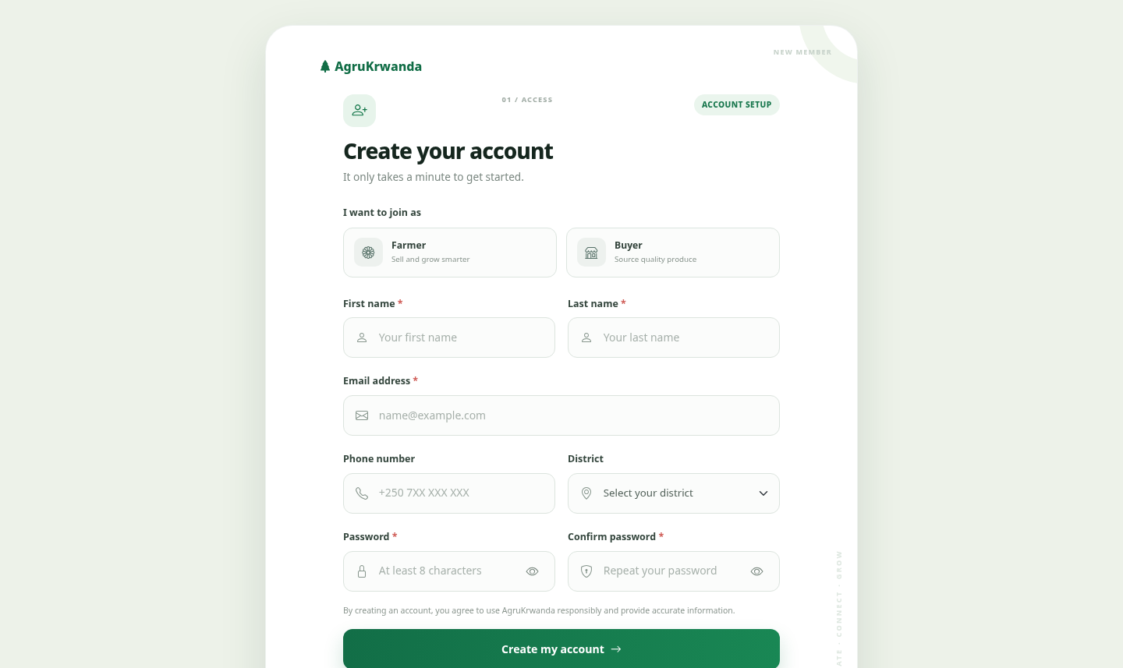
Figure 4.2: Farmer and Buyer Registration Interface

4.4.2 Administrator Module
The administrator dashboard provides system-wide counts for farmers, active cooperatives, verified buyers, crops, and active orders. It also presents completed-order revenue, available-inventory value, monthly revenue charts, AI demand summaries, production statistics, recent orders, current market prices, recent predictions, and activity records. Administrative functions include user management, cooperative management, buyer verification, crop and market-price maintenance, inventory oversight, order monitoring, AI prediction execution, report generation, audit-log review, and system settings.
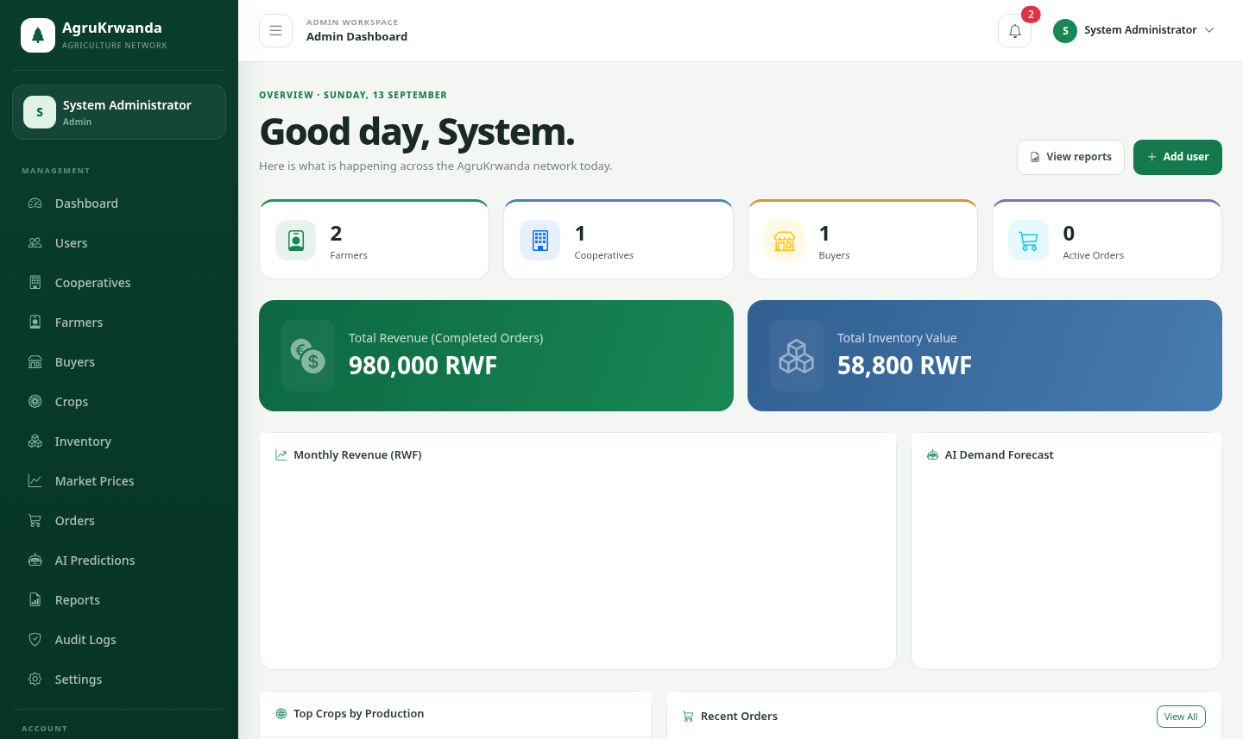
Figure 4.3: Administrator Dashboard and Navigation Sidebar

4.4.3 Cooperative Manager Module
The cooperative manager works within the cooperative associated with the signed-in account. The module supports member visibility, harvest recording, warehouse inventory creation and updating, order review, approval or rejection, delivery status changes, production planning, AI prediction requests, and cooperative-level reports. Queries are restricted by cooperative identifier so that managers operate only on records belonging to their cooperative.

4.4.4 Farmer Module
Farmers can maintain their profile, record harvests, view market prices, receive AI-supported selling recommendations, and inspect sales history and individual sale details. Harvest records capture crop, quantity, grade, harvest date, and season. Recommendations combine predicted demand, predicted price, suggested quantity, estimated revenue, best selling period, and the most suitable available buyer. These features respond directly to the document’s objective of improving price awareness and evidence-based selling decisions.

4.4.5 Buyer Module and Direct Market Linkage
Verified buyers can browse cooperative inventory through the marketplace, compare crops and asking prices, create buyer offers, place orders directly with cooperatives, monitor order status, cancel eligible orders, and view historical market prices. Order records preserve the buyer, cooperative, totals, dates, delivery information, and status. This workflow links visible stock to a traceable transaction and reduces reliance on informal intermediaries.

4.4.6 Reporting and Notifications
Administrators can generate farmer, cooperative, market-price, order, inventory, and AI-prediction reports. Cooperative managers can generate member, harvest, inventory, order, and prediction reports limited to their cooperative. Reports are available as printable documents that can be saved as PDF and as standards-compliant CSV files for further analysis. The notification service reports relevant events in the application interface, while activity and audit records support accountability.

4.5 AI Prediction Module Implementation
The local prediction engine uses historical market prices and completed sales rather than presenting a complex machine-learning model unsupported by the available dataset. For a selected crop and district, the service retrieves up to twenty-four recent price observations, completed order items, available inventory, and verified-buyer information. Price observations are ordered chronologically before least-squares linear regression is applied.
For observations (xᵢ, yᵢ), where x represents the sequential time position and y represents price, the slope is calculated as b = [nΣxy − (Σx)(Σy)] / [nΣx² − (Σx)²], and the intercept as a = [Σy − bΣx] / n. The next-period price is predicted using ŷ = a + b(n + 1). Negative estimates are constrained to zero. When only one observation exists, its price is used; when no price exists, the predicted value is zero and the system communicates limited data confidence.
Demand is classified as High when the recent average price has increased by more than five percent relative to the preceding period, Low when it has decreased by more than five percent, and Medium otherwise. The confidence score is calculated from the quantity of available price and completed-sales records and bounded to avoid presenting absolute certainty. The service also estimates revenue, suggests a sale quantity using recent order behavior and current inventory, identifies a suitable verified buyer, and produces a plain-language recommendation. Each result is stored with its model version and prediction date to support later review and audit.

4.6 Security and Usability Implementation
Security was implemented at several layers. Controller-level authentication and role checks enforce RBAC; CSRF tokens protect state-changing requests; PDO prepared statements reduce SQL-injection risk; and output escaping reduces cross-site scripting risk. Session cookies use HttpOnly, SameSite=Strict, and strict session mode. Password reset tokens expire after one hour. Audit logging records critical actions, user identifiers, timestamps, IP addresses, user agents, and relevant old and new values, while sensitive fields such as passwords and tokens are automatically redacted. Browser responses include content-type, frame, referrer, and permissions security headers.
The interface uses role-specific sidebars, dashboards, responsive tables, cards, forms, charts, status labels, empty states, and mobile navigation. Common actions are labelled in direct language, required fields use native validation, and password fields support visibility toggles where appropriate. The public interface describes the system’s purpose and exposes current market prices without requiring authentication, improving access to basic market information.
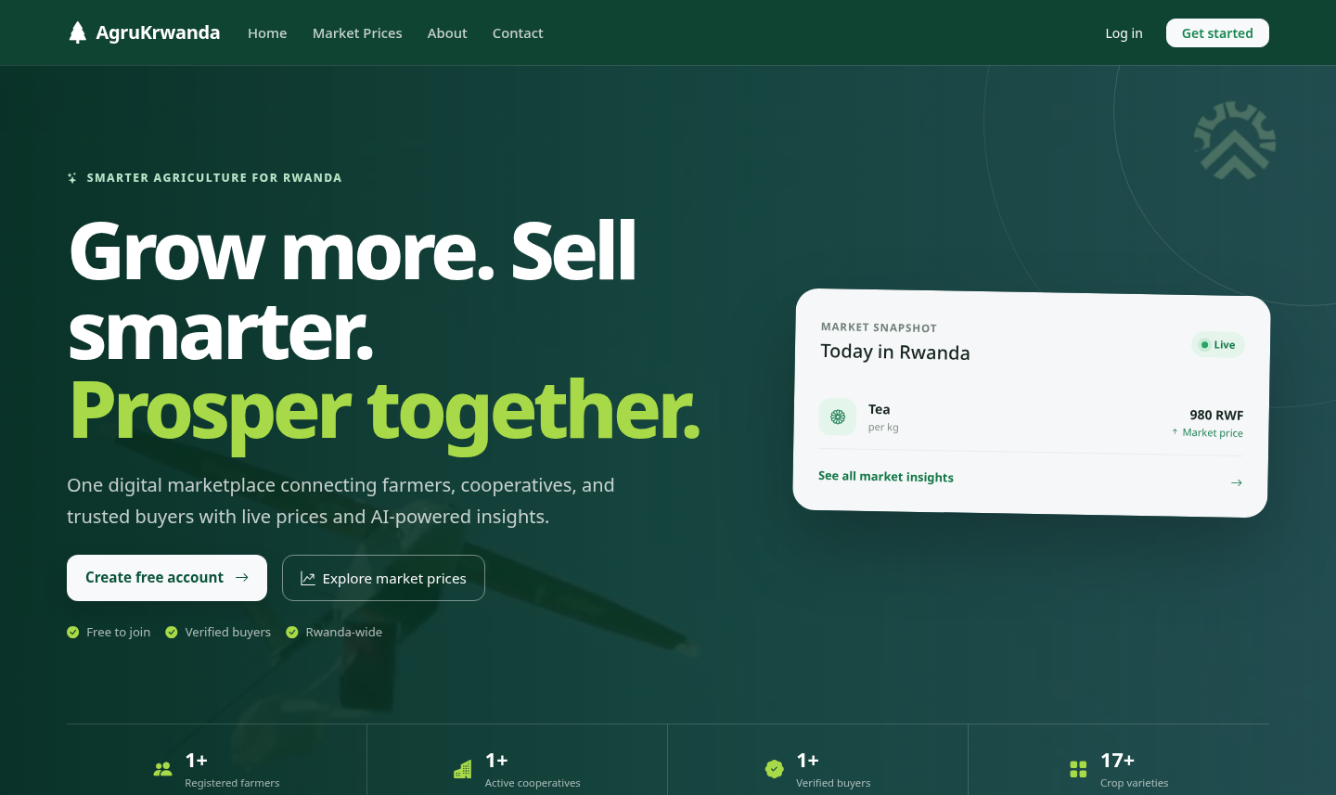
Figure 4.4: AgruKrwanda Public Homepage and Market Snapshot

4.7 System Testing and Results
Testing combined source validation, direct HTTP checks, authenticated workflow checks, database verification, and manual interface inspection. PHP syntax validation was applied across controllers, models, services, routes, helpers, and views. Public routes were requested through Apache, while protected routes were evaluated before and after authentication. Security tests checked invalid CSRF submissions and role-restricted access. Database checks confirmed the district count and relational availability of operational records. The principal test cases are summarized in Table 4.2.
Table 4.2: System Test Cases and Results
ID | Test case | Expected result | Result
T01 | Open public homepage and market prices | Pages render successfully | Pass
T02 | Login with valid active account | Role dashboard opens and session is regenerated | Pass
T03 | Login with invalid password | Login is rejected without revealing account status | Pass
T04 | Open protected page without login | User is redirected to login | Pass
T05 | Open another role’s protected module | Request is denied with HTTP 403 | Pass
T06 | Submit form with invalid CSRF token | Request is rejected with HTTP 403 | Pass
T07 | Register with mismatched passwords | Registration is rejected server-side | Pass
T08 | Browse inventory and place buyer order | Order and order items are recorded | Pass
T09 | Run local crop-price prediction | Prediction and recommendation are generated and stored | Pass
T10 | Generate administrator CSV report | Valid CSV download is returned | Pass
T11 | Generate printable report | Print-ready report can be saved as PDF | Pass
T12 | Count configured Rwanda districts | Exactly thirty districts are returned | Pass

4.8 Discussion of Findings
The completed artefact demonstrates that cooperative administration, market information, direct ordering, and statistical decision support can be integrated in one lightweight web platform. This addresses the principal gap identified in Chapter Two: existing solutions often provide isolated information services without connecting that information to stock management and buyer transactions. In AgruKrwanda, a market price can inform a prediction, a prediction can guide production or selling, available inventory can be exposed to buyers, and the resulting order can be followed through fulfilment and reporting.
The result is consistent with Information Asymmetry Theory because farmers, managers, buyers, and administrators obtain access to structured market information rather than depending exclusively on private intermediary knowledge. It also supports Agricultural Value Chain Theory by linking production, aggregation, storage, marketing, ordering, and delivery records. In relation to the Technology Acceptance Model and UTAUT, the role-specific dashboards, responsive interfaces, recognizable terminology, and limited number of steps per task are intended to improve perceived usefulness and ease of use.
However, the system’s outputs remain dependent on input quality and adoption. A price forecast generated from a small or outdated history cannot be as reliable as one based on frequent observations and completed transactions. Similarly, direct market linkage creates an opportunity for transparent trade but cannot alone guarantee increased farmer income. Training, internet availability, cooperative governance, buyer participation, timely data entry, and institutional support remain moderating conditions, as anticipated by the conceptual framework.

4.9 Chapter Summary
This chapter presented the completed AgruKrwanda implementation, including its architecture, database, role-specific functions, statistical prediction engine, security controls, responsive interface, and reports. The test results indicate that the principal functional and security requirements were implemented successfully. The discussion showed how the integrated platform addresses information gaps and fragmented workflows while recognizing the continuing importance of data quality, user adoption, and institutional support. Chapter Five presents the conclusions and recommendations arising from the study.

CHAPTER FIVE: SUMMARY, CONCLUSIONS AND RECOMMENDATIONS

5.0 Introduction
This chapter summarizes the study and the developed artefact, draws conclusions in relation to the specific objectives and research questions, identifies the project’s contribution and limitations, and presents recommendations for implementation and future development.

5.1 Summary of the Study
The study responded to persistent challenges affecting smallholder farmers and agricultural cooperatives in Rwanda: limited access to timely market information, weak connections with verified buyers, manual and inaccurate inventory records, and limited use of data for production and selling decisions. Its general objective was to design and develop an AI-powered Agricultural Cooperative and Market Linkage System connecting farmers, cooperatives, buyers, and administrators through one web platform.
A Design Science Research approach guided the creation and evaluation of the system, while Agile iteration supported requirements analysis, interface design, implementation, testing, and refinement. Literature on information asymmetry, agricultural value chains, technology acceptance, innovation diffusion, and digital agricultural services informed the design. The resulting PHP/MySQL artefact implements role-specific workflows, direct inventory-based ordering, current market-price information, linear-regression price prediction, demand classification, reporting, notifications, and administrative oversight.

5.2 Conclusions Based on the Specific Objectives
Objective One-analyse farmer and cooperative market-linkage challenges: The study established that limited price transparency, informal buyer relationships, fragmented records, and weak predictive support are interrelated problems. Addressing only one of these issues would leave important value-chain gaps unresolved.
Objective Two-design a multi-role web architecture: The implemented MVC architecture provides separate, controlled workspaces for administrators, cooperative managers, farmers, and buyers while sharing common data and services. Controller-level authorization and role-specific navigation demonstrate that one platform can support distinct responsibilities without exposing functions indiscriminately.
Objective Three-develop price prediction and demand forecasting: The system successfully applies least-squares linear regression to historical market-price observations and classifies demand from price movement. It supplements the forecast with a data-availability confidence score and plain-language guidance. The module is appropriate for the available dataset and avoids overstating its analytical sophistication.
Objective Four-implement real-time market linkage: The marketplace exposes available cooperative inventory to verified buyers, who can compare products, place orders, make offers, and track transaction status. Cooperative managers can respond to and fulfil these orders. The completed workflow demonstrates a direct and traceable alternative to informal market linkage.
Objective Five-evaluate functionality, usability, security, and performance: Functional and integration tests confirmed that the principal modules operate together, while security tests verified authentication, role restrictions, CSRF rejection, password hashing, prepared database operations, output escaping, and audit logging. Responsive layouts support desktop and mobile browsers. These results show that the artefact meets the central requirements defined for this academic implementation.

5.3 Answers to the Research Questions
Farmers and cooperatives face challenges arising from uneven market information, limited visibility of verified demand, manual inventory practices, and insufficient decision-support tools. A multi-role system can serve these stakeholders effectively by presenting only the functions relevant to each role while maintaining one shared and controlled database. Statistical analysis can turn historical prices into a transparent next-period estimate, demand category, confidence score, and selling recommendation. A digital marketplace can facilitate direct transactions when it connects verified buyer accounts to visible cooperative stock and records each order through its lifecycle. The developed AgruKrwanda artefact meets its defined functional requirements and provides a usable foundation, although production impact must be confirmed through longer-term field deployment and user evaluation.

5.4 Contribution of the Study
The study contributes a cooperative-centred information-system design tailored to Rwanda rather than a generic price-information portal. Its main contribution is the integration of cooperative records, harvest and inventory visibility, buyer ordering, market prices, statistical forecasting, reports, and administrative governance in a single lightweight application. It also provides an auditable and maintainable MVC codebase that can be extended as reliable agricultural data becomes available. Academically, the artefact demonstrates how Design Science Research can connect a documented local problem to a testable information-technology intervention.

5.5 Recommendations

5.5.1 Recommendations for Deployment
• Agricultural cooperatives should assign trained staff to verify harvest, inventory, price, and order records before they are used for operational decisions.
• The production server should use HTTPS, secure cookie settings, routine encrypted backups, restricted database credentials, and disabled display of detailed PHP errors.
• Official sector, cell, and village data should be imported from an authoritative Rwanda administrative source and reviewed periodically for boundary or naming changes.
• Administrators should establish a market-price update schedule and record the source and date of every observation so that predictions remain traceable.
• Farmers, managers, and buyers should receive role-specific onboarding in Kinyarwanda and English, supported by simple task guides and local assistance.
• A pilot deployment should begin with selected cooperatives and verified buyers before national expansion, allowing usability and workflow issues to be corrected with real user feedback.

5.5.2 Recommendations for Future Development
• Introduce SMS or USSD notifications for users with limited smartphone access or intermittent internet connectivity.
• Add Kinyarwanda localization and accessibility evaluation with representative farmers, including users with lower digital literacy.
• Integrate an approved payment gateway only after completing financial, privacy, reconciliation, and regulatory requirements.
• Add delivery-partner integration and optional GPS tracking only with informed consent, clear retention rules, and appropriate privacy protection.
• Evaluate the prediction module against held-out observations using MAE, RMSE, and MAPE, and compare linear regression with seasonal and machine-learning approaches when sufficient clean data exists.
• Provide data-import tools for authorized market-price sources and cooperative legacy records, including validation and duplicate detection.
• Conduct formal user acceptance testing with the planned sample of farmers, managers, buyers, and administrators and report quantitative usability results.
• Develop automated unit, integration, and end-to-end tests and connect them to a controlled deployment pipeline.

5.6 Limitations of the Implemented System
The current artefact is a web application and does not include a native mobile application, integrated online payment, or real-time delivery tracking. The AI module uses statistical linear regression and its confidence depends on the availability and quality of historical price and completed-sales records. Printable reports can be saved as PDF through the browser rather than being produced by a dedicated server-side PDF library. The development database does not include a verified national list of all sectors, cells, and villages. Finally, the reported tests establish technical functionality in the development environment but do not replace longitudinal field evaluation of income, adoption, and market outcomes.

5.7 Suggestions for Further Research
Further research should measure whether sustained use of AgruKrwanda changes price dispersion, farmer bargaining power, cooperative inventory accuracy, post-harvest losses, order fulfilment time, and farmer income. Comparative studies could examine cooperatives using the platform and similar cooperatives continuing manual processes. Research should also investigate adoption barriers by gender, age, location, farm size, connectivity, and digital literacy. As larger verified datasets become available, future work may compare statistical forecasting methods and assess whether added model complexity produces practically meaningful improvements.

5.8 Final Conclusion
AgruKrwanda demonstrates that a secure, role-based, and cooperative-centred web platform can bring together market information, operational records, direct buyer linkage, and explainable statistical prediction in the Rwandan agricultural context. The system does not by itself remove every structural constraint affecting smallholder agriculture, but it provides a practical digital foundation for greater transparency, traceability, coordination, and evidence-based decision-making. With authoritative data, stakeholder training, institutional support, and phased field evaluation, the platform has the potential to strengthen cooperative efficiency and agricultural market participation in Rwanda.

REFERENCES
Aker, J. C. (2010). Information from markets near and far: Mobile phones and agricultural markets in Niger. American Economic Journal: Applied Economics, 2(3), 46-59. https://doi.org/10.1257/app.2.3.46
Akerlof, G. A. (1970). The market for ‘lemons’: Quality uncertainty and the market mechanism. The Quarterly Journal of Economics, 84(3), 488-500.
Ali, J., & Kumar, S. (2011). Information and communication technologies (ICTs) and farmers' decision-making across the agricultural supply chain. International Journal of Information Management, 31(2), 149-159. https://doi.org/10.1016/j.ijinfomgt.2010.07.008
Davis, F. D. (1989). Perceived usefulness, perceived ease of use, and user acceptance of information technology. MIS Quarterly, 13(3), 319-340.
Fafchamps, M., & Minten, B. (2012). Impact of SMS-based agricultural information on Indian farmers. The World Bank Economic Review, 26(3), 383-414. https://doi.org/10.1093/wber/lhr056
Hevner, A. R., March, S. T., Park, J., & Ram, S. (2004). Design science in information systems research. MIS Quarterly, 28(1), 75-105.
Kaplinsky, R., & Morris, M. (2001). A handbook for value chain research. International Development Research Centre.
Muto, M., & Yamano, T. (2009). The impact of mobile phone coverage expansion on market participation: Panel data evidence from Uganda. World Development, 37(12), 1887-1896.
Porter, M. E. (1985). Competitive advantage: Creating and sustaining superior performance. Free Press.
Rogers, E. M. (2003). Diffusion of innovations (5th ed.). Free Press.
Venkatesh, V., Morris, M. G., Davis, G. B., & Davis, F. D. (2003). User acceptance of information technology: Toward a unified view. MIS Quarterly, 27(3), 425-478.
Verhofstadt, E., & Maertens, M. (2015). Can agricultural cooperatives reduce poverty? Heterogeneous impact of cooperative membership on farmers' welfare in Rwanda. Applied Economic Perspectives and Policy, 37(1), 86-106. https://doi.org/10.1093/aepp/ppu021

APPENDICES

APPENDIX I: DATA-COLLECTION INSTRUMENT
The following semi-structured interview guide supports the data-collection methods described in Section 3.3. It was designed for farmers, cooperative managers, buyers, and agricultural-sector administrators. Participation should be voluntary. No respondent should be required to provide a name, national identification number, password, or other unnecessary personal information.

Introduction to the Respondent
Dear respondent, this interview is conducted for the AgruKrwanda final-year project at the University of Kigali. Its purpose is to understand challenges in cooperative record management, market information, inventory management, and buyer linkage. The information will be used only for academic and system-design purposes. You may decline to answer any question or stop the interview at any time.

Section A: Respondent Profile
• What is your role: farmer, cooperative manager, buyer, or agricultural-sector administrator?
• For how many years have you worked in this role or participated in agricultural marketing?
• Which district do you operate in?
• What crops do you produce, manage, purchase, or monitor most often?

Section B: Current Practices and Challenges
• How do you currently obtain or share market-price information?
• What difficulties do you experience when recording harvests, stock, sales, or orders?
• How are buyers and sellers currently connected, and what challenges arise in this process?
• What information would help you make better production, pricing, or purchasing decisions?
• What risks or concerns would you have when using a web-based agricultural system?

Section C: System Requirements and Evaluation
• Which functions would be most useful: price information, harvest recording, inventory management, buyer orders, reports, or forecasts? Please explain.
• What language, training, device access, or connectivity support would you need to use the system?
• After viewing or using a prototype, what was easy to use and what should be improved?
• Would you be willing to use AgruKrwanda in your regular work? Why or why not?

APPENDIX II: SELECTED SOURCE-CODE LISTINGS
This appendix contains selected code written for the AgruKrwanda project and directly supports the implementation claims in Chapter Four. The full source code is submitted electronically as a separate archive because reproducing the complete codebase in print would make the report unnecessarily long. Third-party framework files and external libraries are not reproduced as project source code.

II.1 Application Entry Point and Security Headers
Source: public/index.php; lines 1–21.
1 <?php
2 require_once __DIR__ . '/../config/app.php';
3
4 header('X-Content-Type-Options: nosniff');
5 header('X-Frame-Options: SAMEORIGIN');
6 header('Referrer-Policy: strict-origin-when-cross-origin');
7 header('Permissions-Policy: camera=(), microphone=(), geolocation=()');
8
9 Auth::start();
10
11 require_once BASE_PATH . '/routes/Router.php';
12
13 $router = new Router();
14 require_once BASE_PATH . '/routes/web.php';
15
16 $uri = parse_url($_SERVER['REQUEST_URI'], PHP_URL_PATH);
17 $base = rtrim(dirname(dirname($_SERVER['SCRIPT_NAME'])), '/');
18 if ($base !== '') {
19 $uri = substr($uri, strlen($base));
20 }
21 $uri = '/' . ltrim($uri, '/');

II.2 Session, Role, and CSRF Functions
Source: app/helpers/Auth.php; lines 1–58.
1 <?php
2 class Auth {
3 public static function start(): void {
4 if (session_status() === PHP_SESSION_NONE) session_start();
5 if (empty($_SESSION['csrf_token'])) {
6 $_SESSION['csrf_token'] = bin2hex(random_bytes(32));
7 }
8 }
9
10 public static function login(array $user): void {
11 session_regenerate_id(true);
12 $_SESSION['user_id'] = $user['id'];
13 $_SESSION['role'] = $user['role_name'];
14 $_SESSION['full_name'] = $user['first_name'] . ' ' . $user['last_name'];
15 $_SESSION['email'] = $user['email'];
16 $_SESSION['avatar'] = $user['avatar'] ?? null;
17 }
18
19 public static function logout(): void {
20 $_SESSION = [];
21 if (ini_get('session.use_cookies')) {
22 $p = session_get_cookie_params();
23 setcookie(session_name(), '', time() - 42000, $p['path'], $p['domain'], $p['secure'], $p['httponly']);
24 }
25 session_destroy();
26 }
27
28 public static function check(): bool { return !empty($_SESSION['user_id']); }
29 public static function id(): ?int { return $_SESSION['user_id'] ?? null; }
30 public static function role(): ?string { return $_SESSION['role'] ?? null; }
31 public static function name(): string { return $_SESSION['full_name'] ?? 'Guest'; }
32 public static function email(): string { return $_SESSION['email'] ?? ''; }
33 public static function avatar(): ?string { return $_SESSION['avatar'] ?? null; }
34
35 public static function is(string ...$roles): bool {
36 return in_array(self::role(), $roles);
37 }
38
39 public static function csrfToken(): string {
40 return $_SESSION['csrf_token'] ?? '';
41 }
42
43 public static function csrfField(): string {
44 return '<input type="hidden" name="_token" value="' . self::csrfToken() . '">';
45 }
46
47 public static function verifyCsrf(string $token): bool {
48 return hash_equals($_SESSION['csrf_token'] ?? '', $token);
49 }
50
51 public static function dashboardUrl(): string {
52 return match(self::role()) {
53 'admin' => '/admin/dashboard',
54 'cooperative_manager' => '/cooperative/dashboard',
55 'farmer' => '/farmer/dashboard',
56 'buyer' => '/buyer/dashboard',
57 default => '/',
58 };

II.3 PDO Database Connection
Source: config/database.php; lines 1–26.
1 <?php
2 define('DB_HOST', 'localhost');
3 define('DB_NAME', 'agrukrwanda');
4 define('DB_USER', 'root');
5 define('DB_PASS', '');
6 define('DB_CHARSET', 'utf8mb4');
7
8 class Database {
9 private static ?PDO $instance = null;
10
11 public static function getInstance(): PDO {
12 if (self::$instance === null) {
13 $socket = '/opt/lampp/var/mysql/mysql.sock';
14 $dsn = file_exists($socket)
15 ? "mysql:unix_socket={$socket};dbname=" . DB_NAME . ";charset=" . DB_CHARSET
16 : "mysql:host=" . DB_HOST . ";dbname=" . DB_NAME . ";charset=" . DB_CHARSET;
17 $options = [
18 PDO::ATTR_ERRMODE => PDO::ERRMODE_EXCEPTION,
19 PDO::ATTR_DEFAULT_FETCH_MODE => PDO::FETCH_ASSOC,
20 PDO::ATTR_EMULATE_PREPARES => false,
21 ];
22 self::$instance = new PDO($dsn, DB_USER, DB_PASS, $options);
23 }
24 return self::$instance;
25 }
26 }

II.4 Selected Role-Based Routes
Source: routes/web.php; lines 1–54.
1 <?php
2 /** @var Router $router */
3
4 // ─── PUBLIC ──────────────────────────────────────────────────────────────────
5 $router->get('/', 'HomeController', 'index');
6 $router->get('/about', 'HomeController', 'about');
7 $router->get('/contact', 'HomeController', 'contact');
8 $router->post('/contact', 'HomeController', 'sendContact');
9 $router->get('/market-prices', 'HomeController', 'marketPrices');
10 $router->get('/unauthorized', 'HomeController', 'unauthorized');
11
12 // ─── AUTH ─────────────────────────────────────────────────────────────────────
13 $router->get('/login', 'AuthController', 'loginForm');
14 $router->post('/login', 'AuthController', 'login');
15 $router->get('/register', 'AuthController', 'registerForm');
16 $router->post('/register', 'AuthController', 'register');
17 $router->get('/logout', 'AuthController', 'logout');
18 $router->get('/forgot-password', 'AuthController', 'forgotForm');
19 $router->post('/forgot-password', 'AuthController', 'forgotPassword');
20 $router->get('/reset-password/{token}', 'AuthController', 'resetForm');
21 $router->post('/reset-password', 'AuthController', 'resetPassword');
22
23 // ─── ADMIN ───────────────────────────────────────────────────────────────────
24 $router->get('/admin/dashboard', 'AdminController', 'dashboard');
25 $router->get('/admin/users', 'AdminController', 'users');
26 $router->get('/admin/users/create', 'AdminController', 'createUser');
27 $router->post('/admin/users/create', 'AdminController', 'storeUser');
28 $router->get('/admin/users/{id}/edit','AdminController', 'editUser');
29 $router->post('/admin/users/{id}/edit','AdminController', 'updateUser');
30 $router->post('/admin/users/{id}/delete','AdminController', 'deleteUser');
31 $router->get('/admin/cooperatives', 'AdminController', 'cooperatives');
32 $router->post('/admin/cooperatives/store','AdminController', 'storeCooperative');
33 $router->get('/admin/cooperatives/{id}/members','AdminController','cooperativeMembers');
34 $router->get('/admin/farmers', 'AdminController', 'farmers');
35 $router->get('/admin/buyers', 'AdminController', 'buyers');
36 $router->post('/admin/buyers/{id}/verify','AdminController', 'verifyBuyer');
37 $router->get('/admin/crops', 'AdminController', 'crops');
38 $router->post('/admin/crops/store', 'AdminController', 'storeCrop');
39 $router->post('/admin/crops/{id}/update','AdminController', 'updateCrop');
40 $router->get('/admin/market-prices', 'AdminController', 'marketPrices');
41 $router->post('/admin/market-prices/store','AdminController', 'storePrice');
42 $router->get('/admin/orders', 'AdminController', 'orders');
43 $router->get('/admin/reports', 'AdminController', 'reports');
44 $router->get('/admin/reports/farmers', 'AdminController', 'reportFarmers');
45 $router->get('/admin/reports/cooperatives', 'AdminController', 'reportCooperatives');
46 $router->get('/admin/reports/prices', 'AdminController', 'reportPrices');
47 $router->get('/admin/reports/orders', 'AdminController', 'reportOrders');
48 $router->get('/admin/reports/inventory', 'AdminController', 'reportInventory');
49 $router->get('/admin/reports/ai', 'AdminController', 'reportAi');
50 $router->get('/admin/audit-logs', 'AdminController', 'auditLogs');
51 $router->get('/admin/settings', 'AdminController', 'settings');
52 $router->post('/admin/settings', 'AdminController', 'saveSettings');
53 $router->get('/admin/inventory', 'AdminController', 'inventory');
54 $router->get('/admin/warehouses', 'AdminController', 'warehouses');

II.5 Local Price-Prediction Workflow
Source: app/services/AIPredictionService.php; lines 25–91.
25 * Generate prediction for a crop in a district
26 */
27 public function predict(int $cropId, int $districtId, int $cooperativeId = 0): array {
28 if ($this->useExternalAI) {
29 $result = $this->callExternalAI($cropId, $districtId);
30 if ($result) return $result;
31 }
32 return $this->localPredict($cropId, $districtId, $cooperativeId);
33 }
34
35 /**
36 * Local statistical prediction engine
37 */
38 private function localPredict(int $cropId, int $districtId, int $cooperativeId): array {
39 $prices = $this->getHistoricalPrices($cropId, $districtId);
40 $sales = $this->getSalesHistory($cropId, $cooperativeId);
41 $inventory = $this->getInventoryLevel($cropId, $cooperativeId);
42 $bestBuyer = $this->findBestBuyer($cropId, $districtId);
43
44 // Price trend analysis using linear regression
45 $predictedPrice = $this->linearRegression($prices);
46 $avgPrice = count($prices) ? array_sum(array_column($prices, 'price')) / count($prices) : 0;
47 $latestPrice = $prices[0]['price'] ?? $avgPrice;
48
49 // Demand classification
50 $demand = $this->classifyDemand($prices, $sales);
51
52 // Confidence score based on data availability
53 $confidence = $this->calculateConfidence(count($prices), count($sales));
54
55 // Best selling period
56 $bestPeriod = $this->getBestSellingPeriod($prices);
57
58 // Suggested quantity
59 $suggestedQty = $this->suggestQuantity($sales, $inventory);
60
61 // Revenue estimate
62 $estimatedRevenue = $suggestedQty * $predictedPrice;
63
64 // Recommendation text
65 $recommendation = $this->buildRecommendation($demand, $predictedPrice, $latestPrice, $bestPeriod, $bestBuyer);
66
67 $cropName = $this->db->prepare("SELECT name FROM crops WHERE id=?");
68 $cropName->execute([$cropId]);
69 $cropName = $cropName->fetchColumn() ?: '';
70
71 $result = [
72 'crop_id' => $cropId,
73 'crop_name' => $cropName,
74 'district_id' => $districtId ?: null,
75 'cooperative_id' => $cooperativeId ?: null,
76 'predicted_demand' => $demand,
77 'predicted_price' => round($predictedPrice, 2),
78 'best_buyer_id' => $bestBuyer['id'] ?? null,
79 'best_buyer_name' => $bestBuyer['company_name'] ?? ($bestBuyer['name'] ?? 'N/A'),
80 'best_selling_period' => $bestPeriod,
81 'estimated_revenue' => round($estimatedRevenue, 2),
82 'confidence_score' => $confidence,
83 'suggested_qty' => round($suggestedQty, 2),
84 'recommendation_text' => $recommendation,
85 'model_version' => '1.1',
86 'prediction_date' => date('Y-m-d'),
87 ];
88
89 $this->savePrediction($result);
90 return $result;
91 }

II.6 Linear Regression, Demand, and Confidence Logic
Source: app/services/AIPredictionService.php; lines 207–258.
207 /**
208 * Simple linear regression on price time series
209 */
210 private function linearRegression(array $prices): float {
211 if (empty($prices)) return 0;
212 if (count($prices) === 1) return (float) $prices[0]['price'];
213
214 $n = count($prices);
215 $prices = array_reverse($prices); // oldest first
216 $x = range(1, $n);
217 $y = array_column($prices, 'price');
218
219 $sumX = array_sum($x);
220 $sumY = array_sum($y);
221 $sumXY = 0; $sumX2 = 0;
222
223 for ($i = 0; $i < $n; $i++) {
224 $sumXY += $x[$i] * $y[$i];
225 $sumX2 += $x[$i] * $x[$i];
226 }
227
228 $slope = ($n * $sumXY - $sumX * $sumY) / ($n * $sumX2 - $sumX * $sumX);
229 $intercept = ($sumY - $slope * $sumX) / $n;
230
231 // Predict next period
232 return max(0, $intercept + $slope * ($n + 1));
233 }
234
235 private function classifyDemand(array $prices, array $sales): string {
236 if (empty($prices)) return 'Medium';
237
238 $recentPrices = array_slice($prices, 0, 3);
239 $olderPrices = array_slice($prices, 3, 3);
240
241 if (empty($olderPrices)) return 'Medium';
242
243 $recentAvg = array_sum(array_column($recentPrices, 'price')) / count($recentPrices);
244 $olderAvg = array_sum(array_column($olderPrices, 'price')) / count($olderPrices);
245
246 $change = $olderAvg > 0 ? (($recentAvg - $olderAvg) / $olderAvg) * 100 : 0;
247
248 if ($change > 5) return 'High';
249 if ($change < -5) return 'Low';
250 return 'Medium';
251 }
252
253 private function calculateConfidence(int $priceCount, int $salesCount): float {
254 if ($priceCount === 0 && $salesCount === 0) return 0.0;
255 $priceCoverage = min(1, $priceCount / 24);
256 $salesCoverage = min(1, $salesCount / 20);
257 return round(min(95, ($priceCoverage * 70) + ($salesCoverage * 25)), 1);
258 }

