MID-TERM II EXAMINATION 2025-2026

SECTOR: ICT & MULTIMEDIA

TRADE NAME: SOFTWARE PROGRAMMING AND EMBEDDED SYSTEMS

YEAR: 1

MODULE TITLE: (SPEWI302) DEVELOPMENT OF WEB USER INTERFACE

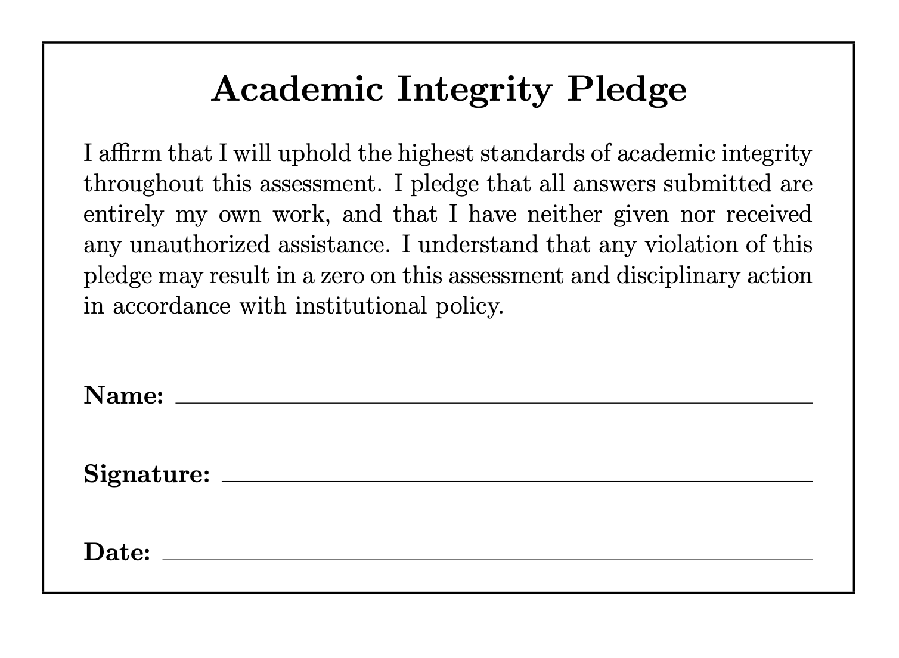
MARKS:

DURATION: 3 HOURS

…………../100

This Exam paper is composed of thirty (22) questions distributed to three Sections (A, B, C). Follow the instructions given below, and answer the indicated questions in each section for a total of 100 marks

Section A: Ten(10) questions, all are compulsory 40 marks
Section B: Ten(10) questions, all are compulsory 20 marks
Section C: Practical questions(2) is compulsory 40 marks

Allowed Materials: Blue pen and Pencil

NB: Computers are not allowed. If you use them, you will receive a score of zero.
Instructions to students:

SECTION A: Answer all questions(30 Marks)
___________________________________________________________________________
Instructions:
- Answer all questions.
- Show clear explanations.

1. Which of the following methods is most true for installing Bootstrap in your web project? (2 marks)

Downloading Bootstrap files and including them in your project

Using a CDN link in your HTML file

Installing via npm or yarn

All of the above

2. Choose CSS frameworks in the below list: (3 marks)

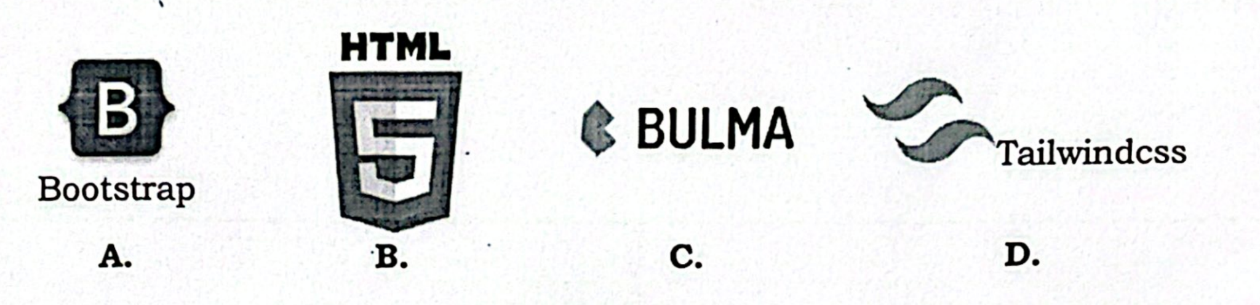

3.What is the primary purpose of containers in Bootstrap? (2 marks)

To add padding and margin to elements

To create fixed-width or responsive layouts

To style text and images

To include JavaScript functionality

4.Bootstrap provides THREE (3) types of containers. What are their class names? (3marks)

5. True or False. The default container is a responsive, fixed-width element that adjusts its max-width at each breakpoint. (1mark)

6. Refer to below code snippet to answer related questions

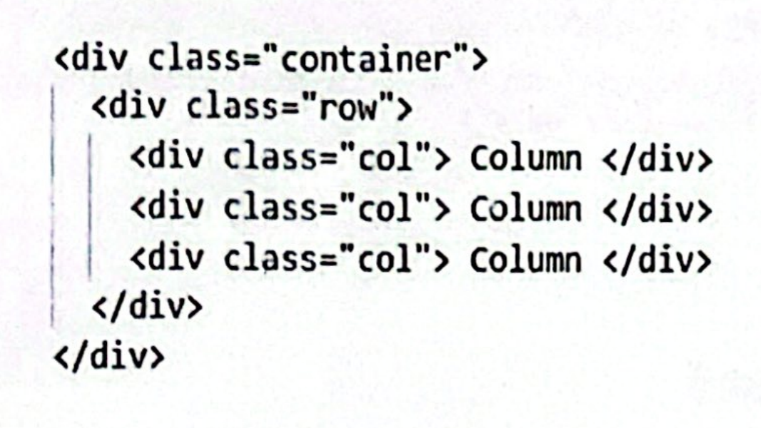

The above example creates three equal-width columns across all devices and viewports using our predefined grid classes. Write corresponding bootstrap classes for:

Second column to extend its width depending on available column contents, irrespective to device screen width type (2marks)

On only small screens (576px and up), the last column to occupy available container width and the first and second columns to stay of equal width. (3marks)

7. Refer to the code snippet provided in question 6. above, write a predefined bootstrap class:

To turn the first column background color to green (2marks)

To add space around only contents of the last column (2marks)

To remove space around only contents of the second column (2marks)

8. Fill the blank with corresponding class prefix (4marks)

Six default grid tiers | Breakpoint | Container max-width | Class prefix
Extra small (xs) | <576px | None (auto)
Small (sm) | ≥576px | 540px | .col-sm-
Medium (md) | ≥768px | 720px
Large (lg) | ≥992px | 960px
Extra large (xl) | ≥1200px | 1140px
Extra extra large (xxl) | ≥1400px | 1320px | .col-xxl-

9.Interpret below script before you answer related questions

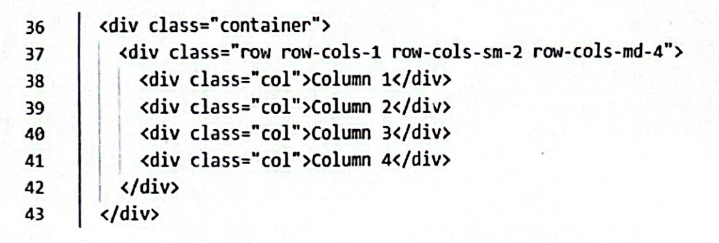

Draw what will happen on:

Extra small (xs) devices displaying the above webpage part (2marks)

Small (sm) devices displaying the above webpage part (2marks)

Medium (md) devices displaying the above webpage part (2marks)

10. Answer the following questions:

Write a CSS selector that targets only the list items (<li>) inside the element with id services. (3 marks)

Mention three semantic HTML5 elements and state their use. (3 marks)

What is the purpose of the alt attribute on images? Give two cases where it should not be empty. (2 marks)

SECTION B: ANSWER ALL QUESTIONS (20 Marks)
___________________________________________________________________________
Instructions:
Choose the most correct answer.
Each question = 2 marks
Total = 10 × 2 = 20 Marks

1. What is the main purpose of responsive web design?

A. To make a website adapt to different screen sizes and devices
B. To increase website animation effects
C. To create separate websites for each device
D. To remove CSS from the website

2. Which HTML tag is required for proper responsive behavior on mobile devices?

A. <meta charset="UTF-8">
B. <meta name="author">
C. <meta name="viewport" content="width=device-width, initial-scale=1.0">
D. <link rel="icon">

3. Why is a mobile-first approach recommended in modern web development?

A. It eliminates the need for CSS
B. It prioritizes essential content and improves performance
C. It works only on desktop
D. It avoids using frameworks

4. What happens when box-sizing: border-box; is applied to an element?

A. Padding and border are included in the element’s total width and height
B. The element becomes responsive automatically
C. Margins are removed
D. The element doubles in size

5. Which Bootstrap class makes a column take full width on small screens and half width on medium screens?

A. col-md-12 col-sm-6
B. col-6 col-md-12
C. col-sm-12 col-md-6
D. col-lg-6 col-sm-6

6. You want to hide an element on small devices but display it on medium and larger devices. Which class is correct?

A. d-block d-sm-none
B. d-none d-md-block
C. d-md-none d-lg-block
D. d-inline d-sm-block

7. A Bootstrap row contains three columns each with col-md-4. How will they appear on medium screens?

A. One column per row
B. Two columns per row
C. All three columns in one row
D. They will overflow

8. A website layout breaks when resized because fixed pixel widths are used instead of percentages or grid classes. What is the main problem?

A. Too many images
B. Lack of JavaScript
C. Poor use of semantic HTML
D. Not using flexible layout techniques

9. A startup needs to quickly build a professional website using ready-made components like cards and navigation bars. Which option is most suitable?

A. Bootstrap framework
B. Writing only custom CSS
C. Inline styling
D. Removing responsiveness

10. A company wants maximum design flexibility and prefers utility-based styling instead of predefined components. Which framework should they choose?

A. Plain HTML only
B. Bootstrap
C. Tailwind CSS
D. jQuery

SECTION C: PRACTICAL ASSESSMENT (40 Marks)
___________________________________________________________________________
- Answer all questions
1. Using only bootstrap, write code to create the following form layout. The form should be fully responsive and adapt gracefully to all screen sizes and devices.
(20 marks)
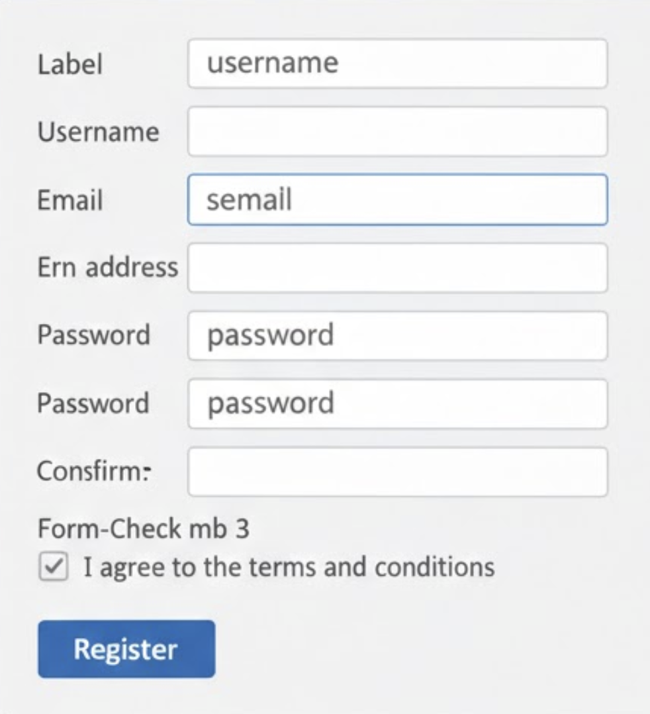
2. Using tailwindcss, write code to create the following form layout. The form should be fully responsive and adapt gracefully to all screen sizes and devices. (20 marks)
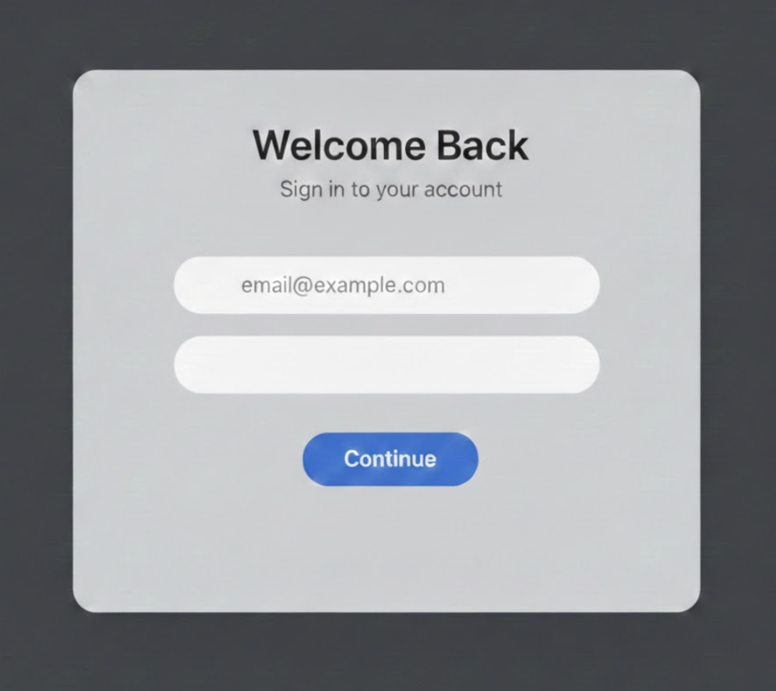

→ Put answers on additional papers

