**NAME:NIYONSENGA Javan**

**Reg:21rp00855**

1. **Client Registration Form:** I created an HTML form for clients to register with their name, phone number, email, and password. It's designed with Bootstrap for a clean and responsive layout.
2. 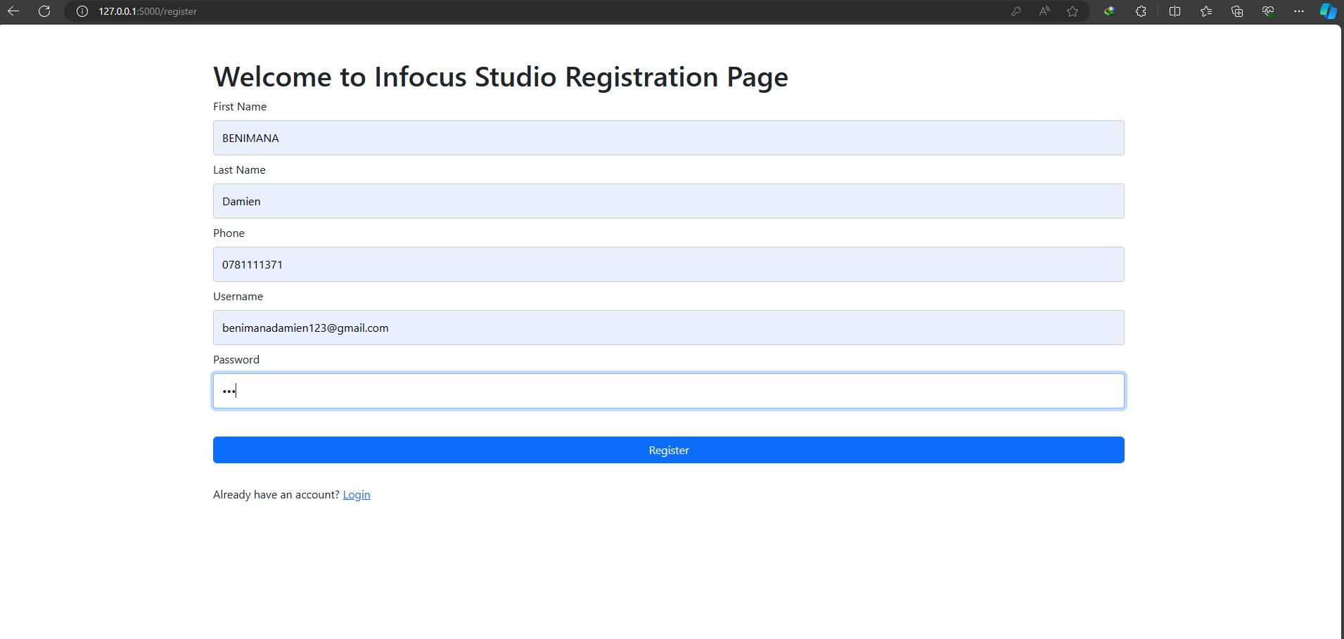

**Login and Logout Functionality:** I created a login form where users can input their username and password to access the system. Additionally, I included a link to the registration page for new users. The page utilizes Bootstrap for styling .

1. 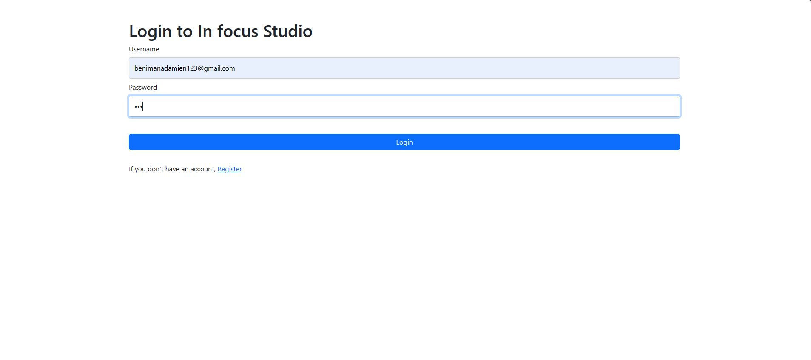

**Ordering Photography and Videography Services**: I designed a webpage where logged-in users can order photography or videography services. It includes fields for selecting the service, price, and date. The page also provides a note about service pricing and uses dynamic dropdowns for service selection.

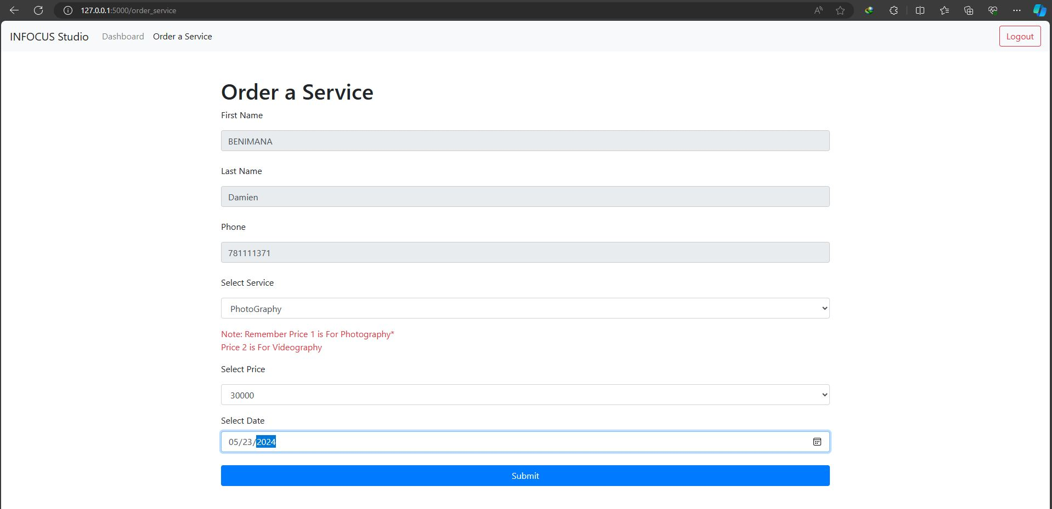

This design presents a dashboard for users logged into the Infocus Studio system:

- Navigation Bar: The navigation bar includes the Infocus Studio logo and links to the Dashboard (currently active) and the Order a Service page. It also provides a logout button for users to log out of the system.

- Dashboard Content: The dashboard container displays a welcome message with the user's username, followed by a brief welcome message to the Infocus Studio system. It lists the available services offered by the studio, including Photography and Videography, in a clean and organized manner.

