IPsec设计文档

IPsec之SPD

SPD介绍
安全策略（Security Policy，简写为SP）：定义对满足条件IP报文进行安全处理的规则。安全策略是用来识别一个数据包是应该处理、忽略、还是应该丢弃。
这些规则用来定义哪些流量需要走IPSec。这些信息有目的端IP、来源端IP、只执行AH 或ESP、同时执行AH 及ESP、目的端Port、来源端Port、走Transport 或Tunnel 模式。
安全策略数据库（Security PolicyDatabase，简写为SPDB）：存放所有本机安全策略的集合。

SPD在报文流里的作用
IPsec模块向IP层注册钩子函数，钩子函数的入参是mbuf
所有的向外发送的报文，当走到IP层时，会被钩子函数取走，此处是被IPsec模块的钩子取走，用安全策略是来识别这个数据包是应该处理、忽略、还是应该丢弃。

automake 的安装
sudo apt install autoconf

IPsec之特性总结

窗口特性

默认是 默认语言，选择UTF8设置即可

Xs
xs

交叉编译器安装

在/usr/local/下建立交叉编译器的安装目录arm：
steven@steven-desktop:/usr/local$ sudo mkdir arm

将下载的交叉编译器包解压到/usr/local/arm目录下：
steven@steven-desktop:~/work$ sudo tar zxf arm-linux-4.4.1.tar.gz -C /usr/local/arm/

解压成功后，修改PATH环境变量目录下
steven@steven-desktop:~$ vi .bashrc

export PATH=$PATH:/usr/local/arm/4.4.1/bin

检测是否安装成功
steven@steven-desktop:~$ whereis arm-linux-gcc
arm-linux-gcc: /usr/local/arm/4.4.1/bin/arm-linux-gcc

strongswan

strongswan编译
带gdb版本
steven@ubuntu:~/study/strongswan-5.6.2$ ./configure CFLAGS="-g -O0"

命令执行

Ipsec start
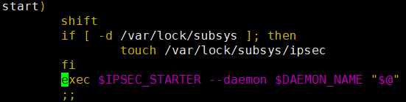
IPSEC_STARTER = /usr/local/libexec/ipsec/starter
DAEMON_NAME = charon

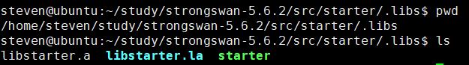

steven@ubuntu:~/study/strongswan-5.6.2/src/libcharon$ sudo ipsec up home
/usr/local/libexec/ipsec/stroke up home
对应
/home/steven/study/strongswan-5.6.2/src/stroke/.libs/stroke

starter分析

Main.c
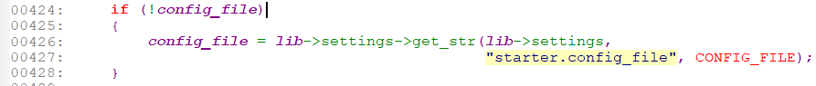

(gdb) p config_file
$5 = 0x40f5da "/usr/local/etc/ipsec.conf"
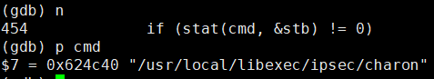

Main.c

(gdb) bt
#0 build_i (this=0x7fffd0000f60, message=0x7fffd0002020) at sa/ikev2/tasks/ike_init.c:537
#1 0x00007ffff791ae71 in initiate (this=0x7fffd0001310) at sa/ikev2/task_manager_v2.c:635
#2 0x00007ffff78ef96b in initiate_execute (job=0x7fffcc001060) at control/controller.c:469
#3 0x00007ffff7ba346b in process_job (worker=0x6414a0, this=0x6075a0) at processing/processor.c:235
#4 process_jobs (worker=0x6414a0) at processing/processor.c:321
#5 0x00007ffff7bb4c4b in thread_main (this=0x6414d0) at threading/thread.c:331
#6 0x00007ffff76c56ba in start_thread (arg=0x7fffeea67700) at pthread_create.c:333
#7 0x00007ffff73fb41d in clone () at ../sysdeps/unix/sysv/linux/x86_64/clone.S:109

charon分析

调试步骤
sudo ./src/starter/.libs/starter --nofork --attach-gdb

Breakpoint 1, thread_create (main=main@entry=0x7ffff7ba3280 <process_jobs>, arg=arg@entry=0x60e2c0) at threading/thread.c:344
344 this->main = main;
(gdb) bt
#0 thread_create (main=main@entry=0x7ffff7ba3280 <process_jobs>, arg=arg@entry=0x60e2c0) at threading/thread.c:344
#1 0x00007ffff7ba315d in set_threads (this=0x6075a0, count=16) at processing/processor.c:453
#2 0x00007ffff78f1053 in start (this=<optimized out>) at daemon.c:817
#3 0x0000000000401d00 in main (argc=1, argv=<optimized out>) at charon.c:443

stroke分析

调试步骤
ipsec up home 与下面等价
steven@ubuntu:~/study/strongswan-5.6.2$ sudo ./src/stroke/.libs/stroke up home
steven@ubuntu:~/study/strongswan-5.6.2/src/stroke/.libs$ gdb --args stroke up home

代码流程
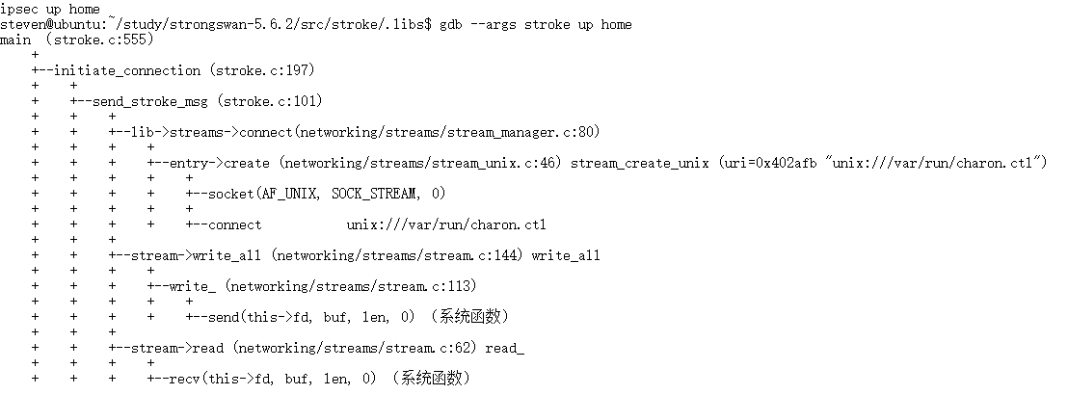

IPSEC 与IKE接口

Kernel acquire 消息
流量满足内核里SP策略，内核通过netlink消息通知用户态IKE
在 IPsec VPN 网关设计中 Netlink 应用实例为进一步说明 Netlink 消息通信机制在 IPsec VPN 网关中所起的作用，下面给出其设计中的Netlink 应用实例。VPN 网关接收到内网向外发送的 IP 包后，首先判断其合法性，然后对其进行 IPsec 安全处理，并转发到目的地址所在的安全网关。本实例中假设 IP 包的对应 SA 未建立，必须新建 SA。网关的具体处 理过程如下：
- 接收到 IP 数据包后，判断合法性，并根据 该包的目的地址、源地址、端口等信息检索 SPD，查找对应安全策略，决定丢弃、忽略或 IPsec 处理，若 为 IPsec 处理则转（2）；
- 根据对应安全策略的 SPI 等信息检索 SAD，未找到对应的 SA；
- 内核 IPsec 调用消息构造模块构造类型为 建立SA 请求（XFRM_MSG_ACQUIRE）的 Netlink 消 息，并通过 Netlink 机制发送到应用层 IKE 密钥管 理进程。密钥管理进程通过动态密钥交换机制与对 方 VPN 网关协商新 SA；
- 协商完成后，密钥管理进程构造类型为新 建 SA 消息（XFRM_MSG_NEWSA），通过设计的 Netlink 应用侧接口将新 SA 发送到内核；
- 内核 IPsec 模块将新建的 SA 应用于相应 的 IP 数据包传送，对数据包进行 IPsec 发送处理。

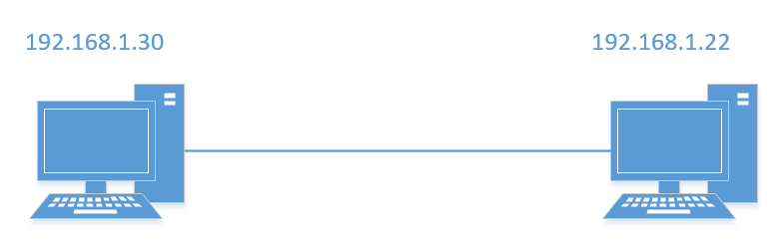

Strongswan 配置：auto=route流量解发IKE协商
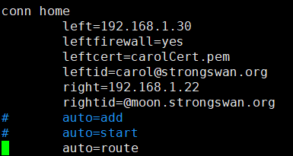

steven@ubuntu:~$ sudo ip xfrm policy
src 192.168.1.30/32 dst 192.168.1.22/32
dir out priority 367232
tmpl src 192.168.1.30 dst 192.168.1.22
proto esp reqid 1 mode tunnel
src 192.168.1.22/32 dst 192.168.1.30/32
dir fwd priority 367232
tmpl src 192.168.1.22 dst 192.168.1.30
proto esp reqid 1 mode tunnel
src 192.168.1.22/32 dst 192.168.1.30/32
dir in priority 367232
tmpl src 192.168.1.22 dst 192.168.1.30
proto esp reqid 1 mode tunnel

在PC(192.168.1.30)上ping 192.168.1.22 会触发netlink的XFRM_MSG_ACQUIRE（23）消息
Netlink Message Header
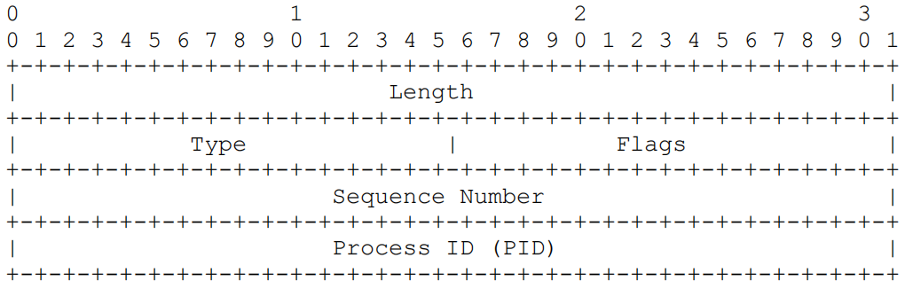
struct nlmsghdr {
__u32 nlmsg_len; /* Length of message including header */
__u16 nlmsg_type; /* Message content */
__u16 nlmsg_flags; /* Additional flags */
__u32 nlmsg_seq; /* Sequence number */
__u32 nlmsg_pid; /* Sending process port ID */
};

(gdb) p hdr
$1 = (struct nlmsghdr *) 0x7fffeda649b0
(gdb) p *hdr
$2 = {nlmsg_len = 364, nlmsg_type = 23, nlmsg_flags = 0, nlmsg_seq = 0, nlmsg_pid = 0}

(gdb) p acquire
$8 = (struct xfrm_user_acquire *) 0x7ffff02699c0
(gdb) p/x *acquire
$9 = {id = {daddr = {a4 = 0x1601a8c0, a6 = {0x1601a8c0, 0x0, 0x0, 0x0}}, spi = 0x0, proto = 0x32}, saddr = {a4 = 0x1e01a8c0, a6 = {0x1e01a8c0, 0x0, 0x0, 0x0}}, sel = {
daddr = {a4 = 0x1601a8c0, a6 = {0x1601a8c0, 0x0, 0x0, 0x0}}, saddr = {a4 = 0x1e01a8c0, a6 = {0x1e01a8c0, 0x0, 0x0, 0x0}}, dport = 0x104, dport_mask = 0xffff,
sport = 0xde98, sport_mask = 0xffff, family = 0x2, prefixlen_d = 0x20, prefixlen_s = 0x20, proto = 0x11, ifindex = 0x2, user = 0x0}, policy = {sel = {daddr = {
a4 = 0x1601a8c0, a6 = {0x1601a8c0, 0x0, 0x0, 0x0}}, saddr = {a4 = 0x1e01a8c0, a6 = {0x1e01a8c0, 0x0, 0x0, 0x0}}, dport = 0x0, dport_mask = 0x0, sport = 0x0,
sport_mask = 0x0, family = 0x2, prefixlen_d = 0x20, prefixlen_s = 0x20, proto = 0x0, ifindex = 0x0, user = 0x0}, lft = {soft_byte_limit = 0xffffffffffffffff,
hard_byte_limit = 0xffffffffffffffff, soft_packet_limit = 0xffffffffffffffff, hard_packet_limit = 0xffffffffffffffff, soft_add_expires_seconds = 0x0,
hard_add_expires_seconds = 0x0, soft_use_expires_seconds = 0x0, hard_use_expires_seconds = 0x0}, curlft = {bytes = 0x0, packets = 0x0, add_time = 0x5e7c5cd3,
use_time = 0x0}, priority = 0x59a80, index = 0x101, dir = 0x1, action = 0x0, flags = 0x0, share = 0x0}, aalgos = 0xffffffff, ealgos = 0xffffffff,
calgos = 0xffffffff, seq = 0xa}

https://www.jianshu.com/p/389a8870a51d
steven@ubuntu:~/study/test$ vi if_name_index.c
steven@ubuntu:~/study/test$ gcc if_name_index.c -o if_name_index
steven@ubuntu:~/study/test$ ./if_name_index
Interfece 1 : lo
Interfece 2 : ens33

reqid struct xfrm_user_tmpl* tmpl; tmpl->reqid
Traffic select struct xfrm_user_acquire *acquire;
src_ts = selector2ts(&acquire->sel, TRUE);
dst_ts = selector2ts(&acquire->sel, FALSE);

install policy 消息

配置

IKE 配置

IKE cfg
Proposal

