## Introduction

1. The application runs on .Net Core 3.0
2. After built solution, please run application ‘Epam.Demo.App.GrpcServer.exe’ first, 2nd run client ‘Epam.Demo.App.ConsoleClient.exe’
3. For demonstration, I have created a simple unit test project named ‘Epam.Demo.Service.Default.Test’
4. As you known, 1000 people have 1000 ideas, as my experience, Repository pattern that for combining multiple data source, like sharding, routing, so here the Repository pattern might not be the same as what you know.
5. To express the different meanings that the User Object represents in different layers, I made some differences to User Object in different layer.
6. You can clone from ‘https://github.com/niyouzhu/Epam.Demo.git’

## Problems

1. The comments are missing, such as summary of classes, methods, parameters, exceptions…
2. I want to realize an interceptor to intercept Repository that can easily use to retry if failure, but workload is relatively large, so it has not been realized yet, just use the for() loop to demonstrate.
3. About the solution, there is still a lot to perfect.

## Class Diagram

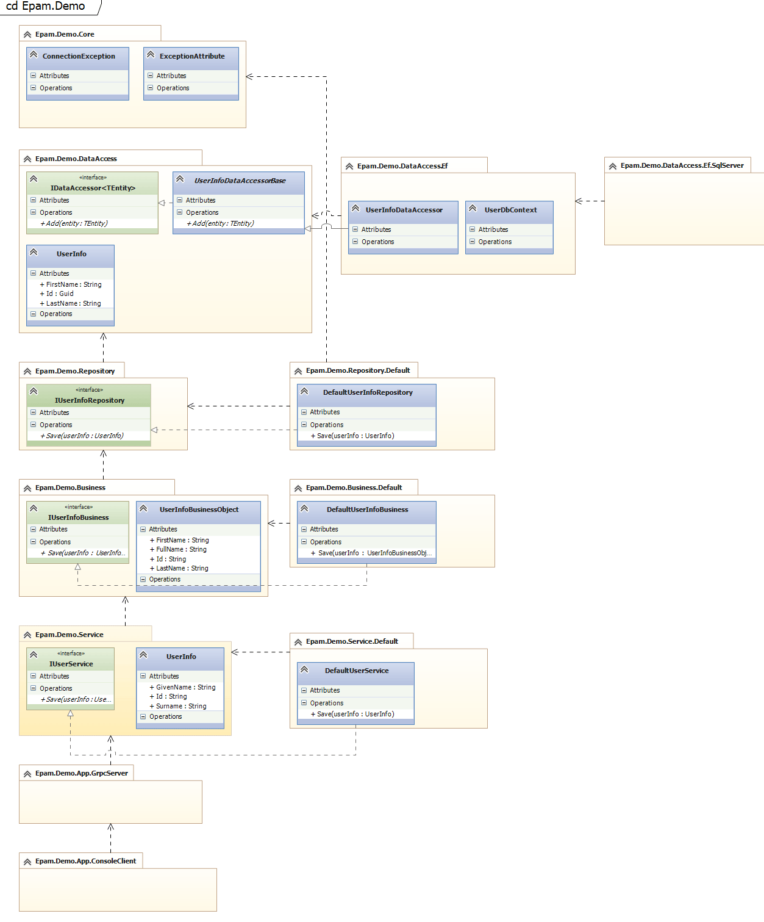

## Application Screenshots

### Client

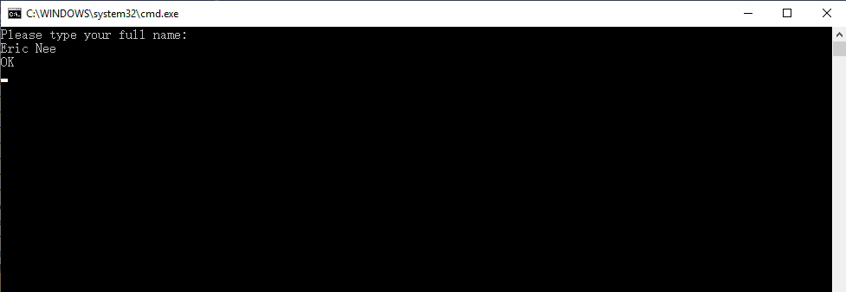

### Server

