

## PROJECT REPORT

**On**

**Budget Management System**

**By**

| **Urmi Vyas** | **22SOECA21057** | **MCA** | **SEM-2** |
| --- | --- | --- | --- |
| Insiya Maldeviwala | 22SOECA21034 | MCA | SEM-2 |
| Niyati Joshi | 22SOECA21023 | MCA | SEM-2 |
| Dipti Joliya | 22SOECA21022 | MCA | SEM-2 |

# **Index**

| 1. | Introduction |
| --- | --- |
| 2. | Purpose |
| 3. | Document convention |
| 4. | Project scope |
| 5. | References |
| 6. | Application features |
| 7. | Operating Enviroment |
| 8. | Flow of project |
| 9. | Flow chart |
| 10. | Use case diagram |

| NAME | DATE | WORK DISTRIBUTION |
| --- | --- | --- |
| All |  | Find 5 definations |
| All |  | Project defination analysis |
| Urmi Vyas |  | Required Hardwer-Software. |
| Insiya Maldeviwala |  | Scop of Project, Current Problem. |
| Dipti Joliya |  | Similar Application,Functionality. |
| Niyati Joshi |  | Explore Project, Introduction of Project |
| Niyati joshi |  | Flow Chart |
| Dipti Joliya |  | Database(create registration table ) |
| Urmi vyas |  | ER diagram,  designing. |
|  |  |  |

* **Introduction & Purpose of the Project:**
* A budget management app is a digital tool designed to help individuals or businesses manage their finances more effectively.
* With this app, users can track their income, expenses, and savings goals in one centralized location.
* The app usually provides various features like automatic categorization of expenses, setting up a budget, tracking bills.
* Using a budget management app is an effective way to take control of one's finances and achieve financial goals.
* It eliminates the need for manual tracking, provides real-time insights into spending patterns, and helps users make informed financial decisions.
* **Document Conventions:**

The main heading for software requirements specification, application name, version number, prepared by, organization and date are written in right handed alignment.

Apart from this, the entire document for software requirements

Convention for Main title:

* Font face: Times New Roman
* Font style: Bold
* Font size:22

32 Convention for Sub title:

* Font face: Times New Roman
* Font style: Bold
* Font size:18

Convention for Body:

* Font face: Arial
* Font style: Regular
* Font Size: 11

* Intended Audience and Reading Suggestions

The document is intended for all the stakeholder customers and the developers

–designers,coders, testers and maintainers. The reader is assumed to have basic knowledge of MobileOS, and user accounting along with knowledge and understanding of DFDs and various other diagrams such as Use case diagrams, activity diagrams and ER diagrams.User must understand the flow of the applications and various redirections too.

* **Scope of the project:**
* It will have various options to keep record (for example Food, Travelling Fuel, Salary etc.)
* In today’s busy and expensive life, we are in a great rush to make moneys, but at the end of the month we broke off. As we are unknowingly spending money on title and unwanted things. So, we have come over with the plan to follow our profit.
* Here user can define their own categories for expense type like food, clothing, rent and bills where they have to enter the money that has been spend and likewise can add some data in extra data to indicate the expense.
* This application used by housewifes ,students ,hostel-student.
* The main purpose of this application is store a our day to day use and to keep record our expenses.
* **References:**

**f**or our application development as well as for the preparation of the software requirements specifications, we took various references from various websites and even a reference of an existing application is taken into consideration. The websites which we refer are as follows:

[www.you-tube.com](http://www.you-tube.com/)

We use this website to solve some error and other some tutorials for effects.

[www.androiddevelopers.com](http://www.androiddevelopers.com/)

We use this search engine solve dependency and others libraries.

There are several budget management apps available, here are some popular ones:

* Money Lover
* Wallet
* My Money
* 21 Days Challenge

* **Functionalities:**
* Login/Register

To access the functionality of an application user must have their account.

* Set Total Balance

User can set their total balance which will be updated and deducted after recording an expenses.

* Record your expenses

User can enter their expense with fields as – Expense Name , Amount and Date

Shows detailed report of your expense date-wise

User can view the report of all the expenses done at specific date

* **E-R Diagram**:-
* **Flow Chart:**

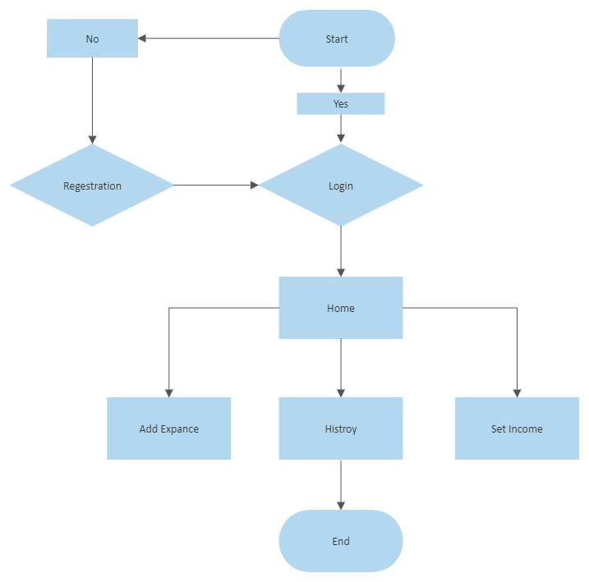

* **Design of Project:**

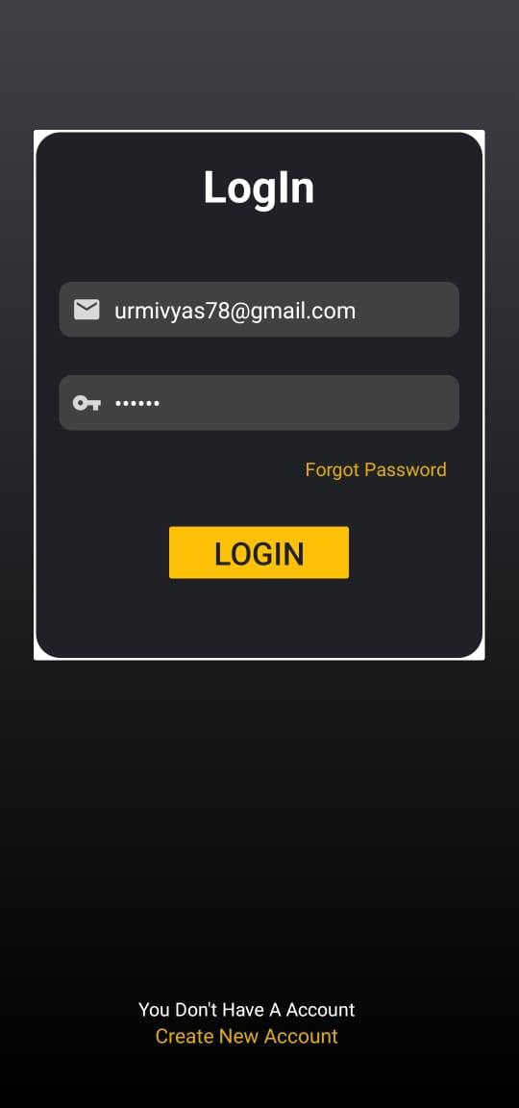

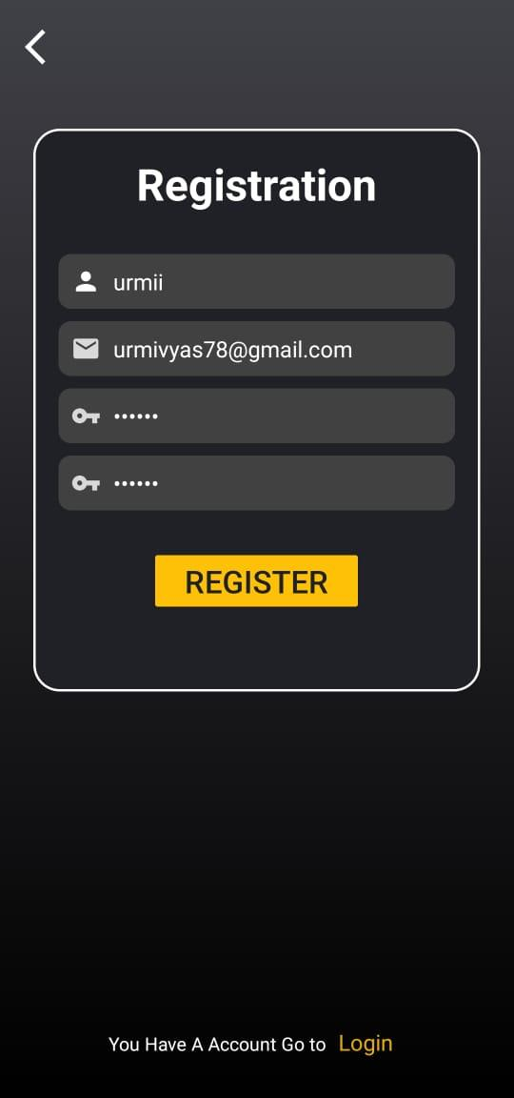

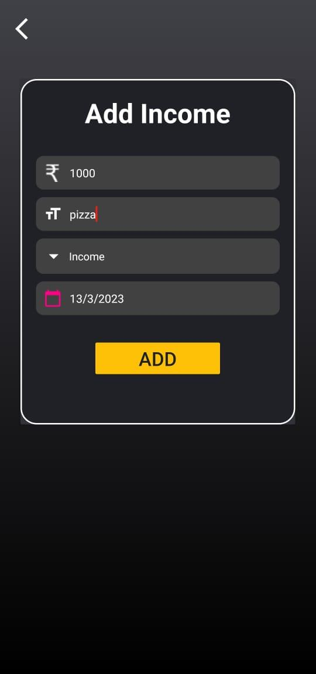

Home Page:

