Business Requirements Document

Coupa S2P Implementation – Sourcing Management

Prepared by: SoluGrowth PSA
Date: 7 January 2026
Version: V2.0

Table of Contents
1 Document Management and VERSIONING 4
1.1 Document Details 4
1.2 Revision History 4
1.3 Abbreviations used in the Document 4
2 Sourcing Process Overview 5
2.1 Key Features 5
2.2 Roles and Responsibilities 5
3 Purpose 7
4 Scope 8
5 Objectives 9
6 Sourcing Process Design 10
7 Sourcing Event (RFx) Process Workflow 11
8 Auction Process 29
9 Savings Definition Sourcing 33
9.1 Sourcing Settings and Configurations (Coupa Admin Tasks) 33
9.2 Sourcing Configuration (Coupa Admin Tasks) 35
10 UAT scenarios (Business scenarios) 36
11 Acknowledgment and Signature 38
11.1 Process Owners 38
11.2 Document Reviewers 38
11.3 Signatures 38

Document Management and VERSIONING

Document Details
Document Title | Business Requirements Document – Sourcing Management
Department | <Procurement Dept name>
 | Name | Date | Signature
Prepared by | Leroy Vieira | 17-11-2025
Reviewed by | <Reviewer’s name> | <DD-MM-YYYY>
Document status | Draft ☒ Reviewing ☐ Approved ☐

Revision History
Version | Revision Date | Revised By | Description of Revision
1.0 | 17-11-2025 | Dhawal Patodi | Initial draft version
1.1 | 07-01-2026 | Leroy Vieira
1.2

Abbreviations used in the Document
Abbreviations | Full Form
CSP | Coupa Supplier Portal
LOA | Limits of Authority
OTP | One Time Password
PR | Purchase Requisition
RFI | Request for Information
RFP | Request for Proposal
RFQ | Request for Quotation
T&C | Terms and Conditions

Sourcing Process Overview
Coupa Sourcing is a powerful, cloud-based solution designed to streamline, automate, and optimize the end-to-end sourcing process. It enables organizations to manage sourcing events more efficiently, drive cost savings, improve supplier collaboration, and enhance overall transparency and compliance. The platform supports strategic sourcing initiatives by offering a structured and user-friendly interface for managing bids, evaluating suppliers, and awarding contracts.

Below are the key features and capabilities of Coupa Sourcing that contribute to a more effective procurement strategy.

Key Features
Event Management:
Coupa Sourcing enables the creation and efficient management of various sourcing events such as RFIs, RFQs, and RFPs. It offers customizable templates tailored to several types of sourcing activities, promoting consistency, and reducing setup time. Automated workflows and real-time notifications ensure that all stakeholders remain informed and engaged throughout the sourcing event lifecycle, improving overall coordination and accountability.

Supplier Collaboration:
The platform provides robust tools for real-time communication and seamless collaboration with suppliers. A dedicated supplier self-service portal allows for easy submission of bids and responses, simplifying participation. Additionally, Coupa supports automated scoring and evaluation of supplier responses, enabling the sourcing team to identify the best value proposals based on pre-defined criteria.
Reporting:
Advanced reporting capabilities offer actionable insights into sourcing events, supplier performance, and spend data. These analytics help organizations make informed decisions, monitor sourcing effectiveness, and continuously improve sourcing strategies.

Roles and Responsibilities
Below are details description of the steps carried out by responsible actors:
S. No. | Roles | Activity
1 | Procurement Admin (Buyer) / Sourcing Advisor/ Specialist | - Create and manage sourcing events  - Convert a Purchase Requisition (PR) into a sourcing event  - Assign and manage suppliers for the event  - Review award approval workflows as per LOA  - Onboard new suppliers  - Configure evaluation settings and assign evaluation teams  - Convert the awarded sourcing event back into a PR
2 | Supplier (External) | - Submit responses to sourcing events via the Coupa email link or through the Coupa Supplier Portal (CSP)
3 | Business Evaluators | - Business can evaluate the supplier responses via Coupa
4 | Procurement Manager + Sourcing LOA | - Review and approve sourcing events and award decisions. Non centre managed sourcing events to be approved by BU Procurement Head

Purpose
The purpose of this document is to define the business requirements for implementing the Sourcing Management module within Coupa S2P for AECI.

This BPD outlines the future-state sourcing processes, system behaviors, roles, approvals, and configuration requirements required to support sourcing activities such as RFIs, RFQs, RFPs, and Auctions within Coupa.

The document serves as a single reference point for business stakeholders, procurement teams, and implementation partners to ensure a shared understanding of how sourcing activities will be executed, governed, and controlled in Coupa. It also provides the basis for system configuration, testing, and user acceptance.

Scope
This document covers sourcing activities performed in Coupa, including but not limited to:
- Strategic and operational sourcing processes.
- Creation and management of sourcing events (RFI, RFQ, RFP).
- Auction-based sourcing (English reverse auctions).
- Supplier participation via email (which will contain CSP link to redirect and participate in sourcing event) and the Coupa Supplier Portal (CSP).
- Event configuration, timelines, evaluations, scoring, and award decisions.
- Approval workflows aligned with Limits of Authority (DOA / LOA).
- Follow-on events, event extensions, and resend-to-production scenarios.
- Savings tracking (planned, negotiated, cost avoidance).
- Relevant sourcing-related system settings and administrative configurations.
- Business scenarios for UAT validation.

Objectives
The key objectives of this document are to:
- Standardize sourcing processes across AECI using Coupa as the single sourcing platform.
- Enable transparent, auditable, and compliant sourcing aligned with governance and approval policies.
- Improve efficiency through structured event creation, supplier collaboration, and automated workflows.
- Support fair and competitive supplier evaluations through defined scoring and evaluation mechanisms.
- Ensure clarity on roles, responsibilities, and system interactions across business, procurement, and suppliers.
- Provide clear functional requirements to support system configuration, testing, and user adoption.
- Establish a controlled and scalable sourcing framework that supports both strategic and operational needs.

Sourcing Process Design
Coupa Sourcing offers two main types of events, which may be run separately, to collect information and prices, and auction type events for competitive bidding.

The process below outlines the two different types of sourcing processes.
Strategic Sourcing
Strategic sourcing focuses on sustainable value creation and supplier relationship management. It involves planned sourcing events aimed at achieving cost optimization, risk mitigation, and quality improvement. Strategic sourcing events are conducted for all requests valued >R1m (South Africa) and $x (ROW)
In Coupa, strategic sourcing typically starts as a standalone sourcing event, independent of any purchase request.
Strategic Sourcing – Responsible Roles
Strategic sourcing activities are led by Category Managers / Procurement team for centre-managed commodities and services. These events are initiated and managed by Procurement Admins (Buyers) in Coupa, with evaluations supported by designated Business Evaluators and approvals governed by the applicable Limits of Authority (LOA).
Operational Sourcing
Operational sourcing addresses immediate or transactional procurement needs. It is often triggered by an existing purchase requirement and emphasizes speed and efficiency over strategic objectives. In Coupa, operational sourcing starts from a purchase request that can be “flipped” into a sourcing event to streamline supplier engagement and ensure competitive pricing.
Aspect | Category/Strategic Sourcing | Operational Sourcing
Objective | Sustainable value, cost optimization, risk management | Immediate procurement, efficiency, transactional savings
Initiation | Standalone sourcing event | From an existing Purchase Request  Standalone sourcing event
Focus | Supplier relationships, market intelligence, contract terms, risk mitigation | Quick execution, fulfilment of specific requirements, transactional sourcing
Typical Horizon | Medium to long-term | Short-term, transactional
Typical Value | >R1m (SA), >$0,5m (ROW) | <R1m (SA), <$0,5m (ROW)

In Coupa sourcing module, users can conduct two types of events –
- RFx (RFI, RFP, RFQ)
- Auctions (English reverse auction, Dutch reverse auction, Japanese reverse auction)
Note : In Coupa, both strategic and operational sourcing can be initiated from a PR or as a standalone sourcing event (without a PR).

Sourcing Event (RFx) Process Workflow
The following section provides a comprehensive and detailed explanation of each step illustrated in the corresponding process diagram on every page. This structured approach is intended to enhance clarity, support better understanding of the workflow, and offer meaningful context to stakeholders reviewing the process design. Each description aligns with the visual representation to ensure consistency and facilitate informed decision-making.

Fig 7 Sourcing Workflow

S. No. | Activity | Description
7.1 | Create Sourcing Request Form | The Requester can initiate a Sourcing Request Form from home screen. All required information must be accurately completed in the form before submitting it to Buyer in accordance with the defined sourcing process.
7.2 | Submit for approval | Once the sourcing request form is completed by the Requester, the form will be submitted for approval. Once approved, the sourcing event gets created in draft status.
7.3 | Create Sourcing Request via PR | The Requester may initiate a Purchase Request (PR) when they require the buyer to conduct sourcing for specific goods or services. Once the PR is submitted and routed to the procurement team, they can convert the PR into a sourcing event and carry out the subsequent activities. Once converted to a Sourcing event, the PR status will be marked as “Pending Buyer Action”.
7.4 | Create Standalone Sourcing event | Procurement Admin (Buyer) navigates to Sourcing module and selects “Create Event” to create a Sourcing Event.  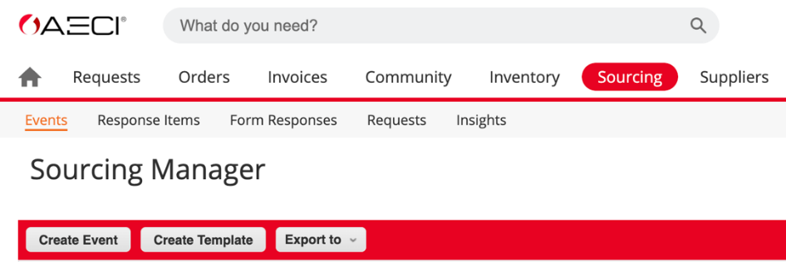
7.5 | Decision | Decision point on how to create the event.  There are 3 ways in which a sourcing event can be initiated. Procurement Admin (Buyer) can also filter specific templates/events by selecting a specific commodity to be procured/sourced.  Create event –  - From scratch, with no prior information.  - From an existing template  - Copying from a previously conducted event.  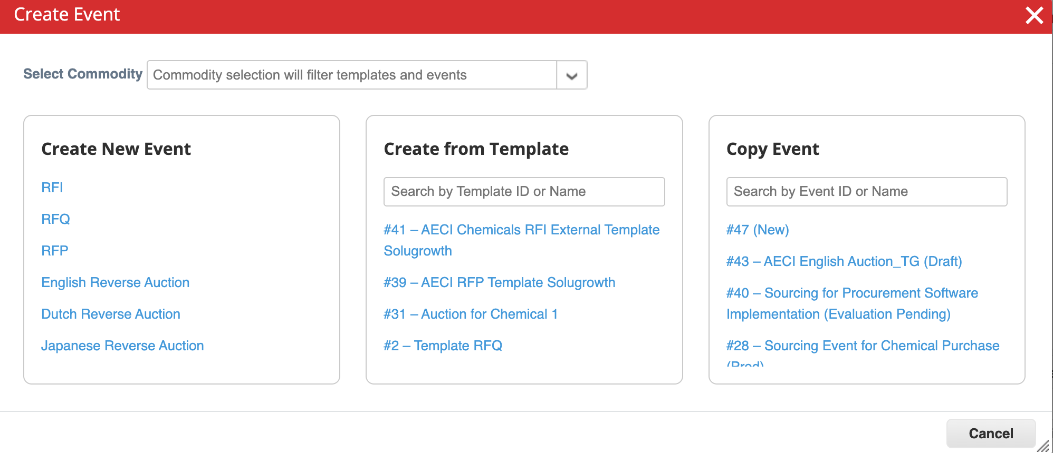  In all the above cases, Procurement Admin (Buyer) must either complete or validate information such as basic settings, timelines, supplier information etc. to create the final sourcing event.
7.6 | Create New Event | Procurement Admin (Buyer) selects 'Create New Event’ and  must complete all the required information to conduct the event.
7.7 | Create From Template | Pre-defined templates can be set up for specific commodities, and these can be updated and validated accordingly depending on the product/service required.
7.8 | Copy from Event | Sourcing event can be duplicated from an existing event.
7.9 | Configure - Event Setting, Event Timelines, Event Details, Add Suppliers, Set Evaluations | Procurement Admin (Buyer) will be able to view multiple sections to complete required sourcing information.  Settings:  Configure event settings  The Settings page is where Procurement Admin (Buyer) can give the sourcing event a name and specify basic information, like event currency, event information, terms and conditions, sourcing team/stakeholders, etc.  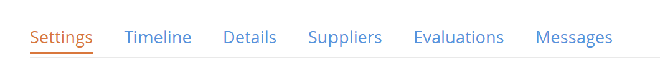  Basic Settings  Under the Basic Settings section, the Procurement Admin (Buyer) is required to fill in the Event Name and Currency.  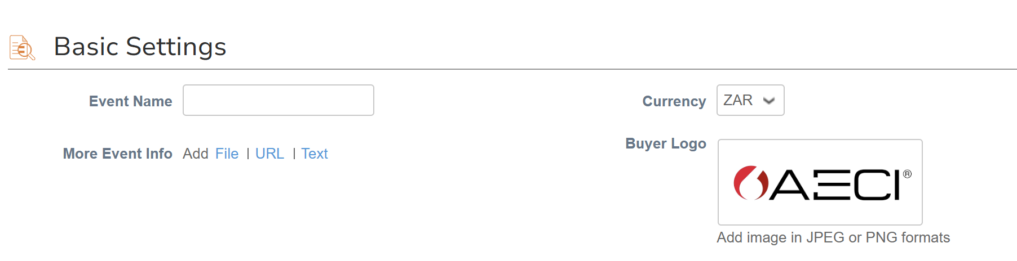  Internal Event Info  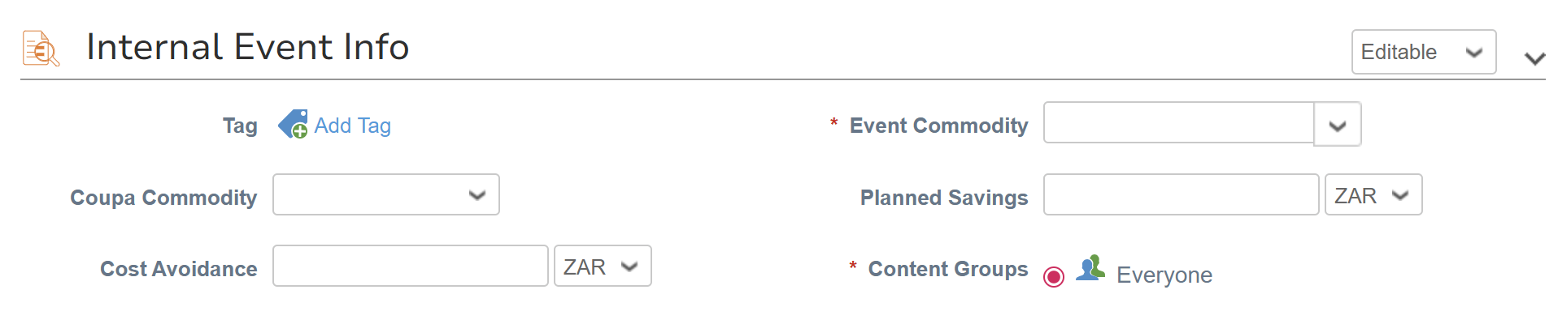Coupa Commodity: Selected from the Coupa commodity list available in pull down menu. Which can be useful during supplier selection from Coupa Community.  Event Commodity: Select from the AECI L3 commodity tree.  Optional:  Cost Avoidance: Cost avoidance value on the event can be entered manually to help track the benefits achieved by the sourcing event.  Planned Savings: Any planned or targeted savings can be manually added here. There is an internal attachment field here if any supporting documents need to be included.  Content Groups:  Event TypeIn the Event Type section, the Procurement Admin (Buyer) can manually select from a variety of options:  RFx stage – In this section, Procurement Admin (Buyer) can define the type of sourcing event being created. (RFI, RFQ, RFP).  E-Auctions - can be added either as a follow-on to a RFx event ‘Auction stage’, or as a stand-alone e-Auction event  Allow multiple responses – This allows the supplier to add multiple responses for the same item.  Hide Supplier responses – This allows the Procurement Admin (Buyer) to either allow or hide the responses from the procurement team. This option would be OFF by default. This setting is also known as sealed bid in Coupa.  Allow suppliers to respond with attachments in Message Centre – This allows the suppliers to add an attachment while communicating on message centre. (For AECI the global setting has been enabled where all the bids will be sealed).  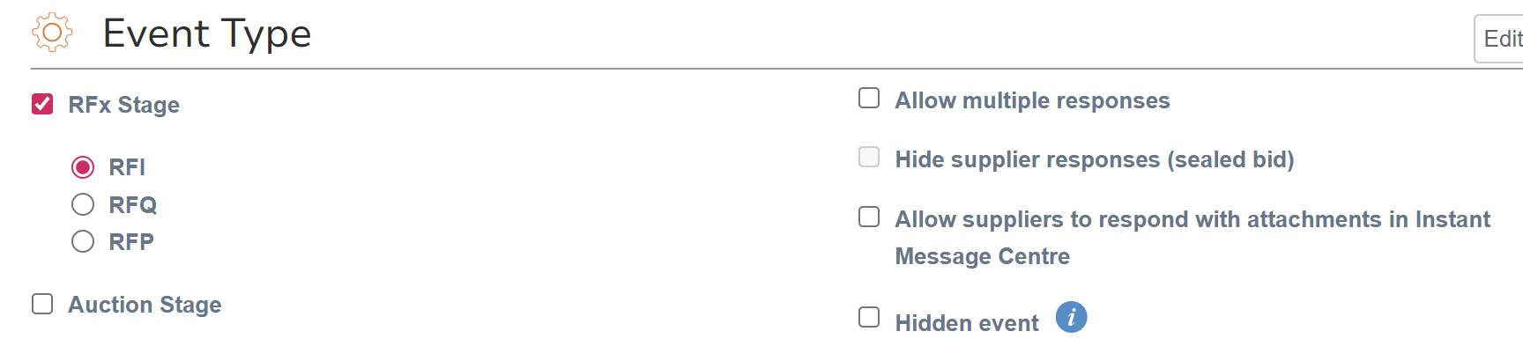  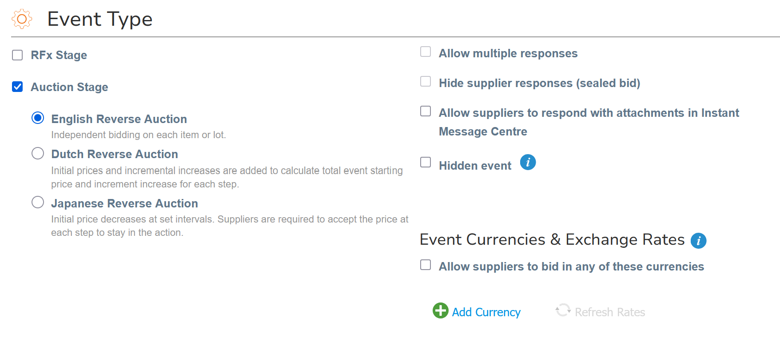  Event currencies and exchange rates  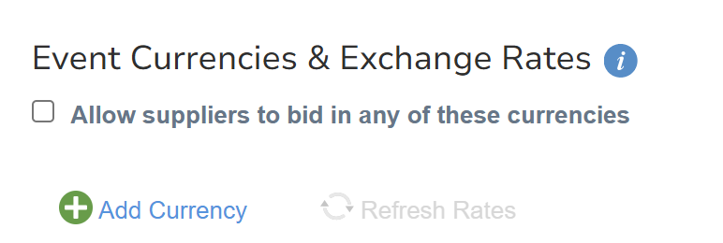 – The Suppliers can bid in different currencies, once you evaluate, you will see the responses in the event currency.  Note: Once the sourcing event is initiated, by default it will be a standard sourcing event. The Procurement Admin (Buyer) however has an option to convert the event into 1 Envelope or 2 Envelope by selecting Unseal manually option.  Terms & Conditions  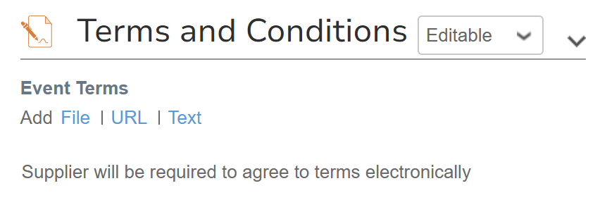  Terms and Conditions: The Procurement Admin (Buyer) will have the option to attach terms and conditions or any other relevant document that the supplier must accept in order to participate in the event.  Event team  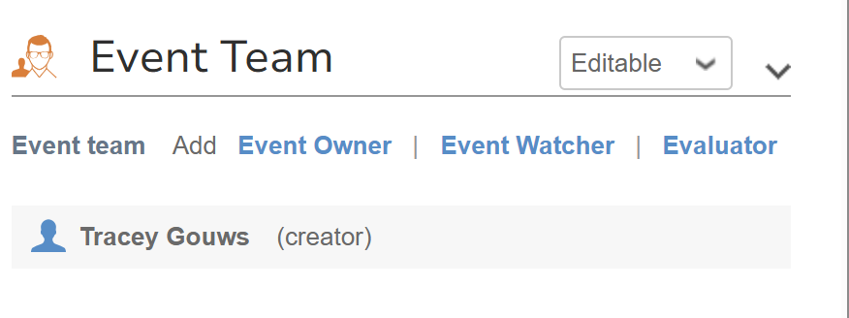  Event Team: Under this section Procurement Admin (Buyer) has the option to add event owner, watcher, and evaluator.  Timeline:  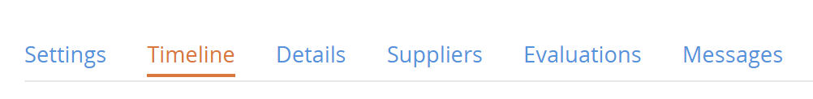  Configure Timelines  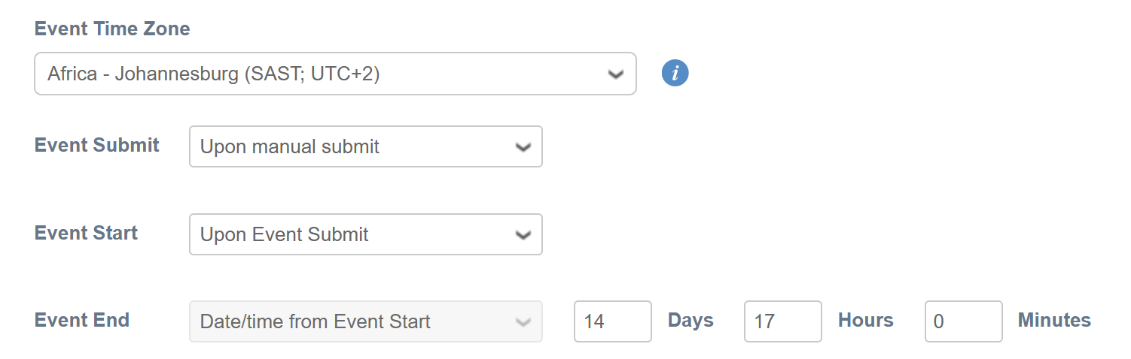  Under the Timeline section, the Procurement Admin (Buyer) can define timelines specific to the event, this includes:  - Event Time Zone – Set to user’s default time zone.  - Event Start - When the event starts.  - Event End - When the event ends.  - Event Timeline  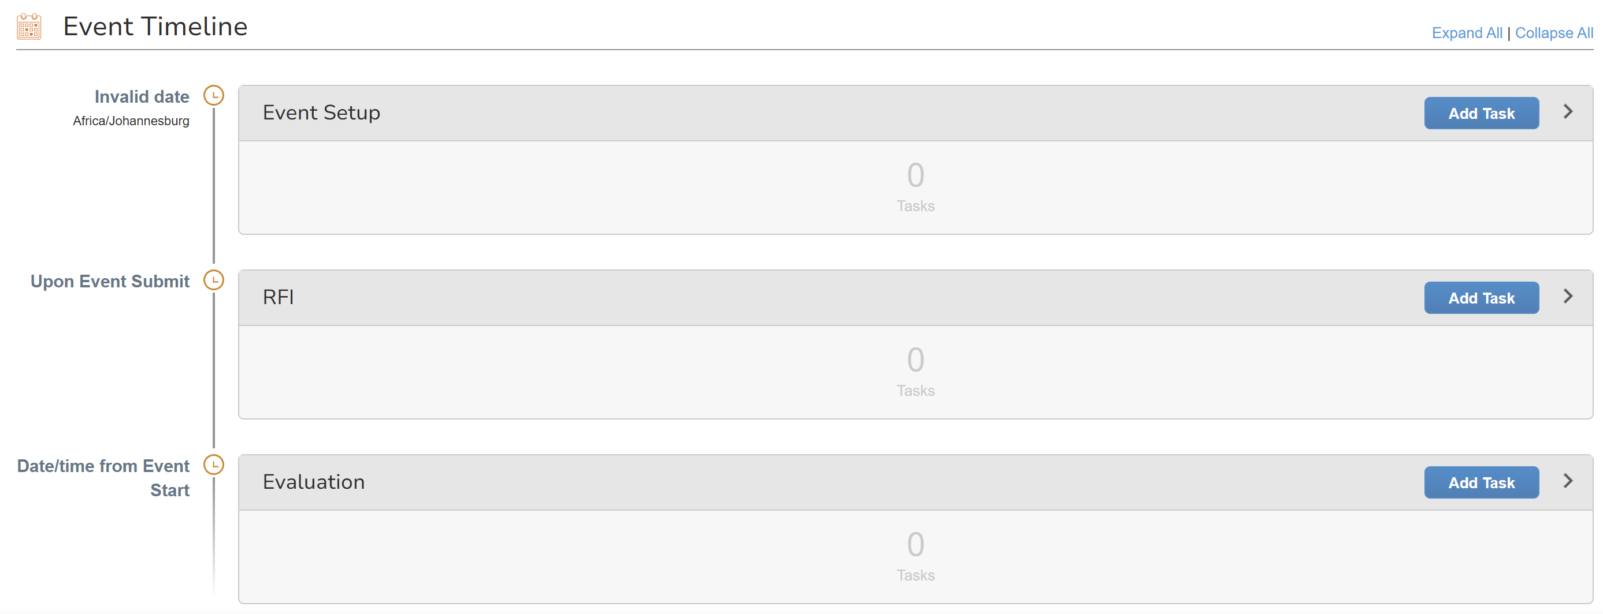  - By using this function the Procurement Admin (Buyer) has the option to invite internal team members using “add task” option for conducting specific tasks such as review the quotation, provide an approval, complete evaluation etc. throughout various stages of the sourcing process. The team members invited will get email and system notifications of the assignment.  Details  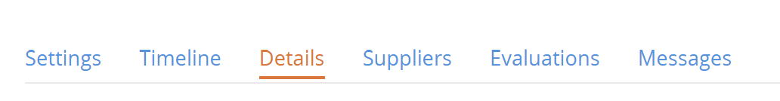  Configure Event Details  This section consists of all the details necessary for the supplier to submit the required pricing.  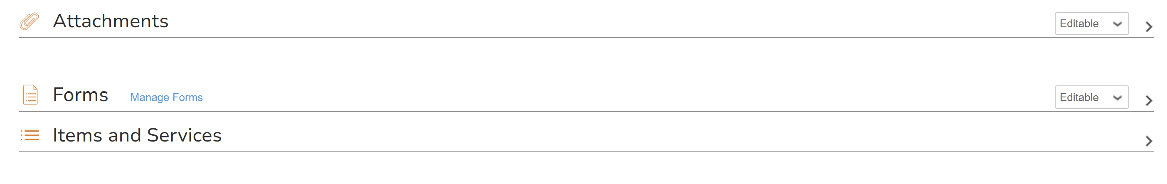  Attachments – By selecting the Add Attachment button, any attachments required by the Supplier to refer to or fill in, such as the Technical details and specifications; Statements of Work etc. Can be added here. There are also provisions for the Procurement Admin (Buyer) to add in instructions to the Supplier and to make responses mandatory.  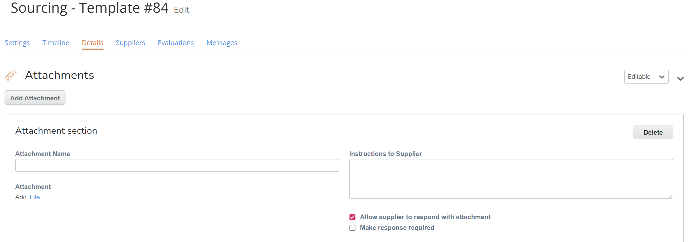  Forms – These are forms which the Procurement Admin (Buyer) shares with the supplier for completion. These forms can be added to the event as New; Existing; from a previous Event or from a Template. There are preloaded forms in the System which the Procurement Admin (Buyer) can use by clicking on Add Form and selecting Add Existing.  Procurement Admin (Buyer) can modify the existing form and add form which is used for any previous event. For AECI Department-based forms can be created and Procurement Admin (Buyer) can choose from the list and add applicable form on sourcing event.  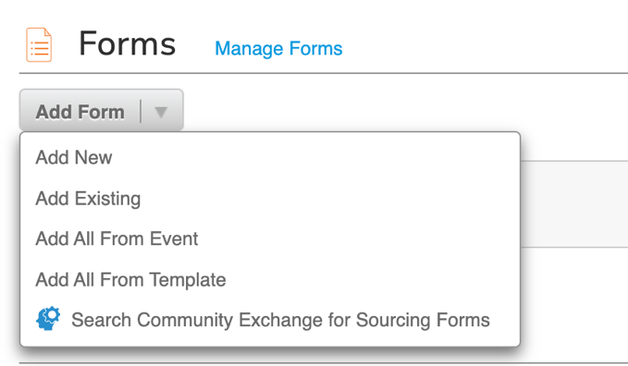  Items and Services  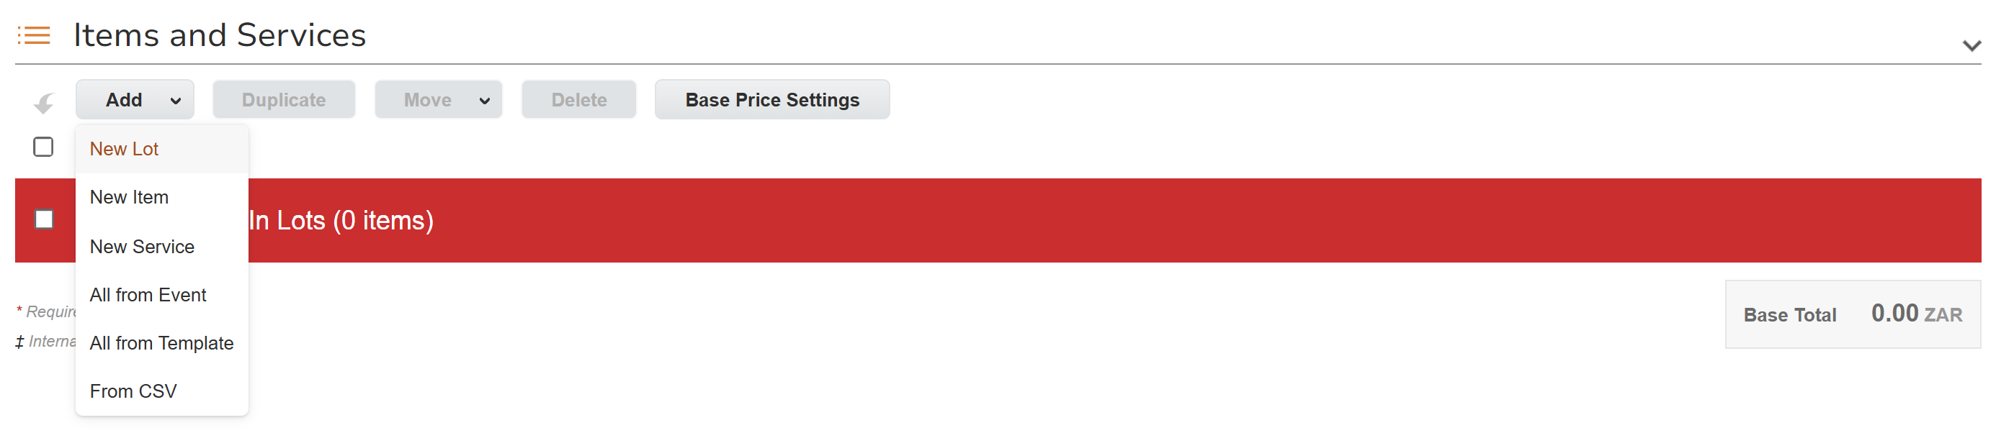  The Procurement Admin (Buyer) can add the items/services individually in this section by clicking on Add New and selecting New Item. The item search has existing preloaded choices for the Procurement Admin (Buyer) to select from. The price of the items can either be manually added (Copied from PR or Buyer can add manually to calculate the saving) or can be auto calculated by the system by clicking on Base Price Settings.  The Procurement Admin (Buyer) can also upload data from CSV (excel) by clicking on Add New and subsequently selecting Add from CSV (excel) Other details which need to be filled include:  - Quantity – Total quantity of the items.  - Add Form – This is a form with additional information required from the supplier at item level.  - Need by Date – Date when the item/s are required.  - Total Cost Formula – Segregates the price offered by the supplier into specific costs, e.g., Manufacturing, Labour Cost, Material Cost, Shipping Cost etc.  The Procurement Admin (Buyer) can also add specifications with respect to items in the item details field on the same page.  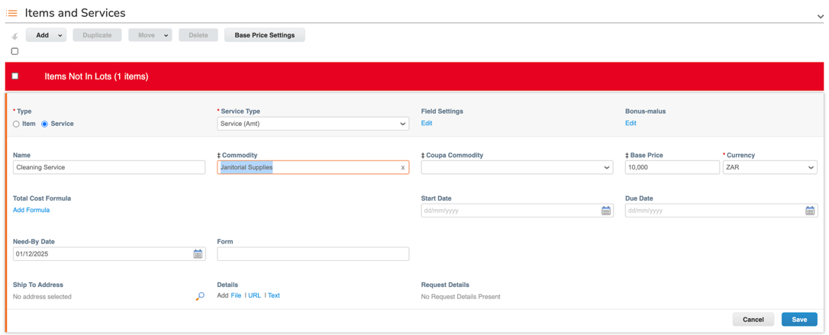  Note: Maximum number of items that can be added are 1000 on Google Chrome while the maximum number of suppliers that can be invited per RFX are 300 and 50 for auctions.  Coupa only supports a maximum of 1,000 lines per event. If there are more than that, we can use an Excel file with all items and attach it to the event as a workaround.  Suppliers:  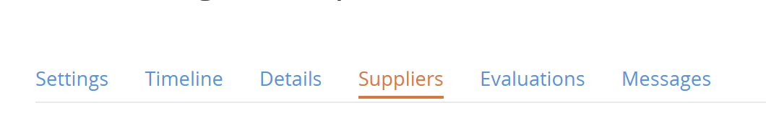  Add Suppliers  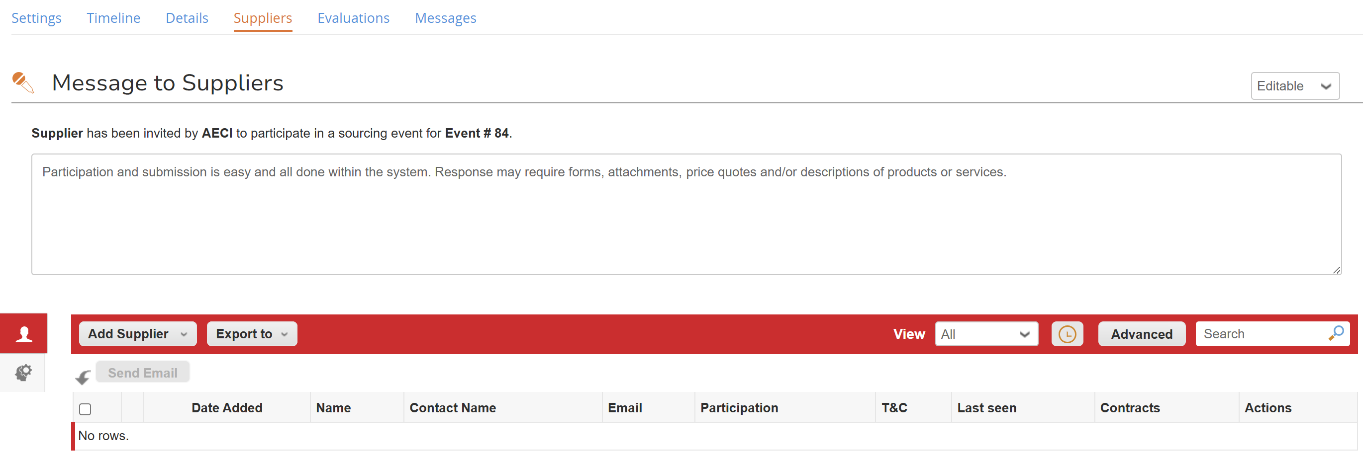  - In this step, the Procurement Admin (Buyer) Can add/invite suppliers to the sourcing event by using the following options under the Add New section: Select from previous event  - Select from Supplier table (Coupa Supplier Record)  - Copy All from Template/Previous Event  - Load from CSV  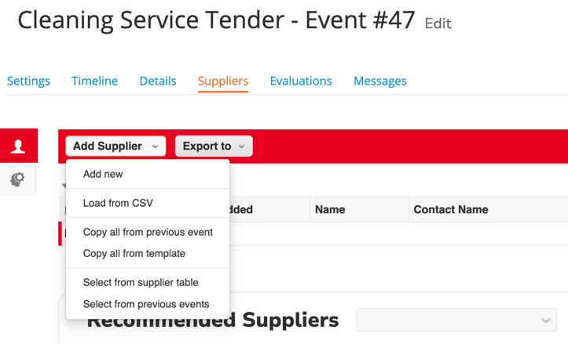  Note: Buyer can also include suppliers who are not on the Coupa supplier list by selecting “Add New” and providing extremely basic detail such as Company Name, Contact Name and Email.  The system does not restrict Procurement Admin (Buyer) from awarding non onboarded suppliers.  Evaluations:  Evaluation Types: Configurations and team members must be added in this section.  Evaluation Type:  Evaluation scoring types are added in this section, either by using the Search function to use an existing scoring type or by creating and adding a new scoring type.  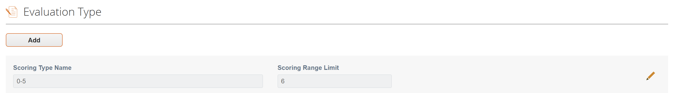  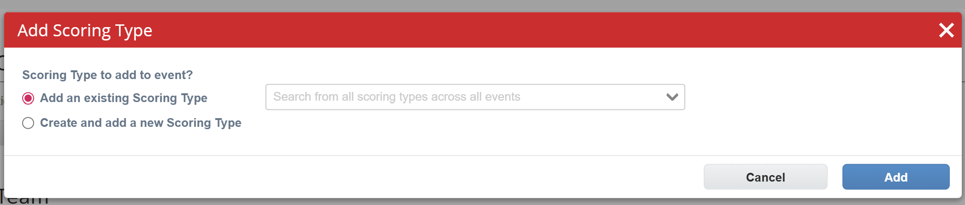  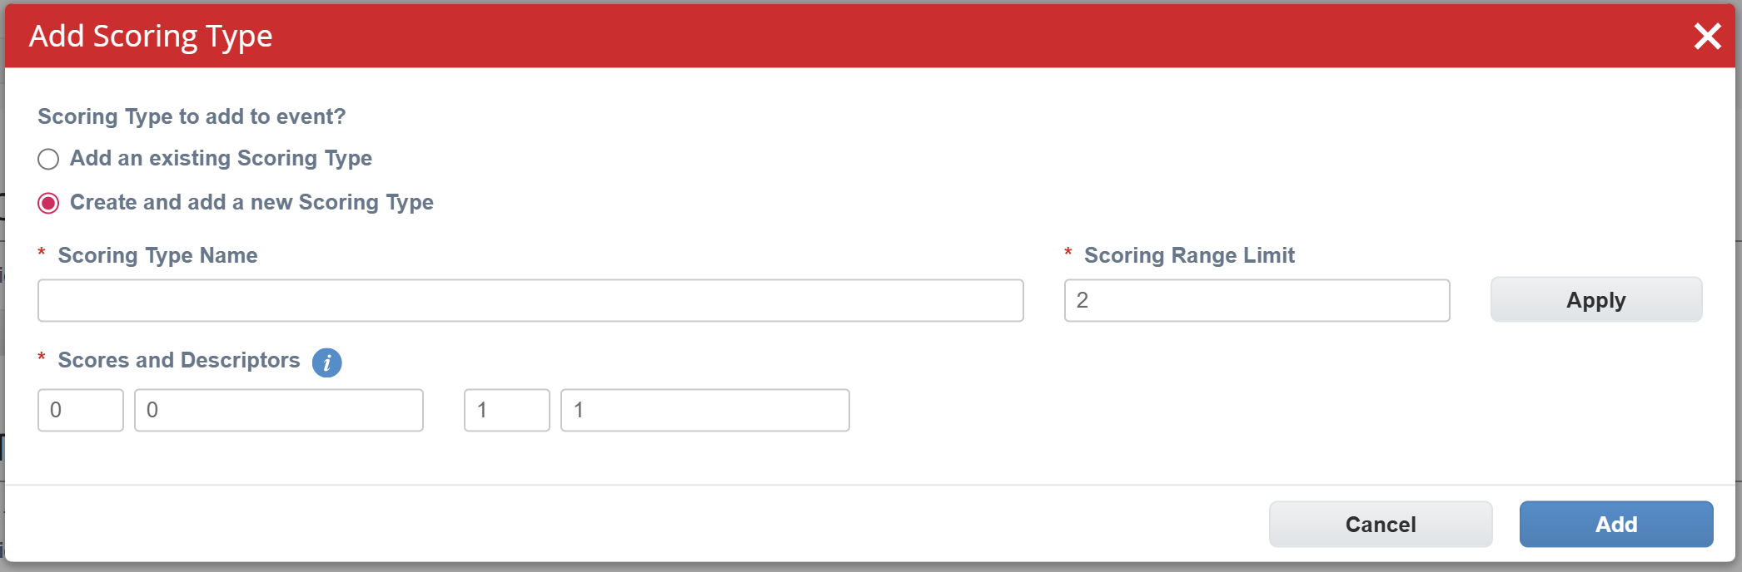  Evaluation Configuration:  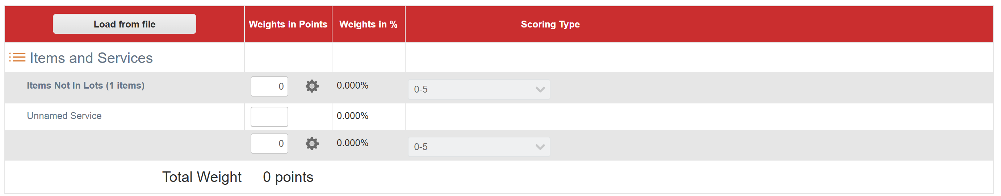  Under the option Evaluation Configuration, the Procurement Admin (Buyer) can add weights to specific categories of the sourcing event which will be calculated in percentages that will eventually round up to a total of 100%. The evaluations can be assigned to all the events (RFP, RFI, RFQ) except auctions. The evaluation criteria can also be edited before the evaluation phase.  Add Evaluators  Evaluators (users with Sourcing Licence) can be manually added for the sourcing event. This can be done by selecting the Add Evaluator option within the Evaluation Team sub-section under the Evaluation section.  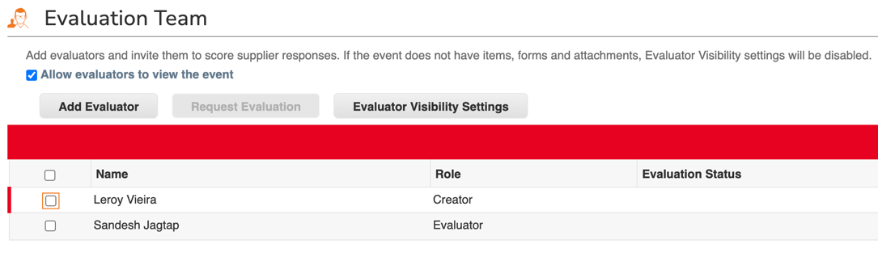  Specific evaluators can be selected for  technical and commercial evaluations or both. These evaluators would only have access to their specific evaluation section (Either Technical or Commercial).  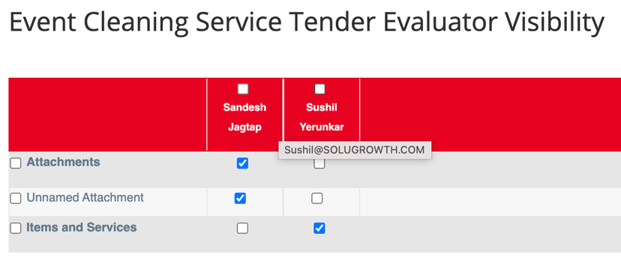  Once all the sections are filled in, the Procurement Admin (Buyer) can proceed to the next stage which is launching the event.  Note: Evaluators can also be added post receiving bids from the suppliers.
7.10 | Publish Event | Publish the event to make it visible to suppliers.  Once all the details are filled, the Procurement Admin (Buyer) can launch the event. There are 2 options on the bottom of the screen which are:  Create Test Event – This is when the Procurement Admin (Buyer) wants to see the Supplier view, but internally. This can be done to evaluate the event from the Supplier’s perspective by entering a dummy email ID.  Preview Event (Submit Production Event) – This is the actual creation of the event wherein the event gets activated, and an email is sent to the Supplier.  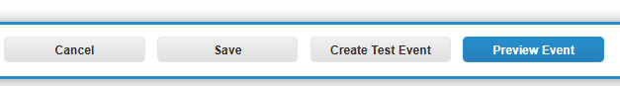  After clicking on the Preview Event, the Procurement Admin (Buyer) will see a brief view of the event along with a message that will be sent to the supplier.  When you click Submit Event, the event publish approval (as per the configuration)chain will get triggered.  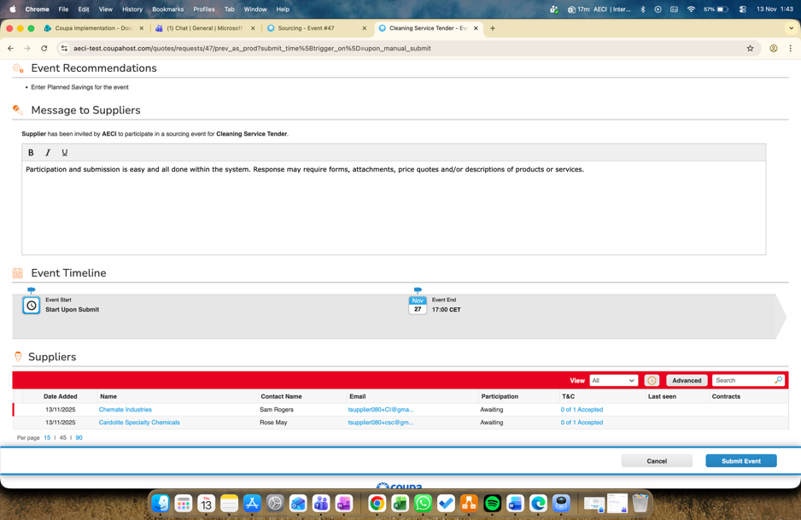  Once launched, you may still edit the event, for instance enter weights for scoring, planned savings etc. However, change of currency and changes in the Terms and Conditions and the Event Type Settings sections will create a new revised event.
7.11 | Auto Disqualification | This feature is configured by the sourcing event creator in the Evaluations tab, under evaluation configuration. It must be enabled at the event level for auto disqualification to apply.  Auto disqualification automatically removes suppliers who fail mandatory requirements such as delivery timelines, certifications, compliance checks, or required fields. It works as a hard filter, allowing only eligible and compliant suppliers to move forward in the event.  This reduces manual checks and avoids delays in decision-making. Note that suppliers are disqualified only if this setting is enabled and they fail to meet the defined event requirements.
7.12 | Auto Scoring | Auto scoring evaluates supplier responses using predefined weights and scoring rules for criteria such as price, SLAs, and technical requirements. It allows consistent and objective comparison across suppliers and works best when responses are structured and measurable.  By minimizing manual evaluation, auto scoring reduces effort for evaluators and speeds up decision-making, helping shorten the overall cycle time of the sourcing event.
7.13 | Publish Approvals | This step triggers the Publish approval for all sourcing events, process based on the workflow configuration for centre managed commodities and services. Procurement Heads at the Business Unit shall approve events for non-centre managed commodities/ services.  - Business Approver (User Defined)  - Buyers Manager  Approval Outcomes:  - Approved – The sourcing event is published, and the event is live.  - Rejected – The system records the rejection comments and notifies the buyer, who can correct and resubmit the event for publish approvals again.
7.14 | Supplier to receive invitation via email | The Supplier receives an invitation email for participating in the event and viewing the event details. The email includes system generated OTP for accessing the event.
7.15 | Terms & Conditions | Acceptance of T&C can be skipped by suppliers to access or participate in the event.  T&C / NDA are shared with suppliers as attachments within the event where they can sign and attach the document. This can be marked as mandatory as per the business requirement.
7.16 | Response Entry | Suppliers can access the event by selecting “Enter Response” and proceed to submit their responses. The event timeline is displayed on the top-right corner, indicating the remaining time before event closure.  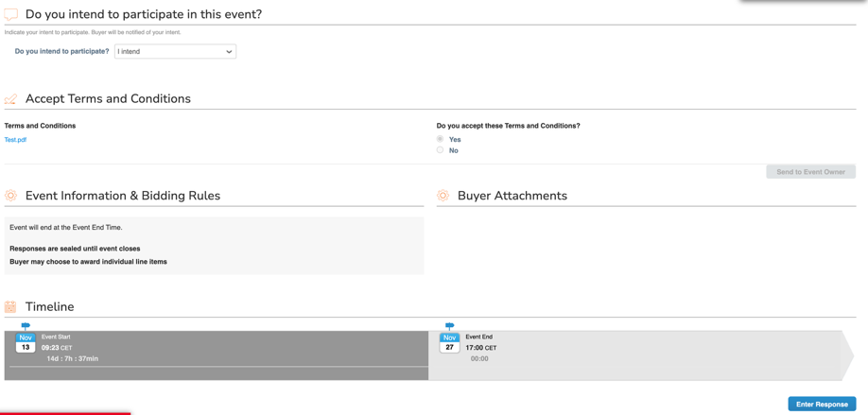  Suppliers can review Event Information, Bidding Rules, and User Attachments provided by the Procurement Admin (Buyer). They can respond to all questions, forms, and item-level requirements as configured in the event.
7.17 | Query resolution via chat window | Suppliers can resolve queries via the chat window (Messaging Centre).  There is a Live communication channel between the Buyer and the Supplier. This can be accessed by the Supplier by maximizing the Messages dialog box on the bottom left of the screen. The Buyer can access this message by going to the event in their system.  Buyer can send messages to all the suppliers who are part of the event, or they can also select an individual supplier for private messaging.  The suppliers which are added at the later stage of the event will not be able to access the messages that have been sent by the Buyer prior to adding them.  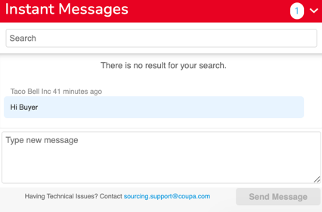
7.18 | Submit the response | Suppliers submit their responses to the event. “My Response” consists of the questions and requirements posted by the Procurement Admin (Buyer) for the Supplier to fill in.  Mandatory information is labelled by a red asterisk. If not completed, the supplier will receive an error message upon submission, and the response is not accepted.  The Supplier also has provisions to Export the questionnaire to Excel and thereby completing it. Once exported, they can load responses in the Excel file and import it back to Coupa. They can also view the History of the changes made to the form by navigating to the History section. The Supplier can also Save their responses and complete their submission at a later stage. Lastly, once the Supplier has completed their response, they can submit the responses back to the Procurement Admin (Buyer) for evaluation by clicking on Submit Responses to Procurement Admin (Buyer).  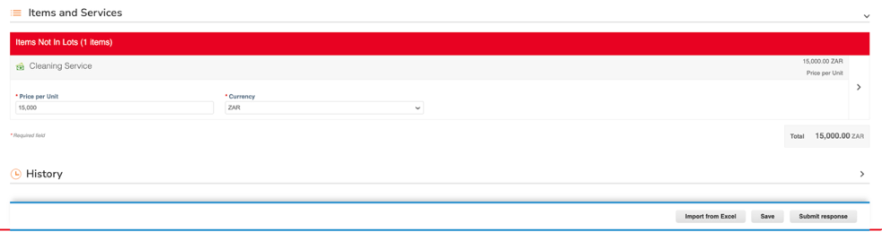
7.19 | Responses Received | Under the event details, the Procurement Admin (Buyer) can view the list of suppliers who were invited to the event and the ones who have responded. The Procurement Admin (Buyer) can also see the number of responses received alongside the event without going into the details. This is visible under the Sourcing section besides the event under the Responses column.
7.20 | Extensions and reminders | The Buyer can also send email reminders to the suppliers.  They have the authority to extend the timeline of the bid if they wish to extend the date by selecting the option Edit Event under the event and resubmitting the production event.  The Supplier can submit and edit their responses until the event ends.
7.21 | Event Ends | The event ends automatically at the scheduled end time or can be manually closed by the Procurement Admin (Buyer) using the “End Event” option. Once ended, bidding closes, responses are locked, and no further submissions or edits are allowed.  In case of a 2 envelope Bid, both technical and commercial evaluations would be done sequentially while in case of a single envelope bid, only the commercials would be considered.
7.22 | Follow On Event | In case of further negotiations with the supplier, the Procurement Admin (Buyer) can create a follow-on event with the final shortlisted suppliers. The information from the first response is prepopulated post which the Buyer can carry out further negotiations with the supplier.  The Procurement Admin (Buyer) can also raise a follow-on event for RFP or RFQ or Auction. In the same way multiple Follow-on events can be raised.  Note: The process for a follow-on event will be exactly the same as the original event. Additionally, the event that has completed it’s duration can be extended by the Event Owner by resending the event to production.  For Auction: The process for Auctions is described in detail in section 3.2
7.23 | Evaluation process starts | The evaluation process starts once responses are submitted. The Procurement Admin (Buyer) can view the responses received by selecting the event and navigating to the Responses Section.  If evaluations are not needed. For example:  - If event is simple, price-only or tactical.  - If event in an RFI  - If the awarding does not require multi-criteria scoring.  Once the responses are received, the Procurement Admin (Buyer) can request internal users for evaluation (technical and commercial). Evaluators can be added in case not added earlier during the creation of the sourcing event.  Under the Evaluators section within the sub section Evaluation Team, the Event owner selects the evaluator who would be evaluating the technical responses of the bid. The Procurement Admin (Buyer) can do so by selecting the checkbox beside the evaluator’s name and selecting the Evaluator Visibility Setting and only checking the relevant options applicable, in this case, Technical Qualifications.  The Procurement Admin (Buyer) can also send a message requesting an evaluation from the evaluator by clicking on Request Evaluation.  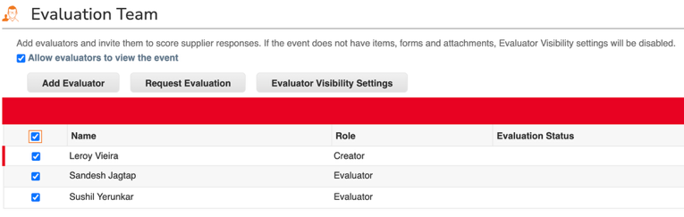  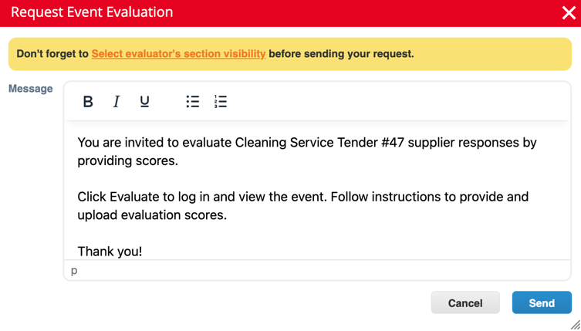
7.24 | Review the responses & evaluate accordingly. | The evaluator will get a notification to Evaluate the event.  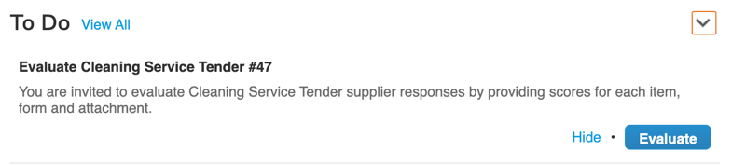  The Event Evaluation Scores page contains the following tabs:  Load from File: evaluate supplier’s responses in the evaluation excel file.  Forms: contains the forms with suppliers' responses.  Attachments: contains attachments uploaded by suppliers.  Items and Services: contains the responses given by suppliers for items and services  After clicking on the link, there are two methods for the Evaluator to add their scores.  - Excel Evaluation: The Evaluator can download the excel template and add the scores. Once scores added, the file has to be uploaded in the system which will populate the details.  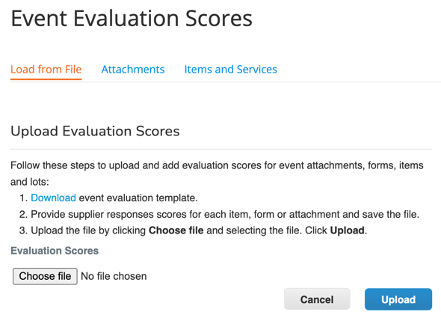  - Manual Evaluation: For evaluating supplier responses in Coupa, go to the Forms, Attachment, and Items and Services tabs, respectively. Evaluators enter scores, evaluations, and comments and Submit.  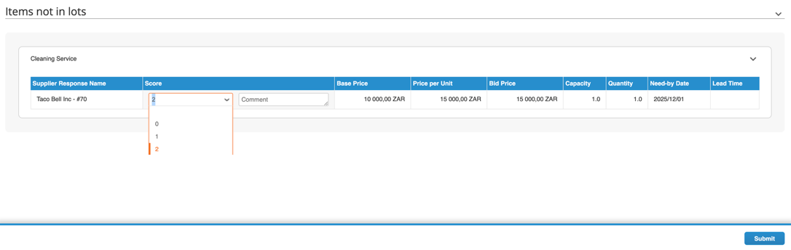  The event status will remain as Pending Evaluation until all invited Evaluators have submitted their evaluations, or the evaluation process has ended.  The buyer can send a reminder to evaluators if the evaluation is not completed on time.
7.25 | Review the evaluation results | Once all evaluations have been received by the respective evaluators, the Procurement Admin can End Evaluation and review Evaluation Summary populated from the inputs provided by the evaluators.
7.26 | Award Event | Decide on the event award based on evaluations.  Go to the Responses page in the sourcing event and open one of the responses you wish to award by clicking it in the Responses table. The Procurement Admin (Buyer) can award the selected winner(s) in the Sourcing event using award option.  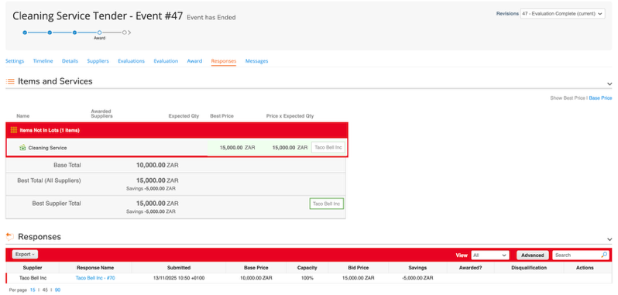  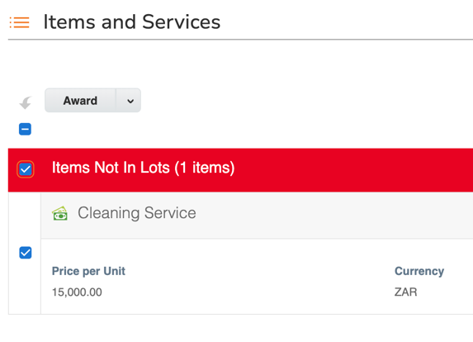
7.27 | Award Approvals | This step triggers the award approval process based on -LOA and workflow configuration.  - TC1: Category Manager  - TC2: VP Procurement  Above a specific amount VP Procurement goes to the board and takes the approval offline, then VP Procurement will approve the event in Coupa and attach board approval.Approval Outcomes:  - Approved – The sourcing event is awarded to the supplier(s).  - Rejected – The system records the rejection comments and notifies the buyer, who can correct and resubmit the event for award approvals again.
7.28 | Approvals completed | Once approvals are completed, mark the event as awarded.  Once the approver approves the event, the supplier will then be awarded the event.
7.29 | Act on award (Optional) | Procurement Admin (Buyer) can flip the Sourcing event into:  - New/Source Requisition or  - Use Source requisition option if Sourcing is initiated from PR and want to flip price back to same PR  - New Contract or  - New/Existing Catalog Items  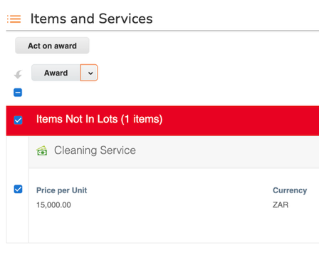  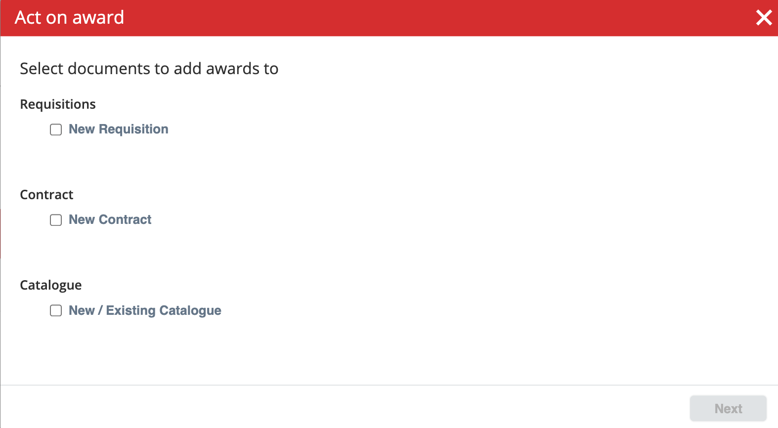  The Award/Rejection letters can be configured as a template in Coupa and can be sent out to the suppliers once the event has been awarded.

Auction Process
Auctions provide a streamlined approach to direct negotiations—particularly effective when suppliers are well-known, the award decision can be made swiftly without extensive evaluation, or when the sourcing event involves a limited number of items without complex pricing structures. In such cases, awarding the business to the lowest bidder becomes a practical strategy. Additionally, auctions serve as a powerful final stage in a broader sourcing initiative, where all key parameters have already been defined and locked during earlier RFx rounds.

Within Coupa, users can leverage three distinct types of reverse auctions—each designed to align with specific sourcing objectives and supplier engagement models. These auction formats promote competitive bidding, unlock cost-saving opportunities, and foster transparency throughout the supplier selection process.
- English Reverse Auction
This is the most widely used auction type, where suppliers submit successively lower bids in response to competitors. The auction remains active for a set duration, allowing suppliers to view (anonymously) the leading bid and attempt to beat it. This dynamic environment encourages intense competition, often leading to optimal market-based pricing.
- Dutch Reverse Auction
In this format, the auction opens at a high starting price, which automatically decreases at scheduled intervals. The first supplier to accept the current price wins the auction. This model instils urgency and is particularly suited for time-critical sourcing scenarios or when buyer control over pricing is paramount.
- Japanese Reverse Auction
Beginning at a low price point, this auction format increases incrementally. Suppliers must continually affirm their willingness to accept the rising price. Once a supplier exits, they cannot rejoin. The last remaining supplier wins the contract. This format is ideal for identifying the vendor most committed to sustaining aggressive pricing throughout the auction duration.

An English reverse auction is characterized by the direct feedback on a submitted quote. In a true English auction, the best (lowest) quote at the end of the event is the awarded one. An auction is not by necessity very quick, but the timeline should be adjusted to the complexity of the event to allow the suppliers enough time for proper quoting.
Together, these auction types empower procurement professionals with adaptable tools to design sourcing strategies that reflect market realities, category-specific needs, and negotiation goals—ultimately driving greater efficiency and value across the sourcing lifecycle.

Please Note: An auction event is implemented in the same way as any event in Coupa Sourcing (i.e., same workflow. The entire process is explained in the previous workflow diagram above, however only the steps which have to be specifically carried out for an English Reverse Auction event are mentioned below.
S. No. | Activity | Description
8.1 | Create the Auction event | Create the event from scratch, an event template, or by copying a previous event. Give the event a name, select the event currency, and provide the information to share with the suppliers about event conditions and scope (More Event Info)  The auction-specific settings are done in the Event Type section. When English Reverse Auction is selected.  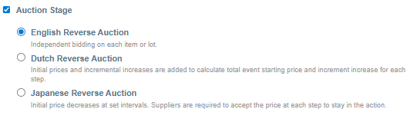
8.2 | Bid Extension | Select Automatic Bid Extensions to give the suppliers time to react on a new best bid placed just before closing time. The auction will be kept open for the number of minutes you set if the new quote is better than the currently best one. Bid extensions is strongly recommended in online auctions to avoid stressful situations at the end of the event.  Check the box and set a number of minutes that may be reasonable to extend the timeline by upon arrival of a new best bid. If the event is only for one or a few items, a few minutes may be enough. When the event comprises a larger number of items, the suppliers may need more time to reconsider their quotes. Remember to allow ample time for the system and browser to refresh. Note that the system tracks relative time (not absolute time) to the minute, and so an event configured to auto-extend by five minutes will extend between five and six minutes to the next whole-minute mark. For example, if the time is 12:30:30 and the event is extended by five minutes, the system will extend the time to 12:36:00.  You also need to select which cost to compare the new quote to. This depends on how you plan to award the items. If you are running an all-to-one event, the total cost for the total event, the Best Supplier Total in the Responses page, should be beaten by the new quote to get a bid extension. If you are awarding items in lots, the total cost on a lot should be beaten, and if you are awarding individual items, a new better price on an individual item will trigger a bid extension. If you select more than one option, the most detailed level will dictate the timeline.  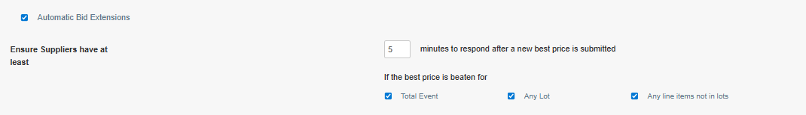
8.3 | What do Suppliers see? | Direct dynamic feedback is the characteristics of an English auction. The purpose of feedback is to help the supplier understand how to improve, and on which items they may have a chance. The best option for feedback is hence to show the currently best price per item or lot, as seen in the screenshots below.  Rank is a blunter tool, which does not give the suppliers the same support in their decisions as the best price. Include the number of responses only if there is a large number of bids.  Note that as items included in a lot are always awarded together, feedback on lots relates to the total offered cost (unit price * quantity) on the items included.  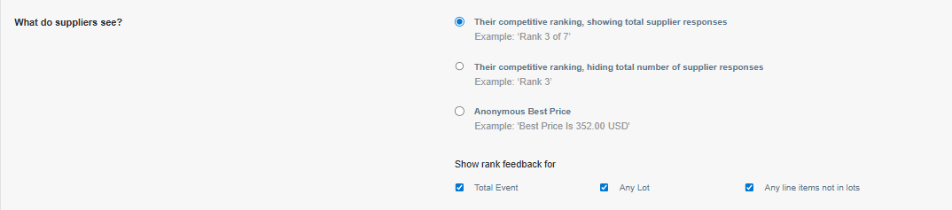
8.4 | Bidding improvement rules | The suppliers may change their quotes as many times they wish depending on the feedback, until the end of the auction phase. To ensure that the price develops in a fair and efficient way, you need to apply bidding rules. The bidding rules force the suppliers to improve their bids by at least the specified change, i.e. they cannot increase their prices, and they cannot take the lead by just an insignificantly better quote. Coupa Sourcing makes sure a supplier cannot increase their prices even if you forget to add a bidding rule.  The rule, i.e. the required change, should be set on the level you plan to award on, just as the bid extension. As items included in lots are awarded as a unit, a bidding rule on the item level does not apply to the individual items in the lot. The required improvement can be expressed as percent of the best bid, or as a monetary amount. Unless all items are of approximately the same value, or you are awarding on the total event level, the percentage change is recommended.  Additionally, you have to decide if you wish to allow ties, i.e. two identical best bids. In a true English auction, the best price wins, i.e. ties are not allowed. A supplier who places a tie bid (a bid which results in the same cost as the currently best one on the level at hand) will receive an error message, and the submission is not accepted. Note that ties are controlled for on each level, unless you allow them. If you are planning to award all to one, it does not matter if two suppliers offer the same prices for a particular item or for a lot, as long as there is a clear winner on the total cost. In this case you can allow ties for individual line items and for lots, but not for the total event.  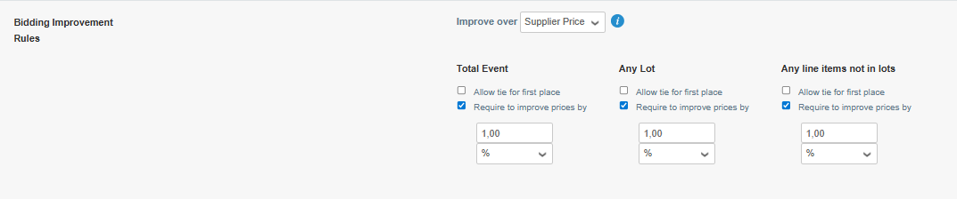
8.5 | Timeline | Coupa Sourcing automatically adds a period of time between Event Start, i.e., when the suppliers can access the event, and Bidding Start, i.e., when the auction opens. This allows the suppliers to take part of the event information you have provided and orient themselves in the interface.  You may include an RFx phase to collect additional information through questionnaires or attachments, or to invite the suppliers to place start bids. These sections are available to the suppliers as soon as the event starts, as usual.  
8.6 | Monitoring the Auction | You can follow the bidding process in the competitive chart in the Responses page. The x-axis shows the time and the y-axis the total bid cost for all suppliers. Drag the cursor across the chart to see more details about the changes during the auction.  The panel to the left allows you to select which items/lots and suppliers to show, and if you wish to display the Baseline or not. The panel can be hidden by clicking the left arrow (<) at the top left.  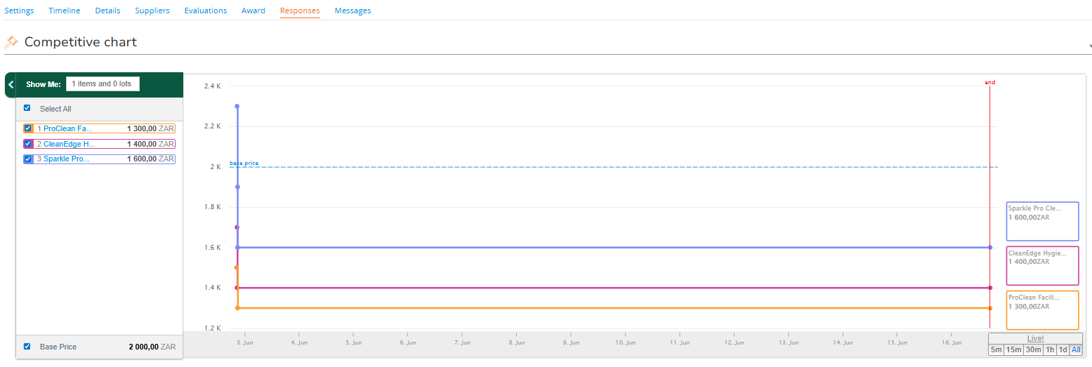  Make sure to keep the Messaging centre open for communication with the participants throughout the event.  Removal of bids on behalf of suppliers:  If a supplier accidentally submits an incorrect quote, they can request its removal. The internal team can delete the supplier’s latest submission from the Responses section. The supplier is notified automatically and can also revise or resubmit the bid from their side.  Suppliers may place improved bids at any time while the event is active. When the internal team deletes a supplier’s most recent bid, the previous submission becomes the standing quote and cannot be removed. If the supplier submits a new bid later, only that latest submission can be deleted again.  All bid removals are logged in the event history for both the buyer and the supplier.  To reduce accidental errors, Coupa Sourcing displays a warning when a supplier attempts to submit a quote that is more than 50% lower than their previous bid.
8.7 | Awarding the Auction | After Monitoring the event, the buyer will send the event for evaluations and once that is completed, the Buyer will proceed to the next process which is Award Approvals. The details of the Approval chain have been captured in the workflow section of this document.  Once the approver approves the Award form, the Procurement Admin (Buyer) proceed ahead to award the selected supplier.  An auction event is awarded, and the awards are implemented in the same way as any event in Coupa Sourcing, which is already covered in the Sourcing Process above.  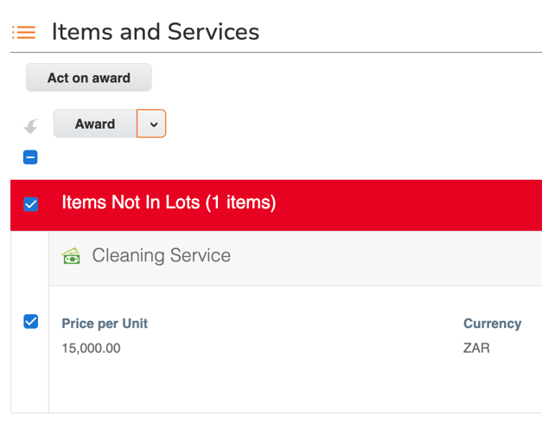

Savings Definition Sourcing
S.No. | Type | Definition
1 | Cost Avoidance | Avoidance savings are computed by the value of each requisition that has been rejected during the approval process. If it was resubmitted and is pending approval or approved, then it is not counted. This is a manual input by the Procurement Admin (Buyer)
2 | Planned Savings | This would be the target savings that would be manually added here. There is an internal attachment field here in case any supporting documents need to be attached.
3 | Base Price | This would be the last purchase price. This is added manually.
4 | Negotiated Savings | The formula for this would be - Base price - Bid price x Quantity and would be auto calculated in the system. This value is automatically calculated and entered into the Negotiated Savings field in the Settings page by Coupa when the event was awarded. However, if items and lots are awarded individually, you need to do the calculation and enter it manually.

Sourcing Settings and Configurations (Coupa Admin Tasks)
Coupa allows certain settings to be customizable such as the ones mentioned below to enable certain controls at the Procurement Admin (Buyer) side. These settings can be found in Setup > Sourcing > Sourcing Settings.

Configuration | Description | Setting
Require suppliers to login | The invitation email will contain a username and a link to set up a password for log in. If login is not required, the invitation email contains a link for direct access into the event. This setting is on by default for new customers to support information security management. | Disabled
Allow suppliers to provide multiple responses | Suppliers may submit multiple responses on the same item during a pre-bidding phase. The option may be revoked in the individual sourcing event. | Enabled
Seal responses | All new events will be run as sealed events, i.e., the Procurement Admin (Buyer) is not able to see the result until the end of the event. | Enabled
Allow editing of sealed bids setting on the event level | Sealed bidding mode may be selected on the event level. | Enabled
Allow sealed bids to be accessed by the API | Sealed bids can be edited through the API. | Disabled
Turn on Source This feature | Requisitions, requisition lines, order lines, invoice lines, and items may be sent directly to a sourcing event. | Enabled
Allow hidden events | Sometimes you need to restrict visibility into Sourcing events that deal with sensitive categories. You can now choose to hide such events. Hidden events are visible only to administrators and Event Team members. | Enabled
Number of days to keep messaging open after event end | Sets the number of days for which the message centre remains open after an event end. | 100
Show Sourcing Advantage events based on Commodity | Coupa Sourcing Advantage is an open forum where users can collaborate to initiate and run sourcing events together with their peers in the Coupa Community. They can also participate in events hosted by Coupa or other partner organizations. The collective buying power and commodity expertise opens opportunities to maximize value and conditions in situations where an individual company's negotiating powers or resources are not sufficient. | Enabled
Enable Supplier Community Search | The Community setting displays suppliers used by the Coupa Community that match users search terms. You can see these suppliers in the Community Suppliers section that appear below AECI’ s local suppliers. You can select a supplier to see the supplier's Coupa Supplier Portal (CSP) profile, and you can select Search All Community Suppliers to see Coupa Community supplier suggestions. | Enabled
Allow public events | A flag field 'Public event' is shown and can be used for sorting and searching in the Sourcing data table. | Enabled
Maximum number of line items | Sets the maximum number of line items in a sourcing event to avoid impaired performance. Setting applies to all events on the instance. The default value is 500. | 500
Maximum number of line items for Internet Explorer | Sets the maximum number of line items in a sourcing event when IE is used to avoid impaired performance. Setting applies to all events on the instance. The default value is 200. | 200
Maximum number of suppliers for RFx | Sets the max number of suppliers that can be added in an RFx type event to avoid impaired performance. Setting applies to all events on the instance. The default value is 300. | 300
Maximum number of suppliers for Auctions | Sets the max number of suppliers that can be added in an auction type event to avoid impaired performance. Setting applies to all events on the instance. The default value is 50. | 50
Auto-population of supplier responses in sourcing questionnaire | Supplier response forms are automatically populated with data in the sourcing questionnaire.  Note: While creating a sourcing event we can add in instructions as part of the questionnaire. | Enabled
Enable Award Scenarios | Coupa Sourcing offers the possibility to run 'what if' scenarios to support the award decision. | Enabled
Publish public sourcing events on CSP | Suppliers can access and participate in public sourcing events created by you and all the other customers that use Coupa. | Disabled
Automatically approve supplier participation requests for public sourcing events | Suppliers will not need approval to participate in public events. | Disabled

Sourcing Configuration (Coupa Admin Tasks)
Configuration | Description | Setting
Content Group | Content groups are subgroups of users within a department and provide a way to manage individual users’ access to content at the department level. | Enabled
Community Matchmaker | Coupa helps you to find and connect with fellow users in the Coupa Community to share experiences of sourcing for a particular commodity and allows you to further strengthen the sourcing opportunities. | Enabled

UAT scenarios (Business scenarios)
S. No. | Scenario | Expected Outcome
1 | Create Sourcing Event (RFI/RFP/RFQ) | Event is successfully created and saved as a draft with all entered details visible.
2 | Add Items or Lots | Items/lots are correctly displayed in the event and visible to suppliers once published.
3 | Add Suppliers to Event | All selected suppliers are successfully invited to participate.
4 | Invite Non-Registered Supplier (if applicable) | Invitation email is triggered to supplier for registration and participation.
5 | Configure Event Settings | System accepts configuration and displays correct event setup summary.
6 | Publish Event | Event status changes from Draft to Prod. Notifications are sent to suppliers.
7 | Supplier Access & Response | Supplier can access the event, submit responses, and system confirms successful submission.
8 | Supplier Revision | Revised bid is accepted, and version history is maintained.
9 | Event Close | Event status changes to Closed; suppliers can no longer edit responses.
10 | Bid Evaluation | Buyer can view all responses, export data, and see side-by-side comparisons.
11 | Scoring and Evaluation | Scores calculate correctly; total weighted score displays per supplier.
12 | Award Recommendation | Award is successfully created and marked in system; report available for audit.
13 | Flip Sourcing event to Contract | Contract draft is generated with auto-populated details from sourcing event.
14 | Flip Sourcing event to New/Source Requisition | Requisition is created/updated with auto-populated details from sourcing event.
15 | Flip Sourcing event to New/Existing Catalog | Catalog items are created with auto-populated details from sourcing event.
16 | System Notifications | Appropriate notifications are sent to buyers and suppliers as per event stage.
17 | Audit Trail & Reporting | All activities (creation, updates, submissions, awards) are traceable in audit logs.
18 | Error Handling / Validation | System displays relevant validation message and prevents submission.
19 | Approval Workflow | Event routes correctly to approver; once approved, can be published/awarded.

Acknowledgment and Signature

Process Owners
No. | Author/Owner | Version | Email
1.
2.

Document Reviewers
No. | Author/ Owner | Division | Signature
1.
2.
3.
4.

Signatures
The undersigned do hereby agree to the information mentioned in the above pages of this document.

AECI | AECI
Signature:  Name :  Title :  Date : | Signature:  Name :  Title :  Date :

