📘 Kubernetes Monitoring & Metrics Collection

🔹 Core Concept
- Prometheus itself does not create metrics.
- Instead, it collects (scrapes) metrics from other places.
- To do this, we need exporters, which act like translators between Prometheus and the system/app being monitored.

🔹 Exporters & Metric Sources

1. Node Exporter → System/Node Metrics
- What it measures: Health of the underlying machine (Linux host).
- Examples:
  - CPU usage (per core)
  - Memory (used, free, swap)
  - Disk usage & I/O speed
  - Network traffic
- Why it’s useful: Helps find machine bottlenecks and plan capacity.
- Analogy: Like a health checkup of the server itself.

2. kube-state-metrics → Kubernetes Object Metrics
- What it measures: State of Kubernetes objects (via API server).
- Examples:
  - Desired vs. running replicas of pods
  - Pod status (Running, Pending, Failed)
  - PersistentVolumeClaims (PVCs) status
  - CronJobs completion info
  - Node conditions (Ready/NotReady)
- Why it’s useful: Ensures Kubernetes is working properly.
- Analogy: Like a health checkup of Kubernetes components.

3. Pushgateway → Short-lived Job Metrics
- What it measures: Metrics from jobs that finish quickly (before Prometheus can scrape them).
- Examples:
  - Backup job duration
  - CI/CD pipeline outcomes
  - Data processing job success/failure
- Why it’s useful: Prometheus pulls metrics → but short jobs vanish too quickly, so Pushgateway acts as storage.
- Analogy: Like a guest book where short-lived jobs leave their status before leaving.

4. Application/Service Exporters → App Metrics
- What it measures: Health of apps/services.
- Examples:
  - RED metrics: Request rate, latency, error counts
  - Database stats: Connections, query time
  - Message brokers: Kafka, RabbitMQ health
- Why it’s useful: Shows if business logic/services are healthy (SLIs/SLOs).
- Analogy: Like a doctor’s report for your application.

5. Other Built-in Metrics
- Kubelet / cAdvisor: Container-level CPU, memory, filesystem usage.
- Etcd: Control-plane database health (latency, size).
- API Server: Request latency, error counts.

✅ In short:
- Node Exporter → Server health
- kube-state-metrics → Kubernetes object health
- Pushgateway → Short jobs health
- App Exporters → Application/service health
- Built-ins → Container + Control-plane health

🔹 Metrics Layers (Hierarchy)
[ Layer 4: Applications ] → App Exporters
[ Layer 3: Batch Jobs ] → Pushgateway
[ Layer 2: Kubernetes Objects ] → kube-state-metrics
[ Layer 1: Nodes/Machines ] → Node Exporter
↓
Prometheus

🔹 Differences Summary
Component | Scope | Metrics Type | Example
Node Exporter | Node/Host | CPU, memory, disk, network | Node disk full
kube-state-metrics | K8s Objects | Replicas, pod status | Pod stuck in Pending
Pushgateway | Short-lived jobs | Job duration, success/fail | Backup job failed
App Exporters | Apps/DBs | Requests/sec, latency, errors | API latency too high
Kubelet/cAdvisor | Containers | Pod CPU/memory usage | Pod OOMKilled
Control Plane | Cluster Infra | API latency, etcd DB size | API server slow
✅ Coverage: Node health, cluster state, app performance, jobs, containers, control plane.

🔹 How Prometheus Works in Background
- Prometheus Server runs as a service
  - It has a built-in time-series database (TSDB).
  - Its main job: scrape (pull) metrics at fixed intervals (default: every 15s).
- Metrics format
  - Exporters and apps expose metrics in a /metrics endpoint (HTTP, plain text).
  - Example:
  - http_requests_total{method="GET", handler="/"} 1027
  - process_cpu_seconds_total 40.22
  - Prometheus reads these and stores them with labels (metadata) + timestamp.
- Scraping mechanism (pull model)
  - Prometheus constantly loops through its config (prometheus.yml) where scrape targets are defined.
  - For each target:
    - Send an HTTP GET request to http://<target>:<port>/metrics
    - Parse the response
    - Save data in TSDB
✅ That’s why Prometheus itself doesn’t generate metrics — it just collects, stores, and makes them queryable.
- Exporters act as translators
  - Most systems (Linux, DBs, message queues) don’t natively speak Prometheus metrics format.
  - Exporters translate raw system stats → Prometheus-readable metrics.
  - Prometheus then scrapes these exporters just like any other target.
- Short-lived jobs → Pushgateway
  - Since Prometheus can’t scrape something that disappears fast, those jobs push their metrics to Pushgateway.
  - Prometheus then scrapes Pushgateway like a normal target.
- Metrics lifecycle
  - Every scrape → new samples (metric + labels + timestamp).
  - Stored in Prometheus TSDB as time series.
  - Queried later using PromQL for dashboards (Grafana) or alerts (Alertmanager).

🔹 Background Data Flow
- Node/Pod/App generates raw stats (CPU, replicas, requests).
- Exporter or built-in endpoint exposes them at /metrics.
- Prometheus (scraper) pulls metrics periodically.
- TSDB stores time-series samples.
- PromQL queries let you aggregate/filter.
- Grafana/Alertmanager use queries for visualization & alerts.

🔹 Analogy
Think of Prometheus as a librarian:
- Exporters = translators writing system health reports in Prometheus-friendly language.
- Prometheus = librarian who visits each translator on schedule, collects reports, and files them in the library (TSDB).
- Grafana/alerts = readers who come later, ask questions, and get insights.

👉 So in the background, Prometheus is basically just:
Scheduled HTTP scrapes → Parse metrics → Store time-series → Serve queries.

📘 Kubernetes (OpenShift) Production Monitoring Stack

🔹 Core Components

1. Prometheus
- Role: Core metrics collection & storage (TSDB).
- Functions:
  - Scrapes /metrics from exporters, services, apps.
  - Stores data in TSDB.
  - Evaluates alerting rules.
  - Feeds metrics into Grafana dashboards.
- OpenShift note: Often runs via the OpenShift Monitoring Operator.
- Scale-out: Use Thanos for long-term storage & multi-cluster observability.

2. Alertmanager
- Role: Notification handler for Prometheus alerts.

- Functions:
  - Group, dedupe, silence alerts.
  - Route by severity/team (critical → PagerDuty, warning → Slack/Email).
  - Handle maintenance windows.

3. Grafana
- Role: Visualization & dashboards.
- Functions:
  - Connects to Prometheus (metrics), Loki (logs), Tempo/Jaeger (traces).
  - Builds dashboards, generates reports, fires alerts.
  - User-friendly system health view.
- Best practice: Dashboards as code (JSON/YAML).

4. Node Exporter
- Role: Exposes OS-level metrics (CPU, memory, disk, network) from each node.
- How: Runs as a DaemonSet on OpenShift worker nodes.

5. kube-state-metrics
- Role: Reports Kubernetes object states (from API server).
- Examples: Deployment replicas, pod phases, PVC bound/unbound, node readiness.
- Why: Shows desired vs current state.

6. Pushgateway
- Role: Captures short-lived job metrics (batch jobs, CI/CD pipelines).
- Flow: Jobs → Pushgateway → Prometheus scrapes.
- Note: ⚠️ Use only for batch jobs, not services.

🔹 Additional Tools in Your Setup

7. Loki (Logs)
- Role: Centralized log aggregation.
- Integration: Used with Grafana → searchable logs alongside metrics.
- Why: Correlate logs with metrics during incident investigation.

8. Instana (APM)
- Role: Application Performance Monitoring.
- What it adds:
  - Tracing & profiling.
  - Dependency mapping.
  - Business transaction monitoring.
- Why: Complements Prometheus by focusing on end-user experience + deep app insights.

9. Thanos (Prometheus Scaling)
- Role: Global query + long-term storage.
- What it enables:
  - Federated metrics from multiple Prometheus instances.
  - Object storage (S3, GCS, etc.) for historical metrics.
  - HA + multi-cluster observability.

🔹 Monitoring Architecture (Production, with Your Tools)

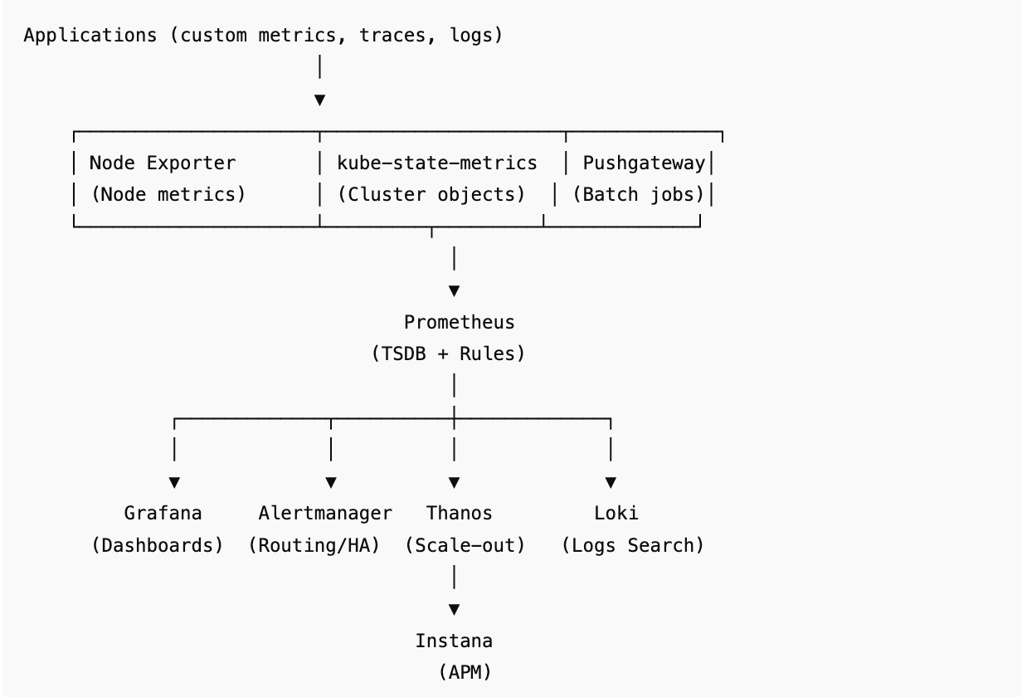

🔹 Best Practices (OpenShift + Your Stack)

✅ Prometheus
- Retention: 15–30d locally, long-term via Thanos.
- Recording rules for expensive queries.
- Avoid high-cardinality labels.
- Use HA Prometheus (2+ replicas with Thanos sidecar).

✅ Alertmanager
- Always run in HA (2+ replicas).
- Route alerts by severity & team.
- Suppress noisy alerts with inhibition rules.
- Integrate with Slack, PagerDuty, Email.

✅ Grafana
- Store dashboards as code (GitOps style).
- Enable SSO (LDAP/OAuth).
- Persistent DB (Postgres/MySQL).
- Integrate metrics + logs + traces.

✅ Node Exporter
- Run as DaemonSet.
- Disable unused collectors.
- Watch disk mount cardinality.

✅ kube-state-metrics
- Use only for object states (not node stats).
- Limit to required namespaces/resources.
- Deploy alongside Prometheus in OpenShift cluster.

✅ Pushgateway
- Use only for short-lived jobs.
- Clean stale metrics.
- Avoid for long-running services.

✅ Loki
- Use for centralized log storage.
- Correlate logs with metrics in Grafana.
- Retention tuned (e.g., 7–30 days).

✅ Instana
- Use for distributed tracing, profiling, APM.
- Integrate with Prometheus/Grafana for full-stack observability.

✅ Thanos
- Store historical metrics in object storage.
- Use querier for cross-cluster queries.
- Run in HA mode for reliability.

🔹 Summary Flow (Your Production Setup)
- Metrics Collection: Node Exporter, kube-state-metrics, Pushgateway, App Exporters.
- Scraping & Storage: Prometheus (short-term) → Thanos (long-term, multi-cluster).
- Alerting: Prometheus rules → Alertmanager → Slack, PagerDuty, Email.
- Visualization: Grafana (metrics + logs from Loki + traces/APM from Instana).

✅ With OpenShift + Prometheus + Grafana + Loki + Instana + Thanos → you achieve full-stack observability: nodes, clusters, apps, jobs, logs, traces, and multi-cluster historical metrics.

📘 Ultimate Prometheus Interview Notes (Production-Level)

🔹 1. Prometheus Basics
- What is Prometheus?
Open-source metrics-based monitoring system + time-series database.
- Key Features:
  - Pull-based scraping model.
  - Multi-dimensional data model (metrics + labels).
  - Powerful PromQL query language.
  - Integrates with Alertmanager + Grafana.
  - Easy service discovery (Kubernetes, EC2, Consul).

🔹 2. Prometheus Architecture
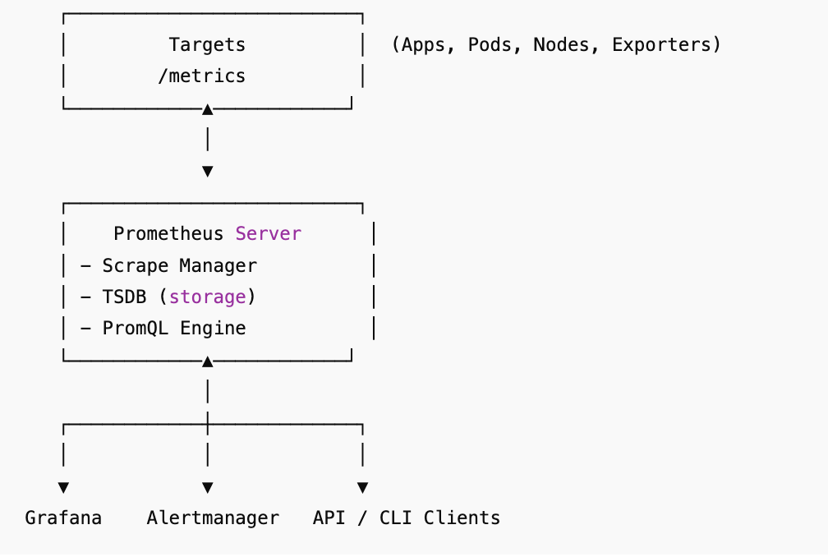

🔹 3. Important Components
- Prometheus Server → scrapes metrics + stores them in TSDB.
- Exporters → expose metrics:
  - Node Exporter → host metrics.
  - kube-state-metrics → K8s objects state.
  - Blackbox Exporter → probe endpoints.
  - Custom exporters.
- Pushgateway → for short-lived jobs (push model).
- Alertmanager → alert routing, grouping, silencing.
- Grafana → visualization layer.

🔹 4. Metrics Types
- Counter → monotonically increasing (requests served).
- Gauge → can go up/down (memory, CPU usage).
- Histogram → distributions (request latency buckets).
- Summary → quantiles (e.g., 95th percentile latency).

🔹 5. PromQL (Interview Favorite)
- Error rate:
- rate(http_requests_total{status=~"5.."}[5m])
- 95th percentile latency:
- histogram_quantile(0.95, rate(http_request_duration_seconds_bucket[5m]))
- CPU usage:
- avg(rate(container_cpu_usage_seconds_total[5m]))

🔹 6. Production-Level Considerations

Scalability
- Single Prometheus = single-node, non-clustered.
- For multi-cluster or long-term → use Thanos, Cortex, or Mimir.
- Use federation to scrape other Prometheus instances.

Retention & Storage
- Default = 15 days.
- Extend with:
- --storage.tsdb.retention.time=30d
- Persistent storage in Kubernetes → PVCs.
- For months/years → offload via Thanos (to S3/GCS).

High Cardinality Problem
- Too many unique label combinations = high memory usage.
- Example bad metric: http_requests_total{user_id="12345"}.
- Fix → aggregate via recording rules.

HA Setup
- Prometheus itself not clustered → run 2 replicas.
- External querier (Thanos/Cortex) handles deduplication.

Security
- /metrics can leak sensitive info → protect with TLS + Auth.
- Use RBAC in Kubernetes.
- NetworkPolicies to restrict access.

🔹 7. Prometheus in Kubernetes (Helm)
- Use kube-prometheus-stack Helm chart.
helm repo add prometheus-community https://prometheus-community.github.io/helm-charts
helm repo update

helm install monitoring prometheus-community/kube-prometheus-stack \
--namespace monitoring --create-namespace
Includes:
✅ Prometheus
✅ Grafana
✅ Alertmanager
✅ Node Exporter
✅ kube-state-metrics

🔹 8. Best Practices (SRE Golden Signals)
- Monitor 4 key signals:
  - Latency
  - Traffic
  - Errors
  - Saturation
- Define SLIs, SLOs, SLAs:
  - SLI: “99th percentile request latency < 500ms”.
  - SLO: “99% of requests meet SLI over 30 days”.
  - SLA: External commitment (with penalties).
- Alerting Best Practices:
  - Avoid “CPU > 80%” → too noisy.
  - Use symptom-based alerts (e.g., “95% of requests failing”).
  - Group alerts in Alertmanager → avoid alert storms.

🔹 9. Common Interview Questions & Answers

Q1: Why does Prometheus use a pull model?
- Predictable load, easier debugging, service discovery integration. Push is only via Pushgateway for batch jobs.

Q2: What is high-cardinality problem?
- Too many unique time-series due to labels → huge memory usage. Avoid labels like user_id, session_id.

Q3: How does Prometheus handle HA (High Availability)?
- Run 2 replicas scraping the same targets. Use Thanos/Cortex/Mimir for deduplication + querying.

Q4: What’s the difference between Histogram vs Summary?
- Histogram → aggregatable across instances, bucket-based.
- Summary → provides quantiles but not aggregatable.

Q5: How to scale Prometheus beyond a single cluster?
- Federation (basic), Thanos/Cortex/Mimir (enterprise-grade).

Q6: How do you secure Prometheus in Kubernetes?
- RBAC, TLS, mTLS, ingress auth, limit access to /metrics.

Q7: How to monitor Prometheus itself?
- Use metrics like:
- prometheus_tsdb_head_series (series count).
- prometheus_engine_query_duration_seconds (query time).

Q8: Difference between Prometheus vs Grafana vs Alertmanager?
- Prometheus = scrape + store + query.
- Grafana = visualize.
- Alertmanager = notifications & routing.

✅ Final Takeaways
- Prometheus = metrics core of observability stack.
- Runs well in Kubernetes with exporters + service discovery.
- For scalability/long-term → always mention Thanos/Cortex.
- Interview tip: Always bring answers back to SLOs, Golden Signals, symptom-based alerts → that’s what Google SREs care about.

🟢 Prometheus Internal Working (Simple Explanation)

1. How Prometheus collects data
- Prometheus pulls metrics — it doesn’t wait for apps to send data.
- It asks each target (like Node Exporter, app /metrics endpoint, etc.) every X seconds:
“Hey, give me your current metrics.”
- Targets reply in plain text (metric_name{labels} value).
📌 Example reply:
http_requests_total{method="GET",status="200"} 1234

2. How Prometheus stores data
- Prometheus turns each metric into a time series:
metric + labels → value over time.
- Data first goes to a WAL (Write Ahead Log) = a “notebook” in case Prometheus crashes.
- Then it writes metrics into blocks (2-hour chunks) on disk.
Old blocks are compacted and eventually deleted when retention expires.

3. How Prometheus answers queries
- You use PromQL to ask questions.
- Example:
"How many requests per second in the last 5 minutes?"
rate(http_requests_total[5m])
- Prometheus reads the stored blocks → applies math → gives back a time series result.

4. How alerts work
- Prometheus regularly checks rules you’ve defined.
- Example rule:
- alert: HighCPU
- expr: node_cpu_seconds_total > 0.8
- for: 5m
- If condition is true → Prometheus sends alert to Alertmanager.
- Alertmanager decides where to send it (Slack, PagerDuty, OCM, etc.).

5. Special case: short-lived jobs
- Normal apps can be scraped continuously.
- But batch jobs might finish before Prometheus scrapes them.
- Solution = Pushgateway → job pushes metrics there → Prometheus scrapes Pushgateway.

6. Scaling Prometheus
- By default, Prometheus is single-node.
- For big clusters:
  - Run two Prometheus replicas (for HA).
  - Use Thanos/Cortex/Mimir for long-term storage & global queries.
  - Or use federation (one Prometheus scrapes another).

🔹 Very Simple Diagram
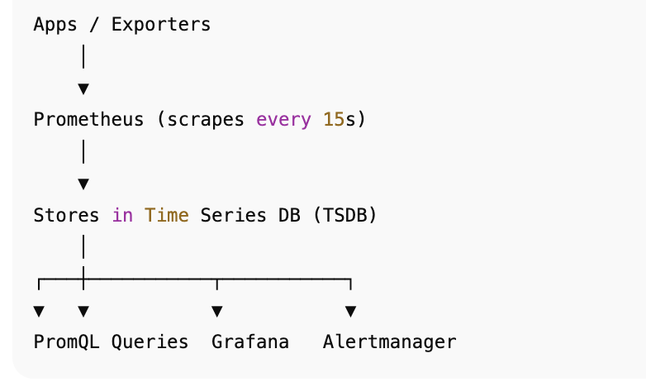

🎯 Key Interview Points
- Prometheus pulls metrics → easier to control, reliable.
- Data stored as time series in blocks with a WAL for crash recovery.
- PromQL is used to query.
- Alerts are generated inside Prometheus but managed by Alertmanager.
- Scaling is done with federation or Thanos (since Prometheus alone is single-node).

📘 Ultimate Grafana Interview Notes (Production-Level)

🔹 1. What is Grafana?
- Open-source observability and visualization platform.
- Allows you to query, explore, and visualize metrics, logs, and traces.
- Works with Prometheus, Loki, Tempo, Elasticsearch, InfluxDB, CloudWatch, Azure Monitor, etc.
- Often used in Kubernetes monitoring stacks with Prometheus.

🔹 2. Why Use Grafana?
✅ Unified dashboards (metrics, logs, traces in one place).
✅ Multi-datasource support.
✅ Easy visualization for SRE teams.
✅ Role-based access control (RBAC) for multi-team environments.
✅ Alerting engine with integrations (PagerDuty, Slack, email, Opsgenie).

🔹 3. Grafana Architecture

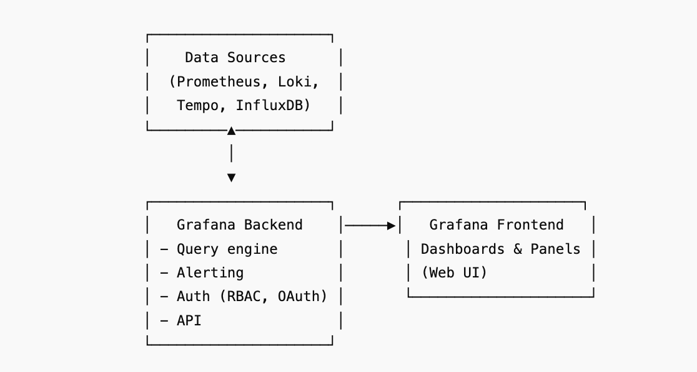

🔹 4. Key Concepts
- Dashboard → Collection of panels (visualizations).
- Panel → Individual visualization (graph, gauge, table, heatmap, etc.).
- Data Source → External system where data is stored (Prometheus, Loki).
- Alerting → Supports multi-channel alerts (Slack, PagerDuty, Teams).
- Annotations → Mark events on dashboards (e.g., deployments, incidents).
- Plugins → Extend functionality (new datasources, visualizations).

🔹 5. Grafana in Production Clusters

Deployment Methods
- Helm chart: grafana/grafana or part of kube-prometheus-stack.
- Docker / Kubernetes manifests.
- Grafana Cloud (managed).

Storage & Persistence
- Use PVCs (Persistent Volume Claims) for dashboards & configs.
- Or use Grafana provisioning with GitOps (dashboards as code).

Authentication & Security
- Local users, LDAP, OAuth (Google, GitHub, Okta, Azure AD).
- RBAC for multi-team environments.
- TLS termination with Ingress/Nginx.

Scaling
- Grafana itself is stateless → scale with replicas behind a load balancer.
- Use external DB (MySQL/Postgres) for shared state across replicas.

🔹 6. Grafana in Kubernetes with Helm

Install Grafana via Helm
helm repo add grafana https://grafana.github.io/helm-charts
helm repo update

helm install grafana grafana/grafana \
--namespace monitoring --create-namespace

Example values.yaml
adminUser: admin
adminPassword: strongpassword

persistence:
enabled: true
storageClassName: gp2
accessModes:
- ReadWriteOnce
size: 10Gi
service:
type: LoadBalancer

datasources:
datasources.yaml:
apiVersion: 1
datasources:
- name: Prometheus
type: prometheus
url: http://prometheus-server.monitoring.svc.cluster.local
access: proxy
isDefault: true

Access Grafana
kubectl port-forward svc/grafana -n monitoring 3000:80
Login → admin / strongpassword.

🔹 7. Alerting in Grafana
- Two alerting systems:
  - Classic alerting (legacy, dashboard panels).
  - Unified alerting (Grafana v8+, integrates across datasources).
- Alerts can notify via:
  - Slack, Teams, PagerDuty, Opsgenie, Email, Webhooks.

🔹 8. Grafana Best Practices (Production)
- Use folders + RBAC for multi-team dashboards.
- Store dashboards in Git (IaC) → version-controlled configs.
- Use annotations to mark deploys & incidents.
- Use provisioning for datasources, dashboards, alerts.
- Use external DB (Postgres/MySQL) for HA deployments.
- Monitor Grafana itself using /metrics endpoint → expose to Prometheus.

🔹 9. Common Interview Questions & Answers

Q1: How does Grafana differ from Prometheus?
- Prometheus = metrics collection + storage.
- Grafana = visualization + alerting + dashboards.

Q2: How do you set up Grafana in Kubernetes?
- Via Helm chart (grafana/grafana) or as part of kube-prometheus-stack. Use PVCs + external DB for persistence.

Q3: How do you scale Grafana for high availability?
- Run multiple replicas behind load balancer + external DB for shared state.

Q4: What authentication methods does Grafana support?
- Local users, LDAP, OAuth (Google, GitHub, Azure AD, Okta).

Q5: How can Grafana dashboards be managed as code?
- Use provisioning (YAML files) or tools like Grafana Terraform provider.

Q6: How do alerts work in Grafana?
- Grafana queries datasource → evaluates rules → sends alerts via integrated channels (Slack, PagerDuty, etc.).

Q7: How do you secure Grafana in production?
- TLS on ingress, OAuth for auth, RBAC, restrict admin accounts.

Q8: How do you monitor Grafana itself?
- Enable /metrics endpoint → scrape with Prometheus. Look at grafana_alerting_active_alerts, grafana_api_request_duration_seconds.

🔹 10. Final Takeaways
- Grafana = visualization + alerting hub.
- Works with Prometheus, Loki, Tempo → full observability.
- In Kubernetes: deploy via Helm, with PVCs + RBAC + Ingress.
- Scale with replicas + external DB.
- Interview Tip: Always mention GitOps (dashboards as code) and unified observability (metrics + logs + traces).

📘 Ultimate Loki Interview Notes (Production-Level)

🔹 1. What is Loki?
- Log aggregation system developed by Grafana Labs.
- Called "Prometheus for logs" → uses a similar label-based model.
- Cost-effective → does not index the full log content, only labels.
- Best used with Grafana for visualization.

🔹 2. Why Use Loki?
✅ Works natively with Grafana → unified observability (metrics + logs + traces).
✅ Efficient & cheap (indexes labels, stores raw logs in object storage).
✅ Kubernetes-native (integrates with promtail & fluent-bit).
✅ Horizontal scalability (via microservices mode).
✅ Query logs with LogQL (PromQL-like syntax).

🔹 3. Loki Architecture
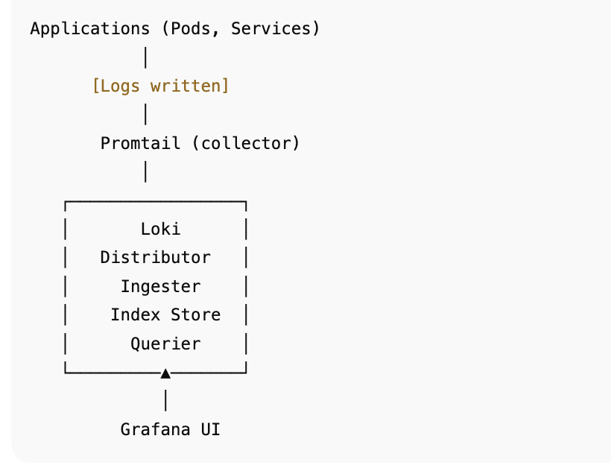

🔹 4. Key Components
- Loki (backend) → stores logs, indexes metadata (labels).
- Promtail → agent running on nodes (collects logs → pushes to Loki).
  - Reads from /var/log or container logs (/var/log/pods/...).
  - Adds labels (namespace, pod, container).
- LogQL (query language) →
  - Filter logs:
  - {app="nginx"} |= "error"
  - Count logs (metrics from logs):
  - count_over_time({app="nginx"}[5m])
- Grafana → queries Loki + displays logs in dashboards.

🔹 5. Loki Deployment Models
- Single Binary → Simple, dev/testing.
- Microservices Mode → HA & scalable (Distributor, Ingester, Querier, Ruler, etc.).
- Loki Stack Helm Chart → includes Loki + Promtail + Grafana.

🔹 6. Loki in Kubernetes with Helm

Install Loki & Promtail
helm repo add grafana https://grafana.github.io/helm-charts
helm repo update

# Install Loki
helm install loki grafana/loki-stack \
--namespace monitoring --create-namespace
This deploys:
- Loki
- Promtail
- (Optional) Grafana

Example values.yaml (Production)
loki:
persistence:
enabled: true
storageClassName: gp2
size: 100Gi
config:
table_manager:
retention_deletes_enabled: true
retention_period: 30d

promtail:
enabled: true
config:
clients:
- url: http://loki:3100/loki/api/v1/push
scrape_configs:
- job_name: kubernetes-pods
kubernetes_sd_configs:
- role: pod
relabel_configs:
- source_labels: [__meta_kubernetes_pod_label_app]
target_label: app

Access Logs in Grafana
- Add Loki as a data source in Grafana.
- Query logs using LogQL in Explore tab.

🔹 7. Production Best Practices
- Use object storage (S3, GCS, MinIO) for log storage.
- Enable retention policies (delete old logs).
- Use labels wisely → avoid high cardinality (don’t add request_id, user_id).
- Run in microservices mode for scale & HA.
- Use Promtail + relabeling to add useful Kubernetes labels.
- Use Loki Canary to verify log ingestion pipeline.
- Monitor Loki with Prometheus (loki_request_duration_seconds, loki_ingester_memory_usage_bytes).

🔹 8. Common Interview Questions & Answers

Q1: How is Loki different from ELK (Elasticsearch + Logstash + Kibana)?
- Loki indexes only labels, not full log text → more efficient.
- ELK is heavier (indexes full logs) → better search, but costlier.

Q2: How does Loki integrate with Prometheus & Grafana?
- Prometheus = metrics, Loki = logs.
- Grafana unifies both (dashboards + queries).

Q3: How do you deploy Loki in Kubernetes?
- Use grafana/loki-stack Helm chart. Include Promtail for log collection.

Q4: What is LogQL?
- Loki’s query language, similar to PromQL. Supports filtering logs, regex search, aggregations, metrics from logs.

Q5: How do you handle high log volume in Loki?
- Use object storage backend, run in microservices mode, enable compaction + retention policies, avoid high cardinality labels.

Q6: How does Promtail work?
- Runs on nodes, scrapes log files (e.g., /var/log/containers), adds Kubernetes metadata, pushes logs to Loki.

Q7: How do you secure Loki?
- Run behind Ingress + TLS, enable authN/Z, use network policies, restrict label usage to avoid log injection attacks.

Q8: How do you monitor Loki itself?
- Expose Loki’s Prometheus metrics (/metrics) → scrape → build dashboards for ingestion rate, query latency, error logs.

🔹 9. Final Takeaways
- Loki = cheap & scalable log aggregation.
- Works best in Kubernetes, as logs are automatically labeled with pod metadata.
- Integrates seamlessly with Grafana + Prometheus → full observability.
- In production → use object storage, retention, microservices mode, RBAC.
- Interview tip: Emphasize Loki’s efficiency vs ELK and tight integration with Prometheus/Grafana.

📘 Alertmanager Notes (Production-Level)

🔹 1. What is Alertmanager?
- A central component of the Prometheus ecosystem.
- Handles alerts generated by Prometheus.
- Responsible for:
  - Grouping (combine related alerts → reduce noise).
  - Routing (send to right receiver: Slack, Email, PagerDuty, etc.).
  - Silencing (temporarily mute known issues).
  - Inhibition (suppress alerts if another related alert is firing).
- Think of it as the "notification brain" of monitoring.

🔹 2. Architecture & Flow

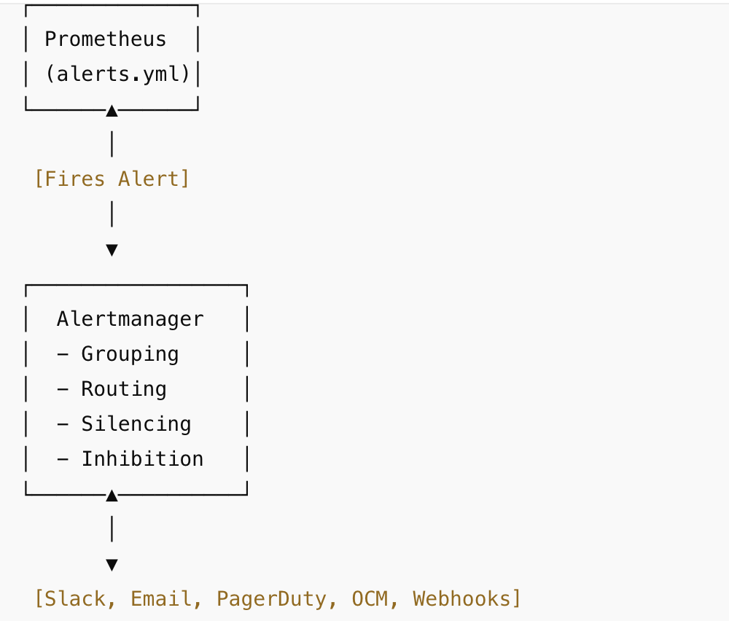

🔹 3. Core Features
- Receivers:
  - Where alerts go → Slack, Email, OCM, PagerDuty, OpsGenie, Webhook, etc.
- Grouping:
  - Example: 100 pod crash alerts grouped into 1 message.
- Silences:
  - Suppress alerts temporarily with matchers.
- Inhibition:
  - Example: Suppress "Pod Down" alert if "Node Down" alert is already firing.
- High Availability:
  - Run multiple Alertmanagers with mesh clustering.

🔹 4. Production Setup

⚙️ Deploy via Helm (kube-prometheus-stack)
Alertmanager is included by default.

📌 Example values.yaml
alertmanager:
alertmanagerSpec:
replicas: 2
resources:
requests:
memory: 1Gi
cpu: 200m
limits:
memory: 2Gi
cpu: 1
storage:
volumeClaimTemplate:
spec:
accessModes: ["ReadWriteOnce"]
resources:
requests:
storage: 10Gi

📨 Slack Integration
Create an Incoming Webhook in Slack, then configure:

🏢 OCM (OpenShift Cluster Manager) Integration
- OCM can consume Alertmanager alerts via webhook.
- Configure Alertmanager to send alerts to OCM:
- OCM will then aggregate alerts across clusters in its console.

🔹 5. Best Practices (Production)
- Always run at least 2 replicas (HA).
- Store configs in GitOps (ArgoCD/Flux).
- Use grouping rules → reduce Slack spam.
- Integrate with SLOs → avoid noisy alerts.
- Set escalation policies → Slack → PagerDuty.
- Regularly clean up silences (avoid muted forever).
- Protect web UI with RBAC + TLS.

🔹 6. Common Interview Questions

Q1: How does Alertmanager differ from Prometheus?
- Prometheus generates alerts, Alertmanager manages + routes alerts.

Q2: How do you prevent alert fatigue?
- Use grouping, inhibition, silencing, and ensure SLO-based alerts (not CPU > 80% type).

Q3: How do you ensure HA for Alertmanager?
- Run 2+ replicas in a cluster with mesh clustering.

Q4: How do you integrate Slack with Alertmanager?
- Configure slack_configs in receivers, use webhooks.

Q5: How does OCM fit in?
- OCM integrates with Alertmanager via webhooks, centralizing alerts from multiple clusters.

Q6: Can Alertmanager do deduplication?
- Yes, it deduplicates alerts before sending to receivers.

Q7: What’s the difference between silence & inhibition?
- Silence = manually muting alerts.
- Inhibition = automatic suppression if higher-priority alert is firing.

Q8: How do you test Alertmanager configs?
- Use amtool check-config alertmanager.yml.

🔹 7. Final Takeaways
- Prometheus = generates alerts
- Alertmanager = manages alerts
- In production →
✅ HA setup
✅ Slack + OCM integration
✅ SLO-based rules
✅ GitOps-managed configs

📘 Observability & Monitoring Stack (Production-Level)

🔹 1. High-Level Roles
Tool | Purpose
Prometheus | Metrics collection & storage (time-series DB)
Thanos | Prometheus at scale (long-term storage + global query + HA)
Grafana | Visualization, dashboards, alerting UI
Loki | Centralized log aggregation (logQL queries, cost-efficient vs ELK)
Instana | APM + distributed tracing + AI RCA (end-to-end observability)

🔹 2. Production-Level Architecture
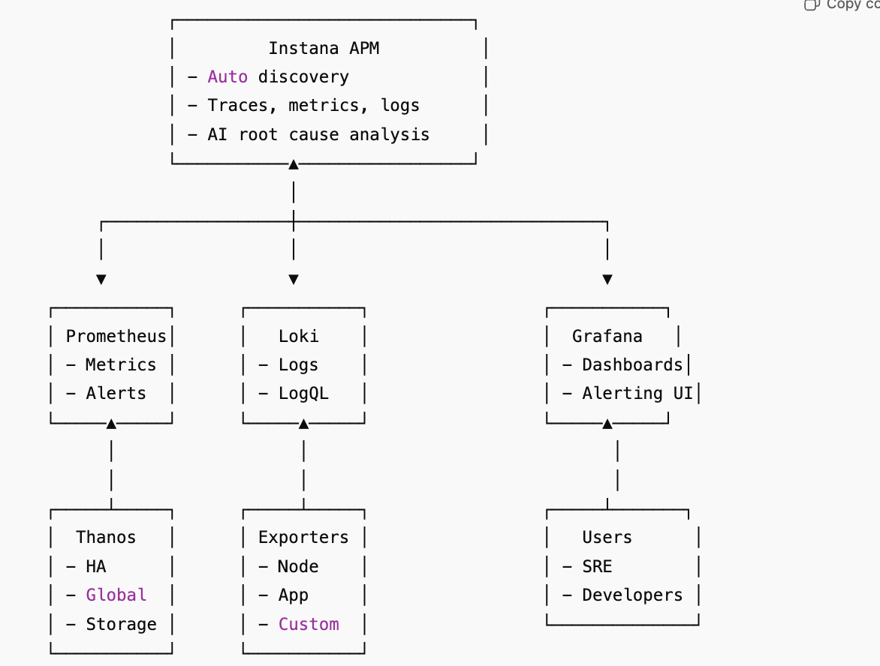

🔹 3. How They Connect
- Prometheus scrapes metrics (Node Exporter, kube-state-metrics, custom apps).
- Thanos federates multiple Prometheus instances, adds HA + long-term storage (S3/GCS).
- Grafana visualizes metrics (PromQL from Prometheus/Thanos) + logs (from Loki) + Instana (via plugin).
- Loki collects logs (via Promtail, Fluentd, or Fluent Bit) and integrates with Grafana.
- Instana agents auto-discover services, collect traces + app metrics, and can integrate with Slack/OCM for alerting.
- Alerts → Prometheus Alertmanager OR Instana → routed to Slack/OCM.

🔹 4. Production Considerations

🔸 Prometheus
- Use 2 replicas per cluster (HA).
- Don’t store long history (delegate to Thanos).
- Control label cardinality.

🔸 Thanos
- Object storage (S3/GCS/Azure Blob).
- Querier → global queries across clusters.
- Compactor → reduces data size.

🔸 Grafana
- Use folders + RBAC for dashboards.
- Enable SSO (OIDC/LDAP).
- Create team-based dashboards (SRE vs app teams).

🔸 Loki
- Use Promtail DaemonSet for log shipping.
- Store logs in object storage.
- Label logs only with low-cardinality fields (pod, namespace, app).

🔸 Instana
- Deploy agents as DaemonSets.
- Tag by env, cluster, team.
- Use Instana for APM + traces + SLOs.
- Integrate Slack + OCM for incidents.

🔹 5. Interview Q&A (Common for This Stack)

Q1. Why Prometheus + Thanos instead of just Prometheus?
- Prometheus alone has limited retention & scale.
- Thanos adds infinite retention, global queries, and HA using object storage.

Q2. How does Grafana use multiple data sources?
- Grafana connects to Prometheus/Thanos (metrics), Loki (logs), Instana (APM), Elasticsearch, etc.

Q3. Why Loki vs ELK?
- Loki is index-light (indexes only labels, not full text) → cost-effective for K8s logs.
- ELK is powerful but resource-heavy.

Q4. When to use Instana if Prometheus already exists?
- Prometheus = infra + app metrics (manual setup).
- Instana = auto-discovery + distributed tracing + AI root cause → faster incident response.

Q5. How does alerting work in this stack?
- Prometheus → Alertmanager → Slack/OCM.
- Instana → direct Slack/OCM integration.
- Grafana → can send alerts, but usually uses Alertmanager/Instana for routing.

Q6. How do you monitor multiple clusters?
- Run Prometheus per cluster → federate via Thanos Querier.
- Instana → one SaaS view across all clusters.
- Grafana → dashboards across all data sources.

Q7. What’s your log + metric correlation workflow?
- In Grafana:
- Start with metric spike (Prometheus/Thanos).
- Pivot into logs (Loki) with the same labels (pod, namespace).
- Use Instana traces to see end-to-end request flow.

🔹 6. Final Takeaways for Interviews
- Prometheus + Thanos → scalable metrics pipeline.
- Grafana → single pane of glass for visualization.
- Loki → lightweight, Kubernetes-friendly log storage.
- Instana → full APM + tracing + RCA.
- Together → complete observability stack (metrics + logs + traces + RCA).
- For interviews, always talk about:
- Scalability (Thanos + Instana SaaS).
- Integration (Grafana as the unified view, Slack/OCM for alerts).
- Correlation (metrics ↔ logs ↔ traces).
- Best practices (labeling, retention, HA, low cardinality).

🔹 Extended Notes

1. Additional Exporters
- Blackbox Exporter
  - Purpose: Probe endpoints externally (HTTP, TCP, DNS, ICMP).
  - Use cases:
    - Check if website/API is up (200 OK).
    - DNS resolution issues.
    - ICMP latency (ping).
  - Example metric: probe_success (1 if reachable, 0 if not).
- TLS/SSL Exporter
  - Purpose: Monitor SSL/TLS certificate validity.
  - Example metric: probe_ssl_earliest_cert_expiry.
  - Use cases: Alert before cert expiry to prevent downtime.
- Process Exporter
  - Tracks resource usage of specific processes.
  - Example metric: process_cpu_seconds_total.
- cAdvisor (Container Advisor)
  - Container-level metrics (CPU, memory, I/O).
  - Usually scraped by kubelet.

2. Essential Grafana Dashboards
- Node Health Dashboard
  - CPU, memory, disk usage, network bandwidth.
  - Key metric: node_filesystem_avail_bytes → disk pressure alerts.
- Kubernetes Cluster Health
  - Pods Pending, CrashLoopBackOff, ReplicaSet mismatches.
  - Metrics:
    - kube_pod_status_phase{phase="Pending"}
    - kube_deployment_status_replicas_unavailable
- RED Method (Rate, Errors, Duration)
  - Used for microservices monitoring.
  - Example:
    - Request rate → http_requests_total
    - Error rate → http_requests_total{status=~"5.."}
    - Duration → histogram_quantile(0.95, rate(http_request_duration_seconds_bucket[5m]))
- Golden Signals Dashboard
  - Latency, Traffic, Errors, Saturation (from Google SRE book).
  - Covers both system + app-level metrics.

3. Troubleshooting Scenarios
Issue | Where to Look | Metrics to Check
Pod keeps OOMKilled | kubelet + cAdvisor | container_memory_usage_bytes vs container_spec_memory_limit_bytes
API server slow | API server metrics + etcd | apiserver_request_duration_seconds, etcd_request_duration_seconds
Disk full on node | Node Exporter | node_filesystem_avail_bytes
Jobs not visible | Pushgateway issues | Check if job metrics were pushed, push_time_seconds
High cardinality | Prometheus memory spike | Metrics with pod, container, path, user_id labels

⚠️ Golden Rule:
Start from alerts, drill down with Grafana, confirm with logs (Loki).

4. Interview Edge Cases
- What happens if Prometheus crashes?
  - WAL (Write Ahead Log) ensures recovery.
  - WAL stores recent samples on disk → replay on restart.
- Why not use Pushgateway for services?
  - Pushgateway is only for short-lived jobs.
  - Services should expose metrics → Prometheus pulls.
  - Risk: Stale metrics if not updated regularly.
- How to reduce noisy alerts?
  - Inhibition rules in Alertmanager (e.g., suppress Pod alerts if Node is down).
  - Deduplication: Avoid multiple alerts for same root cause.
  - Symptom-based alerting: Alert on “service unavailable” instead of CPU high.
- What’s the difference between federation and remote_write?
  - Federation: Pull model (Prometheus scrapes another Prometheus). Good for aggregating specific metrics.
  - remote_write: Push model (Prometheus pushes to remote storage like Thanos, Cortex). Good for long-term storage.

