**Khobiza Pharmacy**

Is a website that helps connect buyers with pharmacies near their locations that helps them to get medicine without searching for a nearby pharmacy and going there themselves saving a lot of time and helping people who can’t go there themselves.

Group Members:

1. Salman Khatib
2. Mohannad Salman
3. Nizam Jawabra
4. Omar Daqqa

**Registration page**

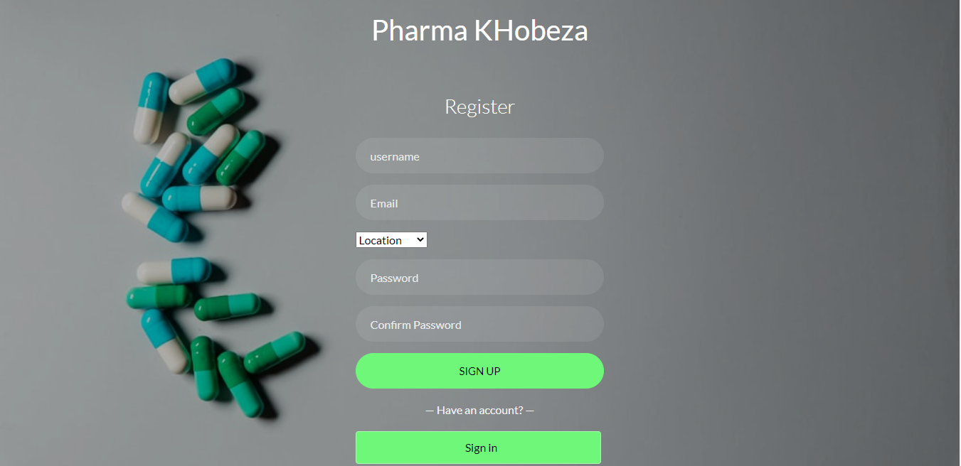

**Login page**

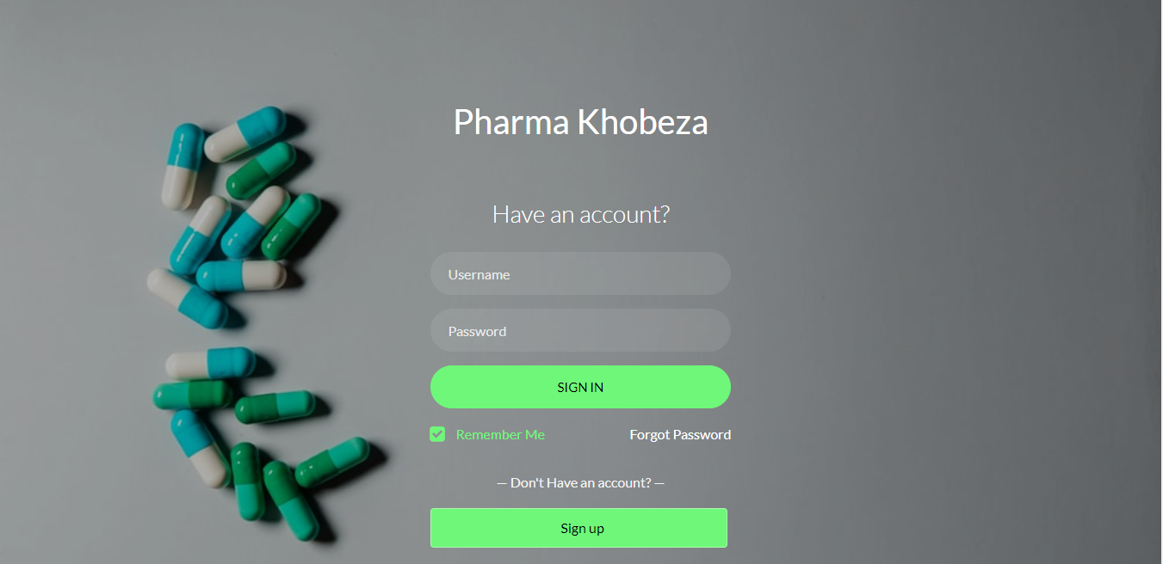

**Token Page**

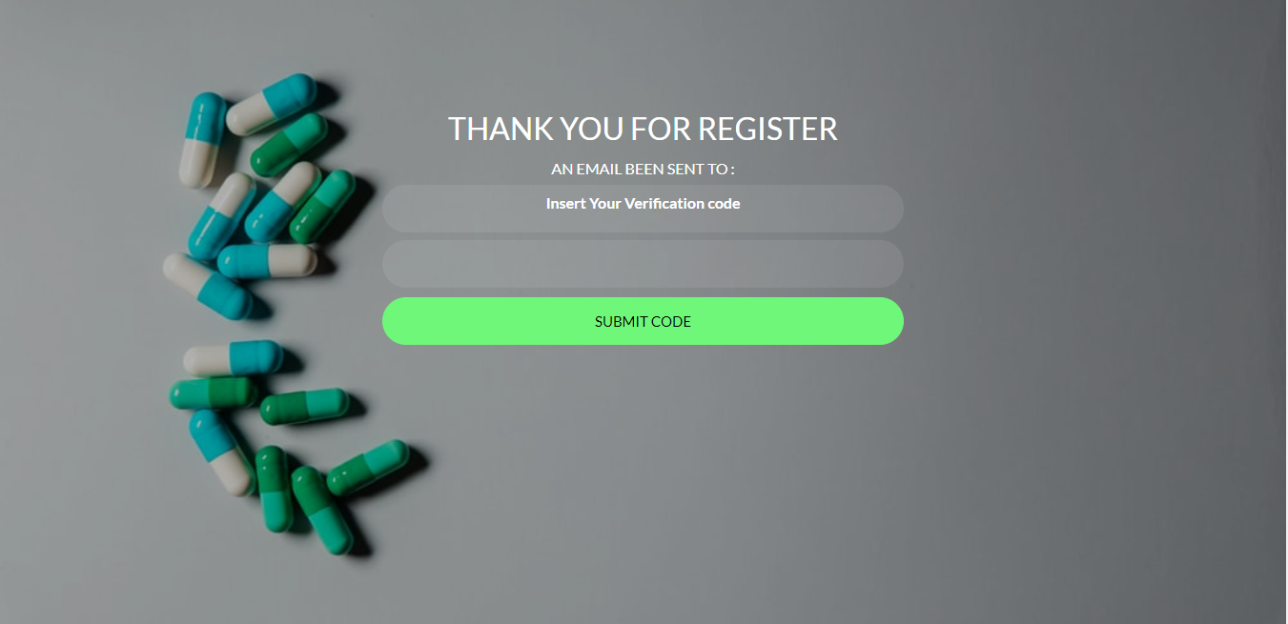

**Admin Page:**

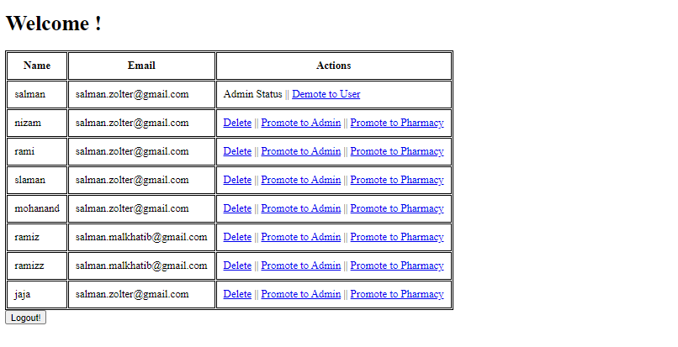

**Create Product Page**

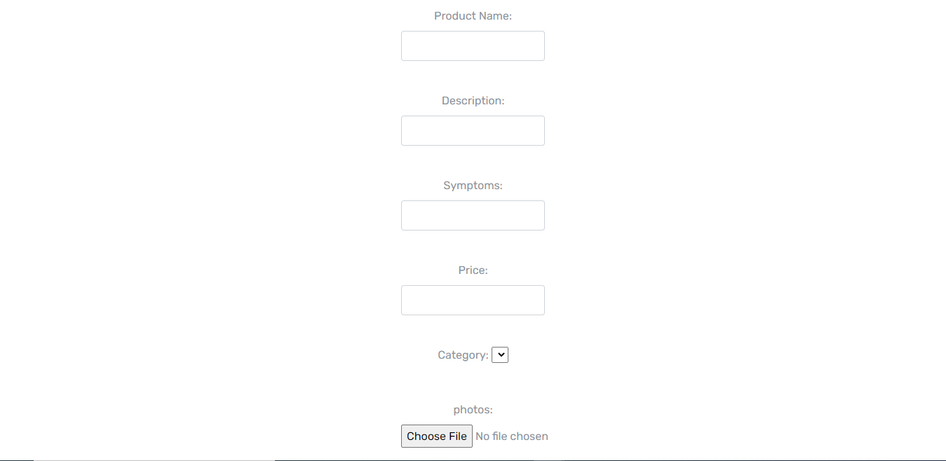

Show All Product Page:

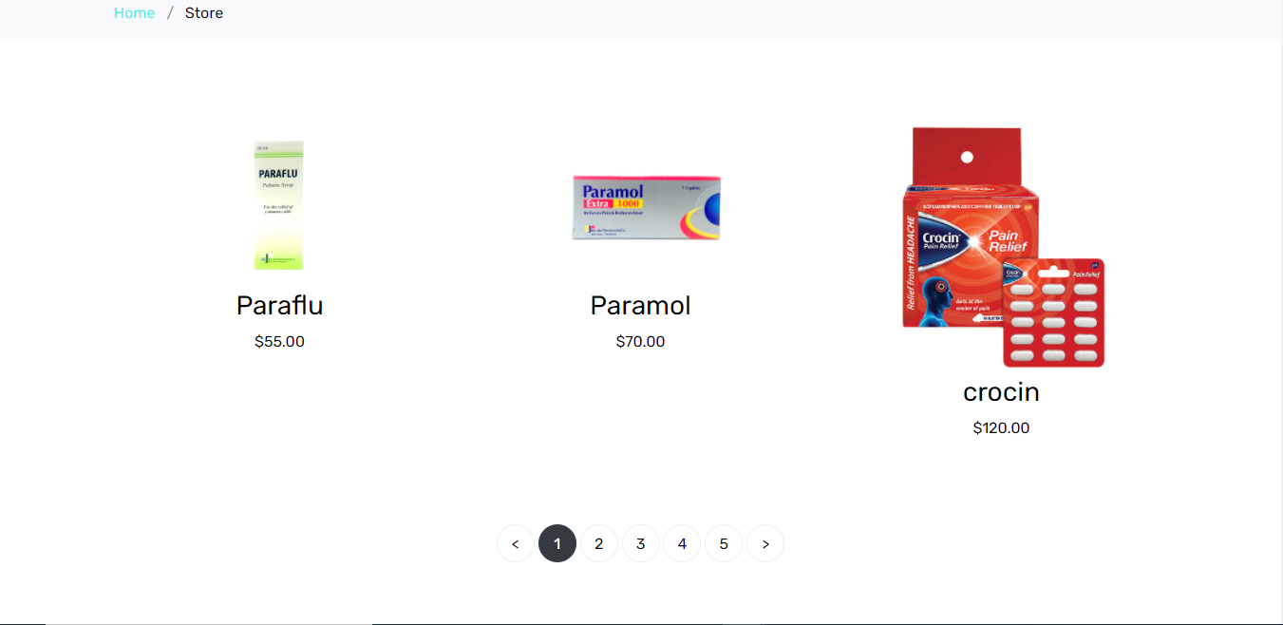

**Edit Product**

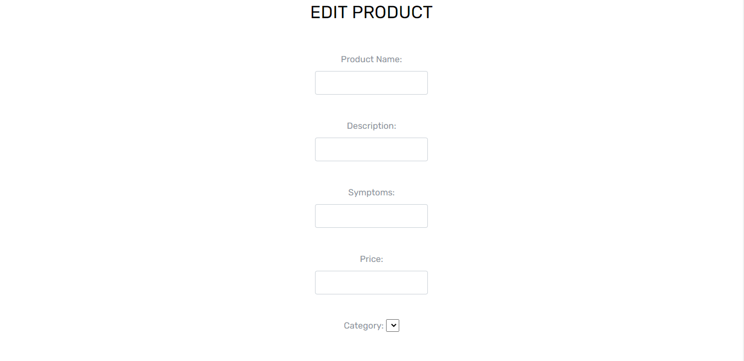

Home page

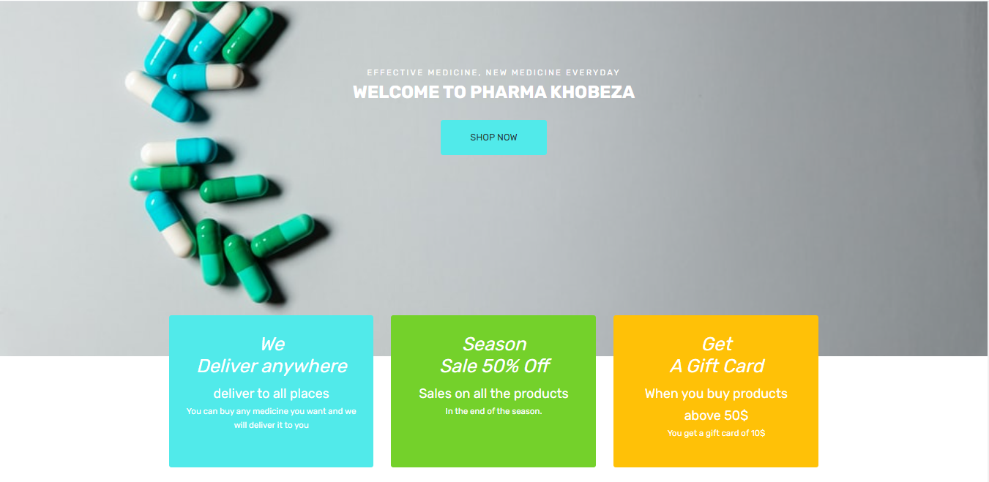

Pharmacies Page:

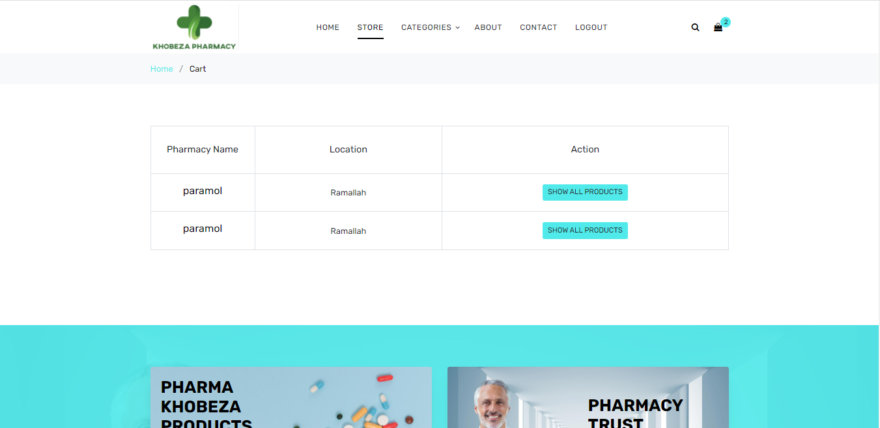

About us Page



All products Page:



Show Specific Product page

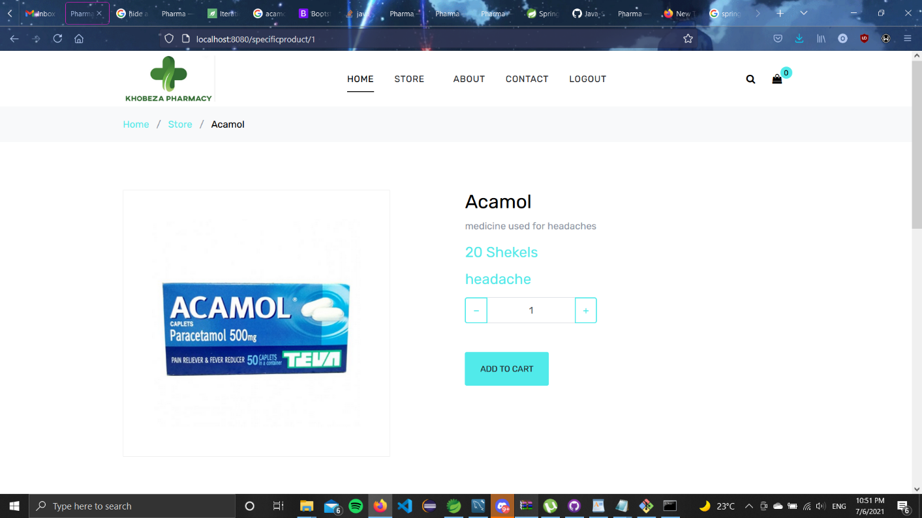

Cart Page:

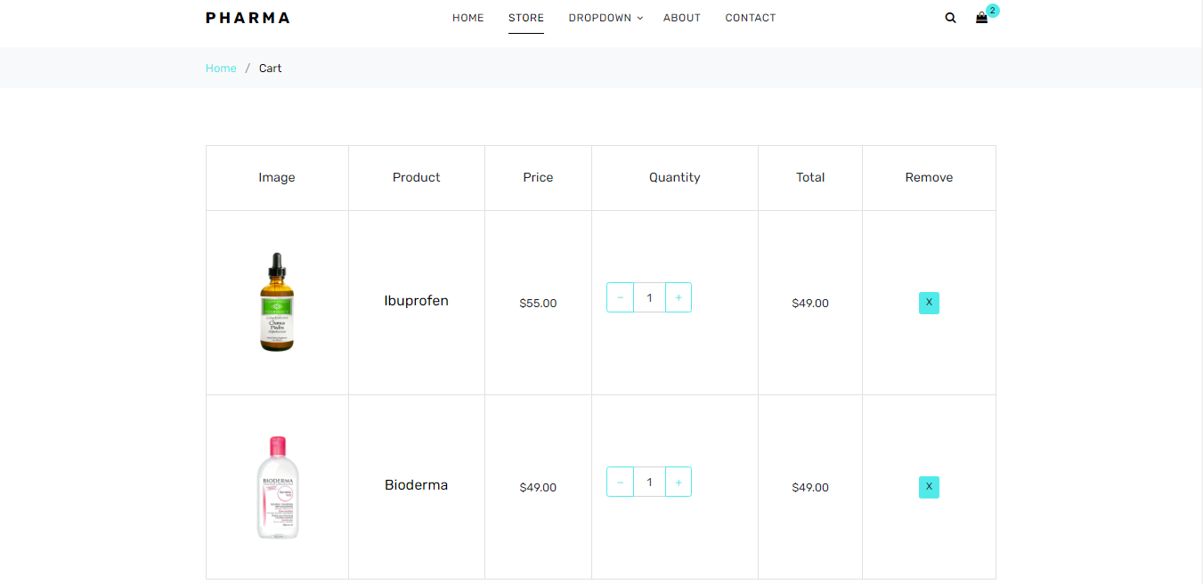

Checkout Page:

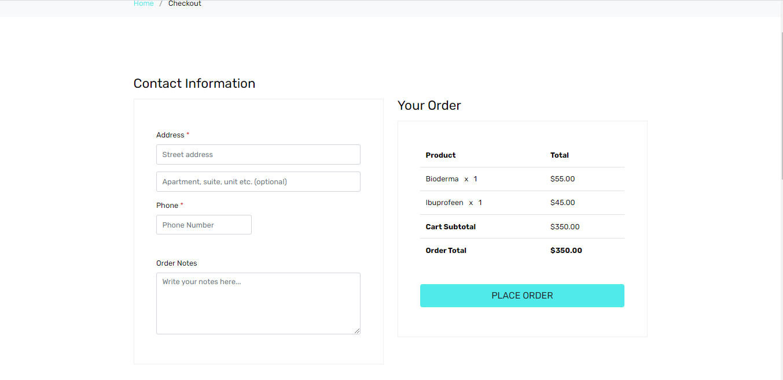

Thank you Page

