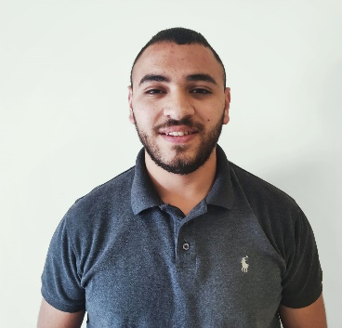Mr. Mohannad Salman

Bethlehem, West Bank, Palestine

Mobile: +970 592371374

Tel.: +970 2 2745677

Email: [mohannadadeeb89@gmail.com](https://mail.google.com/mail/u/0/#inbox)

**PERSONAL DATA:**

* Nationality: Palestinian
* Date of birth: Dec 11,1998
* Place of birth: Bethlehem, Palestine
* Marital status: Single

**EDUCATION AND QUALIFICATIONS:**

**2015-2016. A Certification in Scientific Section At** [**Bethlehem Secondary School**](https://ar-ar.facebook.com/blbss2012/)

**2016-Present.The** [**Palestine Ahliya University College (PAUC)**](http://paluniv.edu.ps/)**,bachelor of degree in Information Technology.**

**2021-Present.**[**AXSOS Academy**](https://academy.axsos.ps/) **Training.**

**Training**

* Subjects included:

**Computer Programming, Introduction in Computer Networks, Calculus, C++, C++ advanced,**

**E learning, computer basics and programming.**

_____________________________________________________________________________

**ACTIVITIES AND INTERESTS:**

* Programming languages.
* Communication Skills.
* Community Involvement.
* Sports.

**WORK EXPERIENCE:**

* **Volunteer at** [**Palestinian Medical Relief Society**](https://www.facebook.com/%D8%AC%D9%85%D8%B9%D9%8A%D8%A9-%D8%A7%D9%84%D8%A7%D8%BA%D8%A7%D8%AB%D8%A9-%D8%A7%D9%84%D8%B7%D8%A8%D9%8A%D8%A9-%D8%A7%D9%84%D9%81%D9%84%D8%B3%D8%B7%D9%8A%D9%86%D9%8A%D8%A9-%D8%A8%D9%8A%D8%AA-%D9%84%D8%AD%D9%85-1641678129482674/) **as a first Aid giver ,Palestine September 23,2013-Present. I participated in the International Marathon of Palestine and Christmas events.**
* **Worked in Jerashi sport center, Palestine for one month.**
* **Worked in a Restaurant, Palestine October 27,2017-December 12, 2019.As a Waiter.**

**PROFESSIONAL AND TECHNICAL SKILLS:**

* **PLATFORMS:**
* **Microsoft Windows including: 7,10, XP**
* **PROGRAMMING LANGUAGES:**
* **C++**
* **Java**
* **CSS**
* **ASP.NET**
* **PHP**
* **Java Script**
* **Python**

**LANGUAGES:**

**Arabic:** Native language.

**English:** Excellent Reading, moderateWriting.

**French:** beginner.

**REFERENCES:**

**Dr. Eng. Ahmad Hasasneh**

**IT Department**

**Supervisor for IT Students**

**Palestine Ahliya University College**

**Bethlehem, Palestine**

[**ahasasneh@paluniv.edu.ps**](https://plus.google.com/105708321709462336751) **Tel: +970 598363438**

**Dr. Jamil Itmazi**

**IT Department/Associate Professor**

**Scientific Research Officer**

**Palestine Ahliya University College**

**Bethlehem, Palestine**

[**J.itmazi@paluniv.edu.ps**](mailto:J.itmazi@paluniv.edu.ps) **Tel: +970 599097780**

**Mr. Sameh Takatka**

**IT Department**

**Supervisor for MIS Students**

**Palestine Ahliya University College**

**Bethlehem, Palestine**

[**Sameh@paluniv.edu.ps**](mailto:Sameh@paluniv.edu.ps) **Tel: +970 569862233**

**Mr. Abed Ghareep**

**Chief of first aid giver groups**

**Palestinian Medical Relief Society**

**Bethlehem, Palestine**

[**Abedghareep12@gmail.com**](mailto:Abedghareep12@gmail.com) **Tel: +970 595840600**