|  |  |  |  |  |  |  |  |  |  |
| --- | --- | --- | --- | --- | --- | --- | --- | --- | --- |
| **SCHOOLOFCOMPUTER SCIENCE AND ARTIFICIAL INTELLIGENCE** | | | | | **DEPARTMENTOFCOMPUTER SCIENCE ENGINEERING** | | | | |
| **ProgramName:**B. Tech | | | | **AssignmentType: Lab** | | | **AcademicYear:**2025-2026 | | |
| **CourseCoordinatorName** | | | | Venkataramana Veeramsetty | | | | | |
| **Instructor(s)Name** | | | | |  | | --- | | Dr. V. Venkataramana (Co-ordinator) | | Dr. T. Sampath Kumar | | Dr. Pramoda Patro | | Dr. Brij Kishor Tiwari | | Dr.J.Ravichander | | Dr. Mohammand Ali Shaik | | Dr. Anirodh Kumar | | Mr. S.Naresh Kumar | | Dr. RAJESH VELPULA | | Mr. Kundhan Kumar | | Ms. Ch.Rajitha | | Mr. M Prakash | | Mr. B.Raju | | Intern 1 (Dharma teja) | | Intern 2 (Sai Prasad) | | Intern 3 (Sowmya) | | NS_2 ( Mounika) | | | | | | |
| **CourseCode** | | | 24CS002PC215 | **CourseTitle** | | AI Assisted Coding | | | |
| **Year/Sem** | | | II/I | **Regulation** | | R24 | | | |
| **DateandDay**  **of Assignment** | | | Week4 - Thursday | **Time(s)** | |  | | | |
| **Duration** | | | 2 Hours | **Applicableto**  **Batches** | |  | | | |
| **AssignmentNumber:7.4**(Presentassignmentnumber)/**24**(Totalnumberofassignments) | | | | | | | | | |
|  | | | | | | | | | |
|  | | | | | | | | | |
|  | **Q.No.** | **Question** | | | | | | ***ExpectedTime***  ***to complete*** |  |
|  | 1 | Lab 7: Error Debugging with AI – Systematic Approaches to Finding and Fixing Bugs  Lab Objectives:   * To identify and correct syntax, logic, and runtime errors in Python programs using AI tools. * To understand common programming bugs and AI-assisted debugging suggestions. * To evaluate how AI explains, detects, and fixes different types of coding errors. * To build confidence in using AI to perform structured debugging practices.   Lab Outcomes (LOs):  After completing this lab, students will be able to:   * Use AI tools to detect and correct syntax, logic, and runtime errors. * Interpret AI-suggested bug fixes and explanations. * Apply systematic debugging strategies supported by AI-generated insights. * Refactor buggy code using responsible and reliable programming patterns.   **Task Description #1:**  • Introduce a buggy Python function that calculates the factorial of a number using recursion. Use Copilot or Cursor AI to detect and fix the logical or syntax errors.    **Expected Outcome #1:**  **•**Copilot or Cursor AI correctly identifies missing base condition or incorrect recursive call and suggests a functional factorial implementation.  **Task Description #2:**  **•**Provide a list sorting function that fails due to a type error (e.g., sorting list with mixed integers and strings). Prompt AI to detect the issue and fix the code for consistent sorting**.**    **Expected Outcome #2:**  **•**AI detects the type inconsistency and either filters or converts list elements, ensuring successful sorting without a crash.  **Task Description #3:**  **•** Write a Python snippet for file handling that opens a file but forgets to close it. Ask Copilot or Cursor AI to improve it using the best practice (e.g., with open() block).  **Code1**    **Code2**    **Code3**    **Code4:**    **Expected Outcome #3:**  **•** AI refactors the code to use a context manager, preventing resource leakage and runtime warnings.  **Task Description #4:**  **•** Provide a piece of code with a ZeroDivisionError inside a loop. Ask AI to add error handling using try-except and continue execution safely.    **Expected Outcome #4:**  **•** Copilot adds a try-except block around the risky operation, preventing crashes and printing a meaningful error message.  **Task Description #5:**  **•** Include a buggy class definition with incorrect __init__ parameters or attribute references. Ask AI to analyze and correct the constructor and attribute usage.  class StudentRecord:  def __init__(self, name, id, courses=[]):  self.studentName = names  self.student_id = id  self.courses = courseList  def add_course(self, course):  self.courses.append(course)  def get_summary(self):  return f"Student: {self.studentName}, ID: {self.student_id}, Courses: {', '.join(self.courses)}"  class Department:  def __init__(self, deptName, students=None):  self.dept_name = deptName  self.students = students  def enroll_student(self, student):  self.students.append(student)  def department_summary(self):  return f"Department: {self.dept_name}, Total Students: {len(self.student)}"    s1 = StudentRecord("Alice", 101, ["Math", "Science"])  d1 = Department("Computer Science")  d1.enroll_student(s1)  print(s1.get_summary())  print(d1.department_summary())  **Expected Outcome #5:**  **•** Copilot identifies mismatched parameters or missing self references and rewrites the class with accurate initialization and usage. | | | | | | Week4 - Thursday |  |

**Task Description #1:**

• Introduce a buggy Python function that calculates the factorial of a number using recursion. Use Copilot or Cursor AI to detect and fix the logical or syntax errors.

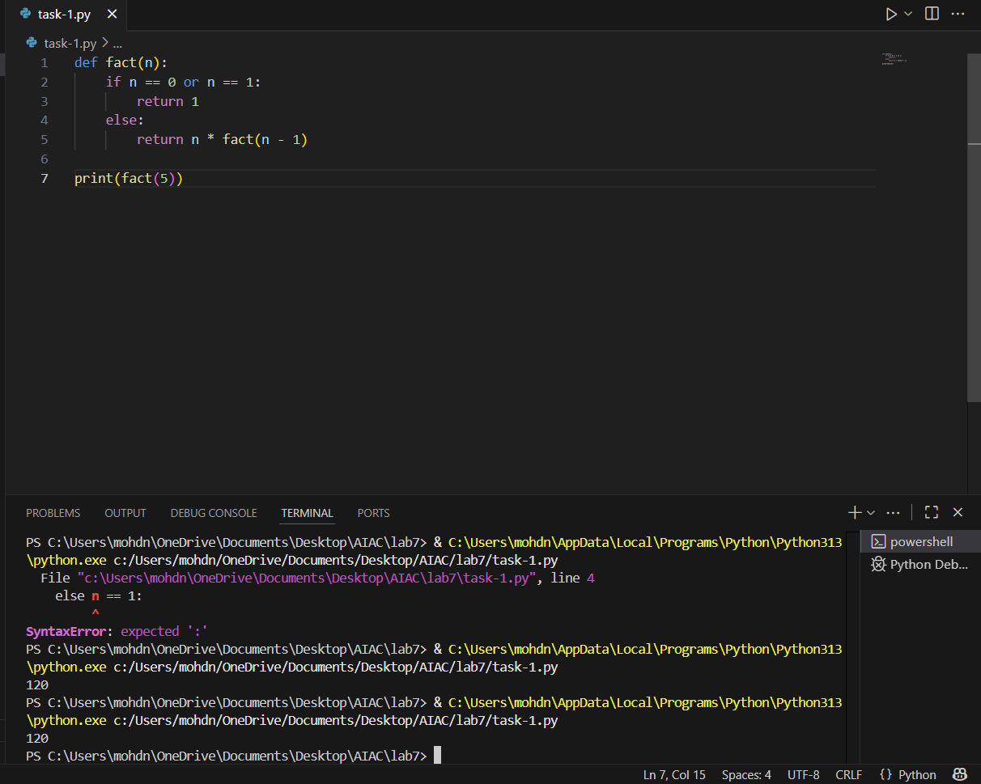

**Task Description #2:**

**•**Provide a list sorting function that fails due to a type error (e.g., sorting list with mixed integers and strings). Prompt AI to detect the issue and fix the code for consistent sorting

**Task Description #3:**

**•** Write a Python snippet for file handling that opens a file but forgets to close it. Ask Copilot or Cursor AI to improve it using the best practice (e.g., with open() block).

**Output:**

**Task Description #4:**

**•** Provide a piece of code with a ZeroDivisionError inside a loop. Ask AI to add error handling using try-except and continue execution safely.

**Task Description #5:**

**•** Include a buggy class definition with incorrect __init__ parameters or attribute references. Ask AI to analyze and correct the constructor and attribute usage.

Output:

