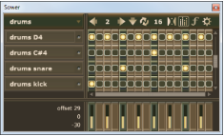
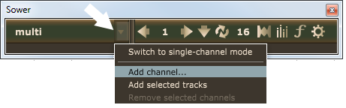
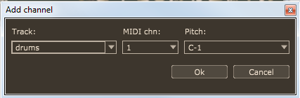
Sower
Reaper DAW Extension
http://nizzei8q.bget.ru/sower
Concepts
Sower is a MIDI editor that looks and works like a step sequencer - but with one difference: it writes musical notes directly into MIDI clips, without use of any intermediate patterns.
The plugin works in two modes. “Multi-channel mode” lets you add a number of rows to the grid, each one of which corresponds to an individual pitch from any track. “Single-track mode” has 128 rows for each pitch from one single track.
Notes are inserted and deleted by clicking the grid cells. If there's no item on a track at the point of note insertion, then either a new item is added automatically or the previous one is expanded, depending on current settings.
The time resolution of the grid may be changed from 1/4th to 1/128th note. During switching to another musical bar, the resolution may be auto-increased if necessary to show all the existing MIDI notes of the new bar. The grid may be set to use triplets and number of bars = 1, 2 , or 4. The channels may be selected to copy and paste notes into another location. The bottom pull-out panel with sliders serves for adjustment of note parameters.
Launching
The plugin adds its item to the Extension menu and the corresponding record to the Action list.
Quick start
The first time you start the plugin, it will look like this. Click the main menu button, choose “Add channel” from the menu and set the track and pitch for a new channel in the dialog window.

Repeat to add more channels. Click on a channel label to open the channel menu.

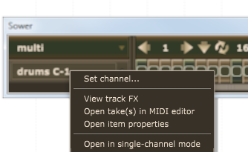
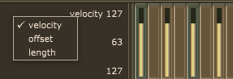
If you prefer to work with all 128 notes from the same one track, select “Switch to single-channel mode” from the main menu, then open the menu again and select “Set channel” to choose a track. Alternatively, click on any channel name in multi-mode and select “Open in single-track mode”.

Click on the grid cells to insert notes, click again to delete. You can also drag mouse to insert/delete several notes at once. Right-click on a cell to set the note properties.

To change the musical bar, either use navigation buttons on the toolbar, or scroll the bar number, or press arrow keys on your keyboard. The toolbar button with a down-arrow on it lets you sync playback position to Reaper.


Click a channel selector to select a channel, click again to select all channels. Use Shift key to add a channel to your selection. To copy and paste selected rows, use menu commands or standard key combinations:
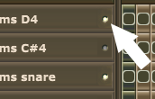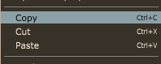

The second scroller is used to adjust the grid resolution (16 here means 1/16th note):
The minimum is 1/4 and the maximum is set in program options (the last button on the toolbar).

This button sets the behaviour in case when there's no item to insert a MIDI note into. The first option is stretching the previous MIDI item and the second is inserting a new one:

This button shows/hides the control panel. Drag sliders to set note properties. Right-click to switch the parameter:

This button opens MIDI Processor:
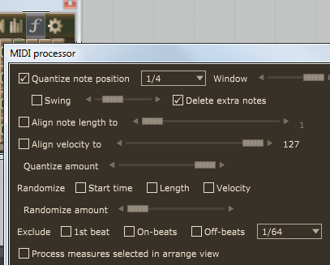

MIDI Processor lets you quantize and randomize notes of selected Sower channels. The time range is either the current bar (you can switch to Sower window and choose another bar without leaving the dialog), or within a range of bars that are selected in Arrange view (“Process measures selected in arrange view” option).
“Quantize note position” - select to line up notes to a grid with resolution set in the adjacent control. Note that if the sequencer window is set to use triplets, the quantizer uses triplets. “Window” parameter determines whether to quantize notes that are far from quantization points or not. “Swing” lets you shift every second note forward by given amount. “Delete extra notes” - erase MIDI notes that are between the quantized ones.
Both quantizing and “Align note length/velocity...” functions depend on the “Quantizing strength” slider, which deternines how closely source values will be moved to the requested value.
“Exclude”: this option lets you leave alone some notes: the first beat of the measure and notes that are on-beats and off-beats with the resolution specified in the drop-down box.
Processing occurs each time you press the “Apply” button.

The last toolbar button opens program settings:
“Max. resolution”: grid time resolution limit; if, for example, set to 1/32th note, then the plugin ignores any 1/64th notes - this prevents the situation when a 1/32th note that is shifted a bit would be treated as a 1/64th one, causing auto-expansion of the grid.
“Default pitch / midi channel” values are used as defaults when new channels are added.
“Delete MIDI item after the last note is deleted” - works only if there's no any other events – e.g. controllers – within any take inside that item.
“Allow undo ..” - clear to prevent adding much to the Undo history.

