1. **INTRODUCTION**

**1.1 PROJECT OVER VIEW**

* The main scope of mini-project titled “HOME ELITE” is to enable the user to search home and shops for rental
* The project contains rental search to find rental both residential and commercial property to find in this web application
* The user can find ,insert property for both commercial and residential by search and post free ad button on the web application.in this website most genuine property are added for customer details
* Admin Module
* User Module

**1.2 MODULE DESCRIPTION**

**ADMIN MODULE :**

This module includes the admin activities such as Viewing the Feedback forms and Reports of updating the Propertys details.

This module consists of the details like sub modules as

* Report Details
* Property Details
* Feedback Details

**USER MODULE :**

* The user can find ,insert property for both commercial and residential by search and post free ad button on the web application.in this website most genuine property are added for customer details and user can edit their accounts and delete their own posted ads.

**2. SYSTEM SPECIFICATION**

**2.1 SOFTWARE REQUIREMENT**

Operating system: WINDOW’S 7

Front End Tool: SUBLIME TEXT

Back End Tool: PHP-MY- ADMIN, MYSQLI

**2.2 HARDWARE REQUIREMENT**

* PROCESSOR : AMD PHENOM™ 2.90 GHZ
* RAM : 2.00 GB
* MONITOR : STANDARD LCD MONITOR
* HARD DISK : 80GB
* KEYBOARD : STANDARD KEYBOARD
* MOUSE : OPTICAL MOUSE

**2.3 SOFTWARE DESCRIPTION**

* FRONT END : HTML,CSS,JS
* BACK END : PHP,MYSQL
* SERVER : XAMPP SERVER
* OPERATING SYSTEM : WINDOWS 7/8/10

**ABOUT PHP:**

**PHP** is a [server-side scripting](https://en.wikipedia.org/wiki/Server-side_scripting) language designed for [web development](https://en.wikipedia.org/wiki/Web_development) but also used as a [general-purpose programming language](https://en.wikipedia.org/wiki/General-purpose_programming_language). It is originally created by [RasmusLerdorf](https://en.wikipedia.org/wiki/Rasmus_Lerdorf) in 1994,the PHP [reference implementation](https://en.wikipedia.org/wiki/Reference_implementation) is now produced by The PHP Group.PHP originally stood for *Personal Home Page*, but it now stands for the [recursive](https://en.wikipedia.org/wiki/Recursive_acronym)[acronym](https://en.wikipedia.org/wiki/Acronym)*PHP: Hypertext Preprocessor*PHP code may be embedded into [HTML](https://en.wikipedia.org/wiki/HTML) code, or it can be used in combination with various [web template systems](https://en.wikipedia.org/wiki/Web_template_system), web content management systems, and [web frameworks](https://en.wikipedia.org/wiki/Web_framework). PHP code is usually processed by a PHP [interpreter](https://en.wikipedia.org/wiki/Interpreter_(computing)) implemented as a [module](https://en.wikipedia.org/wiki/Plugin_(computing)) in the web server or as a [Common Gateway Interface](https://en.wikipedia.org/wiki/Common_Gateway_Interface) (CGI) executable. The web server combines the results of the interpreted and executed PHP code, which may be any type of data, including images, with the generated web page. PHP code may also be executed with a [command-line interface](https://en.wikipedia.org/wiki/Command-line_interface) (CLI) and can be used to implement [standalone](https://en.wikipedia.org/wiki/Computer_software)[graphical applications](https://en.wikipedia.org/wiki/Graphical_user_interface)

The standard PHP interpreter, powered by the [Zend Engine](https://en.wikipedia.org/wiki/Zend_Engine), is [free software](https://en.wikipedia.org/wiki/Free_software) released under the [PHP License](https://en.wikipedia.org/wiki/PHP_License). PHP has been widely ported and can be deployed on most web servers on almost every [operating system](https://en.wikipedia.org/wiki/Operating_system) and [platform](https://en.wikipedia.org/wiki/Computing_platform), free of charge.

The PHP language evolved without a written [formal specification](https://en.wikipedia.org/wiki/Formal_specification) or standard until 2014, leaving the canonical PHP interpreter as a [*de facto*](https://en.wikipedia.org/wiki/De_facto) standard. Since 2014 work has gone on to create a formal PHP specification.

During the 2010s there have been increased efforts towards standardisation and code sharing in PHP applications by projects such as [PHP-FIG](http://www.php-fig.org/) in the form of [PSR-initiatives](http://www.php-fig.org/psr/) as well as [Composer dependency manager](https://en.wikipedia.org/wiki/Composer_(software)) and the [Packagist repository](https://packagist.org/). PHP hosts a diverse array of web frameworks requiring framework-specific knowledge, with [Laravel](https://en.wikipedia.org/wiki/Laravel) recently emerging as a popular option by incorporating ideas made popular from other competing non-PHP web frameworks, like [Ruby on Rails](https://en.wikipedia.org/wiki/Ruby_on_Rails).

PHP development began in 1994 when [RasmusLerdorf](https://en.wikipedia.org/wiki/Rasmus_Lerdorf) wrote several [Common Gateway Interface](https://en.wikipedia.org/wiki/Common_Gateway_Interface) (CGI) programs in C, which he used to maintain his [personal homepage](https://en.wikipedia.org/wiki/Personal_homepage). He extended them to work with [web forms](https://en.wikipedia.org/wiki/Web_form) and to communicate with [databases](https://en.wikipedia.org/wiki/Database), and called this implementation "Personal Home Page/Forms Interpreter" or PHP/FI.

PHP/FI could be used to build simple, dynamic [web applications](https://en.wikipedia.org/wiki/Web_application). To accelerate [bug](https://en.wikipedia.org/wiki/Software_bug) reporting and improve the code, Lerdorf initially announced the release of PHP/FI as "Personal Home Page Tools (PHP Tools) version 1.0" on the [Usenet](https://en.wikipedia.org/wiki/Usenet) discussion group *comp.infosystems.www.authoring.cgi* on June 8, 1995.This release already had the basic functionality that PHP has today. This included [Perl-like variables](https://en.wikipedia.org/wiki/Local_variable#Local_variables_in_Perl), form handling, and the ability to embed HTML. The [syntax](https://en.wikipedia.org/wiki/Syntax) resembled that of Perl but was simpler, more limited and less consistent.

Early PHP was not intended to be a new programming language, and grew organically, with Lerdorf noting in retrospect: "I don’t know how to stop it, there was never any intent to write a programming language […] I have absolutely no idea how to write a programming language, I just kept adding the next logical step on the way." A development team began to form and, after months of work and [beta](https://en.wikipedia.org/wiki/Beta_development_stage) testing, officially released PHP/FI 2 in November 1997.

The fact that PHP was not originally designed but instead was developed organically has led to inconsistent naming of functions and inconsistent ordering of their parameters. In some cases, the function names were chosen to match the lower-level libraries which PHP was "wrapping"while in some very early versions of PHP the length of the function names was used internally as a [hash function](https://en.wikipedia.org/wiki/Hash_function), so names were chosen to improve the distribution of hash values.

**Data types**

PHP stores integers in a platform-dependent range, either a 64-bit or 32-bit [signed](https://en.wikipedia.org/wiki/Signed_number_representations)[integer](https://en.wikipedia.org/wiki/Integer_(computer_science)) equivalent to the [C-language long type](https://en.wikipedia.org/wiki/C_variable_types_and_declarations). Unsigned integers are converted to signed values in certain situations; this behavior is different from other programming languages.[[99]](https://en.wikipedia.org/wiki/PHP#cite_note-99) Integer variables can be assigned using decimal (positive and negative), [octal](https://en.wikipedia.org/wiki/Octal), [hexadecimal](https://en.wikipedia.org/wiki/Hexadecimal), and [binary](https://en.wikipedia.org/wiki/Binary_code) notations.

### Functions

PHP defines a large array of functions in the core language and many are also available in various extensions; these functions are well documented in the online PHP documentation.[[103]](https://en.wikipedia.org/wiki/PHP#cite_note-functions-103) However, the built-in library has a wide variety of naming conventions and associated inconsistencies

### PHP Objects

Basic [object-oriented programming](https://en.wikipedia.org/wiki/Object-oriented_programming) functionality was added in PHP 3 and improved in PHP 4. This allowed for PHP to gain further abstraction, making creative tasks easier for programmers using the language. Object handling was completely rewritten for PHP 5, expanding the feature set and enhancing performance. In previous versions of PHP, objects were handled like [value types](https://en.wikipedia.org/wiki/Value_type). The drawback of this method was that code had to make heavy use of PHP's "reference" variables if it wanted to modify an object it was passed rather than creating a copy of it. In the new approach, objects are referenced by [handle](https://en.wikipedia.org/wiki/Handle_(computing)), and not by value.

**ABOUT THE back-END:**

**Mysql 5.0**

MySQL is an [open-source](https://en.wikipedia.org/wiki/Open-source)[relational database management system](https://en.wikipedia.org/wiki/Relational_database_management_system) (RDBMS). Its name is a combination of "My", the name of co-founder [Michael Widenius](https://en.wikipedia.org/wiki/Michael_Widenius)'s daughter, and "[SQL](https://en.wikipedia.org/wiki/SQL)", the abbreviation for [Structured Query Language](https://en.wikipedia.org/wiki/Structured_Query_Language).

The MySQL development project has made its [source code](https://en.wikipedia.org/wiki/Source_code) available under the terms of the [GNU General Public License](https://en.wikipedia.org/wiki/GNU_General_Public_License), as well as under a variety of [proprietary](https://en.wikipedia.org/wiki/Proprietary_software) agreements. MySQL was owned and sponsored by a single [for-profit](https://en.wikipedia.org/wiki/Business) firm, the [Swedish](https://en.wikipedia.org/wiki/Sweden) company [MySQL AB](https://en.wikipedia.org/wiki/MySQL_AB), now owned by [Oracle Corporation](https://en.wikipedia.org/wiki/Oracle_Corporation).

Mysql is a popular choice of database for use in web applications, and is a central component.

**RELATIONS,DOMAINS& ATTRIBUTES**

A table is a relation. The rows in a table are called tuples. A tuple is an ordered set of n elements. Columns are referred to as attributes. Relationships have been set between every table in the database. This ensures both Referential and Entity Relationship Integrity. A domain D is a set of atomic values. A common method of specifying a domain is to specify a data type from which the data values forming the domain are drawn. It is also useful to specify a name for the domain to help in interpreting its values. Every value in a relation is atomic, that is not decomposable.

**RELATIONSHIPS**

Table relationships are established using key. The two main keys of prime importance are Primary key & Foreign Key. Entity Integrity and Referential Integrity Relationships can be established with these keys. Entity Integrity enforces that no Primary Key can have null values. Referential Integrity enforces that no Primary Key can have null values.

Referential Integrity for each distinct Foreign Key value, there must exist a matching Primary Key value in the same domain. Other key are Super key and Candidate Keys.

Relationships have been set between every table inn the database. This ensures both Referential and Entity Relationship Integrity.

**Normalization**

Normalization is the process of efficiently organizing data in a database. There are two goals of the normalization process: eliminating redundant data (for example, storing the same data in more than one table) and ensuring [data dependencies](https://www.thoughtco.com/database-dependencies-1019727) make sense (only storing related data in a table). Both of these are worthy goals as they reduce the amount of space a database consumes and ensure that data is logically stored.

The basic objectives of normalization are to reduce redundancy, which means that information is to be stored only once. Storing information several times leads to waste of storage space and increase in the total size of data stored. Relations are normalized so that when relation in the database is to be altered during the lifetime of the database, we don’t lose information or introduce inconsistencies. The type of alterations normally needed for relation is:

Insertion of new data values to relation. This should be possible without being forced to leave blank fields for some attributes.

Deletion of a tuple namely, row of a relation. This should be possible without losing vital information technology.

**The Normal Forms**

The database community has developed a series of guidelines for ensuring that databases are normalized. These are referred to as normal forms and are numbered from one (the lowest form of normalization, referred to as first normal form or 1NF) through five (fifth normal form or 5NF). In practical applications, you'll often see 1NF, 2NF, and 3NF along with the occasional 4NF.

Fifth normal form is very rarely seen and won't be discussed in this article.

Before we begin our discussion of the normal forms, it's important to point out that they are guidelines and guidelines only. Occasionally, it becomes necessary to stray from them to meet practical business requirements. However, when variations take place, it's extremely important to evaluate any possible ramifications they could have on your system and account for possible inconsistencies.

That said, let's explore the normal forms.

**First Normal Form (1NF)**

First normal form (1NF) sets the very basic rules for an organized database:

Eliminate duplicative columns from the same table.

Create separate tables for each group of related data and identify each row with a unique column or set of columns (the [primary key](https://www.thoughtco.com/primary-key-definition-1019179)).

**Second Normal Form (2NF)**

Second normal form (2NF) further addresses the concept of removing [duplicative data](https://www.thoughtco.com/remove-duplicate-rows-of-data-3123436):

Meet all the requirements of the first normal form.

Remove subsets of data that apply to multiple rows of a table and place them in separate tables.

Create relationships between these new tables and their predecessors through the use of [foreign keys](https://www.thoughtco.com/foreign-key-definition-1019255).

**Third Normal Form (3NF)**

Third normal form (3NF) goes one large step further:

Meet all the requirements of the second normal form.

Remove columns that are not dependent upon the primary key.

Boyce-Codd Normal Form (BCNF or 3.5NF)

The Boyce-Codd Normal Form, also referred to as the "third and half (3.5) normal form", adds one more requirement:

Meet all the requirements of the third normal form.

Every determinant must be a [candidate key.](https://www.thoughtco.com/candidate-key-definition-1019246)

**Fourth Normal Form (4NF)**

Finally, fourth normal form (4NF) has one additional requirement:

Meet all the requirements of the third normal form.

A relation is in 4NF if it has no [multi-valued dependencies](https://www.thoughtco.com/multivalued-dependency-1019755).

Remember, these normalization guidelines are cumulative. For a database to be in 2NF, it must first fulfill all the criteria of a 1NF database.

**3. SYSTEM ANALYSIS**

**3.1 EXISTNG SYSTEM**

The existing system requires a large storage space for maintaining the records. And they were hard to maintain and keep track of all the record. Manual searching of records from the pile of papers were very hard and it was a time consuming.

Home Elite is a environment of a rental services to provide property for both commercial and residential .

HOME ELITE involves information processing, which means retrieving information from one file and using it to compare,update, or display information from another file. The employee could play an essential role in providing accurate data for managing customer care. Information systems are now necessary to help employee to perform their expanding list of daily tasks efficiently.

**DRAWBACKS IN EXISTING SYSTEM**

* There was chance of collisions due to the inconvenient in knowing block out date / time of a provider as well as previous appointment on the same date / time.
* Records cannot be searched immediately.
* Manual maintenance of data is time consuming process.
* Stationeries and maintenance are highly cost expensive.
* Data may be stole by the unauthorized users.
* Storage of huge data with less cost is impossible.

**3.2 PROPOSED SYSTEM**

The main scope of mini-project titled “HOME ELITE” is to enable the user to search home and shops for rental

The project contains rental search to find rental both residential and commercial property to find in this web application

The user can find ,insert property for both commercial and residential by search and post free ad button on the web application.in this website most genuine property are added for customer details

**Why the new system?**

* Task becomes easy and relevant when one uses this management system.
* It reduces the time consumption to provide easy detail access.
* It reduces the number of assistants, because PC’s can do multi task at a time.
* This system is easy to operate. Anyone who has the basic knowledge of computers can do this task.
* If there are many property in the city and a customer wants details about some property who is not there, then there is no need to waste money by calling but he can search online.

.

**NEED FOR PROPOSED SYSTEM**

HOME ELITE is to ensure that property are accessed and used safely by customers and professionals both within the environments of a of the website and property listed. HOME ELITE involves information processing, which means retrieving information from one file and using it to compare, update, or display information from another file.

Information systems are now necessary to help employees to perform their expanding list of daily tasks efficiently. The HOME ELITE collects stores and manages information related to movies and show timings the use of ticket in online . online booking systems are the most widely used information systems today.

**4. SYSTEM DESIGN**

**4.1 DATA FLOW DIAGRAM**

Data flows are data structures in motion, while data stores are data structures. Data flows are paths or ‘pipe lines’, along which data structures travel, where as the data stores are place where data structures are kept until needed.

Data flows are data structures in motion, while data stores are data structures at rest. Hence it is possible that the data flow and the data store would be made up of the same data structure.

Data flow diagrams is a very handy tool for the system analyst because it gives the analyst the overall picture of the system, it is a diagrammatic approach.

A DFD is a pictorial representation of the path which data takes From its initial interaction with the existing system until it completes any interaction. The diagram will describe the logical data flows dealing the movements of any physical items. The DFD also gives the insight into the data that is used in the system i.e., who actually uses it is temporarily stored.

A DFD does not show a sequence of steps. A DFD only shows what the different process in a system is and what data flows between them.

**LEVEL 0:**

User

Admin

Login

**LEVEL 1:**

View Feedback

Reports

Admin

Staff Get the data

Contactus_db

View Reports

Get the data

Property_db

View User details

Gets the data

Signup_db

View Property details

Gets the data

Property_db

Enter Property details

User

Stores the data

Enter Profile details

Stores the data

View Propertydetails

Gets the data

**4.2 ENTITY RELATIONSHIP DIAGRAM**

E-R (Entity-Relationship) Diagram is used to represents the relationship between entities in the table.

The symbols used in E-R diagrams are:

SYMBOL PURPOSE

Represents Entity sets.

Represent attributes.

Represent Relationship Sets.

Line represents flow

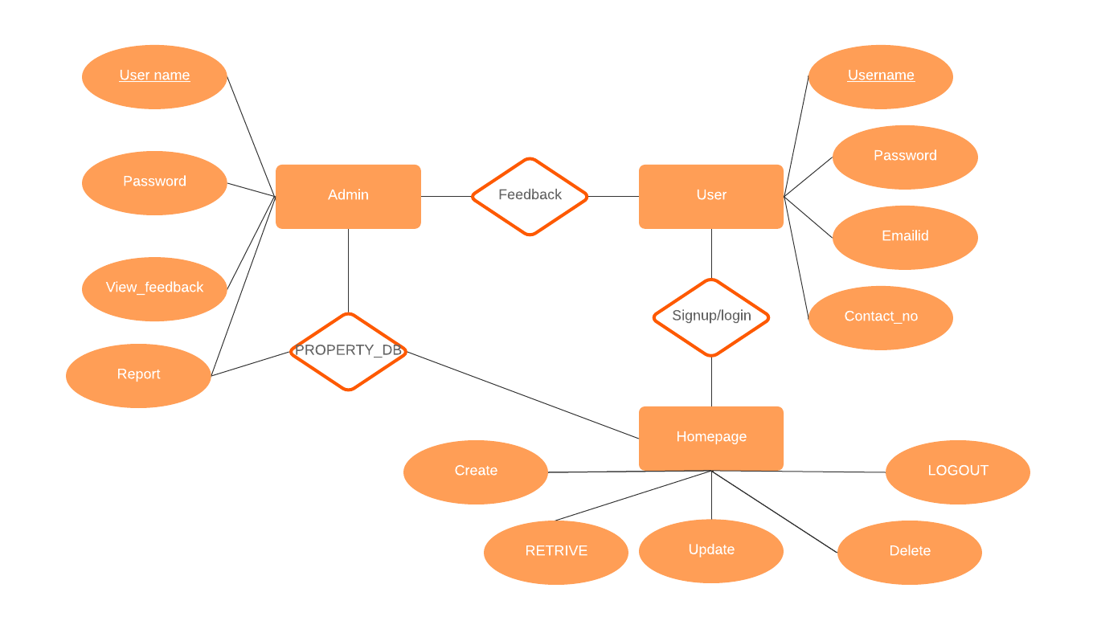

**4.3 UML DIAGRAM**

**4.3.1 USE CASE DIAGRAM**

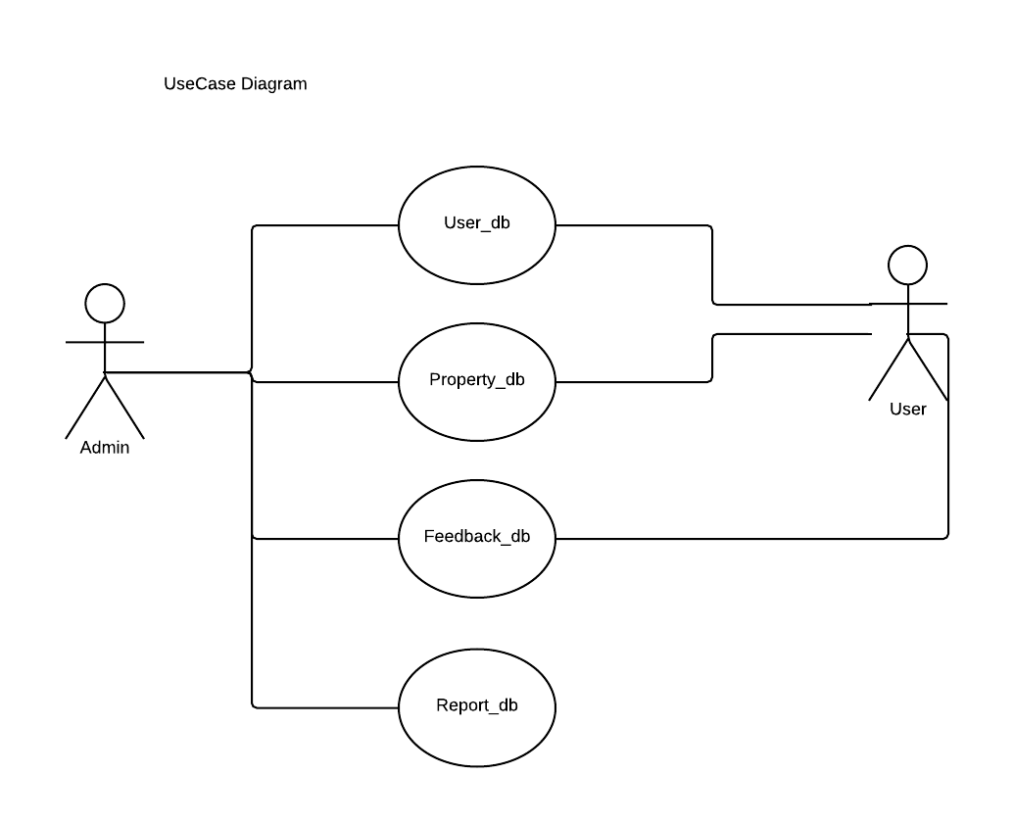

**4.3.2 CLASS DIAGRAM**

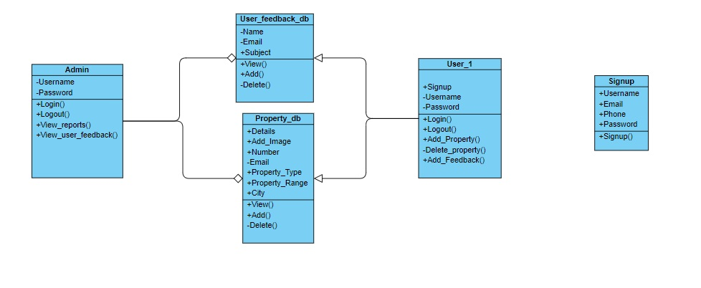

**4.3.3 ACTIVITY DIAGRAM**

**User**

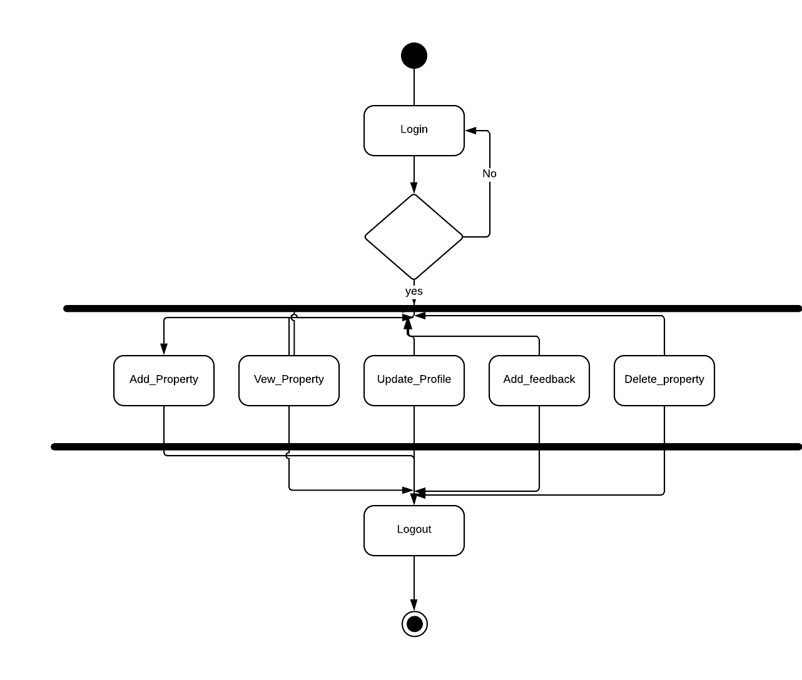

**4.4 DATABASE DESIGN (TABLE DESIGN)**

The database design involves creation of tables. Tables are represented in physical database as stored files. A table consists of rows and columns. Each column corresponds to a piece of information called field. A set of fields constitutes a record. Database design is required to manage the large amount of information. The management of data involves both the definition of structure of the storage of information and provision of mechanism for the manipulation of information

The record contains all the information, specific to a particular item. This is one, which transforms the information models created during analysis. Numeric data structure that will be required to implement the software. The primary activity during this is to select logical representations of data object identified during the requirement definition and specification phase.

**User Signup table:**

* Table name: signup
* Primary key: username

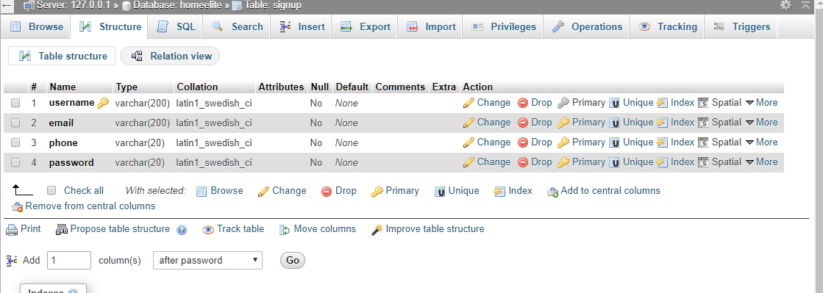

**Property table:**

* Table name: Property
* Primary key: username

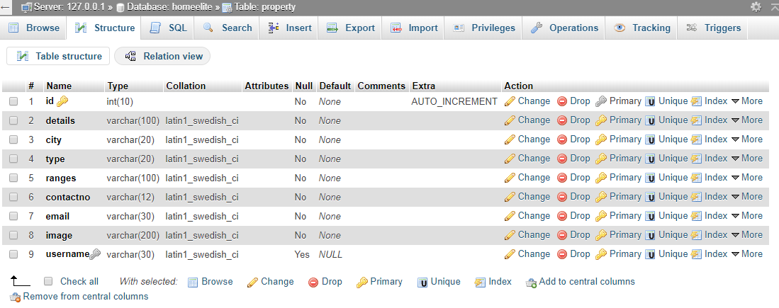

**Feedback table:**

* Table name: contactus
* Primary key: name

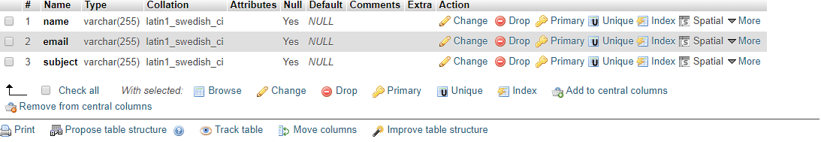

**4.5 INPUT DESIGN**

In accurate input data are most common cause of errors in data proessing. Input design is the process of converting user originated inputs into a computer-based format. The goal of designing is to data entry as easy, logical and free errors as possible.

In the manual system, paper forms are used to collect information. So to have compatibility, the electronic from is designed to be like the original form for pacing requests. The input design incorporates are much automation as possible. The inputs are validated when required. An important part in input design is the checking for incomplete forms. Blank fields do not cause wrong data but incomplete data is equally harmful as the bad data. Before the document is saved it is checked for the existence of any blank fields.

The input forms are designed to be user friendly. Meaningful and labels are given to the input fields. Immediate validation is done for each input form the user that the invalid inputs are not sent to database. The input forms are designed so that they provide the proper links to other forms. Provisions have been given to go back to the main menu as and when required.

**4.6 OUTPUT DESIGN**

Computer outputs are the most important and direct of information to the administrator. They are encountered everywhere in everyone’s day -to -day life. The usefulness and clarity of such common place outputs depend a great deal on that care with which an analyst designed them, keeping their major purpose in mind. Every kind of business produces some kind of reports, and many systems produce a lot.

The screens for the display of the action of customer report, report,feedbacks report,property report and complete report that the output are provided to the administrator can view the form. The design of the output screens include that they are complete with all necessary information requested for. The administrator displays the complete summary of the output depending on the option.

**5. SYSTEM TESTING AND IMPLEMENTATION**

**5.1 SYSTEM TESTING**

Testing is an activity to verify that a correct system is being built and is performed with the intention of finding faults in the system

The testing procedures that has been used is as follows

* Unit Testing
* Validation Testing
* Output Testing

**UNIT TESTING**

The first level of testing is called as unit testing. Here the different modules are tested and the specifications produced during design for the modules. Unit test was conducted to the different modules of the project.

**VALIDATION TESTING**

The proposed system under construction has been tested by using validation testing and found to be working satisfactory. After finishing the integration testing, the modules were tested for validation.

**OUTPUT TESTING**

The output of the software should be acceptable to the system user. The output requirement is defined during the system analysis. Testing of the software system is done against the output requirements and the output testing was completed with success

**5.2 IMPLEMENTATION**

The output of this system was compared with that of the manual system that is running parallel, for the effective implementation of the computerized system that developed proper documentation about the system is done for the reference modification.

**5.3 SYSTEM MAINTENANCE**

**Maintenance or Enhancement**

Maintenance can be classified as corrective, adaptive or perfective.

* Corrective maintenance

Corrective maintenance means repairing processing or performance failures or making changes because of previously uncorrected problems or false assumptions.

* Adaptive maintenance

Adaptive maintenance means changing the program function.

* Perfective maintenance

Perfective maintenance means enhancing the performance or modifying the programs(s) to respond to the user’s additional or changing needs. Of these types more time and money are spent on perfective than on corrective and adaptive maintenance together.

**6 CONCLUSION AND FUTURE ENHANCEMENT**

**6.1 CONCLUSION**

I started this project “ONLINE RENTAL SEARCH” and completed to

my satisfaction with my limited knowledge of PHP. Through this sample project it is

possible to do the file and folder option very easily. The encryption and decryption

concepts are also made through project manually. Although this project performs

some operations, in future we will add some more features in this software to develop

a new version.

**6.2 SCOPE FOR FUTURE ENHANCEMENT**

The system has been designed and developed according to the current requirements of the user. At the same time the system is very flexible and extensible, Hence, future enhancements, if needed can be made without much difficulty, so new applications can be developed and it be integrated with the existing one very easily.

The following future enhancements may be worthwhile to make the tool usable to a wider section of users.

* Currently only text-based reports are handled. It can be extended to include graphics and images. Also music and audio clips are considerable.
* User level authentication and authorization may be of use in certain circumstances.