PRAYER TO ST. THOMAS AQUINAS

Oh, Saint Thomas, Patron of Catholic Schools,
Be thou our guide, our mentor, our hope
Be thou the fountain of spiritual happiness,
Be thou the source of trust and celestial bliss.

Give unto us, thy humble devotees,
Strength to survive the daily ordeal of life,
Wisdom that we be as wise as thee;
Oh, Saintliest of the wise, we pray thee.

Enlighten us oh wisest among the saints,
Partake me of your sagacious talents,
Brighten our way as we journey along;
We pray thee, our lives prolong.

Grant us thy heavenly-given power
That we may speak of the Man of the Cross.
Grant us thy prolific pen;
That we may glorify His Holy Name. Amen

PREFACE

This Student Manual is thoughtfully prepared to serve as a guiding companion for every learner of St. Thomas Aquinas College (STAC) of Sogod S. Leyte, Inc. as they journey through academic and campus life. It provides essential information on institutional policies, academic standards, student services, and the code of conduct and discipline that shape the life of a Thomasian student. More than a set of rules, this manual reflects the principles and ideals that define our academic community.

Rooted in the wisdom and teachings of St. Thomas Aquinas, STAC is committed to the integral formation of the human person—intellectually competent, morally upright, and socially responsible. In faithful adherence to the College’s Vision, Mission, Goals, and Objectives, we strive to nurture individuals who seek truth, uphold justice, and live a life of virtue and service.

This manual aims not only to inform but to form. It invites every student to embrace a culture of excellence, discipline, and compassion, guided by faith and reason. By understanding and living out these principles, students become active partners in building a Christ-centered academic community that responds meaningfully to the needs of society.

May this manual inspire you to grow in knowledge, character, and purpose, as you pursue your educational journey as a proud Thomasian.

THE COLLEGE SEAL AND ITS CORE ELEMENTS
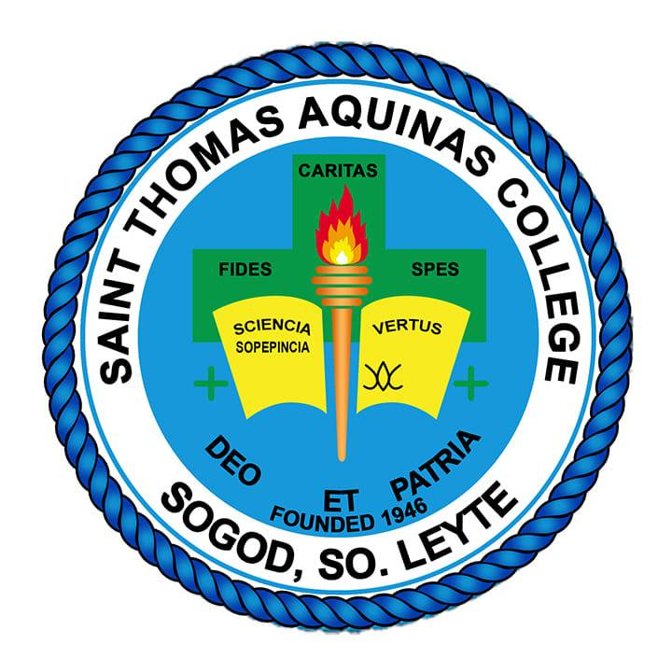

STAC IDENTITY

The St. Thomas Aquinas College (STAC) of Sogod S Leyte Inc is a Diocesan Catholic School of the Diocese of Maasin of the Province of Southern Leyte founded in 1946, under the patronage of St. Thomas Aquinas. Located at Zone 4, Sogod Southern Leyte.

VISION
Emboldened by the teachings of St. Thomas Aquinas, we envisioned to become a globally recognized institution, which fosters transformative leadership through academic innovation, technological advancement, and stewardship for sustainable development in 2030.

MISSION
Inspired by the spirit of Fides, Virtus, Excellentia, and Servitium, Saint Thomas Aquinas College is commissioned to:

1. FIDES (Faith)
• to develop a firm foundation on the teaching of Christ and the church for the fullness of life.
2. VIRTUS (Virtue)
• to teach and exemplify the theological virtues of faith, hope, and love, and the cardinal virtues of justice, fortitude, prudence, and temperance for societal transformation.
3. EXCELLENTIA (Excellence)
• to form habits reflective of the Thomasian values in the fulfilment of life’s purpose and apostolic mission with excellence.
4. SERVITIUM (Service)
- to cultivate a spirit of selfless service and social responsibility, forming servant-leaders committed to the common good, the preferential option for the poor, and active participation in the mission of the Church and society.

MOTTO

"We Educate through Evangelization, We Evangelize through Education."

PHILOSOPHY

STAC believes that education must instill love for work, love for his fellowmen and country, respect for the right of others, love for peace and the practice of Christian values- Faith, Hope and Charity.

GOAL

To make the Thomasian Family an evangelizing and educative community in which all members participate harmoniously in the attainment of its Vision, Mission and Objectives.

GENERAL OBJECTIVES

1. To imbue with Christian conviction, to be academically and professionally competent, vocationally and technically skilled, make a sound judgment and sensible decision, and become active agents of social transformation.
2. To promote the well-being and enhance the professional qualifications of the teaching and non-teaching staff.
3. To apply teaching strategies that could develop in the students’ critical and reflective thinking, independence and sound-mindedness.
4. To upgrade the instructional materials and delivery system to make them responsive to the needs of the time.
5. To inculcate Christian values by integrating them in all subjects’ areas and activities of the institution.
6. To give witness to the life of authentic faith through humble service in the community.

OBJECTIVES OF THE COLLEGE DEPARTMENT
1. To imbue with Christian conviction, to be academically and professionally competent, vocationally and technically skilled, make a sound judgment and sensible decision, and become active agents of social transformation.
2. To promote the well-being and enhance the professional qualifications of the teaching and non-teaching staff.
3. To apply teaching strategies that could develop in the students’ critical and reflective thinking, independence and sound-mindedness.
4. To upgrade the instructional materials and delivery system to make them responsive to the needs of the time.
5. To inculcate Christian values by integrating them in all subjects’ areas and activities of the institution.
6. To give witness to the life of authentic faith through humble service in the community.

THOMASIAN CORE VALUES

T.H.O.M.A.S.I.A.N
• T – Truthful
• H – Happy
• O – Optimistic
• M – Magnanimous
• A – Apostolic
• S – Scholarly
• I – Inspiring
• A – Accountable
• N – Nurturing

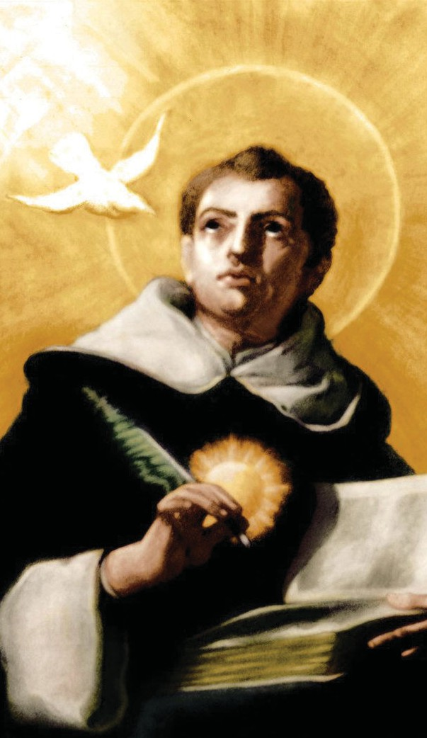

ST. THOMAS AQUINAS

Thomas Aquinas was born around the year 1225 at Rocca Secca in the Kingdom of Naples (in present day southern Italy). Of noble origins, Thomas’ family was considered powerful in the prevalent feudal system, by virtue of their relationship to the German Emperor.
At an early age, Thomas was made to enter the Benedictine Abbey of Monte Cassino. His uncle had been abbot of the monastery and Thomas’ family had the same ambition for him. It was in the abbey that Thomas received his first formal education. Thomas impressed his community with his diligence in study, devotion to prayer, and with the questions he asked which the monks thought were beyond his age. The most remembered of those questions was: “What is God?”
Thomas left the Abbey and continued his studies at the University of Naples between 1239-1244. It was in that university setting that Thomas first encountered the Order of Preachers (Dominicans). Thomas realized that he was being called by God to follow the way of St. Dominic de Guzman, so he sought admission into the Order and received the Dominican habit in 1243, against the will of his family.
Shortly after, in May of 1244, his family intervened forcibly and had him abducted and detained at Rocca Secca. In vain, his family tried to persuade Thomas to give up his Dominican vocation.
Finally, in 1245, Thomas was allowed to return to the Order. He then went north to the University of Paris (France) and then to Cologne (Germany) where he continued his studies under the renowned Dominican professor, Albert the Great.
As a student, Thomas was very quiet and shy. He never showed off his intelligence. His humility was interpreted as dullness, so his peers called him “the Dumb Ox of Sicily”. But Albert saw another side of his student and commented: “We call this young man a dumb ox, but his bellowing in doctrine will one day resound throughout the world.”

In 1250, Thomas was ordained a priest. He was yet to complete his studies though. After much struggle with university authorities, Thomas received his doctoral degree from the University of Paris.
As a theologian, Thomas wrote extensively on the truths of faith. His greatest contribution: the SUMMA THEOLOGIAE (“Summary of Theology”), a compendium of all the doctrines of the Catholic faith, explained by Thomas using philosophy as Ancilla theologiae or “handmaid of theology.”
Because of his brilliance, he was often consulted by monarchs, ecclesiastics, and even by the pope. In terms of his liturgical contribution, Thomas Aquinas was commissioned by the pope to compose the Mass for Corpus Christi, and the Eucharistic hymns (Pange lingua, O Salutaris hostia, Tantum ergo) he crafted are still being sung today.
In exhaustion over his intellectual pursuits, Thomas’ health began to fail. In 1273, he began seeing visions and was often in ecstasy. There were times that he could not finish saying Mass as he would burst into tears during the consecration. While St. Thomas was praying before the crucifix, three brothers reportedly heard Our Lord speak to him, saying, “You have written well of me Thomas, what reward would you ask from me?” Thomas humbly replied: “Nothing but you, Lord.“ From that time on, he refused to write, his Summa still unfinished. He called all his writings “straw,” saying that it was never really possible for any human to fully grasp the glory of God.
In 1274, Pope Gregory X called for a general council in Lysons (France). The pope requested Thomas to travel to Lysons; and Thomas, in all humility, obeyed despite his failing health. On the journey, he fell ill and he was accommodated by the Cistercian monks in Fossa Nuova. The monks took care of him until he died on March 7, 1274. He was 49.
On July 18, 1323, Pope John XXII canonized Thomas Aquinas. In 1567, the Dominican Pope St. Pius V named him Doctor of the Church.
Pope Leo XIII honored St. Thomas by declaring him “prince and Master of all Scholastic Doctors”. On August 4, 1880, he declared St. Thomas Aquinas as patron of all Catholic Universities, Academics, Colleges, and Schools.
Thus, most fittingly, Dominicans all over the world look to St. Thomas Aquinas as patron and model in their educational and intellectual apostolate

ST. THOMAS AQUINAS COLLEGE OF SOGOD S LEYTE, INC.

HYMN

I

Saint Thomas Aquinas College,

Beloved Alma Mater

Thy faithful sons and daughters

Do sing in praise; do sing in praise of thee.

You hold your torch ablaze

Across the dark to me.

Your light so full of bliss

My guide shall always be..

II

Oh! Beloved STAC

There's a saint who guides your way

A saint of old, who has enriched the world

With knowledge brighter than gold.

Fountain of life I know

The stream of truth and good

My source is always you,

Your guiding fountain, the Lord.

Repeat I, finale:

Loyal to you I'll be.

Your symbol I'll always hold.

Oh, beloved STAC,

You give me wealth untold.

CATHOLIC FORMATION STATEMENT

St. Thomas Aquinas College of Sogod, S Leyte, Inc., as a diocesan Catholic institution, participates in the mission of the Church to proclaim and live the Good News through integral, Christ-centered education. The College is committed to forming students who are intellectually competent, morally upright, spiritually mature, and socially responsible.

Grounded in the Thomasian values of Fides (Faith), Virtus (Virtue), Excellentia (Excellence), and Servitium (Service), the College nurtures a deep relationship with God, fosters ethical and disciplined living, promotes academic excellence through the integration of faith and reason, and inspires selfless service for the common good.

Discipline is understood as formative, guiding students toward responsibility, integrity, and authentic Christian witness. Through shared responsibility and a culture of accountability, the College forms servant-leaders who embody its Catholic identity and contribute meaningfully to the Church and society.

HISTORY OF ST. THOMAS AQUINAS COLLEGE OF SOGOD S LEYTE, INC.
STAC opened as learning institution after the 2nd World War. Rev. Fr. Luis D. Caintic as Parish Priest of Immaculate Conception Parish of Sogod, Southern Leyte initiated the establishment of the institution on January 6, 1946, and named after the Patron Saint of Catholic Education, Saint Thomas of Aquinas. As the founder, he became the first School Director. The institution was initially operating as a secondary school and after some time it offered a course known as Elementary Teachers’ Certificate (ETC). Following that year, elementary education opened. STAC suffered a major infrastructure loss in December 1951 when typhoon “Amy” hit the town of Sogod. Eventually the school recovered and produced graduates in 1952.

From 1957-1992 the Academy focused on molding high school students. In 1997 under the directorship of Msgr. Amado Olayvar, the school expanded its academic offerings and applied for change of name from Academy to College.

On August 7, 1997, STAA became a college institution which is now known as Saint Thomas Aquinas College of Sogod, So. Leyte (STAC) with Security Exchange Commission Registration No. A19971565.

The following are the School Directors and their major accomplishments:

1946-1958 Rev. Fr. Luis D. Caintic (later become Msgr. Luis D. Caintic)

- Founder of STAA;
- Offering of the School: Secondary Education, then Elementary Education and Elementary Teacher’s Certificate (ETC), but did not survive for a long time and eventually was phased out in the educational system of the country
Construction of a school building with seven classrooms

1957-1958 Rev. Fr. Sergio Osmeña
1958-1960 Rev. Fr. Generoso Nielo
- Construction of the existing Grotto of Lourdes, now considered as landmark of STAC

1960-1962 Rev. Fr. Licerio Oledan
1962-1972 Rev. Fr. Porferio Suarez
1972-1980 Rev. Fr. Vicente Lora
- Repair of the dilapidating old building
- Concreating of the classrooms
- Construction of library, administration building, and basketball court/quadrangle

1980-1986 Rev. Fr. Juanito Arreglo
- Established Kindergarten School
- Construction of the school building for kindergarten class

1986-1992 Rev. Fr. Manuel Nueve
- Construction of two-room school building

1992 -1998 Rev. Msgr. Amado P. Olayvar
- Offering of Junior Computer Secretarial Course later reclassified into associate in computer Secretarial
- Renovation of the roofing of the old main building
- Conversion of the institution into collegiate level on August 7, 1997 through SEC registration No. A 199715165, thus changing the word Academy to College for the name of the school;
- Addition of 3 more rooms annex to the mai building.

1998-2001 Rev.Fr. Lorenzo Suarez
Offering of the Bachelor of Science in Office Administration (AOA) replacing the Associate in Computer Sectarial.

2001-2003 Rev. Fr. Remegio P. Mollaneda, SVD, PhD
- Offering of Bachelor of Commerce major in Entrepreneurship and in Management
- Acquisition of Multimedia Center (the Immaculate Conception Building, Sogod Terminal, now transferred at the new Computer Laboratory)
Offering of the BSC, now BSBA, BSOA, and BEED.

2003-present Rev. Fr. Merwin L. Kangleon
- Upgraded curricular offering in the Elementary & High School levels featuring computer subjects per grade or year level
Air-conditioning offices and some classrooms
Acquisition of a good number of computers connecting to the Local Area Network (LAN) as well as installation of internet with Wi-Fi
Constructions of 4-storey high school buildings
Constructions of new College Building with six classrooms
Renovation of the old Academic Building where the integrated library is now housed
Provisions for new computer laboratory facilities now as multimedia facilities
Provisions of school canteen
Furnishing TESDA equipment and facilities in Caregiving, Practical Nursing, /IHC, Diploma in Information Technology, Housekeeping, Food and beverages, cookery, etc.
Purchases of school laboratory facilities and equipment
Sent instructors for TESDA training
Opening of BSIS and BSCrim
Air-conditioning of School Library
Construction of the 4-storey Divine Mercy Building
Transferring the college department to Sacred HEART Building
Construction of the STAC AVR
Purchase of multi-cab
Construction of Robotics Laboratory

THE COLLEGE DEAN

1997-2025 Adelina V. Cabardo, Ed. D
2025- Present Annabelle M. Hufalar, Dev. Ed. D

PROGRAM OFFERINGS

1. Bachelor of Science in Office Administration (BSOA)
2. Bachelor in Elementary Education (BEEd)
3. Bachelor of Science in Business Administration (BSBA-HRM)
major in Human Resource Management
4. Bachelor of Science in Information Systems (BSIS)
5. Bachelor of Science in Criminology (BSCrim)
6. Senior High School
7. Junior High School
8. Elementary Education
9. Pre-Elementary Education
10. TESDA Programs

ORGANIZATIONAL STRUCTURE

ORGANIZATIONAL STRUCTURE OF THE COLLEGE

ORGANIZATIONAL STRUCTURE OF THE OFFICE OF THE STUDENT AFFAIRS AND SERVICES



