WEEK 2
PRACTICAL REPORT
FOOTPRINTING, RECONNAISSANCE
AND NETWORK DISCOVERY

Intern Name | NAND JI
Organization | NetworkWalks
Program / Batch | B084
Practical Modules | W2-PM1 – Kali Linux Footprinting; W2-PM5 – Zenmap Scanning
Assessment Period | Week 2
Report Date | 11 November 2026

Document Control
Field | Value | Notes
Document title | Week 2 Practical Report | Footprinting and network discovery
Prepared by | Trishna Gupta | Cybersecurity Intern
Organization | NetworkWalks | Internship practical
Version | 1.0 | Detailed draft for review
Evidence status | Screenshots to be inserted | Use genuine captured outputs

Table of Contents
- 1. Executive Summary
- 2. Introduction
- 3. Scope, Authorization and Rules of Engagement
- 4. Objectives
- 5. Background Concepts
- 6. Tools and Test Environment
- 7. Methodology and Practical Execution
- 8. Consolidated Results
- 9. Security Analysis and Potential Impact
- 10. Recommendations
- 11. Challenges and Limitations
- 12. Learning Outcomes
- 13. Conclusion
- 14. Evidence Appendix
- 15. Commands Reference
- 16. Glossary

1. Executive Summary
This report presents the Week 2 practical activities completed during the cybersecurity internship at NetworkWalks. The work focused on two introductory stages of a security assessment: footprinting/reconnaissance and basic network discovery. The first activity used Kali Linux utilities to inspect publicly observable information associated with the domain networkwalks.com, which was specified as the practical target in the internship assignment. The second activity used Nmap through its graphical interface, Zenmap, to perform host discovery on the intern’s own local Wi-Fi network.
During the domain-footprinting activity, WHOIS returned registration metadata and nameserver details; WhatWeb identified observable web technologies; Nslookup returned an address result while also displaying timeout messages; cURL was used to inspect HTTP response headers; and Wafw00f identified ModSecurity (SpiderLabs). DNSRecon was attempted but returned DNS timeout/error messages, so successful DNS record enumeration could not be confirmed.
For the local network activity, the active Wi-Fi subnet was identified in Windows and scanned in Zenmap using the Ping Scan profile. The scan covered 256 addresses and reported two responsive hosts in approximately 4.90 seconds. The topology view was opened, its legend was enabled, and the topology graphic was saved as a PNG. Since the selected Nmap option was -sn, this was host discovery only: no port scan, service enumeration, vulnerability scan, or exploitation was performed.

2. Introduction
Cybersecurity assessments commonly begin with information gathering. Before testing the security of a system, an analyst needs to understand what is publicly visible, what technologies are in use, how domain names resolve, and which devices respond on an authorized network. These early activities are often described as reconnaissance, footprinting, and network discovery.
Footprinting focuses on collecting information about a target from available sources and observable responses. Network discovery focuses on identifying active or responsive devices within a defined network range. Both activities help build an initial picture of an environment, but neither automatically proves that a vulnerability exists.
This report records the practical steps, commands, observations, interpretation, limitations, and learning outcomes. It uses the intern’s actual observed results where available and does not substitute example values from a sample report.

3. Scope, Authorization and Rules of Engagement

3.1 Activities in scope
- Domain footprinting: networkwalks.com, as named in the internship assignment.
- Local network discovery: the intern’s own Wi-Fi network using Windows and Zenmap.

3.2 Activities out of scope
- Port scanning and service enumeration.
- Vulnerability scanning or exploit validation.
- Password attacks, exploitation, persistence, or data extraction.
- Scanning networks or devices outside the assigned domain and the intern’s own local network.

3.3 Responsible testing statement
The practicals were carried out for educational purposes and within the scope described above. Testing must only be conducted where permission and scope are established. The report does not claim that a formal penetration test or comprehensive security audit was completed. Any further testing would require explicit authorization and a separately defined scope.

4. Objectives
- Understand the purpose of reconnaissance and footprinting in the early stages of security assessment.
- Use WHOIS to review publicly available domain registration information.
- Use WhatWeb to identify web technologies that are observable from the website.
- Use Nslookup to observe DNS resolution behaviour.
- Use cURL with the -I option to inspect HTTP response headers.
- Use Wafw00f to check whether a web application firewall can be identified.
- Attempt DNS record enumeration with DNSRecon and document any errors accurately.
- Identify the local IPv4 configuration and subnet in Windows.
- Use Zenmap/Nmap Ping Scan to discover responsive hosts in the intern’s own local subnet.
- Generate a basic network topology and understand its legend.
- Interpret findings without overstating what the tools have established.

5. Background Concepts

5.1 Footprinting
Footprinting is the process of gathering information about a target environment. It may include domain registration information, DNS data, IP addressing, web technologies and publicly visible services. The information can help an analyst understand the target’s external footprint.

5.2 Reconnaissance
Reconnaissance is an information-gathering stage that helps build an initial understanding of a target. It may be passive, using publicly available sources, or active, involving direct interaction with target systems. The commands in this practical made requests to public services and the assigned website.

5.3 WHOIS
WHOIS is a query protocol/service used to retrieve registration-related information for internet resources such as domain names. Depending on privacy settings and registry policies, returned information may include registrar, dates and nameservers.

5.4 DNS and name resolution
The Domain Name System maps human-readable domain names to network records such as IPv4 (A) and IPv6 (AAAA) addresses. Nslookup is a command-line utility for querying DNS. A timeout message can occur even when a partial or cached answer is displayed.

5.5 Web technology fingerprinting
A web fingerprinting tool analyses observable responses, headers, page content and known patterns to infer technologies such as web servers, content management systems, libraries or plugins. Detection is an indicator, not proof that a version is exploitable.

5.6 HTTP response headers
HTTP headers are metadata exchanged between a client and web server. They can describe content type, caching, server behaviour and security policies. cURL’s -I option requests headers without downloading the full response body.

5.7 Web Application Firewall
A WAF monitors and filters HTTP traffic to a web application according to configured rules. A detection tool may identify a WAF by analysing responses. Detection does not establish that the WAF is correctly configured or blocks every attack.

5.8 Host discovery
Host discovery checks which IP addresses appear responsive within a target range. Nmap’s -sn option disables port scanning and performs host discovery only. A host reported as up has responded to one or more discovery probes; it does not mean its ports are open.

5.9 IP address and MAC address
An IP address is a logical network-layer address used to identify and route traffic between networks. A MAC address is a link-layer identifier used for communication on a local network segment. MAC addresses are not normally routed across the internet and may be randomized by modern devices.

5.10 Network topology
A network topology diagram provides a visual representation of devices and relationships inferred by the discovery tool. The diagram is a visualization of scan observations, not necessarily a complete physical or logical network map.

6. Tools and Test Environment
Tool | Environment | Purpose | Practical stage
Kali Linux | Virtual machine | Linux environment for reconnaissance commands | Footprinting
WHOIS | Kali Linux | Domain registration lookup | Footprinting
WhatWeb | Kali Linux | Web technology identification | Footprinting
Nslookup | Kali Linux | DNS resolution query | Footprinting
cURL | Kali Linux | HTTP response-header inspection | Footprinting
Wafw00f | Kali Linux | WAF fingerprinting | Footprinting
DNSRecon | Kali Linux | DNS enumeration attempt | Footprinting
Windows CMD | Windows 11 | Review local interface configuration | Network discovery
Nmap / Zenmap | Windows 11 | Host discovery and topology visualization | Network discovery

7. Methodology and Practical Execution

7.1 Phase A – Footprinting and Reconnaissance
The domain-based practical was conducted in Kali Linux. Each utility was selected to collect a different category of information. The commands and their observed outcomes are documented individually below.

7.1.1 WHOIS – Domain Registration Information
whois networkwalks.com
Purpose: To retrieve publicly available domain registration details, including registrar, registration dates and nameserver information.
Observed result: The output identified GoDaddy.com, LLC as registrar. It showed a creation date of 06 November 2019, expiry date of 06 November 2027, updated date of 12 November 2025, nameservers NS6135.HOSTGATOR.COM and NS6136.HOSTGATOR.COM, and DNSSEC as unsigned.
Interpretation: The registrar and date fields describe registration metadata. Nameservers indicate which DNS servers are associated with the domain. DNSSEC being shown as unsigned means the queried registration data did not indicate DNSSEC signing for the domain at the time of the lookup.
Security relevance: Registration and nameserver information can help map the public-facing domain infrastructure. Such information is not itself a vulnerability. Analysts should avoid publishing unnecessary infrastructure details in public posts.
Limitation: WHOIS output depends on registry/registrar disclosure policies and can be privacy-protected or incomplete.

7.1.2 WhatWeb – Website Technology Identification
whatweb networkwalks.com
Purpose: To identify technologies that the website reveals through its responses, such as web server software, CMS platforms, libraries and plugins.
Observed result: The output identified Apache, WordPress 7.1.4, WP Download Manager 3.3.76, jQuery 3.7.1 and the address 192.232.216.135.
Interpretation: The result suggests that the website response matched known signatures for these technologies. WhatWeb uses fingerprints; therefore, the result should be treated as an identification based on observable indicators rather than a guarantee about every component in the production environment.
Security relevance: Technology and version information can help defenders check whether software is current and whether vendor advisories apply. An identified version does not automatically mean it is vulnerable; validation requires reliable version confirmation and authorized testing.
Limitation: Fingerprinting can produce incomplete or occasionally inaccurate results, particularly when sites use proxies, caching, customized headers or hidden components.

7.1.3 Nslookup – DNS Resolution
nslookup networkwalks.com
Purpose: To query DNS and observe the address information returned for the domain.
Observed result: The output returned IPv4 address 192.232.216.135 and IPv6-format address 64:ff9b::c0e8:d887. DNS timeout messages were also displayed.
Interpretation: The IPv4 answer indicates the domain was resolved to that address during the query. The IPv6-format address uses the well-known NAT64 prefix format. Because timeout messages appeared, the query should be described as returning an address result alongside resolver/network timeout messages, not as a completely clean response.
Security relevance: DNS resolution helps an analyst understand how a domain maps to network addressing. It can be a starting point for checking the exposed service, but address resolution alone says nothing about whether a host is vulnerable.
Limitation: DNS responses can vary by resolver, geography, time, caching and network configuration.

7.1.4 cURL – HTTP Response Header Inspection
curl -I https://networkwalks.com
Purpose: To request the HTTP response headers without retrieving the complete page body.
Observed result: The command was used to inspect the website’s response headers. The retained practical notes confirm that header information was returned. The exact HTTP status and individual header values are not reproduced here because they have not been independently verified from the captured output.
Interpretation: Headers provide metadata about the server response. Depending on the values returned, they may reveal content handling, caching behaviour, server details or security-related policies.
Security relevance: Defenders should review headers for unnecessary information disclosure and consider suitable security headers. Header observations should be evaluated in context; the presence or absence of one header does not alone prove security or insecurity.
Limitation: The -I option retrieves headers only. It does not crawl the site, test application logic or validate vulnerabilities.

7.1.5 Wafw00f – Web Application Firewall Detection
wafw00f https://networkwalks.com
Purpose: To check whether the target website appears to be protected by a known web application firewall.
Observed result: Wafw00f identified ModSecurity (SpiderLabs).
Interpretation: The tool matched response behaviour to a known ModSecurity signature. This suggests that a WAF technology was detectable from the test vantage point.
Security relevance: A WAF can provide an additional layer of filtering for web requests. Identifying it can help a defender document the visible security architecture and review whether it is maintained and correctly configured.
Limitation: WAF detection does not test the quality of the ruleset, confirm that all malicious traffic is blocked, or establish that the website is protected against every attack.

7.1.6 DNSRecon – DNS Enumeration Attempt
dnsrecon -d networkwalks.com
Purpose: To attempt DNS enumeration and discover records that may be published for the domain.
Observed result: The command encountered DNS timeout/error messages. A successful enumeration of DNS records was not confirmed.
Interpretation: The tool did not provide a verified set of DNS records during this attempt. The timeout may relate to resolver availability, network connectivity, DNS response behaviour or other environmental factors; the precise cause was not established.
Security relevance: DNS record enumeration can help administrators understand the public DNS footprint. Since the command did not complete successfully, no DNSRecon-derived NS, MX, TXT, SPF or SRV findings are asserted in this report.
Limitation and follow-up: If permitted by the assignment, the command may be retried later after checking DNS connectivity and resolver configuration. Any new output should be captured and reported separately; do not fill in expected records from assumptions.

7.2 Phase B – Local Network Discovery with Zenmap

7.2.1 Identify the active network interface
ipconfig
Windows ipconfig was used to review the network interfaces. The active Wi-Fi interface showed IPv4 address 10.237.88.128, subnet mask 255.255.255.0 and default gateway 10.237.88.9. The VirtualBox host-only adapter was a separate virtual interface and was not selected as the target network for this scan.
Subnet interpretation: A subnet mask of 255.255.255.0 corresponds to /24. In this local subnet, the network range contains 256 IPv4 addresses in total. The scan target entered in Zenmap was 10.237.88.0/24.
Privacy note: These private network addresses and hardware identifiers are redacted in the shareable report. They are included here only as contextual values from the practical and should remain hidden in public screenshots.

7.2.2 Nmap and Zenmap
Nmap is a command-line network discovery and security auditing utility. Zenmap is its graphical user interface. Zenmap allows a user to select a scan profile, enter a target and review results in tabs such as Nmap Output and Topology.

7.2.3 Configure and run Ping Scan
nmap -sn 10.237.88.0/24
Command breakdown: nmap launches the scanner; -sn tells Nmap to perform host discovery without a port scan; 10.237.88.0/24 specifies the target subnet.
Observed result: The scan reported 256 IP addresses scanned, 2 hosts up, and an elapsed time of approximately 4.90 seconds. The two responsive hosts were the local gateway and the Windows laptop. Their IP and MAC identifiers are intentionally redacted from the report copy.
Interpretation: The two devices responded to the discovery probes used by Nmap. A host being marked up means it responded to the discovery process; it does not mean that its ports are open or that a service is exposed.
Security relevance: Asset discovery helps a network owner identify which devices are active and compare them with an approved device inventory. Unknown devices should be investigated by the network administrator.
Important limitation: Because -sn was used, no port scanning or service detection was carried out. The practical did not identify open ports, operating systems, vulnerabilities or exploitable weaknesses.

7.2.4 Review topology and legend
After the scan, the Topology tab in Zenmap was opened. The topology view presented the discovered network relationships available from the scan. The legend was enabled to explain the symbols used by the visualization. The localhost label refers to the local machine context and is not evidence of an additional remote device. Since the scan was a Ping Scan, the topology should not be interpreted as proof of open ports.

7.2.5 Save topology evidence
The topology graphic was saved as a PNG file named Network_Topology.png. The PNG should be retained as the original image. If the assignment requires a PDF, the image can be inserted into a document or converted to PDF without cropping out the legend. The final evidence should remain readable and should not expose local IP addresses, MAC addresses or device names when shared publicly.

8. Consolidated Results
Tool / activity | Result recorded | Outcome | What it establishes
WHOIS | Registrar, dates, nameservers, DNSSEC status returned | Completed | Public registration metadata was available
WhatWeb | Apache, WordPress 7.1.4, WP Download Manager 3.3.76, jQuery 3.7.1 | Completed | Technologies were fingerprinted from observable responses
Nslookup | IPv4 and IPv6-format result; timeout messages also appeared | Partial / mixed response | A DNS address result was returned, with timeout context
cURL -I | HTTP response headers inspected | Completed | Header response was retrievable; exact values should be added only from screenshot
Wafw00f | ModSecurity (SpiderLabs) detected | Completed | A WAF signature was identified
DNSRecon | DNS timeout/error; no verified record set | Not completed | Successful DNS enumeration cannot be claimed
Zenmap Ping Scan | 256 addresses scanned; 2 hosts up; ~4.90 sec | Completed | Two hosts responded to discovery probes
Zenmap Topology | Topology displayed; PNG saved | Completed | A visual representation of scan observations was saved

9. Security Analysis and Potential Impact
The following analysis describes why the observations may matter to a security team. These are potential information-exposure considerations, not confirmed vulnerabilities. Risk levels are qualitative and preliminary; a formal risk rating would require business context, asset criticality, exploitability assessment and validation.
Observation | Potential significance | Evidence limitation | Preliminary concern
Public domain metadata | Can assist infrastructure mapping and targeted reconnaissance. | WHOIS data is often intentionally public; no weakness demonstrated. | Low
Technology fingerprinting | May help defenders identify software that needs patch review; attackers may also use it for profiling. | Version fingerprint may not represent every deployed component; no exploit test. | Low to Medium
DNS address resolution | Reveals an address associated with the domain at query time. | Address disclosure is normal for public websites; no exposure severity established. | Low
HTTP response headers | May disclose implementation details or security policy configuration. | Exact header values/status not documented in this draft. | Undetermined / Low
WAF technology detected | Indicates a security control may be present and identifiable. | Detection does not assess WAF effectiveness. | Informational
DNSRecon timeout | Shows the enumeration attempt was unsuccessful in this environment. | No DNS record findings can be concluded. | Not rated
Two local hosts responsive | Helps the owner understand visible devices on their LAN. | Only a small discovery scan was performed; device identity verified from the user’s own context. | Informational
Risk interpretation: The practical primarily gathered information and identified responsive hosts. No exploitation or vulnerability validation was conducted. Therefore, this report does not claim that the target website or local network contains a confirmed vulnerability.

10. Recommendations
- Review externally visible technology information: Maintain an inventory of web servers, CMS platforms, plugins and libraries. Confirm versions through authorized administrative sources and remove unnecessary version disclosures where appropriate.
- Apply security updates: Establish a regular patch-management process for the operating system, web server, CMS, plugins and JavaScript libraries. Prioritize updates using vendor advisories and asset criticality.
- Review DNS configuration: Periodically review A, AAAA, MX, NS, TXT and service records. Remove obsolete entries and ensure that records reflect approved services.
- Review HTTP security headers: Evaluate response headers against the organization’s security requirements. Consider controls such as HTTPS enforcement, content security policy and clickjacking protection where suitable for the application.
- Maintain WAF controls: Keep WAF signatures and rules updated, monitor logs, tune false positives and validate rules through authorized testing. Do not assume detection alone means effective protection.
- Maintain an accurate asset inventory: Compare network discovery results with approved device records. Investigate unfamiliar devices and ensure that guest and personal devices follow network policy.
- Document network topology safely: Keep diagrams current, label assets consistently and store detailed network maps in access-controlled locations. Redact private identifiers before public sharing.
- Repeat DNS troubleshooting carefully: For the DNSRecon timeout, check resolver reachability and network configuration before retrying within the authorized scope. Preserve the error output for auditability.
- Use a phased testing approach: After authorization and scope approval, deeper activities such as port scanning, service enumeration and vulnerability assessment can be planned separately. They were not part of this practical.
- Protect evidence and privacy: Avoid publishing private IP addresses, MAC addresses, hostnames, usernames, tokens or internal configuration details. Keep original evidence securely and share only approved redacted copies.

11. Challenges and Limitations
- DNSRecon returned DNS timeout/error messages. A successful DNS record enumeration was not verified.
- Nslookup displayed timeout messages in addition to returning an address result; the output should be interpreted as a mixed response.
- The exact HTTP status code and complete cURL header values are not reproduced because they are not available in the retained notes. Add them only after checking the original screenshot.
- WhatWeb and Wafw00f identify technologies through fingerprints and response behaviour; results should not be treated as definitive proof of every component or control.
- The Zenmap scan used -sn, which is host discovery only. No port scan, service enumeration, OS detection or vulnerability assessment was performed.
- The topology is based on the available scan observations and should not be treated as a complete network architecture diagram.
- Local IP and MAC values are redacted in the shareable report to protect personal network information.

12. Learning Outcomes
The practical work strengthened understanding in the following areas:
- How public domain registration data can contribute to reconnaissance.
- How web technology fingerprinting can identify visible server, CMS and library technologies.
- How DNS resolution maps domain names to IP addressing information and why resolver timeouts matter.
- How HTTP response headers can be inspected separately from the page body.
- How WAF fingerprinting works at a basic level and why detection is not the same as effectiveness testing.
- How to record an unsuccessful tool run without inventing results.
- How IPv4 address, subnet mask, gateway and /24 subnet notation relate to a local network.
- How Nmap Ping Scan identifies responsive hosts without scanning ports.
- How to use Zenmap’s output and topology views as evidence.
- Why authorization, scope control, evidence accuracy and privacy are essential in cybersecurity.

13. Conclusion
During Week 2 of the cybersecurity internship at NetworkWalks, I carried out practical exercises in footprinting, reconnaissance and basic network discovery. In Kali Linux, I used WHOIS, WhatWeb, Nslookup, cURL, Wafw00f and DNSRecon to examine different categories of publicly observable information associated with the assigned domain. The exercises demonstrated how registration metadata, DNS responses, web technology fingerprints, HTTP headers and WAF identification can contribute to an initial understanding of a web target.
The DNSRecon attempt did not complete successfully because DNS timeout/error messages were returned. This limitation has been stated explicitly and no DNSRecon record findings are claimed. On Windows, I used ipconfig to identify my own local network configuration and Zenmap to perform a Ping Scan. The scan covered 256 addresses and reported two responsive hosts in approximately 4.90 seconds. I also reviewed the topology view, enabled its legend and saved the topology image.
These practicals helped me distinguish information gathering and host discovery from more advanced testing. They also reinforced that technical observations must be interpreted carefully, documented accurately and performed only within an authorized scope.

14. Evidence Appendix
Insert the original screenshots below. Use a short figure caption and, where helpful, one sentence explaining what the screenshot demonstrates. Do not alter the technical result itself. For public sharing, cover private IP addresses, MAC addresses, hostnames and personal identifiers with opaque redaction. Retain unmodified originals securely if required by the internship assessor.
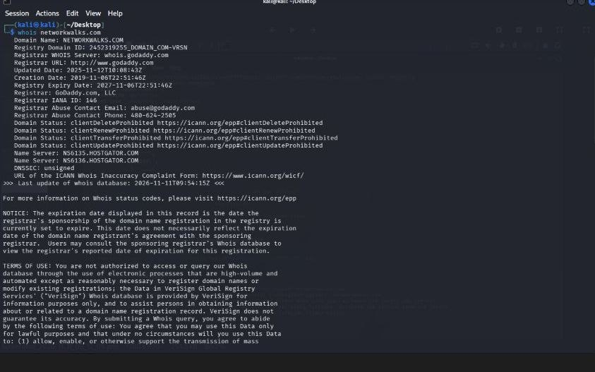
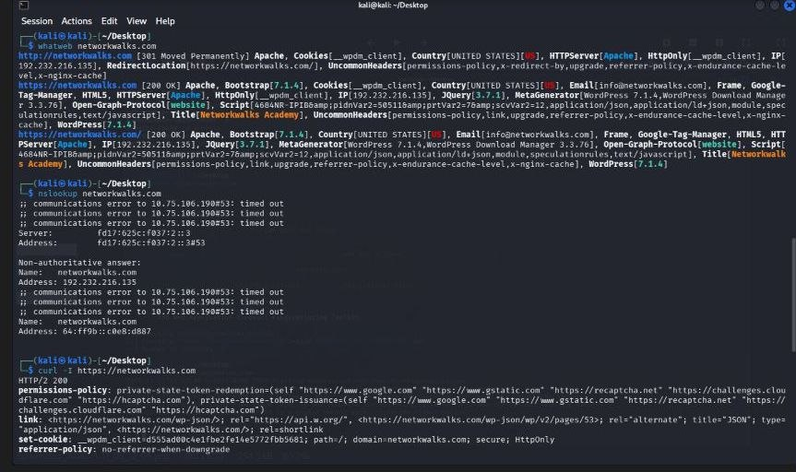
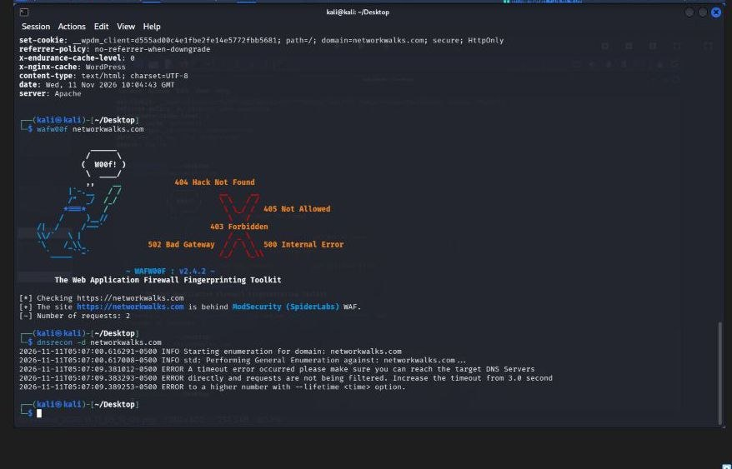
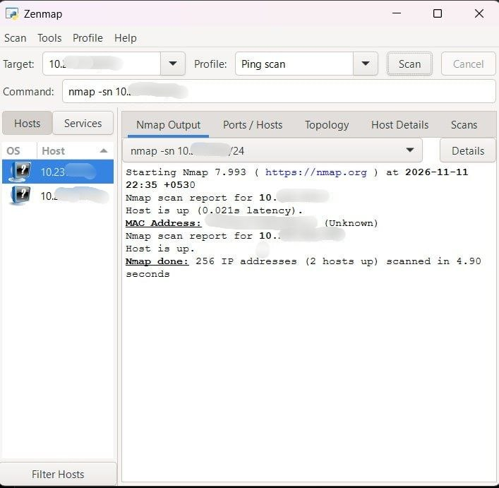
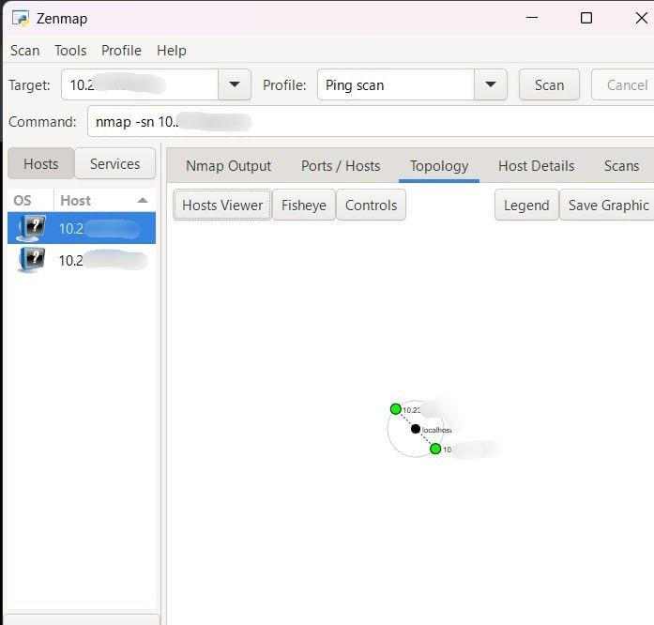
15. Commands Reference
whois networkwalks.com
whatweb networkwalks.com
nslookup networkwalks.com
curl -I https://networkwalks.com
wafw00f https://networkwalks.com
dnsrecon -d networkwalks.com
ipconfig
nmap -sn <authorized-local-subnet>/24

16. Glossary
Term | Meaning
DNS | Domain Name System; translates domain names into DNS records such as IP addresses.
IP address | Logical network-layer address used to identify and route traffic.
MAC address | Link-layer address used for communication on a local network segment.
Subnet mask | Defines which part of an IPv4 address represents the network and which part represents hosts.
/24 | CIDR notation corresponding to subnet mask 255.255.255.0.
Gateway | Router or next-hop device used to reach networks outside the local subnet.
WAF | Web Application Firewall; filters and monitors HTTP traffic to a web application.
Fingerprinting | Inferring technologies or services from observable response patterns.
Host discovery | Determining which IP addresses respond to discovery probes.
Topology | A visual representation of network devices and their observed relationships.

— End of Report —

