Take a microproccesor and Develop a system to perform a specific task , the system can be independent system or part of bigger system
System Design
1)First Step
-Start by choosing which microcontroller or microprocessor to use
-Memory , power requirements
-Capacity and type of memory
2)Second Step

-Make a block diagram and then list of components and cost is made
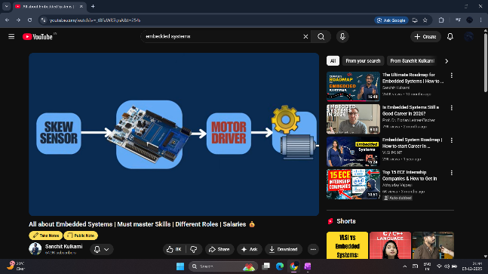

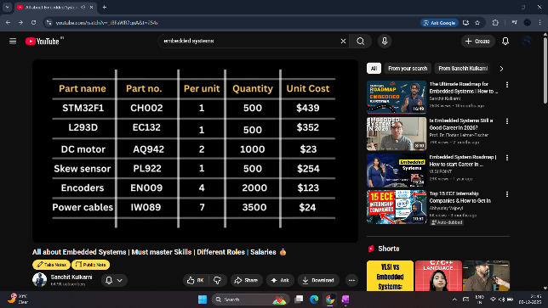
3)Next step is to design the Hardware and program the Microcontroller
Hardware design is done by making the detailed schematic of block diagram and then design the PCB (Embedded Hardware Enginner)
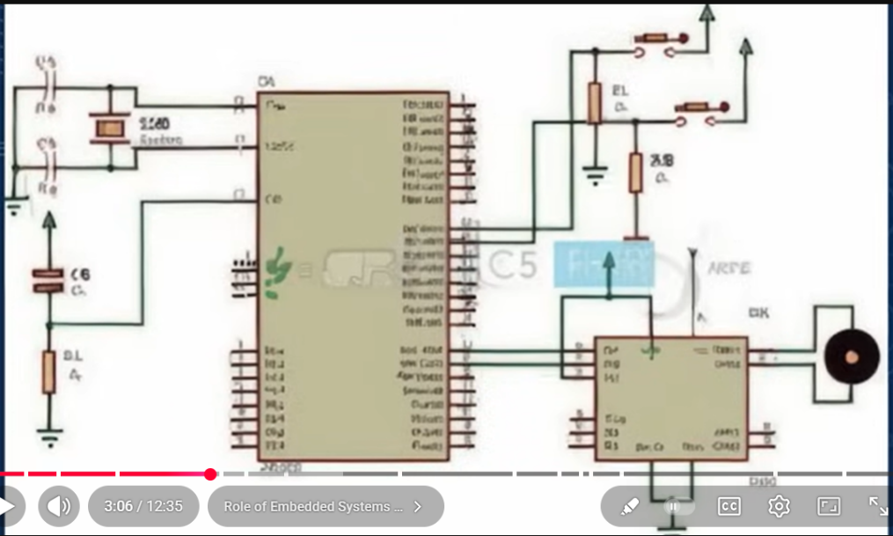
In Programming the microcontroller
-Example is taking readings from sensor and controlling the sensor by progrmming(Embedded Software Enginner)

How embedded software enginnner control the Hardware by microcontroller
They use Hardware development boards
Language used to program Microcontroller -->C Programming
-Boot loaders -->U need to know assembly coding for this
The more closer you get to hardware the more you require assembly,initial bootup is done using UART , u gotta know UART
(VLSI Enginners make the microproccesors or the microcontroller and embedded enginners develop a system around that)
On the PCB , u will have all the connections and the main microprosseror on it
-LT Spice --> simulating the circuit for its behaviour
-PID controller used to control the motor (example) an embeeded enginner has to give values for P ,I and D
-Test Enginners
Industry for Embedded
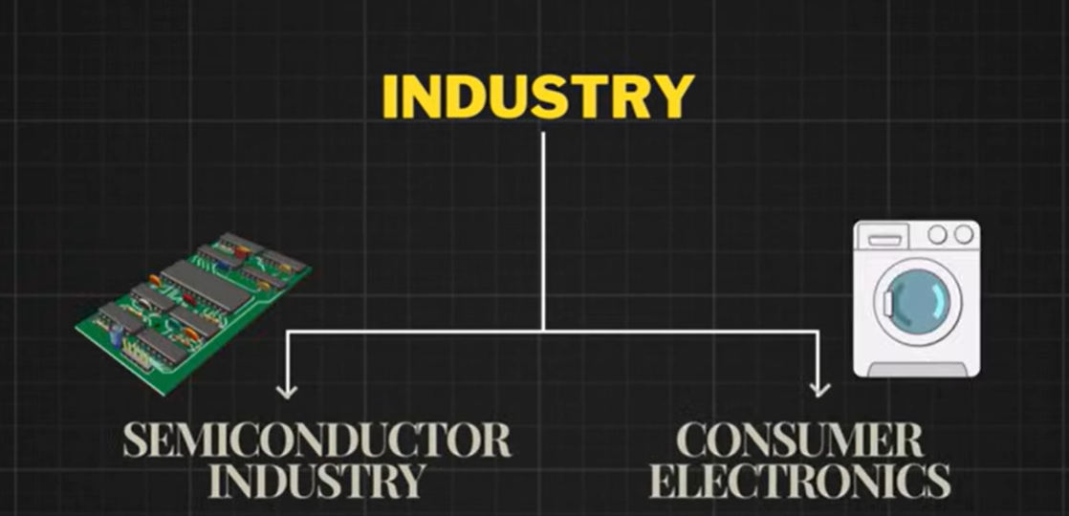

3 skills must have
1)Mastering C
2)Knowing Protocols atleast UART,SPI and I2C
3)Ability of going through data sheets

