Contents

Oracle Virtual Box Name 1

Network Adaptor setting to access internet from FF office: 1

NAT Adaptor: 1

NAT Adaptor Profile: 2

Bridge Adaptor: 2

Bridge Adaptor Profile: 2

Network Adaptor setting to access internet from Home: 3

NAT Adaptor and NAT Adaptor Profile: 3

Bridge Adaptor 3

Bridge Adaptor Profile: 3

Oracle Virtual Box Name: ol7m_deis

# Network Adaptor setting to access internet from FF office:

## NAT Adaptor:

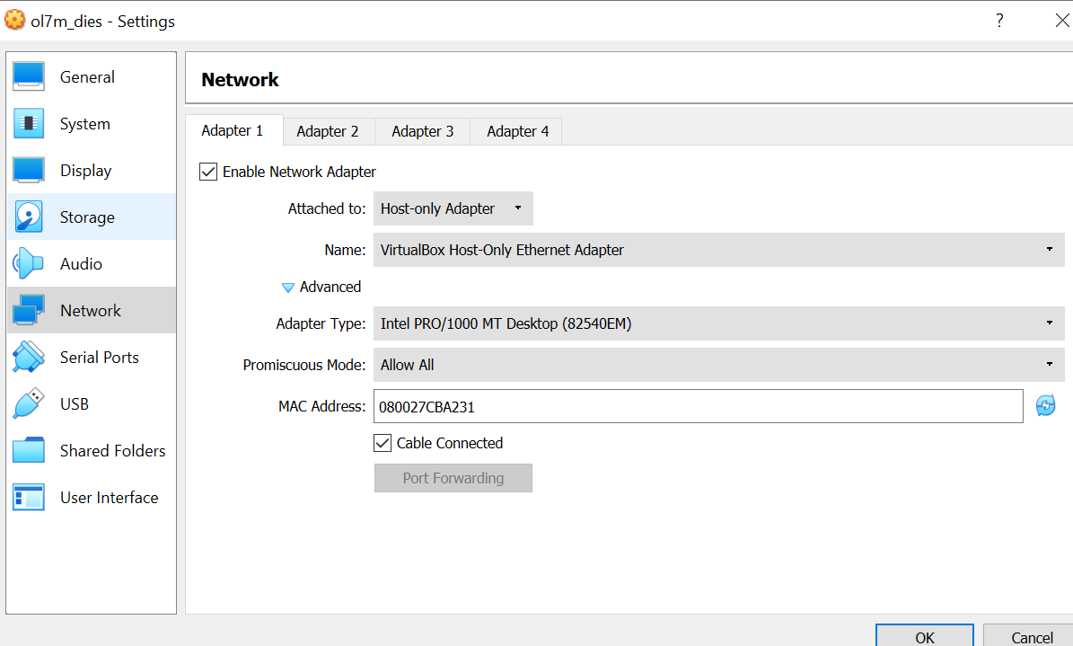

## NAT Adaptor Profile:

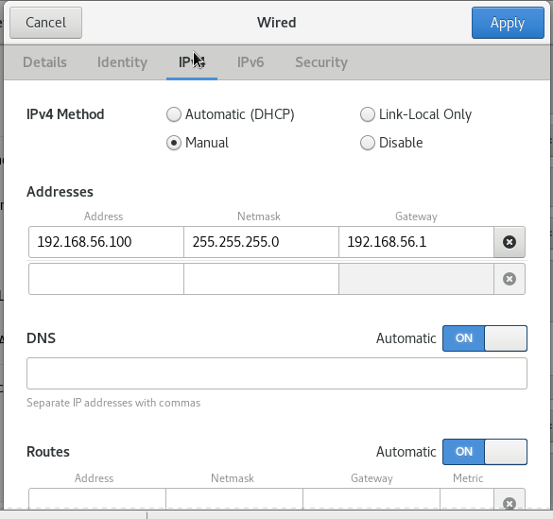

## Bridge Adaptor:

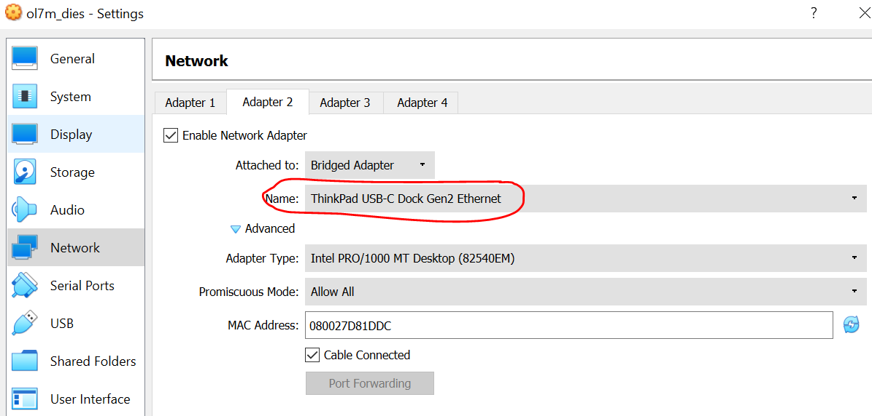

IPv6 is disabled.

## Bridge Adaptor Profile:

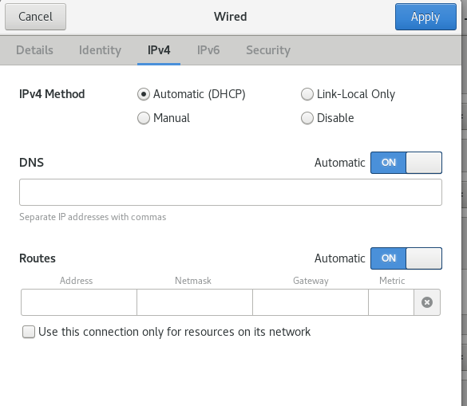

IPv6 is disabled.

# Network Adaptor setting to access internet from Home:

## NAT Adaptor and NAT Adaptor Profile:

No difference.

## Bridge Adaptor

Only difference is that from home bride adaptor use “Intel® Wireless-AC ……”

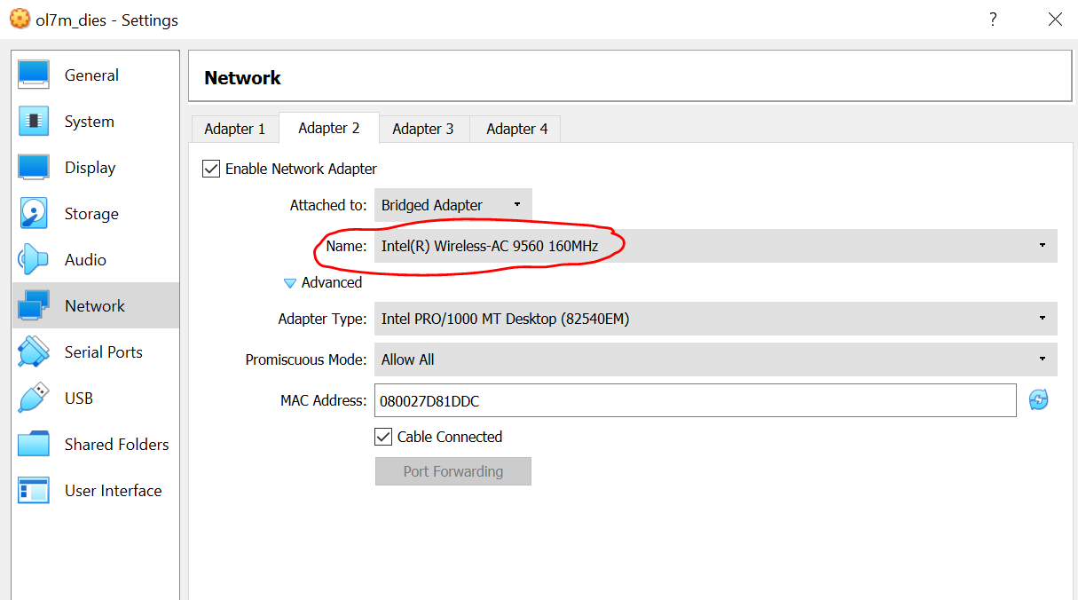

## Bridge Adaptor Profile:

No difference.