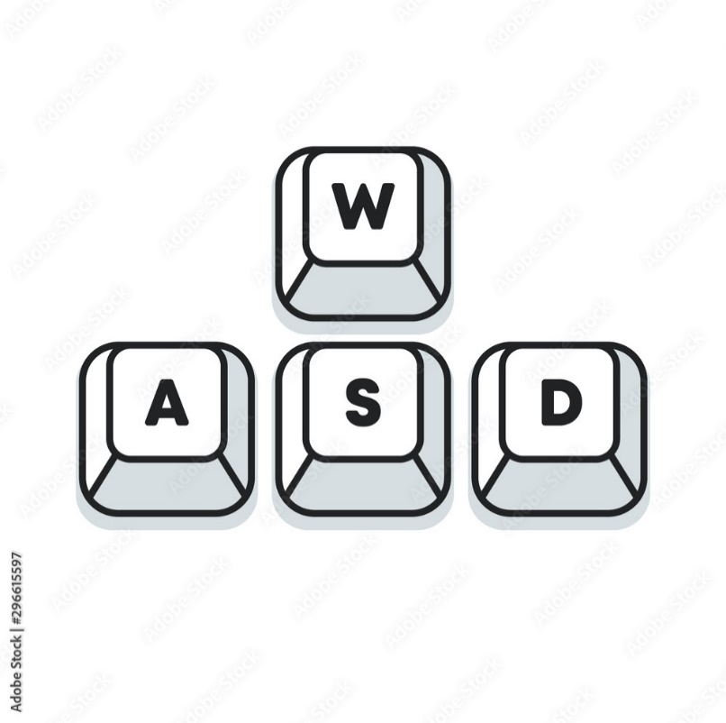**Instruction:**

Character movement works on

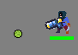

Shooting works on the left mouse button (Warnings: Mage class has no weapons). Bullet is shooting in the position of bullet.

Shooting works on the left mouse button (Warnings: Mage class has no weapons). Bullet is shooting in the position of bullet.

When you kill monsters, you collect crystals that give you experience. When you kill monsters, you collect crystals that give you experience. To pick up crystals you just need to touch them.

In the game there is an experience bar at the bottom of the screen. There is an experience bar at the bottom of the screen in the game. It shows the current amount of experience. When the blue line reaches the end, the player gets a new level.