Descriptive Stats

Loading and cleaning the data

## # A tibble: 134 x 11  
## ceb fbg fbg_sd sbp sbp_sd dbp dbp_sd bmi bmi_sd hypertension  
## <dbl> <dbl> <dbl> <dbl> <dbl> <dbl> <dbl> <dbl> <dbl> <dbl>  
## 1 1 123. NA 127 16 85 5 26 7 NA  
## 2 2 110. NA 126 1 82 3 26 8 NA  
## 3 3 111. NA 127 3 84 4 25 6 NA  
## 4 4 113. NA 137 3 84 2 26 5 NA  
## 5 5 113. NA 132 3 86 3 24 5 NA  
## 6 108 117 NA 134 1 85 7 27 5 NA  
## 7 110 118. NA 130 3 85 4 29 4 NA  
## 8 6 98.6 NA 126 7 83 7 23 7 NA  
## 9 7 154. NA 132 1 85 5 24 4 NA  
## 10 8 106. NA 126 3 85 6 25 8 NA  
## # … with 124 more rows, and 1 more variable: diabetes <dbl>

Looking at outcomes distribution- fasting blood glucose 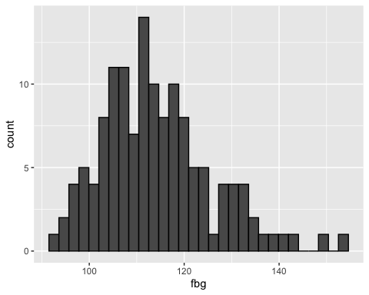

Looking at outcomes distribution- sbp 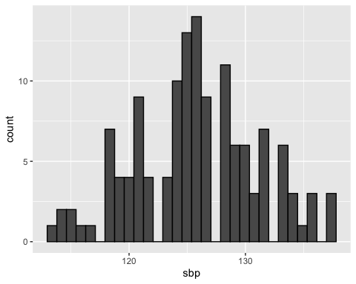

Looking at outcomes distribution- dbp 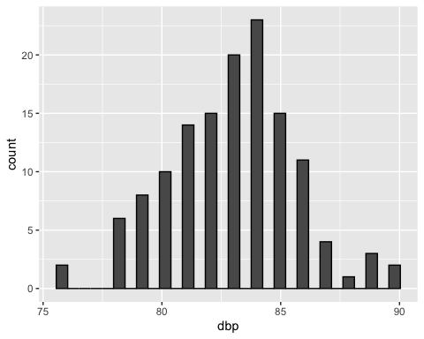

Looking at outcomes distribution- bmi 