Cloud development B POE
Njabulo Mhlangu - ST10451601

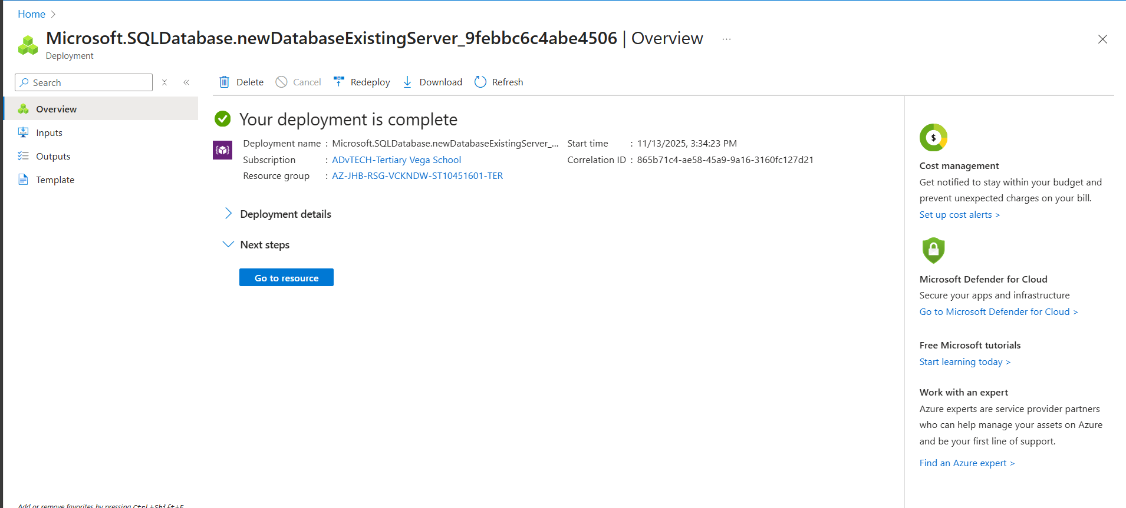
Figure 1: Mhlangu, N. 2025. Screenshot showing the creation of SQL Database.

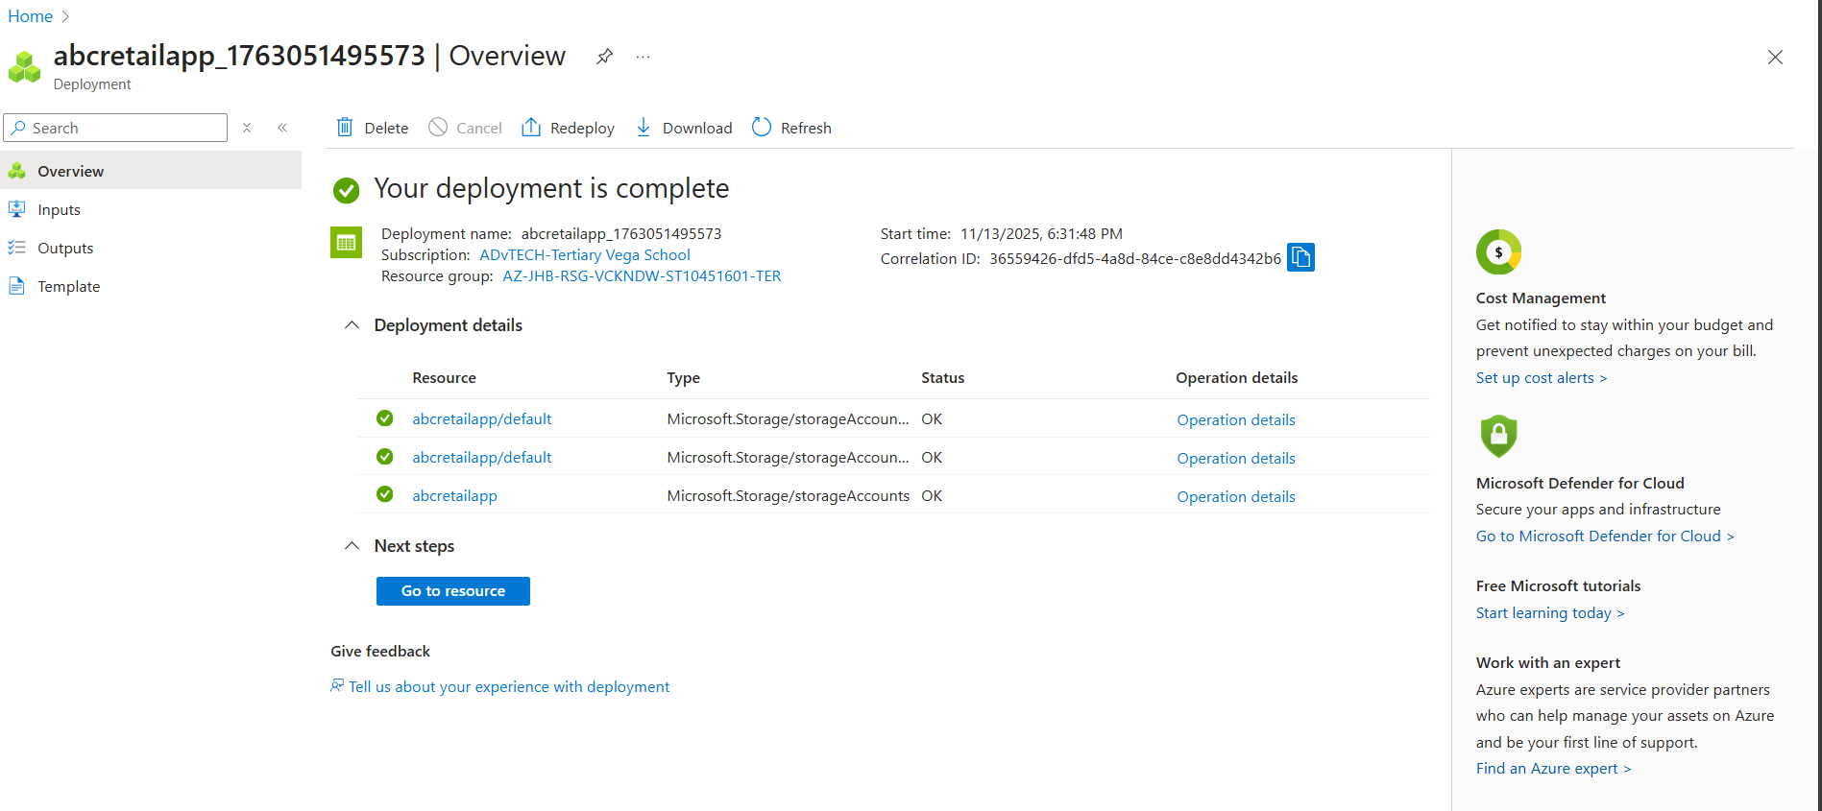
Figure 2: Mhlangu, N. 2025. Screenshot showing the creation of storage account on Azure.

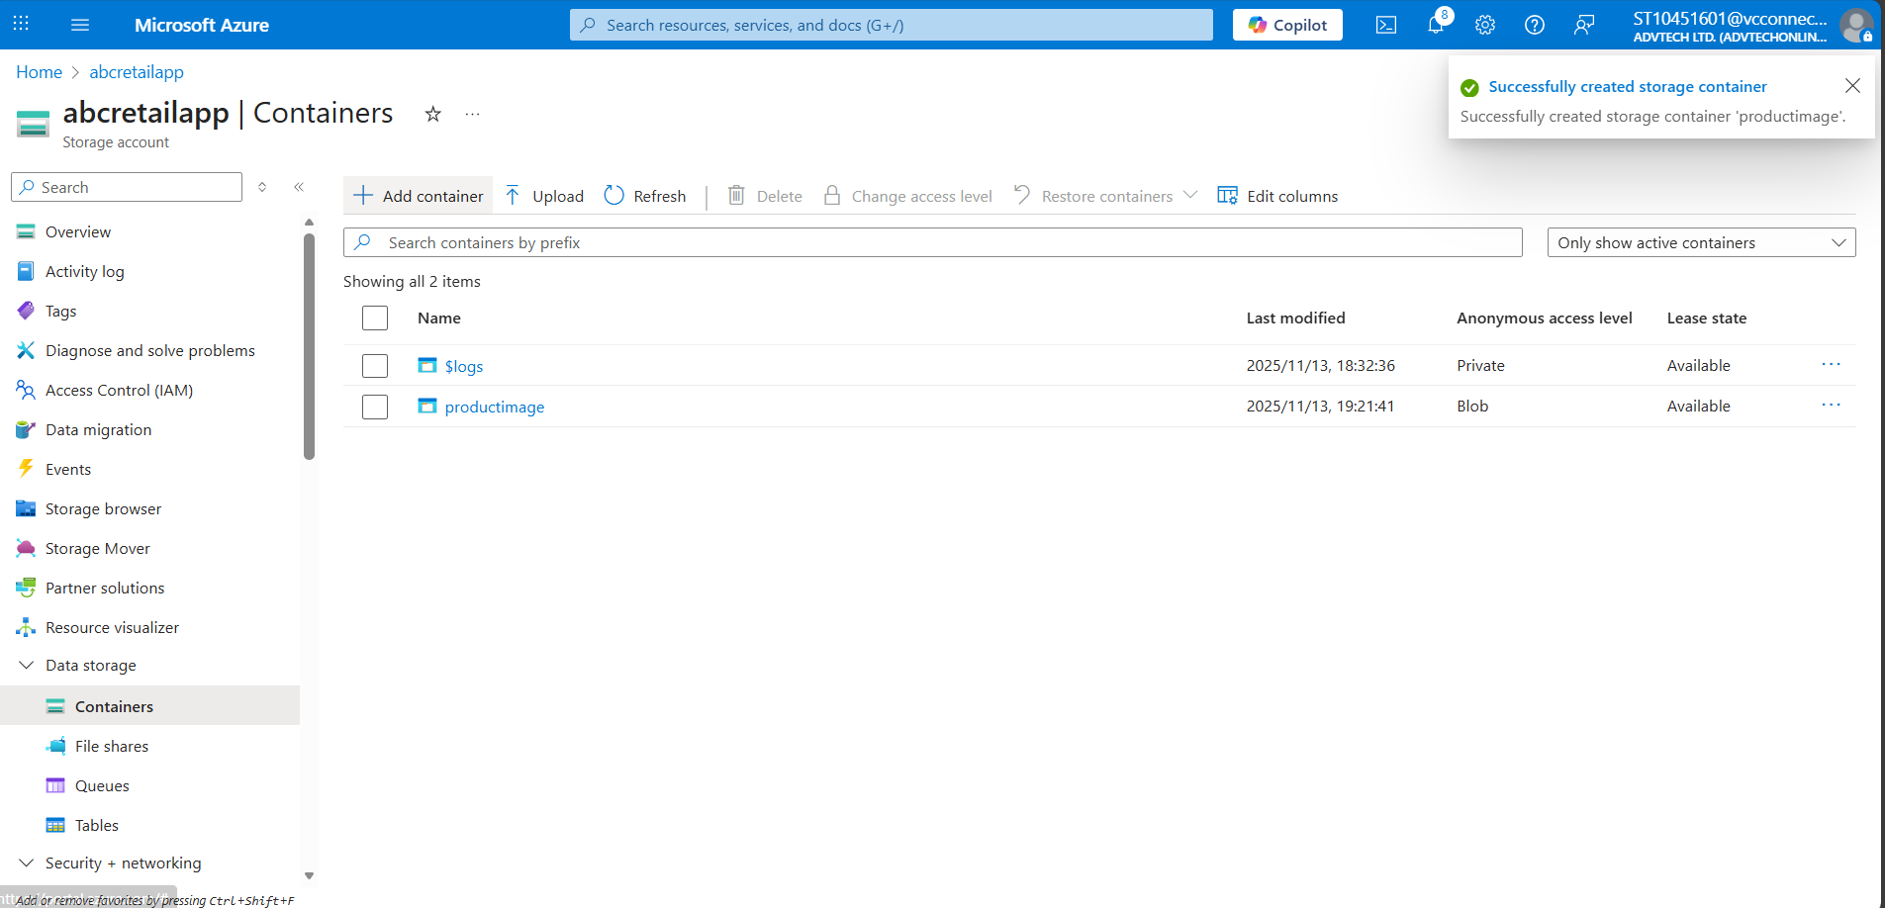
Figure 3: Mhlangu, N. 2025. Screenshot showing the creation of a container on Azure.

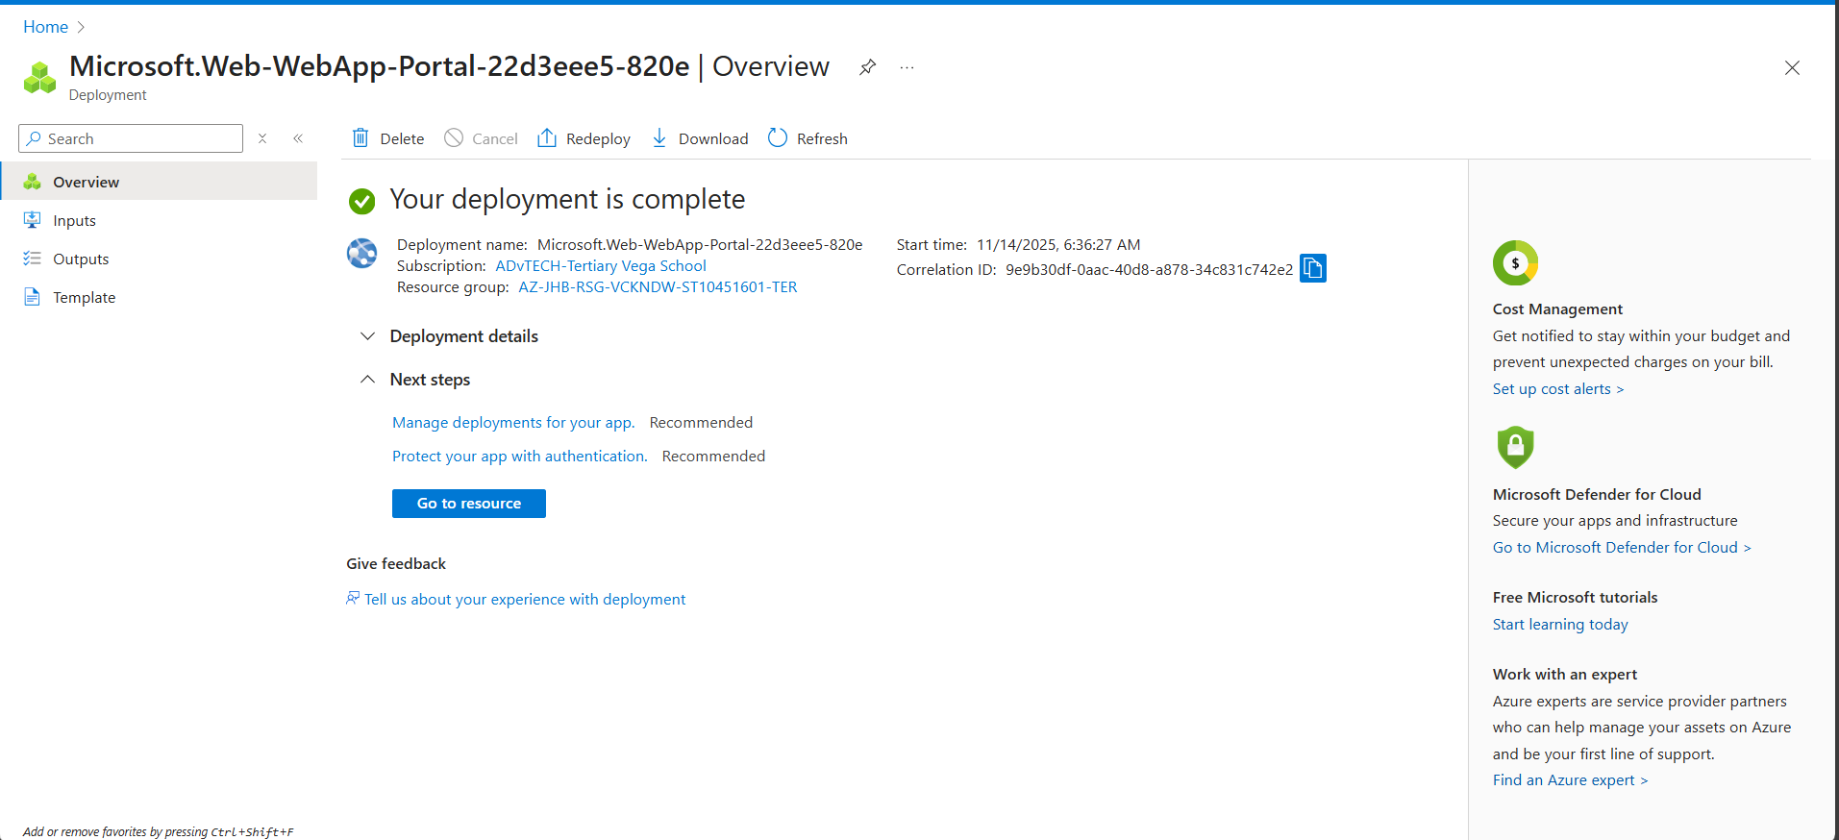
Figure 4:Mhlangu, N. 2025. Screenshot showing the creation of a Web App on Azure

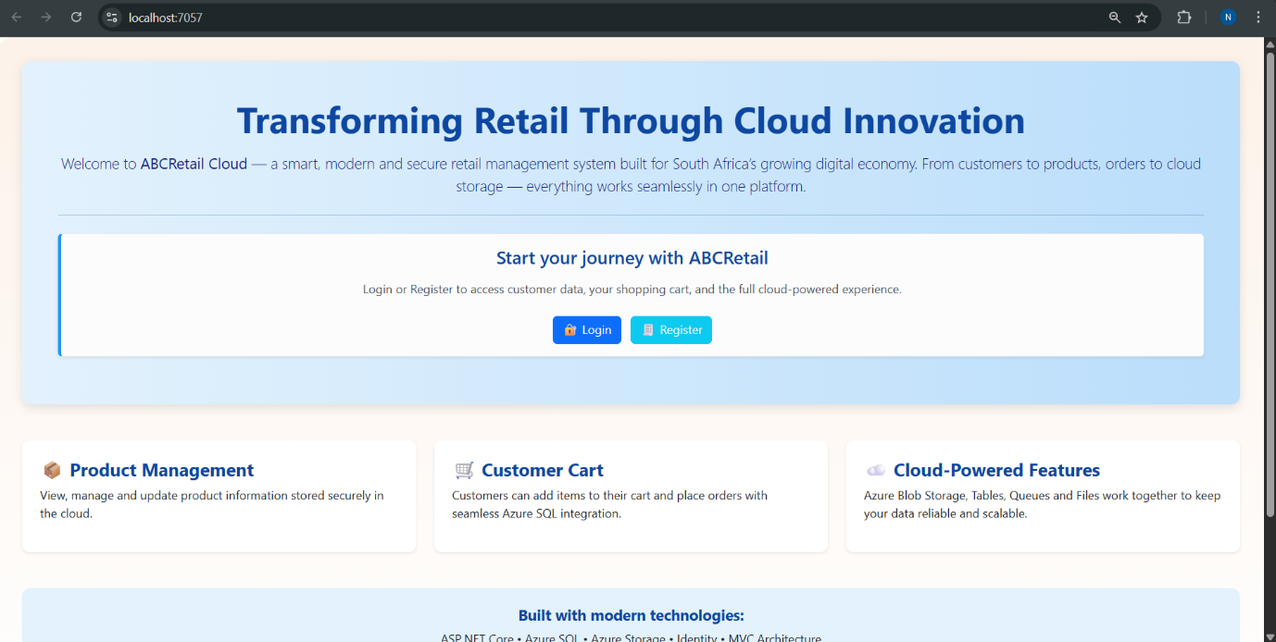
Figure 5:Mhlangu, N. 2025. Screenshot showing the Home page for ABC Retail.

Figure 6:Mhlangu, N. 2025. Screenshot showing the registration confirmation for ABC Retail.

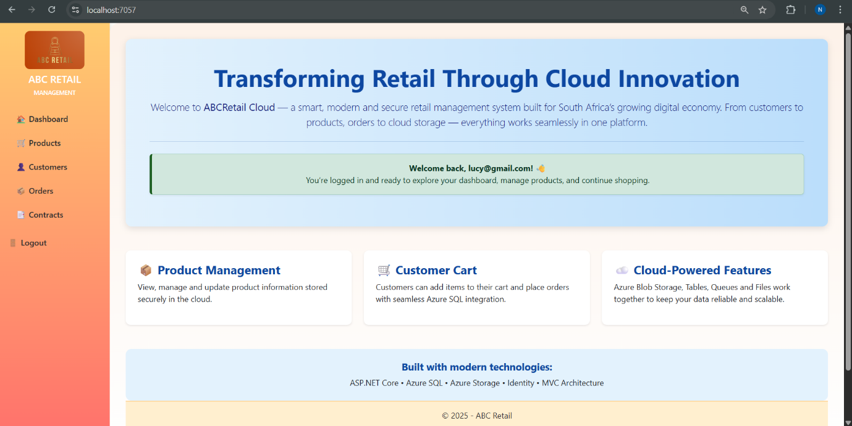
Figure 7: Mhlangu, N. 2025. Screenshot showing the dashboard and the navigation tab.

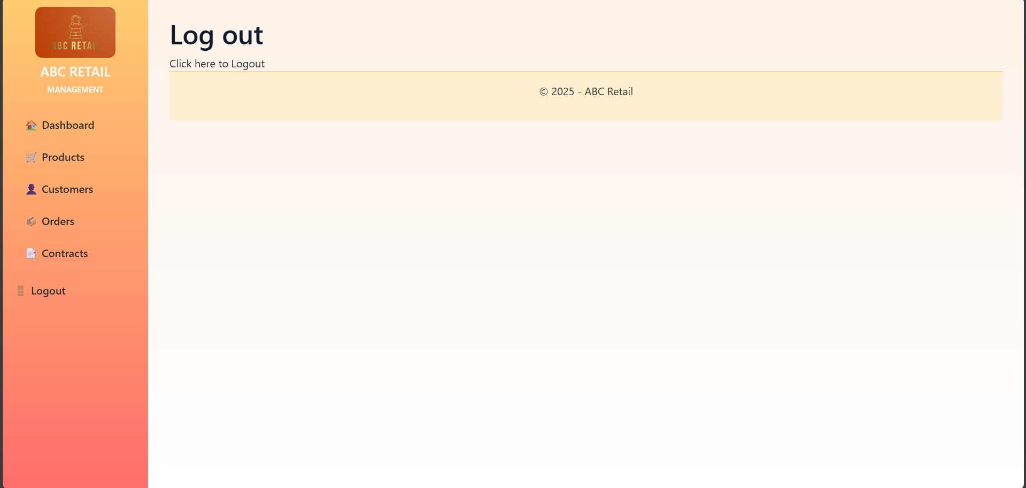
Figure 8:Mhlangu, N. 2025. Screenshot showing the logout feature.

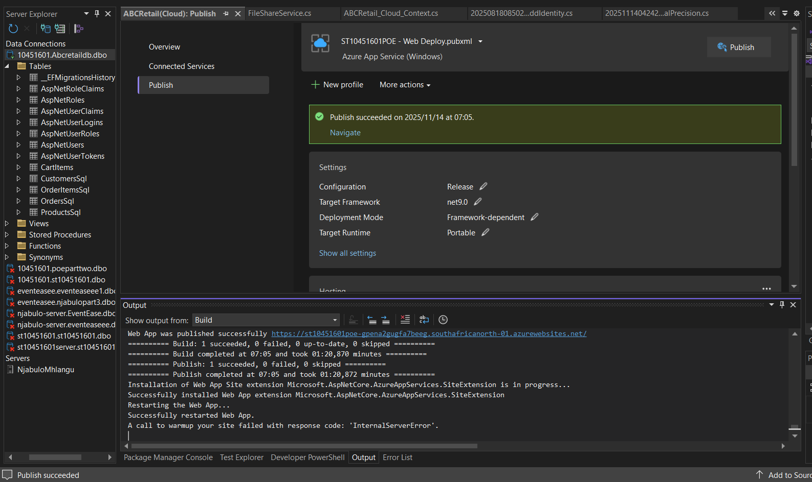
Figure 9:Mhlangu, N. 2025. Screenshot showing the success of publishing the app.

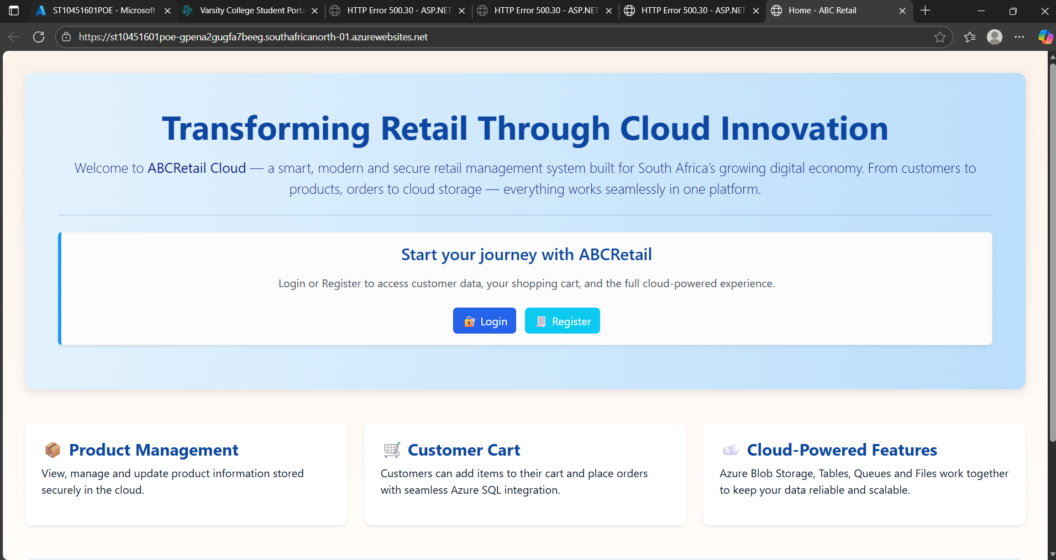
Figure 10: Mhlangu, N. 2025. Screenshot showing the success of publishing the app onto the internet.

B.
Component | Technology Choice | Hosting Model | Description
Azure SQL Database | Data Storage | PaaS | Primary relational database for user authentication, product catalogue, orders, and customer data.
Azure Blob Storage | Data Storage | PaaS | Unstructured data storage for product images, documents, and static content.
Azure Table Storage | Data Storage | PaaS | NoSQL storage for shopping cart data, session state, and application logs.
Azure Queue Storage | Messaging | PaaS | Asynchronous message queuing for order processing and background tasks.
Azure File Shares | Data Storage | PaaS | SMB file shares for shared configuration files and document storage.
Azure App Service | Compute | PaaS | Web application hosting platform for the ASP.NET Core e-commerce application.
SQL Server Management Studio | Development Tool | LaaS | Database management and development tool for Azure SQL Database.

C.
1. User Registration and Authentication
- Application Requirement: Secure user account creation, login, and profile management
- Azure Service: Azure SQL Database + Azure Active Directory (via ASP.NET Core Identity)
- Motivation:
  - Azure SQL Database provides enterprise-grade security with built-in encryption, threat detection, and compliance certifications
  - Automatic backups and point-in-time restore capabilities ensure user data protection
  - Scalable performance handles user authentication traffic spikes during peak shopping periods
  - Integrated with ASP.NET Core Identity for robust authentication workflows
2. Product Catalogue Management with Images
- Application Requirement: Store and serve product information with high-quality images
- Azure Service: Azure Blob Storage
- Motivation:
  - Cost-effective storage solution for unstructured data like product images
  - High availability (99.9% SLA) ensures product images are always accessible
  - Scalable to handle thousands of product images without performance degradation
  - Integration with Azure CDN capability for global image delivery optimization
  - Secure access through signed URLs and access policies
3. Shopping Cart Persistence
- Application Requirement: Maintain shopping cart data across user sessions
- Azure Service: Azure Table Storage
- Motivation:
  - NoSQL schema-less design perfectly suits shopping cart flexibility requirements
  - Cost-effective for small, frequently accessed data objects like cart items
  - Fast read/write operations provide seamless cart management experience
  - Automatic indexing on primary key ensures quick cart retrieval
  - Scalable storage handles peak shopping season traffic
4. Order Processing System
- Application Requirement: Asynchronous order processing and fulfilment
- Azure Service: Azure Queue Storage
- Motivation:
  - Decouples order submission from processing, improving application reliability
  - Ensures no order loss during high traffic periods with guaranteed message delivery
  - Enables background order processing without blocking user experience
  - Scalable queue capacity handles holiday season order volumes
  - Cost-effective messaging solution compared to traditional message brokers
5. Shared Application Configuration
- Application Requirement: Centralized configuration and file sharing across application instances
- Azure Service: Azure File Shares
- Motivation:
  - SMB protocol support allows traditional file system operations
  - Shared access across multiple App Service instances ensures consistency
  - Ideal for storing configuration files, product documentation, and reports
  - Familiar development experience with standard file I/O operations
  - Integrated backup and snapshot capabilities for data protection
6. Web Application Hosting and Scaling
- Application Requirement: Reliable and scalable e-commerce platform hosting
- Azure Service: Azure App Service
- Motivation:
  - Fully managed platform eliminates infrastructure maintenance overhead
  - Automatic scaling handles traffic fluctuations during promotions and sales
  - Integrated deployment pipelines support continuous integration/delivery
  - Built-in SSL certificate management ensures secure transactions
  - Seamless integration with other Azure services simplifies architecture
  - Health monitoring and auto-healing capabilities maintain application availability

D. Alternative Azure Technologies
1. Alternative to Azure SQL Database
- Application Requirement: User authentication and relational data management
- Alternative Service: Azure Cosmos DB (SQL API)
- Motivation:
  - Global distribution capability would provide lower latency for international customers
  - Automatic scaling based on demand eliminates manual performance tuning
  - Schema-agnostic design allows flexible data model evolution
  - Comprehensive SLA covering throughput, availability, and latency
  - Multi-region writes enable global user base support
2. Alternative to Azure Blob Storage
- Application Requirement: Product image storage and delivery
- Alternative Service: Azure Content Delivery Network (CDN) with Storage
- Motivation:
  - Significantly improved image load times for global customers through edge caching
  - Reduced latency by serving images from geographically closer locations
  - Lower bandwidth costs through cached content delivery
  - DDoS protection enhances application security
  - Better user experience through faster page loads
3. Alternative to Azure Queue Storage
- Application Requirement: Order processing and asynchronous operations
- Alternative Service: Azure Service Bus
- Motivation:
  - Advanced messaging patterns (pub/sub) would enable order status notifications
  - Duplicate detection prevents accidental order processing
  - Message sessions maintain order processing sequence
  - Larger message size (1MB vs 64KB) accommodates complex order data
  - Better enterprise integration capabilities
4. Alternative to Azure Table Storage
- Application Requirement: Shopping cart persistence and session data
- Alternative Service: Azure Cosmos DB (Table API)
- Motivation:
  - Global distribution ensures cart availability across regions
  - Higher throughput limits support extreme shopping events (Black Friday)
  - Changeable consistency levels provide flexibility between performance and data freshness
  - Comprehensive monitoring and analytics for cart abandonment analysis
  - Better developer experience with rich query capabilities
5. Alternative to Azure File Shares
- Application Requirement: Shared configuration and document storage
- Alternative Service: Azure Blob Storage with hierarchical namespace
- Motivation:
  - Lower cost for large-scale file storage requirements
  - Better integration with big data and analytics workflows
  - Improved performance for large file operations
  - Enhanced security through Azure AD integration
  - Better versioning and lifecycle management capabilities
6. Alternative to Azure App Service
- Application Requirement: Web application hosting
- Alternative Service: Azure Kubernetes Service (AKS)
- Motivation:
  - Greater control over application runtime environment and configurations
  - Microservices architecture potential for better application modularity
  - Portability across cloud providers reduces vendor lock-in
  - Fine-grained scaling controls for optimal resource utilization
  - Advanced deployment strategies (blue-green, canary) for zero-downtime updates

Architecture Benefits Realized
This Azure-based architecture provides ABC Retail with:
- Scalability: All components can scale independently based on demand
- Reliability: 99.9%+ SLA across all services ensures business continuity
- Cost Optimization: Pay-as-you-go model with ability to scale down during off-peak
- Security: Built-in security features and compliance certifications
- Maintainability: Fully managed services reduce operational overhead
- Global Reach: Potential for easy expansion to international markets
The chosen services provide a balanced approach between development simplicity, operational efficiency, and cost-effectiveness while maintaining the ability to scale with business growth.

References:
- Studioteck, 2023. AZURE COGNITIVE SEARCH: IN-DEPTH OVERVIEW Medium.com Tech blog, [blog] 5 April 2023. Available at: < https://medium.com/@studioteckblog/azure-cognitive-search-in-depth-overview-ed658a402018> [Accessed 25 October 2025].
- IIEVC School of Computer Science. 2025. CLDV6212 (2025 Guide). [Video Online]. Available at: <https://www.youtube.com/playlist?list=PL480DYS-b_kcZiyuCyHolh6Nad8J_Xnk7> Accessed 25 October 2025].
- Microsoft. 2025. What’s Azure AI Search? Microsoft.com Tech blog, [Blog]. Available at: <https://learn.microsoft.com/en-us/azure/search/search-what-is-azure-search >[Accessed 25 October 2025].
- IIEVC School of Computer Science. 2025. CLDV6211: Mastering SQL, Cloud &Azure (2025 Guide). [Video Online]. Available at: https://youtube.com/playlist?list=PL480DYS-b_kevhFsiTpPIB2RzhKPig4iK&si=FhJ_clmBo5tiw_4B [Accessed 25 October 2025].

Links:
- Web App - https://st10451601poe-gpena2gugfa7beeg.southafricanorth-01.azurewebsites.net
- Github - https://github.com/VCWVL/cldv6212-poe-njabulomh3.git

