**Project 1 Analysis**

Nikitha Jagadish

Running Time:

This plot shows the average runtimes for N=10, 25,50,100, 250, and 500 when Percolation is run thirty times.

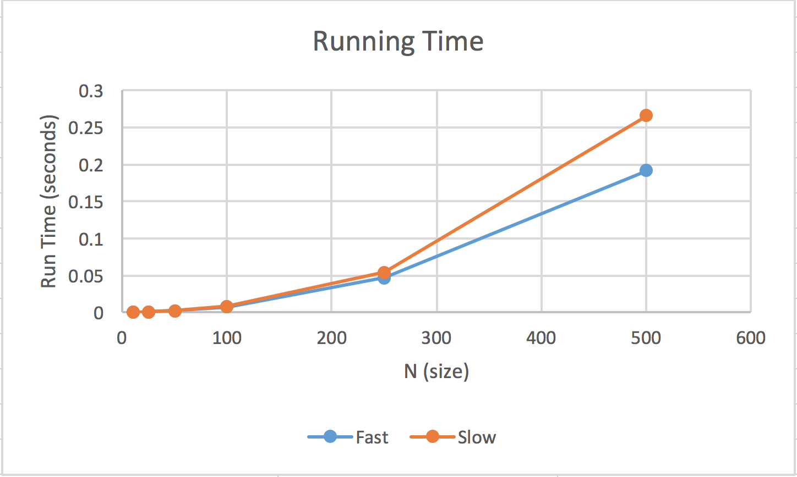

As N increases, the runtime increases as well. This means that the larger the length of the grid, the longer it takes for the program to run. Using the QuickUnionUF.java function results in a longer runtime than when I used WeightedQuickUnionUF.java. This is because unlike QuickUnionUF, WeightedQuickUnion will keep track of the size of each component(or tree) and always connects the smaller component to the larger component. The worst runtime for WeightedQuickUnion with N cells for the methods find(), connected(), and union() is log(N). While the worst runtime for the same methods in QuickUnion is the maximum depth of a tree among its nodes.

p* Estimates:

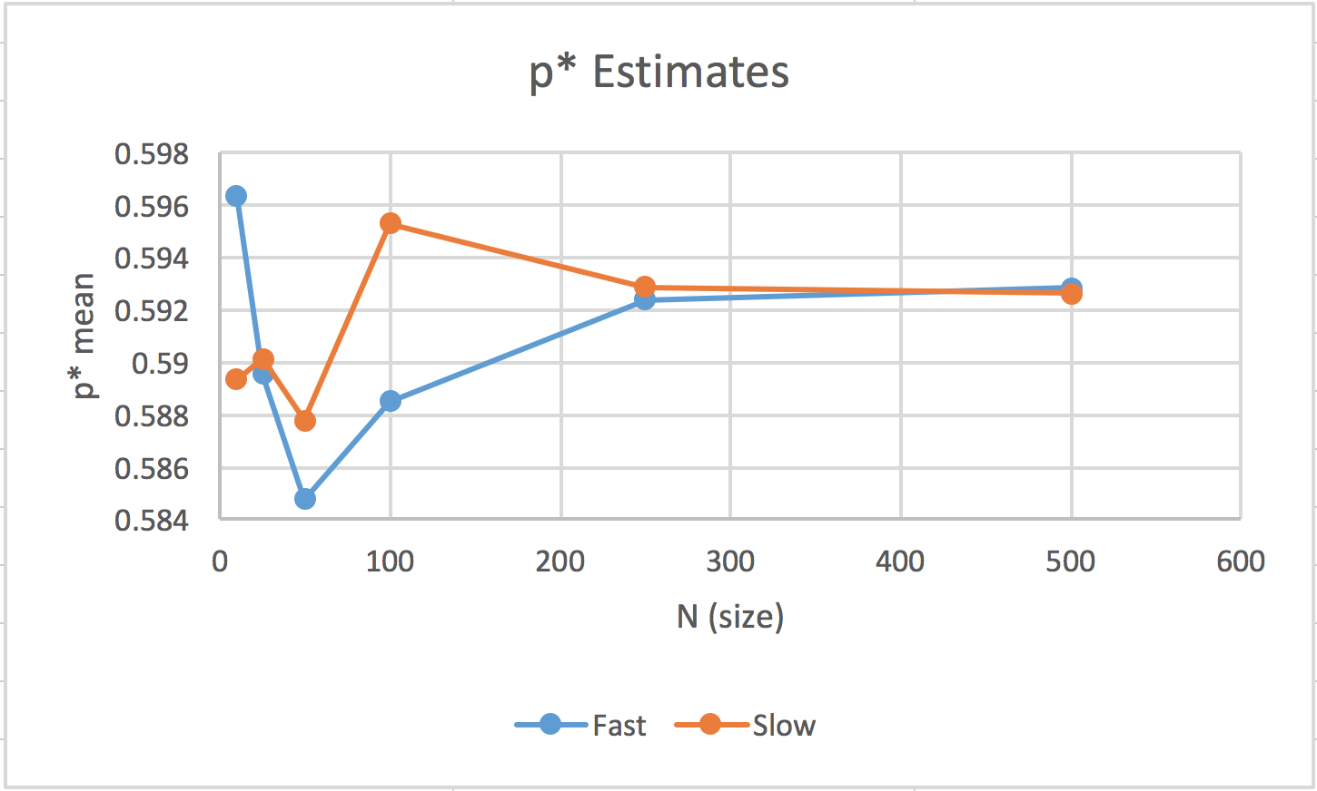

This plot shows the average threshold values (p*) when Percolation is run thirty times for each of the grid lengths (N): 10, 25, 50, 100, 250, and 500. The standard deviation decreases as the grid size gets larger. The estimates of p* become more accurate with a larger grid size.