**Setting up Spring environment**

This chapter will guide you on how to prepare a development environment to start your work with Spring Framework. It will also teach you how to set up JDK, Tomcat and Eclipse on your machine before you set up Spring Framework −

## Step 1 - Setup Java Development Kit (JDK)

You can download the latest version of SDK from Oracle's Java site − [Java SE Downloads.](https://www.oracle.com/technetwork/java/javase/downloads/index.html) You will find instructions for installing JDK in downloaded files, follow the given instructions to install and configure the setup. Finally set PATH and JAVA_HOME environment variables to refer to the directory that contains java and javac, typically java_install_dir/bin and java_install_dir respectively.

If you are running Windows and have installed the JDK in C:\softwares\jdk-11.0.9, you would have to put the following line in your C:\autoexec.bat file.

set PATH= C:\softwares\jdk-11.0.9\bin;%PATH%

set JAVA_HOME= C:\softwares\jdk-11.0.9

Alternatively, on Windows NT/2000/XP, you will have to right-click on My Computer, select Properties → Advanced → Environment Variables. Then, you will have to update the PATH value and click the OK button.

On Unix (Solaris, Linux, etc.), if the SDK is installed in /usr/local/ jdk-11.0.9 and you use the C shell, you will have to put the following into your .cshrc file.

setenv PATH /usr/local/jdk-11.0.9/bin:$PATH

setenv JAVA_HOME /usr/local/jdk-11.0.9

Alternatively, if you use an Integrated Development Environment (IDE) like Borland JBuilder, Eclipse, IntelliJ IDEA, or Sun ONE Studio, you will have to compile and run a simple program to confirm that the IDE knows where you have installed Java. Otherwise, you will have to carry out a proper setup as given in the document of the IDE.

## Step 2 - Install Apache Common Logging API

You can download the latest version of Apache Commons Logging API from <https://commons.apache.org/proper/commons-logging/download_logging.cgi> . Once you download the installation, unpack the binary distribution into a convenient location. For example, in C:\softwares\commons-logging-1.2 on Windows, or /usr/local/commons-logging-1.2 on Linux/Unix. This directory will have the following jar files and other supporting documents, etc.

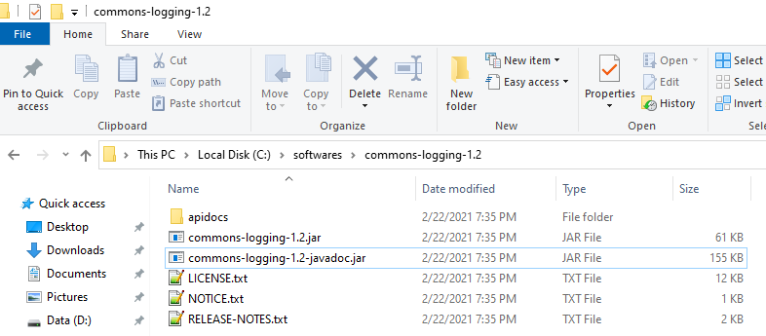

Make sure you set your CLASSPATH variable on this directory properly otherwise you will face a problem while running your application.

## Step 3 - Setup Eclipse IDE

All the examples in this tutorial have been written using Eclipse IDE. So we would suggest you should have the latest version of Eclipse installed on your machine.

To install Eclipse IDE, download the latest Eclipse binaries from <https://www.eclipse.org/downloads/>. Once you download the installation, unpack the binary distribution into a convenient location.

Double click eclipse-inst-jre-win64.exe and install.

On Linux:

Eclipse can be started by executing the following commands on Unix (Solaris, Linux, etc.) machine −

$/usr/local/eclipse/eclipse

After a successful startup, if everything is fine then it should display the following result −

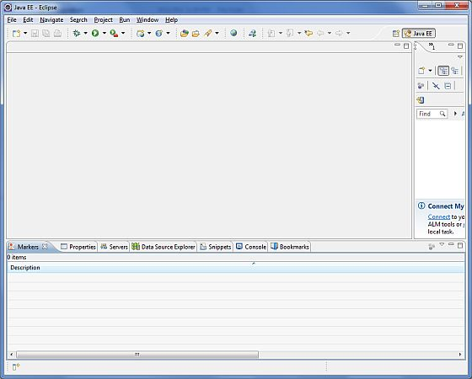

## Step 4 - Setup Spring Framework Libraries

Now if everything is fine, then you can proceed to set up your Spring framework. Following are the simple steps to download and install the framework on your machine.

* Make a choice whether you want to install Spring on Windows or Unix, and then proceed to the next step to download .zip file for Windows and .tz file for Unix.
* Download the latest version of Spring framework binaries from <https://repo.spring.io/release/org/springframework/spring>
* At the time of developing this tutorial, **spring-framework-5.2.9.RELEASE-dist.zip** was downloaded on Windows machine. After the downloaded file was unzipped, it gives the following directory structure inside E:\spring.

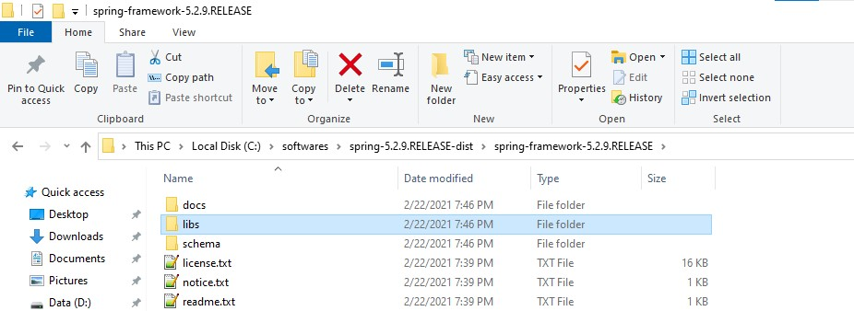

You will find all the Spring libraries in the directory **C:\softwares\spring-5.2.9.RELEASE-dist\spring-framework-5.2.9.RELEASEs**. Make sure you set your CLASSPATH variable on this directory properly otherwise you will face a problem while running your application. If you are using Eclipse, then it is not required to set CLASSPATH because all the setting will be done through Eclipse.

Once you are done with this last step, you are ready to proceed to your first Spring Example in the next chapter.