Neha Jain

Professor Penta

Programming for IT (CIS-153)

April 8, 2020

Milestone 0

1. Project Plan
   1. The main idea of my project is password generator.
   2. Flowchart:

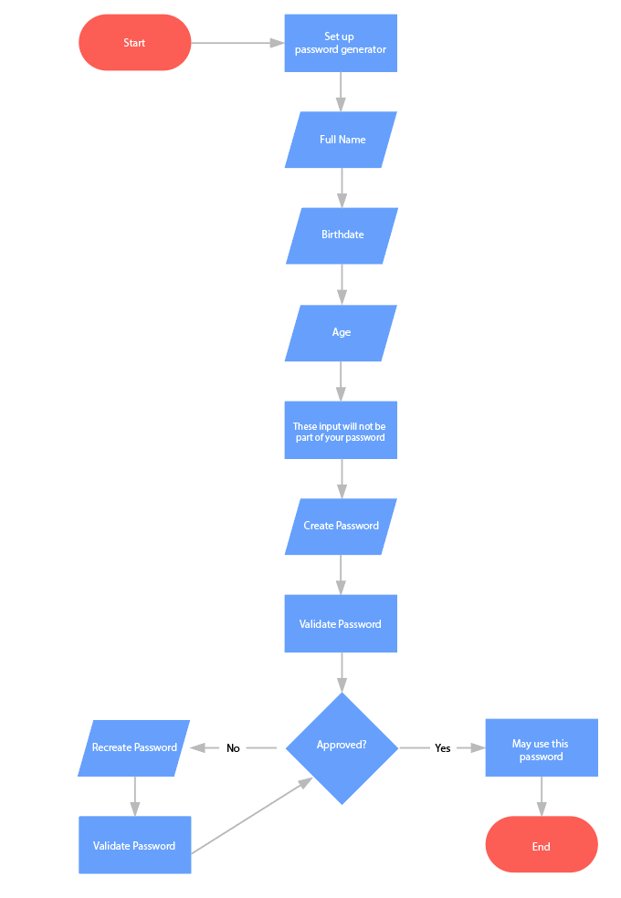

* 1. The resources I will need are PyCharm Edu, GitHub, CS50 IDE, zyBooks.