OBJECT ORIENTED PROGRAMMING USING JAVA 1
TASK: ASSIGNMENT 1
- Use a for loop to compute and print the factorial of a number in Java
public class Factorial {
public static void main(String[] args) {
int number = 5;
int factorial = 1;

for (int i = 1; i <= number; i++) {
factorial = factorial * i;
}

System.out.println("Factorial of " + number + " is: " + factorial);
}
}2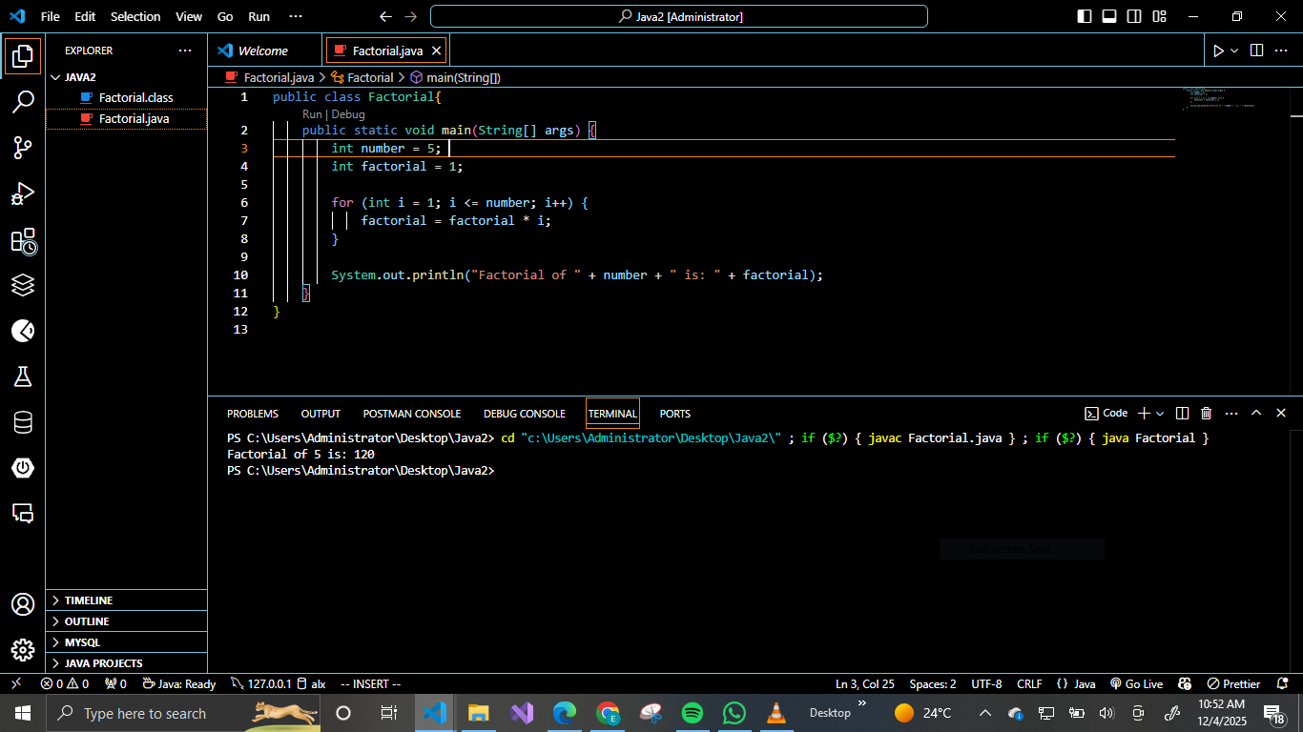2. Write a code to print
*
**
public class StarPattern {
public static void main(String[] args) {

for (int i = 1; i <= 4; i++) { // Controls number of lines
for (int j = 1; j <= i; j++) { // Prints stars per line
System.out.print("*");
}
System.out.println(); // Move to next line
}

}
}

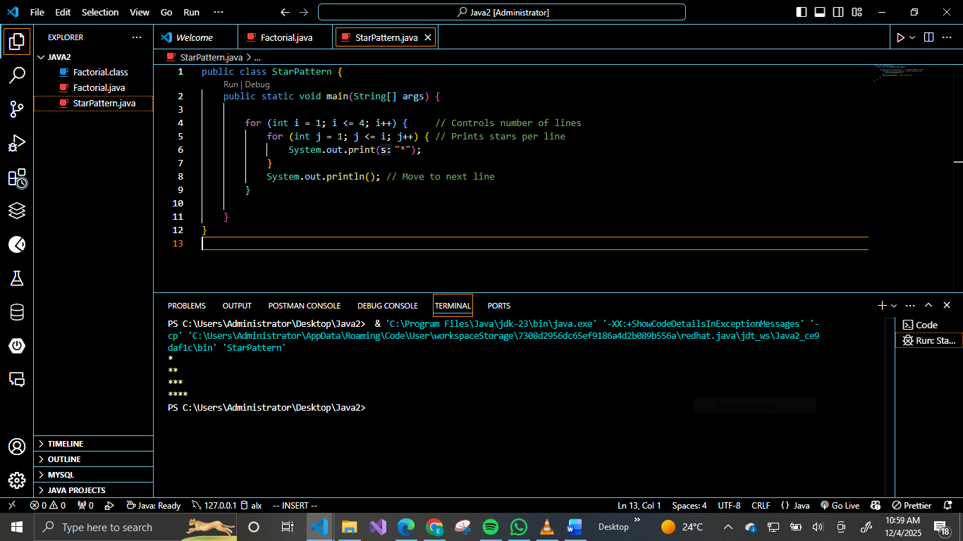
3.Write a code to print all the odd numbers from 0-27
public class OddNumbers {
public static void main(String[] args) {
for (int i = 0; i <= 27; i++) {
if (i % 2 != 0) {
System.out.print(i + " ");
}
}
}
}
