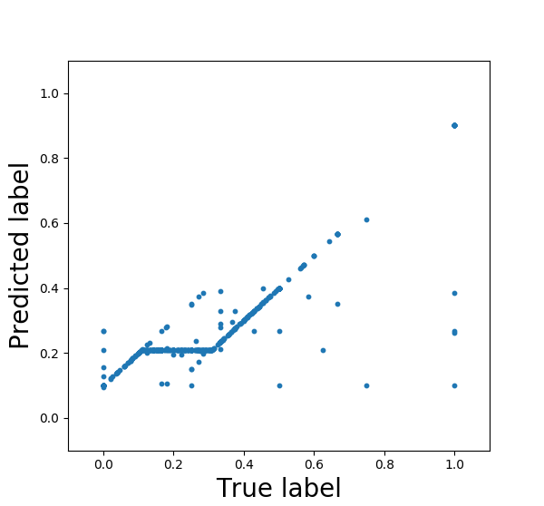C = 1.0

-----------------------

Leave One Out的mse 0.0477302536441

-----------------------

R-Square: 0.711840403272

-----------------------

y_true的平均值 0.196468143414

MSE 0.0130026976761

-----------------------

C = 2.0

-----------------------

Leave One Out的mse 0.0477311383295

-----------------------

R-Square: 0.715343789585

-----------------------

y_true的平均值 0.196468143414

MSE 0.0128446134978

-----------------------

