# Jackline Wavinya I163/5446/2022

# Ngige Mwaniki I163/4777/2022

# Ndemo Veronica I163/1503/2021

# Viola Kambuni I163/6929/2022

# Njange Githuo I163/4747/2022

# Joey Shiundu I163/4776/2022

# Irungu Muthoni I163/5614/2022

HotelTransylvania



Veronica Ndemo | Jackline Wavinya | Ngige Mwaniki | Viola Kambuni | Njange Githuo | Joey Shiundu | Irungu Muthoni

Executive Summary 2

Features 3

Technologies Used 3

Installation 4

Deployment 6

User Navigation 6

System Requirements 6

Login 7

Dashboard 9

Checkout 13

Staff Management 14

View Data 16

# Executive Summary

Welcome to our Room Booking Application! This VB app is designed to streamline the process of booking rooms, just like Airbnb, offering a user-friendly interface for both guests and staff. Users can easily log in, search for available rooms, and complete bookings, mirroring the convenience of popular booking platforms. Staff members have specialised access, allowing them to manage bookings, oversee room availability, and ensure a seamless experience for all users. Whether you're a guest looking for the perfect accommodation or a staff member overseeing the process, this application aims to simplify and enhance the room booking experience.

# 

# Features

These are some of the key features that collectively aim to create a robust, user-centric, and efficient room booking experience for both guests and staff, enhancing usability and satisfaction from the app.

1. **User Authentication:** Secure login for both users and staff members, each with their respective roles and permissions.
2. **Booking & Reservation Management:** Seamless booking process allowing users to select rooms, choose dates, and make reservations. Functionality to manage and update reservations, including cancellations or modifications.
3. **Staff Dashboard:** Exclusive access for staff members to oversee and manage room availability, handle booking requests, and assist guests.
4. **Admin Controls:** Administrative functionalities to manage user accounts, handle system configurations, and monitor overall application performance.
5. **Responsive Design:** Ensuring the application is accessible and user-friendly across different devices and screen sizes.

# Technologies Used

1. **Visual Basic.net** : For rendering and optimal performance
2. **Microsoft access:** Database and ODM for flexible data storage and modelling.

# Installation

1. **Create a New VB.NET Project:**

Open Visual Studio.

Click on "Create a new project."

Select "Visual Basic" and choose the project type (e.g., Windows Forms App).

Name your project and click "Create."

1. **Designing the User Interface:**

Use the Form Designer to create the layout for your application's user interface. Drag and drop controls like buttons, textboxes, labels, etc., to design the forms as needed.

1. **Add Microsoft Access Database:**

Go to "Solution Explorer."

Right-click on your project and select "Add" > "New Item."

Choose "Service-based Database" or "DataSet" to add an Access database file (.accdb).

1. **Connect to Access Database:**

Open Server Explorer/Database Explorer (View -> Server Explorer or View -> Database Explorer).

Right-click on "Data Connections" and select "Add Connection."

Choose "Microsoft Access Database File" and browse to select your Access database file (.accdb).

Click "OK" to establish the connection.

1. **Configure Database Connection in VB.NET:**

Drag a DataSet or TableAdapter from the Server Explorer onto your form. This action automatically generates connections and commands to interact with the database.

1. **Code to Interact with Database:**

Use ADO.NET or Entity Framework to interact with your Access database from your VB.NET code.

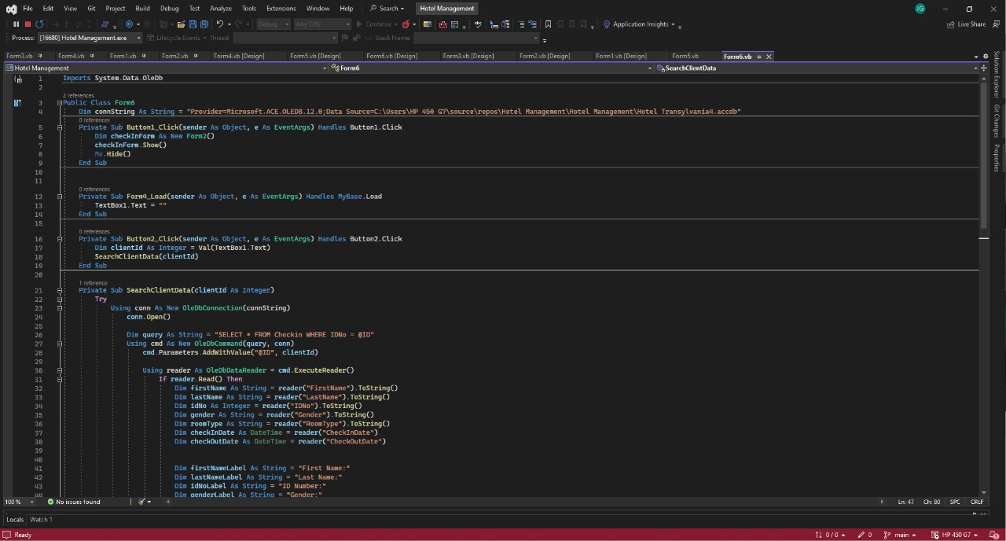

1. **Perform Database Operations:**

Use SQL commands (SELECT, INSERT, UPDATE, DELETE) via ADO.NET to perform operations on the database (read, write, update, delete data).

1. **Test Your Application:**

Run your VB.NET application and test the database operations to ensure they're functioning as expected.

# Deployment

1. **Build the Application:** Compile your VB.NET project to create an executable (.exe) file containing your application's code and resources.
2. **Choose a Deployment Method:** Select how you want users to access your app—options include creating an installer (like an MSI file), using ClickOnce deployment.
3. **Distribute the Application:** Share the executable or deployment package via downloads, physical media, or through a web server, depending on the chosen deployment method.
4. **Run the Application:** Once received, users can simply run the executable file or follow installation instructions to access and use the VB.NET application on their devices.

# User Navigation

The HMS is designed to streamline hotel operations, including guest check-in, check-out, staff management, and data management.

## **System Requirements**

* Microsoft Visual Studio
* Microsoft Access Database

## **Login**

Upon launching the HMS, the user will be presented with a login screen. The login credentials are as follows:

* Username: admin
* Password: 1234

If the entered credentials are correct, a message box will appear displaying "Login Successful". Otherwise, a "Invalid Login" message will be displayed.

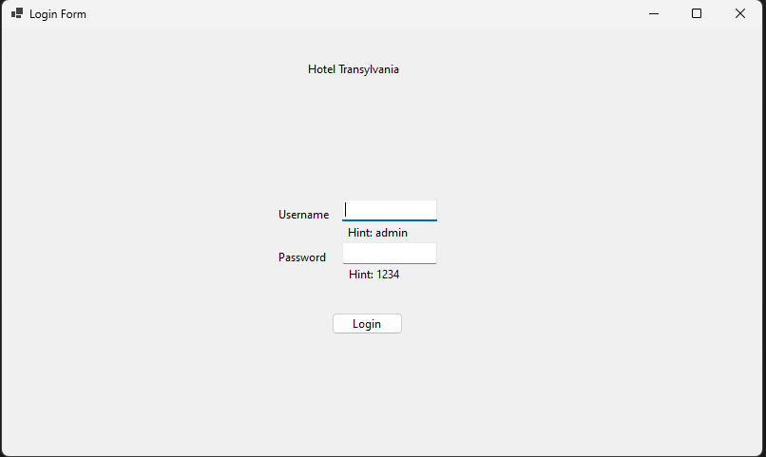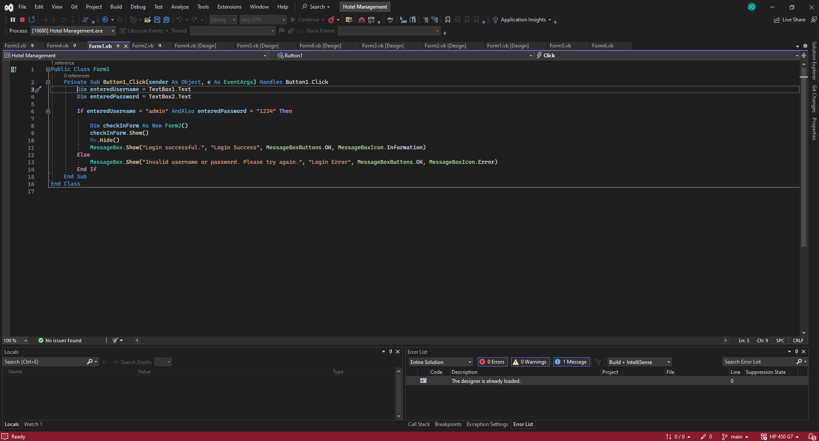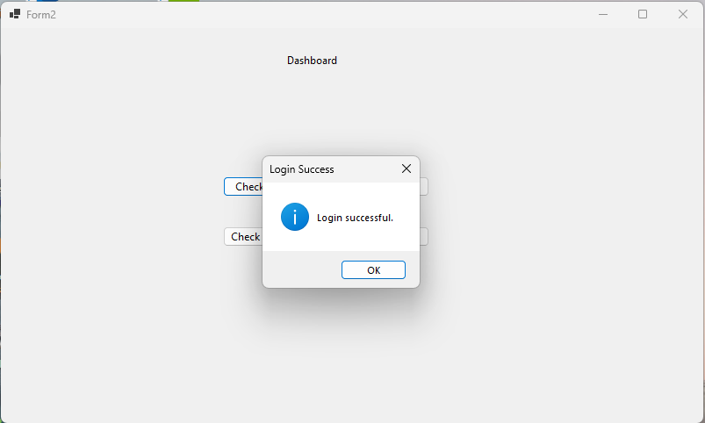

## **Dashboard**

Once successfully logged in, the user will be redirected to the main dashboard. The dashboard comprises four main buttons:

* Checkin: This button initiates the guest check-in process.
* Checkout: This button facilitates guest check-out.
* Staff: This button manages hotel staff information.
* View Data: This button allows viewing guest and staff data.

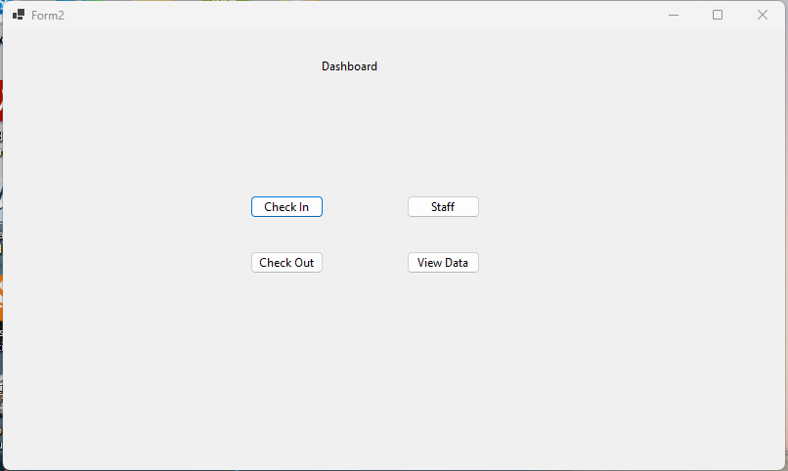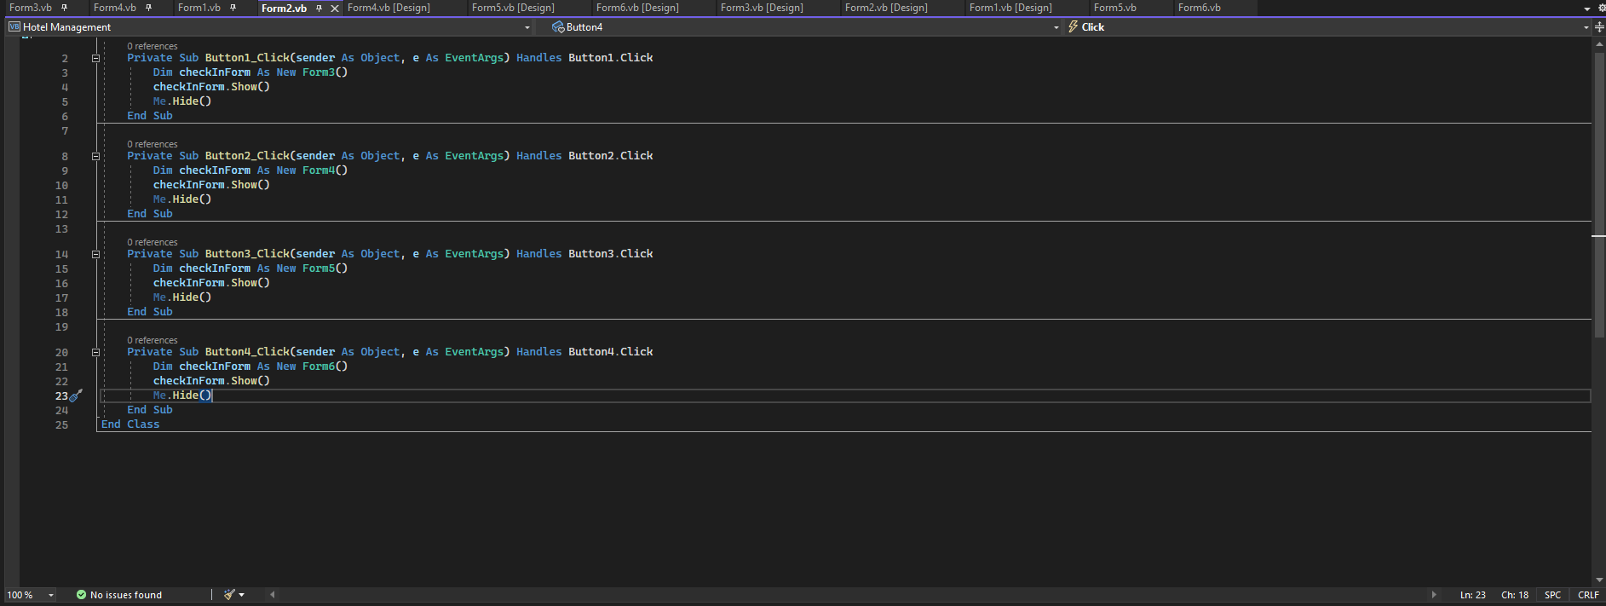

**Checkin**

To check in a guest, follow these steps:

1. Click the "Checkin" button on the dashboard.

Step 1: Access the Check-in Form

1. Click the "Checkin" button on the dashboard.

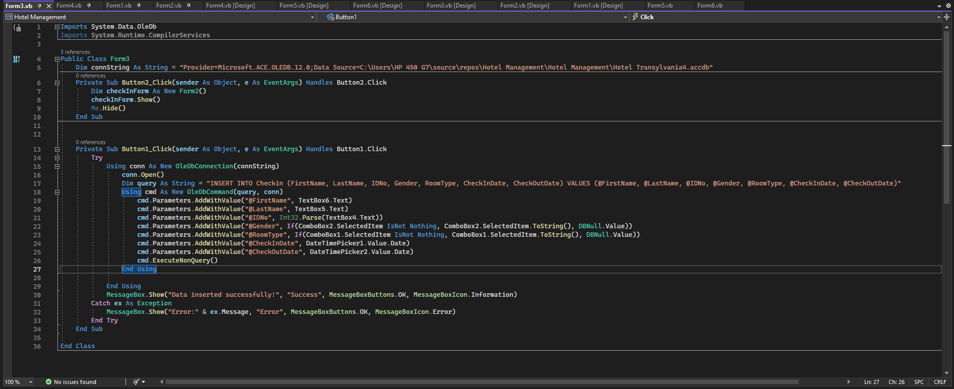

**Check in Button**

Step 2: Enter Guest Information

1. In the "First Name" field, enter the guest's first name.
2. In the "Last Name" field, enter the guest's last name.
3. Select the guest's gender from the "Gender" drop-down menu.
4. In the "ID Number" field, enter the guest's ID number.
5. Select the guest's preferred room type from the "Room Type" drop-down menu.
6. In the "Check-in Date" field, enter the guest's check-in date using the calendar picker.
7. In the "Check-out Date" field, enter the guest's check-out date using the calendar

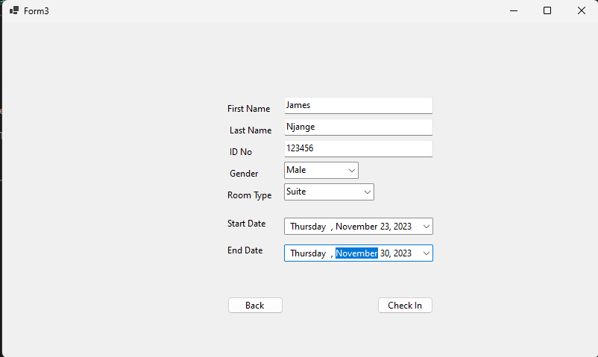

1. Click the "Checkin" button to proceed.
2. A message box will appear displaying "Checkin Successful".

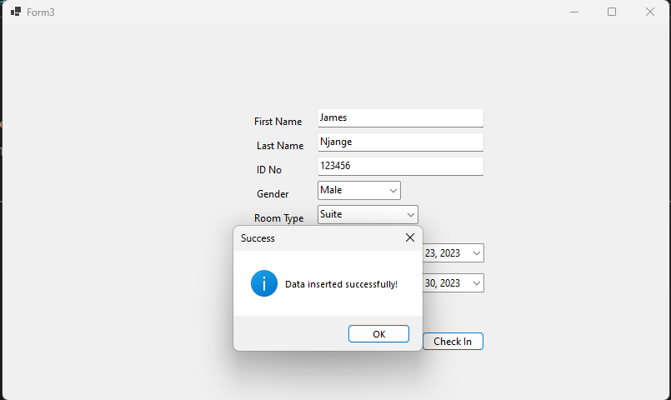

1. The guest's information will be stored in the database.

## **Checkout**

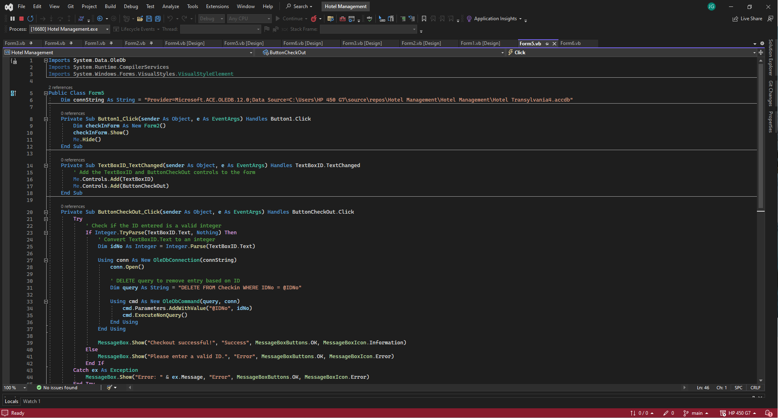

To check out a guest, follow these steps:

1. Click the "Checkout" button on the dashboard.

Checkout Button

1. Enter the guest's ID number in the search field.
2. Click the "Search" button to locate the guest.
3. Once the guest's information is displayed, click the "Checkout" button to remove the guest from the database.
4. A message box will appear displaying "Checkout Successful".

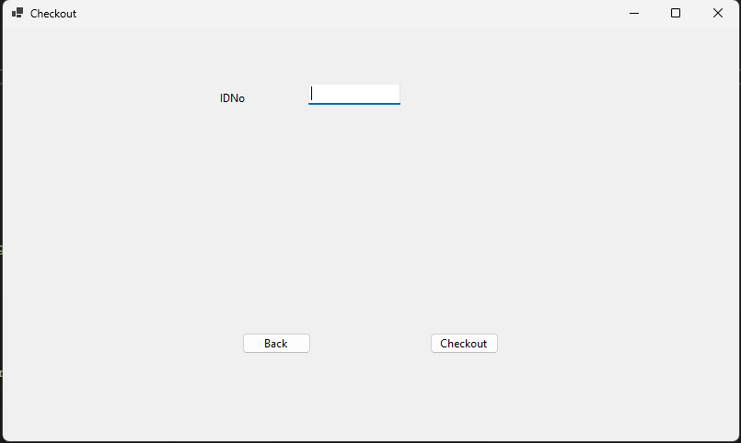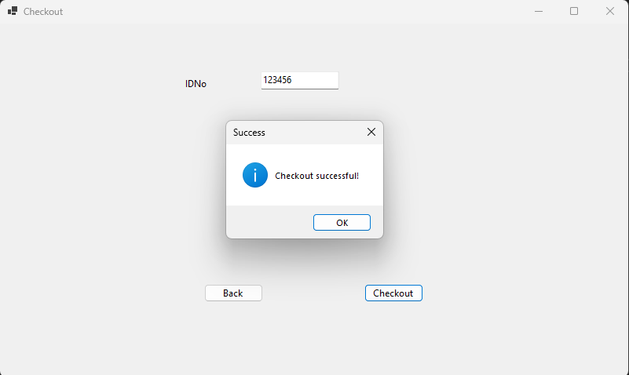

## **Staff Management**

To add or remove staff members, follow these steps:

1. Click the "Staff" button on the dashboard.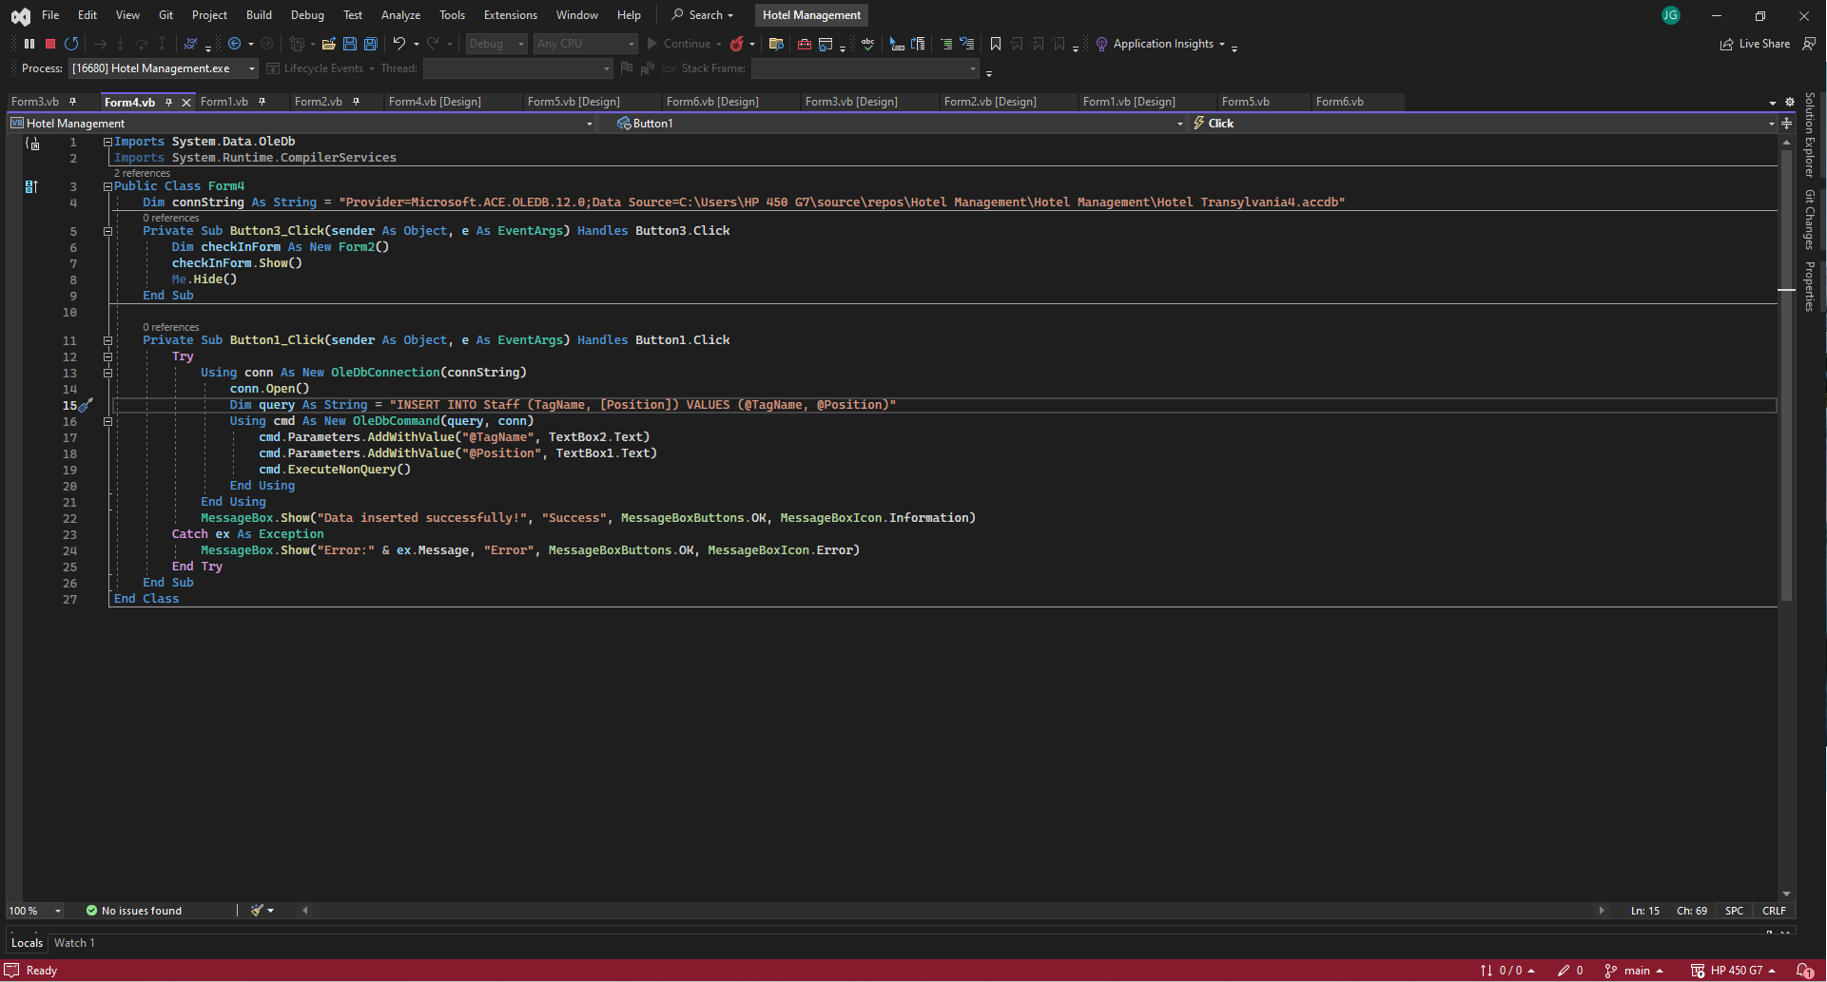

Walkthrough Screenshot:

Staff Button

1. To add a new staff member, enter the staff member's tagname and position in the respective fields and click the "Add" button.
2. A message box will appear displaying "Added Successfully".
3. To remove an existing staff member, select the staff member from the list and click the "Remove" button.
4. A message box will appear displaying "Removed Successfully".

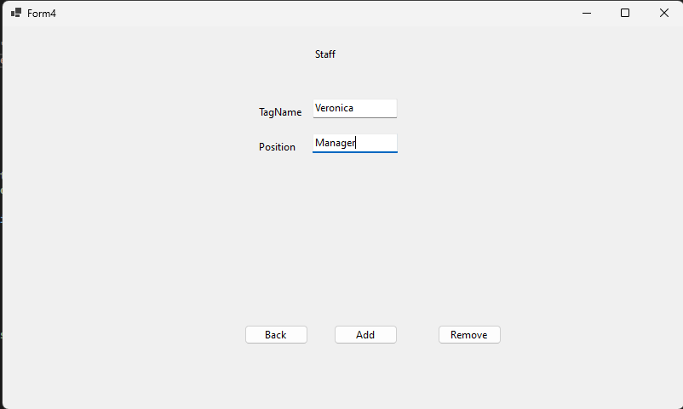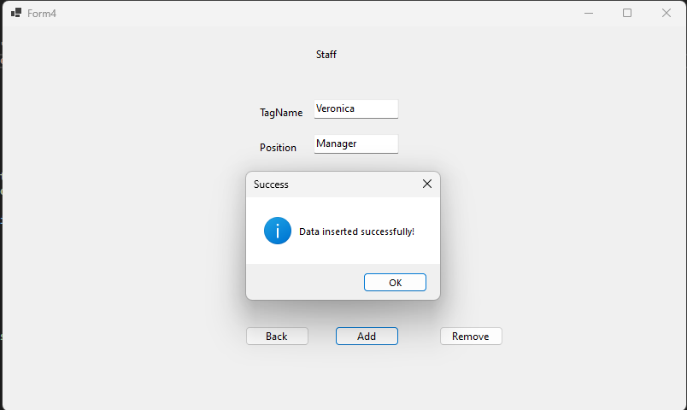

## **View Data**

To view guest or staff data, follow these steps:

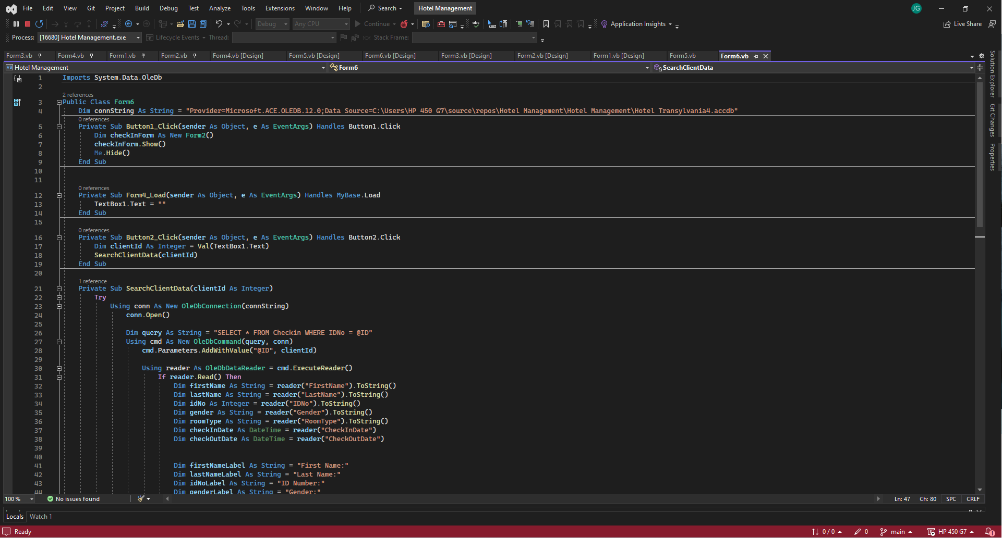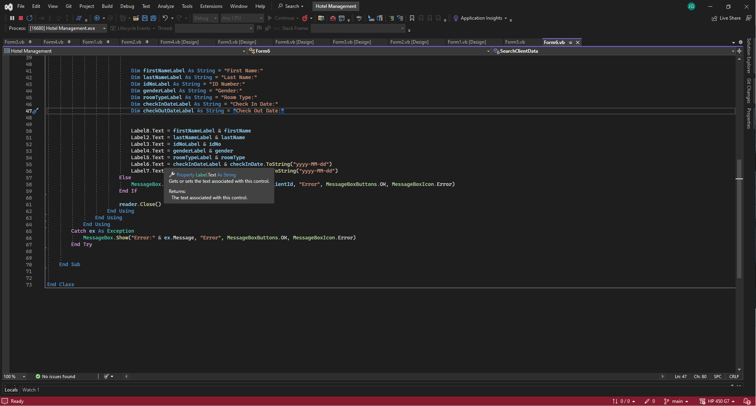

1. Click the "View Data" button on the dashboard.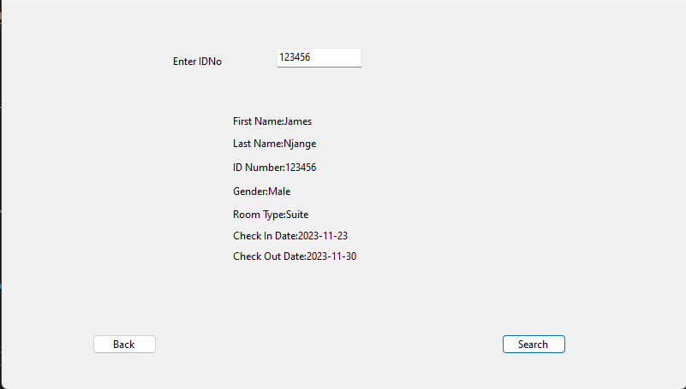

View Data Button

1. Select the "Guest" or "Staff" tab depending on the data you wish to view.
2. Enter the guest's ID number in the search field.
3. Click the "Search" button to locate the guest or staff member.
4. The guest's or staff member's information will be displayed.

# DATABASE CONNECTION

We used Access database in our project in which there are two tables; Checkin and Staff

