**University Accommodation Case Study**

Team Members: Tallapally, Bhavana

Macheti, Ravali

Jangiti, Narendhar

Rivier University

Course Name: Database Management Systems

Professor: Tseng, Yili

Date: 17/12/2022

1. ER Diagram

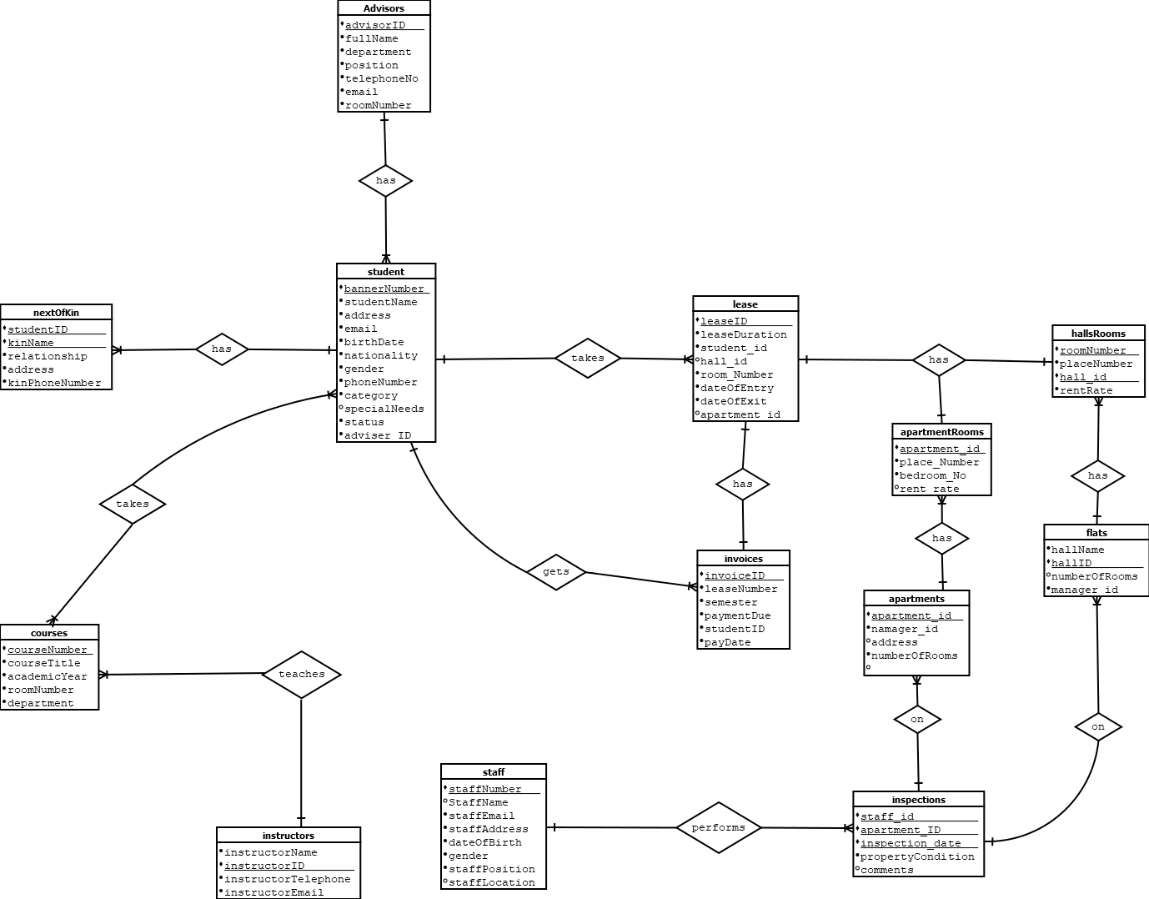

1. Schema

**Student table**

BannerNumber – varchar (Primary Key) Not null

studentName – varchar Not null

address – varchar Not null

email – varchar Not null

birthdate – date Not null

nationality – varchar Not null

gender – tinyint Not null

phoneNumber - varchar

category - varchar

specialNeeds – Boolean null

status – varchar Not null

advisor - varchar( Foreign Key) Not null

**adviser table**

adviserID – varchar (Primary Key) Not null

fullName – varchar Not null

department – varchar Not null

position – varchar Not null

telephone – varchar Not null

email – varchar Not null

roomNumber – varchar Not null

**nextOfKin table**

studentID – varchar Not null

kinName – varchar Not null

relationship - varchar Not null

address – varchar Not null

phoneNumber – varchar Not null

Primary key ( studentID, kinName)

Foreign key (studentID)

**Courses table**

CourseNumber - varchar (Primary Key) Not null

courseTitle – varchar Not null

academicyear – varchar Not null

roomNumber – varchar Not null

department – varchar Not null

**Instructor table**

instructorID – varchar (Primary Key) Not null

instructorName – varchar Not null

instructorTelephone – varchar Not null

instructorEmail – varchar Not null

**instructorCourses table**

instructorID – varchar Not null

CourseNumber - varchar Not null

Primary Key – (instructorID, CourseNumber)

Foreign keys **-** instructorID and CourseNumber

**studentCourses table**

CourseNumber - varchar Not null

studentID – varchar Not null

Primary Key – (studentID, CourseNumber)

Foreign keys **-** studentID and CourseNumber

**Lease table**

leaseID – varchar (Primary Key) Not null

leaseduration – int Not null

studentID – varchar (Foreign key) Not null

flat_room_number – varchar (Foreign Key) Not null

apartment_room_number – varchar (Foreign Key) Not null

dateofEntry – date null

dateOfExit – date null

**Invoices table**

InvoiceID – varchar (Primary Key) Not null

leaseNumber – varchar (Foreign Key) Not null

semester – varchar Not null

paymentDue – float Not null

studentID – varchar (Foreign Key) Not null

payDate – Date Not null

**staff table**

staffNumber (Primary Key) Not null

staffEmail – varchar Not null

staffName – varchar Not null

staffAddress – varchar Not null

dateOfBirth – varchar Not null

gender – varchar Not null

staffPosition – varchar Not null

staffLocation – varchar Not null

**Inspections** **table**

staffID – varchar (Foreign key) Not null

apartment_Or_hall_id – varchar (foreign key) Not null

inspection_date – date Not null

propertyCondition – varchar

comments – varchar Not null

Primary key ( staffID, apartment_Or_hall_id, inspection_date )

**apartment table**

apartment_id – varchar (Primary key) Not null

manager_id – varchar (Foreign key) Not null

address – varchar Not null

numberOfRooms – varchar Not null

**apartment_rooms table**

apartment_id – varchar (Foreign key) Not null

bedroomNo – varchar Not null

place_number – varchar Not null

rent_rate – float Not null

Primary key (apartment_id, bedroomNo )

**Flats Table**

hallName – varchar Not null

hallID – varchar (Primary Key) Not null

numberOfRooms – varchar Not null

manager_id – varchar (Foreign Key) Not null

**flats_rooms table**

roomNumber – varchar Not null

placeNumber – varchar Not null

hall_id – varchar Not null

rentRate – varchar Not null

Primary key (hall_id, roomNumber)